Thesis -Final Document

**Metrics**

**1. Airflow**

**8th November**

**Worker0**

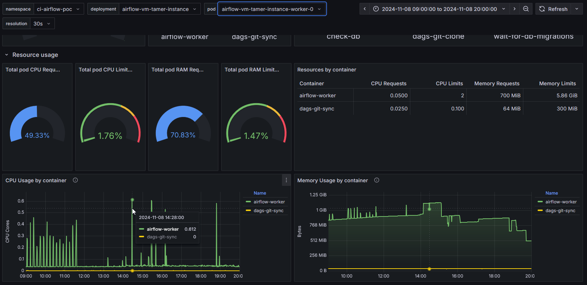**Worker1**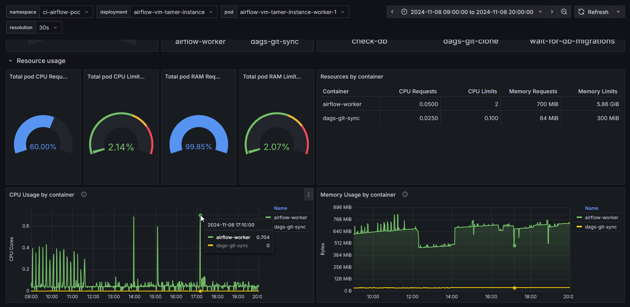

**Worker0**

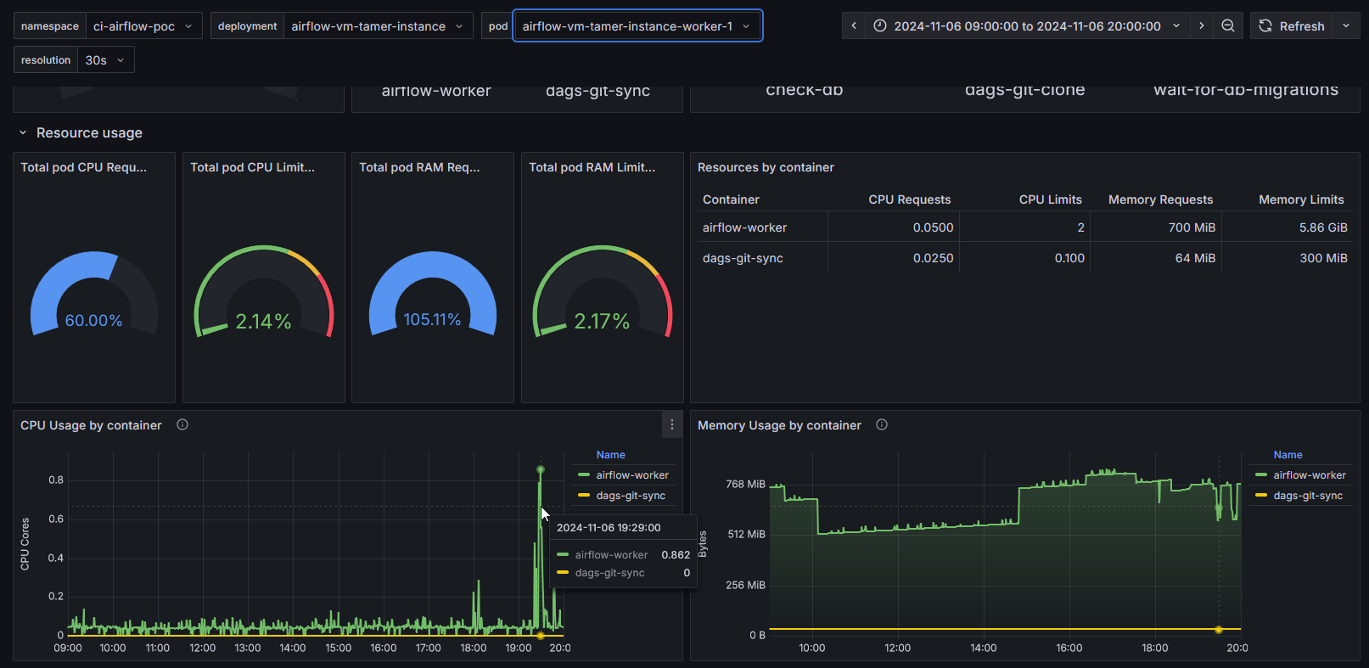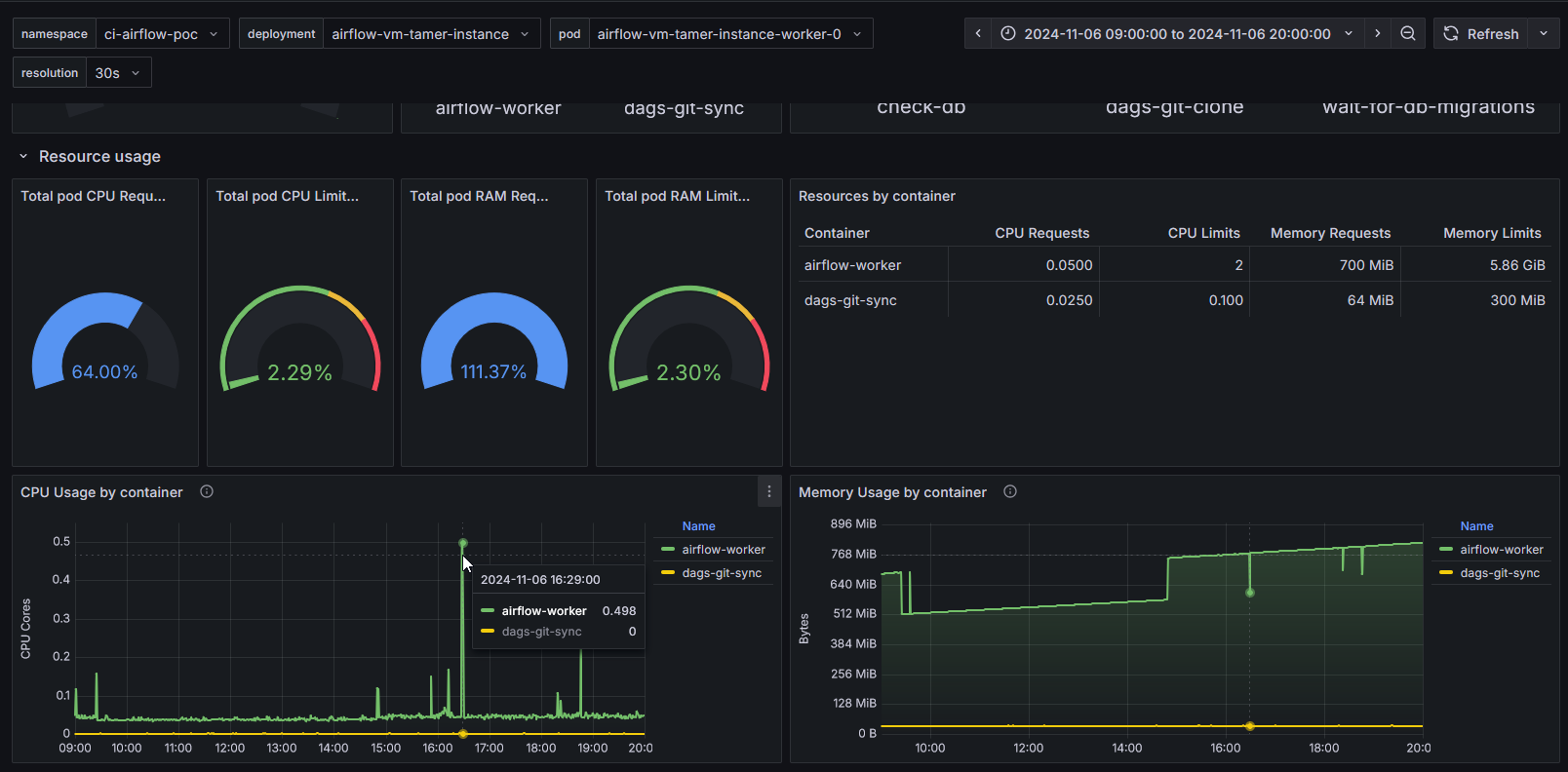

06November Worker1

**Worker0**

Openshift

CPU Usage

**06 Nov**

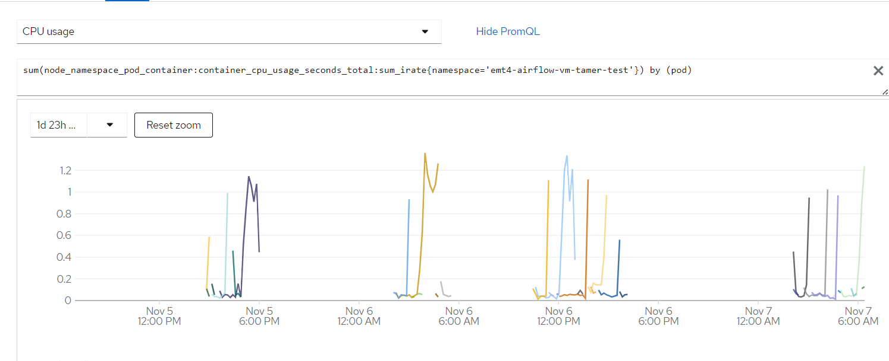



**08/ Nov**

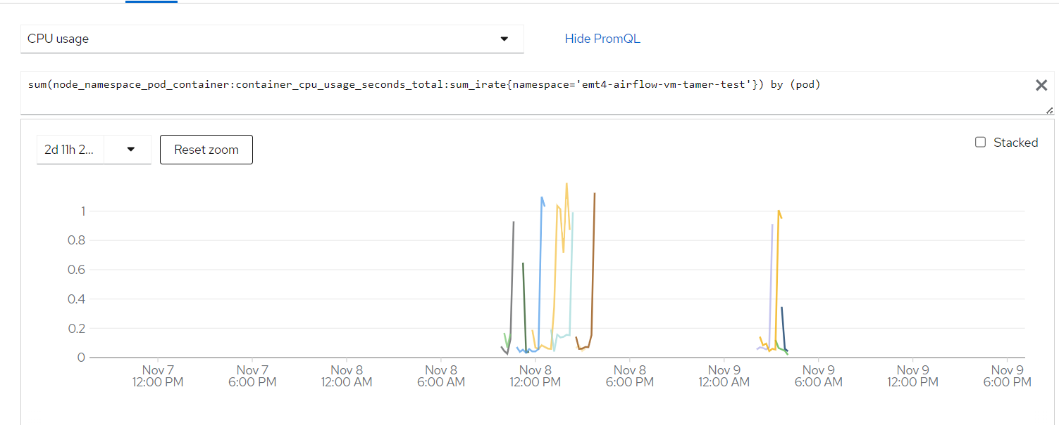



**Memory Usage**

**06 Nov**

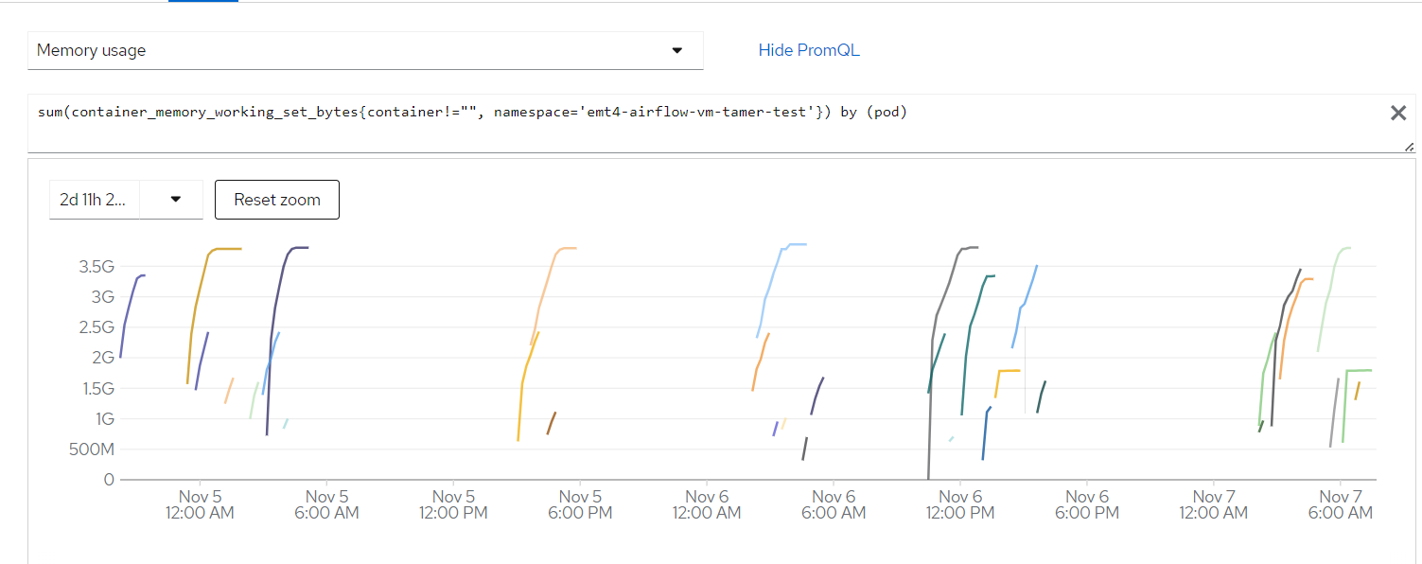



**08 Nov** 

