# 2. OVERALL DESCRIPTION

## 2.1. Product perspective

### 2.1.1. Scenarios

* **End user wants to pay the money for service**

After Giulia’s EV had been charged, she received a notification in her phone in the eMSP app to be notified about the completion of her car charging process. She can pay the cost on her phone through her debit/credit card online or she can pay the cost at the charging station through the CP which are NFC card reader and cash machine or QR which includes a link to the payment gateway. Hence Giulia has already charged her profile credit, just paid the invoice through the app.

* **End user wants to book a charge in charging station**

The user Bertil has a business meeting at 4 pm in another city near his hometown but his EV battery charge is not enough for such a distance, and it is really crucial for him to be present on time. So, he decided to book a charging point to avoid being in the charging point line and wasting his time. Therefore, he opens the app and finds his destination location to get a list of proper charging points on his way to the meeting and books a charging point among them for a specific time.

* **End user wants to find the nearest charging station**

Alex has an electric car. He knows there is an application named eMSP which besides all the features, shows all charging stations so he can find the nearest one. He already signs in and chooses his car model so when he goes to charging station section in the application and turns on his mobile phone GPS, the map shows his location on the map and all charging station. He can filter all the stations by price, other user ratings and travel distance and also, he can see all the new offers that CPOs provided for him.

* **End user sees the notification to indicate the completion of charging**

John is sitting in the coffee shop near to the charging station while his car is plugged in. He can see the status of his car’s battery, battery percentage, the speed of charging and remaining time to get fully charged. When his car gets full charged the eMSPS mobile application send him a notification “your car is ready to pick up” so he go to the charging station to use his car. Also, he can set a limit in the application for battery charging, When the battery percent reach that the mobile application shows the notification.

* **End user views suggestions**

Rachel is CEO in a big company, so she doesn’t have enough time to Handle her plans and she is very busy. When she got into her car, she sees that her car didn’t have enough battery, so she opens the mobile application and goes to suggestion section. The application asks for location and her calendar permissions, she accept that, and she enables her phone GPS and Bluetooth. The application gets her cars battery status by Bluetooth and it sends her current location and her today plans to eMSP servers, after a few seconds the application shows some suggestion that relied on her available time and her location.

* **CPO suggests charging stations**

Peter has an EV and wants to find a proper charging point to charge his car battery. He opens his eMSP app and creates his profile. He enters the type of charging socket, battery capacity, and car model. Then he clicks on the charging point suggestion button and waits for the app to show a list of suggested charging station around him. Meanwhile, the app sends all the information plus the location of Peter car's through the API to the CPO. Since the CPO knows about all the charging stations through the CPMS, try to find the nearest charging point with the minimum cost of charging price and with a socket that matches Peter's EV charging socket. The CPO prepares a list of CP locations ordered descending by the calculated score for each charging point and returns them as a response to the request. App then retrieves this list and shows them in a list and also on the map.

* **CPO finds the location of charging station**

Mike is a CPO. He signs in to the CPMS dashboard so he can see the status of all charging stations such as booked one, free one, in use and the energy consumption of the charging station. In the manage charging station section, he can search for all charging stations by their name, address.

* **CPO knows the external status of charging station**

Federico is a CPO, and he wants to know the external status of charging stations such as the sockets availability, types of them and so on. He can go through his admin panel and see all the statistics about the CPMS. All this information gathered and sent to CPO through the CPMS.

* **CPO knows the internal status of a charging station**

Monica is a CPO in the Viale Romagna street station. All the charging ports are in use. She go to CMPS dashboard and started looking for the information of that station. She can see all the cars models and their current battery percentage, the ports output voltage, how much costs users must pay, the remaining time to cars get full charged, how much energy each port consumes to generate electricity, each port temperature, ports which are booked, the cost of energy they should provide and how much power each car absorb.

* **CPO gets information about the current price of energy**

Alessandro opened the eMSP app and chose a charging point to book it for one hour later. He entered his battery status in the app. Through the defined API, the application sends all the information including the time of booking, battery status, and the charging point id to the CPMS. CPO gets the charging station battery status and gets the status of the grid (whether the booked time is during peak electricity usage or not) through the DSO to decide to use the station battery for charging or use the grid. Then it can calculate the cost which has been received from the DSO through the CPMS and turn it back to the user. Then based on the price, he can choose among the suggested or available charging points.

### 2.1.2 Class Diagram

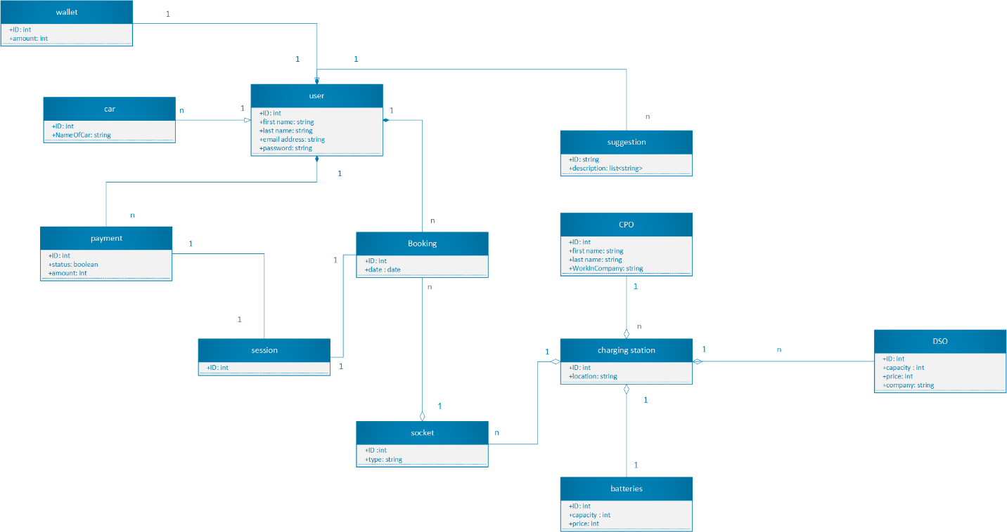

Figure 1 Class Diagram

### 2.1.3 Statecharts

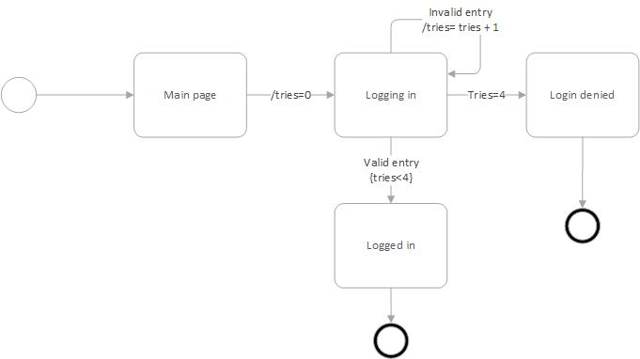

Figure 2 Statechart for login

Regarding figure 2, user goes to the main page and tries to login. If she/he inserts her/his information wrong for 4 times, then user must wait utill the login page appears to her/him again. Else the user loged in.

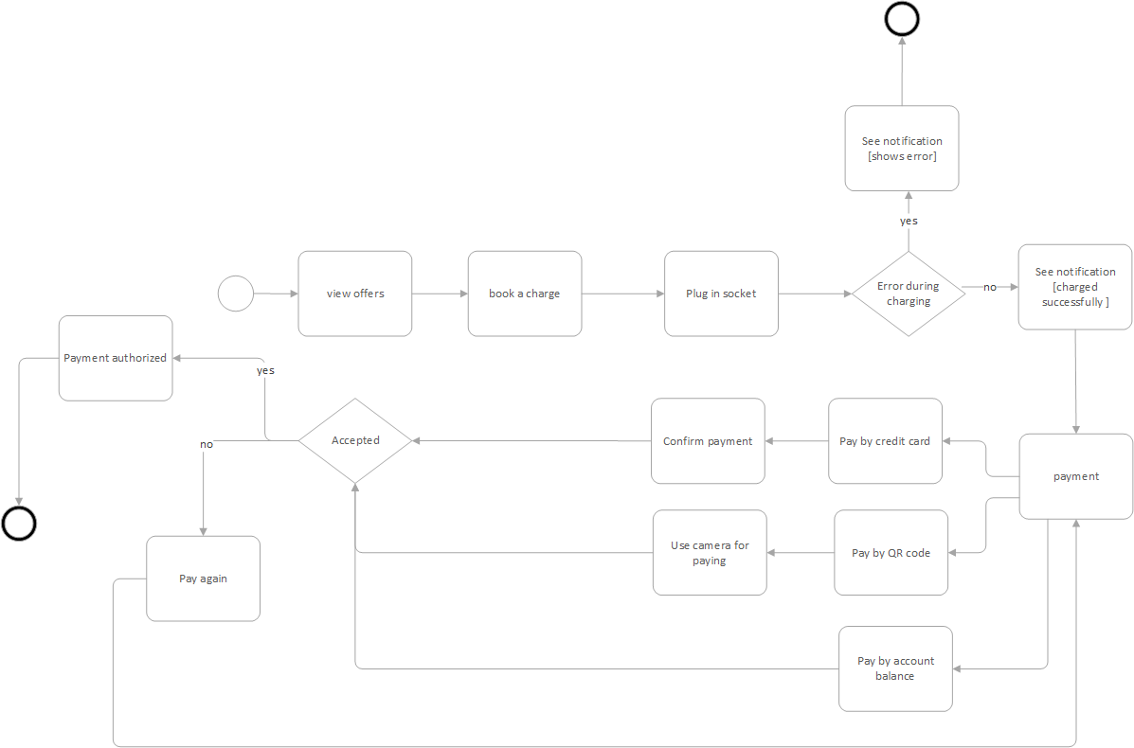

Figure 3 Statechart for session

About figure 3, the user can view offers and suggestions, then she/he can book a charge and plugs in the socket. After that if charging process is successful or unseccessful, the user can see the notification about it. If the charging process is successful, the user must pay for the services. The user can pay by QR code, credit card or her/his account balance. During payment process if the user cannot pay, she/he must try again. Else the payment authorized.

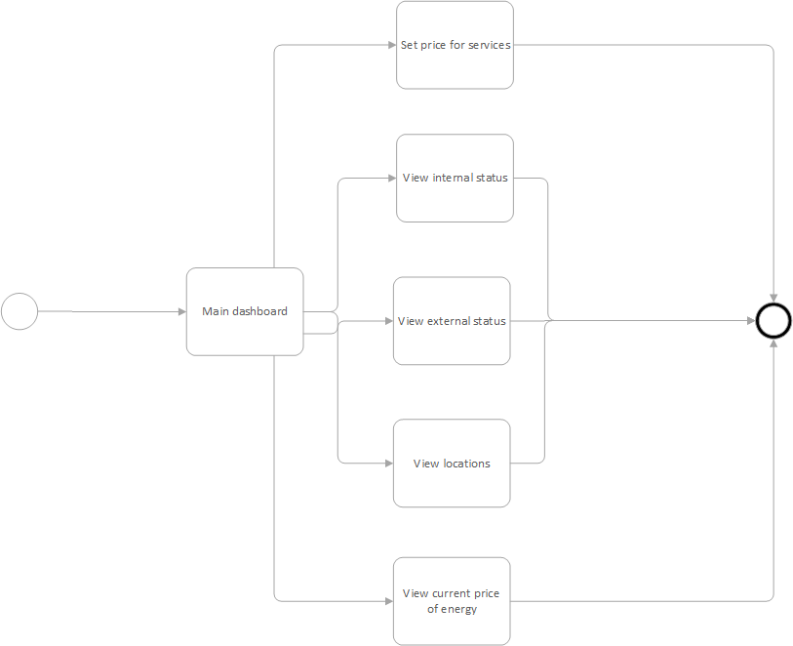

Figure 4 statechart for CPO

Regarding figure 4, CPO can do some works in her/his dashboard main page. The CPO can set the price for services, view internal status, view external status, view locations, and view current price of energy.

## 2.2. Product functions

Here are described the majority of functions of the systems. The less important ones are mentioned in other sections as well.

* **Service payment methods**

One of the important features in eMall application is having payment function. Therefore, developers provide multiple methods for the payment. Users can pay for the charging with Apple pay or Google pay application as third-party application or just use their credit card, or they can save some money in their eMSP account and pay automatically with that money. Also, there are some more methods for payment like contactless cards.

* **Book a charge in a specific charging station**

The most important thing that users care about is find the best charging station and book a port for specific time. Users can see all the stations and sort all of them by different parameters. After all of this, user can select one charging station and book one place. When they want to go to booked charging port, one scanner read their car plaque number or drivers show their application barcode to barcode scanner then CPMS shows a message to the CPO.

* **Create a notification when the charging process is finished**

It is one of the basic features of the app for users. As respects as the charging process is time consuming and long, it is crucial for the system to notify the user about the status of the charging and in this case, notify the user when the charging is finished. Notification allows the end-user (EV owner) to use it’s time meanwhile his/her car is charging and be notified to take his/her car from CP whenever the charging process has been completed. This notification will be sent to the user through the eMSM app installed on the user mobile phone.

* **Getting energy for charging**

One of the major functionalities of the CPMS is to decide how an electric car should be charged. An electric car can be charged by three ways: 1) station battery 2) DSO or 3) A mix thereof according to availability and cost. So, CPO can see how an electric machine are charging. This decision is dynamically with CPMS.

## 2.3. User characteristics

The following two actors are considered in the system.

* **End user**

A person who has an electric car and wants to charge her/his car at charging station through eMSP.

* **CPOS**

CPOs are the owner of some charging points. In other words, their job is installing and maintaining charge stations in charging stations.

## 2.4. Assumptions, dependencies and constraints

Domain assumptions are the facts that we assume to be true in the world.

Table 8 Domain Assumption

|  |  |
| --- | --- |
| Domain Assumption | Description |
| D1 | User and no other organizations/existing systems handles the insertion of her/his information |
| D2 | User must have an electric car |
| D3 | User must arrive to charging station at the time that she/he booked |
| D4 | CPO must know the exact current price of energy from DSOs |
| D5 | Each CPO works only for a specific company |
| D6 | CPO gives different offers for each user |
| D7 | CPO sets current price for services |
| D8 | DSOs’ prices must be updated |
| D9 | Voltage of each charging point must be appropriate |
| D10 | Each charging point must have battery and DSOs for charging |