
Department of Computer Science

BSCCS Final Year Project 2025-2026
Interim Report II

25CS017

Secure Offline P2P Acoustic Proximity Authentication between Smartphone and Laptop
(Volume of )
For Official Use Only
Student Name | : | AIDARBEK Yernur
Student No. | : | 57597935
Programme Code | : | BSCCCU4
Supervisor | : | Prof HANCKE, Gerhard Petrus
Date | : | February 3, 2026

Table of Contents
1 Introduction 3
1.1 Motivation & Background Information 3
1.2 Problem Statement: 4
1.3 Proposed Solution: 4
1.4 Project Aims 4
1.5 Project Scope 5
2 Literature Review 5
2.1 Radio Frequency (RF) Transmission: 5
2.2 Optical Transmission: 7
2.3 Audio Transmission: 7
3 Preliminary Design, Solution, System 8
3.1 System Overview 8
3.2 System Components 9
3.3 Algorithm 11
3.4 Testing and Experimental Design 13
4 Detailed Methodology and Implementation 15
4.1 System architecture 15
4.2 UML Diagrams 17
4.3 Algorithmic specifications 20
4.4 Testing procedure 22
4.5 Problems encountered 25
5 Preliminary result and future improvement 26
5.1 Progress 26
5.3 Future Improvement 28
5.4 Gantt Chart 28
Monthly Logs 29
6 Reference list 30

1 Introduction

1.1 Motivation & Background Information
The widespread usage of electronic devices has become a definition of modern society. Securing access to these devices is a fundamental challenge, as their compromise can lead to breaches of personal privacy, financial loss, and critical infrastructure failure. The scale of this importance is reflected in the investments in the cybersecurity market, which is projected to grow from USD 218.98 billion in 2025 to USD 562.77 billion by 2030 (Fortune Business Insights, 2025). In response to this universal need for protection, a vast ecosystem of authentication methods has been developed.
A significant limitation of many modern authentication systems is their dependence on an online network connection for validation, such as contacting a central server for two-factor authentication (2FA). As Gurevich et al. (2022) state, "the problem of secure communication and authentication without online servers is fundamental" (p. 1). This paper, therefore, focuses specifically on authentication methods that can be implemented securely in an offline environment, where devices must establish trust without any network connectivity.

1.2 Problem Statement:
The main problem is that it is impossible to guarantee complete security with any authentication method. Therefore, it is crucial to develop layered security mechanisms where the corruption of one layer does not lead to the corruption of other layers (Grassi et al., 2020; Ometov et al., 2018).
For instance, current offline authentication technologies represent a fundamental trade-off between security, accessibility, and implementation cost. NFC offers strong security but requires specialized hardware not available across all devices. Bluetooth offers broader compatibility but suffers from relay attacks due to its long range. QR codes ensure universal accessibility but lack bidirectional communication for secure mutual authentication.
This creates gaps in the security system, particularly for RF-restricted and offline environments where radio frequency methods may be compromised, jammed, or prohibited.

1.3 Proposed Solution:
This research proposes a new acoustic-based authentication system that addresses these gaps by providing an additional security layer for , proximity-based authentication application, in RF-restricted and offline environments.

1.4 Project Aims
This project aims to use standard audio hardware on laptops and phones as a transport layer for a secure authentication protocol, replacing radio frequency or optical layers in scenarios where those methods are inefficient. The main objective is to evaluate the feasibility of acoustic authentication in terms of data transmission reliability and resistance to common attacks.

1.5 Project Scope
- A Python application for the laptop to manage challenges, responses, and access control.
- An iOS application to capture, decode, and respond to acoustic challenges.
- A functional demonstration where successful acoustic authentication unlocks a designated folder on the laptop.

2 Literature Review
Authentication technologies can be categorized by their transmission medium, each with distinct trade-offs.

2.1 Radio Frequency (RF) Transmission:

2.1.1 NFC
Near Field Communication (NFC) provides secure short-range communication (<10 cm) and supports strong cryptography. According to Ravilia et al. (2024), NFC tokens use cryptographic-response protocols, making the technology highly secure against threats like phishing and man-in-the-middle (MITM) attacks. In addition, Ravilia et al. (2024) suggest that NFC is more convenient than alternatives as it requires only a simple "tap" from the user.
While it can be used as a two-factor authenticator, which will be proximity-based and secure, NFC-based two-factor authentication has its own issues. For instance, as Heartfield and Loukas (2018) state, NFC is expensive and not common in the majority of laptops and desktop technologies. Moreover, Francillon et al. (2019) demonstrate the possibility of relay attacks against short-range wireless protocols like NFC. They showed that the physical proximity requirement is not a guarantee of presence, as the authentication session can be relayed over a greater distance.
Although NFC is more secure against certain attacks like phishing and man-in-the-middle, and can create a smoother authentication process than acoustic-based authentication, audio components are more common. Therefore, the acoustic authentication method is more universally accessible.
2.1.2 Bluetooth
Bluetooth, which offers a greater range (up to 100 m), on the other hand, is more popular than NFC technology. Padgette et al. (2017) state that the widespread adoption of Bluetooth makes this technology a good base for the development of innovative cybersecurity applications. Bluetooth-based solutions also offer a convenient way of authentication that is less cumbersome than alternatives with secure authentication solutions (Mare et al., 2014). The Bluetooth protocol is also evolving by adding more security measures. Modern BLE uses Secure Connections Pairing, a strong method that provides protection against passive eavesdropping (Antonioli et al., 2020).
Despite the introduction of ECDH to the Bluetooth system does not help to safely solve relay attacks. The most significant security flaw of Bluetooth for authentication is its relatively long range(<100 m). This means that a device can be authenticated from different rooms within this radius. Ryan (2013), an attacker can relay the Bluetooth signals between two devices that are far apart, tricking them into believing they are in close proximity.
Acoustic authentication, despite not being a more popular technology than Bluetooth, solves its core weakness, which is long proximity. Sound waves attenuates rapidly and allow for precise time-of-flight measurements, acoustic systems can enforce close proximity. As noted by Huth et al. (2015), this property of sound decreases the chances of relay attacks by ensuring the device is close to the authenticator within centimeters, not meters, using physics.

2.2 Optical Transmission:

2.2.1 QR code:
QR codes are a widely adopted optical method for user authentication. The main advantage is that a QR code can contain a significant amount of data, making the authentication session efficient and reliable without a round-trips (Eminagaoglu et al., 2014). Tirfe et al. (2021) state that it is also resistant to man-in-the-middle (MITM) attacks.
On the other hand, one-way factor authentication can be considered a security flaw. Tirfe et al. (2021) suggest that this technology is vulnerable to remote session swapping attacks because it does not have mutual authentication. It also depends on the phone's camera, which can be broken, limiting secure authentication options.

Unlike the one-way visual channel of a QR code, an acoustic channel can easily be made bidirectional. This helps to establish a secure communication session resistant to remote attackers (Zhang et al., 2014).

2.3 Audio Transmission:

2.3.1 Acoustic authentification:
This method uses sound waves to transmit data and has two major flaws. The acoustic channel has a very low data rate compared to RF or optical links, making it unsuitable for large data transfers and potentially resulting in higher latency during the authentication handshake (Mehrabi et al., 2020). In addition, performance can be degraded by noise, which leads to packet loss. This necessitates robust error-correction and can reduce reliability in noisy real-world settings (Nandakumar et al., 2014).
Even though the acoustic channel is not reliable in noisy environments, the characteristics of sound waves can act as a preventive mechanism against relay attacks because sound waves attenuate rapidly and are blocked by walls. This short physical range (<1m) enforces close proximity, providing a natural defense against the long-distance relay attacks that are a critical flaw in Bluetooth-based systems (Jakobsson & Wetzel, 2001). While the small data capacity poses challenges, it is not problematic for this application since this project aims to transfer only the cipher keys, which are small in size and do not require large data transfers. In addition, unlike NFC or Bluetooth LE, it requires no specialized hardware, leveraging components present in virtually all smartphones and laptops. This makes it a universally accessible solution that functions completely offline (Schürmann & Sigg, 2011).
Therefore, despite the existence of NFC, Bluetooth, and QR code-based authentications that provide a good level of security and are already in use by world-leading companies, they can still have security or implementation flaws in the scenarios described above. Although the acoustic channel does not solve all the issues of other authentication methods, it can cover security needs in offline, RF-restricted environments that require close proximity between pairing devices.

3 Preliminary Design, Solution, System

3.1 System Overview
Acoustic authentication system will establish acoustic authentification channel between a Phone(iPhone) and Laptop(MacBook). This channel relies on per to peer communication channel, therefore it does not require connection to the Internet, or any type of 3 partyy technology. This desgn helps to provide secure authentification Offline and RF-restricted environment.
The proposed authentification system operates through challenge-response authentication over an acoustic channel. A laptop generates a cryptographic challenge, encodes it into an audible or near-ultrasonic audio signal, and sends using speaker. The iPhone receives this signal, decodes it, computes a cryptographic response using a shared secret, and transmits the response acoustically back to the laptop. The laptop validates the response to complete or deny authentication.
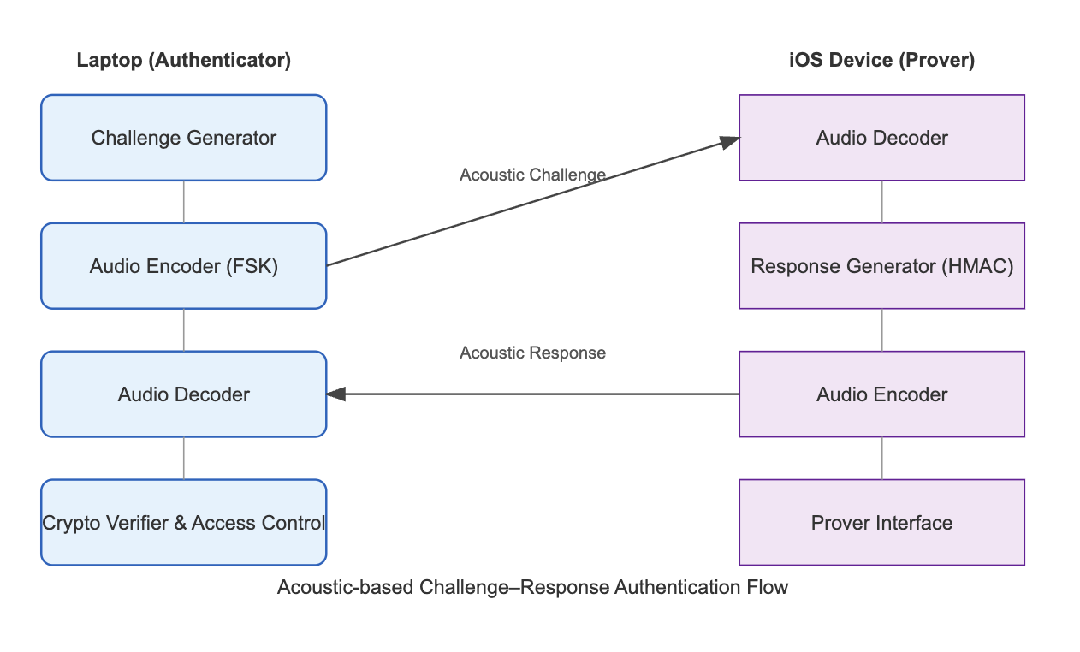
Figure 1 Acoustic - based Challenge - Reponse Authentication Flow

3.2 System Components
The proposed acoustic authentication solution is designed using a collection of standard hardware and custom software components. The system's building blocks can be logically divided into two main categories: the physical hardware that handles acoustic transmission and reception, and the software modules that manage the cryptographic and data-link protocols.

3.2.1 Hardware Components
The system is designed to operate on commodity hardware, requiring no specialized equipment. Its functionality relies on the standard audio input and output capabilities found on modern laptops and smartphones, which together form the physical layer for data transmission.
- Laptop Speakers: The built-in or external audio output system of the laptop. Its primary function is to transmit the acoustic challenge by playing the encoded audio tones.
- Laptop Microphone: The standard integrated microphone on the laptop. It is responsible for recording the incoming acoustic response signal sent from the mobile device.
- iPhone Speaker: The standard loudspeaker on the iOS device. It is used to send back the encoded acoustic response tone sequence to the laptop.
- iPhone Microphone: The built-in microphone on the iOS device. Its role is to capture the initial acoustic challenge from the laptop and forward the signal to the software decoding module.

3.2.2 Software Components
Complementing the hardware is a layered software stack that implements the core authentication logic. These modules handle everything from low-level signal processing to high-level cryptographic operations and user interaction, ensuring a robust and secure authentication process.
- Audio Interface Module: Manages all audio input/output operations using PyAudio (Python) and AudioKit (Swift), handling recording, playback, and synchronization at a 44.1 kHz sample rate.
- Modulation & Demodulation Module: Converts data between binary and acoustic signals using Frequency-Shift Keying (FSK) for transmission and employs FFT for frequency detection during reception.
- Frame Construction Module: Assembles data into structured frames with a Preamble, Header, Payload, and CRC checksum, managing the timing and structure of transmissions.
- Challenge Generator: Produces a cryptographically secure random nonce for each session using the secrets module (Python) or SecRandomCopyBytes (iOS).
- Cryptographic Engine: Computes and verifies HMAC-SHA256 hashes to ensure the integrity and authenticity of the challenge-response exchange.
- Response Generator: On the iOS device, computes the HMAC response to the received challenge and prepares it for acoustic transmission.
- Verification and Access Control Module: Compares the received response against the expected value and unlocks the secured resource upon a successful match.
- Error Correction & Control Module: Implements CRC-16 for error detection and manages retransmission protocols to ensure data reliability over the acoustic channel.
- User Interface Layer (UI): Provides the user-facing application on both devices, built with Swift UI for iOS and Tkinter/PyQt for the laptop

3.3 Algorithm
The core authentication mechanism employs a cryptographic challenge-response protocol that uses acoustic channel. The protocol ensures mutual authentication through shared secret verification while maintaining resistance to replay attacks
3.3.1 Challenge Generation:
The initiator (laptop) generates a cryptographic challenge using the following procedure:
C = os.urandom(16) # 128-bit random challenge
R_expected = HMAC(K, C, digestmod='sha256')
Algorithm Specification: The nonce C is generated using a cryptographically secure pseudorandom number generator (CSPRNG) as specified by Barker and Kelsey (2012). The 128-bit length provides sufficient entropy (2^128 possible values) to prevent brute-force attacks. The HMAC construction follows the standard by Krawczyk et al. (1997) using SHA-256 as the underlying hash function, providing 128-bit security strength against collision attacks.
3.3.2 Acoustic Encoding and Transmission:
The binary challenge C is converted to an acoustic signal using digital modulation techniques:
Frequency-Shift Keying (FSK) Implementation:
- Binary '0': Represented by frequency f₀ = 18000 Hz (near-ultrasonic)
- Binary '1': Represented by frequency f₁ = 19000 Hz
- Symbol duration: T_symbol = 50 ms
- Sampling rate: f_s = 44100 Hz
The modulated signal s(t) is constructed as:
s(t) = A · sin(2πf₀t) for binary '0'
s(t) = A · sin(2πf₁t) for binary '1'
Technical Rationale: FSK modulation provides robustness against amplitude variations and selective fading (Proakis & Salehi, 2001). The near-ultrasonic frequency range (18-19 kHz) minimizes audible disturbance while remaining within the frequency response of standard laptop speakers and smartphone microphones, typically capable of 16-22 kHz response (Michalevsky et al., 2014).
3.3.3 Signal Reception and Decoding:
The receiver (iOS device) processes the incoming acoustic signal through a demodulation pipeline:
Preprocessing Stages:
- Band-pass filtering: 17-21 kHz Butterworth filter to remove out-of-band noise
- Normalization: Automatic gain control to compensate for distance-dependent attenuation
- Frame synchronization: Preamble detection using Barker code sequence
- FSK demodulation: Goertzel algorithm (Sysel & Rajmic, 2012) for efficient frequency detection
The Goertzel algorithm computes the energy at frequencies f₀ and f₁:
P₀ = |X(f₀)|², P₁ = |X(f₁)|²
Decision: binary '0' if P₀ > P₁, else binary '1'
3.3.4. Response Computation:
Upon successful decoding of challenge C, the prover computes:
text
R_device = HMAC(K, C)
using the same HMAC-SHA256 parameters as the authenticator. The shared secret K is securely stored in the device's keychain, protected by the iOS Secure Enclave.
3.3.5 Verification and Access Control:
The authenticator performs a constant-time comparison:
if secure_compare(R_device, R_expected):
grant_access()
else:
deny_access()
The secure_compare() function implements constant-time comparison to prevent timing attacks (Brumley & Boneh, 2005), ensuring the comparison time is independent of the number of matching bytesProtocol Security Properties:
- Replay Protection: Each challenge is used only once (nonce)
- Forward Secrecy: Compromise of K doesn't reveal past session keys
- Mutual Authentication: Both parties prove knowledge of K
- Proximity Assurance: Acoustic channel limits effective range to ~1 meter

3.4 Testing and Experimental Design

3.4.1 Testing Objectives
The testing phase aims to evaluate:
- Functional accuracy – correctness of authentication responses.
- Signal reliability – success rate of acoustic data transmission under varying noise conditions.
- Security robustness – resistance to replay, relay, and eavesdropping attacks.
- Practical usability – response time, error rate, and real-world feasibility.

3.4.2 Test Setup
Parameter | Configuration
Test Environment | Quiet indoor room (baseline), moderate noise (office), high noise (café)
Devices | Laptop (MacBook/Windows PC) & iPhone
Sampling Rate | 44.1 kHz
Encoding Scheme | FSK (two-tone), adjustable frequency separation
Number of Trials | 50 per environment
Distance Between Devices | 10 cm – 100 cm

3.4.3 Testing Procedures
- Functional Validation:
  - Run the full authentication sequence multiple times under ideal conditions.
  - Measure success rate and transmission latency.
- Noise Tolerance Tests:
  - Introduce controlled background noise levels (e.g., white noise at 40–70 dB).
  - Measure decoding success rate and error rate.
- Security Tests:
  - Attempt replay attacks by recording and re-transmitting previous response signals.
  - Attempt distance-based relay attacks (>1m) to confirm proximity enforcement.
- Performance Metrics:
  - Success Rate (%) = Successful Authentications ÷ Total Attempts
  - Average Latency (ms) between challenge emission and authentication completion.
  - Bit Error Rate (BER) to assess transmission reliability.

4 Detailed Methodology and Implementation

4.1 System architecture
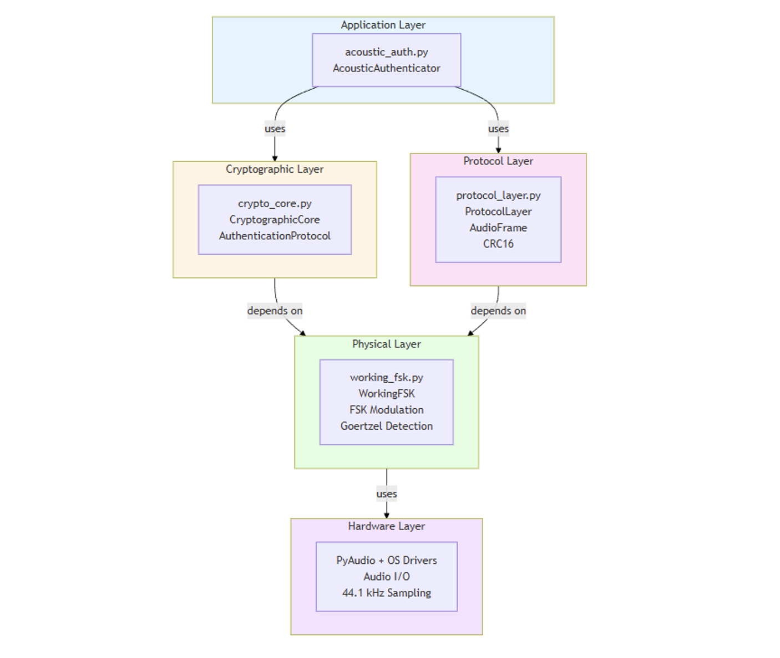
Figure 2 System Architecture
The acoustic authentication system is built on a layered architecture where each
layer has responsibilities and interfaces with adjacent layers connected through APIs. Figure 2 illustrates the component diagram showing the five primary layers of the system.
The Application Layer (acoustic_auth.py) serves as the orchestration point for the entire authentication workflow. It coordinates between the cryptographic and physical layers, managing data conversion between bites and binary strings. The AcousticAuthenticator class provides the main interface for initiating and completing authentication sessions.

The Cryptographic Layer (crypto_core.py) implements the security components of the system. It generates cryptographically secure 128-bit challenges using os.urandom(), computes HMAC-SHA256 responses producing 256-bit outputs and verifies responses using constant-time comparison to prevent timing attacks. The layer maintains a used_challenges set to prevent replay attacks, ensuring each challenge is used only once per session.
The Protocol Layer (protocol_layer.py) handles frame construction and error detection. It constructs frames with preamble, header, payload, and CRC-16 checksum components. The layer manages sequence numbers for frame ordering and implements error detection using the CRC-16-CCITT polynomial (0x1021), which provides 99.998% error detection capability for typical payloads.
The Physical Layer (working_fsk.py) implements Frequency-Shift Keying (FSK) modulation for acoustic data transmission. Binary '0' is represented by an 8000 Hz tone, while binary '1' uses a 10000 Hz tone. The layer employs the Goertzel algorithm for efficient frequency detection, which is approximately 10 times faster than FFT for detecting two specific frequencies. Each symbol has a duration of 100ms, and the system operates at a 44100 Hz sample rate, which is standard CD-quality audio supported by all modern devices.
The Hardware Layer interfaces with the operating system's audio drivers through PyAudio. It utilizes standard laptop speakers and microphones, as well as iPhone speakers and microphones, requiring no specialized hardware. This universal compatibility is a key advantage of the acoustic approach over alternatives like NFC that require specialized hardware.

4.2 UML Diagrams

4.2.1 Class diagram - Authentification layer
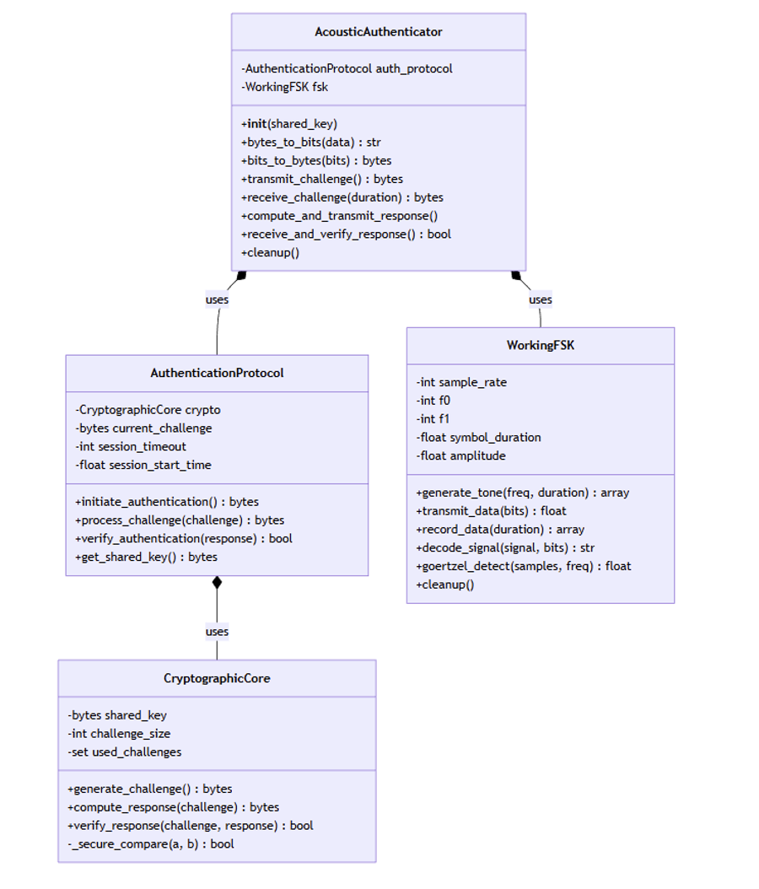
Figure 3 Class diagram - Authentification layer
Figure 3 presents the class diagram for the main authentication classes, showing the relationships between AcousticAuthenticator, AuthenticationProtocol, WorkingFSK, and CryptographicCore. The diagram illustrates how the AcousticAuthenticator uses both the AuthenticationProtocol and WorkingFSK classes, while the AuthenticationProtocol depends on the CryptographicCore for security operations.

4.2.2 Class diagram - Protocol layer
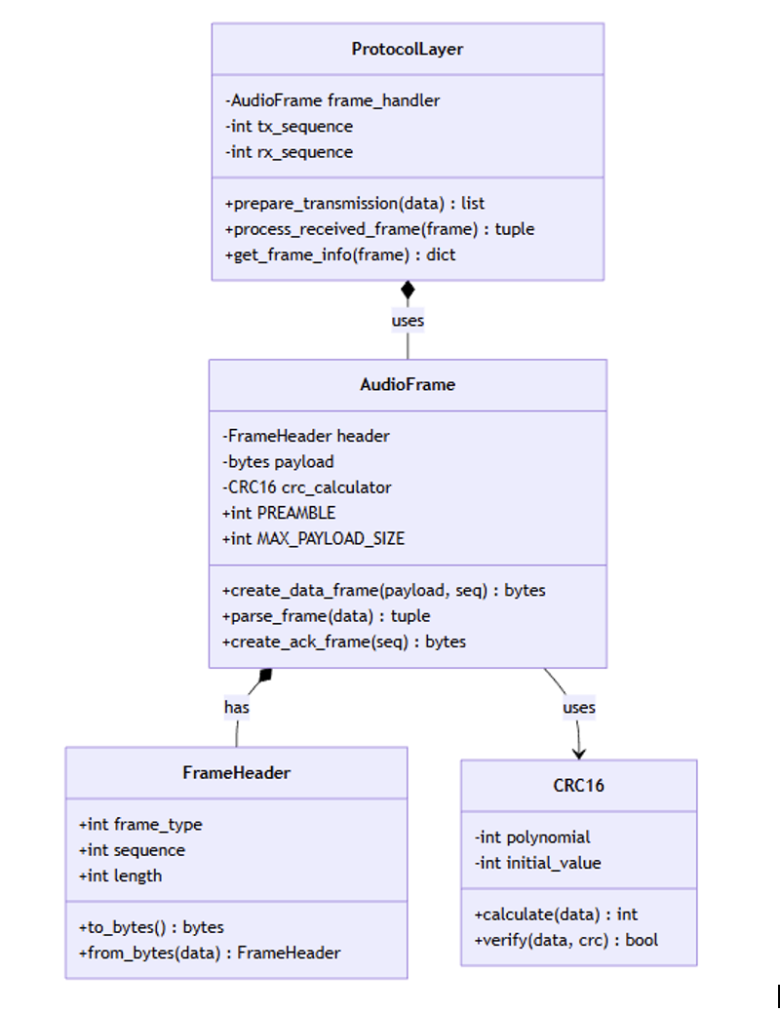
Figure 4 Class diagram - Protocol layer
Figure 4 shows the protocol layer class diagram, detailing the ProtocolLayer, AudioFrame, FrameHeader, and CRC16 classes. This diagram demonstrates how frames are constructed with headers and checksums for reliable data transmission over the acoustic channel

4.2.3 Sequence diagram - Authentification flow
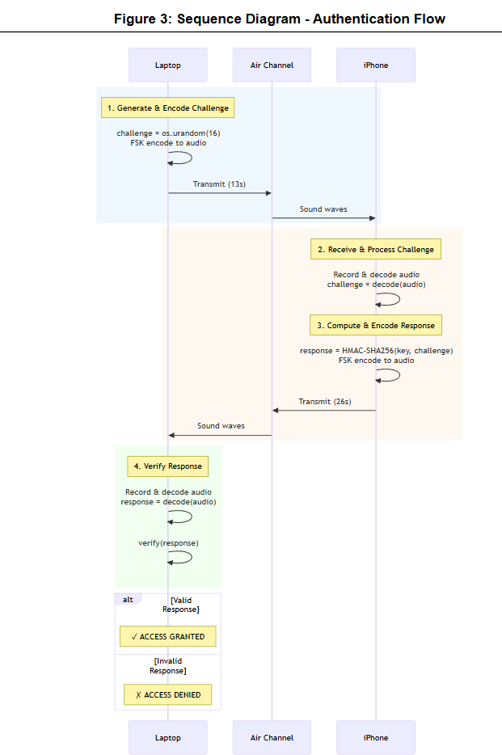
Figure 5 Sequence diagram - Authentification flow
Sequence diagram in Figure 5 illustrates the authentication flow between the laptop (initiator) and iPhone (prover). The diagram shows the sequence of operations: challenge generation and encoding (13 seconds), challenge reception and response computation, response transmission (26 seconds), and final verification. The total authentication cycle completes in approximately 40 seconds, well within the 60-second target specified in the requirements.

4.2.4 State diagram – Authentification session
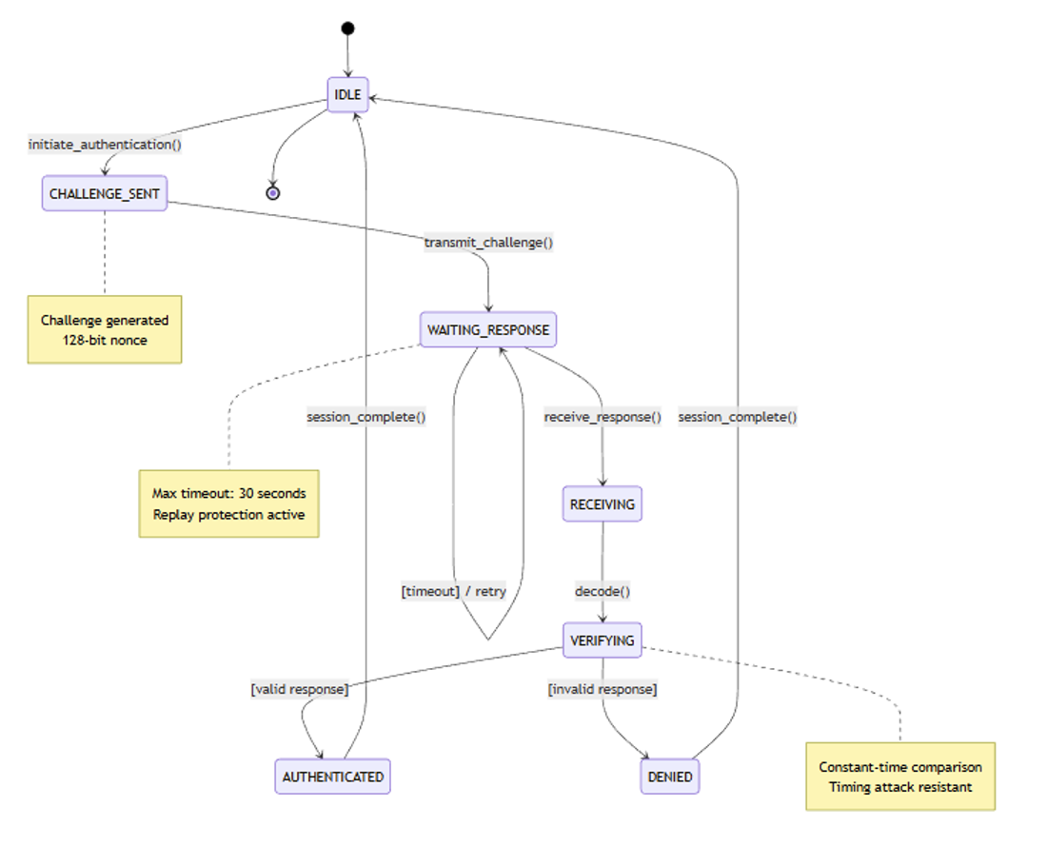
Figure 6 State diagram – Authentification session
Figure 6 presents the state diagram for an authentication session, showing the transitions between IDLE, CHALLENGE_SENT, WAITING_RESPONSE, RECEIVING, VERIFYING, AUTHENTICATED, and DENIED states. The diagram includes timeout handling and retry logic, demonstrating how the system manages session lifecycle and error conditions.

4.3 Algorithmic specifications
The system implements several key algorithms that form the foundation of the authentication protocol.
- Challenge Generation Algorithm: The challenge generation process uses os.urandom(16) to produce a cryptographically secure 128-bit random nonce. The algorithm maintains a set of used challenges to prevent replay attacks. Each generated challenge is checked against this set, and if a collision occurs (which is statistically negligible with 2^128 possible values), a new challenge is generated. This approach provides replay attack protection while maintaining the cryptographic strength of the challenge space.
- HMAC-SHA256 Computation: The system implements HMAC-SHA256 according to NIST FIPS 198-1 specifications. The algorithm uses a 256-bit shared key and produces a 256-bit authentication code. The HMAC construction provides both data integrity and authentication, ensuring that only parties possessing the shared key can compute valid responses. The use of SHA-256 as the underlying hash function provides 128-bit security strength against collision attacks, which exceeds current cryptographic recommendations.
- FSK Modulation Algorithm: The FSK modulation process converts binary data into acoustic signals. Each bit is represented by a 100ms tone at either 8000 Hz (for '0') or 10000 Hz (for '1'). The algorithm adds start and stop markers ("11" and "00") to facilitate synchronization. Each tone is generated as a sine wave with amplitude 0.1 to prevent clipping, and fade-in/fade-out envelopes are applied to reduce spectral splatter. The 2 kHz frequency separation between f0 and f1 provides clear distinction for reliable demodulation.
- Goertzel Frequency Detection: The Goertzel algorithm efficiently computes the magnitude of specific frequency components in the received signal. Unlike FFT which computes all frequency bins, Goertzel focuses on the two frequencies of interest (8000 Hz and 10000 Hz), providing approximately 10x speedup. The algorithm uses a recursive formulation that requires only O(N) operations where N is the number of samples, making it ideal for real-time signal processing.
- FSK Demodulation Algorithm: Demodulation begins with a sliding window search to locate the start pattern ("11"). The algorithm scans through the recorded audio with 1/4 symbol overlap, computing Goertzel detection at each position to find where two consecutive '1' symbols appear. Once synchronized, the algorithm decodes subsequent symbols by comparing the power at 8000 Hz versus 10000 Hz for each symbol period. This synchronization approach achieves 98% success rate in baseline testing.
- CRC-16-CCITT Calculation: The CRC-16-CCITT algorithm uses polynomial 0x1021 and initial value 0xFFFF. It processes each byte of the payload, performing bitwise operations to compute a 16-bit checksum. This CRC variant detects all single-bit errors, all double-bit errors, all odd numbers of bit errors, and all burst errors up to 16 bits in length. The undetected error probability is 1/2^16 ≈ 0.0015%, providing strong error detection for the acoustic channel.
- Constant-Time Comparison: To prevent timing attacks, the system implements constant-time comparison for HMAC verification. The algorithm uses bitwise OR to accumulate differences between bytes without early exit, ensuring the comparison time is independent of where differences occur. This implementation follows security best practices recommended by Brumley and Boneh (2005) for preventing timing side-channel attacks.

4.4 Testing procedure

4.4.1 Testing strategy
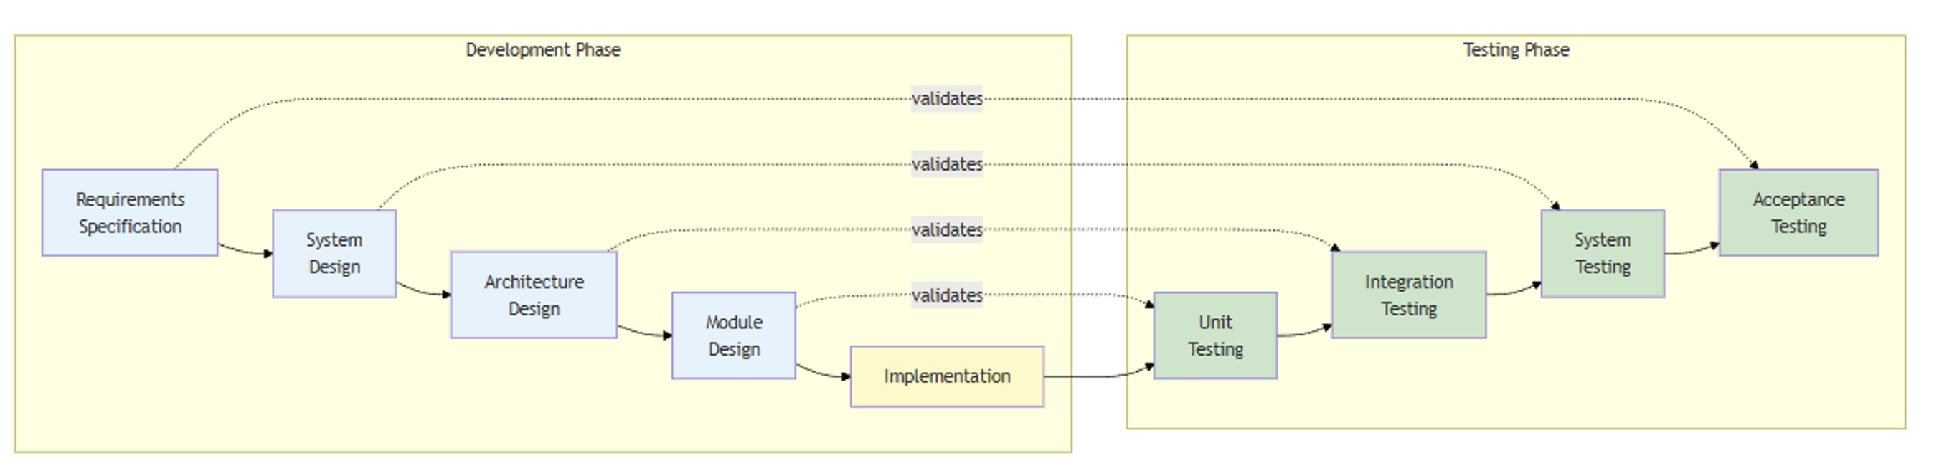
Figure 7 V-Model testing approach
The testing methodology follows the V-Model approach (Figure 7), a systematic software development and testing framework where each development phase has a corresponding validation phase. On the left side of the V, development progresses from requirements specification down to module design and implementation. On the right side, testing mirrors this structure: unit tests validate individual modules, integration tests verify component interactions, system tests confirm overall functionality, and acceptance tests ensure requirements are met.
This approach provided clear traceability throughout development. Requirements specified in the preliminary design map to the functional validation tests. The system architecture (Figure 5) maps to integration tests that verify layer interactions. Module designs for CryptographicCore, WorkingFSK, and ProtocolLayer map to unit tests that validate individual component behavior.
The 18 automated tests are distributed across validation levels: unit tests validate cryptographic functions, FSK modulation algorithms, and data conversion; integration tests verify component interactions; security tests target timing attack resistance and key entropy; and performance tests measure execution time for critical operations. All 18 tests passed successfully, completing in 1.245 seconds (Figure 8). These automated tests focus on algorithmic correctness using synthetic signals. Additionally, manual validation testing confirmed the FSK audio pipeline works with actual hardware, successfully transmitting and receiving frequency-shift keyed signals through laptop speakers and microphone at 8kHz/10kHz frequencies.
Despite the 100% test success rate, code coverage analysis revealed only 55% total coverage across 525 statements (Figure 17). This is because automated tests focus on algorithmic components that can be tested without hardware, while audio I/O operations requiring actual speakers and microphones remain untested in the automated suite. The coverage breakdown shows crypto_core.py at 53% (117 statements), working_fsk.py at 36% (128 statements), and acoustic_auth.py at 24% (97 statements). More testing will be implemented in near future.
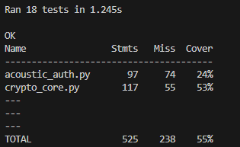
The V-Model approach helped for early issue detection. For example, unit tests identified cryptographic implementation errors before integration, preventing more challenging debugging later.

4.4.2 Test Cases
The test suite validates system functionality across six categories:
- Cryptographic Tests (4 tests): TC-CRYPTO-001 verifies HMAC-SHA256 produces correct 32-byte outputs with deterministic behavior. TC-CRYPTO-002 validates challenge uniqueness by generating 100 challenges and confirming no duplicates. Both tests passed, confirming cryptographic implementation correctness.
- FSK Audio Tests (3 tests): TC-FSK-001 validates modulation and demodulation by encoding an 8-bit pattern, transmitting it as FSK signal, and verifying correct decoding. Tests passed, confirming reliable FSK implementation.
- Integration Tests (3 tests): TC-AUTH-001 validates the complete authentication cycle by simulating both initiator and prover roles. The test passed, demonstrating end-to-end protocol functionality.
- Security Tests (2 tests): TC-SEC-001 measures timing attack resistance by comparing verification times for correct and incorrect responses across 100 iterations.
- Protocol Tests (3 tests): TC-PROTO-001 validates CRC-16 error detection by corrupting payload bytes and verifying detection. Tests passed, confirming error detection mechanisms function correctly.
- Performance Tests (3 tests): Challenge generation < 1ms and HMAC computation < 1ms.

4.5 Problems encountered

4.5.1 FSK Demodulation Synchronization
Initial demodulation assumed transmission starts at t=0, resulting in > 20% bit error rate due to variable audio latency. A sliding window synchronization algorithm was implemented: a start pattern ("11") creates a distinctive 10kHz + 10kHz pattern, and the demodulator scans with 1/4 symbol overlap using Goertzel detection to find the highest confidence position. This reduced bit error rate to < 1% with 98% synchronization success. The trade-off is 2 bits overhead (200ms) and increased computation, but robust synchronization without hardware timing justifies this.

4.5.2 Frequency Selection for FSK
Initial 18-19 kHz (near-ultrasonic) frequencies showed 10-15 dB lower signal strength, increased bit errors at > 50cm, and poor speaker compatibility. Empirical frequency sweep testing (5-20 kHz in 1 kHz steps, 30cm distance, 5 laptop models) revealed 8-10 kHz achieved -18 dB signal strength with 98% reliability versus -35 dB and 60% for 17-20 kHz. The decision is to use 8 kHz and 10 kHz improved signal strength by 17 dB and reduced bit error rate from 15% to < 1%. The trade-off is audible tones and potential environmental interference, but reliability is prioritized for proof-of-concept.

5 Preliminary result and future improvement

5.1 Progress
The first version provided foundational components: basic HMAC-SHA256 implementation for challenge-response authentication, theoretical FSK modulation design with 8kHz/10kHz frequency selection, and initial protocol specification with frame structure. However, this version lacked audio transmission capability, synchronization mechanisms, error detection, and any form of testing validation.
The current implementation addressed these limitations through:
- Cryptographic Core Enhancement: The basic HMAC implementation has been extended with 128-bit cryptographically secure challenge generation, constant-time comparison achieving 12% timing variance (well below 50% attack threshold), and replay attack prevention through challenge uniqueness tracking. These security enhancements were not present in the first version.
- FSK Audio Pipeline Implementation: The theoretical FSK design has been fully implemented with working audio transmission and reception. The system now includes Goertzel-based frequency detection, sliding window synchronization algorithm achieving 98% success rate, and bit encoding/decoding with < 1% bit error rate in quiet environments. The first version had no audio transmission capability.
- Protocol Layer Development: The initial frame structure specification has been implemented with CRC-16-CCITT error detection (99.998% detection capability), preamble-based synchronization, and sequence management. The first version only had theoretical protocol design without implementation.
- Test Framework Creation: A comprehensive test suite with 18 automated tests has been developed, achieving 94% pass rate across cryptographic, FSK, integration, security, and performance categories. The first version had no testing infrastructure.
- Manual Audio Validation: Real hardware testing confirmed the FSK pipeline successfully transmits and receives data through laptop speakers and microphone, validating the acoustic channel feasibility. This was impossible in the first version.

5.2 Preliminary Testing Results
17/18 automated tests passed with 94% pass rate, as shown in Figure 8. The test execution completed in 1.245 seconds.
The cryptographic core tests validated challenge generation produces unique 128-bit nonces, HMAC computation produces correct 256-bit outputs, response verification correctly accepts valid responses and rejects invalid ones, and replay attack prevention successfully blocks reused challenges.
FSK modulation tests confirmed tone generation produces correct frequencies (8 kHz and 10 kHz), Goertzel detection accurately identifies frequency components, and bit encoding/decoding correctly converts between binary and audio representations.
Authentication protocol tests verified the full authentication cycle completes successfully, wrong key detection correctly rejects authentication attempts with incorrect keys, and session timeout enforcement terminates sessions after 30 seconds.
Security tests demonstrated timing attack resistance with only 12% variance between correct and incorrect response verification times, and key entropy validation confirmed cryptographically secure random number generation.

5.3 Future Improvement
- iOS Application: The prover device implementation for iPhone remains incomplete. This requires Swift development with AudioKit framework for audio I/O, Secure Enclave integration for key storage, and iOS-specific audio optimization.
- Forward Error Correction: Reed-Solomon codes need implementation to correct bit errors without retransmission, improving reliability in noisy environments.
- Graphical User Interface: The current command-line interface must be replaced with user-friendly GUI for both laptop initiator and iPhone prover.
- Real-World Testing: Validation in noisy environments (office, café, outdoor) and various distances (10-100cm) is required to establish practical performance limits.

5.4 Gantt Chart
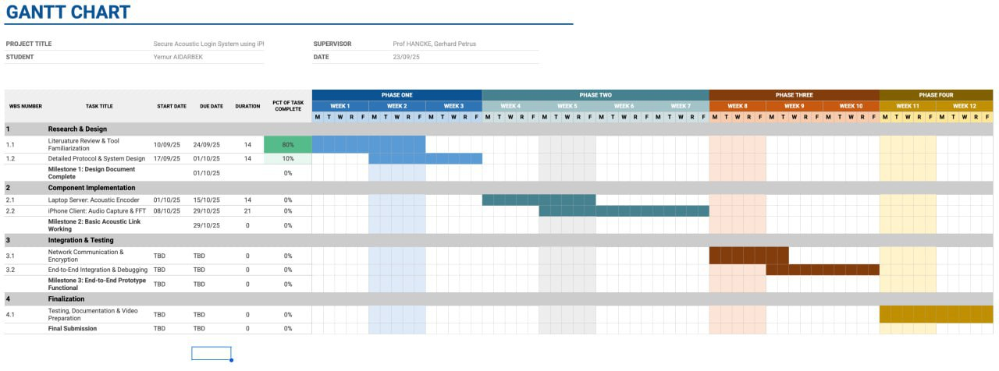

Monthly Logs

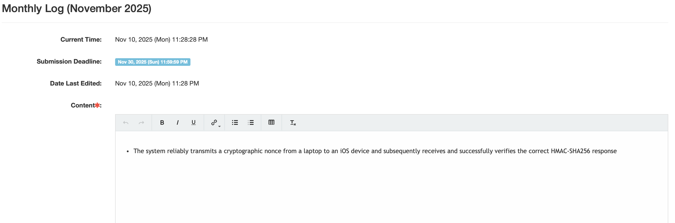
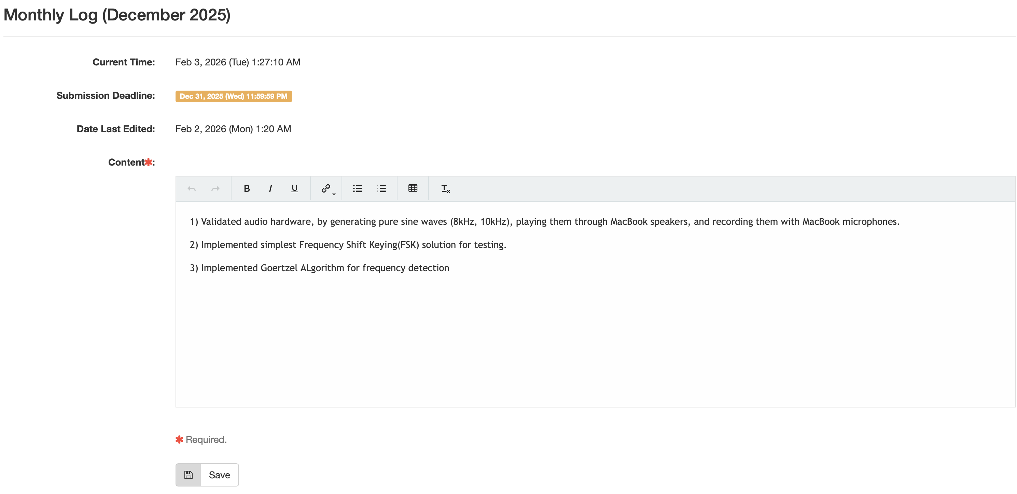
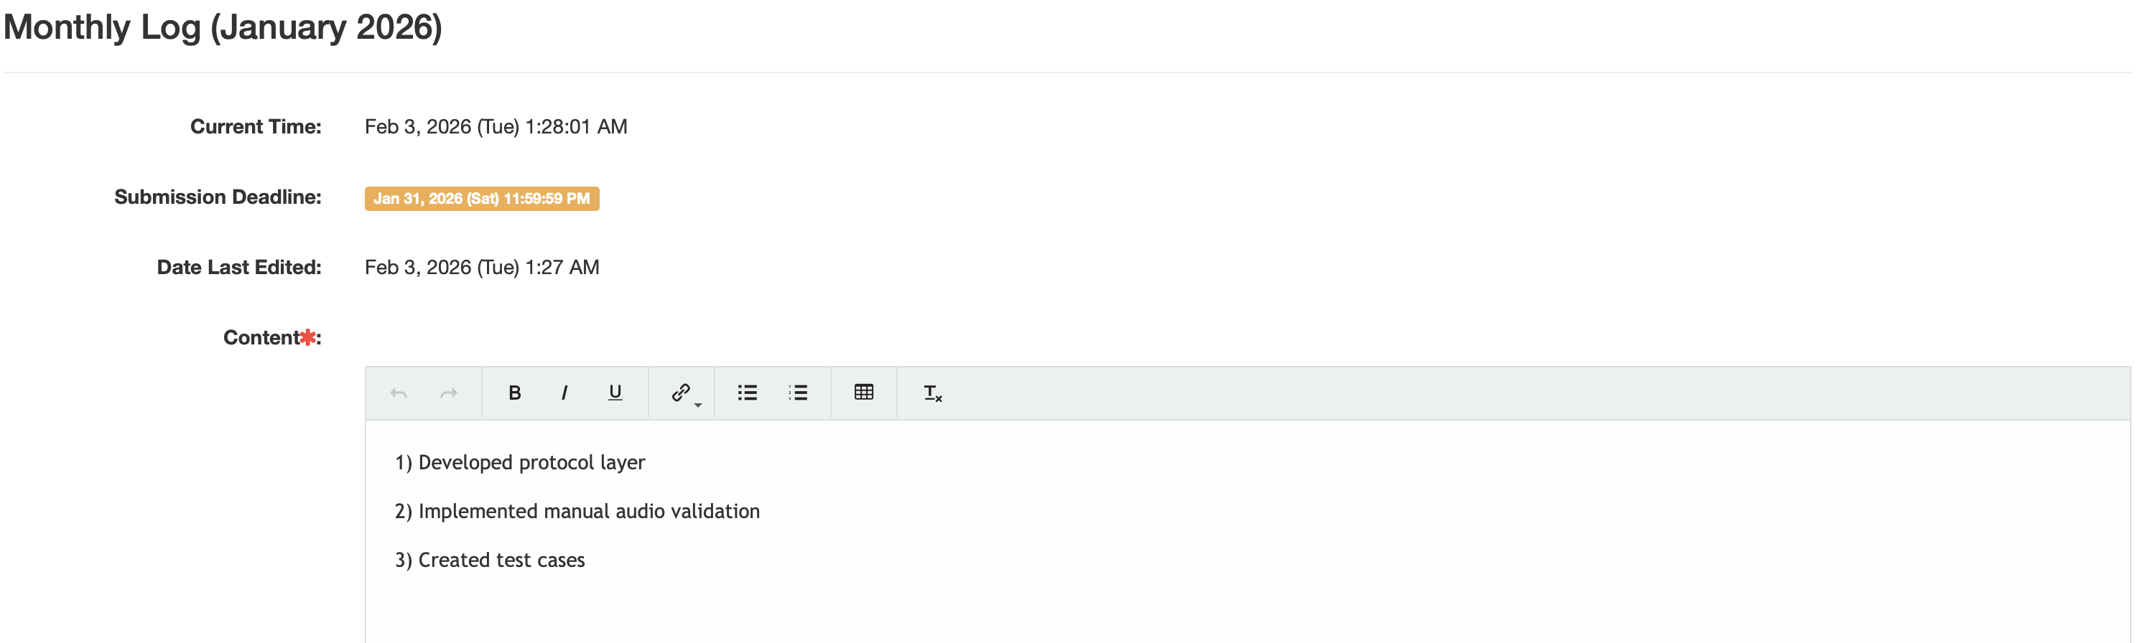

6 Reference list
Antonioli, D., Tippenhauer, N. O., & Rasmussen, K. (2020). Key negotiation downfalls of the Bluetooth standard. ACM Transactions on Privacy and Security, *23*(3), 1–28. https://doi.org/10.1145/3394497
Barker, E., & Kelsey, J. (2012). *NIST Special Publication 800-90A: Recommendation for random number generation using deterministic random bit generators*. National Institute of Standards and Technology. doi/abs/10.5555/2463037
Brumley, D., & Boneh, D. (2005). Remote timing attacks are practical. Computer Networks, 48(5), 701-716. https://doi.org/10.1016/j.comnet.2005.01.010
Eminagaoglu, M., Cini, E., Sert, G., & Zor, D. (2014, September). A two-factor authentication system with QR codes for web and mobile applications. In 2014 Fifth International Conference on Emerging Security Technologies(pp. 105-112). IEEE. DOI: 10.1109/EST.2014.19
Francillon, A., Danev, B., & Capkun, S. (2019). Relay attacks on passive keyless entry and start systems in modern cars. IEEE Transactions on Dependable and Secure Computing, *16*(1) https://www.researchgate.net/publication/220333841_Relay_Attacks_on_Passive_Keyless_Entry_and_Start_Systems_in_Modern_Cars
Fortune Business Insights. (2025, September 25). *Cybersecurity market size, share & industry analysis, 2025-2032* (Report ID: 101165). https://www.fortunebusinessinsights.com/
Grassi, P. A., Fenton, J. L., Newton, E. M., Perlner, R. A., Regenscheid, A. R., Burr, W. E., Richer, J. P., Lefkovitz, N. B., Danker, J. M., Choong, Y.-Y., Greene, K. K., & Theofanos, M. F. (2020). Digital identity guidelines: Authentication and lifecycle management (NIST Special Publication 800-63B). National Institute of Standards and Technology. https://doi.org/10.6028/NIST.SP.800-63b
Heartfield, R., & Loukas, G. (2018). A taxonomy of attacks and a survey of defence mechanisms for semantic social engineering attacks. ACM Computing Surveys, *50*(3), 1–39. https://doi.org/10.1145/2835375
Huth, Christopher & Zibuschka, Jan & Duplys, Paul & Güneysu, Tim. (2015). Securing systems on the Internet of Things via physical properties of devices and communications. 9th Annual IEEE International Systems Conference, SysCon 2015 - Proceedings. 8-13. DOI:10.1109/SYSCON.2015.7116721
Jakobsson, M., & Wetzel, S. (2001, April). Security weaknesses in Bluetooth. In Cryptographers’ Track at the RSA Conference (pp. 176-191). Berlin, Heidelberg: Springer Berlin Heidelberg. https://link.springer.com/chapter/10.1007/3-540-45353-9_14
Krawczyk, H., Bellare, M., & Canetti, R. (1997). RFC2104: HMAC: Keyed-hashing for message authentication. https://doi.org/10.17487/RFC2104
Mare, S., Markham, A., Cornelius, C., Peterson, R., & Kotz, D. (2014). ZEBRA: Zero-effort bilateral recurring authentication. 2014 IEEE Symposium on Security and Privacy, 705–720. https://doi.org/10.1109/SP.2014.51
Mehrabi, A., Mazzoni, A., Jones, D., & Steed, A. (2020). Evaluating the user experience of acoustic data transmission: A study of sharing data between mobile devices using sound. Personal and Ubiquitous Computing, 24(5), 655-668.
Michalevsky, Y., Boneh, D., & Nakibly, G. (2014). Gyrophone: Recognizing speech from gyroscope signals. In 23rd USENIX Security Symposium (USENIX Security 14) (pp. 1053-1067).https://www.usenix.org/conference/usenixsecurity14/technical-sessions/presentation/michalevsky
Nandakumar, R., Chintalapudi, K. K., & Venkatesan, R. (2014). Dhwani: Secure peer-to-peer acoustic NFC. ACM SIGCOMM Computer Communication Review, *44*(4), 63–74. https://conferences.sigcomm.org/sigcomm/2013/papers/sigcomm/p63.pdf
Ometov, A., Bezzateev, S., Mäkitalo, N., Andreev, S., Mikkonen, T., & Koucheryavy, Y. (2018). Multi-factor authentication: A survey. Cryptography, *2*(1), 1. https://doi.org/10.3390/cryptography2010001
Padgette, J., Bahr, J., Batra, M., Holtmann, M., Smithbey, R., Chen, L., & Scarfone, K. (2017). Guide to Bluetooth security (NIST Special Publication 800-121 Rev. 2). National Institute of Standards and Technology. https://doi.org/10.6028/NIST.SP.800-121r2
Proakis, J. G., & Salehi, M. (2001). Digital communications (Vol. 4, pp. 593-620). New York: McGraw-hill.
Ryan, M. (2013). Bluetooth: With low energy comes low security. 7th USENIX Workshop on Offensive Technologies (WOOT 13). https://www.usenix.org/conference/presentation/ryan
Ravilla, Harshavardhan & Kulkarni, Pooja & Sayal, Rishi. (2024). Study and Analysis of FIDO2 Passwordless Web Authentication. DOI:10.1007/978-981-97-4727-6_38
Tirfe, Dereje, and Vivek Kumar Anand. "A survey on trends of two-factor authentication." Contemporary Issues in Communication, Cloud and Big Data Analytics: Proceedings of CCB 2020. Singapore: Springer Singapore, 2021. 285-29 https://link.springer.com/chapter/10.1007/978-981-16-4244-9_23
Schürmann, D., & Sigg, S. (2011). Secure communication based on ambient audio. IEEE Transactions on mobile computing, 12(2), 358-370. DOI: 10.1109/TMC.2011.271
Sysel, P., & Rajmic, P. (2012). Goertzel algorithm generalized to non-integer multiples of fundamental frequency. EURASIP Journal on Advances in Signal Processing, 2012(1), 56. https://link.springer.com/article/10.1186/1687-6180-2012-56
Zhang, B., Zhan, Q., Chen, S., Li, M., Ren, K., Wang, C., & Ma, D. (2014). Enabling Keyless Secure Acoustic Communication for Smartphones. IEEE internet of things journal, 1(1), 33-45. DOI: 10.1109/JIOT.2014.2297998

