**Author: Yair Davidof, 2024Project Overview:**This document serves as a comprehensive guide and report for the machine learning project conducted as part of the AI Survey Workshop.

The project is centered around the application of the Gradient Boosting Classifier to the Wine Quality dataset from the UCI Machine Learning Repository.**Detailed Summary and ExplanationAlgorithm Description:**The Gradient Boosting Classifier is utilized for its robust capabilities in handling complex datasets by building an ensemble of decision trees sequentially. Each tree in the sequence focuses on the errors of the previous tree, improving the model's accuracy through boosting. Boosting helps increase the accuracy by focusing more on the hard-to-classify instances and less on those already well-handled. This method differs fundamentally from models like Random Forests, which build trees in parallel and average their predictions.**Data Fetching and Preparation:**The Wine Quality dataset is fetched using a custom function, fetch_ucirepo, designed to retrieve data from the UCI Machine Learning Repository. This dataset includes various physicochemical properties of wines and a quality rating. For our machine learning model, the quality ratings are categorized into three classes: low, medium, and high. This categorization is essential for transforming our regression problem into a classification task, making it suitable for the Gradient Boosting Classifier.

Figure 1 below shows the initial distribution of wine quality categories. This visualization helps us understand the baseline categorization of the dataset into low, medium, and high quality, which is pivotal for subsequent model training and evaluation.

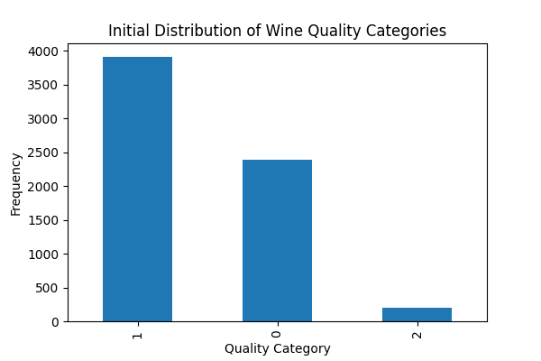

**Preprocessing and Feature Engineering:**Preprocessing involves standardizing the feature set to ensure that our model does not become biased towards variables with larger scales. The StandardScaler is employed to normalize the features, resulting in data with zero mean and unit variance. This step is critical for many algorithms in scikit-learn's suite that are sensitive to the scale of input data.

**Model Training and Hyperparameter Tuning:**The core of our project is the application of the Gradient Boosting Classifier. We use GridSearchCV to automate the selection of the best parameters for our model, including the number of trees (n_estimators), the rate at which the model learns (learning_rate), and the maximum depth of the trees (max_depth). This exhaustive search over specified parameter values aims to find the combination that yields the highest accuracy.

Figure 2 presents the PCA of features by quality category before classification, offering a visual representation of the dataset's structure in a reduced dimensional space, facilitating the identification of inherent clustering prior to model application.

**Handling of SettingWithCopyWarning:**A SettingWithCopyWarning was encountered, which warns about an assignment to a copy of a DataFrame slice instead of the original. This was addressed by modifying the assignment operation to ensure that changes are made directly to the original DataFrame using the .loc accessor, thereby preventing potential issues related to data manipulation inaccuracies.

**Model Evaluation:**The model's performance is evaluated using a split of training and testing data. Initial results show promising accuracy, with detailed metrics provided through a classification report and a confusion matrix. Furthermore, we apply 10-fold cross-validation to assess the model's performance more robustly, ensuring that our findings are not merely tailored to a particular subset of the data.

Figure 3 illustrates the PCA of features by predicted quality category after applying the Gradient Boosting Classifier. This visualization helps in evaluating the model’s effectiveness in clustering and classifying the different quality categories in a reduced dimensional space.

Below are the detailed metrics provided through a classification report and a confusion matrix, demonstrating the model's precision, recall, and overall accuracy. These metrics provide deeper insight into the model's ability to generalize across unseen data.

Our findings illustrate the robust performance of the Gradient Boosting Classifier, which adeptly managed the complexity of the Wine Quality dataset. The visual and quantitative analysis, particularly the PCA post-classification, highlights the model's capability to effectively discriminate between different wine quality categories. The overall accuracy of 78% and a best cross-validation score of 79% further affirm the model's efficacy.Moving forward, comparing these results with those obtained from other classification algorithms, such as Random Forest and Support Vector Machines, will provide deeper insights into model suitability for various types of data. This comparative approach will help in identifying the best-performing models for specific datasets, fostering more targeted and effective applications of machine learning techniques in the wine industry.Additionally, the variation in performance across different quality categories suggests potential areas for further data collection, feature engineering, and model tuning. Enhancing the representation of underrepresented categories in the training set could improve model accuracy and fairness.

**Conclusion and Future Work:**Working with the Gradient Boosting Classifier on the Wine Quality dataset provided insightful experience into the practical application of machine learning techniques. The process of tuning and evaluating the model underscored the importance of careful parameter selection and the benefits of cross-validation. Moving forward, comparing these results with those obtained from other classification algorithms used by peers will offer deeper insights into how different models perform on the same dataset and which models are better suited for specific types of data or tasks.**Significance of Collaborative Tools:**This project not only enhanced technical skills in machine learning but also emphasized the value of collaboration and shared tools in a data science environment.

The use of version control systems like Git facilitated seamless collaboration among versions, allowing for effective versioning and updates of scripts and reports.