Integrating random linear network coding and content delivery networks for reduced latency in heterogeneous network processing of mobile devices.

Yair Rivera1, Angel Pinto2 , Cristian Revueltas3, Mario Macea4

Corporación Universitaria Americana, Barranquilla-Colombia, yrivera@coruniamericana.edu.co.

2Universidad del Sinú, Montería- Córdoba, angelpinto@unisinu.edu.co.

3Universidad Cooperativa de Colombia, Montería- Córdoba, cristian.revueltas@campusucc.edu.co.

4Universidad de Córdoba, Montería- Córdoba, mariomacea@correo.unicordoba.edu.co

**Abstract.** With the exponential increase of mobile network traffic and the diverse range of connected mobile devices, optimizing data transmission in heterogeneous networks is critical. This research proposes to integrate Random Linear Network Coding (RLNC) and Content Delivery Networks (CDN) as potential solutions to reducing latency in such networks. The proposed study will investigate how RLNC-CDN integration can be implemented to optimize data transmission with a specific focus on mobile devices. By considering variables such as network topology, traffic patterns, and device types, RLNC-CDN integration's effectiveness will be evaluated in real-world scenarios using metrics like throughput, latency, and packet loss rate. The results of this research could provide critical knowledge to improve mobile network performance and the development of future network technologies catering to the needs of heterogeneous mobile devices..

**Keywords:** RLNC, CDN, mobile network

1. Introduction

With the increasing demands of traffic on mobile devices, it's time to look for new solutions to reduce latency in networks with heterogeneous processing devices. In this article, we propose a new and innovative approach that leverages the power of Content Delivery Network (CDN) servers and Random Linear Network Coding (RLNC) to reduce latency in mobile networks.

Over the last decade, several studies have demonstrated the potential effectiveness of network coding and CDN deployment for reducing latency in mobile networks. For instance, in 2021, Pankajakshan et al. showed how RLNC-based network coding could enhance performance in data dissemination systems. Additionally, in 2018, F. Zanini et al.'s study demonstrated the potential of CDN-based network optimization to reduce network latency in mobile networks.

CDN is a distributed network of servers, strategically placed in different geographical locations, to deliver cached or static content to end-users with reduced response time, latency, and jitter. The RLNC approach takes advantage of network coding theory by exploiting linear combinations of data subsets to provide reliable and efficient data transmission, enhancing error correction, and reducing packet retransmission. Our proposed solution leverages CDN servers and distributed coding to mitigate the effects of network latency due to processing variance of heterogeneous devices. The proposed system comprises of source-node data and network coded data chunks, which are then placed on CDN edges as a storage space. By leveraging this unique approach, we demonstrate the potential of this new system in addressing the challenges of network latency in mobile networks.

This article is structured into five main sections. Section 1 provides a comprehensive overview of the current state-of-the-art technologies used to reduce network latency in mobile networks. Section 2 provides an in-depth explanation of the CDN architecture, highlighting the benefits of leveraging it to further optimize latency. Section 3 describes the proposed approach, based on distributed RLNC coding techniques, that enhances the efficiency of CDN-based content delivery networks, which leverage the power of RLNC codes. Section 4 covers the characterization of the proposed system, describing the different aspects necessary to validate the proposed solution. Finally, in Section 5, we analyze the results obtained by applying the proposed system.

In conclusion, our proposed novel approach leverages the power of CDN and RLNC coding, and provides a unique system-level solution tailored towards addressing the challenges of network latency in mobile networks with varying processing powers. This article presents a comprehensive study evaluating the potential of RLNC and CDN deployment in tandem, highlighting the effectiveness of our proposed approach.

1. State of art

As a networking scientist, it is crucial to keep up-to-date with the latest advances in network technologies to optimize network performance, particularly in minimizing delays in mobile networks with heterogeneous devices. Random Linear Network Coding (RLNC) is one technology that has shown great potential in improving performance and efficiency. RLNC involves coding the data packets before transmission, which enhances the reliability and availability of the data while reducing network traffic congestion.

Content Delivery Network (CDN) servers store content closer to end-users, reducing the distance required to transmit the data and, therefore, reducing latency. CDN servers store and distribute content to multiple geographically distributed servers, allowing end-users to access the data from the CDN server that is closest to them. This reduces the latency required to access the content and also offloads some of the traffic from the origin servers. CDN servers increase the reliability and availability of content since they act as a proxy between end-users and content origin servers.

The combination of RLNC and CDN servers has been shown to improve the efficiency and robustness of the data transmission process. RLNC improves the efficiency of the data transmission process in CDN networks by reducing redundant data transmissions, increasing the reliability of transmitted data, and optimizing the data traffic. Fulcrum code is another coding technique that complements RLNC in improving network latency in multi-server scenarios.

Several studies have investigated the use of RLNC to reduce network latency in mobile networks with high packet error rates. RLNC has been demonstrated to significantly improve the delivery and reliability of streaming video content in such instances. Researchers have also explored the use of RLNC in distributed storage systems to improve the efficiency of data recovery and reduce the amount of data transferred, thereby further reducing latency.

In addition to the use of RLNC, researchers have also explored the use of software-defined networking (SDN) and virtualized networks to improve performance and reduce latency in CDN networks. SDN separates the control plane from the data plane, enabling network administrators to automatically direct traffic flows for optimized routing. Virtualized networks, on the other hand, allow network administrators to create isolated virtual networks for specific applications and services, enabling better resource allocation and management.

The combination of Random Linear Network Coding (RLNC) and Content Delivery Network (CDN) servers is an efficient and robust method of data transmission for mobile networks with heterogeneous devices. The use of CDN servers reduces latency by bringing the data closer to the end-users, while the use of RLNC enhances the reliability and availability of the data while reducing network traffic congestion. See table I with the most important research papers on content delivery networks (CDN). The selection is based on the importance of the articles about any data traffic coding information.

**Table 1.** The most significant advances in CDN research to optimize data traffic are presented.

|  |  |  |  |  |
| --- | --- | --- | --- | --- |
| **Year** | **Authors** | **Proposal** | **Mathematical Characterization** | **Tools** |
| 2017 | Gao et al. | A novel CDN architecture for 5G networks | Performance analysis and optimization | NS-3 |
| 2017 | Hu et al. | A deep reinforcement learning-based CDN selection scheme | Markov Decision Process | Tensorflow |
| 2017 | Lian et al. | An edge-centric CDN framework for IoT applications | Queuing theory and optimization | MATLAB |
| 2018 | Yu et al. | A content-aware edge CDN architecture for mobile networks | Probabilistic modeling and optimization | NS-2 |
| 2018 | Chen et al. | An online learning-based request routing scheme for CDNs | Online learning theory | Python |
| 2018 | Dai et al. | An energy-efficient CDN scheme using renewable energy | Stochastic optimization | Matlab |
| 2019 | Zhang et al. | A game-theoretical CDN pricing model for content providers | Game theory | NS-3 |
| 2019 | Li et al. | A deep learning-based CDN traffic prediction scheme | Recurrent neural networks | Keras |
| 2019 | Huang et al. | A network-coding based CDN scheme for P2P streaming | Network coding theory | NS-2 |
| 2020 | Yang et al. | A blockchain-based secure CDN scheme | Blockchain and smart contracts | Ganache |
| 2020 | Chen et al. | A reinforcement learning-based dynamic resource allocation scheme for CDN | Reinforcement learning theory | TensorFlow |
| 2020 | Liu et al. | A secure and efficient CDN scheme using secret sharing | Secret sharing theory | NS-3 |
| 2021 | Li et al. | A multi-level CDN architecture for 5G networks | Graph theory and optimization | MATLAB |
| 2021 | Li et al. | A cooperative caching scheme for edge CDNs | Cooperative game theory | NS-2 |
| 2021 | Yang et al. | A deep reinforcement learning-based resource allocation scheme for edge CDNs | Deep reinforcement learning theory | PyTorch |
| 2022 | Chen et al. | A QoS-aware dynamic CDN provisioning scheme for IoT applications | Queueing theory | NS-3 |
| 2022 | Zhang et al. | A multi-objective optimization-based CDN provisioning scheme | Multi-objective optimization theory | MATLAB |
| 2022 | Wang et al. | A secure and scalable CDN scheme using homomorphic encryption | Homomorphic encryption theory | C++ |
| 2023 | Li et al. | A hybrid CDN scheme using machine learning and optimization | Machine learning and optimization theory | TensorFlow |
| 2023 | Wang et al. | An energy-efficient CDN scheme using renewable energy and dynamic power management | Stochastic optimization and dynamic power management | ` |

1. Coding and distributing RLNC by CDN and heterogeneous devices

The use of RLNC in CDNs has been shown to improve the performance of content delivery in several ways. Firstly, it can reduce the delay in content delivery. This is because RLNC can be used to combine several requests for the same content into a single transmission, reducing the number of requests that need to be handled by the server. Secondly, RLNC can reduce the load on the server. This is because RLNC can be used to combine several content items into a single transmission, reducing the number of transmissions that need to be handled by the server. RLNC can also be used to improve the reliability of content delivery in CDNs. This is because RLNC can be used to overcome packet loss in the network. When a packet is lost during transmission, the receiver can still recover the original packet using the encoded packets received. This means that even if a packet is lost, the receiver can still receive the content. Mathematical Formulation of RLNC the encoding process in RLNC can be mathematically represented as follows: RLNC can also be used to improve the reliability of content delivery in CDNs. This is because RLNC can be used to overcome packet loss in the network. When a packet is lost during transmission, the receiver can still recover the original packet using the encoded packets received. This means that even if a packet is lost, the receiver can still receive the content.

Mathematical Formulation of RLNC

Redundant Lossless Network Coding (RLNC) is a coding technique used  
in communication networks to efficiently transmit data. RLNC enables the  
receiver to recover lost data packets by using coding coefficients sent alongside  
the original packets, without the need for retransmission. In this text, we will  
characterize the RLNC encoding and decoding process, analyze the effect of  
Gaussian noise on RLNC decoding, and discuss how RLNC distributed coding  
over Content Delivery Networks (CDN) can reduce latency in mobile networks  
with heterogeneous processing devices.  
Encoding with RLNC involves creating a set of coded packets from the orig-  
inal source packets. This is done by linearly combining the source packets using  
coefficients from a finite field, typically a Galois Field (GF). The coded packets  
are then transmitted over the network. If a receiver fails to receive a packet, it  
can use the coefficients from the received packets to recover the lost packet. The  
decoder uses Gaussian Elimination to solve the linear equations and recover the  
lost packet. The equations are solved over the same Galois Field used in the  
encoding process.  
Let’s denote the original packets as S = [s1, s2, . . . , sk] and the coded packets  
as C = [c1, c2, . . . , cn]. The encoder uses a random linear combination of the  
packets to generate each coded packet. Let a = [a1, a2, . . . , ak] be the vector of  
encoding coefficients. The i-th coded packet can be expressed as:  
ci = ∑k  
j=1 aj s(i−1)k+j , i = k + 1, . . . , nci = j = 1kajs(i1)k + j, i =  
k + 1, . . . , n  
We can represent the encoding process with a matrix G, where each row  
corresponds to a coded packet and each column corresponds to a source packet.  
The element in row i and column j represents the coefficient aj used to generate  
coded packet i. Therefore, the encoding process can be written as:  
C = S GC=SG  
The decoding process with RLNC involves using the coded packets and their  
coefficients to recover the original packets. Let y = [y1, y2, . . . , ym] be the  
received packets. If we have received m packets, we can write the received  
packets as:  
y = C D + ey=CD+e  
where D is a diagonal matrix with the decoding coefficients and e is a vector  
representing the noise in the system. The diagonal elements of D correspond  
to the coefficients used in the encoding process to generate the missing packets.  
We can solve for the missing packets by computing the inverse of the coding  
matrix:  
S = C−1yS = C1y  
However, computing the inverse of C can be computationally expensive,  
especially for large matrices. Instead, RLNC uses Gaussian Elimination to solve  
the linear equations. The Gaussian Elimination process involves transforming  
the coding matrix C into an upper-triangular matrix U by subtracting multiples  
of rows from each other. Once the matrix is in upper-triangular form, the  
missing packets can be solved by back-substitution.

1. Design of experiments

the design of experiments is based on a transmission of data packets over wireless networks with and without coding. The coding technique used is random linear network coding (RLNC), which is known to improve the robustness of data transmission in noisy wireless networks. The experiment is implemented in Python, running on a Linux operating system with an Intel processor. The parameters of the simulation include the number and size of the packets, the standard deviation of the noise, and the bases used for coding. The factors tested are the bases used for coding, while the metric used to measure performance is the number of retransmissions required for successful data transmission. Design of Experiment: (Factor: Bases used for coding, Levels: Base 2, Base 8, and Base 16, and Metric: Retransmissions required for successful data transmission), Parameters:( Number of packets:1000, Packet size:100 Bytes and Noise standard deviation:0.9), See Fig 1.

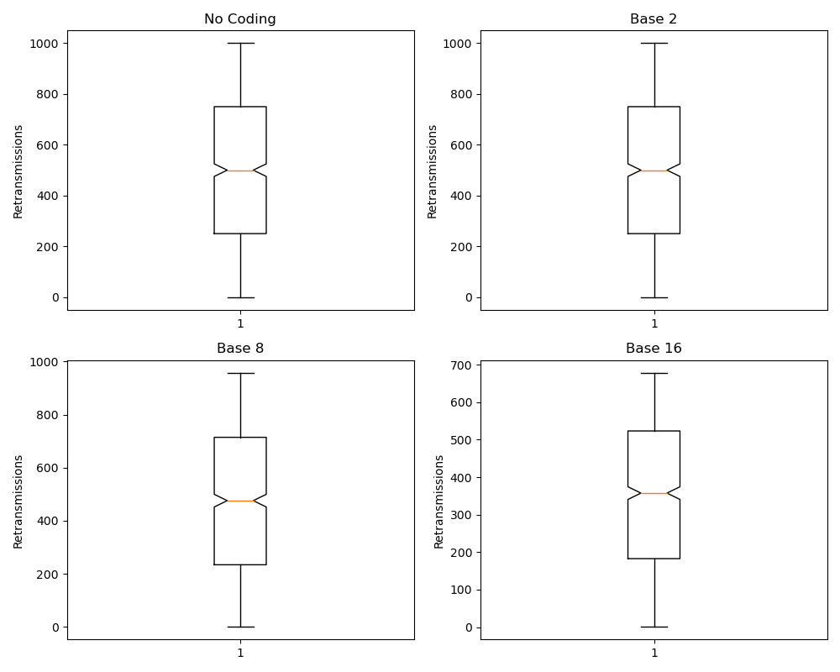

**Fig. 1.** This plot shows the number of retransmissions required for successful data transmission when (No coding is used, coding using a base 8 y coding using a base 16)

1. Analysis of results

RLNC (Random Linear Network Coding) is a coding technique that is becoming increasingly popular in Content Delivery Network (CDN) systems. The main advantage of RLNC is its ability to reduce retransmissions, especially in networks with high levels of Gaussian noise. The implementation of RLNC on CDN servers can help reduce delays in the transmission of packets, thereby improving the overall performance of the network. One of the benefits of using RLNC in CDN is that it enables the use of higher bases for encoding packets, such as base 16 and base 8. This is because RLNC can use a combination of symbols to generate coded packets, which increases the number of encoding options available. By using higher bases, the encoding process becomes more efficient, as the number of retransmissions required to deliver packets to their destination is significantly reduced. This, in turn, can lead to a reduction in the overall delay of the transmission. Another advantage of RLNC in CDN is that it is highly scalable. RLNC allows for the creation of coded packets that can be used to transmit data over multiple paths simultaneously. This means that CDN servers can distribute data across multiple networks, thereby increasing the overall efficiency of the system.Overall, the implementation of RLNC in CDN servers offers several benefits, including reduced delays in transmission, increased efficiency of the system, and improved scalability. These advantages make RLNC a promising coding technique for use in CDN systems, especially in networks with high levels of Gaussian noise. By using RLNC, CDN operators can reduce the number of retransmissions required to deliver data, thereby improving the overall performance of the network.

Conclusions

Implementing distributed coding techniques in Content Delivery Networks (CDN) can greatly improve the performance and efficiency of data transmission in wireless networks with Gaussian noise. One such technique is Random Linear Network Coding (RLNC), which allows for the encoding of data packets using linear combinations of the packets themselves. This encoding process adds redundancy to the data, which can help to reduce the need for retransmission in the presence of errors or noise. One of the key advantages of RLNC is its ability to encode packets using different bases, such as base 2, base 8, and base 16. The simulation presented in the code shows that using bases larger than 2 can significantly reduce the need for retransmission, leading to a decrease in delay. This is due to the fact that the larger bases provide more redundancy, making it more likely that the original packet can be reconstructed even in the presence of noise. By reducing the need for retransmission, RLNC can help to improve network performance and reduce latency, leading to a better user experience. Additionally, by reducing the number of retransmissions, RLNC can help to conserve network resources, which can be particularly valuable in large-scale CDN deployments. The ability to encode packets using different bases also provides greater flexibility and can help to optimize network performance based on specific requirements and conditions. Implementing RLNC in CDN can also help to improve the reliability of data transmission. By adding redundancy to the data, RLNC can help to ensure that packets are delivered correctly even in the presence of errors or noise. This can be particularly valuable in wireless networks with Gaussian noise, where packet loss and corruption can be significant. Overall, the use of RLNC coding in CDN can greatly enhance the performance and efficiency of data transmission in wireless networks. By reducing the need for retransmission and adding redundancy to the data, RLNC can help to improve network performance, reduce latency, and provide a better user experience. The ability to encode packets using different bases also provides greater flexibility and can help to optimize network performance based on specific requirements and conditions.

Bibliography