Title of the manuscript
Angie A. Smith¹, B. Bradley Miller¹, Carl Carter²
¹Department example, University example, city, postal code, country
²Laboratory example, city, postal code, country
Correspondence to: Angie A. Smith (angie@email.com)
Abstract. The abstract should be intelligible to the general reader without reference to the text. After a brief introduction of the topic, the summary recapitulates the key points of the article and mentions possible directions for prospective research. Reference citations should not be included in this section, unless urgently required, and abbreviations should not be included without explanations. An abstract should be short, clear, concise, and written in English with correct spelling and good sentence structure. The inclusion of graphical abstracts depends on the format of the publication. For journal articles, the preferred way is to use the graphical abstract as key figure. It will then be used to visually advertise the paper on the journal website but is not part of the paper *.pdf file. If the graphical abstract should be part of the paper, it has to be unnumbered and must be placed directly after the text abstract. For preprints, since these have no key figure, graphical abstracts must always be included in the paper as unnumbered graphic placed directly after the text abstract.

1 Headings (here a section as Heading 1)
The headings of all sections, including introduction, results, discussions, or conclusions must be numbered. Three levels of sectioning are allowed, e.g. 3, 3.1, and 3.1.1. The abbreviation "Sect." should be used when it appears in running text and should be followed by a number unless it comes at the beginning of a sentence. Footnotes should be avoided in the text, as they tend to disrupt the flow of the text. If absolutely necessary, they should be numbered consecutively. Footnotes to tables should be marked by lowercase letters.

1.1 Styles (here a subsection as Heading 2)
Please use only the styles of this template (MS title, Authors, Affiliations, Correspondence, Normal for your text, and Headings 1–3). The title page must include the title (concise but informative), author first and last names, full institutional addresses of all authors, and correspondence email for proofs. Deceased co-authors should be marked accordingly. After the abstract, the sequence of the sections of your manuscript is introduction, sections of your choice, and conclusions.

1.1.1 Figures (here a subsubsection as Heading 3)
Figure 1 uses the style Caption. The abbreviation “Fig.” should be used when it appears in running text and should be followed by a number unless it comes at the beginning of a sentence (e.g. “The results are depicted in Fig. 5. Figure 9 reveals that.”). Figures and tables as well as their captions must be inserted in the main text near the location of the first mention (not appended to the end of the manuscript). Regarding colour schemes, it is important that your maps and charts allow readers with colour vision deficiencies to correctly interpret your findings. Please check your figures using the Coblis – Color Blindness Simulator and revise the colour schemes accordingly.

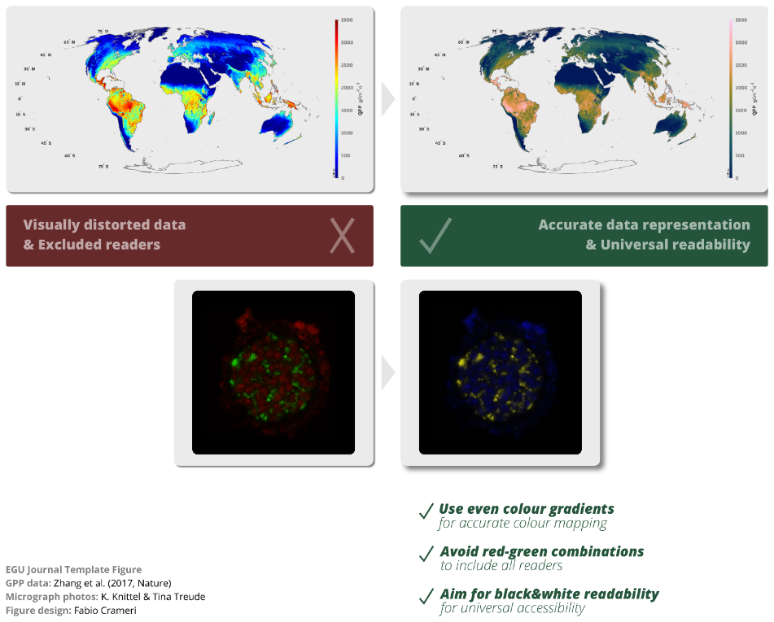
Figure 1: An example for accurate data representation & universal readability of figures.
Please see all guidelines on figures & tables as well as maps & aerials in the submission guidelines.

1.1.2 Equations
Equations should be numbered sequentially with Arabic numerals in parentheses on the right-hand side, e.g. (1), (2). If too long, split them accordingly. If there are chemical formulae included, e.g. reactions, please number them (R1), (R2), etc. The equation editor and not the graphic mode should be used under all circumstances. In the text, equations should be referred to by the abbreviation "Eq." and the respective number in parentheses, e.g. “Eq. (14)”. However, when the reference comes at the beginning of a sentence, the unabbreviated word “Equation” should be used (e.g. “Equation (14) is very important for the results; however, Eq. (15) makes it clear that...”).
$Y=\frac{∆M_{0}}{∆\left[\text{isoprene}\right]}$ , (1)
Please see all guidelines on mathematical notation and terminology in the submission guidelines.

2 Appendices
All material required to understand the essential aspects of the manuscript such as experimental methods, data, and interpretation should preferably be included in the main text. Additional figures, tables, as well as technical and theoretical developments which are not critical to support the conclusion of the manuscript, but which provide extra detail and/or support useful for experts in the field and whose inclusion in the main text would disrupt the flow of descriptions or demonstrations may be presented as appendices. These should be labelled with capital letters: Appendix A, Appendix B etc. Equations, figures, and tables should be numbered as (A1), Fig. B5, or Table C6, respectively. Please keep in mind that appendices are part of the manuscript whereas supplements (see below) are published along with the preprint or journal article.

Code and data availability
Authors are required to provide a statement on how their underlying research data and/or code can be accessed. This must be placed as an unnumbered section “Code availability”, “Data availability”, or “Code and data availability” (combined statement) at the end of the manuscript. The best way to provide access to data or code is by depositing them (as well as related metadata) in FAIR-aligned reliable public data or code repositories, assigning digital object identifiers, and properly citing data sets and code as individual contributions. If different data sets or code are deposited in different repositories, this needs to be indicated in the availability section. If data or code from a third party were used, this needs to be explained (including a reference to these data).
If the data or code are not publicly accessible at the time of final publication, the statement should describe where and when they will appear and provide information on how readers can obtain the data or code until then. Nevertheless, authors should make such embargoed data or code available to reviewers during the review process to foster reproducibility. The Copernicus review system allows to define such assets as “access limited to reviewers” and reviewers must then sign that they will use such data or code only for the purpose of reviewing without making copies, sharing, or reusing.
In rare cases where the data or code cannot be deposited publicly (e.g., because of commercial constraints), a detailed explanation of why this is the case is required. The data needed to replicate figures in a paper should in any case be publicly available, either in a public database (strongly recommended), or in a supplement to the paper.

Supplement link
The link to the supplement will be included by Copernicus, if applicable.

Team list
If your manuscript has been co-authored by a team, please indicate the team name in the author list on the title page of your manuscript and then add a section “Team list” providing the names of the team members and, optionally, the affiliations.

Author contributions
Authors are required to add a section in which the contributions of all co-authors are briefly described. Example: “AA and BB designed the experiments, and CC carried them out. DD developed the model code and performed the simulations. AA prepared the manuscript with contributions from all co-authors.” We recommend using the CRediT contributor roles taxonomy. If some of the co-authors contributed equally to the work, we recommend including a corresponding mark in the author list on the title page and a corresponding affiliation-type statement.

Competing interests
A declaration of all potential conflicts of interest is required by Copernicus Publications as this is an integral aspect of a transparent record of scientific work. Please see our competing interests policy.

Disclaimer
Copernicus Publications adds a standard disclaimer: “Copernicus Publications remains neutral with regard to jurisdictional claims made in the text, published maps, institutional affiliations, or any other geographical representation in this paper. While Copernicus Publications makes every effort to include appropriate place names, the final responsibility lies with the authors. Views expressed in the text are those of the authors and do not necessarily reflect the views of the publisher.”
Please feel free to add disclaimer text at your choice, if applicable.

Acknowledgements
Besides the author’s statement of gratitude to and recognition of the people and institutions that helped the author’s research and writing, authors are also asked to include relevant research infrastructure they have benefitted from during their research, where research was conducted or data/resources were used. Examples are Field Stations and Marine Laboratories (FSMLs).

Financial support
Support funds and grant agreement numbers are listed as specified upon manuscript registration and reported to FundRef upon publication.

Review statement
The review statement will be added by Copernicus Publications listing the handling editor as well as all contributing referees according to their status anonymous or identified.

References
Buiter, S.: How syn-rift sedimentation promotes the formation of hyper-extended margins, EGU General Assembly 2020, Online, 4–8 May 2020, EGU2020-18622, https://doi.org/10.5194/egusphere-egu2020-18622, 2020.
Loew, A., Bennartz, R., Fell, F., Lattanzio, A., Doutriaux-Boucher, M., and Schulz, J.: Surface Albedo Validation Sites, EUMETSAT [data set], https://doi.org/10.15770/EUM_SEC_CLM_1001, 2015.
Porter, J. G., De Bruyn, W., and Saltzman, E. S.: Eddy flux measurements of sulfur dioxide deposition to the sea surface, Atmos. Chem. Phys., 18, 15291–15305, https://doi.org/10.5194/acp-18-15291-2018, 2018.
Jung, M., Koirala, S., Weber, U., Ichii, K., Gans, F., Gustau-Camps-Valls, Papale, D., Schwalm, C., Tramontana, G., and Reichstein, M.: The FLUXCOM ensemble of global land-atmosphere energy fluxes, arXiv [preprint], arXiv:1812.04951, 11 December 2018.
Randall, D., Dazlich, D., Heikes, R., and Konor, C.: CSU model for DCMIP 2016, Zenodo [code], https://doi.org/10.5281/zenodo.5800992018, 2017.
Singh, O. N. and Fabian, P. (Eds.): Atmospheric Ozone: a Millennium Issue, Copernicus Publications, Katlenburg-Lindau, Germany, 147 pp., ISBN 393658608X, 2003.
van Edig, X., Schwarze, S., and Zeller, M.: The robustness of indicator based poverty assessment tools in changing environments – empirical evidence from Indonesia, in: Tropical Rainforests and Agroforests under Global Change, Environmental Science and Engineering (Environmental Engineering), edited by: Tscharntke, T., Leuschner, C., Veldkamp, E., Faust, H., Guhardja, E., and Bidin, A., Springer, Berlin, Heidelberg, Germany, 191–211, https://doi.org/10.1007/978-3-642-00493-3_9, 2010.

