**Department of Electronics & Communication Engineering**

**Consumer Electronics Lab**



**Maharaja Surajmal Institute of Technology**

**C-4, Janakpuri, New Delhi-110058**

**Affiliated to G.G.S.I.P.U**

**Submitted To: Submitted By:**

**Ms. Vishakha Tomar Name: Yajash Goplani**

**Assistant Professor Enroll no: 06515002817**

**Class: ECE-I**

**Roll no: 32**

**List of Experiments**

|  |  |  |
| --- | --- | --- |
| **S.No.** | **Title** | **Page No.** |
| 1. | To study the B/W Receiver with Block diagram. | 1 |
| 2. | To study the RF tuner through test point and fault simulation and step –by- step fault finding procedure of tuner section. | 5 |
| 3. | To study the VIF section through test point and step – by- step fault finding procedure of VIF section. | 9 |
| 4. | To study the Video & Chromed section through test point and step – by- step fault finding procedure of Video and Chroma section | 13 |
| 5. | To study the Horizontal output section through test point and step – by- step fault finding procedure of Horizontal output section . | 19 |
| 6. | To study the Vertical output section through test point and step – by- step fault finding procedure of Vertical output section . | 24 |
| 7. | To study the System control section through test point and step – by- step fault finding procedure of System control section . | 27 |
| 8. | To study the Introduction of Tape Recorder and Tape Transport Mechanism. | 31 |
| 9. | To study of various fault simulated in the Tape Recorder trainer. | 35 |
| 10. | To study the tape mechanism through test point. | 38 |

**Experiment No. 1**

**Objective**: To study the B/W Receiver with Block diagram.

**Theory**

It is desirable to have a general idea of the organization of the receiver before going into circuit details. Figure 1 shows block schematic diagram of a typical monochrome TV receiver. As shown there, the receiver has been divided into several main sections depending on their functions and is discussed below.

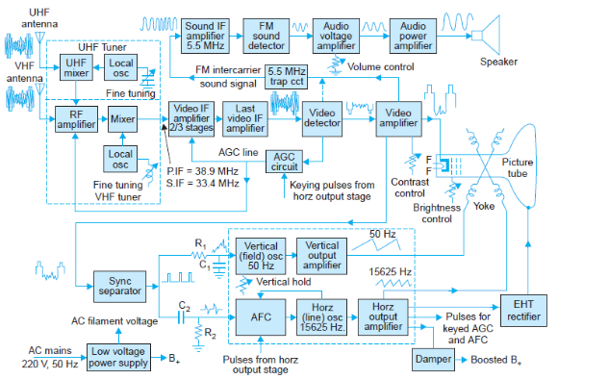

**Figure 1.1 Block Diagram of Monochrome TV receiver**

**1. Antenna System**

Strongest signal is induced in the antenna if it has same polarization as the transmitting antenna. All TV antennas are mounted in horizontal position for better reception and favorable signal to noise ratio. The need for good signal strength has led to the use of tuned antennas. A transmission line connects antenna to the receiver input terminals for the RF tuner. A twin-lead is generally used for the same. This type is an unshielded balanced line with characteristic impedance equal to 300 ohms. When there is a problem of interference, a shielded coaxial cable is used. This cable has high attenuation, especially at UHF channel frequencies. It has a characteristic impedance of 75 ohms.

## RF Section

This section consists of RF amplifier, mixer and local oscillator and is normally mounted on a separate sub-chassis, called the ‘Front End’ or ‘RF Tuner’. Either tubes or transistors can be used. With tubes, local oscillator and mixer functions are usually combined in one stage called the ‘frequency converter’. The purpose of the tuner unit is to amplify both sound and picture signals picked up by the antenna and to convert the carrier frequencies and their associated bands into the intermediate frequencies and their sidebands. The receiver uses superhetrodyne principle as used in radio receivers. The signal voltage or information from various stations modulated over different carrier frequencies is heterodyned in the mixer with the output from a local oscillator to transfer original information on a common fixed carrier frequency called the intermediate frequency (IF). The setting of the local oscillator frequency enables selection of desired station. The standard intermediate frequencies for the 625-B system are-Picture

IF = 38.9 MHz, Sound IF = 33.4 MHz.

1. **IF Amplifier Section**

A short length of coaxial cable feeds tuner output to the first IF amplifier. This section is also called video IF amplifier since composite video signal is the envelope of the modulated picture IF signal. Practically all the gain and selectivity of the receiver is provided by the IF section. With tubes, 2 or 3 IF stages are used. With transistors, 3 to 4 If stages are needed. In integrated circuits, one IC chip contains the entire IF amplifier stages.

1. **Picture Tube Circuitry And Controls**

The output from the video amplifier may be fed either at the cathode or control grid of the picture tube. In either case a particular polarity of the video signal is essential for correct reproduction of picture details. In most cases cathode drive is preferred. The grid is thus left free to receive retrace blanking pulses to ensure that no retrace lines are seen on the screen for any setting of the brightness control. Figure 2 shows the passage of video signal from video detector to the picture tube.

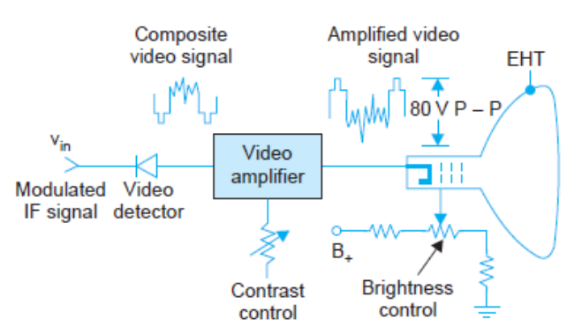

**Figure 1.2 Video Signal from detector to Picture Tube**

1. **Sound Section**

As shown in the receiver block diagram (Fig. 1.1), the relatively weak FM sound signal, now on a carrier frequency of 5.5 MHz is given at least one stage of amplification before feeding it to the FM detector. This stage is a tuned amplifier, with enough bandwidth to pass the FM sound signal. This tuned amplifier is known as sound IF. The FM detector is normally a ratio detector or a discriminator preceded by a limiter. Special ICs have been developed which contain FM demodulator and most parts of the audio amplifier. These are fast replacing discrete circuits hitherto used in the sound section of the receiver. The audio amplifier feeds into one or two loudspeakers provided at a convenient location along front panel of the receiver.

1. **Sync Separation**

The horizontal and vertical sync pulses that form part of the composite video signal are separated in the sync separator. The composite video signal is either taken from the video detector output or after one stage of video amplification. A sync separator is a clipper that is suitably biased to produce output, only during sync pulse amplitude of the video signal. In some receivers, a noise gate preceds the sync separator. This suppresses strong noise pulses if present in the video signal.

1. **Horizontal And Vertical Deflection Circuit**

The horizontal oscillator (see Fig. 1.1) is similar to the vertical oscillator and is set to develop

Sweep drive voltage at 15625 Hz. However, the frequency of this oscillator is controlled by dc Control voltage developed by the AFC circuit. This is known as’ Vertical Hold Control’ (see Fig. 1.1) and enables resetting of the vertical oscillator frequency when it drifts far away from 50 Hz. The output from the oscillator-cum-wave shaping circuit if fed to a power amplifier, the output of which is coupled to the vertical deflection coils to produce vertical deflection of the beam on picture tube screen.

**Table 1.1 Sound Carrier Frequency and Picture carrier frequency**

|  |  |  |  |  |
| --- | --- | --- | --- | --- |
| Band | TV Channel | Frequency in MHZ (7MHZ) | Picture carriers add in 1.25MHZ in lower Freq. | Sound carrier in less 0.25MHZfrom higher Freq. |
| Ist VHF lower (41to68MHZ)  2ndBand frequency is not used in TV communication (88to 108MHZ)used for FM Broad cast.  3rd VHF upper (174to 223MHZ) | 1  2  3  4  5  6  7  8  9  10  11  12 | 40-47  47-54  54-61  61-68  174-181  181-188  188-195  195-202  202-209  209-216  216-223  223-230 | 41.25  48.25  55.25  62.25  175.25  182.25  189.25  196.25  203.25  210.25  217.25  224.25 | 46.75  53.75  60.75  67.75  180.75  187.75  194.75  201.75  208.75  215.75  222.75  229.75 |

**Experiment No. 2**

**Objective**: To study the RF tuner through test point and fault simulation and step –by- step fault finding procedure of tuner section.

**Equipment Required:**

1. ST2651 trainer

2. Multi Meter

3. Cathode ray oscilloscope with necessary connecting probe

**Theory**

The RF-Section is mainly consisting of RF Tuner. This tuner has RF amplifier, a mixer and a local oscillator. The antenna receives the radio frequency (RF) waves from the atmosphere and converts them into corresponding signal variations. These RF variations are fed to RF tuner. The input impedance of RF Tuner is 75 ohms. The antenna system and co-axial cable should be properly matched. If a co-axial cable of 75 ohms impedance is employed, there is no need of any extra matching device between cable and antenna socket at the receiver. But in case if a feeder wire of 300 ohms is employed then an impedance matching transformer (300-75ohms) is added between feeder and antenna socket at the receiver. There is also a need of impedance matching between output terminals of antenna and co-axial cable or feeder wire. The RF tuner selects the signal of the desired channel, amplifies it and converts in to Intermediate frequencies (IF). The video IF is at 38.9 MHz and sound IF is at 33.4 MHz.

**Technical Description**

Tuner section has +12V approximately supply voltage at TP14 (MB). This voltage is used for all the operations. In this section +12V is provided from horizontal output section. Transistors QA02, QA03, QA04 (BC558) are used for selecting the desired band from tuner section. To switch on these transistors approximately 10.8 V is provided at their base. Output is obtained at IF terminal (TP20). AGC Voltage (2.8V approximately) is obtained from pin 11 of IC7680 (IC101). This voltage is used for automatic gain controlling purpose. AFT voltage is provided from pin 13 of IC7680. It is available at TP16. Tuning pulse output from system control IC is fed in to the base of transistor Q903 (BC547). Which switches on the transistor and so tuning voltage of 0-33V approximately is obtained at TV terminal (TP19). Following are the various terminal of RF tuner, which are provided in the form of Test Points (TP) in our trainer kit.

**UB :** The system control IC provides the UHF band selection voltage. This voltage switches ON the transistor, hence UHF band is selected.

**HB :** VHF band III selection voltage available from system control IC through switching transistor at HB pin.

**LB :** VHF band I selection voltage is available at LB pin from system control IC through switching transistor.

**TU :** Channel selection voltage is available at this pin through transistor. It varies from 0-33V during channel selection.

**AGC :** Automatic Gain Control voltage is available at this pin from IC7680.

**AFT :** Automatic Fine Tuning voltage is available at this pin from IC7680.

**MB :** It is tuner section's Power Supply pin. Here 12 volt (approximately) is available.

**IF :** Intermediate frequency output signal from tuner is available at IF pin. Tuner section has 12V approximately supply voltage at TP14

**Procedure:**

1. Connect the power supply trainer ST2651.

2. Measure all Test point mentioned in Section 1

3. Observe the test point removing the jumpers mentioned in Section 2

**Section 1(Checking of Test Point):**

**TP21 Blue:**

Tuner section (UB) requires supply of 10.8V approximately if UHF band is selected, otherwise 0V. On selecting the UHF band of system control IC, 10.8V approximately is obtained at pin no. 3 (for other band selection, it is 0V) **TP19 Blue:**

Tuner section (TU) selection 0-8V (approximately varying) during channel. Pin 33 of system control IC provides the tuning pulse output to TV terminal through transistor Q903 (BC547)

**TP18 Blue:**

Tuner section (HB) 10.8V approximately, if VHF III band to selected otherwise 0V. On selecting the VHF III band of system control IC feeds VHF III band to switching output from pin no. 2 (10V approximately). So 10.8V approximately is obtained here & (for other band selection it is 0V)

**TP20 Blue:**

Tuner section 6.8V approximately (AGC) adjustable, this voltage is used for automatic gain controlling purpose and coming from IC7680.

**TP17 Blue:**

Tuner section (LB) requires supply of 10.8V (approximately) if VHF I band is selected otherwise 0V. On selecting VL band System control IC provides at pin 1 (10V approximately). So, 10.8V approximately is obtained & for other band selection it is 0V.

**TP16 Blue:**

Tuner section AFT required supply of 5.7V approximately, this voltage is obtained from pin no. 13 of IC7680 for the purpose of Automatic Fine Tuning.

**TP14 Red:**

Tuner section (MB) Supply for Tuner section is 11V (approximately). It is obtained from Horizontal Output Section.

**TP15 Red:**

Tuner section (IF) Tuner Output signals according to band selection.

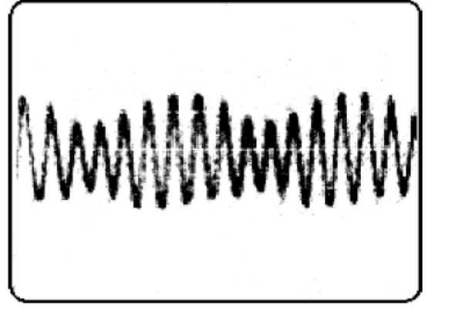

**Fig. 2.1 Tuner Section Output**

**Section 2 (Fault Finding):**

**Fault Insertion:**

**Fault 1:** No picture, only low contrast snow on screen

**Fault Insertion:** Remove the shorting shunt from 2 & 3 pin and place it between pin 1 & 2 of jumpers J1

**Symptoms:** Even antenna is connected but there is no picture only sound is present with low contrast.

**Fault Section:** Tuner Section

**Procedure:**

* Check power supply at TP14 (MB) of tuner section, it should be +12V if not
* Then Check +12V supply at TP13 if it is OK
* Remove the shorting shunt from pin 1 & 2 and place it between pin 2 & 3 of

jumpers J1.

**Result:** Now you should get +12V at TP14.

**Fault 2:** No picture, No transmitting sound**.**

**Fault Insertion:** Remove the shorting shunt from 2 & 3 pin and place it between pin

1 & 2 of jumper J3

**Symptoms:** No picture, No sound and tuning is not possible.

**Fault Section:** Tuner Section

**Procedure:**

* Check the voltage at TP4 (33V approximately) if it is not present then,
* Track may be open or components are faulty.
* Remove the shorting shunt from pin 1 & 2 and connect it between 2 & 3 of

jumper J3.

**Result:** Now you should get picture with OK sound.

**Experiment No. 3**

**Objective**: To study the VIF section through test point and step – by- step fault finding procedure of VIF section.

**Equipment Required:**

1. ST2651 trainer

2. Multi Meter

3. Cathode ray oscilloscope with necessary connecting probe

**Theory**

This section includes VIF and SIF sections. This trainer uses IC101 (CD7680) for VIF and SIF sections. The signals at terminal (TP15) of tuner section are fed at the base of transistor Q161 (C388A) through coupling capacitor C161 (01μf). This amplified IF signals are available at collector of this transistor and then fed to Saw Filter through capacitor C163 (.01μf) collector of pre-amplifies transistor gets positive supply by resistances R164 (220Ω) and R165 (470Ω). Base biasing is given by resistance R163 (5.6K) and R162 (1K) to base of pre-amplifier and its emitter is grounded by R166 (27Ω). Output of saw filter is fed to pin no. 7 and 8 of IC101 (IC7680) by coil L102 (TRF 1452) R101 (820Ω) and C101 (.01μf) network. Pin no. 7 & 8 are VIF amplifier pins. The signal from this section is fed to video detector after amplification. Video detector detects line video signal and amplified by video pre amplified section. Composite colour video signals are obtained at pin no. 15. The signal is shown at TP23.This composite signal also has SIF signal of 5.5 MHz. Ceramic filter Z106 (5.5 MHz) sets sound IF signals 5.5 MHz through capacitor C7 (68pF). This ceramic filter separates the second IF signal from composite video signal. The filtered sound IF signals are fed to pin no. 21 of this IC sound. IF amplifier section amplifies the sound IF signals and send it to FM detector section where audio signals are obtained. Audio signals are available at pin no. 3 of this IC at pin no. 22 and 24 FM detector circuit is connected with FM detectors coil. Pin no. 1 of this IC gets the volume control signal from pin no. 39 of system control IC through transistor Q901 (BC547).

Pin no. 17 and 18 are the pins of video detector section. Here L151 (1445) video detector coil is used. Resistance R108 (3.9K) video detector coil and a capacitor parallel to this coil passes the signal to video detector section for detection. After that the signal reaches to AFT detector section. The detected signals from AFT section are obtained at pin no. 13 which is AFT output pin. AFT signals are fed to AFT terminal of Tuner by resistance R171 (2.7K). From tuner's AFT point this AFT signals are fed to base of buffer transistor Q910A (BC547) which comes out from its emitter. Then the circuit of C196 (4.7KPF) R925 (4.7K) R924 (470Ω) and diode D903 (IN4148) passes this signal to pin no. 15 of system control IC. It is very important to give the signal to system control section because the channels cannot be locked without this signal. AGC voltage is given to AGC terminal of tuner from pin no. 11 of this IC through resistance R105 (220Ω). There is (15K) R151 variable resistance for AGC adjustment.

The IC 7680 incorporates the following functions.

* Gain controlled wide band amplifier providing complete IF gain.
* Video detection.
* Video pre-amplification.
* AFC detection output providing.
* IF AGC and RF AGC
* Sound IF limitation and amplification.
* FM detection.
* Attenuation and providing

**Procedure:**

1. Connect the power supply trainer ST2651.

2. Observe the all Test point mentioned in Section 1

3. Observe the test point removing the jumpers mentioned in Section 2

**Section 1(Checking of Test Point):**

**TP23 Red VIF section:**

Composite video signal (Pin no. 15 of IC7680).TP21 Blue is shown in fig 3.1

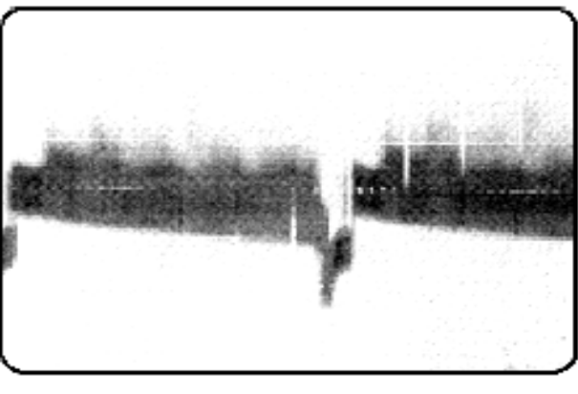

**Fig 3.1 VIF output at TP 23**

**Section 2(Fault Finding):**

**Fault 1:** No Sound, No Picture only plane raster on the screen.

**Fault Insertion:** Remove the shorting shunt from 2 & 3 pin and place it between pin 1 & 2 of jumper J2

**Symptoms:** There is neither sound nor picture on the screen. Only plane raster is present.

**Fault Section:** VIF Section

**Procedure:**

* Check power supply at pin no. 20 of IC101 (IC7680) If not then,
* Check +12V at TP13 if it is OK
* Then may be track open between TP13 and Pin 20 of IC101
* If not then check the continuity connection between TP13 and TP6.
* Remove the shorting shunt from pin 1 & 2 and place it between pin 2 & 3 of jumper J2.

**Result:** Now you should get +12V at pin no. 20 of IC101.& good picture with sound

**Fault 2:** Plane Raster on the Screen.

**Fault Insertion:** Remove the shorting shunt from pin 2 & 3 and place it between pin 1 & 2 of jumper 31

**Symptoms:** Only plane raster on the screen without any sound.

**Fault Section:** VIF Section.

**Procedure:**

* First check the composite colour video signal at pin no15 of IC101. If it is OK then,
* Check the composite colour video signal at pin no. 39 of IC501.
* The components connected between TP23 and pin no. 34 of IC501 may be faulty. If these are OK then,
* Check the track between TP23 and pin no. 39 of IC501.
* Remove the shorting shunt from pin 1 & 2 and connect it between 2 & 3 of Jumper 4.
* **Result:** Now you should get clear picture with sound.

**Fault 3:** No Picture. No transmitting sound.

**Fault Insertion:** Remove the shorting shunt from pin 1 & 2 and place it between pin 2 & 3 of jumper J37

**Symptoms:** No Picture, there is only snow

**Fault Section:** VIF Section

**Procedure:**

* First check the antenna wire and antenna. If it is properly connected then,
* Check the tuner voltage +12V at TP-14. If it is OK then tuner may be faulty.
* Now try to get the picture with the help of Auto tuning/ Fine tuning. If you are not getting the picture then,
* Check the +33volt at TP4 DA13. If it is OK then,
* During the auto mode, check the voltage variation of 0V to 8V at emitter of TRQ902. If it is not varying then,
* Track may be track open between DA13 and Q902.
* Remove the shorting shunt from pin 2 & 3 and connected between 1 & 2 Jumper J21

**Result:** Now you should get clear picture with sound.

**Experiment No 4**

**Objective**: To study the Video & Chromed section through test point and step – by- step fault finding procedure of Video and Chroma section .

**Equipment Required:**

1. ST2651 trainer

2. Multi Meter

3. Cathode ray oscilloscope with necessary connecting probe

**Theory**

IC CD7698 (IC501) is used for video & chroma section. Vital part of the IC is used for chroma section. For chroma section pin no. 1-23 and pin no. 38-42 are used, other pins are used for Video section. For chroma section following are the main sub sections in the IC:

* Chroma amplifier
* Colour oscillator
* Colour killer detector
* Matrix
* Luminance (Y) signal amplifier.

VIF section IC101 (CD7680) pin no. 15 supplies the composite colour video signal to the inverter pin no. 39 of IC501 (CD7698) by circuit made up of L105 (3.3μH) R958 (330Ω), Trap5.5 MHz (ceramic filter) and L201 (12μH). In inverter section this signal is amplified as well as detected, After detection Y signal goes to Y amplifier which is in built in IC, Remaining amplified composite colour and sink signal are obtained at pin no. 40 of this IC, then fed to pin no. 5 of this IC through resistance R501 (820Ω), C560 (18pF) and C502 (10pF). Pin no. 5 is Band pass amplifier pin. Signal goes to band pass amplifier by this pin and amplified here. Amplified signal is obtained at pin no 8.

From pin no. 8 the signal fed to pin no. 19 of this IC by passing it through chroma trap circuit. This trap circuit consists of VR551 (1K) C507 (0.01μf), C508 (15Pf), C502 (10μH) X502 (DL701 delay line), L551 (TRF5418) R510 (470Ω) and C509 (.01μF). From pin no. 8 this signal is also fed to pin no. 17 of this IC in the form of colour sink signal by resistance R509 (1.5K), C510 (.01μF) pin no. 17 is of matrix section. Pin no. 41 is contrast control pin. Pin no. 41 gets the contrast control signal from pin no. 37 of system control IC through resistance R946 (560Ω), R945 (1.5K) and R213 (47K). Pin no. 4 of this IC is brightness control pin. Pin no. 38 of IC901 (system control section) supplies the brightness control signals at this pin through resistance R941 (1K), R956 A (47K), R212 (10K). Pin no. 7 of IC501 (CD7698) receives the colour control signals from pin no. 36 of IC901 through resistance R947 (1K), R942 (12K) and R505 (2.2K). Pin no. 20 of IC501 (CD7698) is output pin of green colour signal. Green colour output signal from this pin is fed to base of green colour amplifier transistor. In the same way red colour signal obtained at pin no. 21 of this IC and then fed to base of red colour output transistor Q507 (C2310). Blue colour signal obtained at pin no. 22 of this IC and then fed to base blue colour output transistor Q509 (C2310).R-Y signals & B-Y signals. Y signals from pin no. 42 of this IC are fed to pin no. 3 of the same IC through resistance R203 (1.5K), R210 (1.5K) arid capacitor C204 (.47μF) circuit network. Luminance signals are out from pin no. 23 of this IC and fed to base of luminance amplifier transistor TQ202 (2SA 1015) this transistor amplifies the signal and out the signal by its emitter, which is then fed to all the three emitters of three colour output transistors. Pin no. 30 to 37 of IC501 (CD7698) works for horizontal oscillator AFC and sync separator sections.

**Procedure:**

1. Connect the power supply trainer ST2651.

2. Observe the all Test point mentioned in Section 1

3. Observe the test point removing the jumpers mentioned in Section 2

**Section 1: (Checking of Test Point)**

**TP26 Blue** Video & Chroma section +12V (approximately)

**TP28 Blue** Video & Chroma section Colour composite video signal

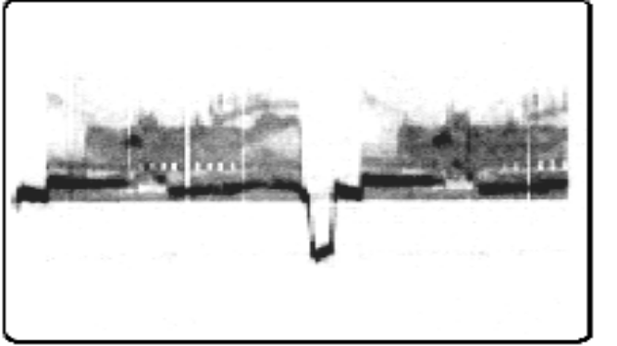

**Fig 4.1 Video and Chroma output at TP 28**

**TP29 Red** Video & Chroma section Inverted Colour composite Video signal

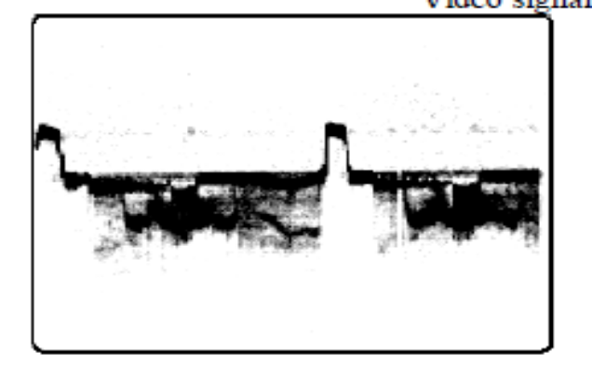

**Fig 4.2 Video and Chroma output at TP 29**

**TP 31 Red** Video & Chroma section Luminance Signal.

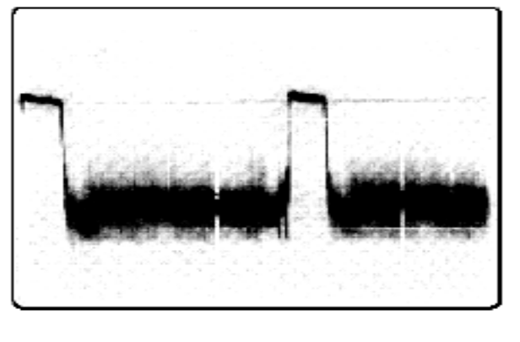

**Fig 4.3 Video and Chroma output at TP 31**

**TP34 Blue** Video & Chroma section + 10V (approximately)

**TP37 Blue** Video & Chroma section 4.43 MHz sub carrier frequency

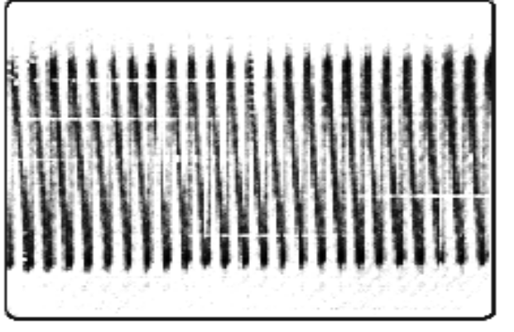

**Fig 4.3 Video and Chroma output at TP 37**

**TP38 Blue** Video & Chroma section + 12 V (approximately)

**TP39 Red** Video & Chroma section for colour adjustment.

To observe Colour burst signal at Pin no. 5 of IC501, connect pattern generator

(colour bar pattern) at antenna socket

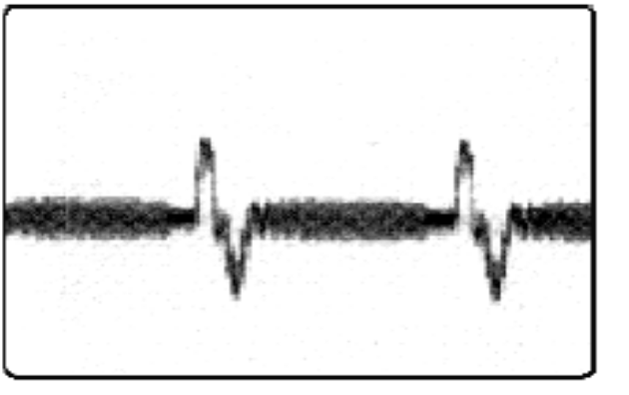

**Fig 4.4 Video and Chroma output at TP 39**

**Section 2(Fault Finding):**

**Fault 1** There is green shade colour on the screen with OK picture

**Symptoms:** There is good picture on the screen with green shade colour

**Fault Section:** Video & Chroma section

**Procedure:**

* Turn ON the instrument from stand by mode
* Check pin no. 22 of IC501 (IC7598) it should be +7.2V approximately . if it is OK (if not then IC may be faulty) if OK then
* ( since we know that if there is yellow shade on the screen it means blue colour is absent) so first check proceed circuit of pin 23 (B-Y out put) Le.- check this+7.2 V approx. at B terminal (Berg strip pin), if it is not
* There may be track open between this B terminal and pin 23 of IC 501
* Remove the shorting shunt from pin 1 &2 of and connect it between 1 & 2 of

**Result:** Turn on the instrument picture with normal colours

**Fault 2** There is blue shade colour on the screen with OK picture

**Symptoms:** Sound and picture ok only screen has blue colour shade

**Fault Section:** Video & Chroma section

**Procedure:**

* Turn ON the instrument from stand by mode
* Check pin no. 22 of IC501 (IC7598) it should be +7.2V approximately . if it is OK (if not then IC may be faulty) if OK then
* ( since we know that if there is cyan colour on the screen it means red colour is absent) so first check proceed circuit of pin 21 of IC 501 it should be 7.2 appox.( if not IC may be faulty), if OK then
* Check this voltage at R terminal, if it is not then
* There may be track open between 21 of IC 501 & R terminal
* Remove the shorting shunt from pin 2 &3 and correct it between 1 & 2 of jumper J14

**Result:** Turn on the instrument picture with normal colours

**Fault 3:** There is magenta shade colour on the screen with OK picture.

**Fault Insertion:** Remove the shorting shunt from pin 1 & 2 and connect it between 2 & 3 of jumper J13

**Symptoms:** Sound and picture OK with magenta shade

**Fault Section:** Video & Chroma section.

**Procedure:**

* Turn ON the instrument from standby mode
* (since we know that if there is magenta colour on the screen it means green colour is absent) so first check proceed circuit of pin 21 of IC 501 it should be 7.2 appox.( if not IC may be faulty), if OK then
* Check this voltage at G terminals. If it is not then
* There may be track open between 20 of IC 501 & R terminal
* Remove the shorting shunt from pin 2 &3 and correct it between 1 & 2 of jumper J13

**Result:** Turn on the instrument**,** picture with normal colours

**Fault 4:** Dull Coloured Picture

**Fault Insertion:** Remove the shorting shunt from pin 1 & 2 and connect it between 2 & 3 of jumper J19

**Symptoms:** There is dull picture (Negative type) on the screen with full colours.

**Fault Section:** Video and Chroma Section

**Procedure:**

* Check the luminance signal at pin no. 23 of IC501. If it is not then IC may be faulty, if it is OK then,
* Check this luminance signal at base of T202 (1015). If it is not here then,
* There may be track open between pin no. 23 of IC501 and base of T202.
* Replace the shorting shunt from 2 & 3 and connect it between 1 & 2 of Jumper J9j

**Result:** Turn on the instrument, picture on the screen.

**Fault 5: Picture is vertically rolling with OK sound**

**Fault Insertion:** Remove the shorting shunt from pin 1 & 2 and connect it between 2

& 3 of jumper J11

**Symptoms:** There is OK sound from the trainer kit but picture is vertically rolling.

**Fault Section:** Video and Chroma Section

**Procedure:**

* Check vertical sync pulse at pin no.36 of IC 501 (CD 7698). If it is OK then
* Check the same – pulse at pin no. 28 of same IC. If it is not then,,
* There may be track open between these two pins or R330 (30K) or capacitor..
* Replace the shorting shunt from 2 & 3 and connect it between 1 & 2 of Jumper J11

**Result:** Turn on the instrument, clear picture with sound.

**Experiment No. 5**

**Objective**: To study the Horizontal output section through test point and step – by- step fault finding procedure of Horizontal output section .

**Equipment Required:**

1. ST2651 trainer

2. Multi Meter

3. Cathode ray oscilloscope with necessary connecting probe

**Theory**

Pin no. 40 of IC501 (CD7698) supplies the composite sync signal to pin no. 37 (Sync Separator) of this IC through the circuit of R301 (750Ω), R302 (560K), capacitor C301 (1μF), C302 (.01μF), C303 (560PF) R513 (15K) and diode D301 (IN4148). Sync separator section separates the horizontal sync and vertical sync. Horizontal sync signals are supplied to AFC section in built in IC from sync separator section.This horizontal section produces the signal of frequency 15625 Hz.

**Procedure:**

1. Connect the power supply trainer ST2651.

2. Observe the all Test point mentioned in Section 1

3. Observe the test point removing the jumpers mentioned in Section 2

**Section 1: (Checking of Test Point)**

**TP5 Red** Horizontal output section +110V (approximately)

**TP6 Red** Horizontal output section +12V (approximately) for VIF Section

**TP7 Red** Horizontal output section +185V (approximately) for R-G-B video output section

(CRT base PCB)

**TP8 Red** Horizontal output section Filament Voltage 6.3V AC (approximately)

**TP27 Red** Horizontal Oscillator Ident (Sync) signal part of Video & Chroma IC501

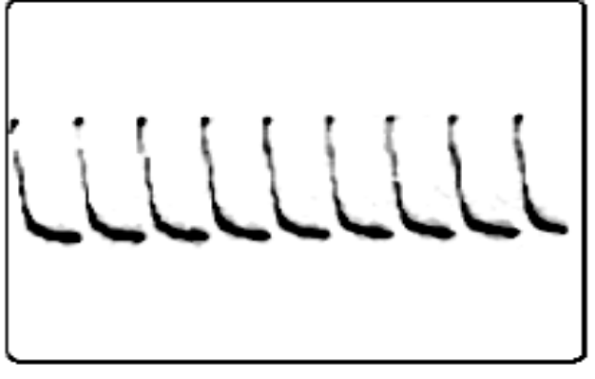

**Fig 5.1 Sync Signal TP 27**

**TP30 Red** Horizontal Oscillator part of Video & Chroma IC501

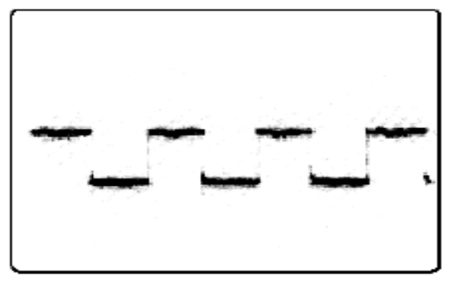

**Fig 5.2 Horizontal driven Signal TP 30**

**TP35 Red** Horizontal Oscillator part of Video & Chroma IC501

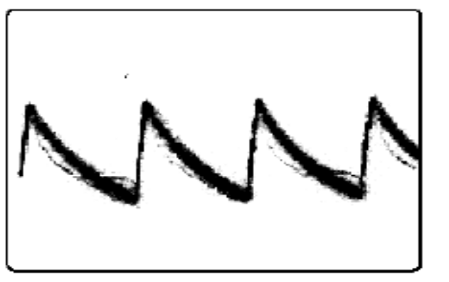

**Fig 5.3 Horizontal driven Signal TP 35**

**TP40 Blue** Horizontal output

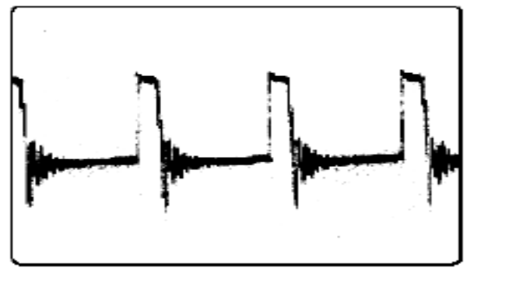

**Fig 5.3 Horizontal blanking pulse TP 40**

**Section 2(Fault Finding):**

**Fault 1:** There is no clear picture on the screen and screen is shaking horizontally.

**Fault Insertion:** Remove the shorting shunt from pin 1 & 2 and place it between 2 & 3 of jumper J5.

**Symptoms:** Clear sound without clear picture. Horizontal shaking is present on the screen.

**Fault section:** Horizontal output section

**Procedure:**

* Check fly back pulse of frequency 15625 Hz at pin no. 35 of IC501 (IC7698) if not then,
* Check this fly back pulse at resistance R402 (27Kohm) if it is not then, Track may be open between pin no. 10 of EHT and this resistance.
* Remove the shorting shunt from pin 2 & 3 and place it between 1 & 2 of jumper J5.

**Result:** now you should get fly back pulse of frequency 15,625 Hz at pin no. 35 of IC501 and so good picture with good sound is observed.

**Fault 2:** Dark Screen, (Neither Raster nor snow) No sound

**Fault Insertion:** Remove the shorting shunt from pin 1 & 2 and place it between 2 &3 of jumper J6.

**Symptoms:** There is no picture no sound condition even raster or snow are also absent.

**Fault section:** Horizontal output section

**Procedure:**

* First check whether LED for power indication is glowing or not, If it is not then,
* Check AC mains cord and fuse of trainer kit, if LED is glowing then,
* Check +110V at TP5 if it is OK
* If it is not then it may be problem of regulation circuit which should be serviced by service personal only
* Then check pin no. 33 of IC501 (IC7698) it should be 6.9V approximately
* Check pin no. 32 of IC501 it should be 15625 Hz (Horizontal frequency) if it is

present then,

* If not then IC501 may be faulty or related circuit may be faulty
* Check the same signal at R411 (33ohm) it is OK then,
* Check same signal at base of transistor Q402. If it is not then, Track may be open between base of Q402 and resistance R411.
* Remove the shorting shunt from Pin 2 & 3 and place it between 1 & 2 of

jumper J12.

**Result:** Now you should get good picture with good sound.

**Fault 3:** Set Dead i.e. Dark Screen

**Fault Insertion:** Remove the shorting shunt from pin 1 & 2 and place it between 2 & 3 of jumper J12

**Symptoms:** There is no picture no sound from trainer kit.

**Fault Section:** Horizontal Oscillator Section (part of Video& chroma IC501)

**Procedure:**

* First check whether LED for power indication is glowing or not.
* If it is not then check AC mains cord and fuse of trainer kit. If it is OK then,
* Check +110V at TP5 if not then it may be the problem of regulation circuit which should be serviced by service personal only
* Check 6.9V approximately at pin no. 33 of (IC7698). If it is OK then,
* Check horizontal frequency at pin no. 32 of IC501 it is 15625 Hz. If it is OK then,
* If it is not then that may be the fault of IC or related circuitry
* Check this signal at base of Q402, if it is not then,
* Track may be open between pin no. 32 of IC501 and base of Q402.
* Remove the shorting shunt from pin 2 & 3 and place it between 1 & 2 of jumper J12.

**Result:** Now you should get picture & sound both from the trainer kit.

**Fault 4:** Horizontal sync out

**Fault Insertion:** Remove the shorting shunt from pin 1 & 2 and place it between 2 & 3 of umper J20

**Symptoms:** Horizontal sync is not adjustable (Preset VR451)

**Fault Section:** Horizontal Oscillator

**Procedure:**

* Check the signal at pin no. 39 of IC501 If it is OK then,
* Check the inverted video signal at pin no. 40 of IC501, If it is OK then if it is not then IC may be faulty
* Check the video signal at pin no. 37 of IC501. If it is not then IC may be faulty.
* If it is OK then components connected between pin no. 37 and 40 of IC501 are faulty. If these are OK then,
* Track may be open between pin no. 37 and 40 of IC501.
* Remove the shorting shunt from pin 2 & 3 and connect it between 1 & 2 of Jumper J20.

**Result:** You should get clear picture.

**Experiment No. 6**

**Objective**: To study the Vertical output section through test point and step – by- step fault finding procedure of Vertical output section .

**Equipment Required:**

1. ST2651 trainer

2. Multi Meter

3. Cathode ray oscilloscope with necessary connecting probe

**Theory**

Vertical oscillator is also built in IC501 (CD7698) & pin no. 24, 25, 26, 27, 28, 29 are its connection pins. As we have already studied that vertical sync signal is present at pin no. 36 after sync separation. The vertical sync signal from pin no. 36 passes from circuit network of R304 (10K), R330 (3K), R305 (2.4K) and capacitor C310 (.47mF) and obtained at pin no. 28.

Vertical oscillator produces 50 Hz frequency which is amplified inside the IC and available at pin no. 24 which is vertical driver pin. This vertical driver signal from pin no. 24 is fed to base of vertical driver transistor Q303 (C2229) by resistance R325 (330W). Collector of this transistor provides amplified output which is supplied to vertical output section for amplification

15625 Hz.

**Procedure:**

1. Connect the power supply trainer ST2651.

2. Observe the all Test point mentioned in Section 1

3. Observe the test point removing the jumpers mentioned in Section 2

**Section 1:**

**TP32 Red** Vertical oscillator Part of video & Chroma IC

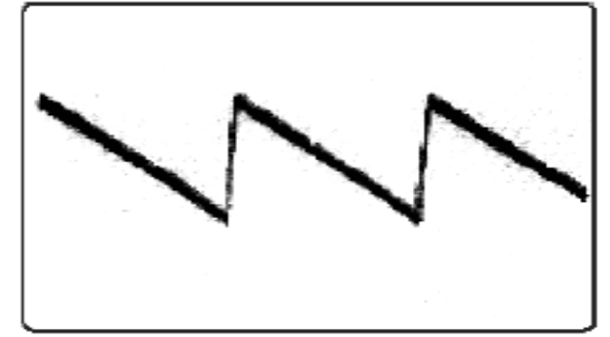

**Fig 6.1 Vertical feedback TP 32**

**TP33 Blue** Vertical Oscillator Part of chroma IC

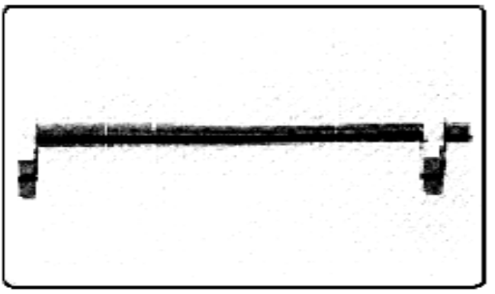

**Fig 6.2 Vertical driver TP 32**

**TP41 Red** Vertical output section +17 V (approximately

**Section 2(Fault Finding):**

**Fault 1:** There is Horizontal Line on the screen.

**Fault Insertion:** Remove the shorting shunt from pin 1 & 2 and place it between 2 & 3 of jumper J8

**Symptoms:** No picture OK sound. Only Horizontal line is present on the screen.

**Fault Section:** Vertical oscillator (part of video & chroma IC501)

**Procedure:**

* Check vertical frequency of 50 Hz at pin no. 24 of IC501 (IC7698) if it is OK then,
* If it is not then IC or related circuit may be faulty
* Check this signal at base of transistor Q303, if it is not then
* Faulty R325 or track may be open between pin no. 24 of IC501 and base of Q303.
* Remove the shorting shunt from pin 2 & 3 and place it between 1 & 2 of jumper J8.

**Result:** Now you should get picture on the screen.

**Fault 2:** Bottom fold over the picture on the screen.

**Fault Insertion:** Remove the shorting shunt from pin 2 & 3 and place it between 1 & 2 of jumper J7

**Symptoms:** The 90% of picture screen is OK only bottom side 10% picture is folded over on the original picture.

**Fault Section:** Vertical output Section.

**Procedure:**

* Check output of the vertical driver pin no. 24 of IC501 It is vertical frequency of 50 Hz. If it is OK then,
* Check output of vertical output section at R333 (1R). It should be amplified signal. It is not correct then,
* Faulty components in its circuit or ground may be open.
* Check R313 (15K) and its ground connection.
* Remove the shorting shunt from pin 1 & 2 and connect it between 2 & 3 of jumper J7.

**Result:** Now you should get clear picture.

**Experiment No. 7**

**Objective**: To study the System control section through test point and step – by- step fault finding procedure of System control section .

**Equipment Required:**

1. ST2651 trainer

2. Multi Meter

3. Cathode ray oscilloscope with necessary connecting probe

**Theory**

The IC901 FONDA4ST for system control purpose. It is dual in line package 40 pin IC which controls all the sections of the TV Trainer. Pin no. 1, 2 and 3 are band switching pins. 1st pin is used for switching the VL band. Second one is used to switch VH band and third pin is for UHF band Pin no. 4 provides TV/AV switching signals on pressing the AV switch from remote control, the RF signals coming from antenna or cable are disconnected with VIF section. Hence there is only raster on the screen without snow. Pin no. 5, 6, 7, 21, and 22 are the key matrix pins, which are connected with keyboard. Keyboard is used for selecting one function from front panel. Pins 8 & 9 are the on screen display oscillator pins. Horizontal and vertical sweep frequencies are obtained in these pins with the help of ON screen display oscillator. These frequencies (signals) play an important role for getting ON screen display (OSD) on the screen. The coil connected on pin no.8 & 9 decides the frequency of Internal Oscillator. These horizontal and vertical sweep frequencies are synchronized with horizontal and vertical blanking pulses. Pin no. 11 & 12 are memory input and output pins. Pin no. 11 is connected with pin no. 5 of memory IC902 and pin no. 12 is connected with pin no. 6 of this memory IC. Whenever we store any channel or put it into memory then these memory signals are stored in memory IC with the help of these pins. Therefore whenever the stored channel is required, memory IC feeds it to system control IC.

**Procedure:**

1. Connect the power supply trainer ST2651.

2. Observe the all Test point mentioned in Section 1

3. Observe the test point removing the jumpers mentioned in Section 2

**Section 1(Checking of Test Point):**

**TP24 Blue** + 18V (approximately)

**TP25 Red** + 5V (approximately)

**TP42 Red** System Control Section 9V approximately from system control IC to select VHF I band (VL) otherwise 0V.

**TP43 Red** System control Section 0V when VHF III (VH) band selected otherwise 9V approximately

**TP44 Red** System control Section 0V when UHF band selected otherwise 9V approximately

**TP45 Blue** System Control Section Horizontal blanking pulse input for system control

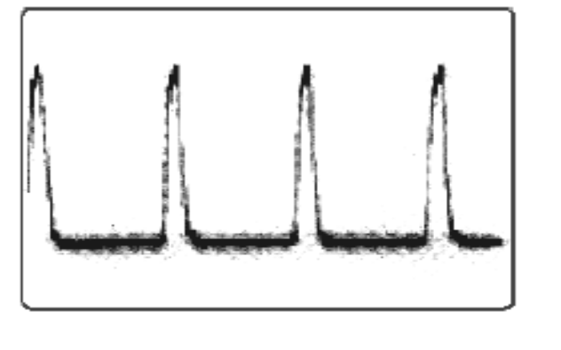

**Fig 7.1 Horizontal blanking pulse TP 45**

**TP45 Blue** System Control Section Vertical blanking pulse input for system control

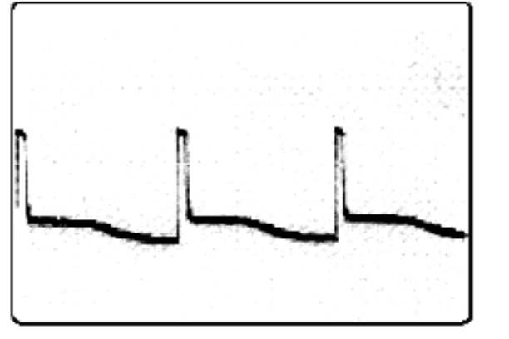

**Fig 7.2 Vertical blanking pulse TP 45**

**TP47 Blue** System Control Section Input for AFT 3.2 VDC (approximately)

**TP48 Blue** System Control Section Ident signal 0.2-5 VDC (approximately)

**TP49 Red** System Control Section Input pin for standby Mode +5V when power is ON otherwise 0V

**TP50 Red** System Control Section Output of tuning signal 5Vpp approximately

**TP51 Blue** System Control Section +5V approximately Infrared signal from Remote

**TP52 Red** System Control Section Colour control pin 0.2-8V approximately**:**

**Section 2(Fault Finding):**

**Fault 1:** Set Dead

**Fault Insertion:** Remove the shorting shunt from pin 2 & 3 and place it between 1 &

2 of jumper J16

**Symptoms:** There is no picture nor sound neither raster/snow.

**Fault section:** System control section

**Procedure:**

* First check whether LED for power indication is glowing or not, if it is not then,
* Check 110V at TP3 if it is OK
* If it is not then it may be problem of regulation circuit which should be serviced by service personal only
* Then check pin no. 33 of IC501 (IC7698) it should be 6.9V approximately then,
* Check power supply of system control IC901 (Fonda 4ST) at pin no. 40 it should be +5V, if it is OK then,
* Check pin no. 26 of IC 901 for signals of 4 MHz frequency, if it is not then,
* Track may be open between crystal of 4 MHz and pin no. 26 of IC901 or crystal may be faulty or IC901 may be faulty.
* Remove the shorting shunt from pin 1 & 2 and place it between 2 & 3 of jumper J32.

**Result:** Now you should get picture with sound.

**Fault 2:** No volume variation

**Fault Insertion:** Remove the shorting shunt from pin 1 & 2 and place it between 2 &

3 of jumper J17

**Symptoms:** There is good picture without sound variation facility.

**Fault section:** System control section

**Procedure:**

* Check ident signal on pin no. 27 of IC901 (Fonda 4ST) if it is not then (Check only with oscilloscope)
* Check this signal at collector of transistor Q909 if it is not here then,
* Check it at the base of same transistor if it is not here then,
* Transistor may be faulty or track may be open between pin no. 27 of IC901 and collector of transistor Q909.
* Remove the shorting shunt from pin 2 & 3 and place it between 1 & 2 of jumper J17.

**Result:** Now you should get volume variation when operated.

**Experiment No. 8**

**Objective**: To study the Introduction of Tape Recorder and Tape Transport Mechanism.

**Equipment Required:**

1. ST2656 trainer

**Theory**

1. **Principles of magnetic recording and reproduction:**

Magnetic recording is based on the principle (shown in figure 8.1) that certain materials (like iron oxide) when brought in a magnetic field, get magnetized and retain that magnetism permanently until altered. The various steps involved in magnetic recording are described below.

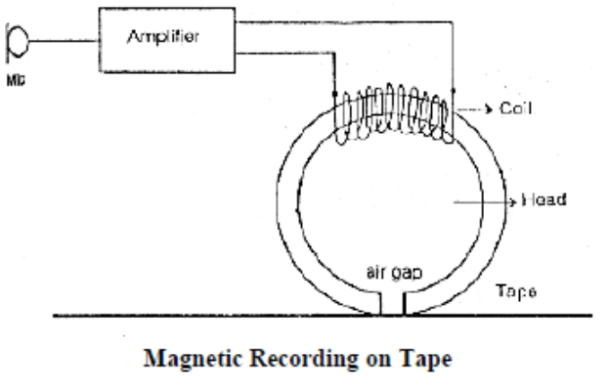

**Fig 8.1**

Sound pressure variations are converted into electrical variations (audio signal) by a microphone. The audio output of the microphone is amplified and fed to the coil of an electromagnet. The electromagnet (called 'record head') has a minute air gap through which magnetic lines of force cannot pass easily due to high reluctance of air. When a tape with a coating of a magnetic material (like iron oxide) is made to pass across the gap, the lines of force get an easy path through the iron oxide which is formed into elementary magnets.

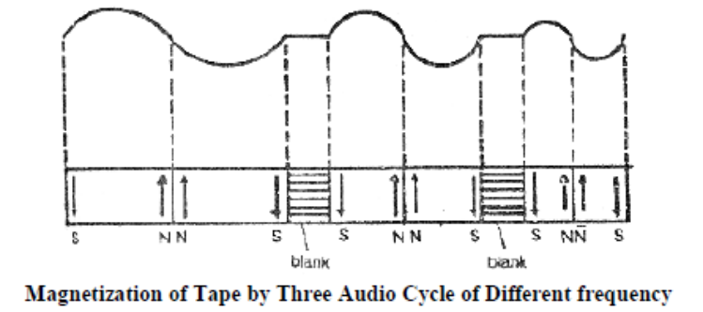

**Fig 8.2**

The magnetic strength of electromagnet, through the gap covered by the iron oxide tape, depends on the current. Thus, the coating of iron oxide on the tape is magnetized in accordance with the audio current and hence, in accordance with the sound pressure variations. The magnetism in the iron oxide is retained for long time. This means that sound has been recorded in the form of varying magnetic field.

In reproducing the recorded sound, the tape is again made to pass through a similar head with a gap, causing changes of lines of force through the coil. This induces e.m.f. (audio signal) in the coil, which is in accordance with the rate of change of magnetic flux in the tape. The induced e.m.f. is amplified and is fed to a loudspeaker which converts the audio signal into sound. Figure 2 shows a magnetized tape for 3 cycles of audio signal. The figure shows that wavelength decreases, the length of bar magnets formed on the tape decreases. Each cycle gives rise to two bar magnets.

**2. Tape and Tape Material:**

Tape consists of a tough un-stretchable non-magnetic base or backing material coated with fine particles of a magnetic material, such as ferric oxide or cobalt doped ferric oxide (Fe2O3) or chromium di-oxide (CrO2). The tapes come in various standard widths, like 6.3, 12.7, 25.4 and 50.8 mm (or quarter inch, half inch, 1 inch and 2 inches). The standard quarter inch wide tape can accommodate two tracks each 2.5mm wide with a guard band of 1.3 mm in between. The thickness of the standard tape is about 38 micron. The thinner the tape, greater will be the length of tape in a spool.

**3. Characteristics of good quality tape:**

* Should not be stretchable.
* Coercively of magnetic material should be high.
* Tape base material should be tough.
* Coating of magnetic material on the base material should be uniform.
* Base thickness should be uniform.
* Foreign particles should not be present.
* Should be well polished and impregnated with compounds that act as lubricants to reduce the friction between tape and head.
* The tape must press the head properly.

**4. Tape Transport Mechanism**

In the studio type, separate motors are used to drive the capstan, supply spool and take-up spool. But in the domestic type only a single motor serves the purposes as shown in figure 4. It drives the capstan and then with the help of pulleys and belts spools are driven.

The tape transport mechanism consists of the following components

**1.** Motor

**2.** Capstan and press roller (pinch roller)

**3.** Flywheel

**4.** Tape guides and

**5.** Spools

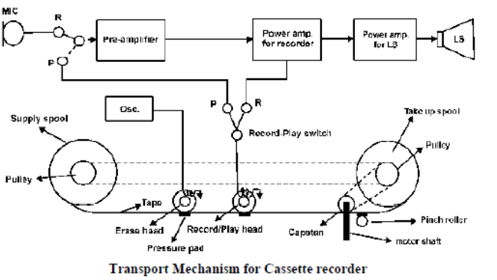

**Fig.8.3**

**Motor :**

The motor used in good quality tape transport mechanism is synchronous type. A synchronous motor has its speed locked to the frequency of the supply voltage and therefore, maintains constant speed irrespective of variation of supply voltage or load. This steadiness results in reduction of wow and flutter distortion. In good tape machines, wow and flutter are not more than 0.2%.

**Capstan and press (or pinch) roller:**

Capstan is a spindle, machined accurately, and pulls the tape past the heads. The tape is pressed against the capstan by means of a rubber covered by pinch roller.

**Flywheel:**

It is a very heavy wheel made of metal and is fitted to the capstan shaft. This damps minor variations in the speed. It should be free from any tendency to vibrate, because any vibration here will cause rumbling problem.

**Tape guides:**

These provide the desired tension in the tape and keep it in the correct position. The angle round which the tape should turn at any point in the transport should not be excessive. All the bearings over which the tape passes must be of high quality.

**Spools:**

There are two spools. While in use, one spool feeds tape to the other spool, and hence, the spools are known as:

**1.** Feed spool or supply spool, and

**2.** Take up spool.

Indication of the position of any recorded signal is achieved by fitting a rotation Counter to the take-up spool’s spindle.

**Experiment No. 9**

**Objective**: To study of various fault simulated in the Tape Recorder trainer.

**Equipment Required:**

1. ST2651 trainer

2. Multi Meter

**Theory**

The tape present in the cassette is made up of thin plastic material. Magnetic material is present in the above portion of the tape. If any electric current is passed near to this magnetic material of the tape, due to the magnetic property of electric current, that particular portion of tape gets converted to small temporary magnets. The distance between North Pole and South Pole of these small temporary magnets depend on the speed of the tape as well as the direction of current. This process of conversion into magnetic property of the rotating tape is termed as recording. The required current for recording to feed to the tape head situated properly within the gap of the tape head. This gap of the tape head keeps on touching the rotating tape and thus recording takes place over the tape.

The sound which is recorded is converted into the audio signal by the help of microphone. The low level signals are amplified by pre amplifier and amplifier circuit thus converting into high level audio current. This current is further provided to the tape head for recording purpose.

**Procedure:**

1. Connect the power supply trainer ST2656.

2. Observe the Fault through the jumpers mentioned in Section 1

**Section 1: (Fault Finding):**

**Fault 1: This fault is inserted by placing jumper J1 on pin 1&2.**

**Symptoms:** Due to this motor will not move hence cassettes also will not move**.**

**Reason:** This fault disconnects +12V supply at the pin 1of IC 101 (7812)**.**

**Fault 2: This fault is inserted by placing jumper J2 on pin 1&2.**

**Symptoms:** Due to this fault both the channels will not work but motor will move.

**Reason:** This fault disconnects the operating +12V supply of the circuit.

**Fault 3: This fault is inserted by placing jumper J3 on pin 1&2.**

**Symptoms:** Due to this fault, though the cassette will move we will not listen any recorded audio signal at TP9. If we click any metallic item then we can listen audio signal on speaker it means output amplifier section is OK.

**Reason:** This fault stop the audio output signal of pre-amplifier to reach TP7

**Note:** The same kind of fault is inserted with jumper J9 for right channel.

**Fault 4 : This fault is inserted by placing jumper J4 on pin 2 & 3.**

**Symptoms:** Due to this fault, at the time of recording (according to the Recording procedure) the LED do not glow and audio signals are not recorded on the magnetic tape.

**Reason:** Due to this fault, connection between microphone and preamplifier is cut hence output will not come at TP16.

**Note:** The same kind of fault is inserted with jumper J10 for right channel.

**Fault 5 : This fault is inserted by placing jumper J5 on pin 1 & 2.**

**Symptoms:** Cassette will be played but the recorded audio signals will not be converted to sound by speaker.

**Reason:** This fault disconnects one track of R/P head. Due to this R/P Head do not reproduce the recorded sound.

**Note:** The same kind of fault is inserted with jumper J11 for right channel.

**Fault 6 : This fault is inserted by placing jumper J6 on pin 1 & 2.**

**Symptoms:** Cassette will be played but the recorded audio signals will not be converted to sound by speaker.

**Reason:** This fault stops reproduced sound signal to reach to the preamplifier section by disconnecting the track.

**Note:** The same kind of fault is inserted with jumper J12 for right channel.

**Fault 7: This fault is inserted by placing jumper J7 on pin 1&2.**

**Symptoms:** Due to this fault right channel will work properly but left channel will stop functioning completely.

**Reason:** This fault disconnects operating power supply +12V of left channel.

**Note:** The same kind of fault is inserted with jumper J13 for right channel.

**Fault 8: This fault is inserted by placing jumper J8 on pin 1&2.**

**Symptoms:** Though IC 810 amplifies the audio signal but loud speaker does not reproduce sound signals.

**Reason:** This fault stops the amplified audio signal to be fed to loud speaker.

**Note:** The same kind of fault is inserted with jumper J14 for right channel.

**Fault 9: This fault is inserted by placing jumper J16 on pin 1&2.**

**Symptoms:** Bass and treble will not work at all.

**Reason:** This fault cut the operating power supply voltage +9V approximately given to the bass/treble section.

**Experiment No. 10**

**Objective**: To study the tape mechanism through test point.

**Equipment Required:**

1. ST2656 trainer
2. 2. Multi Meter

**Theory**

1. **There are various fault in Tape Recorder**

* Tape does not move in the playback position.
* Tape motion is irregular Resulting in wow or flutter.
* Some whistling sound is Heard playback.
* Tape is not wound on the take up reel while recording or playing .
* No rewinding.
* No fast forward winding.
* The tape moves up or down on the capstan and the edges are wrapped.

**Procedure:**

1. Connect the power supply trainer ST2656.

2. Observe the Test point as given table 1.

**Table 10.1**

|  |  |  |
| --- | --- | --- |
| **Test**  **Point No.** | **Section** | **Voltages for Play Position** |
| TP1 | Power supply section | 13V approximately |
| TP2 | Power supply section | 12V approximately |
| TP3  TP23 | Output amplifier section | 13V approximately |
| TP4  TP24 | Pre-amplifier section | 2.8V approximately |
| TP5  TP25 | Pre-amplifier section | Audio Signal 30mVpp (Voltage depend on audio tape) |
| **Test**  **Point No.** | **Section** | **Voltages for Play Position** |
| TP6  TP26 | Pre-amplifier section | Audio Signal 30mVpp (Voltage depend on audio tape) |
| TP7  TP27 | Pre-amplifier section | Audio Signal 0.1Vpp (Voltage depend on audio tape) |
| TP8  TP28 | Bass/treble section | Audio Signal 0.1Vpp (Voltage depend on audio tape) |
| TP9  TP29 | Pre-amplifier section | Audio Signal 0.1Vpp (Voltage depend on volume control) |
| TP10  TP30 | Pre-amplifier section | Audio Signal 0.1Vpp (Voltage depend on volume control) |
| TP11 | Output amplifier section | Audio Signal 12Vpp (Voltage |
| TP31 |  | depend on volume control) |
| TP12  TP32 | Output amplifier section | Audio Signal 12Vpp (Voltage depends on volume control) |
| TP13  TP33 | Bass/treble section | Audio Signal 20mVpp  (approximately) |
| TP14  TP34 | Bass/treble section | Audio Signal 0.1Vpp  (approximately) |
| TP15  TP35 | Pre-amplifier section | +ve or -ve 0.1Vpp depends on signal variation |
| TP16  TP36 | Pre-amplifier section | Audio Signal 1mVpp depends on volume control |
| TP17  TP37 | Pre-amplifier section | Audio Signal 0.1Vpp  (approximately) |