SUPERSTORE SALES DASHBOARD
Project Report: Sales and Profit Analysis using Power BI

Dataset: Kaggle Superstore Sales Dataset (2014 to 2017)
Tool: Microsoft Power BI Desktop
T.Y.B.Sc. Data Science
SIES College of Arts, Science and Commerce, Sion West, Mumbai
Name : Yajat Rajashekar Eppakayala Roll No : TDS2627012
October 2026

1. Introduction
This report explains the Superstore Sales Dashboard, an interactive report built in Microsoft Power BI Desktop. The dashboard analyses four years of retail transactions (2014 to 2017) and answers three practical questions: how sales and profit change over time, which places and products drive them, and where discounts reduce profit.

2. Objectives
- Track total sales, total profit, profit margin and number of orders in one view.
- Show monthly sales trends and compare them with the previous year.
- Identify the top-selling states and the best and worst sub-categories by profit.
- Let a viewer filter the whole report by year, region and customer segment.
- Find the causes of loss-making sales so that recommendations can be made.

3. Dataset description
The data is the Superstore dataset from Kaggle. It contains 9,994 rows (one row per product line in an order) and 21 columns, covering orders placed between 2014 and 2017 across four US regions. The columns fall into five groups.
Group | Columns | Used for
Order details | Row ID, Order ID, Order Date, Ship Date, Ship Mode | Time analysis and order counts
Customer | Customer ID, Customer Name, Segment | Segment filter
Location | Country, City, State, Postal Code, Region | Region and state analysis
Product | Product ID, Category, Sub-Category, Product Name | Product performance
Numbers | Sales, Quantity, Discount, Profit | KPIs and measures

4. Methodology
The dashboard was built in the following steps.
- Downloaded Sample - Superstore.csv from Kaggle.
- Loaded the file in Power BI with Get data, Text/CSV, using the Western European (1252) file origin so that product names display correctly.
- Cleaned the data in Power Query: renamed the table to Orders and set data types (dates as Date, Sales, Profit and Discount as Decimal Number, Quantity as Whole Number, Postal Code as Text).
- Created a Date table with Year, Month and Month No columns, linked it to Orders[Order Date], and sorted Month by Month No so that months appear in calendar order.
- Wrote the DAX measures described in section 5.
- Built the visuals and slicers described in section 6.
- Applied a custom navy and orange theme, arranged the layout and cleared all slicers before saving and exporting.

5. Data model and DAX measures
The model has two tables: Orders (the transactions) and Date (a calendar table). They are joined one-to-many on the order date, which allows time-based calculations such as last-year comparisons. The Date table was created with this formula:
Date = ADDCOLUMNS(CALENDAR(DATE(2014,1,1), DATE(2017,12,31)), "Year", YEAR([Date]), "Month No", MONTH([Date]), "Month", FORMAT([Date], "MMM"))
Measure | DAX formula | Purpose
Total Sales | SUM(Orders[Sales]) | Total revenue
Total Profit | SUM(Orders[Profit]) | Total profit
Profit Margin % | DIVIDE(SUM(Orders[Profit]), SUM(Orders[Sales]), 0) | Profit as a share of sales
Total Orders | DISTINCTCOUNT(Orders[Order ID]) | Number of unique orders
Sales LY | CALCULATE([Total Sales], SAMEPERIODLASTYEAR('Date'[Date])) | Sales in the same period last year
Sales YoY % | DIVIDE([Total Sales] - [Sales LY], [Sales LY], 0) | Year-on-year growth

6. Dashboard design
The page follows a top-to-bottom reading order: a title banner, filters, key figures, and then the detailed charts. A custom theme with navy and orange colours, white cards and a light grey background keeps the report consistent and readable.
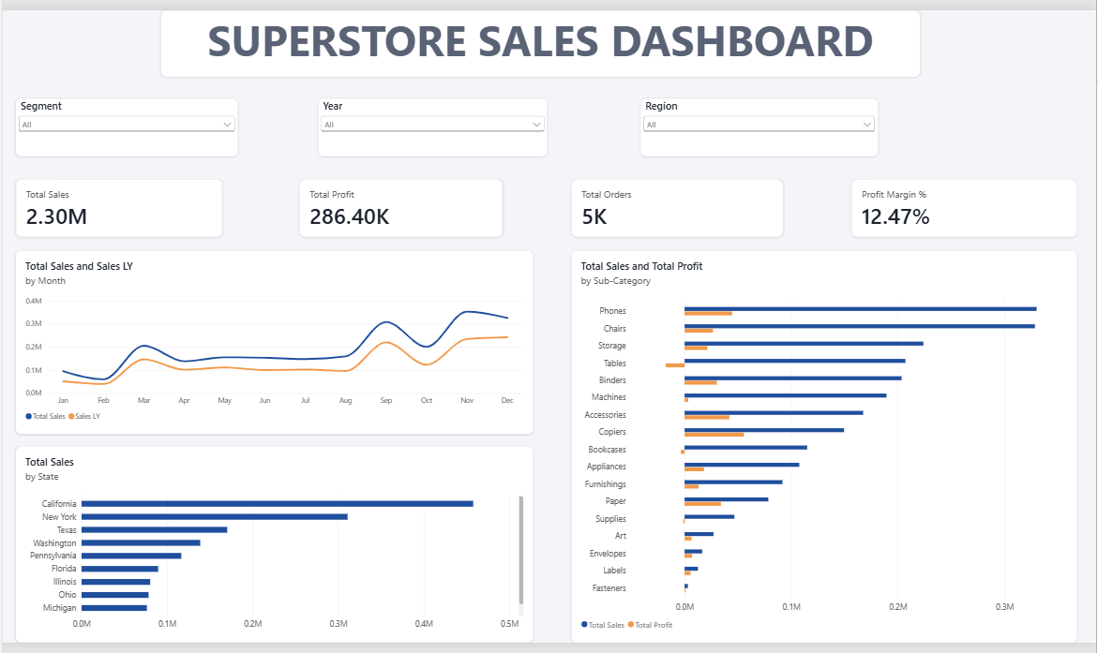
Figure 1: Superstore Sales Dashboard (all years, all regions, all segments)

Dashboard components
Component | Fields used | What it shows
Slicers (3) | Segment, Year, Region | Filter every visual on the page at once
KPI cards (4) | Total Sales, Total Profit, Total Orders, Profit Margin % | Overall business performance at a glance
Line chart | Month, Total Sales, Sales LY | Monthly sales trend and comparison with last year
Bar chart: states | State, Total Sales (Top 10 filter) | The ten states with the highest sales
Bar chart: sub-categories | Category, Sub-Category, Total Sales, Total Profit | Sales and profit side by side for each product group

7. Key findings
With no slicer selected, the dashboard shows the following overall results.
Indicator | Value
Total sales | $2.30 million
Total profit | $286.4 thousand
Profit margin | 12.47%
Total orders | 5,009 (from 9,994 order lines)

Sales growth by year
Year | Sales (USD)
2014 | 484,247
2015 | 470,533
2016 | 609,206
2017 | 733,215

Main observations
- Strong growth in 2017. Sales rose from about $609 thousand in 2016 to about $733 thousand in 2017, an increase of roughly 20 percent, after a small dip in 2015.
- Sales peak in the last quarter. November ($352 thousand) and December ($325 thousand) are the two strongest months, with September ($308 thousand) next. This points to seasonal demand.
- California leads by a wide margin. California records about $458 thousand in sales (around 20 percent of the total), followed by New York ($311 thousand) and Texas ($170 thousand).
- West and East earn most of the profit. The West ($108 thousand) and East ($92 thousand) together produce about 70 percent of total profit, while the Central region is the weakest at $40 thousand.
- Three sub-categories lose money. Tables (-$17.7 thousand), Bookcases (-$3.5 thousand) and Supplies (-$1.2 thousand) have negative profit. The most profitable are Copiers ($55.6 thousand), Phones ($44.5 thousand) and Accessories ($41.9 thousand).
- Discounts explain most losses. Of the 1,871 order lines that lost money, 72 percent carried a discount of 30 percent or more.

8. Recommendations
- Limit deep discounts. Cap discounts below 30 percent, especially on Tables and Bookcases, where heavy discounting turns sales into losses.
- Review pricing and costs. Re-check prices and supplier costs for Tables, Bookcases and Supplies.
- Prepare for the fourth quarter. Plan stock, staffing and promotions ahead of September to December.
- Invest where profit is strongest. Focus marketing on California, New York and the West and East regions, and study why the Central region earns less.
- Promote high-profit products. Give more visibility to Copiers, Phones and Accessories, which combine strong sales with healthy profit.

9. Limitations
- The data covers only 2014 to 2017 and comes from a sample store, so the results may not describe a real business today.
- With all years selected, the Sales LY line compares each month with the same month a year earlier across the whole dataset. A single year should be chosen for a clean year-on-year view.
- States are shown in a bar chart instead of a map, because the bar chart ranks them more clearly.
- The dataset has no cost fields beyond Profit, so deeper margin analysis is not possible.

10. Conclusion
The Superstore Sales Dashboard turns a 9,994-row transaction file into a single, interactive page. It shows that the business is growing, that sales are concentrated in the fourth quarter and in a few states, and that profit is mainly lost through heavy discounting on a small number of sub-categories. These findings support clear actions: control discounts, review the weakest products, and prepare for seasonal peaks.

