GEOSEG: A FULL-STACK EARTH OBSERVATION AND GEOSPATIAL AI PLATFORM FOR MULTISPECTRAL LAND-COVER SEGMENTATION
A PROJECT REPORT
Submitted by
YAJAT KATARIA (25BCE10191)
ANUSHKA MATHUR (25BCE10039)
GAURAV JAIN (25BCE11422)
TANISHA (25BCE10578)
SANIDHYA WABHITKAR (25BCE10355)
in partial fulfillment for the award of the degree
of
BACHELOR OF TECHNOLOGY
in
COMPUTER SCIENCE AND ENGINEERING

SCHOOL OF COMPUTING SCIENCE AND ENGINEERING
VIT BHOPAL UNIVERSITY
KOTHRIKALAN, SEHORE
MADHYA PRADESH - 466114
October 2026

VIT BHOPAL UNIVERSITY, KOTHRIKALAN, SEHORE
MADHYA PRADESH - 466114
BONAFIDE CERTIFICATE
Certified that this project report titled “GEOSEG: A Full-Stack Earth Observation and Geospatial AI Platform for Multispectral Land-Cover Segmentation” is the bonafide work of “YAJAT KATARIA (Register No: 25BCE10191), ANUSHKA MATHUR (Register No: 25BCE10039), GAURAV JAIN (Register No: 25BCE11422), TANISHA (Register No: 25BCE10578) and SANIDHYA WABHITKAR (Register No: 25BCE10355)” who carried out the project work under my supervision. Certified further that to the best of my knowledge the work reported at this time does not form part of any other project/research work based on which a degree or award was conferred on an earlier occasion on this or any other candidate.
PROGRAM CHAIR | PROJECT GUIDE
Dr. Vikas Panthi | Dr. Rajneesh Kumar Patel, Assistant Professor
School of Computing Science and Engineering | School of Computing Science and Engineering
VIT BHOPAL UNIVERSITY | VIT BHOPAL UNIVERSITY

The Project Exhibition I Examination is held on 8/10/2026
ACKNOWLEDGEMENT
First and foremost we would like to thank the Lord Almighty for His presence and immense blessings throughout the project work.
We wish to express our heartfelt gratitude to Dr. Dheresh Soni, Head of the Department, School of Computing Science and Engineering, for his valuable support and encouragement in carrying out this work.
We would like to thank our internal guide Dr. Rajneesh Kumar Patel, for continually guiding and actively participating in our project, giving valuable suggestions to complete the project work.
We would like to thank all the technical and teaching staff of the School of Computing Science and Engineering, who extended directly or indirectly all support.
Last, but not least, we are deeply indebted to our parents who have been the greatest support while we worked day and night for the project to make it a success.
LIST OF ABBREVIATIONS
Symbols and Nomenclature
Term | Meaning
C, H, W | Number of channels, height and width of an image tensor
K | Number of land-cover classes
ε | Small constant (10⁻⁶) added to index denominators to avoid division by zero
W_{pre}, W_{new} | Pretrained (3-channel) and expanded (16-channel) first-convolution weights
S | Tile size in pixels (512)
O | Tile overlap in pixels (32)
w_{1D}(x) | One-dimensional linear feather ramp
W_{2D} | Two-dimensional feather weight matrix (outer product of w_{1D})
P_{k} | Softmax probability map of tile k
w_{k}, f_{k} | Class weight and class pixel frequency in weighted cross-entropy
α, β | Tversky loss penalties for false positives and false negatives
λ | Weight-decay coefficient of AdamW
η_{max}, η_{min} | Maximum and minimum learning rate of cosine annealing
T_{max} | Period (in epochs) of the cosine-annealing schedule

Abbreviations
Term | Meaning
AMP | Automatic Mixed Precision
AOI | Area of Interest
API | Application Programming Interface
ASGI | Asynchronous Server Gateway Interface
CNN | Convolutional Neural Network
CORS | Cross-Origin Resource Sharing
CPU | Central Processing Unit
CRS | Coordinate Reference System
CUDA | Compute Unified Device Architecture
EO | Earth Observation
ESA | European Space Agency
FCN | Fully Convolutional Network
GDAL | Geospatial Data Abstraction Library
GIS | Geographic Information System
GPU | Graphics Processing Unit
IGBP | International Geosphere-Biosphere Programme
IoU | Intersection over Union
mIoU | Mean Intersection over Union
JSON | JavaScript Object Notation
L2A | Level-2A (bottom-of-atmosphere reflectance product)
MSI | MultiSpectral Instrument
NDBI | Normalized Difference Built-up Index
NDVI | Normalized Difference Vegetation Index
NDWI | Normalized Difference Water Index
NIR | Near-Infrared
OOM | Out of Memory
OOP | Object-Oriented Programming
PSNR | Peak Signal-to-Noise Ratio
PSISRNet | Progressive Super-resolution Network
RAII | Resource Acquisition Is Initialization
REST | Representational State Transfer
RGB | Red, Green, Blue
SIMD | Single Instruction, Multiple Data
SPA | Single-Page Application
SR | Super-Resolution
SSIM | Structural Similarity Index Measure
SWIR | Shortwave Infrared
UBCF | Upscaling Block with Correlation Filter
UI | User Interface
YAML | YAML Ain't Markup Language

LIST OF FIGURES AND GRAPHS
FIGURE NO. | TITLE | PAGE NO.
4.1 | End-to-end inference workflow of GEOSEG | 14
4.2 | Overlapping 512 × 512 tiles with a 32 px overlap | 17
4.3 | Feather weights computed from the formula for S = 512 and O = 32 | 17
4.4 | Layered software architecture of GEOSEG | 18
5.1 | PSISRNet PSNR and SSIM at 2×, 4× and 8× (local run) | 29
LIST OF TABLES
TABLE NO. | TITLE | PAGE NO.
2.1 | Comparison of existing approaches | 6
3.1 | Environment prerequisites | 7
3.2 | Languages and tools | 8
3.3 | Libraries and frameworks | 8
3.4 | Datasets used in the four phases | 9
3.5 | Sentinel-2 bands used in GEOSEG | 9
3.6 | Spectral indices appended to the 13 bands | 10
3.7 | Class schemes | 10
4.1 | The four-phase methodology | 13
4.2 | Loss functions | 16
4.3 | Architecture layers and repository elements | 19
4.4 | C++ engine files | 20
4.5 | Object-oriented paradigms demonstrated in the engine | 20
4.6 | REST endpoints | 21
4.7 | Frontend components | 23
5.1 | Per-phase configuration (configs/) | 24
5.2 | Working of the user-interface pages | 26
5.3 | Prototype deliverables | 26
5.4 | Test and validation measures | 27
5.5 | Results recorded in the project documentation | 28
5.6 | PSISRNet super-resolution (local run) | 28
5.7 | Short comparison run (local) | 29
6.1 | Objectives and outcomes | 31
7.1 | SWOT analysis | 34
ABSTRACT
Purpose. Accurate, frequently updated land-cover maps are needed for environmental monitoring and urban planning, but manual mapping does not scale, RGB imagery cannot separate many surface types, and one Sentinel-2 scene is too large for a GPU. GEOSEG is a full-stack Earth Observation platform that produces pixel-level land-cover maps from multispectral imagery.
Methodology. A U-Net with a ResNet-34 encoder takes 16 channels: the 13 Sentinel-2 L2A bands plus NDVI, NDWI and NDBI. The pretrained first convolution is expanded from 3 to 16 channels by scaling averaged RGB filters by 3/16. Scenes are processed as overlapping 512 × 512 tiles merged by 2D feather blending into a GeoTIFF, and data are split by scene to prevent leakage. A C++17 engine, FastAPI service and React/Leaflet interface complete the platform.
Findings. The system reached accuracy above 93% (Phase 1), mIoU above 0.52 (Phase 2, RGB) and above 0.74 (Phase 3, 16 channels), with tiled inference below 1.5 s per tile. A PSISRNet super-resolution extension reached 26.44, 24.10 and 22.93 dB PSNR at 2×, 4× and 8×. Accuracy on real regions unlike the training scenes remains to be evaluated on held-out data.
TABLE OF CONTENTS
CHAPTER NO. | TITLE | PAGE NO.
 | List of Abbreviations | iii
 | List of Figures and Graphs | v
 | List of Tables | vi
 | Abstract | vii
1 | CHAPTER-1:  PROJECT DESCRIPTION AND OUTLINE | 1
 | 1.1 Introduction | 1
 | 1.2 Motivation for the Work | 1
 | 1.3 About the Project and Techniques Used | 2
 | 1.4 Problem Statement | 2
 | 1.5 Objective of the Work | 3
 | 1.6 Organization of the Project | 3
 | 1.7 Summary | 3
2 | CHAPTER-2:  RELATED WORK INVESTIGATION | 4
 | 2.1 Introduction | 4
 | 2.2 Core Area of the Project | 4
 | 2.3 Existing Approaches and Methods | 4
 | 2.3.1 Spectral indices and threshold-based mapping | 4
 | 2.3.2 Classical machine learning on spectral features | 5
 | 2.3.3 Deep convolutional networks for classification and segmentation | 5
 | 2.3.4 Super-resolution of satellite imagery | 5
 | 2.4 Pros and Cons of the Stated Approaches | 6
 | 2.5 Issues and Observations from the Investigation | 6
 | 2.6 Summary | 6
3 | CHAPTER-3:  REQUIREMENT ARTIFACTS | 7
 | 3.1 Introduction | 7
 | 3.2 Hardware and Software Requirements | 7
 | 3.3 Specific Project Requirements | 8
 | 3.3.1 Data requirement | 8
 | 3.3.2 Functions requirement | 10
 | 3.3.3 Performance and security requirement | 11
 | 3.3.4 Look and feel requirements | 11
 | 3.4 Summary | 12
4 | CHAPTER-4:  DESIGN METHODOLOGY AND ITS NOVELTY | 13
 | 4.1 Methodology and Goal | 13
 | 4.2 Functional Modules Design and Analysis | 14
 | 4.2.1 Reflectance scaling and spectral-index module | 14
 | 4.2.2 Segmentation model: U-Net with a ResNet-34 encoder | 15
 | 4.2.3 Pretrained weight expansion (3 → 16 channels) | 15
 | 4.2.4 Loss functions for class imbalance | 15
 | 4.2.5 Optimisation and training stability | 16
 | 4.2.6 Sliding-window tiling and 2D feather blending | 16
 | 4.2.7 Preventing spatial leakage | 17
 | 4.2.8 Super-resolution extension (PSISRNet) | 18
 | 4.3 Software Architectural Designs | 18
 | 4.4 Subsystem Services | 19
 | 4.4.1 Native C++17 engine (backend/) | 19
 | 4.4.2 REST service (api/) | 21
 | 4.5 User Interface Designs | 22
 | 4.6 Summary | 23
5 | CHAPTER-5:  TECHNICAL IMPLEMENTATIONS AND ANALYSIS | 24
 | 5.1 Outline | 24
 | 5.2 Technical Coding and Code Solutions | 24
 | 5.3 Working Layout of Forms | 25
 | 5.4 Prototype Submission | 26
 | 5.5 Test and Validation | 26
 | 5.6 Performance Analysis (Graphs/Charts) | 27
 | 5.7 Summary | 30
6 | CHAPTER-6:  PROJECT OUTCOME AND APPLICABILITY | 31
 | 6.1 Outline | 31
 | 6.2 Key Implementation Outlines of the System | 31
 | 6.3 Significant Project Outcomes | 31
 | 6.4 Project Applicability on Real-World Applications | 32
 | 6.5 Inference | 32
7 | CHAPTER-7:  CONCLUSIONS AND RECOMMENDATION | 33
 | 7.1 Outline | 33
 | 7.2 Limitations and Constraints of the System | 33
 | 7.3 Future Enhancements | 34
 | 7.4 Inference | 34
 | REFERENCES | 36
 | APPENDIX A: INSTALLATION, CONFIGURATION AND EXECUTION | 38
 | A.1 Setup | 38
 | A.2 Run | 38
 | APPENDIX B: VIVA QUESTIONS AND ANSWERS | 39

CHAPTER-1:
PROJECT DESCRIPTION AND OUTLINE

1.1 Introduction
Earth Observation (EO) uses satellite and airborne sensors to record the surface of the Earth. Multispectral sensors measure reflected energy in several wavelength bands, so materials that look alike in an ordinary colour photograph, for example a green golf course and dense forest, can have clearly different reflectance in the near-infrared (NIR) and shortwave-infrared (SWIR) bands. These measurements are the raw material for land-cover mapping, which assigns every pixel of a scene to a class such as forest, cropland, water or built-up area.
GEOSEG is a full-stack EO and geospatial AI platform for pixel-level land-cover classification of multispectral satellite imagery. It combines a PyTorch segmentation pipeline, a native C++17 image-processing engine, a FastAPI service layer and a React/Leaflet web interface in a single repository [1]. The core model is a U-Net with a ResNet-34 encoder that ingests 16 channels (the 13 optical bands of Sentinel-2 plus three derived spectral indices) and predicts 11 simplified IGBP land-cover classes for each pixel.

1.2 Motivation for the Work
Urban expansion, deforestation, water scarcity, changing agricultural patterns and climate change all demand frequently updated, high-resolution maps of land cover. Environmental scientists, urban planners and governments need these maps to be pixel-level and current. Hand-drawn cartography cannot keep pace with changes across the Earth's land area, and a single satellite acquisition produces gigabytes of data that cannot be handled by a conventional deep-learning workflow without special treatment.
The project is also motivated by Indian civic and environmental use cases. The map interface of GEOSEG ships with area-of-interest presets such as Bhopal Upper Lake, New Delhi, the Kerala wetlands and the Sundarbans, so that students and analysts can explore their own region of interest directly from a browser.

1.3 About the Project and Techniques Used
GEOSEG is built around four technical ideas, each of which is described in detail in later chapters:
- 16-channel multispectral fusion. All 13 Sentinel-2 L2A bands are combined with NDVI, NDWI and NDBI so that the network can use information outside the visible spectrum.
- Pretrained weight expansion. ImageNet weights exist only for 3-channel input. GEOSEG expands the first convolution of the pretrained ResNet-34 from 3 to 16 channels by averaging the RGB filters, replicating them across channels and scaling by 3/16, which keeps the learned edge and texture filters and preserves activation variance.
- Sliding-window tiling with 2D feather blending. Large scenes are cut into overlapping 512 × 512 tiles (32 px overlap), processed in batches, and reassembled with distance-weighted blending to suppress seams at tile borders.
- Scene-level data splitting. Patches are grouped by geographic scene before the train/validation split so that spatially autocorrelated neighbours cannot leak between the two sets.
Around the model, the platform provides a C++17 engine (generic image container, band mathematics, tile manager and GeoTIFF handler exposed to Python through pybind11), a FastAPI REST service for training, inference, AOI export and result browsing, and a React 18 + TypeScript + Vite + Leaflet web application. The system was developed in four test-driven phases: an EuroSAT 13-band sanity-check classifier, a DeepGlobe RGB U-Net, a 16-channel multispectral U-Net on SEN12MS, and large-area sliding-window inference over Google Earth Engine AOI exports. The project additionally includes a PSISRNet super-resolution module (2×, 4× and 8×), which is treated in this report as a secondary extension [2].

1.4 Problem Statement
- Manual mapping does not scale. Hand-drawn maps or simple thresholds cannot keep up with frequently changing land cover over the Earth's land area.
- RGB alone is ambiguous. Three visible bands cannot separate many surface types that have similar colour.
- Scenes are very large. A 100 km × 100 km scene at 10 m resolution is about 10,000 × 10,000 pixels × 13 bands (roughly 2.6 GB as 16-bit integers). Feeding it whole into a GPU causes out-of-memory failures, and down-sampling it would erase narrow features such as roads.

1.5 Objective of the Work
- Classify land cover per pixel using all Sentinel-2 bands plus derived spectral indices.
- Reuse ImageNet-pretrained encoders for 16-channel input without discarding the pretrained filters.
- Handle gigapixel scenes through overlapping tiling and seam-free blending.
- Avoid inflated accuracy by splitting data at scene level rather than patch level.
- Provide a native C++ engine for band mathematics and tile management, exposed to Python through pybind11.
- Expose training, inference, AOI export and result browsing through REST endpoints, with a browser interface for map exploration and monitoring.

1.6 Organization of the Project
The report follows the prescribed seven-chapter structure. Chapter 1 introduces the project, its motivation, problem statement and objectives. Chapter 2 reviews related work in spectral indices, machine learning and deep learning for land-cover mapping. Chapter 3 lists the hardware, software, data, functional, performance, security and interface requirements. Chapter 4 presents the design methodology and its novelty, including the functional modules, architecture, subsystem services and user interface. Chapter 5 describes the technical implementation, tests and performance analysis. Chapter 6 summarises the project outcome and its applicability. Chapter 7 gives the conclusions, limitations and recommendations for future work. References and appendices follow the last chapter.

1.7 Summary
This chapter introduced GEOSEG as an end-to-end platform for multispectral land-cover segmentation, explained why such a platform is needed, and stated the problem and objectives that drive the design described in the remaining chapters.

CHAPTER-2:
RELATED WORK INVESTIGATION

2.1 Introduction
This chapter surveys the techniques that precede and underpin GEOSEG: spectral indices and threshold-based mapping, classical machine learning on spectral features, deep convolutional networks for scene classification and semantic segmentation, and learning-based super-resolution. The aim is to identify the strengths and weaknesses of each approach and the gaps that GEOSEG addresses.

2.2 Core Area of the Project
The core area of the project is semantic segmentation of multispectral satellite imagery. Semantic segmentation maps an input tensor of shape C × H × W to a class label for every pixel; in GEOSEG C = 16 and the number of classes is K = 11. The imagery comes from the European Space Agency's Sentinel-2 mission [3]. The twin satellites (2A and 2B) fly in a sun-synchronous orbit at about 786 km, carry the MultiSpectral Instrument (MSI) with a 290 km swath, and give a revisit time of about 5 days at the equator. The bands have 10 m, 20 m or 60 m ground resolution.
GEOSEG uses Level-2A products, which are bottom-of-atmosphere surface reflectance after atmospheric correction, stored as integers scaled by 10,000. Level-1C data are top-of-atmosphere reflectance and still include haze and scattering. Using L2A makes the same surface give comparable values across dates and viewing conditions.

2.3 Existing Approaches and Methods

2.3.1 Spectral indices and threshold-based mapping
Normalised-difference indices combine two bands so that a physical property dominates the result. NDVI uses the contrast between NIR and red reflectance to highlight vegetation [4]; NDWI contrasts green and NIR to delineate open water [5]; and NDBI contrasts SWIR and NIR to map built-up land [6]. Thresholding such an index is simple and cheap, but a single threshold is sensitive to cloud, shadow and local surface conditions, and a single index cannot separate eleven classes.

2.3.2 Classical machine learning on spectral features
Per-pixel classifiers such as random forests [7] learn decision rules from band values and indices. They cope with high-dimensional spectral input and need little data preparation, but they treat each pixel in isolation and therefore ignore the spatial context (shape, texture, neighbourhood) that distinguishes, for example, a road from bare soil.

2.3.3 Deep convolutional networks for classification and segmentation
Deep networks learn spatial and spectral features jointly. The EuroSAT benchmark showed that convolutional networks can classify 13-band Sentinel-2 patches into ten land-use classes [8]. For dense prediction, fully convolutional networks replace the final classifier by convolutions so that every pixel receives a label [9]. The U-Net adds skip connections that concatenate high-resolution encoder features into the decoder, which recovers boundaries such as riverbanks and building edges [10]. Residual blocks compute y = F(x, {W_{i}}) + x, letting gradients flow through the identity shortcut so that very deep encoders such as ResNet-34 can be trained [11]. Other decoders, such as DeepLabv3+ with atrous separable convolutions, are available as alternatives [12]. Public datasets used in this work include SEN12MS [13] and DeepGlobe [14].

2.3.4 Super-resolution of satellite imagery
Super-resolution estimates a sharper image from a low-resolution one. Convolutional approaches such as SRCNN [15] learn this mapping end to end. PSISRNet, the super-resolution module of this project, follows the published method of Sharma et al. [2]: cascaded Upscaling Blocks with Correlation Filter (UBCF) stages move through 2×, 4× and 8× scales, dilated convolutions widen the receptive field, a Pearson correlation filter models feature correlation, and PixelShuffle performs the final sub-pixel upscaling. Super-resolution and segmentation are separate tasks: an enhanced image is not a land-cover map.

2.4 Pros and Cons of the Stated Approaches
Table 2.1: Comparison of existing approaches
Approach | Advantages | Limitations
Spectral-index thresholds | Simple, fast and physically interpretable | Sensitive to cloud and shadow; one index cannot separate many classes
Per-pixel classical ML | Handles many bands; modest compute | Ignores spatial context; needs engineered features
CNN scene classifiers | Strong accuracy on patch classification | One label per patch; no pixel-level map
Encoder-decoder segmentation (U-Net) | Pixel-level output; skip connections preserve boundaries | Pretrained encoders expect 3 channels; large scenes exceed GPU memory
Learning-based super-resolution | Sharper imagery for inspection | Estimates detail that was not captured; does not assign classes

2.5 Issues and Observations from the Investigation
- Pretrained encoders are trained on RGB images, so using all 13 Sentinel-2 bands plus indices needs a principled way to expand the first convolution without destroying the pretrained filters.
- Neighbouring satellite patches are strongly spatially autocorrelated, so random patch shuffling can leak the landscape between training and validation sets and report accuracy that collapses on a new region.
- Land cover is heavily imbalanced: forest and grassland can exceed 70% of pixels, while water, wetland, snow and barren classes are rare, so plain cross-entropy can reach high pixel accuracy by predicting the dominant class everywhere.
- Whole scenes cannot be processed at once, and naive tile pasting leaves visible grid seams because convolutions near a tile border see only partial context.
- Research code is often a single script; a usable platform needs a service layer, a native engine for heavy raster operations and an interface for non-programmers.

2.6 Summary
The survey shows that each existing family of methods solves part of the problem. GEOSEG combines their strengths: spectral indices as additional input features, a pretrained U-Net for spatial context, scene-level splitting and compound losses to avoid misleading accuracy, and tiling with feather blending to scale to full scenes.

CHAPTER-3:
REQUIREMENT ARTIFACTS

3.1 Introduction
This chapter lists what GEOSEG needs in order to be built and run: the hardware and software environment, the data it consumes, and the functional, performance, security and interface requirements derived from the objectives in Chapter 1.

3.2 Hardware and Software Requirements
The prerequisites for building and running GEOSEG are given in Table 3.1. An NVIDIA GPU is optional but recommended; the local comparison runs reported in Chapter 5 used an NVIDIA RTX 5050 laptop GPU. Whole-scene processing is infeasible without tiling because a 10,000 × 10,000 × 16 float32 tensor is about 6.4 GB before any network activations.
Table 3.1: Environment prerequisites
Component | Requirement
Python | 3.10 or 3.11
Node.js | 18 or 20 LTS
CMake | 3.16 or newer
C++ compiler | MSVC (Visual Studio 2022) on Windows or GCC 9+ on Linux; C++17 standard
GPU (optional) | NVIDIA GPU with CUDA 11.8 or 12.x

Table 3.2 lists the languages and tools, and Table 3.3 the libraries and frameworks used. Exact package versions are recorded in requirements.txt, setup.py and package.json of the repository.
Table 3.2: Languages and tools
Language / tool | Role in GEOSEG
Python | ML models, data pipelines, training and inference orchestration, REST API, utility scripts
C++17 | Native engine: generic Image<T> container, band maths, tile manager, GeoTIFF handling
TypeScript / React | Frontend pages and components; typed API client
YAML | Per-phase model, dataset, training and inference configuration
CMake | Cross-platform C++ build (MSVC, GCC, Clang); optional pybind11 bindings
Shell / command line | Environment setup, training and inference commands, server launch

Table 3.3: Libraries and frameworks
Library / framework | Purpose
PyTorch, torchmetrics | Tensor computation, training, mixed precision; multiclass Jaccard (IoU) metrics
TorchGeo | EuroSAT and SEN12MS dataset access
segmentation_models_pytorch | U-Net, DeepLabV3+, FPN and PSPNet builders with ResNet / EfficientNet encoders
Kornia | GPU spatial augmentation (flips, rotation)
rasterio / GDAL | GeoTIFF reading and windowed access, CRS and transform handling
TensorBoard, matplotlib | Training logs; thread-safe preview PNG generation
Google Earth Engine API | Sentinel-2 L2A median-composite export for AOIs
FastAPI, Pydantic v2, Uvicorn | Asynchronous REST API, validation schemas, ASGI server
React 18, Vite, Leaflet | SPA framework, dev server and API proxy, interactive GIS map
Tailwind CSS v4 | Utility-first styling of the web interface
pybind11 | C++ ↔ Python bridge for BandMathEngine, TileManager and BoundingBox
pytest | Automated tests

3.3 Specific Project Requirements

3.3.1 Data requirement
GEOSEG consumes Sentinel-2 L2A reflectance with all 13 optical bands in the order B01, B02, B03, B04, B05, B06, B07, B08, B8A, B09, B10, B11, B12. Table 3.4 gives the datasets used in each phase.
Table 3.4: Datasets used in the four phases
Dataset | Phase | Details
EuroSAT (TorchGeo) | 1 | 13-band Sentinel-2 patches, 10 classes; 80/20 train/validation split; batch size 64
DeepGlobe Land Cover | 2 | RGB, 7 classes; 24-bit RGB masks mapped to class indices; hard-class window miner crops 512 × 512 patches rich in rare classes (water, rangeland); image and mask augmented jointly
SEN12MS (TorchGeo) | 3 | 13-band Sentinel-2 with IGBP labels remapped to 11 classes; scene-level split; a synthetic SEN12MS generator exists for offline runs
Earth Engine AOIs | 4 | export_aoi.py builds a cloud-filtered (≤ 10%) Sentinel-2 L2A median composite for a bounding box and date range; the API falls back to a synthetic 13-band GeoTIFF if Earth Engine is not authenticated

Results measured on synthetic data must be labelled as such and must not be presented as real-world land-cover accuracy. Table 3.5 lists the Sentinel-2 bands and their main use, and Table 3.6 the spectral indices.
Table 3.5: Sentinel-2 bands used in GEOSEG
Band | Centre λ | Res. | Main use in GEOSEG
B01 | 443 nm | 60 m | Coastal aerosol correction, bathymetry
B02 | 490 nm | 10 m | Blue; soil vs vegetation, snow cover
B03 | 560 nm | 10 m | Green; peak vegetation reflectance; NDWI numerator
B04 | 665 nm | 10 m | Red; chlorophyll absorption; NDVI denominator term
B05 | 705 nm | 20 m | Red Edge 1; early vegetation stress, crop classification
B06 | 740 nm | 20 m | Red Edge 2; leaf area index estimation
B07 | 783 nm | 20 m | Red Edge 3; canopy chlorophyll content
B08 | 842 nm | 10 m | Broad NIR; biomass and land-water boundary
B8A | 865 nm | 20 m | Narrow NIR; biomass calibration
B09 | 945 nm | 60 m | Water-vapour absorption
B10 | 1375 nm | 60 m | Shortwave cirrus; thin high cloud mask
B11 | 1610 nm | 20 m | SWIR 1; moisture and built-up surfaces (NDBI)
B12 | 2190 nm | 20 m | SWIR 2; soil mineralogy, burn scars

Table 3.6: Spectral indices appended to the 13 bands
Index | Formula (ε = 10⁻⁶) | Interpretation
NDVI | (B08 − B04) / (B08 + B04 + ε) | Vegetation: healthy canopy reflects strongly in NIR and absorbs red
NDWI | (B03 − B08) / (B03 + B08 + ε) | Water: water absorbs NIR, so clear lakes give high positive values and forest canopy gives negative values
NDBI | (B11 − B08) / (B11 + B08 + ε) | Built-up surfaces: concrete and asphalt reflect more in SWIR than NIR

The constant ε is added to every denominator because, in cloud shadow or at sensor dropouts, NIR and red can both be zero; a 0/0 division gives NaN, which would propagate through the backward pass and destroy the weights. Table 3.7 gives the two class schemes.
Table 3.7: Class schemes
Dataset / phase | Classes
DeepGlobe (Phase 2), 7 classes | Urban, Agriculture, Rangeland, Forest, Water, Barren, Unknown (index 6, ignored in loss and metrics)
SEN12MS / simplified IGBP (Phases 3 and 4), 11 classes | 0 Background / no-data; 1 Forest; 2 Shrubland; 3 Savanna; 4 Grassland; 5 Wetlands; 6 Croplands; 7 Urban / built-up; 8 Snow / ice; 9 Barren / soil; 10 Water

The SEN12MS loader remaps the 17 raw IGBP classes to these 11 using the IGBP_TO_SIMPLIFIED lookup. Data preparation checks require that the bands exist in order and that the file has 13 bands before indices are appended; that dimensions, data types, nodata values, CRS and geotransform of GeoTIFF inputs are checked; that masks use the intended class encoding; that the same reflectance scaling is applied in training and inference; and that scenes, not patches, stay intact within one split.

3.3.2 Functions requirement
1. Classify each pixel of a multispectral scene into one of the defined land-cover classes using 13 bands plus NDVI, NDWI and NDBI.
2. Train models phase by phase from YAML configuration files, from the command line or from the web interface, with live loss, accuracy and mIoU reporting.
3. Run tiled inference on large GeoTIFF files and write a GeoTIFF with the source CRS and affine transform, plus preview images.
4. Export a Sentinel-2 L2A composite for a user-drawn bounding box through Google Earth Engine.
5. Perform band mathematics and tile management in a native C++17 engine and expose it to Python.
6. Offer REST endpoints for health check, training control, inference jobs, result listing and download, checkpoint listing, AOI export and a C++ benchmark.
7. Provide a browser interface for training, inference, AOI selection, C++ demonstration and results browsing.

3.3.3 Performance and security requirement
- Throughput: Phase 4 inference targets less than 1.5 s per tile; the C++ engine is documented to give a 4.8× speed-up over NumPy sliding-window tiling [1].
- Memory: inference must work on scenes larger than GPU memory by tiling (512 × 512, 32 px overlap) and batching.
- Responsiveness: long jobs are asynchronous; prediction returns a pending job ticket immediately and the frontend polls the result endpoint every 2 seconds.
- Reproducibility: a fixed seed (42) seeds random, NumPy and PyTorch (CPU and CUDA); configurations are validated before the model is built.
- Input safety: uploads are limited to .tif/.tiff files of at most 100 MB; checkpoint and download paths are checked against path traversal; bounding boxes are validated (−180 ≤ west < east ≤ 180, −90 ≤ south < north ≤ 90) and date ranges must be ordered.
- Cross-origin access: CORS is enabled for the Vite development ports (5173, 3000). The API has no authentication, so hosted deployments would need authentication, quotas and timeouts.

3.3.4 Look and feel requirements
The interface is a single-page application with a home page that shows the pipeline overview, Sentinel-2 band reference cards and headline statistics; a training page with phase tabs, hyper-parameter controls and live convergence curves; an inference page with GeoTIFF drag-and-drop upload; a Leaflet map with four base layers (Google Satellite, ISRO Bhuvan WMS, Esri World Imagery, OpenStreetMap) and drag-to-draw bounding boxes; a C++ engine demonstration page; and a results page with download links.

3.4 Summary
The requirements combine a modest software stack with demanding data handling: 13-band input, indices, scene-level splits, tiling and georeferenced output, together with a safe and responsive service layer.

CHAPTER-4:
DESIGN METHODOLOGY AND ITS NOVELTY

4.1 Methodology and Goal
The goal of the design is to turn multispectral Sentinel-2 imagery into a georeferenced land-cover map of arbitrary size, with a platform around the model that makes training, inference and inspection repeatable. To ensure that each stage verifies the previous one before more complexity is added, GEOSEG was developed in four sequential, test-driven phases (Table 4.1). Figure 4.1 shows the end-to-end inference workflow that results.
Table 4.1: The four-phase methodology
Phase | Goal | Dataset | Model | Channels → classes | Result reported
1 | Verify 13-band ingestion | EuroSAT | SimpleCNN (3-stage ConvNet) | 13 → 10 | Accuracy > 93%
2 | Prove pixel-level U-Net mapping | DeepGlobe Land Cover | U-Net, ResNet-34 | 3 → 7 | mIoU > 0.52
3 | Multispectral fusion with weight expansion | SEN12MS | U-Net, ResNet-34 with 16-channel expansion | 16 → 11 | mIoU > 0.74
4 | Large-area deployment | Google Earth Engine AOIs | Phase 3 checkpoint, tiled inference | 16 → GeoTIFF | < 1.5 s per tile

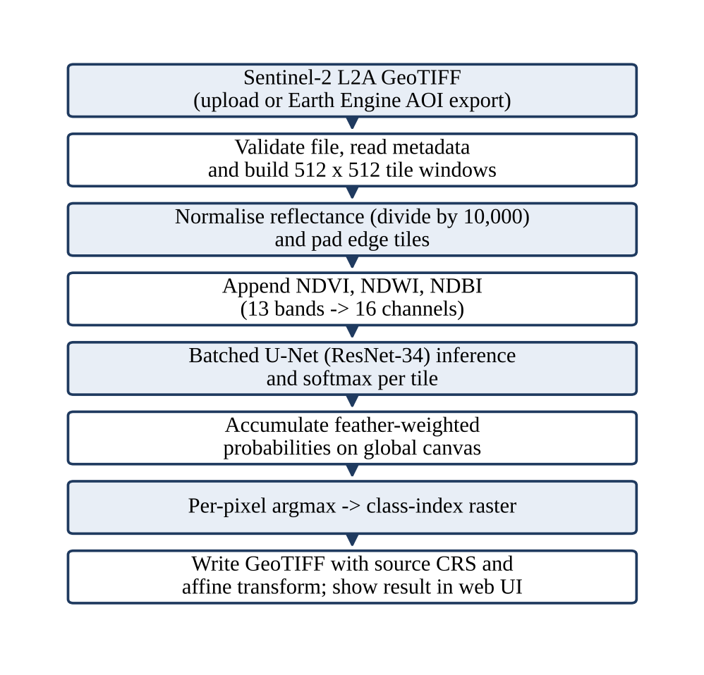
Figure 4.1: End-to-end inference workflow of GEOSEG
The novelty of the design lies in how known components are combined for multispectral data at scale:
- a variance-preserving 3 → 16 channel expansion of ImageNet weights, so that pretrained low-level filters are kept for multispectral input;
- 2D linear feather blending of overlapping tile probabilities, which makes gigapixel scenes tractable without visible seams;
- scene-level (not patch-level) splitting of SEN12MS to prevent spatial leakage and inflated accuracy;
- a compound loss strategy (weighted cross-entropy, Dice and Tversky terms) that targets the extreme class imbalance of land cover;
- a hybrid implementation in which a native C++17 engine and a PyTorch pipeline are exposed through one REST API and one web application.

4.2 Functional Modules Design and Analysis

4.2.1 Reflectance scaling and spectral-index module
Level-2A inputs are divided by 10,000.0 (and clamped to [0, 1] in the normalisation utility) so that values are physical reflectance. NDVI, NDWI and NDBI are then appended as three extra channels using the formulas in Table 3.6, giving the 16-channel tensor. The ε = 10⁻⁶ term protects against 0/0 in shadow or at sensor dropouts. The indices are informative features, not class labels, and are affected by cloud, shadow and local surface conditions.

4.2.2 Segmentation model: U-Net with a ResNet-34 encoder
The model is built through segmentation_models_pytorch [16], which also provides DeepLabV3+, FPN and PSPNet decoders and ResNet-50 or EfficientNet-B2 encoders as alternatives. The encoder downsamples to gain context; the decoder upsamples back to full resolution; skip connections concatenate high-resolution encoder features so that boundaries are recovered [10]. Each residual block of ResNet-34 computes y = F(x, {W_{i}}) + x [11].

4.2.3 Pretrained weight expansion (3 → 16 channels)
ImageNet weights exist only for 3-channel input, and random initialisation of a 16-channel first convolution would discard the pretrained edge, texture and gradient filters. For the first-convolution weights W_{pre} of shape 64 × 3 × 7 × 7, GEOSEG builds W_{new} of shape 64 × 16 × 7 × 7 as follows:
W_avg = (1/3) * sum over k=0..2 of W_pre[:, k, :, :]
W_new[:, c, :, :] = W_avg * (3/16) for every channel c = 0..15
The variance of a convolution's output grows with the number of input channels. Replicating the averaged filter over 16 channels without scaling would multiply the variance by 16/3 ≈ 5.33. Scaling by 3/16 keeps the output variance equal to that of the original 3-channel layer, so the downstream BatchNorm and ReLU layers see familiar statistics. The function expand_first_conv() in src/models/channel_expand.py replaces the first Conv2d with a new Conv2d(16, 64, kernel 7, stride 2, padding 3, bias off).

4.2.4 Loss functions for class imbalance
Forest and grassland can exceed 70% of pixels, while water, wetland, snow and barren classes are rare. A network trained with plain cross-entropy can reach high pixel accuracy by predicting the dominant class everywhere, so GEOSEG combines several losses built by build_loss_function() (Table 4.2). Dice-based losses follow the overlap formulation introduced for segmentation in [17], and the Tversky loss follows [18].
Table 4.2: Loss functions
Loss | Role
Weighted cross-entropy | Per-class weights w_{k} = 1 / log(1.02 + f_{k}), where f_{k} is the class pixel frequency; gives smooth gradients early in training
Soft Dice loss | Optimises overlap per class, independent of class pixel counts; sharpens object boundaries
Tversky loss | Dice generalisation with α penalising false positives and β penalising false negatives; with α = 0.25 and β = 0.75 the model favours recall on thin or rare features such as rivers
dice_ce (Phase 3 default) | L_{Dice} + L_{CE}
tversky_ce (Phase 2) | Tversky + cross-entropy, used for the DeepGlobe configuration

4.2.5 Optimisation and training stability
- AdamW with decoupled weight decay (λ = 10⁻⁴) [19]; SGD is also supported by build_optimizer().
- Cosine annealing learning-rate schedule with T_{max} equal to the number of epochs (η_{max} = 10⁻³ and η_{min} = 10⁻⁶ as an example range).
- Automatic mixed precision (AMP): forward passes run under torch.amp.autocast and a GradScaler scales the loss to avoid FP16 gradient underflow.
- Gradient clipping with max_norm = 1.0 after unscaling.
- Determinism: set_seed(42) seeds random, NumPy and PyTorch (CPU and CUDA).
- Config validation: validate_config() asserts in_channels = len(band_order) + 3 when use_indices is true and checks num_classes before the model is built.
- Checkpoints: model, optimiser and scheduler state are saved; BestModelTracker handles early stopping and seeds its best value on resume so that a better checkpoint is not overwritten.

4.2.6 Sliding-window tiling and 2D feather blending
Tiles of size S = 512 with overlap O = 32 give a stride of S − O = 480; edge tiles are zero-padded and their real sub-window size is recorded (Figure 4.2). Convolutions near a tile border see only partial context, so naively pasting tiles leaves grid seams. GEOSEG therefore weights each tile's prediction with a 2D ramp that is 1 in the core and falls linearly to 0 at the edges (Figure 4.3):
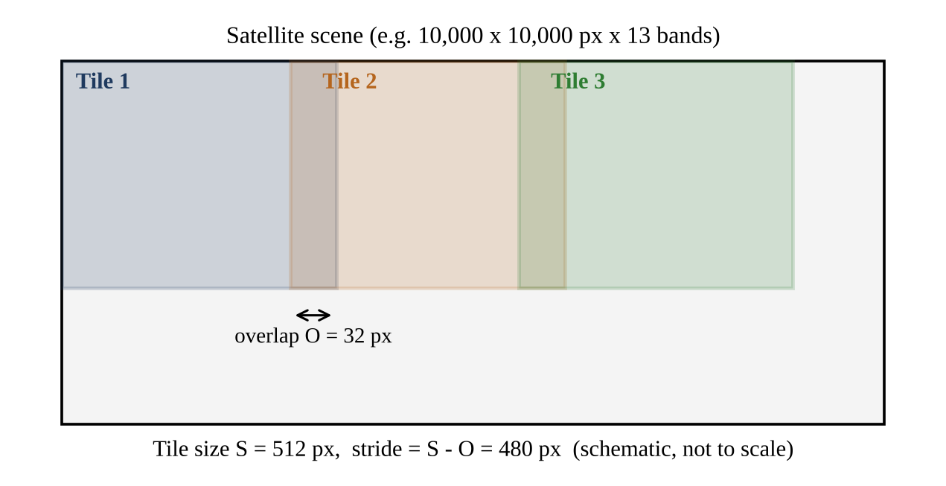
Figure 4.2: Overlapping 512 × 512 tiles with a 32 px overlap
w1D(x) = x/O for 0 <= x < O
1.0 for O <= x <= S-O
(S-x)/O for S-O < x <= S
W2D(y, x) = w1D(y) * w1D(x) # outer product, values in [0,1]

A_prob[:, y:y+S, x:x+S] += P_k * W2D # P_k: softmax of tile k
A_weight[y:y+S, x:x+S] += W2D
Class(y, x) = argmax_c A_prob[c, y, x] / (A_weight[y, x] + 1e-6)
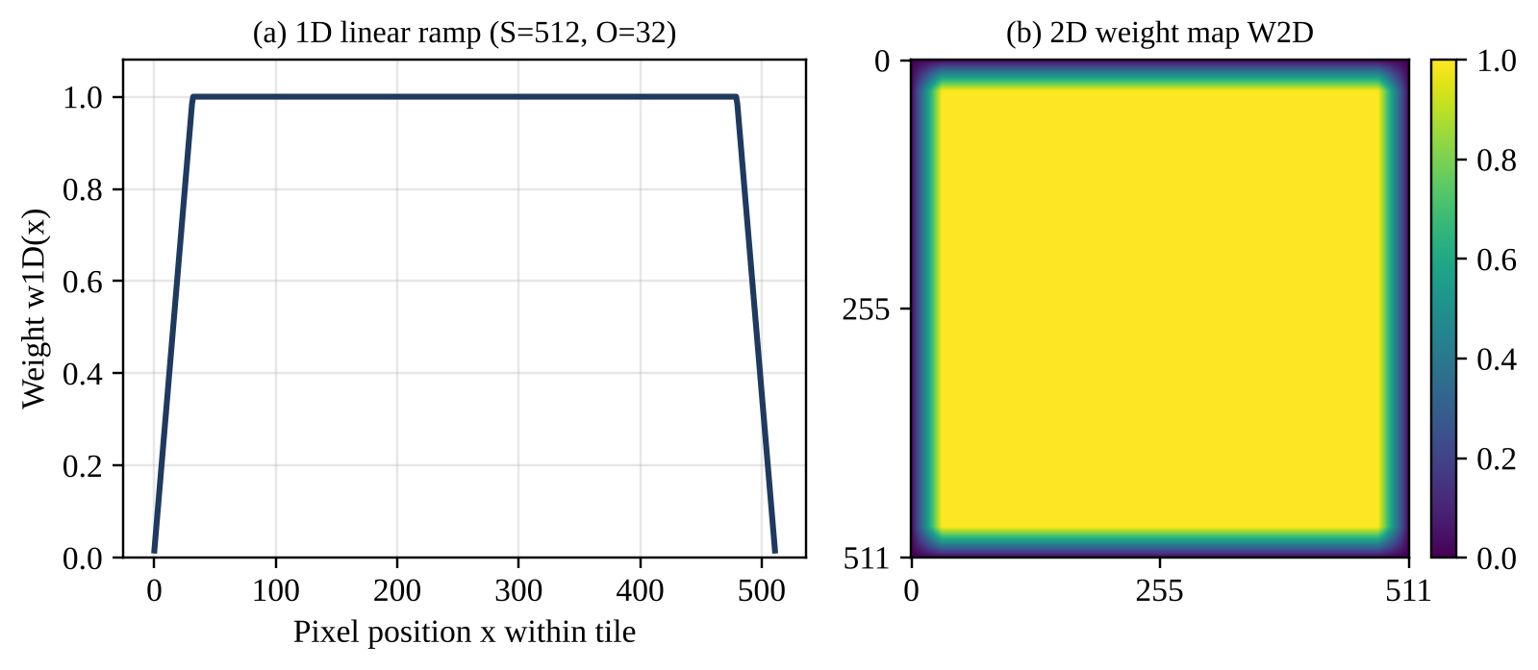
Figure 4.3: Feather weights computed from the formula for S = 512 and O = 32

4.2.7 Preventing spatial leakage
Neighbouring satellite patches are strongly spatially autocorrelated. If one patch is in the training set and its neighbour in the validation set, the network can memorise the landscape and report inflated accuracy that collapses on a new region. src/datasets/sen12ms.py therefore groups patches by geographic scene identifier (pattern ROIs<season>_<scene_id>), shuffles the scenes with a fixed seed, and assigns every patch of a scene entirely to training or entirely to validation (80/20 by scene by default).

4.2.8 Super-resolution extension (PSISRNet)
PSISRNet is a progressive network that moves through 2×, 4× and 8× scales with cascaded UBCF blocks, dilated convolutions, a Pearson correlation filter and PixelShuffle, trained with an adaptive loss that balances MSE and (1 − SSIM) with w = MSE / (MSE + L_{SSIM}) and u = 1 − w [2]. It is a separate task from segmentation and is therefore kept as a secondary component.

4.3 Software Architectural Designs
GEOSEG is organised in six layers from the web interface down to the native engine (Figure 4.4). Table 4.3 summarises what each layer is responsible for and which repository elements implement it.
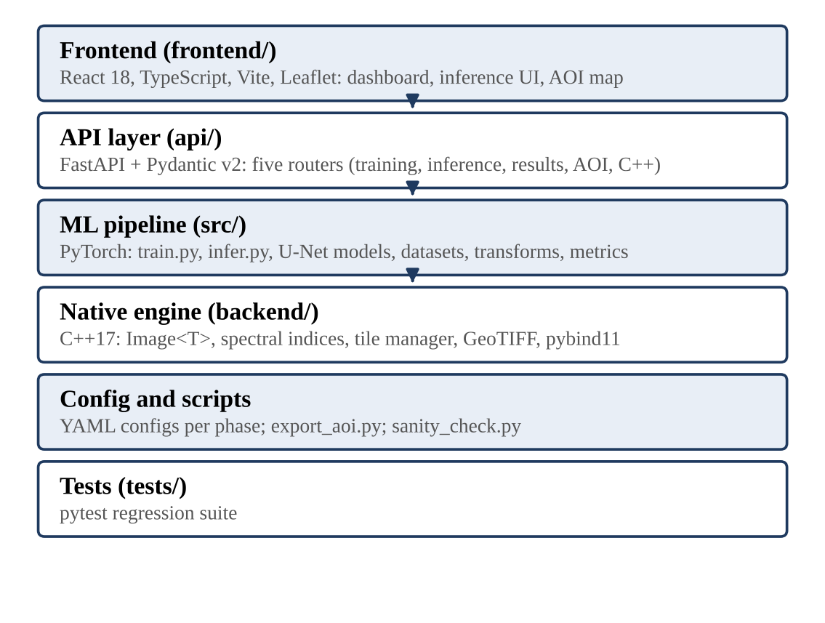
Figure 4.4: Layered software architecture of GEOSEG
Table 4.3: Architecture layers and repository elements
Layer | Main responsibility | Repository elements
Frontend (frontend/) | Interaction and visualisation | React 18, TypeScript, Vite; Leaflet AOI map; training curves; GeoTIFF inference UI; results archive; C++ engine demo page
API (api/) | HTTP interface and job orchestration | FastAPI app (server.py), Pydantic v2 schemas, routers for training, inference, results, AOI export and C++ benchmark
ML pipeline (src/) | Training, inference, datasets, transforms | train.py, infer.py; models (SMP U-Net, SimpleCNN, channel expansion); datasets (EuroSAT, DeepGlobe, SEN12MS, AOI); utils (checkpoints, metrics, logging, visualisation)
Native engine (backend/) | Image and raster operations | C++17 templates, operator overloading, polymorphic spectral indices, RAII GeoTIFF handler, tile manager, pybind11 module, CMake build
Config and scripts | Experiments and data utilities | YAML configs per phase; export_aoi.py (Earth Engine); sanity_check.py (environment and GPU diagnostics)
Tests (tests/) | Regression checks | pytest suite

The repository layout is:
GEOSEG/
api/ server.py, schemas.py, routes/ (training, inference,
results, aoi, cpp_engine)
backend/ CMakeLists.txt, main.cpp, include/, src/, bindings/
src/ train.py, infer.py, models/, transforms/,
datasets/, utils/
configs/ phase1_eurosat.yaml ... phase4_aoi.yaml
scripts/ export_aoi.py, sanity_check.py
frontend/ Vite + React + TypeScript SPA
tests/ pytest suite

4.4 Subsystem Services

4.4.1 Native C++17 engine (backend/)
The C++ engine implements high-throughput image and band operations and demonstrates seven object-oriented paradigms. It builds as a static library (geoseg_lib) and a standalone executable (geoseg_backend), with an optional pybind11 Python module (Tables 4.4 and 4.5).
Table 4.4: C++ engine files
File | Purpose and key points
include/types.hpp | Image<T> template with contiguous CHW storage, bounds-checked at(), element-wise + − × / with if constexpr (ε for floats, non-zero checks for integers), scalar operators and crop(); BoundingBox with contains(lon, lat)
include/image_processor.hpp | Abstract ImageProcessor: pure virtual process() and getInfo(); virtual destructor; deleted copy constructor and assignment to prevent slicing; ProcessorPtr = unique_ptr
include/spectral_index.hpp | Polymorphic SpectralIndex with NDVI, NDWI and NDBI subclasses; factory createIndex(name) returning unique_ptr
include/band_math.hpp | BandMathEngine (encapsulation): holds band order and index objects; process() returns an N+M band stacked tensor
include/tile_manager.hpp | Tile struct and TileManager: tile size, overlap, stride; splitIntoTiles() pads edges; stitchTiles() rebuilds a single-channel U8 raster
include/geotiff_handler.hpp | RAII GeoTIFFHandler and RasterMetadata (width, height, channels, CRS, 6-element affine transform, bounds)
main.cpp | CLI demo: synthetic 12-band 64 × 64 scene, operator maths, factory indices, 32 × 32 tiles with 8 px overlap, polymorphic processors in a vector
bindings/pybind_module.cpp | Exposes BoundingBox, BandMathEngine (compute_ndvi, compute_ndwi, compute_ndbi, NumPy conversion) and TileManager getters
CMakeLists.txt | C++17 standard; library + executable; BUILD_PYTHON_BINDINGS option

Table 4.5: Object-oriented paradigms demonstrated in the engine
OOP paradigm | Where it appears
Abstraction | ImageProcessor pure virtual interface
Polymorphism | SpectralIndex::compute() dispatch across NDVI, NDWI, NDBI; vector of ProcessorPtr
Encapsulation | BandMathEngine private band order and index list
Operator overloading | Image<T> arithmetic operators
Templates / generic programming | Image<T> for PixelU8, PixelU16, PixelF32
RAII | GeoTIFFHandler and Image<T> buffers released deterministically in destructors
Factory pattern | createIndex(name) hides concrete classes

The engine is built to the C++17 standard. According to the repository documentation [1], it uses AVX2/FMA SIMD vectorisation and OpenMP parallelism and gives a 4.8× speed-up over NumPy sliding-window tiling. This speed-up depends on the CPU and compiler flags used and should be re-measured on the target hardware.

4.4.2 REST service (api/)
The API (api/server.py) uses FastAPI and Pydantic v2. It enables CORS for the Vite development ports, serves outputs under /static/outputs, includes five routers, and in production mounts the compiled frontend (frontend/dist) at the root. Swagger documentation is served at /docs. Table 4.6 lists the endpoints.
Table 4.6: REST endpoints
Method | Endpoint | Purpose
GET | /api/health | Status and GPU discovery via the PyTorch CUDA runtime
POST | /api/training/start | Validate the YAML config path, set state to running, launch training in a background thread
GET | /api/training/status | Thread-safe live metrics and full epoch history
POST | /api/training/stop | Set stop flag; terminate the training subprocess
POST | /api/inference/predict | Upload a .tif/.tiff (max 100 MB), validate the checkpoint path, start tiled inference in the background
GET | /api/inference/result/{job_id} | Poll job status and output URLs
GET | /api/results/ | List predictions in outputs/predictions
GET | /api/results/download/{filename} | Path-traversal-safe GeoTIFF download
GET | /api/results/preview/{id} | Preview PNG rendered with a matplotlib Figure and FigureCanvasAgg (no global pyplot state)
GET | /api/results/checkpoints | List saved .pth checkpoints for the phases
POST | /api/aoi/export | Validate bounding box and dates; Earth Engine export or synthetic 13-band fallback
POST | /api/cpp-engine/run | Run the compiled C++ benchmark and report timing and throughput
GET / POST | /api/sr/… | Super-resolution endpoints (paper metadata, AID catalogue, benchmarks, upscale)

Key design points of the service are: (i) training runs as a subprocess of src/train.py with unbuffered output (python -u, PYTHONUNBUFFERED=1) which is parsed with regular expressions for epoch counter, loss, accuracy and mIoU and appended to the metrics history, a non-zero exit code setting the status to failed; (ii) typed Phase, TrainingStatus, TrainingConfig, TrainingMetrics, InferenceResult, AOIExportRequest and CppEngineRunResponse schemas; (iii) input safety checks as described in Section 3.3.3; and (iv) long-running jobs, where prediction returns a pending ticket at once and the frontend polls until completion.

4.5 User Interface Designs
The frontend is a single-page application built with Vite. The Vite development server (port 5173) proxies /api to the FastAPI server on port 8000. Table 4.7 lists its main components.
Table 4.7: Frontend components
Component | Function
utils/caseTransform.ts | Recursive snakeToCamel / camelToSnake conversion so that Python keys (train_loss, batch_size) and JavaScript keys (trainLoss, batchSize) match across the HTTP boundary
services/api.ts, trainingApi.ts, inferenceApi.ts | Typed fetch wrapper with case conversion, readable parsing of FastAPI 422 errors, training and inference clients, AOI export and automatic job polling
pages/Home.tsx | Pipeline overview, Sentinel-2 band reference cards, architecture diagram, phase links, headline stat cards
pages/Training.tsx | Phase tabs, hyper-parameter controls, live loss and mIoU convergence curves, per-class IoU bars
pages/Inference.tsx | GeoTIFF drag-and-drop upload, checkpoint selection, tile size (256/512/1024) and overlap (0/32/64 px) settings, prediction viewer with class area distribution
components/Map/AOIMap.tsx | Leaflet map with four base layers, drag-to-draw bounding box, presets (Bhopal Upper Lake, New Delhi, Kerala wetlands, Sundarbans, Amazon, Tokyo Bay), export status alerts
pages/CppDemo.tsx | Runs the C++ benchmark and shows execution time, memory and throughput plus an OOP paradigm status matrix
pages/Results.tsx | Lists processed rasters with size, timestamp and download links

4.6 Summary
The design is a phased, layered system. A variance-preserving weight expansion lets a pretrained U-Net use 16 channels, feather-blended tiling lets it process whole scenes, scene-level splitting keeps the evaluation honest, and the C++ engine, REST service and web interface make the pipeline usable beyond the command line.

CHAPTER-5:
TECHNICAL IMPLEMENTATIONS AND ANALYSIS

5.1 Outline
This chapter explains how the design of Chapter 4 was implemented: the configuration of each phase, the code that realises the key algorithms, the working of the user-interface forms, the prototype deliverables, the tests and validation performed, and the performance figures available for the project.

5.2 Technical Coding and Code Solutions
Each phase is driven by a YAML file in configs/ so that experiments are repeatable. Table 5.1 compares the four configurations.
Table 5.1: Per-phase configuration (configs/)
Setting | Phase 1 | Phase 2 | Phase 3 | Phase 4
Dataset | eurosat | deepglobe | sen12ms | AOI GeoTIFF
Model | simple_cnn | U-Net, resnet34, ImageNet | U-Net, resnet34, ImageNet, expand_pretrained | Phase 3 checkpoint
Input channels | 13 | 3 | 16 (13 bands + 3 indices) | 16
Classes | 10 | 7 (ignore index 6) | 11 | 11
Epochs | 5 | 10 | 15 | inference only
Batch size | 64 | 8 | 8 | 4
Learning rate | 1e-3 | 2.5e-4 | 1e-3 | n/a
Loss | cross_entropy | tversky_ce | dice_ce | n/a
AMP | off | on | on | n/a
Tile / overlap | n/a | 512 tiles | n/a | 512 / 32 px

The principal code solutions are summarised below.
- Weight expansion: expand_first_conv() in src/models/channel_expand.py implements the averaging and 3/16 scaling described in Section 4.2.3.
- Inference: src/infer.py opens the raster with rasterio, builds the tile list, reads each window, normalises by 10,000, pads to 512 × 512, batches tiles, appends the three indices, runs the model, applies softmax, accumulates weighted probabilities and weights, takes the argmax and writes the GeoTIFF with the original CRS and transform.
- Scene-level split: src/datasets/sen12ms.py groups patches by scene identifier and splits scenes 80/20.
- Metrics: mIoU is computed with torchmetrics JaccardIndex (multiclass, with an ignore index).
- Training service: api/routes/training.py runs src/train.py as an unbuffered subprocess and parses its output for live metrics.
- Case conversion: frontend/src/utils/caseTransform.ts converts keys at the HTTP boundary so that no property comes back undefined.
- C++ engine: the Image<T>, SpectralIndex factory, BandMathEngine, TileManager and GeoTIFFHandler classes of Section 4.4.1, built with CMake and optionally exposed through pybind11.
Installation, configuration and execution commands are given in Appendix A.

5.3 Working Layout of Forms
The web interface is organised as pages (forms). Table 5.2 describes how each page is used.
Table 5.2: Working of the user-interface pages
Page | Working sequence
Home | Shows the pipeline overview, band reference cards and headline statistics, and links to the four phases.
Training | Choose a phase tab; adjust hyper-parameters; start training (POST /api/training/start); watch live loss and mIoU curves and per-class IoU bars from the polled status; stop if required.
Inference | Drag and drop a Sentinel-2 GeoTIFF; select a checkpoint, tile size (256/512/1024) and overlap (0/32/64 px); submit; the page polls the job every 2 seconds and then shows the prediction with the class area distribution.
AOI map | Select a base layer; choose a preset or drag a bounding box; submit the export; the API validates the box and dates and returns an Earth Engine export or a synthetic 13-band fallback with a status alert.
C++ demo | Run the compiled benchmark; view execution time, memory, throughput and the OOP paradigm matrix; a message with build instructions is shown if no binary exists.
Results | List processed rasters with size and timestamp; open the preview PNG; download the GeoTIFF.

5.4 Prototype Submission
The prototype is the complete GEOSEG repository together with the trained checkpoints, as listed in Table 5.3.
Table 5.3: Prototype deliverables
Deliverable | Description
Source repository | github.com/yajatkataria08-a11y/GEOSEG: api/, backend/, src/, configs/, scripts/, frontend/, tests/ [1]
Project guide | COMPLETE_PROJECT_GUIDE.md in the repository root
Web application | FastAPI server on http://127.0.0.1:8000 (Swagger at /docs) and React/Vite dashboard on http://127.0.0.1:5173
Phase 3 checkpoint | outputs/checkpoints/phase3/best_model.pth (294 MB; 16 channels → 11 classes)
Clean source archive | project_code_clean.zip (167.7 KB)

5.5 Test and Validation
Table 5.4 summarises how the system was tested and validated. Passing tests support confidence in the tested behaviour only; they do not prove model accuracy or deployment security.
Table 5.4: Test and validation measures
Measure | Description
Automated tests | pytest tests/ -v runs the regression suite.
Environment diagnostics | scripts/sanity_check.py reports CUDA device properties and the versions of PyTorch, TorchGeo, GDAL, rasterio, SMP and Kornia.
Phase-wise verification | Each phase checks the previous one: 13-band ingestion (Phase 1), pixel-level U-Net (Phase 2), 16-channel expansion (Phase 3), tiled deployment (Phase 4).
Scene-level validation split | Validation scenes are never seen in training, preventing spatial leakage.
Configuration validation | validate_config() checks channel and class counts before the model is built.
Input validation | Upload extension and size, path-traversal checks, coordinate range and date ordering checks in the API.
Metrics | Accuracy (Phase 1); IoU and mIoU with torchmetrics JaccardIndex; Dice and cross-entropy as training objectives; MSE, PSNR and SSIM for super-resolution.

A recommended evaluation protocol for further work is to evaluate on held-out scenes, report per-class IoU, precision, recall and F1 with a confusion matrix (stating whether background and ignored classes are included), measure inference time, memory and seam behaviour on representative real GeoTIFF scenes with the hardware noted, and record the checkpoint, configuration, seed, dataset split and dependency versions.

5.6 Performance Analysis (Graphs/Charts)
Table 5.5 lists the results recorded in the project documentation [1]. The Phase 4 timing and the C++ speed-up were recorded without a stated hardware configuration, so they are indicative rather than exact.
Table 5.5: Results recorded in the project documentation
Item | Value stated | Comment
Phase 1 accuracy (EuroSAT) | > 93% | Sanity-check baseline
Phase 2 mIoU (DeepGlobe) | > 0.52 | Target was > 0.45
Phase 3 mIoU (SEN12MS) | > 0.74 (74.2% on the Home page) | Target was > 0.70
Phase 3 checkpoint validation mIoU | 0.9695 (best_model.pth, 294 MB) | Validation score of the saved checkpoint; headline result is 0.74
Phase 4 inference speed | < 1.5 s per tile | Hardware not recorded
C++ acceleration | 4.8× | Versus NumPy tiling, per repository documentation

Phase 3 is reported as mIoU above 0.74, which is the headline segmentation result. The saved checkpoint also logged a validation mIoU of 0.9695. A value near 0.97 would be unusually high for real SEN12MS land-cover segmentation, and the project includes a synthetic SEN12MS generator for offline development, so this value is not quoted as real-data accuracy; identifying the dataset behind it and evaluating on held-out real scenes is part of the future work in Section 7.3.
The following figures come from our own local training output. Table 5.6 and Figure 5.1 show the dedicated PSISRNet super-resolution model (22.9 M parameters, 100 epochs, PSNR computed on the Y channel on the [0, 255] scale following Sharma et al. [2]; checkpoint at checkpoints/psisr/best_model.pth).
Table 5.6: PSISRNet super-resolution (local run)
Scale | PSNR (dB) | SSIM
2× | 26.44 | 0.9195
4× | 24.10 | 0.8905
8× | 22.93 | 0.8255

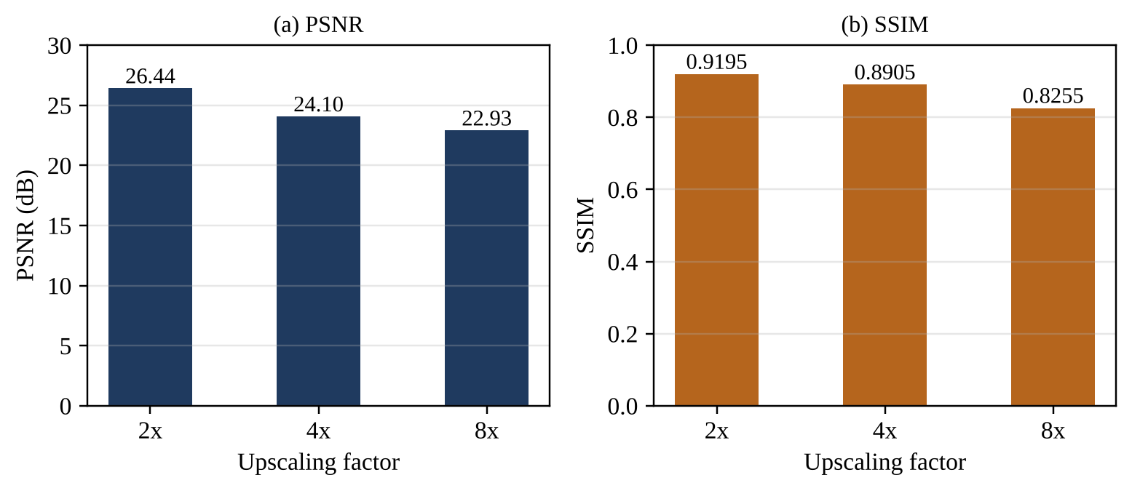
Figure 5.1: PSISRNet PSNR and SSIM at 2×, 4× and 8× (local run)
A short comparison run on an NVIDIA RTX 5050 laptop GPU is given in Table 5.7.
Table 5.7: Short comparison run (local)
Model | Epochs | Best val. loss | Key metric | Time
ColNet | 50 | 4.0788 | PSNR 8×: 12.31 dB | 0:01:18
UNetFormer | 16 | 3.4062 | mIoU 0.14% | 0:00:50
FarSeg | 16 | 3.4040 | mIoU 0.14% | 0:00:35

The total wall-clock time of the three runs was 2 min 44 s. Because each run lasted under 90 seconds, an mIoU of 0.14% and an 8× PSNR of 12.31 dB show that the models were far from trained; the run demonstrates that the pipeline executes end to end and says nothing about model quality. UNetFormer, FarSeg and ColNet are not part of the GEOSEG pipeline described in this report and their training budget differs from the Phase 3 U-Net, so these figures must not be compared with the Phase 3 mIoU. Likewise, the local PSISRNet 2× PSNR of 26.44 dB is below the 31.42 dB bicubic value in the benchmark table of the source paper, so the local values cannot be compared with those tables until dataset, down-sampling method and evaluation protocol are matched. The published benchmark values of the source paper have not been reproduced in this project.

5.7 Summary
The implementation realises every module of the design. Configuration, code and tests are organised phase by phase, and the available performance figures are reported with their provenance and limits: the segmentation results are those recorded in the project documentation, and the super-resolution and comparison-run figures are from short local runs.

CHAPTER-6:
PROJECT OUTCOME AND APPLICABILITY

6.1 Outline
This chapter summarises what the project delivered, how the outcomes relate to the objectives set in Chapter 1, and where the platform can be applied.

6.2 Key Implementation Outlines of the System
- A PyTorch pipeline with four phase configurations, a 16-channel U-Net with expanded ImageNet weights, compound losses, mixed-precision training, checkpointing and a scene-level split.
- A tiled inference routine (512 × 512, 32 px overlap) with 2D linear feather blending that writes a GeoTIFF preserving the source CRS and affine transform.
- A C++17 engine with generic image container, polymorphic spectral indices, tile manager and RAII GeoTIFF handler, exposed to Python through pybind11.
- A FastAPI service with endpoints for training, inference, results, AOI export (Google Earth Engine [20]) and the C++ benchmark.
- A React 18 + TypeScript + Leaflet web application for training, inference, AOI selection, C++ demonstration and results browsing.
- A PSISRNet super-resolution extension, trained locally.

6.3 Significant Project Outcomes
Table 6.1: Objectives and outcomes
Objective | Outcome
Per-pixel classification with 13 bands plus indices | Achieved: 16-channel input, 11 classes; Phase 3 mIoU > 0.74
Reuse pretrained encoders for 16-channel input | Achieved: first convolution expanded with 3/16 variance-preserving scaling
Handle gigapixel scenes | Achieved: 512 × 512 tiling with 32 px overlap and feather blending; stated speed < 1.5 s per tile
Avoid inflated accuracy | Achieved by design: scene-level split of SEN12MS
Native C++ engine exposed to Python | Achieved: C++17 library, executable and pybind11 module; 4.8× speed-up documented
REST endpoints and browser interface | Achieved: five routers and a seven-page web application

The segmentation figures are those recorded in the project documentation (Table 5.5), with mIoU > 0.74 as the headline Phase 3 result (Section 5.6). The super-resolution results (26.44, 24.10 and 22.93 dB PSNR at 2×, 4× and 8×) are lower than the values reported in the source paper, whose published values have not been reproduced in this project.

6.4 Project Applicability on Real-World Applications
- Land-cover mapping and environmental monitoring: forest, wetland, water, cropland and built-up area.
- Smart-city and urban-expansion studies, including Indian urban contexts such as Bhopal (the map interface ships with a Bhopal Upper Lake preset).
- Vegetation, water and built-up analysis using NDVI, NDWI and NDBI.
- Exploratory analysis of large satellite scenes and GeoTIFF rasters through the web interface or the REST API.
- Teaching and research: a documented, phase-wise reference implementation of multispectral deep learning with a native engine and web front end.
For operational use, accuracy on regions unlike the training scenes (for example Indian urban areas) has still to be demonstrated, and the platform would need authentication and quotas for hosted deployment.

6.5 Inference
The project shows that a pretrained RGB encoder can be adapted to 16-channel multispectral input without losing its learned filters, that overlapping tiles with feather blending make full Sentinel-2 scenes tractable, and that a scene-level split is needed for honest evaluation. The surrounding C++ engine, REST service and web interface convert the model into a usable analysis platform.

CHAPTER-7:
CONCLUSIONS AND RECOMMENDATION

7.1 Outline
This chapter concludes the work, lists the limitations and constraints of the system, and recommends future enhancements.

7.2 Limitations and Constraints of the System
- The Phase 3 result (mIoU above 0.74) has not yet been confirmed on held-out real scenes, and some data paths use synthetic fallbacks whose results must be kept separate from real validation.
- The local super-resolution results (26.44, 24.10 and 22.93 dB at 2×, 4× and 8×) are below the paper-reported values, and the 50-epoch and 16-epoch comparison runs are far from converged.
- Quality depends on training data, label quality, class balance and spectral calibration; SEN12MS labels are coarse IGBP classes simplified to 11.
- Land-cover accuracy on regions unlike the training scenes (for example Indian urban areas) is not yet demonstrated.
- With linear feather weights, tile-border pixels covered by only one tile (at the scene edge) receive weights near zero, so predictions at the very edge of a scene rest on small weights and may be less stable; a minimum weight at scene boundaries is a possible refinement.
- Super-resolution gives an estimated reconstruction and cannot recover information the sensor never captured.
- Several languages and subsystems (Python, C++17 and TypeScript) raise setup and maintenance cost.
- Hardware compatibility, operating-system support and dependency versions must be checked per installation.
Table 7.1 summarises the strengths, weaknesses, opportunities and threats of the system.
Table 7.1: SWOT analysis
Strengths | Weaknesses
End-to-end platform: data, model, native engine, API and web UI in one repository.  Multispectral 16-channel input with a variance-preserving pretrained weight expansion.  Scene-level split and feather blending address leakage and seam artefacts.  Phased, test-driven development with per-phase configs. | Phase 3 accuracy is not yet confirmed on held-out real scenes.  Some data paths use synthetic fallbacks that can be mistaken for real validation.  Several languages and subsystems raise setup and maintenance cost.  The short UNetFormer/FarSeg/ColNet comparison run was far from converged.
Opportunities | Threats
Controlled benchmarks against other SMP architectures (DeepLabV3+, FPN).  Uncertainty maps, model versioning, richer geospatial export.  Smart-city and environmental-monitoring use cases. | Dataset shift between regions, seasons and sensors; cloud cover and shadow.  CPU instruction incompatibility, dependency conflicts, very large uploads.  Misreading model labels as ground truth.

7.3 Future Enhancements
- Complete longer training runs with fixed seeds and held-out test scenes; publish per-class metrics and confusion matrices.
- Add uncertainty maps and flag low-confidence or out-of-distribution regions.
- Validate geospatial alignment and metadata after every export; test very large scenes and tile boundaries.
- Provide environment lock files or container images and continuous-integration tests.
- Add authentication, quotas and timeouts for hosted deployments, and model versioning with reproducible job records.
- Evaluate across multiple locations, seasons and sensors, and extend to temporal change detection.
- Benchmark other SMP architectures (DeepLabV3+, FPN) under a controlled protocol and train the comparison models to convergence.

7.4 Inference
GEOSEG connects a multispectral deep-learning pipeline to practical geospatial data handling. A 16-channel ResNet-34 U-Net, initialised from ImageNet through a variance-preserving weight expansion, classifies Sentinel-2 imagery into 11 land-cover classes; overlapping tiles with 2D feather blending make gigapixel scenes tractable; a scene-level split guards against inflated accuracy; and a C++17 engine, FastAPI service and React/Leaflet interface turn the model into a usable analysis platform. The next step toward research-grade results is validation: confirm the Phase 3 metrics, train the comparison models to convergence, evaluate on real held-out scenes with per-class reporting, and document the exact environment and checkpoints used.

REFERENCES
[1] Y. Kataria, “GEOSEG: README and COMPLETE_PROJECT_GUIDE.md,” GitHub repository. [Online]. Available: https://github.com/yajatkataria08-a11y/GEOSEG (accessed Oct. 10, 2026).
[2] A. Sharma et al., “Enhanced satellite image resolution with a residual network and correlation filter,” Chemometr. Intell. Lab. Syst., vol. 256, Art. no. 105277, 2025, doi: 10.1016/j.chemolab.2024.105277.
[3] M. Drusch et al., “Sentinel-2: ESA’s optical high-resolution mission for GMES operational services,” Remote Sens. Environ., vol. 120, pp. 25–36, 2012.
[4] C. J. Tucker, “Red and photographic infrared linear combinations for monitoring vegetation,” Remote Sens. Environ., vol. 8, no. 2, pp. 127–150, 1979.
[5] S. K. McFeeters, “The use of the Normalized Difference Water Index (NDWI) in the delineation of open water features,” Int. J. Remote Sens., vol. 17, no. 7, pp. 1425–1432, 1996.
[6] Y. Zha, J. Gao, and S. Ni, “Use of normalized difference built-up index in automatically mapping urban areas from TM imagery,” Int. J. Remote Sens., vol. 24, no. 3, pp. 583–594, 2003.
[7] L. Breiman, “Random forests,” Mach. Learn., vol. 45, no. 1, pp. 5–32, 2001.
[8] P. Helber, B. Bischke, A. Dengel, and D. Borth, “EuroSAT: A novel dataset and deep learning benchmark for land use and land cover classification,” IEEE J. Sel. Topics Appl. Earth Obs. Remote Sens., vol. 12, no. 7, pp. 2217–2226, 2019.
[9] J. Long, E. Shelhamer, and T. Darrell, “Fully convolutional networks for semantic segmentation,” in Proc. IEEE Conf. Comput. Vis. Pattern Recognit. (CVPR), 2015, pp. 3431–3440.
[10] O. Ronneberger, P. Fischer, and T. Brox, “U-Net: Convolutional networks for biomedical image segmentation,” in Medical Image Computing and Computer-Assisted Intervention (MICCAI), 2015, pp. 234–241.
[11] K. He, X. Zhang, S. Ren, and J. Sun, “Deep residual learning for image recognition,” in Proc. IEEE Conf. Comput. Vis. Pattern Recognit. (CVPR), 2016, pp. 770–778.
[12] L.-C. Chen, Y. Zhu, G. Papandreou, F. Schroff, and H. Adam, “Encoder-decoder with atrous separable convolution for semantic image segmentation,” in Proc. Eur. Conf. Comput. Vis. (ECCV), 2018, pp. 801–818.
[13] M. Schmitt, L. H. Hughes, C. Qiu, and X. X. Zhu, “SEN12MS – A curated dataset of georeferenced multi-spectral Sentinel-2 data for land cover classification and data fusion,” ISPRS Ann. Photogramm. Remote Sens. Spatial Inf. Sci., vol. IV-2/W7, pp. 153–160, 2019.
[14] I. Demir et al., “DeepGlobe 2018: A challenge to parse the Earth through satellite images,” in Proc. IEEE Conf. Comput. Vis. Pattern Recognit. Workshops (CVPRW), 2018, pp. 172–181.
[15] C. Dong, C. C. Loy, K. He, and X. Tang, “Learning a deep convolutional network for image super-resolution,” in Proc. Eur. Conf. Comput. Vis. (ECCV), 2014, pp. 184–199.
[16] P. Iakubovskii, “Segmentation Models PyTorch,” GitHub repository, 2019. [Online]. Available: https://github.com/qubvel/segmentation_models.pytorch
[17] F. Milletari, N. Navab, and S.-A. Ahmadi, “V-Net: Fully convolutional neural networks for volumetric medical image segmentation,” in Proc. Int. Conf. 3D Vision (3DV), 2016, pp. 565–571.
[18] S. S. M. Salehi, D. Erdogmus, and A. Gholipour, “Tversky loss function for image segmentation using 3D fully convolutional deep networks,” in Machine Learning in Medical Imaging (MLMI), 2017, pp. 379–387.
[19] I. Loshchilov and F. Hutter, “Decoupled weight decay regularization,” in Proc. Int. Conf. Learn. Represent. (ICLR), 2019.
[20] N. Gorelick, M. Hancher, M. Dixon, S. Ilyushchenko, D. Thau, and R. Moore, “Google Earth Engine: Planetary-scale geospatial analysis for everyone,” Remote Sens. Environ., vol. 202, pp. 18–27, 2017.

APPENDIX A: INSTALLATION, CONFIGURATION AND EXECUTION

A.1 Setup
git clone https://github.com/yajatkataria08-a11y/GEOSEG.git
cd GEOSEG
pip install -r requirements.txt
pip install -e .

# optional: native C++ engine
cd backend && mkdir build && cd build
cmake .. && cmake --build . --config Release
cd ../..

# frontend
cd frontend && npm install && npm run build && cd ..

A.2 Run
# API (port 8000; Swagger at /docs)
python -m uvicorn api.server:app --host 127.0.0.1 --port 8000

# frontend dev server (port 5173)
cd frontend && npm run dev -- --host 127.0.0.1 --port 5173

# command-line training and inference
python src/train.py --config configs/phase1_eurosat.yaml
python src/train.py --config configs/phase2_deepglobe.yaml
python src/train.py --config configs/phase3_multispectral.yaml
python src/infer.py --config configs/phase4_aoi.yaml

# tests
pytest tests/ -v
A direct g++ command using -mavx2 -mfma -fopenmp can be used for the SIMD build; these flags need a compatible CPU and compiler.

APPENDIX B: VIVA QUESTIONS AND ANSWERS
Q1. Why not use plain RGB imagery?
RGB covers only about 400 to 700 nm. Different materials can look similar there. NIR and SWIR bands expose chlorophyll content and water absorption, which separates vegetation, water and built-up surfaces.
Q2. Why does water give a negative NDVI?
Water absorbs almost all NIR (reflectance about 0.01) and reflects a little red (about 0.05), so (0.01 − 0.05) / (0.01 + 0.05) ≈ −0.66.
Q3. Why add ε = 10⁻⁶ to index denominators?
In shadow or at dropouts NIR and red can both be zero. 0/0 gives NaN, which breaks the backward pass. ε prevents it without changing normal index values.
Q4. Why a U-Net rather than a plain FCN?
Downsampling loses fine spatial detail. U-Net skip connections pass high-resolution encoder features to the decoder, so boundaries of rivers, roads and buildings are recovered.
Q5. How does the 3 → 16 channel expansion work and why scale by 3/16?
Average the three pretrained RGB filters, replicate across 16 channels and multiply by 3/16. Without the scale the output variance would be 16/3 times larger, which destabilises BatchNorm and ReLU layers.
Q6. Why dice_ce instead of cross-entropy alone?
Cross-entropy favours dominant classes. Dice optimises overlap directly, so rare classes such as water are not ignored; cross-entropy keeps gradients smooth early in training.
Q7. What does AMP do?
It runs the forward pass in FP16 on Tensor Cores for speed and lower memory; a GradScaler scales the loss to avoid FP16 gradient underflow.
Q8. Why tile the scene and what causes seams?
A full scene does not fit in GPU memory and resizing loses detail. Convolutions at tile borders see partial context, so naive pasting gives visible seams.
Q9. How does feather blending remove seams?
Each tile's softmax output is multiplied by a 2D weight that is 1 in the core and ramps to 0 at the edges; weighted outputs and weights are accumulated and the argmax is taken over the normalised result.
Q10. What is spatial leakage and how was it prevented?
Neighbouring patches are autocorrelated, so a random patch split lets the model memorise the landscape. GEOSEG groups patches by scene identifier and splits whole scenes.
Q11. How does the C++ engine show RAII and the factory pattern?
GeoTIFFHandler and Image<T> release files and buffers in destructors. createIndex(name) returns a unique_ptr to NDVI, NDWI or NDBI without exposing the concrete classes.
Q12. Why delete the copy constructor of ImageProcessor?
To prevent object slicing when derived objects are copied through a base-class value.
Q13. Why a case-transform layer between FastAPI and React?
Python uses snake_case and JavaScript uses camelCase. The adapter converts keys at the HTTP boundary so properties do not come back undefined.
Q14. How are long inference jobs handled?
POST /api/inference/predict returns a pending job at once and runs inference in the background; the UI polls /api/inference/result/{job_id} until it completes.

