Quarter-Car RL Suspension — 50% Checkpoint
Explanation Guide for the MBD Review
Mentor: Mrs. Mrunalini Bhandarkar
How this is split: Roughly half the explanation each. Yash covers the model, the road inputs, and the two baseline controllers (the "what and why"). Yajat covers the equations, the RL environment, training, and the results (the "how, and what we actually found"). Read your own section closely — skim the other's so neither of you is stuck if Maam asks something from the other half.
One-line project recap: We're studying whether an AI controller (trained with reinforcement learning) can adjust a suspension's damping better than a fixed or rule-based controller — framed around road safety, not just ride comfort. Today's demo shows the simulation pipeline for the standard "quarter-car" model working end-to-end, with a first training run of the AI controller.

PART 1 — Yash's Section: The Model, the Road, and the Baselines

1. What is a quarter-car model?
Picture one wheel of a vehicle and the small slice of the vehicle's body sitting directly above it — that's a "quarter" of the vehicle. We represent this corner with two masses connected by a spring and a damper: the body mass on top (called the sprung mass) and the wheel/axle mass below (the unsprung mass). This is the standard simplified model used across suspension research, because it captures the essential up-and-down motion without needing a full vehicle model with four wheels and a chassis.

2. The numbers that define our system
These are standard, well-validated academic quarter-car values — not arbitrary guesses:
Symbol | Meaning | Value | Unit
ms | Sprung mass (body portion over this corner) | 250 | kg
mu | Unsprung mass (wheel + axle) | 50 | kg
ks | Spring stiffness | 16,000 | N/m
c (passive) | Fixed damping — today's normal suspension | 1,000 | Ns/m
kt | Tyre stiffness | 190,000 | N/m
c (AI-controlled) | Semi-active damper range the AI is allowed to choose within | 200 – 4,000 | Ns/m

3. Road inputs we tested
- Bump: a single smooth 5 cm bump, like a speed breaker — tests how the system reacts to one sharp, isolated event.
- Random road (ISO 8608 Class B): a statistically realistic "everyday road" profile, generated using an international road-roughness standard — tests performance under continuous, ordinary disturbance rather than one event.
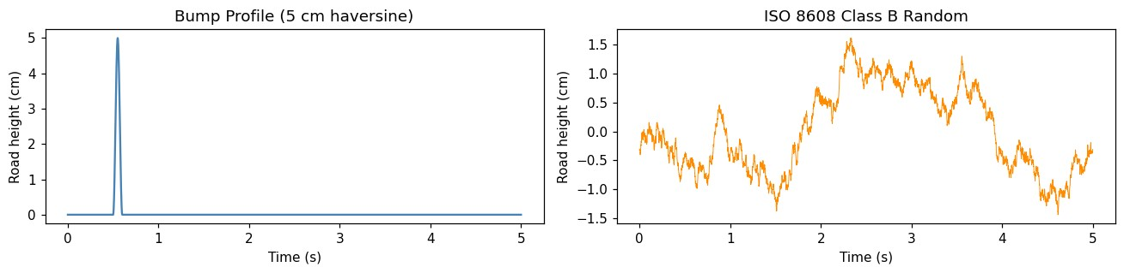

4. Baseline 1: Passive suspension
This is what a normal suspension does today — damping is fixed and never changes, no matter what the road is doing. It's our reference point: if the AI-controlled version can't beat this, there's no case for using AI at all.

5. Baseline 2: Skyhook controller
Before jumping to AI, we compare against "skyhook control" — a well-known rule-based strategy already used in some real vehicles. Its logic in plain terms: stiffen the damper when the body is moving in a way that would make the ride worse, and soften it otherwise. It's a smart, hand-written rule — it doesn't learn or adapt, it just always follows the same logic.

6. What is reinforcement learning / SAC, in plain terms?
Reinforcement learning (RL) lets software learn a behaviour through trial and error rather than following a rule someone wrote by hand. It tries actions, receives a "reward" number telling it how good or bad that action was, and gradually adjusts to earn better rewards — similar to learning to balance a bicycle through practice, not a rulebook. SAC (Soft Actor-Critic) is a specific, well-established RL algorithm suited to problems like this one, where the action is a continuous number (a damping value) rather than a small fixed set of choices.

PART 2 — Yajat's Section: Modelling, Environment, Training, and Results

1. The governing equations
The quarter-car system is described by two coupled equations of motion:
ms·x1'' = -ks(x1-x2) - c(x1'-x2') + Fa
mu·x2'' = ks(x1-x2) + c(x1'-x2') - kt(x2-zr) - Fa
x1 is the body's vertical position, x2 the wheel's, zr the road height, and Fa an active force we leave at zero here — this checkpoint only controls damping (c), not an injected force. The first equation says the body accelerates due to the spring and damper forces acting between it and the wheel; the second says the wheel's acceleration comes from those same forces plus the tyre reacting against the road.

2. Simulating the physics
For clean, accurate plots (like the passive-suspension comparison), we solve these equations with scipy's solve_ivp, an adaptive Runge-Kutta solver, stepping every 1 millisecond. Inside the RL training loop, we instead use a simpler, fixed 5-millisecond step — less numerically precise, but far faster to run, and SAC needs hundreds of thousands of steps to learn anything, so speed matters more than perfect accuracy during training. The trained policy is then evaluated separately using the finer step, so the final comparison plots stay accurate.

3. Turning this into an RL problem
State (what the agent observes) — 5 numbers: suspension deflection (x1-x2), relative velocity (x1'-x2'), tyre deflection (x2-zr), body velocity (x1'), wheel velocity (x2').
Action (what the agent controls): a single continuous number, the damping coefficient, bounded between 200 and 4,000 Ns/m. This is damping only, not an arbitrary force — a real variable damper can only dissipate energy, it can't push back with any force it likes. Keeping the action space this way keeps the simulation honest about what real semi-active hardware can actually do.
We also numerically clip the state during training (position within ±2 m, velocity within ±30 m/s). This isn't a physical limit — it's a safety net so that if the simple Euler integrator produces an unstable spike, it doesn't cascade and corrupt the rest of that training episode. Before training, we sanity-checked the environment with a random policy: it ran without errors (episode reward around -220,000, which is expected — a random damping choice performs badly, that's exactly why we need the agent to actually learn).

4. The reward function
r = -( w1·(body accel)² + w2·(suspension travel)² + w3·(tyre deflection)² + w4·(damping used)² )
with w1 = 1.0, w2 = 0.1, w3 = 0.05, w4 = 0.0001. Body acceleration is weighted highest because it's the strongest proxy for both ride comfort and, for our safety framing, how much shock is transmitted to the vehicle and rider. Suspension travel and tyre deflection are penalized at lower weights, and the tiny w4 weight discourages using large damping just for its own sake, without dominating the objective.

5. Training the SAC agent
We trained using Stable-Baselines3's SAC implementation (MLP policy) for 200,000 timesteps — roughly 500 short, 2-second episodes, each on a freshly randomized road so the agent doesn't just memorize one road. Key settings: learning rate 3×10⁻⁴, replay buffer 100,000, batch size 256, γ = 0.99. This is one untuned training run — a first pass to prove the pipeline works end-to-end, not a final, tuned result.

6. Results so far — and the honest reading of them
Metric (Bump Input) | Passive | Skyhook | SAC (partial)
RMS Body Acceleration (m/s²) | 1.29 | 1.76 | 2.33
RMS Suspension Travel (cm) | 0.68 | 0.72 | 0.42

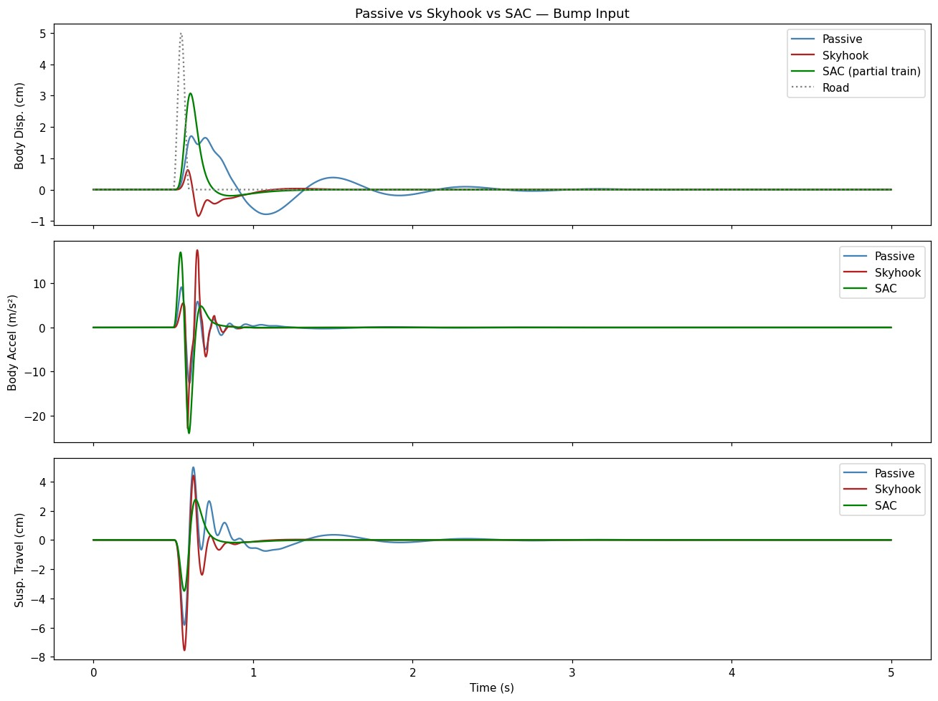
Right now, SAC cuts suspension travel by about 40% versus skyhook, but at the cost of higher body acceleration — not the balance we ultimately want. That's expected at this stage: this is a single 200,000-step run with no hyperparameter tuning, so the agent hasn't yet learned to balance all four reward terms the way we intended. What this checkpoint actually proves is that the full pipeline — physics model, environment, both baselines, and the training loop — runs end-to-end without errors, and that the agent is demonstrably learning something from the reward signal, just not yet the fully balanced behaviour we're aiming for. If asked "so is the AI better?", the honest answer is: not yet — this is a working first training run, not the final result.

7. What's explicitly not done yet
- Full training to convergence, plus hyperparameter tuning
- Testing across many/randomized road profiles for a robustness result, not just one bump
- An ISO 2631-weighted comfort score, for a standardized comfort metric
- A fully active-force controller as an idealized upper-bound comparison

Anticipated Questions From Maam

General questions — Yash
Q: What is this project actually trying to solve?
A: Whether an AI controller can outperform today's fixed or rule-based suspension control, specifically framed around road safety impact rather than comfort alone.
Q: What do ms, mu, ks, c, and kt physically mean?
A: They're the body mass, wheel mass, spring stiffness, damping, and tyre stiffness for one corner of the vehicle — see the table in our section.
Q: Why test on both a bump and a random road?
A: The bump tests one sharp event, like hitting a pothole; the random ISO 8608 road tests everyday, continuous riding conditions. A system that only looks good on one isn't proven yet.
Q: What is skyhook control, and why compare against it?
A: It's a well-known, already-used-in-industry rule-based control strategy. It gives us a fair, non-AI comparison point before we judge whether the AI is actually adding value.
Q: In simple terms, what is the AI doing?
A: It's learning, through trial and reward, to continuously choose the best damping value moment to moment — rather than following one fixed rule like skyhook does.

Technical questions — Yajat
Q: Can you walk me through the equations of motion?
A: Yes — see Part 2, Section 1. Two coupled equations for body and wheel acceleration, driven by spring, damper, tyre, and road forces.
Q: Why does the RL environment use a coarser time step than your evaluation plots?
A: Training needs hundreds of thousands of steps, so we trade some numerical accuracy (5ms Euler steps) for speed. We validate the final policy separately using a finer, more accurate step (1ms) for the comparison plots.
Q: Why is the action space only damping, not force?
A: It matches what a real semi-active actuator can physically do — dissipate energy, not inject an arbitrary force. This keeps our simulation honest about what the eventual hardware can deliver.
Q: Why is SAC currently worse than skyhook on body acceleration?
A: This is one untuned 200,000-step training run. The agent has learned to reduce suspension travel substantially but hasn't yet balanced that against acceleration the way the reward function intends. Longer training and hyperparameter tuning is the direct next step.
Q: Why do you clip the state during training?
A: Purely a numerical safety measure for the simple Euler integrator, to stop a single unstable step from corrupting the rest of that training episode — it isn't a physical limit.
Q: What's left before this is a finished result?
A: Full convergence with hyperparameter tuning, testing across many road profiles for robustness, an ISO 2631-weighted comfort metric, and an idealized active-force comparison case.

