Template for Preparation of Papers for Chinese Control Conference
ZHANG San¹, LI Si^{1,2}, WANG Wu²
1. Academy of Mathematics and Systems Science, Chinese Academy of Sciences, Beijing 100190
E-mail: ccc@amss.ac.cn
2. Harbin Institute of Technology, Harbin 150001, China
E-mail: xxx@hit.edu.cn

Abstract: This is the paper style requirement for the Chinese Control Conference. The writers of papers should and must provide normalized electronic documents in order for readers to search and read papers conveniently.
Key Words: Paper, formatting instructions, Chinese Control Conference

- Introduction
These are instructions for authors typesetting for the Chinese Control Conference (CCC). This document has been prepared using the required format. The latest electronic copy of this document is available in the annual Chinese Control Conference website or the online paper submission system at http://cms.amss.ac.cn/resources/. Please use this document as a “template” to prepare the camera-ready version of your manuscript. For submission guidelines, follow instructions on online paper submission system as well as the conference website. The paper is to be written in two-column format and be right and left justified. The column width should be 84.5mm. The gap between the two columns should be 7mm.
  - Instructions for Authors
In order for the proceedings to be ready for distribution at the conference, an electronic copy of the final version of your paper (both MS word and PDF formats) must be submitted via the TCCT Conference Paper Management System via http://cms.amss.ac.cn. Please follow the submission instructions shown on the website.
- Formatting Instructions
MS Word Authors: please try to use the paragraph styles contained in this document.
  - Page/Font Settings
It is strongly recommended that prospective authors download suitable style file for use with LaTeX and templates for use with MS Word.
Style files and templates provided here have been created to ensure that margin requirement is adequately met. If, for some reason, you are not able to use provided templates or style files, please observe the following margins and font settings strictly.
Table 1: Page Margins
Paper Size | 21cm×29.7cm
Top Margin (1st page) | 3cm
Top Margin (rest) | 2cm
Left Margin | 1.7cm
Right Margin | 1.7cm
Bottom Margin | 2.2cm
Text Width | 17.6cm
Text Height | 25.5cm
Column Width | 8.45cm
Column Separation | 0.7cm
Table 2: Font Settings
Title | Times New Roman, 16pt, bold
Author List | Times New Roman, 11pt
Authors’ Address | 9pt
Abstract, Key Words | 9pt
Section Titles | 11pt, bold
Subsection Titles | 10pt, bold
Normal Text | 10pt
Table/Figure Captions | 9pt
Footnotes | 8pt
References | 9pt
  - Section and Subsection Headings
Number section and subsection headings consecutively in Arabic numbers and type them in bold. Avoid using too many capital letters. If any further subdivision of a subsection is needed the titles should be 10 point and flushed left.
  - Main Text
Use Times New Roman with font size 10 point for text (character size). There is no separation between paragraphs, and the first line of each paragraph is indented by 1em. You may type on plain white A4 paper. Typing area should not exceed 176mm×255mm. The text should be prepared with a double column format and single line spacing.
  - Tables
All tables must be centered in the column and numbered consecutively (in Arabic numbers). Table headings should be placed above the table. Place tables as close as possible to where they are mentioned in the main text (see Table 1 and Table 2).
  - Figures
All illustrations should be original drawings or photographic prints of originals. Photographs should be glossy prints. Photocopies are often not good enough and should be avoided. All illustrations must be numbered consecutively, using Arabic numbers. Center figure captions beneath the figure (see Fig. 1). If possible, do not assemble figures at the back of your article, but place them as close as possible to where they are mentioned in the main text. No part of a figure should go beyond the typing area. Captions should appear below graphical objects, as in Fig. 1.

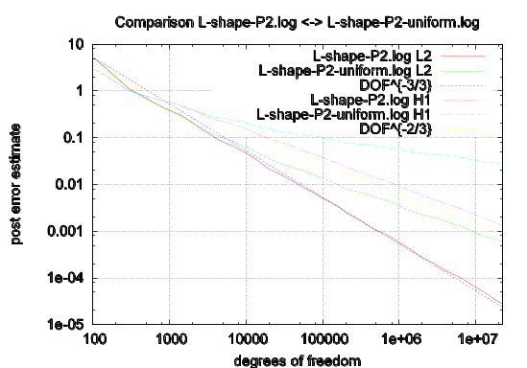

Fig. 1: The caption

Color and grayscale figures should be prepared with 400 dpi resolution and saved with no compression; monochrome figures should be prepared with 600 dpi resolution and saved with no compression.
  - Mathematical Formulas
Mathematical formulas should be roughly centered and could be numbered as formula (1).
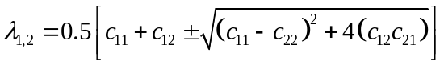 (1)
  - References
References must be listed in alphabetical order of author and the reference items are represented as Arabic numbers in square brackets, e.g. [1, 2, 3, 4, 5].
References are titled as “References” with 11pt bold font, flush left and no indent, paragraph spacing before 6pt and after 6pt. The body text of references is formatted as 9pt Times New Roman, initial paragraph no indent, hanging indent 0.7cm, single space.
For journal paper references, the information should be included such as author name, article title, journal title, volume number, issue number, page number, year. Similarly, author name, book name, edition number, publisher and year should be included for book references. Examples of both journal paper and book references are shown at the end of this template.
- Proceedings or Books
Give publisher and its location. Give date as (year, month) or (year).
- Journal Article
Include the issue number in parentheses immediately after the volume number. Give page numbers.
- Article in Proceedings or Books
Give publisher and its location. Give date as (year, month) or (year). Include page numbers.
- Fine Tuning
- Do not end a page with a section or subsection heading.
- Do not include page numbers in the text.
- Large figures, tables and mathematical equations may span both columns.
- Do not delete the first blank line of the main text, otherwise the footnote of the first page will be removed.
- Paper Submission
After proofreading your paper, it must be submitted via http://cms.amss.ac.cn electronically including both MS Word and PDF formats.
  - Electronic Image Files (Optional)
You will have the greatest control over the appearance of your figures if you are able to prepare electronic image files. Please prepare the image files in PostScript (PS) or Encapsulated PostScript (EPS) formats. Use a separate file for each image. File names should be of the form “fig1.ps” or “fig2.eps”. Please pack the image files and the paper files (both MS Word and PDF formats) altogether in Zip or Rar format and upload the packed file.
References
- D. Cheng, Controllability of switched bilinear systems, IEEE Trans. on Automatic Control, 50(4): 511–515, 2005.
- H. Poor, An Introduction to Signal Detection and Estimation. New York: Springer-Verlag, 1985, chapter 4.
- B. Smith, An approach to graphs of linear forms, accepted.
- D. Cheng, On logic-based intelligent systems, in Proceedings of 5th International Conference on Control and Automation, 2005: 71–75.
- D. Cheng, R. Ortega, and E. Panteley, On port controlled hamiltonian systems, in Advanced Robust and Adaptive Control — Theory and Applications, D. Cheng, Y. Sun, T. Shen, and H. Ohmori, Eds. Beijing: Tsinghua University Press, 2005: 3–16.

 *This work is supported by National Natural Science Foundation (NNSF) of China under Grant 00000000.

