Techniques for multi-resolution image registration in the presence of occlusions

Morgan McGuire
Harold S. Stone
morganm@mit.edu, hstone@research.nj.nec.com

Abstract
This paper describes and compares techniques for registering an image with respect to a template image when one or both are partially occluded. These techniques can be used to build correlation-based image registration (alignment of similar images) and image search (finding a sub-image within a larger image) algorithms. Binary masks as developed by Stone and Shamoon [18], and extended by Stone [15] to multi-resolution images, allow exact comparison of partially occluded images. Fractional masks, introduced in this paper, extend this idea for better discrimination on low-resolution images. The low and multi-resolution images result from searching the low-pass subbands of wavelet representations of images. By operating on low-resolution images and computing the correlation function in the frequency domain, the mask based algorithms can be implemented efficiently.

We present experimental evidence supporting the use of occlusion masks in the registration process and find that binary masks produce higher registration peaks while fractional masks produce sharper peaks.

Keywords: image registration, multi-resolution, fractional mask, occlusions, wavelets

1 Introduction
Image registration algorithms attempt to recover the transformation parameters that describe a mapping of one image onto another, where both images are of the same scene. One of the primary uses of registration is to account for the transformations that result from the image acquisition process, so that differences in the underlying scene can be discovered. For example, once images are aligned with respect to each other they may be subtracted, revealing differences in the scene. Registration is an important pre-processing step that enables the use of satellite images for environmental studies and the use of sequences of radiology images for studying the progression of medical pathology.

A variety of image registration techniques have been used for successfully registering images that are unoccluded. In an unoccluded image all of the pixels are valid and are candidates to participate in the registration process. In contrast, partially occluded images contain invalid pixels that should not participate in the registration. If these invalid pixels contribute information to the registration process as if they were valid, a false registration may be produced. In satellite images of land features, clouds frequently occlude parts of the scene. Techniques exist for identifying cloud pixels as invalid (occluded) portions of the image. Unoccluded images may be considered a subset of partially occluded images.

The techniques for unoccluded image registration fall into three main categories:

1. feature based registration with arbitrary transformations (warping)
2. pixels correlation based algorithms, and
3. spectral correlation based algorithms.

Because they do not distinguish between occluded and unoccluded pixels these techniques tend to fail when occluded pixels are present in the image. The matching of the unoccluded pixels must be of sufficiently high quality to compensate for the degradation due to matching occluded pixels to unoccluded pixels and vice versa. A scheme proposed by Ching, Toh, and Er [6] incorporates occlusion detection and registration in a manner that bears some similarity to the general approach of this paper. They compute the correlation of two images based on all data, then selectively remove regions are that are poorly correlated between the two images. Another technique called expansion matching [3] attempts to remove occlusions by substituting modeled values for occluded pixels. Stone and Shamoon [18] describe a method for using binary occlusion masks to ensure that the correlation function only represents a comparison of valid pixels to valid pixels. In their convention, these masks have value 1 for pixels corresponding to valid image pixels and value 0 for pixels corresponding to occluded image pixels. Stone [15] expands this technique for high-speed registration by operating on reduced resolution images. A factor of N reduction in resolution speeds up the correlation operations by a factor of N². Le Moigne [12] and Le Moigne, Campbell, and Cromp [13] explored wavelet representations for this purpose, without occlusion masks. In Stone's algorithm a very conservative criterion is applied when producing low-resolution representations of the masks. If any of the fine pixels that contribute to producing a low-resolution pixel are invalid then the entire low-resolution pixel is invalid. This criterion correctly eliminates the effects of invalid data, however it also eliminates the effects of some valid data.

This paper introduces a new technique, called fractional masking, which is based on Stone's algorithm. The intent is to capture more valid data at low resolution to assist with discrimination during registration. The results of image registration tests show that both binary and fractional masking are very effective for registering partially occluded images, compared to unmasked algorithms. At low resolution fractional masks indeed tend to produce sharper registration peaks in the correlation function at the correct locations than binary masks. However the peaks at the correct locations may not be as high as those produced by binary masks, so it is possible for a fractional mask algorithm to miss a correct registration discovered by a binary mask algorithm.

The next section of the paper reviews binary occlusion masks. Section 3 extends occlusion masks to fractional masks for wavelet representations. Section 4 presents the results of experiments comparing a binary mask algorithm, fractional mask algorithm, and unmasked algorithm applied to low resolution representations of data sets containing occluded images. The final section contains a summary and suggestions for future research.

2 Occlusion Masks
Fractional masks are the result of a natural progression of ideas involving correlation and masking. In this section we review the correlation operation, pixel correlation based registration, and occlusion masking techniques that led us to derive fractional masks. For this review we will work with one dimensional factors, and note that the extension to two-dimensional images is straightforward. Let y be a vector that is to be registered against vector x where x = (x₀, x₁, ... x_{N-1}) and y = (y₀, y₁, ..., y_{M-1}), such that M is small compared to N. We assume that vector y is equal to a series of M contiguous components of x starting at position j, plus a small amount of noise added to each component of the result.

To register y with x in one dimension, one seeks position j in x for which the M successive components of x starting at that point are most like y. This computation appears to require O(NM) operations because O(M) operations are required to check each position, and there are O(N) possible positions. By reducing the comparison operations to circular correlations, the entire computation can be computed in O(N log N) in the frequency domain.

The circular correlation of x and y, written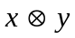, is the vector of length N whose j^{th} component is given by

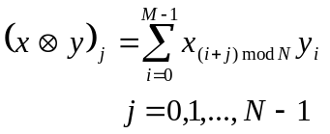. (1)

Calculating all components thus takes O(NM) operations. This correlation is circular because the subscripts are taken modulo N. The subscripts in all derivations that follow are all modulo N, so we will simplify the notation by not explicitly showing this dependence from here on.

By the Convolution Theorem, the circular correlation may be computed in the following way. Extend y to length N by appending N - M zeros. Let F be an N x N Fourier transform matrix and let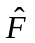be the complex conjugate of F. The circular correlation of x and y is

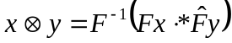, (2)

where the operation .* denotes array (point-by-point) multiplication. The array multiplications take O(N) operations. Using the fast Fourier transform, the products against the F matrices can be computed in O(N log N) operations, so the entire right side of the equation can be computed in O(N log N) operations as compared to O(NM) for directly calculating the components using Eq. (1).

Stone and Li [17] show how to compute various measures of "closeness" between two images in terms of circular correlations, and incorporate occlusion masking. Consider the sum of squares differences criterion. In the pixel domain this function is given by

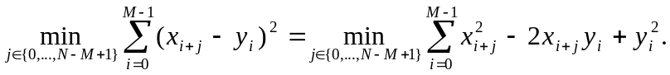 (3)

The middle term of Eq. (3) is 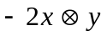 and the last term is constant. The first term reduces to circular correlation of x .* x and a mask for y. The mask for y is not an occlusion mask; it is simply to remove the zero padding of y from the computation. Specifically, let h be a pattern mask for y with 1s for the first M components which correspond to valid values of y and 0s in the next N-M components where y has been extended with 0s. Let x⁽²⁾ be the vector x .* x. Then the first term is 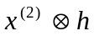 and the sum of squares criterion becomes

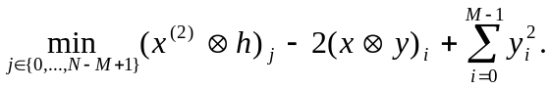 (4)
In Eq. (4) the vector y acts as if it were actually of length M with its last N - M components occluded. The extension to arbitrary occlusion masking is simple; we allow zeros to be placed in the components of h that correspond to actual pixel values in y, not just the zero extension. x may be masked as well by providing a template mask m of length N.

An equation for computing the sum of squares in using circular correlations is:

(5)

where x’ = x .* m, y’ = y .* h, x⁽²⁾’= x .* x .* m, and x⁽²⁾’= y .* y .* h. The coefficient 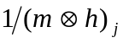 normalizes the criterion because for each j it is the number of valid pixels in the summation. For some values of j there are no terms in the summation. For these values, we define the sum of squares to be infinite, indicating a poor match.

The normalized correlation coefficient, defined as

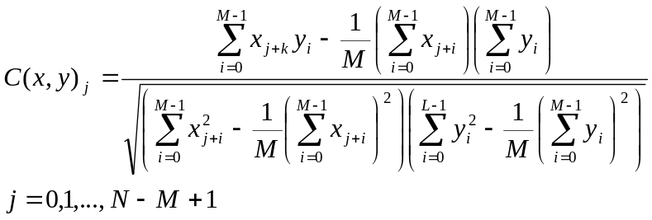 (6)

is another popular criterion for image registration. As shown by Stone [16], this reduces to the form shown in Eq. (7) when incorporating occlusion masks. By reducing all the vector operations to correlations, they can be efficiently computed in the frequency domain.

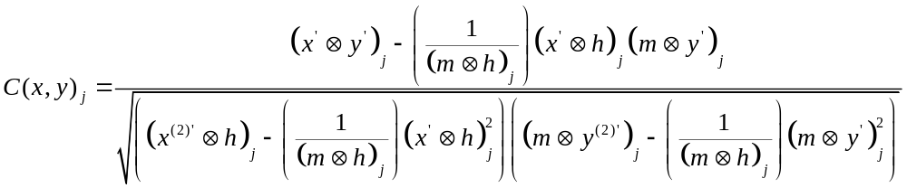 (7)

The normalized correlation coefficient is ideal for matching images that differ by an affine transformation of the intensity map. In this case, and intensity i in x maps to an intensity α i+β in y, where α and β are constant. This type of transformation occurs when to images differ only in lighting intensity. If the source of the lighting has moved relative to the scene in the images, the differences cannot usually be modeled by affine transformations of the intensity map. In this situation the correlation coefficient is less useful. Medical and satellite imaging have the advantage that the illumination conditions can either be explicitly controlled or selected.

This completes the review of binary occlusion masking and prior art. The next section extends occlusion masking to fractional occlusion masks.

3 Fractional Occlusion Masks
A major goal of image registration algorithms is speed. Recall from the previous section that correlation based registration operations in the pixel domain have complexity that grows as O(NM) for registering an image of M pixels against one with N pixels. By moving to the Fourier domain, the same operations can be accomplished in O(NlogN) operations. Further speed-up can be achieved by lowering the resolution of the images. If the number of pixels in the images are reduced by factor of R through filtering and down-sampling, then registration requires only O(NM/R²) operations in the pixel domain and O([N log N] / R²) operations in the frequency domain. The cost of this speedup is a small degradation in accuracy and reduction in precision by a factor of R maximum resolution pixels.

The precision and accuracy can be recovered by progressively refining the search to higher resolutions. Each level of refinement provides information for the next higher resolution level of search so the total cost of fine level registration may still be less than direct registration at that level. For example, poor matches will be eliminated quickly at the low-resolution levels, and correct matches need only be resolved within a factor of R fine pixels after low-resolution registration [12]. The fine pixels are the high-resolution pixels in contrast to the low-resolution coarse pixels.

The process of producing low-resolution, filtered and down-sampled versions of an image is captured naturally by the wavelet transform. The first order wavelet representation of a two-dimensional image contains four subbands, one for each possible combination of horizontal- and vertical- low and high frequency data. The subbands are each 1/4 the size of the original image. The low-low subband, which contains horizontal-low- and vertical-low-frequency data, is a thumbnail of the original image; similar in appearance to the full resolution image but containing only 1/4 the number of pixels. A second order wavelet representations is produced by substituting the first order wavelet transform of the low-low subband in place of that subband. This process, known as the fast wavelet transform (FWT), may be repeated, producing higher order wavelet representations and lower resolution thumbnails. In addition to speed up available from searching low-resolution versions of the image, the wavelet representation can often be compressed with great efficiency [19].

Occlusion masks for low-resolution images work in the same manner as full resolution occlusion masks. A mask pixel with value 1 designates that the corresponding coarse pixel is valid, and a mask pixel with value 0 designates the corresponding coarse pixel is invalid. There are many possibilities for deciding the values of mask pixels that correspond to image pixels produced from both valid and invalid fine pixels. Stone suggests a coarse mask pixel should be equal to equal to 1 if and only if all of the corresponding fine pixels are valid. Otherwise the coarse mask pixel should have value 0. The sum of square differences and the normalized correlation coefficient can then be computed according to Eqs. (5) and (7). We consider this a binary masking approach because low-resolution masks maintain the property of containing only the binary values 0 and 1.

An interesting problem arises from this approach at low resolution, as illustrated by Fig. 1. Fig. 1 shows the same image at three resolutions. A program processed the original image to identify occlusion created by clouds, and marked pixels as invalid depending on reflectivity, temperature, and the intensity of pixels in the neighborhood. Invalid pixels are colored deep black in the figure. Notice how the relative size of black region greatly enlarge is as the resolution diminishes. This occurs because the scattered clouds occlusions tend to touch a large fraction of coarse pixels, whereas they touch only a small fraction of fine pixels. Clearly, image registration operations based on the low-resolution image in Fig. 1 will be using only a small fraction of information available for registration, due to the binary masking approach.

Because binary masking is conservative (any invalid constituent fine pixel results in an invalid coarse pixel) it is guaranteed that the correlation is based on only data known to be free of occlusion contamination, and will generally produce a higher correlation in the correct position than will be produced by an algorithm that treats the invalid pixels as valid. However, because some valid data is eliminated from consideration and fewer pixels contribute, it is more likely that the high correlation peaks will not be in the correct locations.

To obtain higher discrimination by using more data in the correlations that is used in the scheme described in section 2, we propose the use of masks containing fractional values between 0 and 1, in a manner that incorporates the valid data in partially occluded coarse pixels. Although the concept of using fractional masks to represent fractional validity is straightforward, the implications for the wavelet transform and correlation function demand some care be taken. Fortunately the equations derived for computing the sum of squares differences and the normalized correlation still hold, but the wavelet transform must be altered to allow the wavelet basis to exclude pixels where occlusions occur.

Consider the wavelet analysis used to produce the low-resolution images. Using the Haar wavelet basis, each coarse pixel is the simple average of four pixels at one level finer resolution. Let Level 0 be the highest resolution level, and consider how to generate the pixels and mask for Level 1 from pixels and mask for Level 0. The boundary cases are simple, and are identical to binary masks. If all fine pixels are valid, the coarse pixel at Level 1 should be the average of the fine pixels, and a mask at level one should be 1. Likewise, if all fine pixels are invalid, the coarse pixel should be 0 and its corresponding mask should be 0. What should the values be in other cases?

First we examine the calculation of the mask coefficients, and then derive a formula for the wavelet coefficients. The fractional mask approximation stems from the fact that the mask acts as a measure of area in Eqs. (5) and (7). Consider, for example, the term 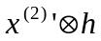in Eq. (5). h is the mask for the pattern, y. A 1 in h indicates that the corresponding pixel of y is valid. This 1 incorporates a pixel from x⁽²⁾’ into the correlation for each cyclical shift of h. For each cyclic shift of h, the mask as a whole selects an area of x⁽²⁾’ to participate in a correlation sum, because this area aligns with valid pixels of y in the selected shift position.

If a coarse pixel of y is partially occluded then its area is the fraction of its fine resolution pixels that are unoccluded. This value may be recursively calculated by the following process, which is equivalent to computing the low-low subband of the Haar transform of the mask. Let m be a coarse mask coefficient and n_{i}, i = 0, 1, ... s-1, be the mask coefficients one level of resolution finer. Compute m by

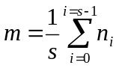 (8)

Beginning with a two-dimensional Level 0 mask containing only values 0 and 1, the Level 1 mask may have values that are multiples of 1/4, and the Level k mask may have values that are multiples of 1/4^{k}. For d-dimensional signals, the Level k mask may have values that are multiples of 1/d^{k}. The multiple reflects the number of fine pixels that contribute to this coarse pixel.

Now we treat the computation of the wavelet coefficients. Consider the Level 1 thumbnail of a partially occluded image. Each coarse pixel should have a value derived from us fine pixel components. The coarse pixel value that best represents the unoccluded components is a weighted average of the unoccluded components. The weighting comes from the low pass filter in the wavelet basis, and from the mask that indicates which pixels should contribute. Let the equation for the coarse pixel q be given by the s-order filter polynomial:
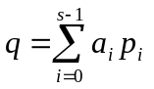 (9)

Where the coefficients of the s-term low-pass filter are a_{i} in the values of the fine pixels are p_{i}. The following equation has the properties that we seek for q:

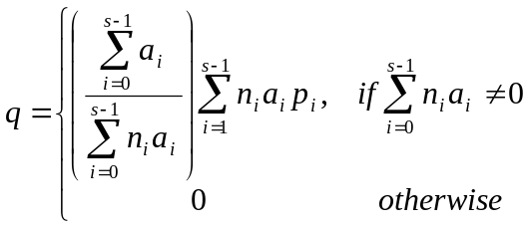 (10)
Where n_{i} are the fractional mask values as above. The only terms that contribute are those for which the fine components are unoccluded. The multiplier 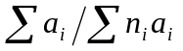 normalizes the filter polynomial so that it occupies the full dynamic range of the original polynomial in the absence of the occluded terms. If there are no occluded pixels, Eq. (10) and Eq. (9) produce identical thumbnails. Eq. (10) may be applied recursively to produce wavelet coefficients at higher levels.

Fig. 2 illustrates the effect of using the fractional masks. Figs. 2(a-b) correspond to Figs. 1(b-c), which were produced using binary masks. Note the difference in the black (occluded) areas. In the fractional masks, the effects of small, scattered clouds have been greatly diminished in the visible image. Because the masks are fractional, many visible pixels have mask pixels less than unity to weigh them in proportion to their information content. As we will show in the next section this sharpens the correlation peak and improves discrimination.

4 Example
In this section we compare the results of experiments on binary, fractional, and unmasked algorithms for solving a sample image registration problem for a partially occluded image set. Fig. 3 is a picture of the Western Coast of South Africa. The coastline is quite irregular with a structure that lends itself well to image registration. The large black regions are clouds that have been identified as occlusions. The white rectangle shows the sub-image that will be used as a pattern by the registration algorithms. Fig. 4 shows a database of nine images of the same area taking over a period of approximately nine days. These images are among the most cloud free for that region in a three-month period. Even these images have substantial cloud coverage.

The cloud detection algorithm places narrow clouds along the Northwest coastline in all images. This is the coastline in the registration pattern in Fig. 3. Typically coastlines are chosen as features for registration because of their high contrast and large size, but in this set of images the coastline is of little use because the cloud detection algorithm has marked it as occluded.

Figures 5, 6, and 7 show the results of the fractional, binary, and unmasked registration algorithms applied to the database. Each figure depicts nine query results. Each query result shows the image the template was registered against on the left, and the thresholded normalized correlation function on the right. The normalized correlation is calculated as giving in Eq. (7) and thresholded such that values of less than 0.71 are rounded to 0.00. The correlation function is smaller than the image by the dimensions of the template because positions that would cause the template to wrap around the borders of the image under circular correlation have been omitted. The correlation function is drawn in a gray scale where a good match (1.00) is dark black and a poor match (0.00) is white. The black border marks the edge of the correlation functions and does not represent data. A small circle is centered on the highest peak. A white rectangle is placed at the position of the template in the image that generated the highest peak.

Figures 8, 9, and 10 show horizontal cross sections of the correlation function through the correct registration point for every query. An ideal result would have a sharp peak at pixel position 32 on the horizontal axis with maximum value 1.00, and negligible values elsewhere.

In Fig. 5 the fractional mask algorithm identified the correct registration in eight out of nine trials. Examining the corresponding correlation cross sections in Fig. 8, we observe that the correlation with peaks for those trials that succeeded are near unity and reasonably sharp. The trial at row 2, column 1, which failed to determine the correct registration location, had a low correlation peak at the correct location and a high noise peak and incorrect location, triggering a false match. In this case a cloud occluded a significant portion of the image, so very few pixels contributed at the correct location, a difficult case for the algorithm to handle.

In Fig. 6, the binary mask algorithm also succeeded in eight out of nine trials. More noise is present in the correlation function than was observed when using fractional masks. Comparing Fig 8. and Fig. 9, the binary mask peaks are 2% to 3% higher than fractional mask peaks, although more noise is clearly present and binary masks.

Fig. 7 shows the results of an unmasked algorithm (binary mask where all pixels are considered valid) applied to the database. In this case occlusion masking was effectively turned off. The unmasked algorithm failed on two out of nine trials. Examining Fig. 10, the cross-section of the correlations produced without occlusion masking, it is obvious that the correlation peaks are degraded by the occlusions. The overall signal noise ratio is degraded as well because the peaks at the correct locations are lower and the noise peaks are higher, as compared to the correlations observed with the masking algorithms. For the trial in row 2, column 1, the correlation value at the correct registration point in is only about 0.5 as compared to values near 1.0 observed with the algorithms that handle collisions. Both of the mask-based algorithms give better discrimination and more accurate results than the uncompensated algorithm.

5 Open Research
We have demonstrated that occlusion masks produce better search results by removing occluded areas from computation. Moreover, the experimental results suggest that may be better to retain partial information in low-resolution images and discard the information to avoid errors cause by occlusions. However, the results are not conclusive. Binary masks and fractional mask did not produce distinctly different results in our tests. There is a trade-off between increased discrimination in the fractional mask algorithm and a slightly better peak detection with the binary mask. The choice between them may depend on the application.

The idea of removing occlusions from images has applicability beyond the context here, which is correlation based. For example, feature based searches can use occlusion information to make registration faster and more robust. If regions were known to be invalid, such algorithms would not attempt to find and identify features that lie within such regions.

Additional speedups and accuracy over binary masks may be possible using the fractional masks. With low-resolution transforms, conservative binary masks increase the relative size of occluded regions as resolution is reduced, while fractional masks maintain the proportion of invalid to valid weighted data. This can be observed by visually comparing Fig. 1c and Fig. 3. At low resolutions, the invalid regions of a binary mask can grow large enough to include all significant features. This problem does not occur when using fractional masks, so fractional masks enable some low-resolution searches to succeed, leading to faster search in practice. However, some relevant features may fall below the detection threshold in low-resolution images, making registration difficult, especially in the presence of noise from other sources. The loss of accuracy diminishes the value of the faster processing available at low-resolution. Because pre-processing with transformations like rotation and dilation also tend to increase the fraction of invalid pixels when using binary masks, fractional masks may increase the accuracy of searches on image sets that have undergone such transformations. It remains open as to whether this will have a significant effect on the search results.

We believe that there is no simple way to incorporate occlusion masking into spectral correlation algorithms. These algorithms rely on frequency domain representations of images. It is very costly to remove the effects of invalid pixels in the frequency domain representation, because a single pixel contributes energy to all spectral coefficients. This forces algorithms to return to the pixel domain to remove the occlusion effects. However once in the pixel domain an invalid pixel cannot be removed from the same position in two images unless the images are registered with respect to one another. But the objective of the algorithm is to register the images, so that it does not seem feasible to prepare images for registration without registering them first.

Other approaches may illuminate to reduce the effects of occlusions by replacing occluded areas with predictions of what the data would be in the absence of occlusions. For small occlusions in images that display continuity this may be fairly accurate. Also, edge features that appear to pass through occlusions may be extended with some certainty. For example a coastline that is partially occluded by a cloud is known to continue beneath the cloud.

6 Acknowledgements
The collection of images used in this paper was provided by NASA through Dr. J. Le Moigne. Interested parties should contact the authors contain copies of the images. The authors thank Robert Wolpov of the NEC Research Institute, Bo Tao of Princeton University, Louis Wang of Columbia University, and Talal Shamoon for their contributions to the program that produce the results in this paper.

References
[1] Alliney, S., G Cortelazzo, and G. A. Mian, "On the registrations of an object translating on a static background," Pattern Recognition, vol. 29, no. 1, pp. 131-141, January 1996

[2] Anuta, P. E., "Spatial registration of multispectral and multitemporal digital imagery and using fast-Fourier transform techniques," IEEE Trans. on Geoscience Electronics, vol. 8, no. 4, pp. 353-368, October, 1970.

[3] Ben-Arie, J., and K. R. Rao, " on the recognition of occluded shapes and generic faces using multiple template expansion and matching," Proc. IEEE 1993 CVPR, New York, pp 214-219, June 1993.

[4] Casasent, D., R. Schaefer, and R. Sturgill, "Optical hit-miss morphological transform," Applied Optics,vol. 31, no. 29, pp. 6255-6263, 10 Oct, 1992

[5] Casasent, D., J. S. Smokelin, and R. Schafer, "Optical correlation filter fusion for object detection," Optical Engineering, vol. 33, no. 6, pp. 1757-1766, June 1994.

[6] Ching, W. S., P. S. Toh, and M. H. Er, "Recognition of partially occluded objects," Proc. IEEE TENCON'93, vol. 2, Computers, Communication, Control, and Power Engineering, Beijing, China, andpp. 930-933, October 1993.

[7] Cracknell, A.P., and K. Paithoonwattanakij, "Pixel and sub-pixel accuracy in geometrical correction of AVHRR imagery," International Journal of Remote Sensing,vol. 10, nos. 4 and 5, pp. 661-667, 1989.

[8] Devereux, B.J., R.M. Fuller, L. Carter, and R. J. Parselll, "Geometric correction of airborne scanner imagery by matching Delaunay triangles," International Journal of Remote Sensing, vol. 11, no. 12, pp. 2237-2251, 1990.

[9] Fiore, P.D., "Image registration using both distance and angle information," Proc. ICIP 1995, IEEE, Washington D.C., October 1995.

[10] Khosravi, M., and R. Schaefer, "Template matching based on a grayscale hit-or-miss transform," IEEE Trans. on Image Processing, vol 5, no. 6, pp. 1060-1066, June 1996.

[11] Kuglin, C. D., and D. C. Hines, "The phase correlation image alignment method," IEEE 1975 Conference on cybernetics and society, pp. 163-165, September 1975.

[12] Le Moigne, J., "Parallel registration of multi-sensor remotely sensed imagery using wavelet coefficients," Proc. SPIE O/E Aerospace Sensing, Wavelet Applications, Orlando, pp. 432-443, April 1994.

[13] Lemoigne, J., W.J. Campbell, and R.F. Cromp, "An automated parallel image registration technique of multiple source remote sensing data," to appear in IEEE Trans. on Geoscience and Remote Sensing, 1998.

[14] Reddy, B.S., and B.N. Chatterji, "An FFT-based technique for translation, rotation, and scale-invariant image registration," IEEE Trans. on Image Processing, vol. 3, no. 8, pp 1266-1270, August 1996.

[15] Stone, H.S., "Fourier-Wavelet techniques in image searching," Proceedings of 1997IEEE International Symposium on Circuits and Systems, vol II, Circuit theory and power systems, communications and multimedia, Hong Kong,pp. 1472-1475, June, 1997.

[16] Stone, H.S., "Progressive wavelet correlation using Fourier methods," submitted to IEEE Transactions on Signal Processing, November, 1996.

[17] Stone, H.S., and C.S. Li, "Image matching by means of intensity and texture matching in the Fourier domain," Proceedings of SPIE conference on image and video databases, vol. to 2670, storage and retrieval for image and video databases IV, San Jose, California, pp. 337-349, February 1996.

[18] Stone, H.S., and T. Shamoon, "The use of image content to control image retrieval and image processing," to appear in Journal of Digital Libraries, 1998. An early version appeared in Multimedia Computing, Proc. of the Sixth NEC Research Symposium, SIAM, pp. 43-54, June, 1995.

[19] Strang, G., and T. Nguyen, Wavelets and filter banks, Wellesley-Cambridge Press, Wellesley MA, 1996.

[20] Wong, J. W., and E. L. Hall, "Scene matching with invariant moments," Computer Graphics and Image Processing, vol. 8, pp. 16-24, 1978.

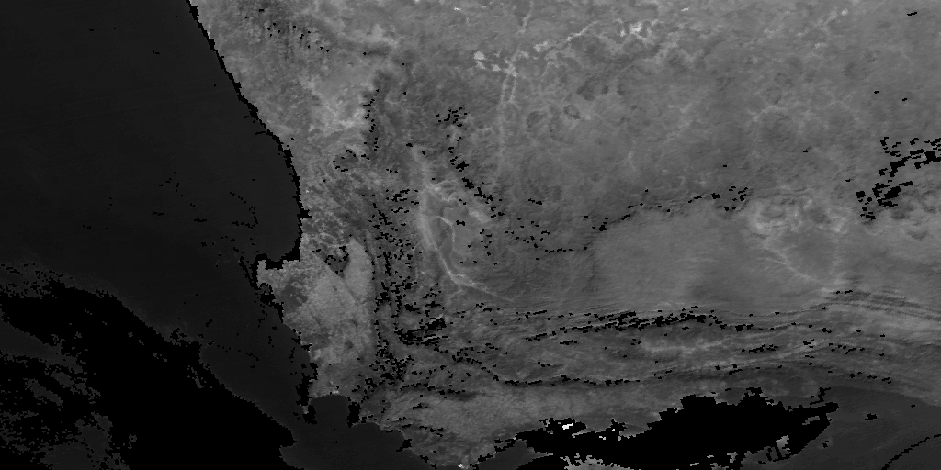
Fig 1a. Original image of South Africa (binary mask), 512x1024 pixels.

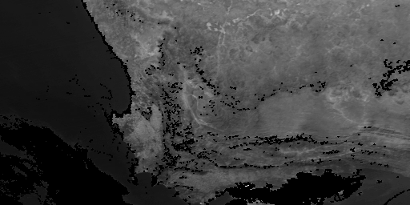

Fig 1b. Level 1 Haar transform low-low subband produced using a binary mask.
256x512 pixels

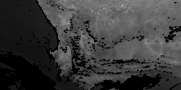
Fig 1c. Level 2 Haar transform low-low subband produced using binary mask.
128x256 pixels.

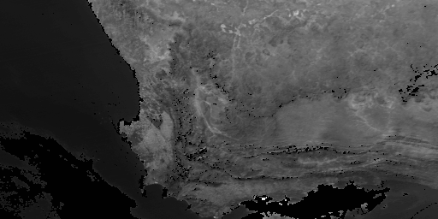

Fig 2a. Level 1 Haar transform low-low subband produced using fractional mask. 256x512 pixels.

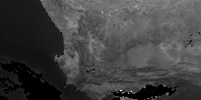
Fig 2b. Level 2 Haar transform low-low subband produced using fractional mask. 128x256 pixels.

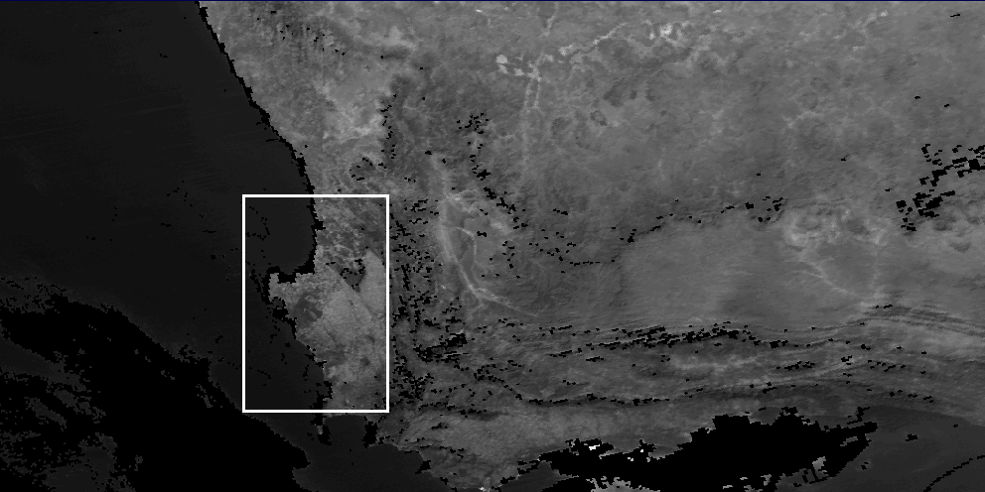

Fig 3. Coastline pattern used in experiments.

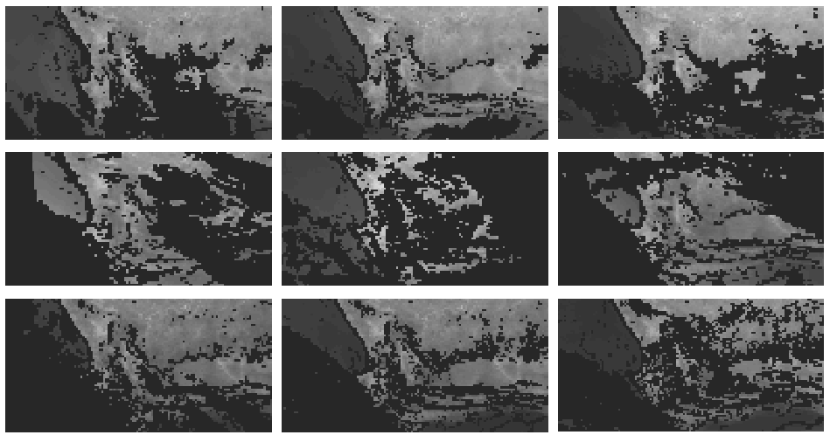
Fig 4. Database of partially occluded images of South Africa used in the trials. Occlusions are black, ocean is dark gray, land is light gray.

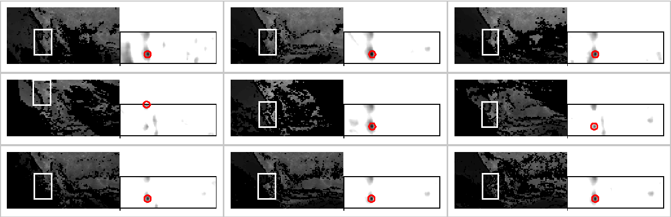

Fig 5. Query results from the fractional mask algorithm

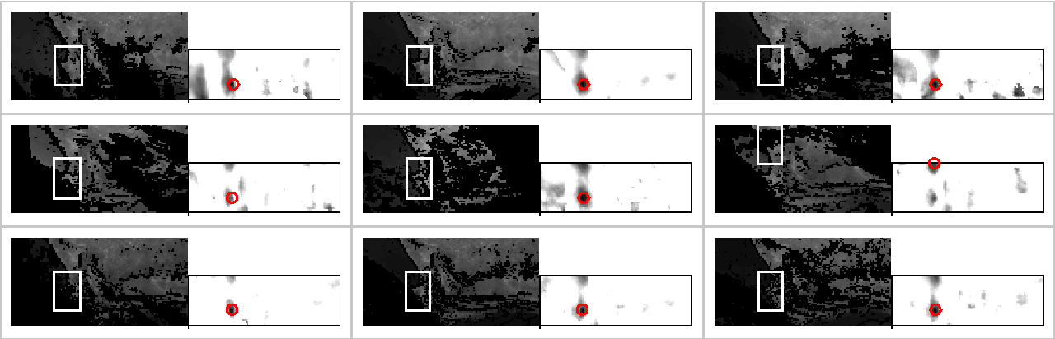
Fig 6. Query results from the binary mask algorithm

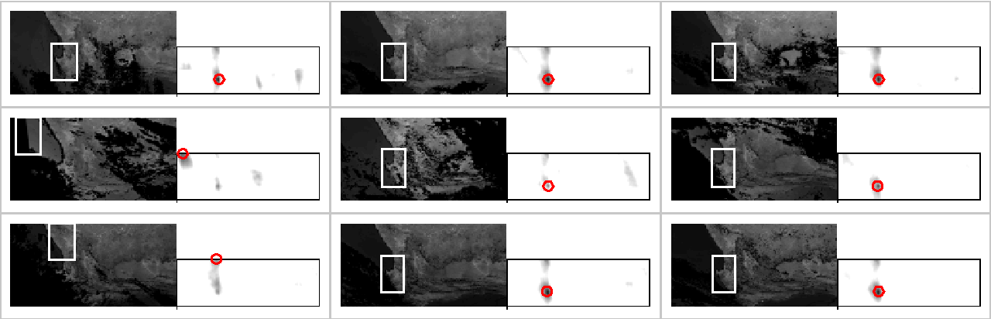

Fig 7. Query results from the unmasked algorithm

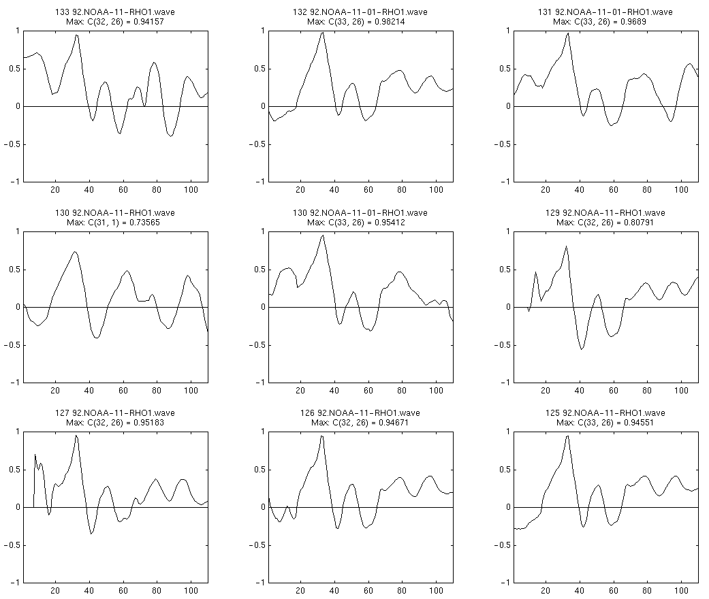
Fig 8. Cross-section of the correlations from the fractional mask algorithm

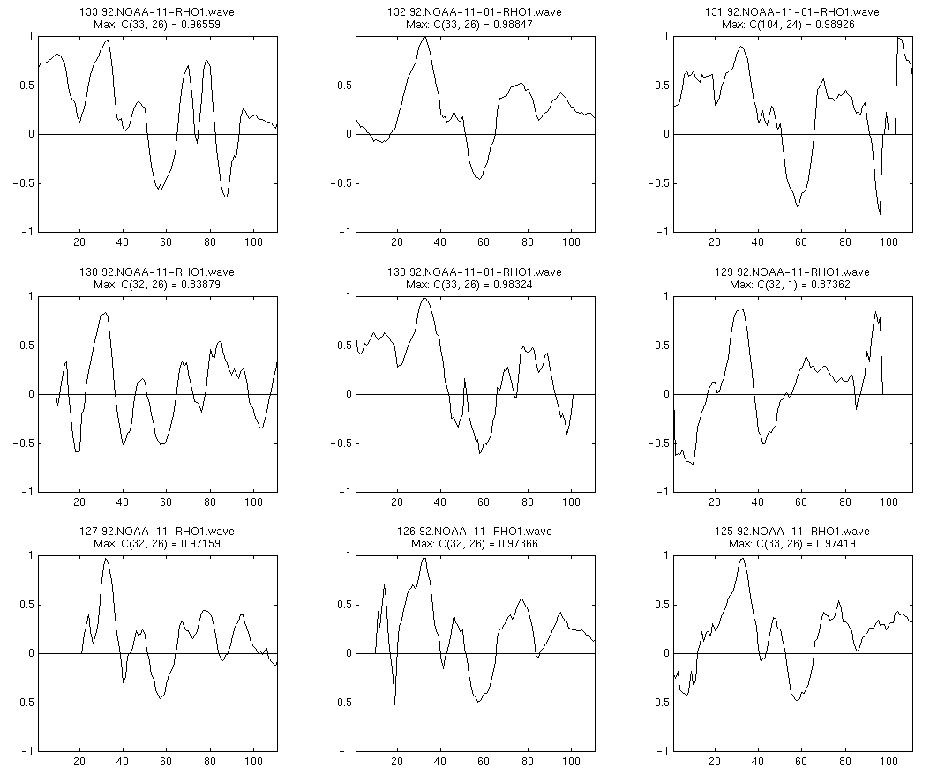
Fig 9. Cross-section of the correlations from the binary mask algorithm

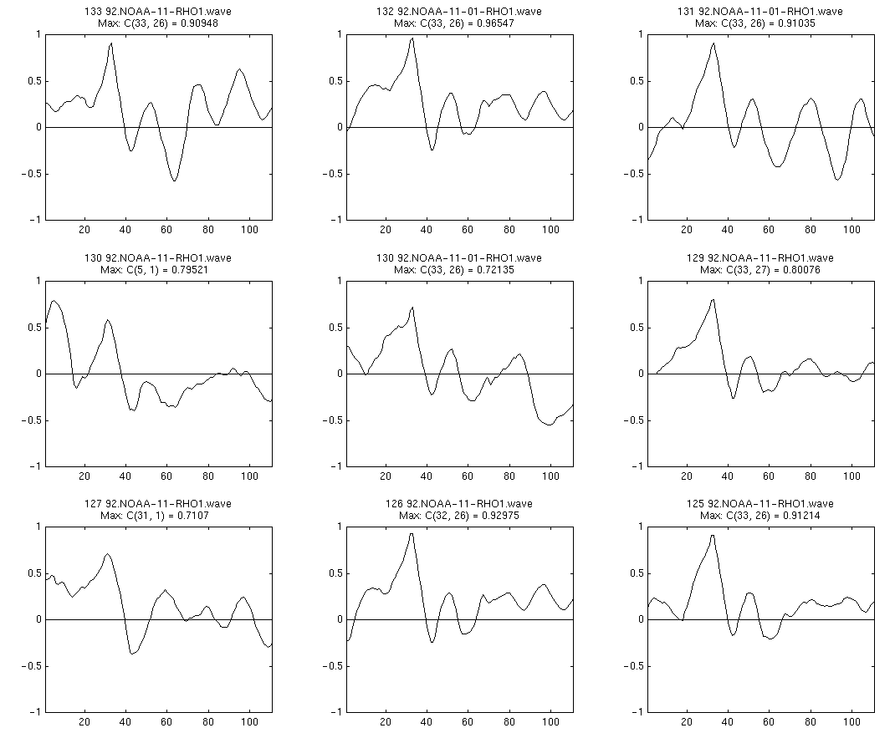
Fig 10. Cross-section of the correlations from the unmasked algorithm

An early version of this paper appeared at the Image Registration Workshop, Goddard Space Flight Center, Greenbelt, MD, Nov 20-21, 1997.

