**Preprocessing of the image:**

1. Open *.nd2 file in Imagej (FIJI)
   1. UnCheck Autoscale
   2. Color mode: Composite
2. Crop the image (Ctrl+Shift+X)
3. Duplicate the image(Ctrl+Shift+D)
4. Image – Stacks – Images to Stack
5. Save as *.tiff

**Script:**

File can be opened in Jupyter notebook (Please let me know if you need a help)

Packages required:

*PySimpleGUI; cv2; numpy; pandas; matplotlib; skimage*

1. Run the first cell in the file (Shift+Enter)
2. Settings:
   1. Change to 100 um and 50 columns
   2. Save settings
3. Analysis of images
4. Browse - Select the folder with the file
5. Select the image
6. Load image
7. Grid

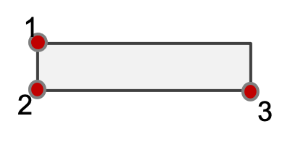

* 1. Top-left well (#1)
  2. Bottom-left well (#150)
  3. Bottom-right well (#200)

1. Report
2. Save the results
3. Open *.csv file
4. Intensities will in the column for Green (Live) channel