**Preprocessing of the image:**

1. Open *.nd2 file in Imagej (FIJI)
   1. **UnCheck** Autoscale
   2. **Color mode:** Composite
2. Crop the image (Ctrl+Shift+X)
3. Save as *.tiff

**Script:**

File can be opened in Jupyter notebook (Please let me know if you need a help)

Packages required:

*PySimpleGUI; cv2; numpy; pandas; matplotlib; skimage*

1. Run the first cell in the file (Shift+Enter)
2. Analysis of images
3. Browse - Select the folder with the file
4. Select the image
5. Load image
6. Grid

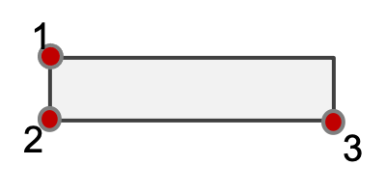

* 1. Top-left well (#1)
  2. Bottom-left well (#150)
  3. Bottom-right well (#200)

1. Report
2. Save the results