Georgia Institute of Technology

CS 4365/6365: IEC

Spring 2026

Project Checkpoint Report
Group: TBD
Name(s): Yaman Akbas
Project: AGORA
Project Plan (Plan):
Point A
The x402 protocol, launched by Coinbase, is an open source protocol that embeds stablecoin transactions directly into HTTP by using the 402 Payment Required status code. It allows APIs, applications and AI agents to transact easily without authenticating or needing an API key through one of the most simple flows on the internet. The client requests a resource, the server responds with a 402 status “challenge” containing the payment requirements, the client signs a payment (usually through facilitators), after the verification the server responds with the resource. When this is done with cryptocurrencies, the entire transaction can take milliseconds and can be done with payments as little as $0.00001. This brings the possible feature of finance on the internet, micropayments. As it may be the case for many agents, clients require not entire subscriptions but bits of data, in which case it makes more sense to use microtransactions.
However the x402 network currently has an issue that is bottlenecking even wider adoption and that is the discovery infrastructure. The x402 Bazaar currently is the only “official” paginated list endpoint (not counting facilitators) and it has very limited server-side search, filtering, or categorization. It is also lacking the sufficient mechanisms that are allowing for an efficient search pagination that we take granted today with search engines. The community has been actively expressing concerns about such issues and many of the github issues remain open (as of the last date before submission, Feb 20). One example is the issue #1057 (https://github.com/coinbase/x402/issues/1057) explicitly requesting server-side rendering. As of today, new issues have been spawning requesting a stronger reliability layer (https://github.com/coinbase/x402/issues/1277). The lack such capabilities in the discovery layer is a blockage for higher levels of adoption. Another issue is that, many of the endpoints are not returning high quality metadata as they register themselves to the network. This causes a large amount of “garbage” data to be mixed into the agents context every time the agent queries the discovery endpoint. Also there are not built in mechanisms to verify if the endpoints are online and functional. Coinbase themselves has commented on the discovery layer and have said that “it is more like the early days of search engines”, suggesting the current inefficiency of their discovery layer.
Several third-party attempts exist to address parts of this problem. SentEdge AI built a Bazaar dashboard with keyword search and filtering by method, network, and cost range. The x402 Index (x402index.com) maintains an independent community-submitted directory behind an x402-gated API. QuickNode created an interactive testing tool that includes Bazaar search. Standalone health-monitoring tools also exist in the ecosystem. However, none of these provide a unified solution that combines semantic search, reliability scoring, and a programmatic API interface designed for autonomous agent consumption.
Point B
By the end of the semester, AGORA will deliver the following:
A complete, continuously-updated index of all x402 endpoints sourced from the Coinbase Bazaar API and potentially other facilitators (PayAI, ChaosChain, x402.org testnet). The indexer will handle pagination, rate limiting, deduplication, and incremental refresh.
Semantic search over endpoint metadata using text embeddings to enable natural language queries such as “find me a crypto price feed API under $0.005” or “text anonymization service.” This will also include traditional keyword and filter-based search (by price range, network, HTTP method, domain).
Endpoint reliability scores computed through periodic health checks that verify liveness (does the endpoint respond?), proper x402 compliance (does it return a valid 402 with correct headers?), and response time. These scores will be stored historically to track reliability trends. Also thinking of using on-chain transaction records to infer reliability but this might be far fetched so this will stay as a possible feature.
A REST API designed for agent consumption that accepts a query and returns ranked results with full metadata including descriptions, input/output schemas, pricing, supported networks, and reliability scores.
Enrichment of low-quality metadata by inferring endpoint purpose from URL patterns, probing 402 responses, and clustering similar services to fill gaps where descriptions are missing or generic.
The target accuracy for search relevance is that the correct endpoint appears in the top 5 results for at least 80% of natural language queries tested against a manually curated evaluation set (though this might be farfetched, may need to change the goal in the next checkpoints). As I am the sole team member, I will be responsible for all tasks in the milestone chart below.
Milestone Chart
Week | Deliverables
5 | Research & literature review on x402 protocol, Bazaar API, and existing discovery tools; initial project proposal, Set up the Github Repo
6 | Set up project infrastructure: database schema design, initial API scaffolding
7 | Build Bazaar API crawler: paginate and cache all 12,000+ endpoints into local index
8 | Implement semantic search using embeddings over endpoint descriptions and schemas
9 | Implement keyword/filter search (by price, network, method, domain)
10 | Build reliability scoring system: periodic health checks, liveness probing, response time tracking
11 | Build REST API for agents: natural language query endpoint returning ranked results with metadata
12 | Integrate multi-facilitator support (CDP, PayAI, x402.org testnet); enrichment of low-metadata endpoints
13 | End-to-end integration testing with real x402 endpoints; handle edge cases (stale endpoints, duplicates)
14 | Performance optimization, caching layer, documentation, and demo preparation
15 | Final testing, demo, and project presentation
System Architecture (High Level)
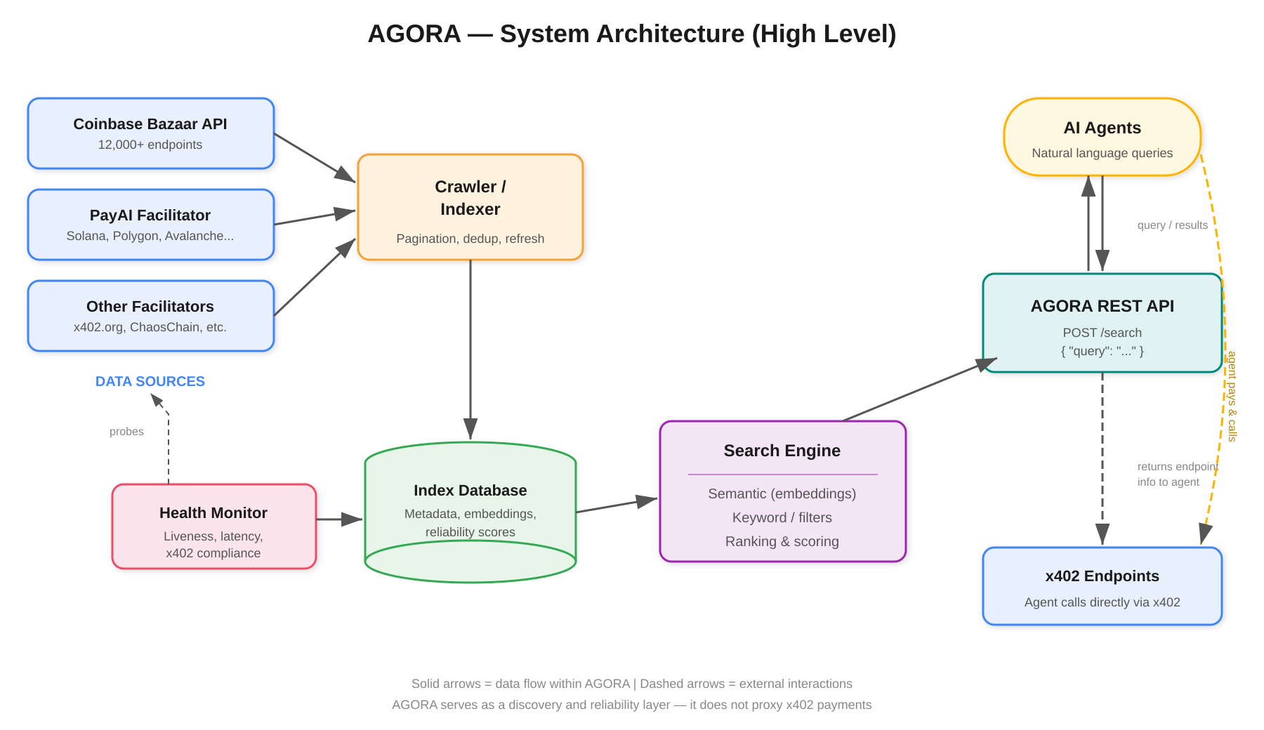
Figure 1: AGORA system architecture. Solid arrows represent internal data flow; dashed arrows represent external interactions.
Current Progress Report (Match):
As this is the initial project proposal, the primary work completed has been research into the x402 protocol, including analysis of the Bazaar API’s data structure and limitations. Through direct API testing, it was confirmed that the Coinbase discovery endpoint (https://api.cdp.coinbase.com/platform/v2/x402/discovery/resources) is publicly accessibl, returning paginated JSON with endpoint metadata. Analysis of the returned data revealed 3 tiers of metadata quality across the 12,000+ endpoints: richly described endpoints with full input/output schemas, partially described endpoints, and low-quality or spam-like registrations. These all can be checked independently. Ask your agent to query the endpoints.
By the next checkpoint, the GitHub repository will be initialized, the database schema will be designed, and the Bazaar API crawler will be operational, capable of ingesting and caching the full endpoint catalog. Then we will be seeing more results and possibly changing, iterating, and improving the product.
Supporting Evidence (Factual):
The GitHub repository for AGORA has not yet been created but will be hosted at: https://github.com/yakbas3/agora .
Research evidence includes direct testing of the Coinbase Bazaar API, review of the x402 protocol specification on GitHub (coinbase/x402), analysis of community issues including GitHub issue #1057 (https://github.com/coinbase/x402/issues/1057) documenting the rate limiting and missing search functionality, and review of the Coinbase and Cloudflare developer documentation for x402.
Note: I believe this is a fascinating piece of technology that could be the future of transactions of the internet (though I might just be fanboying). Research indicated that the adoption is in early stages but rapidly expanding. Some facilitators are projecting fiat money to be used in their next project so if that happens to be the case this project will be even more important.
Skill Learning Report:
Protocol Analysis and API Reverse Engineering: Through this initial research phase, I have developed a deeper understanding of how to evaluate the practical usability of a protocol by directly probing its APIs rather than relying solely on documentation. Testing the Bazaar endpoint revealed undocumented behaviors (such as the 1,000 max limit parameter and rate limiting after page 8, also said in the github issue) that are critical to the design of AGORA’s crawler.
Search and Information Retrieval Design: I am building foundational knowledge in semantic search architectures, specifically how to combine embedding-based similarity search with structured filtering (price, network, method) to serve hybrid queries. This will be the core technical challenge of the project. Also this search has to be very fast as the microtransactions and decision making in this sector take place within microseconds.
Ecosystem and Market Analysis: Through this work I was able to do competitive benchmarking, and was able to analyze gaps in a growing network and did market research. It was important to distinguish between problems that mattered and didn’t. I was able to understand that I found an issue that mattered as I found another github issue posted on the day I am submitting this file on the same issue.
Self-Evaluation:
Scope: I estimate the scope at 100%. AGORA addresses a validated infrastructure gap in a rapidly growing protocol ecosystem. The project combines multiple technical domains including web crawling, semantic search, reliability monitoring, and API design, which adds meaningful complexity. The direct applicability to the emerging agentic AI economy further elevates the project’s significance. Another aspect that I wanted to talk about, but refrained was the scalability issue. Depending on the possible use cases of the software, hardline scalability measures would need to be taken which would definitely bring the project to an undeniable 120%.
Match: I estimate match at 100%. The milestone chart is realistic given the project’s scope and my background. The key risk is the Bazaar API’s rate limiting, which could slow the initial indexing phase, but this is mitigable through incremental crawling and caching strategies.
Factual: I estimate factual at 100%. The core data source (Bazaar API) has been confirmed as publicly accessible, and I have direct experience with the technologies that will be used (Python/Node.js for the backend, embedding models for search, and standard database systems for the index). All claims about the x402 ecosystem’s state are backed by direct API testing and public documentation. I will also be leaving some of the research that I have generated on the matter, you can find it in the public github repository.

