Essential Studio

Essential_Studio

Essential DocIO

Text that will preserve source formatting.

Essential PDF

PDF

Essential XlsIO

Text that will preserve target formatting.

Image

Syncfusion inc | 
Essential Studio includes ten component libraries in one great package. Each of these products has a unique and useful feature set.
Essential DocIO is a .NET library that can read and write Microsoft Word files. It features a full-fledged object model similar to the Microsoft Office COM libraries. It does not use COM interop and is built from scratch in C#. It can be used on systems that do not have Microsoft Word installed.
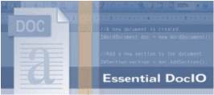

Essential PDF is a .NET library that can produce Adobe PDF files. It features a full fledged object model for the easy creation of PDF files from any .NET language. It does not use any external libraries and is built from scratch in C#. It can be used on on the server side (ASP.NET or any other environment) or with Windows Forms applications.

