Import RTF to Word Demo

Essential DocIO now supports conversion from Rich Text Format into Word document.

Essential Studio User Interface Edition
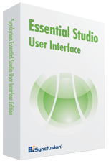 | The most complete set of User Interface Components for Windows and Web development. High performance Grid, Docking and Menu frameworks, data binding controls, Scheduler, Data Visualization Chart, Gauge, Diagram and more.
Essential Studio Reporting Edition
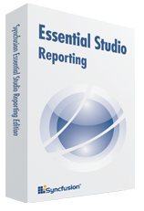 | Create advanced reports with our WPF based reporting solution or integrate document based reporting (PDF, Excel, Word) into your Windows and Web applications.

