How to insert pictures into Word?
Open the Insert menu (fourth menu from the left). Click on “picture” and “from file.”
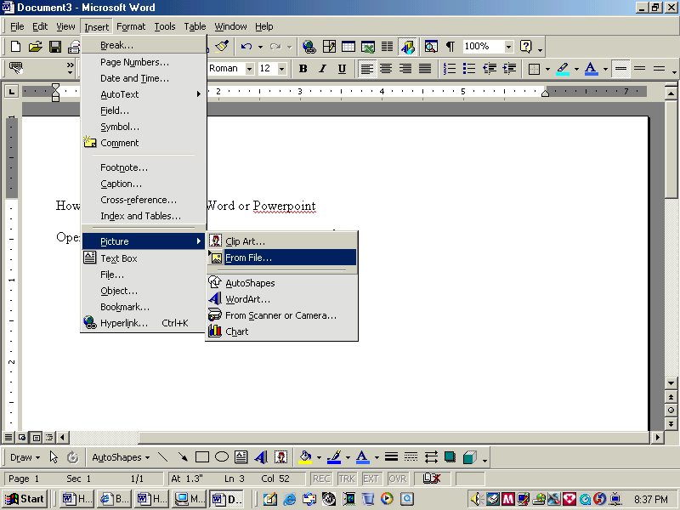

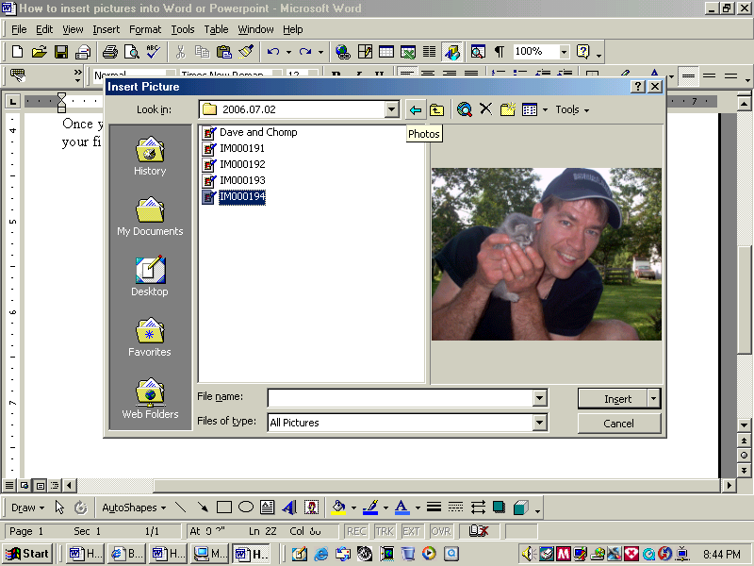

Once you do this, you will get an “Insert Picture” window that allows you to use the pop-up menu to find your files. You will be given the chance to preview pictures before you insert them. Once you find the picture you want, click the Insert button.

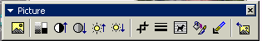
Once you insert the picture, a picture toolbar usually pops up. You can use this toolbar to change the layout (1), and adjust the image. If this toolbar doesn’t show up or it disappears, you can find it by using the View menu (third from the left). Select toolbars and choose the picture toolbar from this menu.
(1)

You can also format a picture by right clicking on the picture and choosing “Format Picture” from the menu that pops up there. You can resize it, change the layout and do other things from these menus. Now you can create a newsletter or a story with your pictures.

How to insert Tables?

To make a TABLE select the Table icon or go to Table > Insert Table
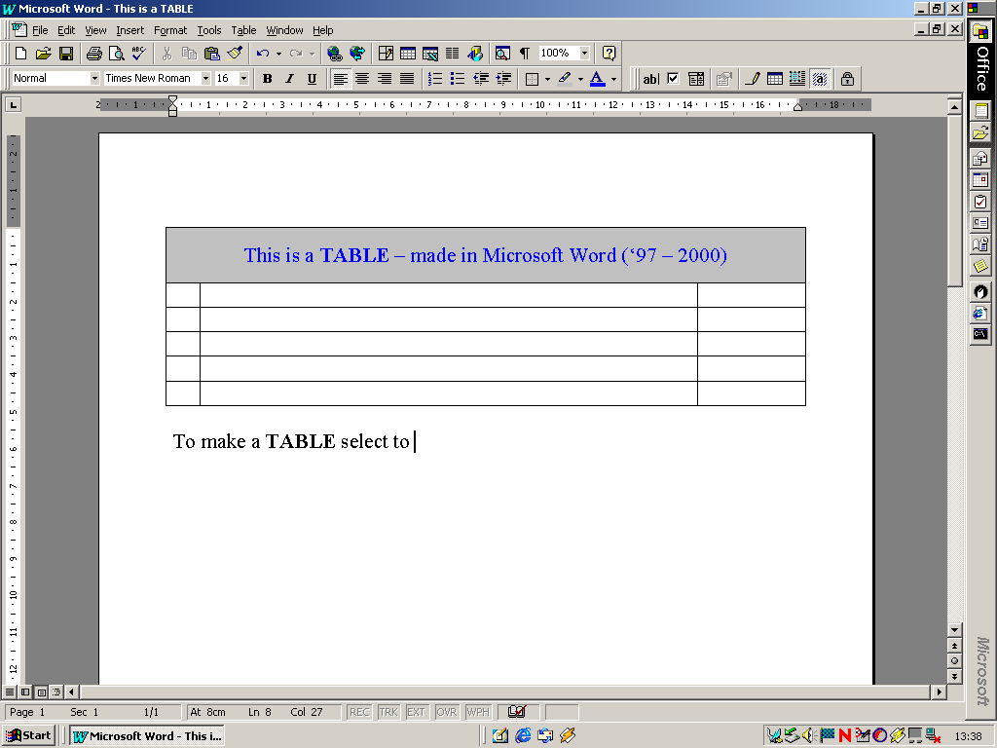

Table icon
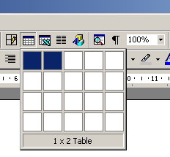

Drag your mouse pointer to select the amount of CELLS you wish to make.

A series of Vertical cells is called a COLUMN and a series of Horizontal cells is called a ROW.

You can then manipulate the cells by dragging them with your mouse pointer.

You need to HOVER over a ROW or COLUMN divider and watch for the mouse pointer changing into directional arrows. By pressing your left mouse button – these can then be dragged!

Here is the table inserted:

INSERT TABLE

INSERT PARAGRAPH ITEMS

