ILT System - Functional Requirements Specification (FRS / SRS v1.0)
Functional Design, Screen Wireframes, Clinical Workflows, and Algorithmic Motor Learning Specification
Document Parameter | Value & Specification | Document Parameter | Value & Specification
Document ID: | ILT-FRS-V1.0-EN (Functional Specification) | Release Date: | October 2026
Clinical Basis: | Dr. Hagit Hollander & Prof. Esther Adi-Japha (Bar-Ilan Univ.) | Target Hardware: | Wacom Movink / DTHA116 (EMR 133Hz)
Approval Status: | Approved Specification (Post-Researcher Q&A) | Target Cohort: | Grade 2 Elementary Students (Low-SES Focus)
Architecture & Network: | Web Kiosk + Direct Local LAN P2P (Local Wi-Fi) | Cloud Sync: | Asynchronous (PostgreSQL, TimescaleDB, MinIO)

1. Introduction, Objectives & Clinical Research Background
This document establishes the official Functional Requirements Specification (FRS v1.0) for the Invented Letter Task (ILT) Application System. Designed as an open-source educational research platform, the ILT system provides early, objective, and standardized screening for children at risk of learning disabilities and literacy deficits (dyslexia, dysgraphia, reading comprehension impairments, and written expression difficulties), with a primary focus on 2nd-grade students from low socioeconomic backgrounds (Low-SES).
1.1 Scientific Rationale & Procedural Learning System (PLS)
Pioneering clinical research conducted by Dr. Hagit Hollander and Prof. Esther Adi-Japha (School of Education, Bar-Ilan University) demonstrated an empirical link between motor procedural memory consolidation and written language acquisition. While writing real alphabet letters is confounded by prior knowledge, home literacy environment, and formal classroom instruction, the Invented Letter Task isolates an entirely novel graphomotor procedural skill: connecting three sequential target dots in a single continuous stroke. The rate of motor stabilization, pressure modulation, and kinematic error reduction across training blocks serve as significant predictors of end-of-year reading and writing achievements.
1.2 Transition from Legacy Paper-on-Digitizer to Interactive Screen Tablet
The legacy research apparatus relied on physical paper sheets affixed over an opaque Wacom digitizer board. This setup imposed severe clinical and technological bottlenecks:
• Disruptive Physical Sheet Swapping: The evaluator had to manually swap printed paper sheets between every block. This broke the child's concentration, disrupted inter-block consolidation timing, and burdened testing sessions.
• Mechanical Misalignment & Slippage: Accidental paper shifts relative to the underlying digitizer board distorted coordinate registration, requiring labor-intensive post-hoc manual rectification.
• Lack of Interactivity & Post-Correction Prevention: The physical paper could not prevent children from backtracking to modify earlier shapes, corrupting velocity and segmentation analytics.
The new ILT application transitions the entire evaluation to an interactive digital screen tablet (Wacom DTHA116 / Movink). The solution combines high-precision direct visual feedback, high-frequency EMR pen sampling (133Hz–200Hz), 4,096 pressure levels, in-air hover tracking, dynamic forward-only canvas locking, and automated real-time error evaluation.
2. Key Clinical & Methodological Decisions (Lead Researcher Q&A)
Following a detailed clinical review with the lead researcher, all open methodological and technical questions have been resolved and formalized into the system specifications:
# | Clinical Parameter | Mandatory Clinical Decision | Engineering & UI Implementation
1 | Verbatim Instructions & Video Demos | Standardized verbal script using child-friendly metaphors ('house', 'street', 'neighborhood'). Single-stroke emphasis without backtracking ('whatever comes out, I'm happy'). 20-second intro video before Block 1; 20-second notebook demo after Block 4. | Dynamic proctor teleprompter card; automated 20s video player embedded in student tablet kiosk prior to canvas presentation.
2 | Inter-Block Consolidation Delay | Mandatory 20–30s delay between blocks. Child places pen in dedicated 'pen holder' area and presses green 'Next Block' button. Pen-down rest is biologically critical for procedural memory consolidation. | Configurable countdown timer (default 25s); canvas locked during delay; visual pen-holder rest target; evaluator manual override button.
3 | Block Termination & Disruption | Inactivity timeout: 20s without movement, or 30s after 15th letter completion. Evaluator warning badge ('Waiting for response...'). Critical capability: Repeat Block button for disruptions (bells, breaks). | Real-time inactivity watchdog; amber cockpit status badge; [Repeat Block] control that discards interrupted attempt and re-initializes block.
4 | Skipped Houses (Forward-Only) | Children are strictly prohibited from backtracking. Any skipped house is automatically flagged as an error and permanently locked against writing. Time metrics normalized per completed shapes. | Forward-only dynamic canvas locking; immediate touch in box N+1 locks all unfilled boxes 1..N; visual locked boundary.
5 | Segment Width & Tolerance | Nominal letter width is 15 mm. Allowable clinical tolerance: ±2 mm (valid range: 13–17 mm). Stroke must pass through the middle target dot circle. | Kinematic deviation algorithm normalized against start-to-end baseline; bounding hit-circle around middle dot; automated width violation logging.
6 | Pen Lifts & Error Model | Letter level: internal pen lift (>0) or missed middle dot = letter error. Block level: benchmark of exactly 15 lifts (transitions between houses); >15 indicates stroke fragmentation. | Dual-tier error calculation: real-time letter classification (internal lifts, middle hit, width) + block summary (total lifts, locked skipped houses).
7 | DCD Transfer Task (Blank Grid) | Dedicated 'Blank Task Template' (3x5 grid without guidance dots) supported in v1.0. Measures timing and kinematics; structured for future AI vision legibility scoring. | Template generator extension for dotless grid; raw stroke vector logging optimized for future computer vision contour and baseline adherence analysis.
8 | Classroom Oversight Mode | Primary mode is 1:1. Support multi-student cockpit allowing one proctor to supervise 4 children simultaneously (up to 6 max) to optimize school testing throughput. | Multi-Student Cockpit layout featuring 4 live quadrant thumbnails, real-time status badges, inactivity alerts, and individual drill-down controls.
9 | Pilot Scope (October 2026) | The October 2026 pilot exclusively requires the 3x5 invented letter template (with dots and blank DCD transfer variant). No extra shapes needed. | Software engineering focus concentrated on 3x5 template stability, local P2P reliability, and sub-15ms mirroring performance.

3. Software Architecture, Local P2P Protocol & Cloud Synchronization
The ILT architecture is engineered for zero-dependency resilience within school and clinic environments. The runtime operations execute entirely over a local peer-to-peer (P2P) network channel between the examinee tablet and evaluator workstation, with asynchronous synchronization to the cloud.
3.1 Local P2P Channel (WebRTC DataChannel / Local WSS)
In typical clinical and school setups, both devices share the same local Wi-Fi router. Telemetry streams directly over the local network:
• Ultra-Low Latency (<15ms): Direct local transmission ensures instantaneous pen mirroring on the evaluator's monitor without lag or packet drops.
• Zero WAN Dependency: Testing sessions proceed uninterrupted even during full external internet blackouts or restrictive school firewalls.
• Batching Policy (3–5 Samples Window): At 133Hz–200Hz sampling rates, individual sample transmission induces severe TCP/IP header overhead. Telemetry is batched into compact binary frames of 3–5 samples (every 15–25ms, default 4 samples), reducing network overhead while maintaining 60 FPS rendering fidelity.
3.2 Local Storage & Asynchronous Cloud Synchronization
• Local Redundancy (IndexedDB & OPFS): During testing, all raw EMR samples are persisted to the browser's IndexedDB. Synchronized face/hand video recorded via USB webcam is written directly to the Origin Private File System (OPFS) on the evaluator's machine.
• Asynchronous Idle Upload: When the session finishes and valid internet connectivity is detected, an automated sync daemon dispatches bulk uploads: session metadata to PostgreSQL, high-density telemetry to TimescaleDB, and encrypted video recordings to MinIO S3 Object Storage.
4. Protocol OpCodes & Event Dictionary
Real-time communication across the local WebRTC/WebSocket channel is governed by standardized binary OpCodes:
OpCode | Command / Event Name | Direction | Functional Purpose & Payload
0x01 | PEN_DATA_BATCH | Tablet -> Cockpit | Batched binary packet containing 3–5 EMR samples (X, Y, Pressure, Tilt, Time, Flags).
0x02 | STROKE_START | Tablet -> Cockpit | First pen contact (Pen Down) registered inside an active segment.
0x03 | STROKE_END | Tablet -> Cockpit | Pen liftoff (Pen Up) event. Used to calculate in-air time and hand raises.
0x04 | SEGMENT_COMPLETED | Tablet -> Cockpit | Successful completion of a letter shape and advancement to next house.
0x05 | SEGMENT_SKIPPED_LOCKED | Tablet -> Cockpit | Triggered when a house is skipped: locks skipped house and records error.
0x06 | BLOCK_START | Cockpit -> Tablet | Loads next block canvas following instructional video or consolidation delay.
0x07 | BLOCK_TIMEOUT_WARNING | Tablet -> Cockpit | Inactivity alert: 20s idle during block, or 30s elapsed after 15th letter.
0x08 | BLOCK_COMPLETED | Bidirectional | Normal completion of all 15 shapes, initiating consolidation rest timer.
0x09 | BLOCK_REPEAT_TRIGGERED | Cockpit -> Tablet | Proctor command resetting the current block due to external disruption.
0x0A | DELAY_TIMER_TICK | Tablet -> Cockpit | Synchronized countdown tick during the 20–30s consolidation delay.
0x0B | SESSION_START | Cockpit -> Tablet | Launches a new evaluation session (Day 1, 2, or 14) post-PIN pairing.
0x0C | SESSION_FINISH | Bidirectional | Terminates the session upon completion of scheduled blocks and triggers sync.
0x0D | PAIRING_PIN_REQUEST | Tablet -> Server/Cockpit | Tablet requests direct P2P pairing via 5-digit one-time token.
0x0E | PAIRING_PIN_VERIFIED | Server/Cockpit -> Tablet | Handshake confirmed; establishes encrypted WebRTC DataChannel.
0x0F | EMERGENCY_PAUSE | Cockpit -> Tablet | Evaluator emergency freeze pausing all timers and pen event intake.
0x10 | CLINICAL_NOTE_ADDED | Cockpit -> DB | Timestamped clinical observation recorded by evaluator during live task.

5. Detailed Clinical & System Workflow Specifications
The ILT application executes a structured multi-stage workflow derived from Dr. Hollander and Prof. Adi-Japha's research methodology:
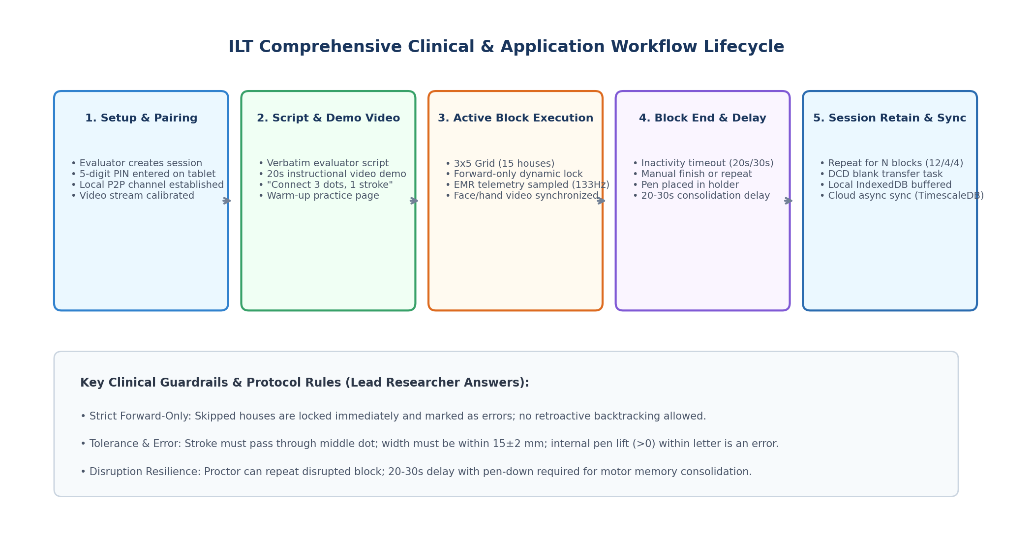
Figure 1: Comprehensive ILT Clinical and System Lifecycle Workflow
5.1 Student Intake & Device Pairing Workflow
• Step 1: Session Initiation: The evaluator logs into the cockpit, selects the educational jurisdiction/domain, and enters protected child demographics: anonymous Participant ID, student initials (2 letters only), date of birth/calculated age, dominant hand (Mandatory: Right/Left), and pen grip type.
• Step 2: Protocol Configuration: The evaluator designates session stage (Day 1 Acquisition: 12 blocks, Day 2 Retention: 4 blocks, or Day 14 Automaticity: 4 blocks), consolidation delay (25s default), and writing direction (Right-to-Left for Hebrew).
• Step 3: 5-Digit PIN Pairing: The console generates a 5-digit PIN (e.g., 84920). The tablet, running in full Kiosk mode, prompts for the PIN. Entering the code establishes an instant local WebRTC DataChannel, while calibrating the USB camera stream.
5.2 Instruction Script & Video Demonstration Workflow
• Official Verbatim Script: The evaluator delivers the exact standardized verbal prompt displayed on the cockpit teleprompter:
'Today we will learn how to write an invented letter on a special board, in notebook lines, and on paper. In front of you is a made-up letter, (pointing to the shape) it has 3 dots that help us draw it. You need to connect the three dots in one continuous line, starting from the top dot (pointing consecutively to the three dots). Make sure not to skip any dot. Look (pointing to the line), every letter has a house. And every line is like a street with 5 houses. You write a letter and then move on to the next letter in order, finishing the entire street. When you finish, you move down to the street below. Every three streets make up a block (neighborhood). Remember to write each letter in a single stroke, as fast and as accurately as you can. Pay attention: you don't need to go back and correct mistakes—whatever comes out, I'm happy with! Later we will practice and it will get better and better. Don't worry. When you finish the entire block on the page, place the pen here (showing the pen-holder) and press the green 'Next Block' button, and then we will practice in a new neighborhood. This is how you'll learn to write. It's really fun! But first, let's watch a video showing how it's done, and then we'll do a trial. Are you ready?'
• 20-Second Instructional Video: Before the first drawing canvas appears, the tablet plays a 20-second video demonstrating an overhead view of a child's hand connecting the 3 dots in a single stroke.
• Reinforcement Prompt: Immediately as the video concludes, the evaluator repeats the core instruction: 'Remember to write each letter in one stroke, as fast and accurately as you can!'
5.3 Warm-Up Practice Block
A dedicated warm-up canvas featuring a single row of houses is presented. Data from this trial is excluded from formal research analytics, serving exclusively to familiarize the child with tablet mechanics and mitigate testing anxiety.
5.4 Active Block Execution & Forward-Only Dynamic Locking
• 3x5 Grid Rendering: The canvas displays 3 horizontal streets containing 5 houses each (15 houses total). Writing flows right-to-left.
• Forward-Only Dynamic Lock: Children must advance strictly from House 1 to House 15. If a child touches a subsequent box without completing the preceding one, the skipped box is instantly flagged as an error and permanently locked against writing.
• Real-Time Evaluator Mirror: The cockpit mirrors drawing progress at 60 FPS, with strokes dynamically colored by pressure: Green (Light 0–20%), Blue (Medium 20–40%), Red (Heavy 40–100%). In-air hover is highlighted with a violet reticle.
5.5 Block Completion, Consolidation Delay & Disruption Handling
• Termination Conditions: A block ends when all 15 houses are processed, upon 20s continuous inactivity, or 30s after the 15th letter.
• Evaluator Warning Lamp: During prolonged pauses, an amber status indicator flashes on the cockpit: 'Waiting for response...'. The proctor can manually close the block or allow extra time.
• Repeat Block Action: If an external disruption occurs (school bell, bathroom emergency, pen dropped), the evaluator clicks [Repeat Block]. The corrupted attempt is preserved for audit but invalidated, and the identical block restarts fresh.
• Consolidation Delay (20–30s): Following a successful block, the tablet locks for 20–30s. The child rests the pen in the 'pen holder' area. This biomechanical pause promotes motor memory consolidation. Once the timer elapses, the green [Next Block] button activates.
5.6 Multi-Session Longitudinal Protocol & DCD Transfer Task
• Day 1 (Acquisition): 12 blocks (180 shapes total). Crucial protocol checkpoint: after Block 4, the evaluator screens a 20s video demonstrating notebook execution without dots. The child completes 4 blocks in a physical notebook, then returns to the tablet for 4 final blocks.
• Day 2 (24-Hour Retention): Conducted 24 hours later; consists of 4 tablet blocks (60 shapes) to evaluate motor memory stabilization following sleep.
• Day 14 (Two-Week Automaticity): Conducted 14 days later; consists of 4 tablet blocks to evaluate long-term automaticity, followed by 2 paper blocks timed via stopwatch.
• DCD Transfer Task (Blank Template): A specialized 3x5 grid devoid of dots is administered to assess spatial organization, stroke curvature, and baseline adherence in children with developmental coordination disorder.
5.7 Small Group Multi-Student Classroom Workflow (1:4 Oversight)
To maximize testing efficiency in school settings, the console supports 1:4 simultaneous monitoring:
• 4-Quadrant Split Screen: Displays 4 student cards simultaneously with live canvas thumbnails, block numbers, active houses, error counters, and status badges (NORMAL, CONSOLIDATION, ATTENTION).
• Individual Intervention: The evaluator can click any quadrant to expand to 1:1 view, trigger [Repeat Block], or pause an individual student.
6. User Interface Wireframes & Screen Component Specifications
The following wireframes define the visual hierarchy, component layouts, and interaction patterns across the system:
6.1 Evaluator Setup & Intake Console
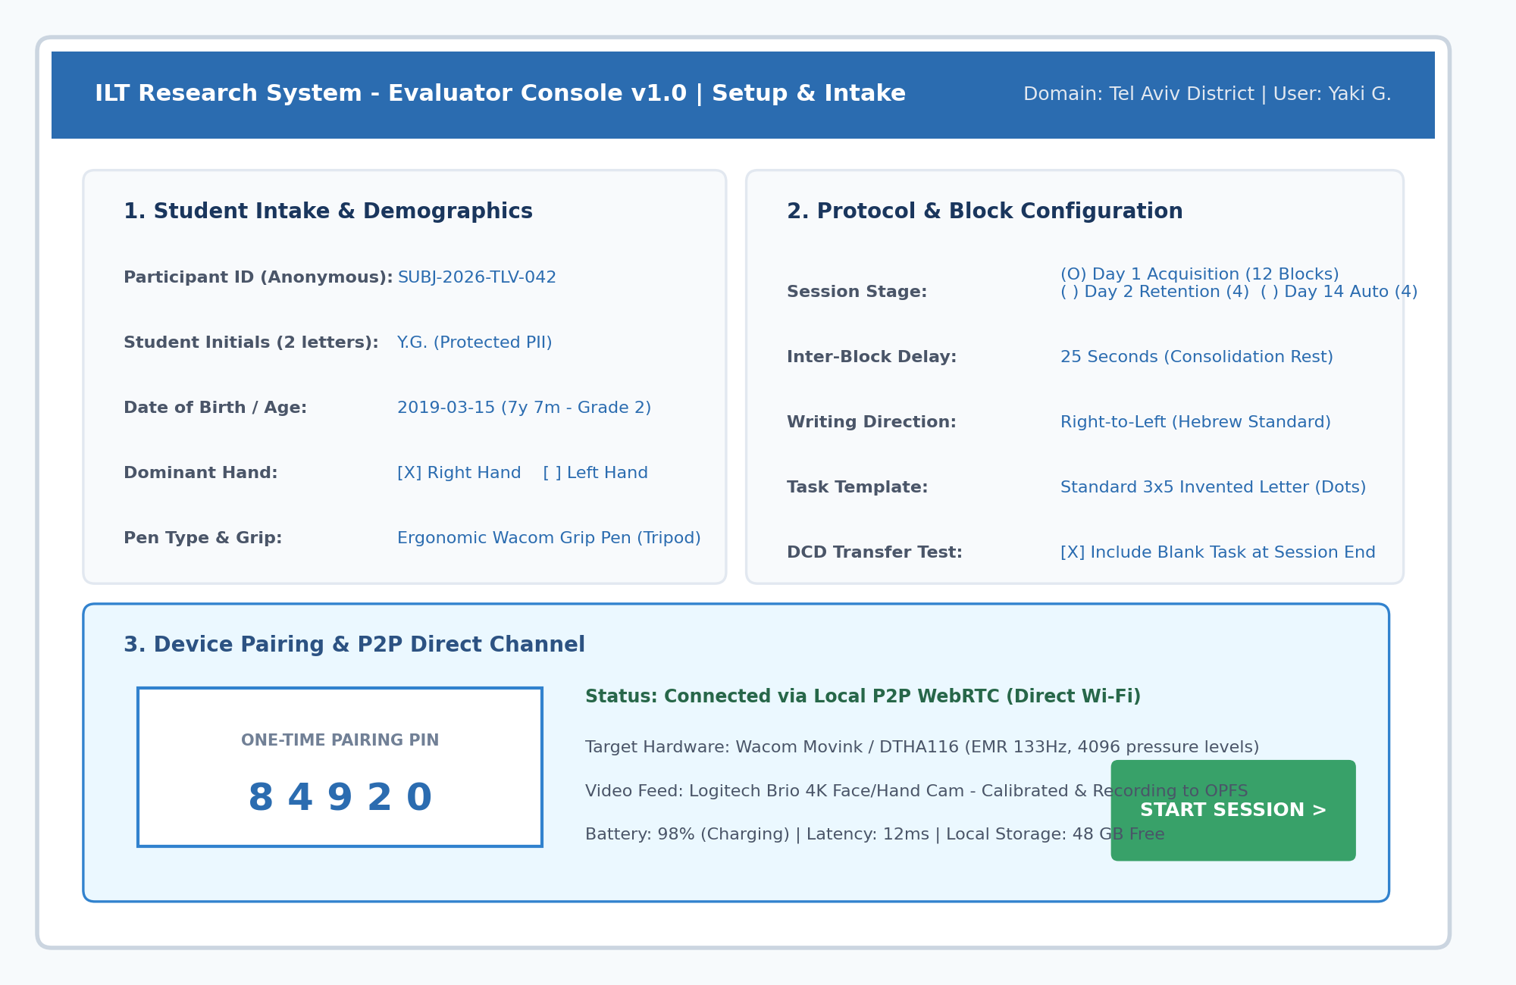
Figure 2: Evaluator Setup, Student Intake & P2P Pairing Wireframe
• Card 1: Student Intake & Demographics: Fields: Anonymous Participant ID, Student Initials (2 letters), Birth Date / Age calculation, Dominant Hand radio toggles, Pen Type and grip documentation.
• Card 2: Protocol & Block Configuration: Fields: Session Stage selector (Day 1 / Day 2 / Day 14), Consolidation Delay slider (20–30s), Writing Direction, Task Template selector (Dots vs. Blank DCD).
• Card 3: Device Pairing & Local Hardware Telemetry: Prominent 5-digit PIN token display, WebRTC P2P direct connection badge, tablet battery level, latency gauge, and USB webcam feed status.
6.2 Student Kiosk Writing Canvas
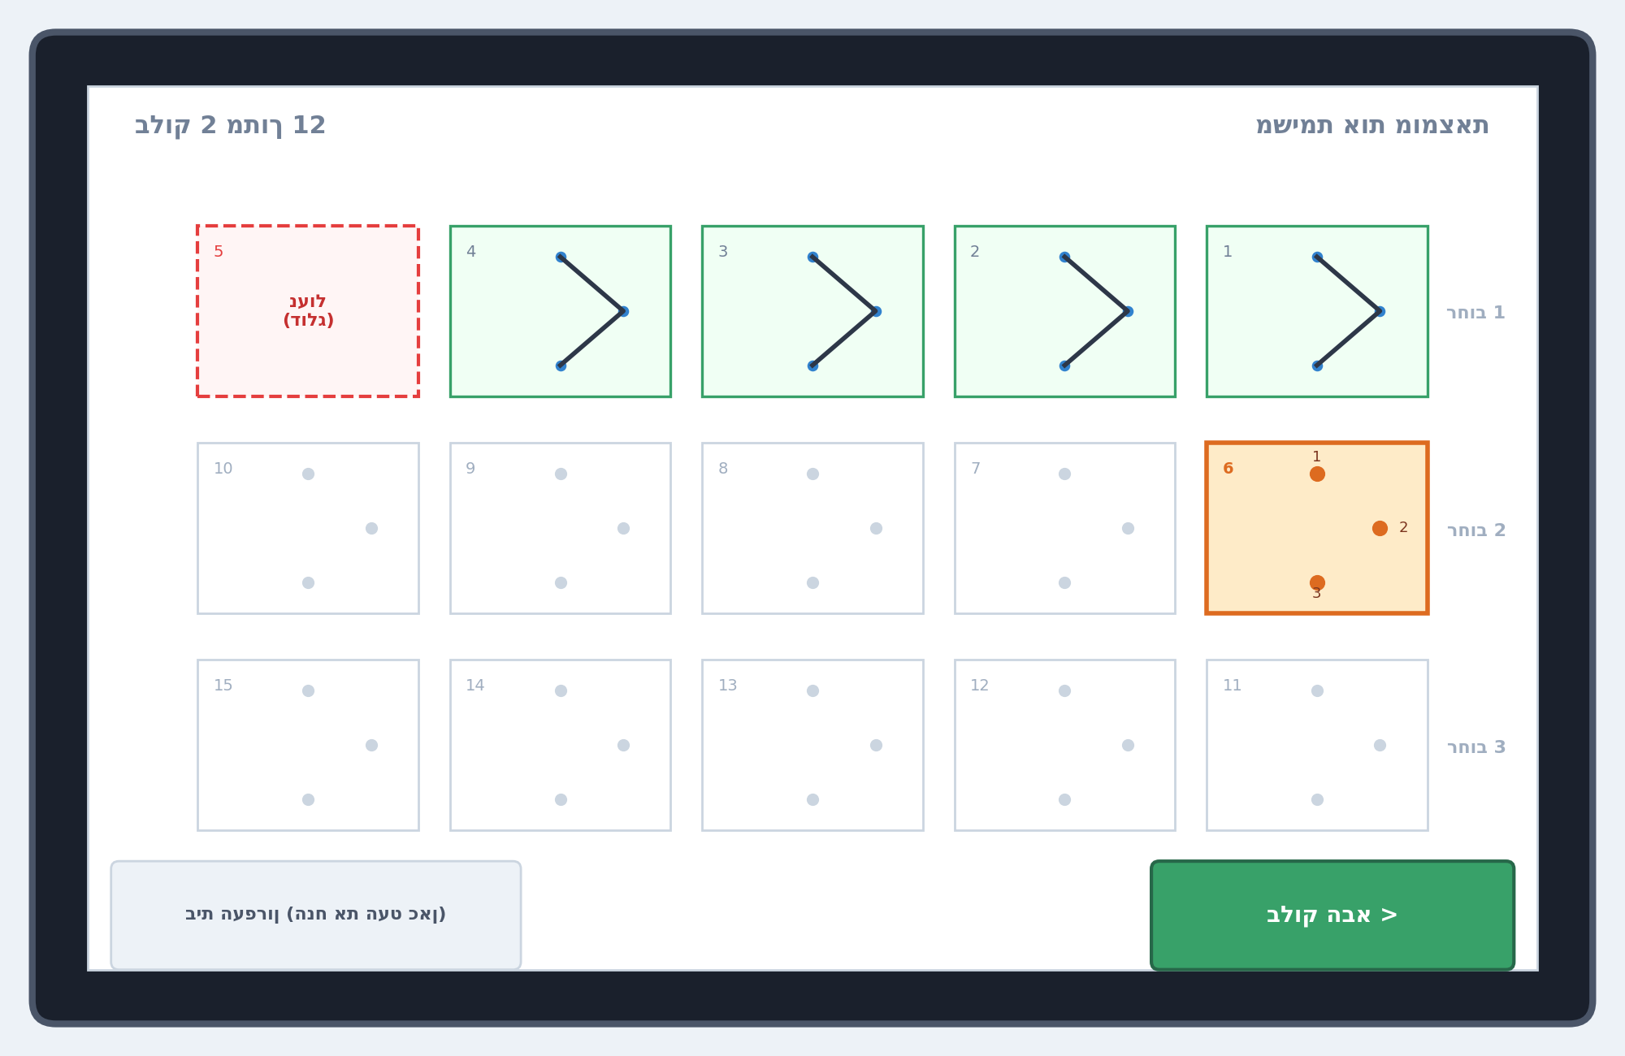
Figure 3: Student Interactive Kiosk Drawing Canvas Wireframe
• Distraction-Free Kiosk Mode: Strict full-screen viewport devoid of system navigation bars, clocks, scores, or complex menus.
• 3x5 Grid Layout (Streets & Houses): Structured into 3 horizontal streets containing 5 houses each. Unfilled target houses display 3 distinct target dots, with the active house highlighted in amber.
• Dynamic Forward-Only Locking: Completed houses turn soft green. Skipped houses turn light red with a dashed border and 'Locked' label, blocking retroactive attempts.
• Pen Holder & Next Block Target: A graphic pen rest zone is anchored at the bottom-left, beside a large green [Next Block] button that unlocks following consolidation pause.
6.3 Evaluator Cockpit 1:1 Screen (80% Live Mirror / 20% Telemetry)
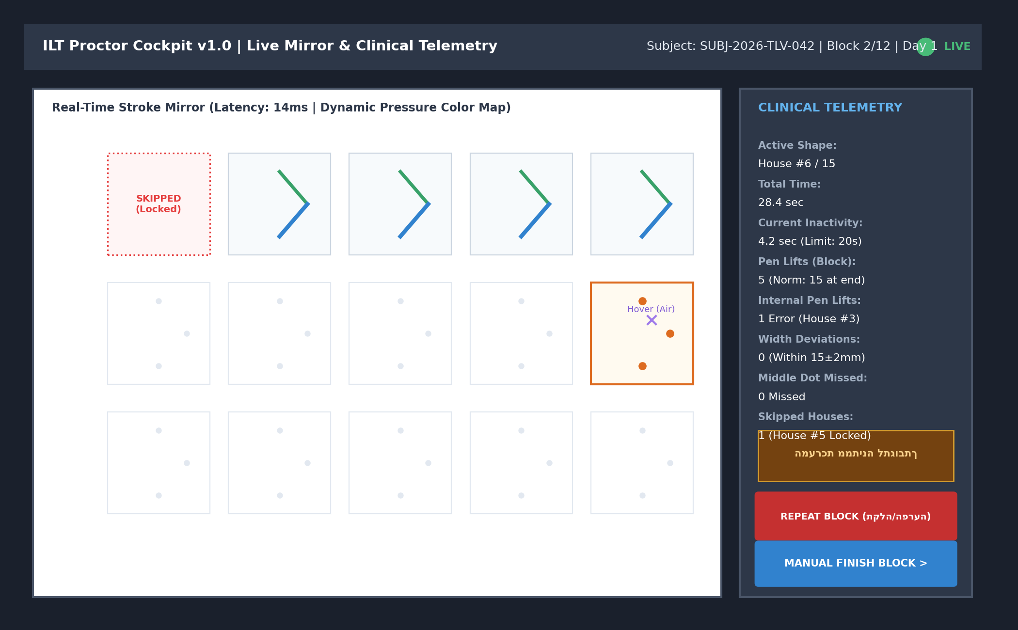
Figure 4: Evaluator Proctor Cockpit (80% Live Mirror / 20% Telemetry Side Panel)
• 80% Live Stroke Mirror: Sub-15ms canvas mirror showing real-time pen strokes rendered in dynamic pressure colors: Green (Light 0–20%), Blue (Medium 20–40%), Red (Heavy 40–100%), alongside in-air hover crosshairs.
• 20% Clinical Telemetry Panel: Displays real-time parameters: Active House #, Total Block Time, Inactivity Counter, Block Pen Lifts, Internal Pen Lifts (Errors), Width Deviations, and Skipped House count.
• Warning Lamp & Controls: 'Waiting for response...' warning badge, red [Repeat Block] emergency reset button, and blue [Manual Finish Block] control.
6.4 Multi-Student Classroom Console (1:4 Small Group)
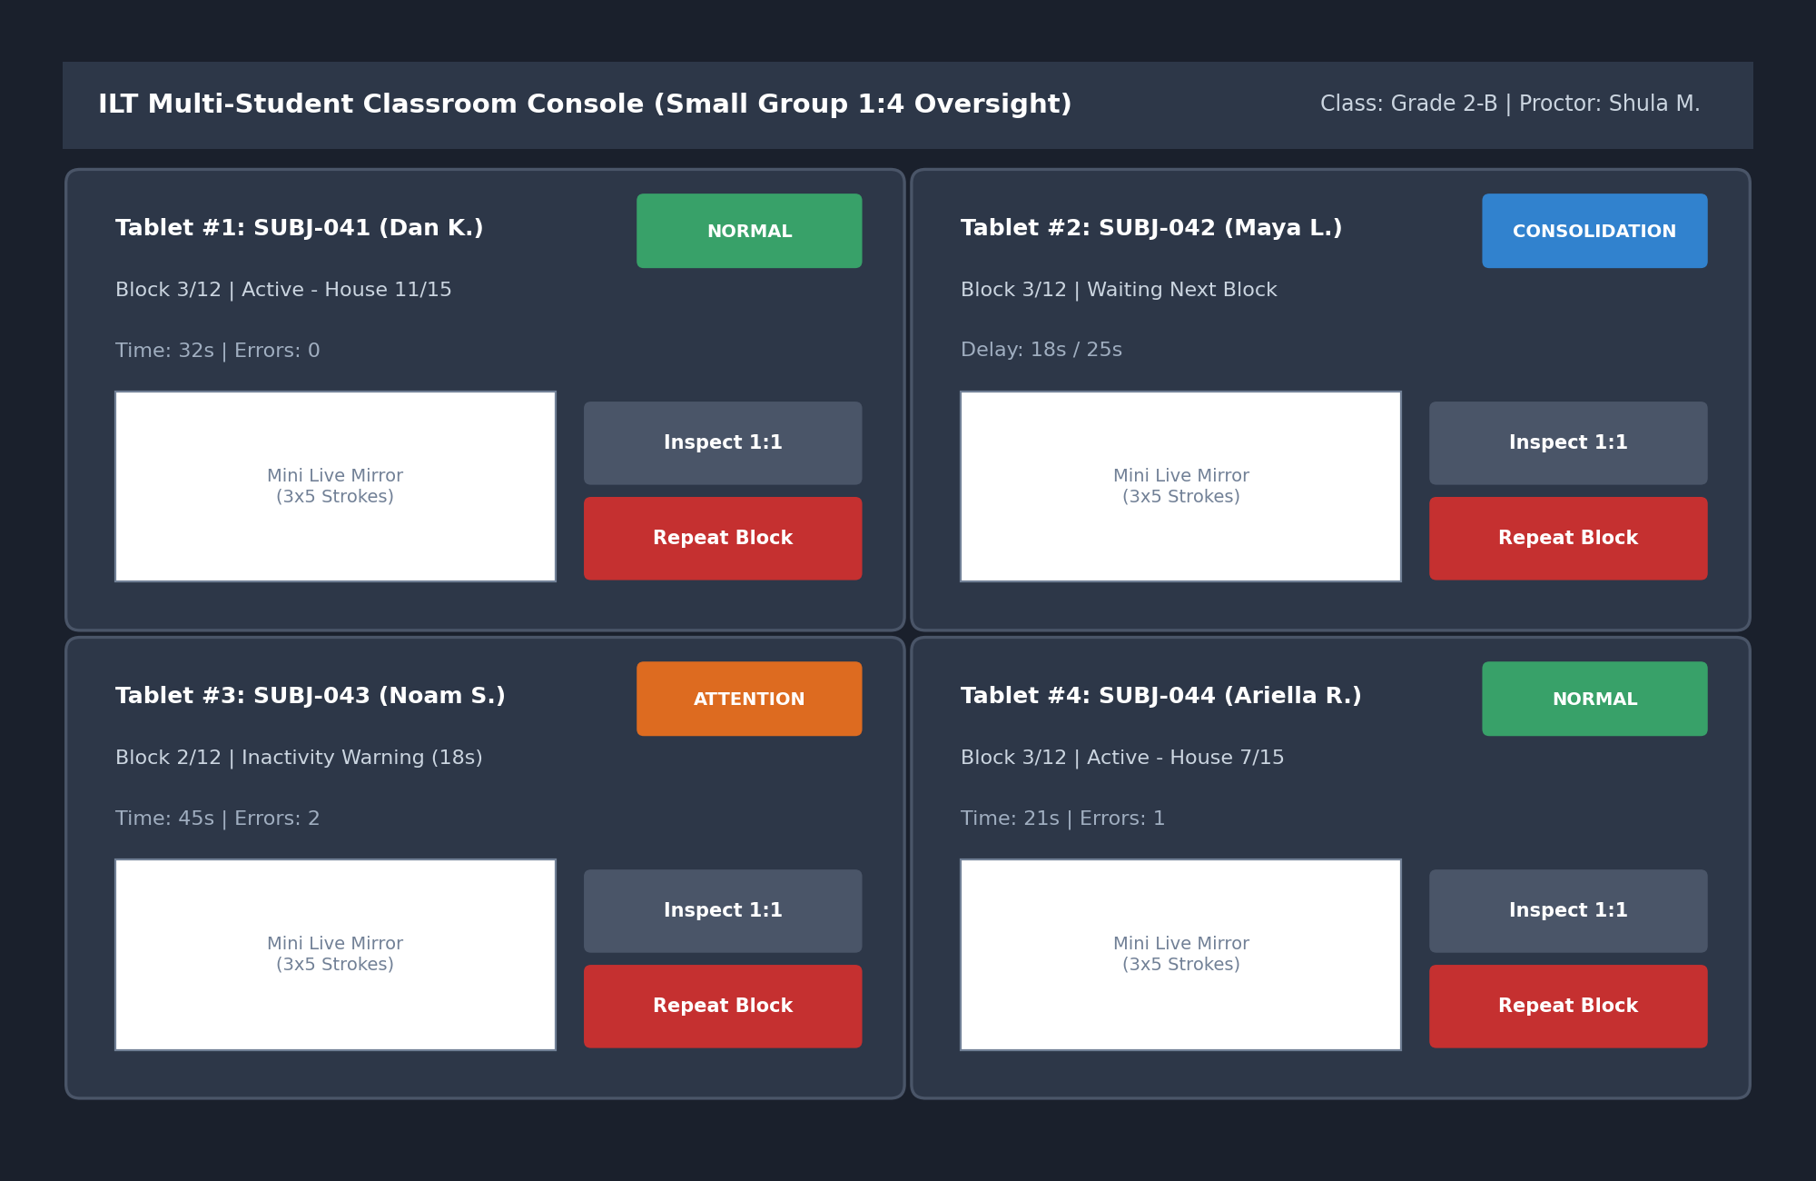
Figure 5: Multi-Student Classroom Console (1:4 Simultaneous Oversight Wireframe)
• 4-Quadrant Oversight Grid: Presents 4 concurrent student streams with real-time thumbnails, session progress indicators, and color-coded status badges.
• Rapid Intervention Controls: Dedicated [Inspect 1:1] and [Repeat Block] buttons per student quadrant.
7. Error Calculation Model, Kinematic Metrics & Clinical Algorithms
In strict adherence to the researchers' methodology, the evaluation engine implements a dual-level analytical model:
7.1 Letter-Level Error Model (Segment Evaluation)
• Internal Pen Lifts (>0): Each letter must be formed in a single continuous stroke. A Pen Up event (pressure = 0) prior to reaching target point P3 is logged as an internal lift error.
• Middle Target Dot Hit: The trajectory must pass through the bounding circular zone (R = 3 mm) of the middle target dot (P2). Missing the middle dot registers an error.
• Segment Width Tolerance (15±2 mm): Nominal letter width is 15 mm. Permissible clinical tolerance is ±2 mm (valid range: 13–17 mm). Deviations outside this window are recorded as width errors.
7.2 Block-Level Error Model & Kinematic Telemetry
• Total Block Pen Lifts (Norm = 15): A standard block consists of exactly 15 pen lifts corresponding to transitions between houses. Counts exceeding 15 reflect stroke fragmentation and motor hesitation.
• Locked Skipped Houses: Quantifies skipped houses resulting from forward-only locks. Each counts as an omission error.
• Normalized Execution Time: Total block duration is normalized by the count of successfully executed shapes.
• Advanced Kinematic Features: On-Surface Writing Time, In-Air Hover Time, Velocity Profiles, Peak Velocity, Pressure Modulation Curves, and Normalized Jerk Metric (measure of movement smoothness).
8. Non-Functional Requirements, Security & Privacy Compliance
• Latency & Performance: P2P mirroring latency must remain below 20ms across local Wi-Fi, sustaining 133Hz–200Hz data sampling.
• Strict Child PII Protection: No full student names are collected. Subjects are indexed via anonymous IDs and 2-letter initials.
• Restricted Video Access: Webcam recordings are strictly accessible to the supervising evaluator who performed the test. Analysts only receive de-identified kinematic data.
• Encryption at Rest and in Transit: TLS/WSS local encryption; LUKS storage encryption for PostgreSQL/TimescaleDB; SSE-S3 encryption for MinIO video buckets.
• Cascading Deletion: Manual deletion of a session triggers automated deletion of associated video files and TimescaleDB telemetry.
9. Implementation Roadmap & Pilot Readiness
With all 9 clinical parameters formalized, engineering teams are equipped to construct the v1.0 release:
• Immediate Development Readiness: Direct transition to React/Vue frontend implementation, Wacom tablet canvas integration, OpCode serialization, and WebRTC P2P signaling.
• Pilot Deployment Scope: Targeted for October 2026 deployment across selected primary schools, evaluating Grade 2 students utilizing the 3x5 invented letter and blank transfer templates.

