ILT System - Functional Requirements Specification (FRS / SRS v2.0)
Functional Design, Screen Wireframes, Clinical Workflows, Sricam IP Camera Integration & Motor Learning Telemetry
Document Parameter | Value & Specification | Document Parameter | Value & Specification
Document ID: | ILT-FRS-V2.0-EN (Functional Specification) | Release Date: | October 2026
Clinical Basis: | Dr. Hagit Hollander & Prof. Esther Adi-Japha (Bar-Ilan Univ.), Dr. Shoshi Dorfberger (Gordon College) | Target Hardware: | Wacom MovinkPad 11 / DTHA116 (EMR 133Hz)
Approval Status: | Approved Specification (Field Remarks & CMS Release) | Target Cohort: | Early Elementary Students (General & Special Ed, Low-SES Focus)
Video Surveillance: | Sricam SP006 720p Wireless IP Cameras (Desk/Hands only) | Network Topology: | Direct Local P2P Wi-Fi + CMS + Async Cloud Sync

1. Introduction, Objectives & Clinical Research Background
This document establishes the official updated Functional Requirements Specification (FRS v2.0) for the Invented Letter Task (ILT) Application System. Developed as an open-source educational research platform, the ILT system provides early, objective, standardized screening for young children and early elementary students (across general education and special education) at risk for learning and literacy deficits (dyslexia, dysgraphia, reading comprehension impairments, and written expression difficulties), with a primary focus on low socioeconomic status (Low-SES) cohorts.
1.1 Scientific Rationale & Procedural Learning System (PLS)
Longitudinal research led by Dr. Hagit Hollander and Prof. Esther Adi-Japha (School of Education, Bar-Ilan University), Dr. Shoshi Dorfberger (Gordon Academic College), and laboratory researchers demonstrated an empirical link between motor procedural memory consolidation (Procedural Learning System - PLS) and written language acquisition.
The initial stage in writing acquisition is learning letter letterforms and graphic design. Writing real alphabet letters across languages is heavily confounded by prior home literacy exposure, parental mediation, and formal classroom instruction. In contrast, the ILT task isolates an international, language-free, pure graphomotor procedural skill: connecting three sequential target dots in a single continuous stroke to create an 'invented letter'. The task tracks procedural consolidation trajectories, velocity profiles, and dynamic writing pressure.
A critical empirical breakthrough revealed that kinematic error metrics and execution time across training blocks significantly predict complex literacy achievements—specifically reading comprehension and written expression—8 months later in the subsequent school year.
1.2 Transition from Legacy Paper-on-Digitizer to Interactive Screen Tablet
The legacy research apparatus relied on physical paper sheets affixed over an opaque Wacom digitizer board. While simulating real paper, this apparatus imposed severe clinical bottlenecks:
• Cumbersome Sheet Swapping & Re-Taping: Evaluators manually swapped and re-taped printed paper between every block, breaking the child's concentration and perturbing critical consolidation delay intervals.
• Digital Inking Pen Refill Failures: Legacy inking pens suffered from expired ink refills, causing frequent mechanical dropouts and data loss in the middle of active trials.
• Paper Slippage & Coordinate Skew: Physical paper slippage relative to the underlying digitizer board distorted coordinate registration, requiring labor-intensive post-hoc rectification.
• Lack of Interactive Constraints: Physical paper could not prevent children from backtracking to modify earlier shapes, corrupting velocity and segmentation analytics.
The new ILT application transitions the protocol to an interactive digital screen tablet (Wacom MovinkPad 11 / DTHA116) offering paper-like tactile feel, direct screen feedback, 133Hz–200Hz EMR sampling, 4,096 pressure levels, in-air hover tracking, dynamic forward-only canvas locking, and automated error classification.
Clinical Validation Study: A controlled comparative study is planned, benchmarking 100 children on the digital tablet system against 100 on standard physical paper (with manual scoring) and 100 historical digitizer records to confirm measurement equivalence across modalities.
2. Updated Clinical & Methodological Decisions (Field Remarks v2.0)
Following iterative field testing and review with the lead research team, all clinical specifications have been formalized:
# | Clinical Parameter | Mandatory Clinical Decision | Engineering & UI Implementation
1 | Avatar Script & Video Demonstrations | Verbatim instructions delivered by an animated teacher Avatar on the tablet with synchronized visual graphics. 20s intro video before Block 1; 20s notebook demo video before notebook trials. | Avatar engine integrated into student kiosk; automated video playback dispatched via proctor control console.
2 | Consolidation Delay & Pen Rest | 20–30s delay between blocks. Child places pen on desk beside tablet (on-screen 'pen house' box removed). Child presses green 'Next Block >>' button at bottom-center. | On-screen pen holder graphic eliminated; [Next Block >>] button anchored at bottom-center, unlocked only post-delay; configurable timer (25s).
3 | Block Termination & Disruption Alerts | Inactivity timeout: 20s idle, or 30s after 15th letter. Static warning box removed; [MANUAL FINISH BLOCK] button blinks dynamically. Critical [Repeat Block] control. | Watchdog timer triggers dynamic button blinking in cockpit; dedicated [Repeat Block] button invalidates disrupted attempts and restarts fresh.
4 | Skipped Houses (Forward-Only) | Children cannot backtrack. Any skipped house is permanently locked and flagged as an error. Overall execution time spans all completed segments. | Forward-only dynamic canvas locking; immediate touch in box N+1 locks all preceding unfilled boxes; full duration logged.
5 | Segment Width & Tolerance (15±2 mm) | Nominal letter width is 15 mm. Allowable clinical tolerance: ±2 mm (valid range: 13–17 mm). Stroke must pass through the middle target dot circle. | Kinematic deviation algorithm normalized against start-to-end baseline; bounding hit-circle around middle dot; automated width violation logging.
6 | Pen Lifts & In-Air Hover Path | Letter level: internal pen lift (>0) or missed middle dot = letter error. Block level: benchmark of 15 transitions. Continuous yellow line renders in-air hover path. | Dual-tier error calculation; real-time yellow in-air hover trajectory connecting transitions rendered on proctor mirror.
7 | Lined Notebook & DCD Scaffolding | Support dedicated lined notebook template (NB2Pages, 3 lines x 5 letters, time only). DCD scaffolding: Row 1 full dots, Row 2 start dot only, Row 3 blank. | Lined notebook canvas engine; 3-tier scaffolding transfer template supported; time-only evaluation module.
8 | Wireless Sricam IP Cameras & CMS | Cameras are Sricam SP006 720p Wi-Fi IP cameras. Paired by scanning tablet 5-digit PIN/QR code. Desk/hands view ONLY (no faces!). Camera Preview button in console. | RTSP Wi-Fi camera streaming & CMS integration; [CAMERA PREVIEW] button for field calibration; [SHOW VIDEO] with [X] button in multi-cockpit.
9 | Multilingual & Mirrored Geometry | Full multilingual support (Hebrew, Arabic, English). LTR languages (English) feature mirrored block geometry (left-to-right flow, horizontally mirrored letter). | Language dropdown in login & student intake; coordinate mirroring transformation matrix for LTR blocks.

3. Software Architecture, Local P2P Network & IP Camera Subsystem
The ILT architecture operates entirely within the local school/clinic Wi-Fi network without wide-area internet dependencies:
3.1 Sricam SP006 Wireless IP Cameras & CMS Subsystem
• Dedicated Desk IP Cameras: Video surveillance utilizes Sricam SP006 720p Wireless Indoor IP Cameras connected over local Wi-Fi, streaming high-definition H.264 video via RTSP.
• QR Code Pairing Protocol: Upon tablet PIN handshake, the tablet displays a high-contrast QR code encoding the session token. Presenting the tablet before the Sricam IP camera lens binds the RTSP stream 1:1 to the active session within the CMS.
• Child Privacy by Design (Desk & Hands Only): Cameras are strictly positioned to capture the desk surface, tablet, and hands. Capturing children's faces is prohibited. The proctor console provides a [CAMERA PREVIEW] button enabling visual calibration prior to testing.
• Classroom CMS Integration: In Multi-Student Classroom mode (1:4 up to 1:6), the Camera Management System (CMS) manages concurrent streams. Clicking [SHOW VIDEO] on any student card renders a live stream overlay with an [X] close button.
3.2 Local P2P Telemetry Channel & Asynchronous Sync
• Local WebRTC DataChannel (<15ms): Raw EMR samples stream directly from tablet to proctor cockpit over local Wi-Fi with sub-15ms latency.
• Batching Policy (3–5 Samples Window): Samples are grouped into 4-sample binary frames (every 20ms), generating only ~2.6 KB/s network traffic while sustaining 60 FPS rendering.
• Local Storage & Cloud Idle Sync: Telemetry is buffered in IndexedDB and video in local files/OPFS, syncing asynchronously to PostgreSQL, TimescaleDB, and MinIO during idle periods.
4. Updated Protocol OpCodes & Event Dictionary
The binary communication dictionary incorporates all new protocol controls and camera triggers:
OpCode | Command / Event Name | Direction | Functional Purpose & Payload
0x01 | PEN_DATA_BATCH | Tablet -> Cockpit | Batched binary packet containing 3–5 EMR samples (X, Y, Pressure, Tilt, Time, Flags).
0x02 | STROKE_START | Tablet -> Cockpit | First pen contact (Pen Down) registered inside an active segment.
0x03 | STROKE_END | Tablet -> Cockpit | Pen liftoff (Pen Up) event for in-air time and hand raise tracking.
0x04 | SEGMENT_COMPLETED | Tablet -> Cockpit | Successful completion of an invented letter shape.
0x05 | SEGMENT_SKIPPED_LOCKED | Tablet -> Cockpit | House skipped: locks skipped house and records omission error.
0x06 | BLOCK_START | Cockpit -> Tablet | Loads next block canvas for drawing.
0x07 | BLOCK_TIMEOUT_WARNING | Tablet -> Cockpit | Inactivity timeout (20s idle / 30s post-letter 15); triggers button blink.
0x08 | BLOCK_COMPLETED | Bidirectional | Normal completion of 15 shapes, initiating consolidation rest timer.
0x09 | BLOCK_REPEAT_TRIGGERED | Cockpit -> Tablet | Proctor command resetting the current block due to external disruption.
0x0A | DELAY_TIMER_TICK | Tablet -> Cockpit | Synchronized countdown tick during consolidation delay (20–30s).
0x0B | SESSION_START | Cockpit -> Tablet | Launches a new evaluation session post-PIN/QR pairing.
0x0C | SESSION_FINISH | Bidirectional | Terminates the session and queues data for cloud sync.
0x0D | PAIRING_PIN_REQUEST | Tablet -> Cockpit | Tablet requests direct P2P pairing via 5-digit one-time token.
0x0E | PAIRING_PIN_VERIFIED | Cockpit -> Tablet | Handshake confirmed; displays QR code for Sricam IP camera pairing.
0x0F | EMERGENCY_PAUSE | Cockpit -> Tablet | Evaluator emergency freeze pausing all timers.
0x10 | CLINICAL_NOTE_ADDED | Cockpit -> DB | Timestamped clinical observation recorded by evaluator.
0x11 | CONTROL_PAGE_NAVIGATE | Bidirectional | Navigation between Control Page dispatcher and Live Cockpit.
0x12 | SHOW_INTRO_VIDEO | Cockpit -> Tablet | Plays 20s intro video demonstrating single-stroke invented letter drawing.
0x13 | SHOW_NB_VIDEO | Cockpit -> Tablet | Plays demo video showing invented letter execution in lined notebook.
0x14 | NB_PAGE_START | Cockpit -> Tablet | Loads lined notebook template (NB2Pages) for time-only assessment.
0x15 | NB_PAGE_COMPLETE | Tablet -> Cockpit | Notebook page completed via [Next Page >>] button or timeout.
0x16 | CAMERA_QR_GENERATED | Tablet -> CMS | Generates QR code on tablet screen for Sricam camera binding.
0x17 | CAMERA_PREVIEW_TOGGLE | Cockpit -> CMS | Toggles desk camera live preview for angle verification.
0x18 | HOVER_PATH_STREAM | Tablet -> Cockpit | Streams in-air hover coordinates for rendering yellow trajectory.
0x19 | AVATAR_AUDIO_SYNC | Cockpit -> Tablet | Synchronizes Avatar teacher speech and animated graphics.
0x1A | MULTI_VIDEO_TOGGLE | Cockpit -> Tablet | Toggles [SHOW VIDEO] stream overlay in classroom multi-student view.

5. Detailed Clinical & System Workflow Specifications
The updated clinical workflows formalize the complete testing protocol:
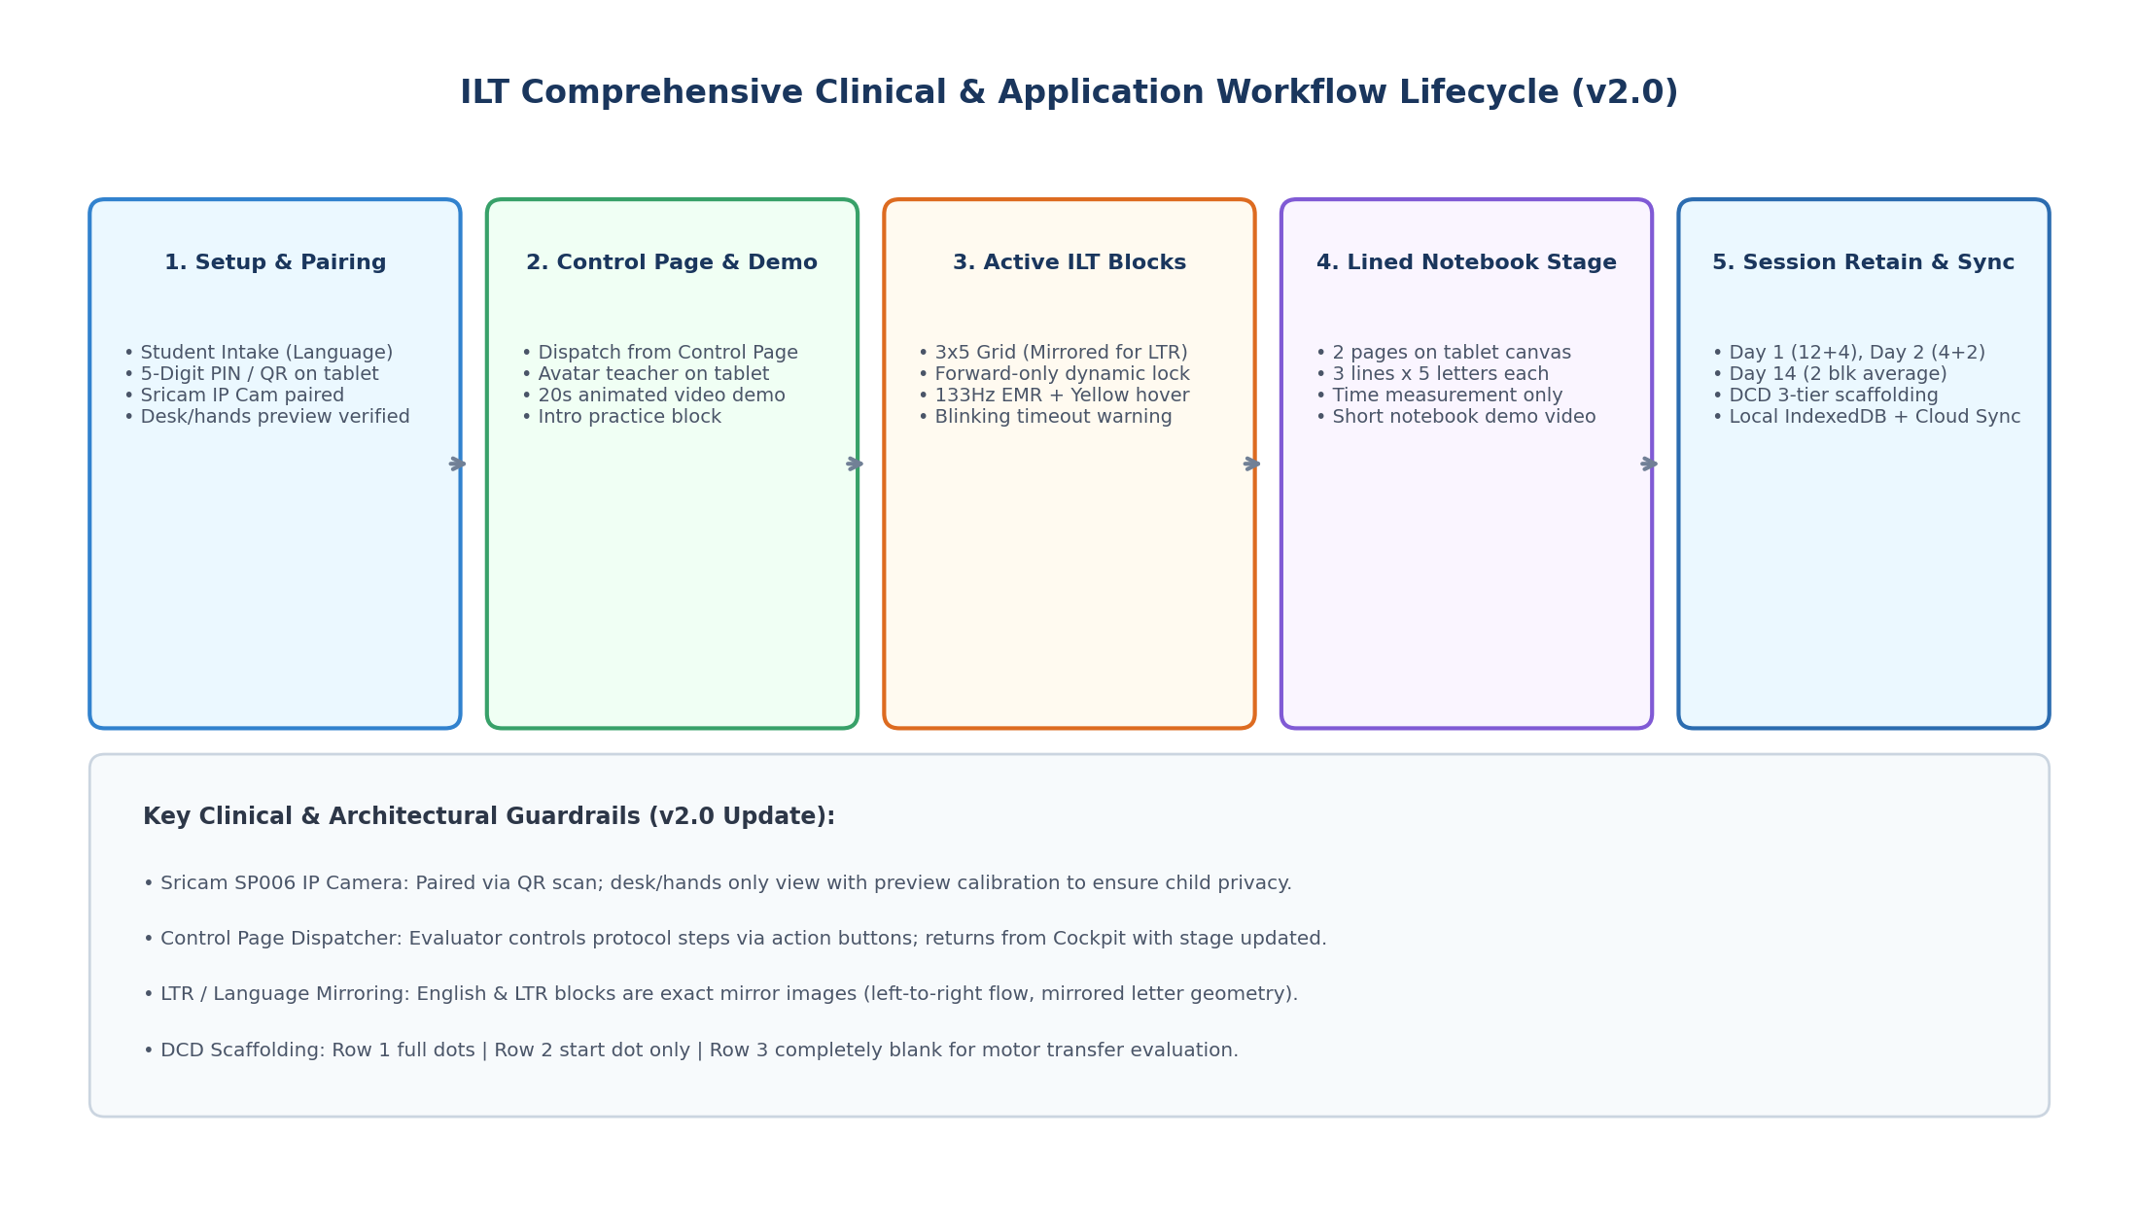
Figure 1: Comprehensive ILT Clinical and System Lifecycle Workflow (v2.0)
5.0 System Login & Language Selection
The evaluator accesses the system URL, authenticates, and selects interface language (Hebrew or English). The UI adapts typography and RTL/LTR directionality instantly.
5.1 Student Intake, Pairing & IP Camera Calibration
• Student Demographics: Evaluator selects educational Domain and enters protected child details: anonymous Participant ID, student initials (2 letters), date of birth/age, dominant hand (Right/Left), pen type (Dr. Grip Digital / Noris Jumbo), and Student Language dropdown (Hebrew / English / Arabic).
• PIN & QR Code Pairing: Console generates a 5-digit PIN (e.g. 84920). Tablet in Kiosk mode connects via P2P and displays a QR code. Sricam IP camera scans the QR code, binding the video stream in CMS.
• Desk View Calibration: Evaluator clicks [CAMERA PREVIEW] on console. A preview window verifies the camera captures the desk and hands only, strictly excluding the child's face.
5.2 Evaluator Control Page Workflow
Testing is driven by a central Control Page featuring discrete dispatch buttons with color-coded status badges (Completed / Active / Pending). Clicking an action button dispatches the task to the tablet and transitions to Cockpit view. In Cockpit, clicking [CONTROL PAGE] returns the proctor with stage status updated.
5.3 Day 1 Protocol (Acquisition)
• 1. [Show Intro Video]: Plays 20s demo on tablet with Avatar teacher narrating the verbatim instructions with synchronized animations.
• Official Verbatim Script: 'Today we will learn how to write an invented letter on a special board, in notebook lines shown on the screen. In front of you is a made-up letter, (pointing to shape) it has 3 dots that help us draw it. You connect the three dots in one continuous line, starting from the top dot. Don't skip any dot. Look, every letter has a house. Every line is like a street with 5 houses. You write a letter and move to the next in order, from right to left (in English: left to right), finishing the street, then moving down. Every three streets make a neighborhood (block). Remember to write each letter in one stroke, as fast and accurately as you can. No need to go back and correct mistakes—whatever comes out, I'm happy! Later we will practice and it will get better. When you finish the block, place the pen on the table beside the tablet and press the green Next Block button in the center. But first, let's watch a video. Are you ready?'
• 2. [Intro Block]: Unscored practice block on tablet; live mirrored in cockpit.
• 3. [ILT4Blocks]: Blocks 1–4 of standard ILT task with full kinematic scoring.
• 4. [NB2Pages]: 2 lined notebook pages (3 lines x 5 letters). Child clicks [Next Page >>]. Time measured only.
• 5. [Show NB Video]: Short demo video demonstrating invented letter writing in lined notebook.
• 6. [NB2Pages]: 2 more lined notebook pages on tablet (time only).
• 7. [ILT4Blocks]: Final 4 standard ILT blocks for Day 1 (Blocks 5–8 / total 12 blocks).
5.4 Day 2 Protocol (24-Hour Retention)
Conducted 24 hours later to assess procedural consolidation following sleep:
• [ILT4Blocks]: 4 standard ILT blocks with full kinematic telemetry.
• [NB2Pages]: 2 lined notebook pages (time only).
5.5 Day 3 Protocol (Day 14 - Two-Week Automaticity)
Conducted 14 days later to assess long-term automaticity:
• [ILT2Blocks]: 2 standard ILT blocks. Cockpit automatically calculates and displays the **average score of both blocks**.
5.6 Active Block Execution & Visual Feedback
• Forward-Only Dynamic Locking: Sequential execution from House 1 to 15. Skipped houses are locked and flagged as errors; execution time spans total completed shapes.
• Yellow In-Air Hover Path: Cockpit renders a continuous yellow line tracing pen trajectory in the air between letters and rows.
• Pressure Color Legend: Horizontal bar at mirror bottom displays color thresholds: Light Green (0-20%), Medium Blue (20-40%), Firm Red (40-100%), In-Air Hover (Yellow).
• Blinking Timeout Button: On 20s idle or 30s post-letter 15, the [MANUAL FINISH BLOCK] button blinks amber to prompt the proctor.
• [Repeat Block] Control: Disruptions (bells, noise) can be reset fresh by proctor, invalidating corrupted attempts.
• Consolidation Delay (20–30s): Child rests pen on desk; green [Next Block >>] button in bottom center unlocks post-delay.
5.7 DCD Scaffolding Transfer Task
• Row 1 (Street 1): Full 3-dot connection guides.
• Row 2 (Street 2): Start dot only (Point 1 only, no points 2 and 3).
• Row 3 (Street 3): Completely blank—evaluates motor retrieval without visual guides.
5.8 Multi-Student Classroom Mode (1:4 / 1:6)
Quadrants display live thumbnails. Clicking [SHOW VIDEO] opens a live Sricam desk stream with [X] close button.
6. User Interface Wireframes & Component Specifications (v2.0)
6.1 Evaluator Control Page Console
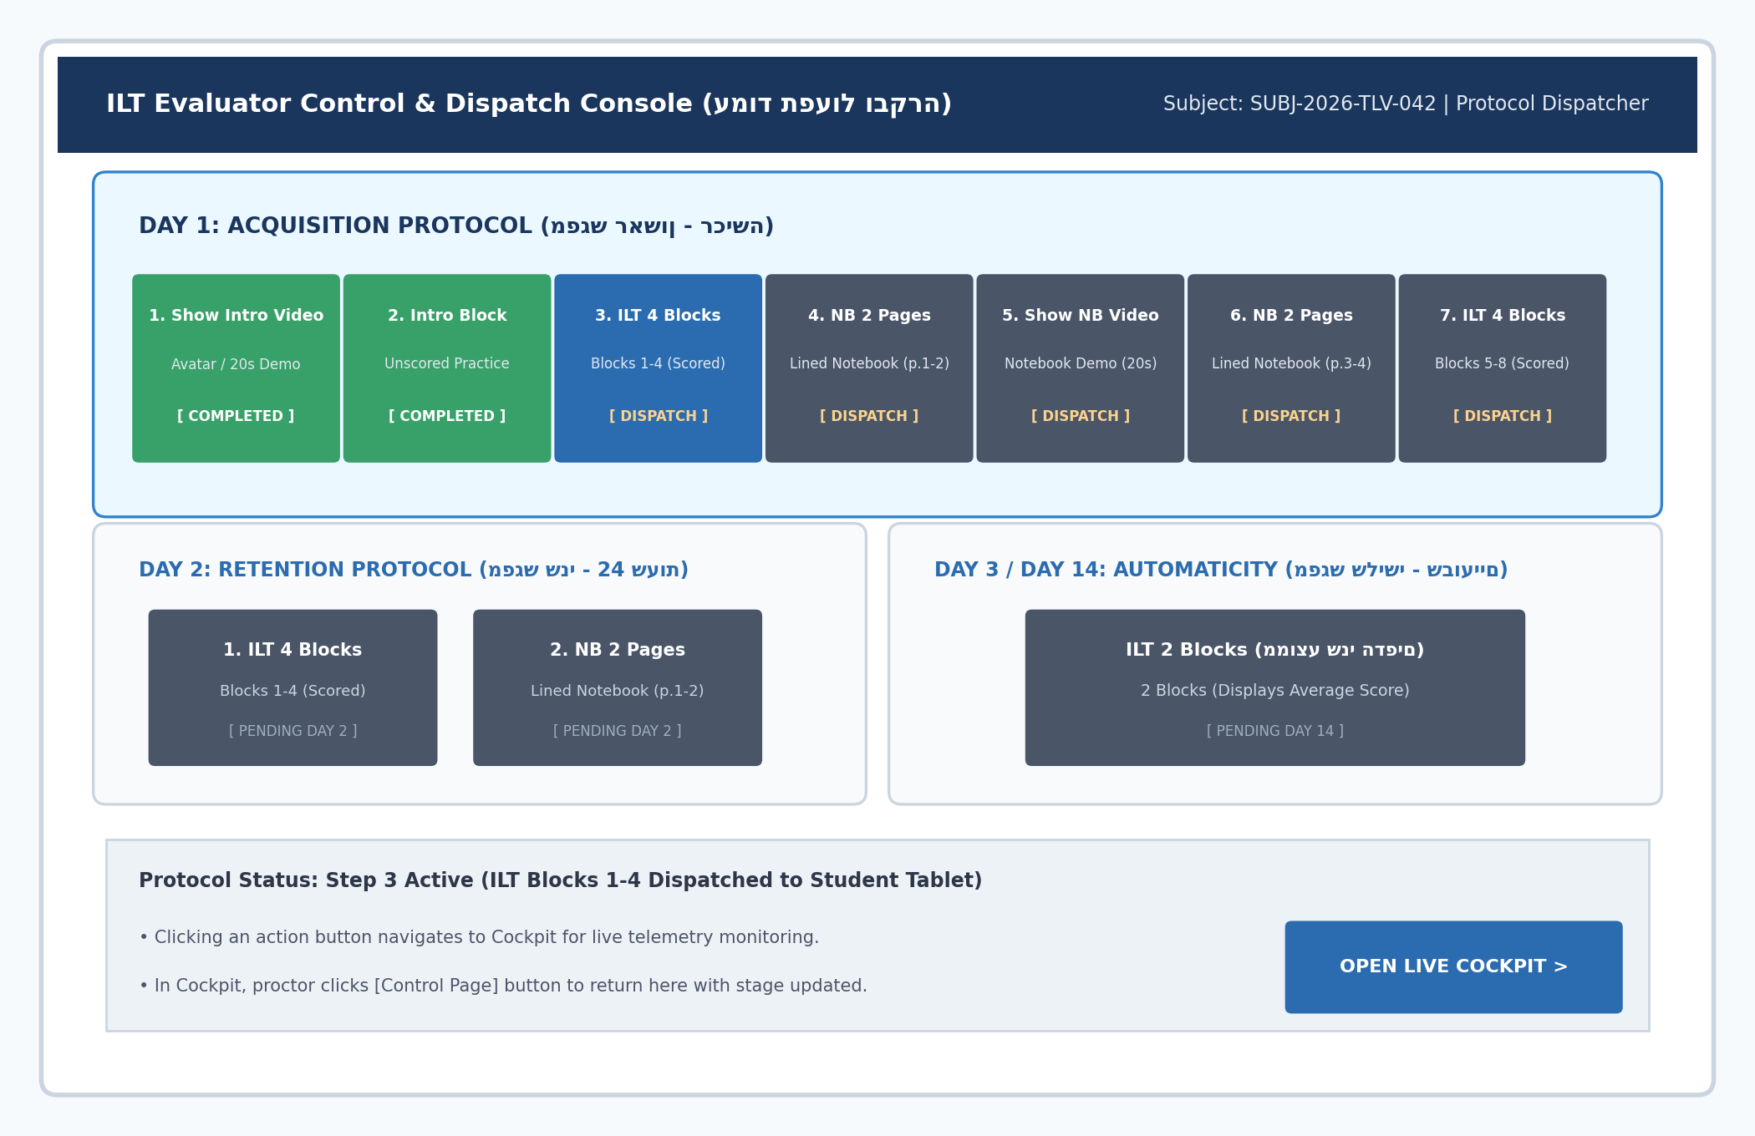
Figure 2: Evaluator Control Page Dispatcher Wireframe (Day 1, 2, 3 Action Buttons)
• Layout: Displays protocol dispatch buttons for Day 1, 2, 3 with stage progress indicators and [OPEN LIVE COCKPIT] shortcut.
6.2 Evaluator Setup & Intake Console
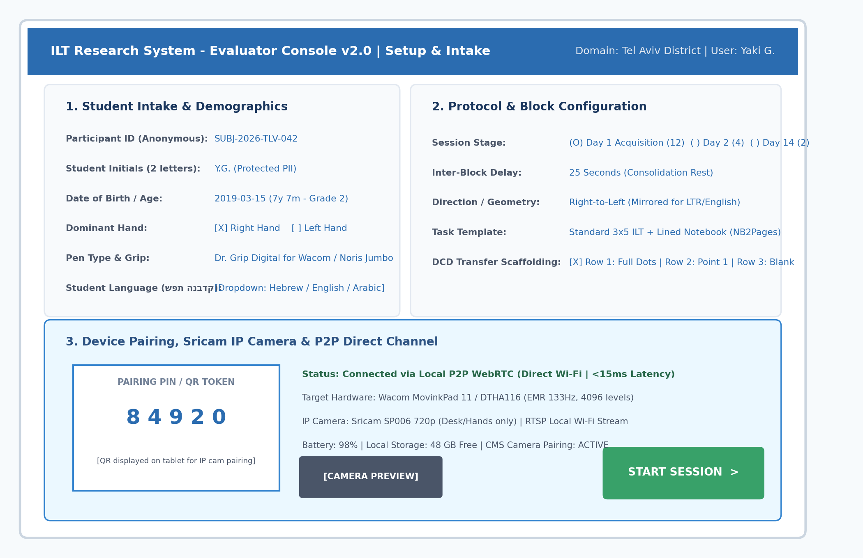
Figure 3: Setup & Intake Console Wireframe (Language Dropdown, Camera Preview & Repositioned Start Button)
• Layout: Includes Student Language dropdown in Card 1, [CAMERA PREVIEW] button, and [START SESSION >] positioned cleanly in Card 3.
6.3 Student Kiosk Canvas
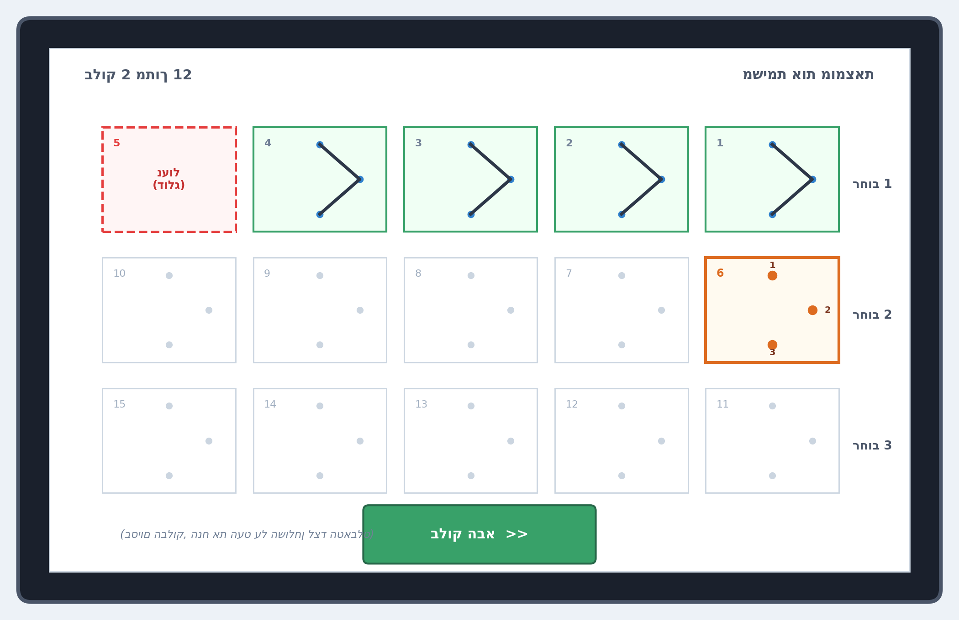
Figure 4: Student Kiosk Canvas Wireframe (Centered Next Block Button & Table Rest Instruction)
• Layout: Pen house box removed. [Next Block >>] centered at bottom. RTL labels corrected ('רחוב 1'). Mirrored for LTR.
6.4 Lined Notebook Canvas (NB2Pages)
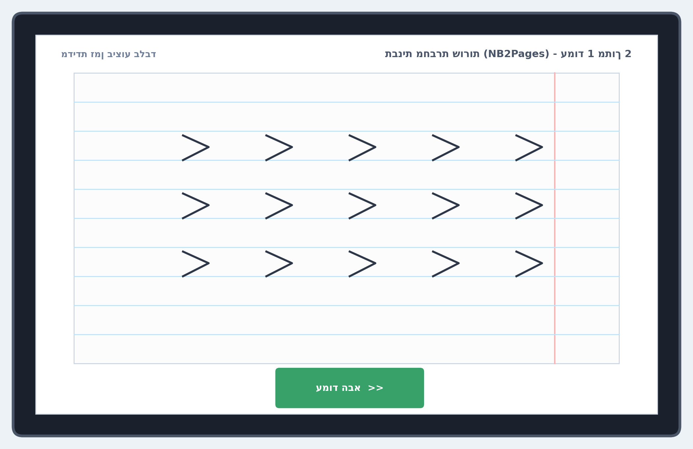
Figure 5: Lined Notebook Canvas Wireframe (Authentic Ruling Lines, 3 Lines x 5 Letters, Time Only)
• Layout: Renders notebook blue ruling and margin line. 3 lines of 5 letters. Centered [Next Page >>] button.
6.5 Evaluator Cockpit 1:1 Screen
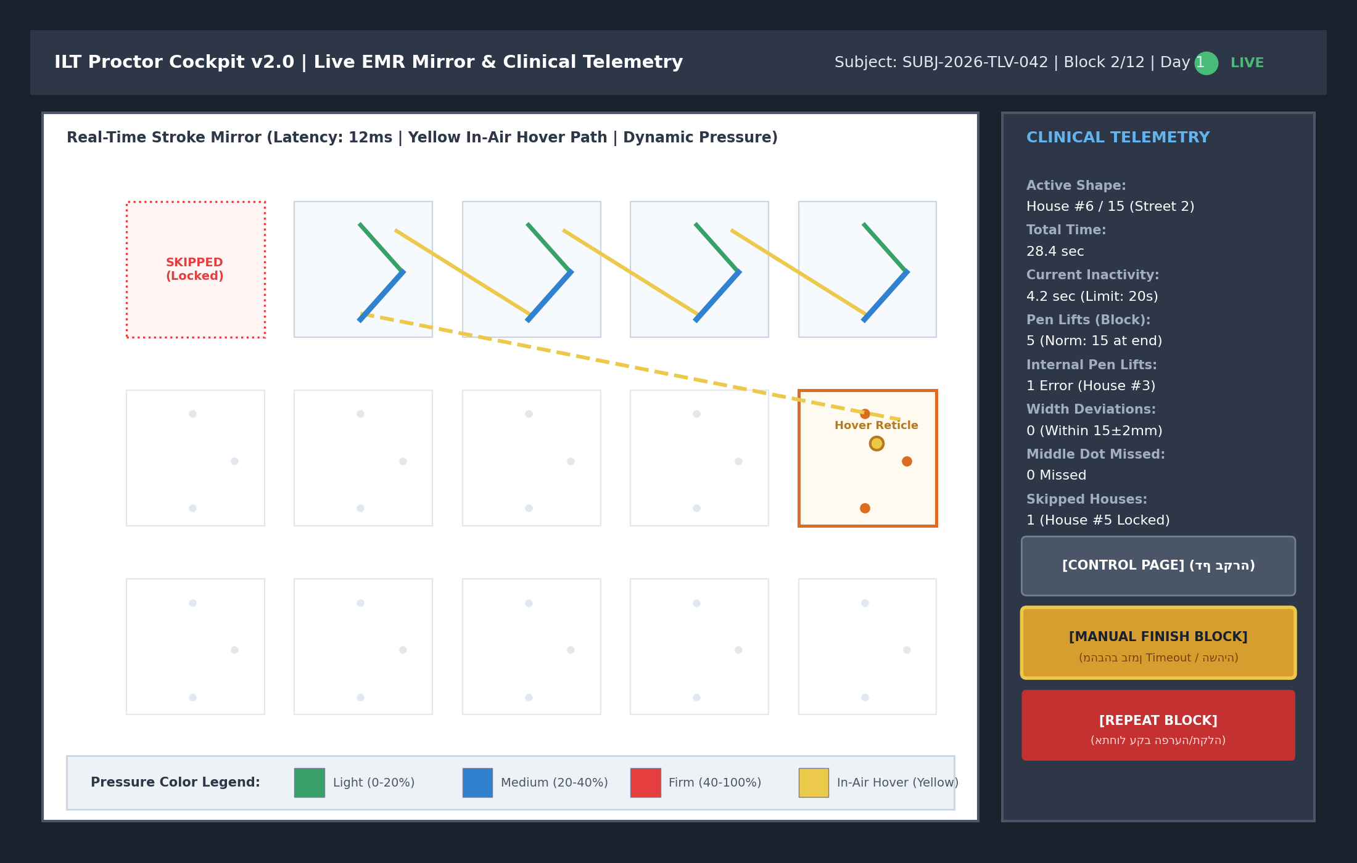
Figure 6: Evaluator Cockpit Wireframe (Yellow In-Air Hover Path, Pressure Legend & Blinking Finish Button)
• Layout: Yellow in-air hover lines, bottom pressure legend, blinking [MANUAL FINISH BLOCK] button, and [CONTROL PAGE] return button.
6.6 Multi-Student Classroom Console
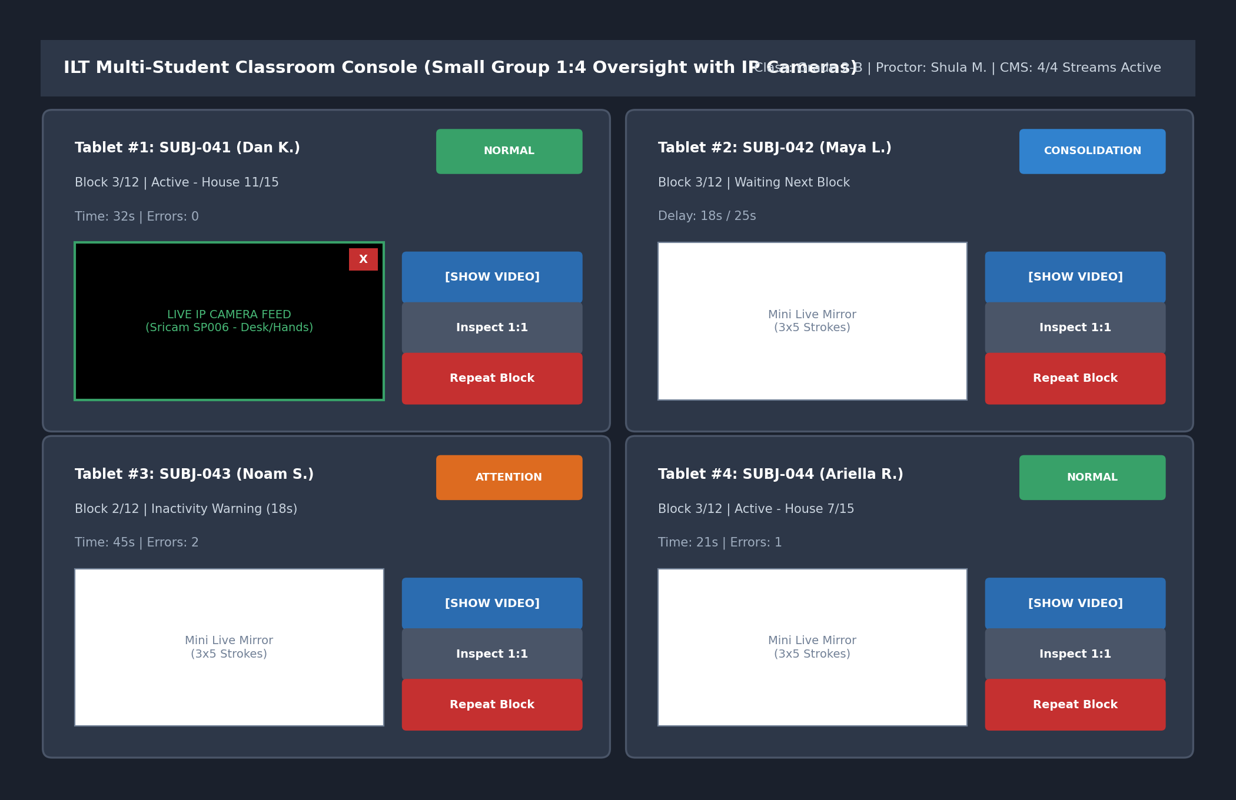
Figure 7: Multi-Student Classroom Console Wireframe with Live Sricam Video Overlay
• Layout: [SHOW VIDEO] button on each student card opens live RTSP stream overlay with [X] close button.
7. Validated Field Equipment, Ergonomic Pens & IP Cameras
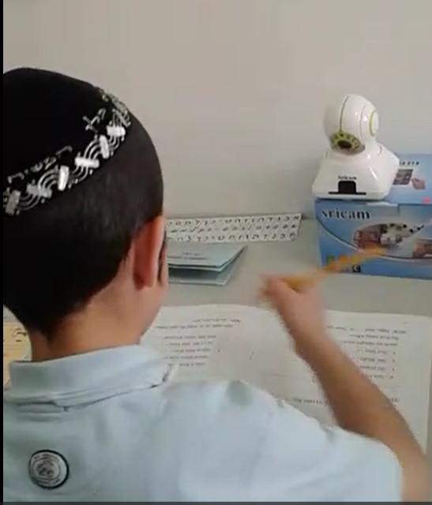
Figure 8: Sricam SP006 Wireless IP Camera Desktop Setup (Hands/Desk View Only for Privacy)
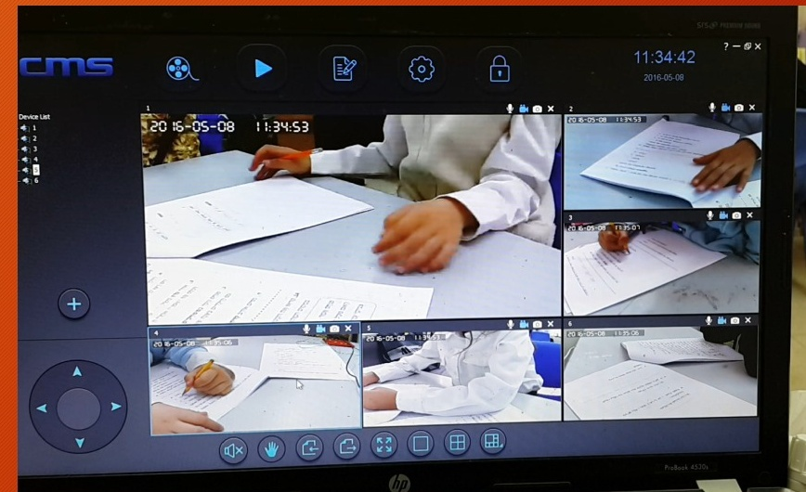
Figure 9: CMS (Camera Management System) Multi-Camera View Monitoring 6 Clinical Stations
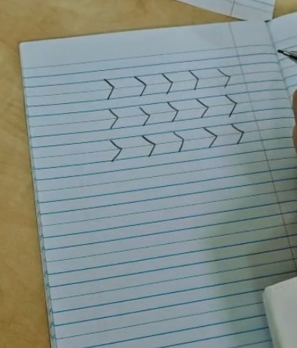
Figure 10: Original Research Artifact: Lined Notebook Page with 3 Rows x 5 Invented Letters
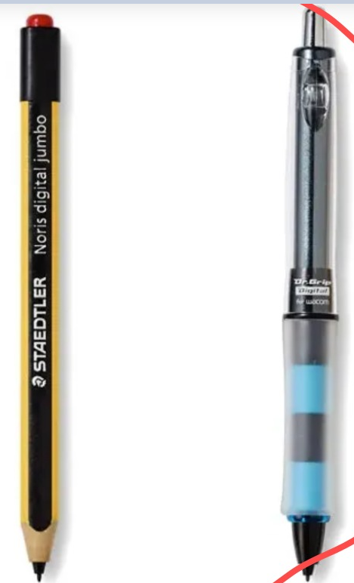
Figure 11: Validated EMR Styluses: Right - Dr. Grip Digital for Wacom | Left - STAEDTLER Noris digital jumbo
• Ergonomic EMR Styluses: Two approved styluses: Dr. Grip Digital for Wacom (wide ergonomic grip preventing fatigue) and STAEDTLER Noris digital jumbo (thick triangular pencil feel with digital eraser).
8. Error Calculation Model & Kinematic Algorithms
• Internal Pen Lifts (>0): Single-stroke requirement; pen liftoff prior to bottom point P3 registers an error.
• Middle Target Dot Hit: Trajectory must intersect middle target circle (R = 3 mm).
• Segment Width (15±2 mm): Deviations outside 13–17 mm register width errors.
• Block Transitions (Benchmark = 15): Excess lifts reflect stroke fragmentation.
• Notebook Execution Time: Total duration logged per notebook page from first touch to page completion.
9. Non-Functional Requirements, Security & Privacy Compliance
• Child Privacy (Desk Only): Facial recording strictly prohibited; cameras calibrated to desk/hands only. Video accessible to evaluating proctor only.
• Performance & Storage: P2P latency <15ms; batched frames ~2.6 KB/s; TLS/WSS and LUKS/SSE-S3 encryption.
10. Implementation Roadmap & Readiness
The v2.0 specification fully incorporates field remarks, Sricam IP camera integration, lined notebook templates, and LTR mirroring for the October 2026 pilot.

