ILT Research System - Software Requirements Specification & Functional Design (SRS / FRS v3.2)
Functional Requirements, UI Wireframes, Clinical Workflows, Unlimited Dynamic Templates Engine, Open Video Ingestion, and Multidimensional Scoring Model
Document Parameter | Specification Value | Document Parameter | Specification Value
Document Identifier: | ILT-FRS-V3.2-EN (Functional Specification) | Publication Date: | October 2026 (Release 3.2 Full Edition)
Clinical & Scientific Basis: | Prof. Esther Adi-Japha & Dr. Hagit Hollander (Bar-Ilan Univ.), Dr. Shoshi Dorfberger (Gordon College) | Dedicated Tablet Hardware: | Wacom MovinkPad 11 / DTHA116 (EMR 133Hz, Full Continuous Charging Support)
Approval Status: | Fully Approved (Incorporating Researcher Directives, Open Video, and Unlimited Templates) | Target Population: | Kindergarten through All Elementary School Grades (Special & General Ed, Low-SES Focus)
Video Integration: | Agnostic Video Ingestion: Wireless IP Cameras (Sricam SP006 / RTSP / ONVIF / USB; Admin Disable Switch) | Network & Sync: | Local P2P Wi-Fi Direct WebRTC + CMS + Cloud Sync (MinIO/Postgres)

1. Introduction, Objectives, and Clinical Research Foundation
This document establishes the comprehensive Software Requirements Specification and Functional Architecture (SRS / FRS v3.2) for the Invented Letter Task (ILT) Application System. The platform is designed as an open-source, non-commercial educational research system created for early, objective screening and remediation of learning disabilities—specifically developmental dyslexia, dysgraphia, and complex literacy deficits—among young children from kindergarten across all elementary school grades, with a specialized clinical focus on low socioeconomic status (Low-SES) populations.
1.1 The Scientific Rationale: Procedural Learning System (PLS) and Written Language Acquisition
Empirical research conducted by Prof. Esther Adi-Japha and Dr. Hagit Hollander (School of Education, Bar-Ilan University), Dr. Shoshi Dorfberger (Gordon Academic College), and laboratory researchers has demonstrated a robust, statistically significant relationship between the consolidation of simple procedural motor skills and written language acquisition.
The foundational phase of handwriting acquisition is the mastery of letter-form motor schemas. This procedural phase is clinically established as a critical gatekeeper for reading fluency and written expression. Traditional letter-writing evaluations in different languages are heavily confounded by prior home literacy exposure, parental mediation, socio-cultural background, and formal school instruction. In contrast, the Invented Letter Task (ILT) is linguistically isolated, culture-fair, and internationally standardized, isolating pure graphomotor procedural learning.
The task requires children to connect three target dots in a single continuous stroke to produce a novel letter form. The assessment is structured in standardized blocks executed according to script directionality (RTL for Hebrew/Arabic, horizontally mirrored LTR for English/Latin), simulating authentic handwriting practice drills. Crucially, empirical longitudinal studies revealed that kinematic error rates and execution times across training blocks significantly correlate with literacy performance from kindergarten through grade 3, and reliably predict complex literacy outcomes (reading comprehension and written expression) 8 months later in the subsequent academic year.
1.2 Transition from Legacy Paper-Digitizer Apparatus to Interactive Screen Tablet
The legacy research apparatus utilized an opaque Wacom digitizing tablet upon which printed paper block sheets were manually clipped. While this simulated physical paper, it introduced severe clinical and operational handicaps:
• Inter-Block Paper Handling Overhead: Proctors had to physically unclip, align, and re-tape paper sheets between every block. This fragmented examinee attention, introduced erratic inter-block delays, and compromised time-sensitive memory consolidation windows.
• Inking Cartridge Malfunctions: Wacom digital inking styli frequently clogged or ran out of ink mid-session, invalidating trials.
• Mechanical Misalignment and Calibration Drift: Accidental paper movement caused offset between printed targets and digitizer coordinate space, requiring tedious retrospective manual post-processing.
• Absence of Dynamic Error Prevention: Legacy paper could not prevent children from backtracking to fix skipped houses, distorting kinematic metrics.
The modern ILT platform transitions all administration to an interactive digital display tablet (Wacom MovinkPad 11 / DTHA116) featuring an authentic paper-like etched anti-glare glass surface, 133Hz–200Hz EMR coordinate sampling, 4,096 pressure levels, in-air hover tracking, dynamic canvas locking, and automated real-time telemetry. This system aligns directly with OECD learning evaluation guidelines.
• Continuous Operation During Charging: The Wacom MovinkPad 11 hardware is fully certified for uninterrupted clinical administration and full touch/EMR fidelity while plugged into USB-C Power Delivery (PD), eliminating battery depletion anxiety during full-day school administrations.
• Clinical Validation Pilot Cohort: The upcoming clinical pilot protocol establishes a balanced comparative validation study: 50 children tested on the interactive digital tablet, 50 children tested on standard paper sheets with manual timing, and 50 legacy historical datasets, confirming measurement equivalence.
2. Summary of Clinical, Operational, and Technical Decisions (Release 3.2)
# | Clinical / Operational Domain | Approved Policy & Specification | Technical & Engineering Impact
1 | Instructional Demo Video & Warm-up Pass Criterion | Standard instructional video plays on student tablet with female voiceover in the selected language. Warm-up (Intro Block) requires completing exactly 1 valid row (5 houses with single continuous stroke, 0 internal pen lifts). Speed and width are unscored. Success on Row 1 permits immediate transition to Block 1; failure triggers repeating instructions and a new warm-up block. | Automated rule validation engine evaluating row-level pen lift continuity; instant protocol advance upon 1 valid row.
2 | In-Transition Delay Timer & Research Director Governance | System Default timers: In-Transition Delay = 20 seconds; Inactivity Timeout = 20 seconds (and 30s post-15th letter). Domain-level overrides (15-20s / 20-30s) are permitted prior to session start, but require explicit Research Director authorization code. An Admin Tooltip alerts that changing timers impairs cross-cohort normative standardization. | Configuration hierarchy (Domain > System Default); Research Director authorization lock; session-level snapshot persistence for analytics factoring.
3 | Block Termination, Blinking Alert & Disruption Repeat | Block concludes when all 15 houses are filled (regardless of sequence) or upon timeout. Skipped houses count as errors, but total block execution time includes correction time spent. At timeout, the [MANUAL FINISH BLOCK] button blinks in the Proctor Cockpit only. External disruptions permit an instant [Repeat Block] reset. | Cockpit-only dynamic visual alert; accurate cumulative duration tracking; dedicated Repeat Block state machine.
4 | 3 Distinct Metric Scores & Comparative Summary View | Per Prof. Esther Adi-Japha's clinical directive, the system preserves and reports all 3 metrics independently: (1) Pen Lifts Count, (2) Accuracy Rate %, and (3) Total Block Execution Time. Day 14 Comparative Summary compares all 3 metrics side-by-side against 4 anchor points (Day 1 opening/closing pairs, Day 2 opening/closing pairs). Optional composite score verifies Sum(Weights) == 100%. | Comparative Summary Dashboard in Cockpit; three distinct first-class database metric columns; strict Sum(Weights)==100% check constraint.
5 | Unlimited Dynamic Templates Engine & Grade Expansion | System features an unlimited template engine supporting arbitrary notebook rulings (10 lines, 14 lines, 1 line, custom grids, blank canvas) with configurable movement rules and error states. Target population expanded to all elementary school grades (not restricted to Grade 3) to enable tracking handwriting vs. typing skills. | Table dynamic_templates storing JSON ruling geometry and validation rules; grade-agnostic student intake; tablet charging certification.
6 | Open Video Ingestion Architecture & Video-Optional Mode | System architecture is camera-agnostic: supports any RTSP/H.264/H.265 IP camera (Sricam, Hikvision, Dahua, Reolink, TP-Link Tapo), ONVIF Profile S/T, and USB UVC webcams (desk/hands view only, no faces). System Admin can toggle video-optional mode, allowing administration without video cameras. | Agnostic RTSP/WebRTC ingest pipeline; video_recording_enabled boolean flag in session configuration.
7 | Intervention Program (A-Z / Hebrew) & Row 3 DTW Algorithm | Letter learning curriculum starts in Session 3. Stages 1 and 3 are executed entirely on tablet with automated timing across all 4 training blocks. Row 3 freehand writing accuracy is objectively evaluated via Continuous DTW, Procrustes shape similarity, stroke topology, and baseline adherence. Stage 4 uses physical paper notebook and wipe-clean board. | Multi-tier handwriting recognition & DTW scoring algorithm for Row 3; Intervention Program dispatcher rubric in Control Page with Repeat / Next Letter Block.

3. Software Architecture, Local P2P Network, and Open Video Subsystem
• Camera-Agnostic Video Ingestion Layer: The ILT platform implements an open video abstraction layer. While the Sricam SP006 720p wireless camera served as an empirical reference, the ingestion gateway natively supports any network camera transmitting via RTSP/H.264/H.265, ONVIF Profile S/T compliant cameras, and standard USB UVC webcams. Cameras connect to the local school Wi-Fi network and stream directly to the evaluator console and CMS.
• Child Privacy Protection (Desk & Hands Only): Cameras are positioned to record exclusively the tablet surface, desk plane, and examinee hands. Capturing the child's face is strictly prohibited. The Evaluator Console features a dedicated [CAMERA PREVIEW] button enabling proctors to calibrate the camera angle prior to session launch.
• Administrator Video Disable Switch (Video-Optional Mode): System administrators can designate a Domain or School as 'Video-Optional'. When disabled, the session launches without camera pairing, and the system logs EMR pen kinematics exclusively.
4. Timer Governance, Unlimited Dynamic Templates, and Wire Protocol (OpCodes)
4.1 Two-Tier Timer Hierarchy (Domain > System) & Research Director Governance
• System Default Timer Constants: In-Transition Delay Timer = 20 seconds; Inactivity Timeout Timer = 20 seconds (and 30s post-15th letter completion).
• Research Director Authorization Required: To prevent research variance, modifying timers at the Domain level requires Research Director authorization. The Admin Console includes a mandatory warning tooltip: 'Modifying In-Transition Delay or Inactivity Timeout alters standardized procedural consolidation windows and may compromise comparability against national research norms.'
• Snapshot Persistence & Analytical Factoring: Every session record captures a permanent immutable snapshot of the active System and Domain timers. The Analytics Module allows researchers to display either raw metric values or factored scores normalized by the ratio: Factoring Ratio = T_domain / T_system.
4.2 Unlimited Dynamic Templates Engine
• Configurable Rulings and Geometry: The system decouples canvas rendering from hardcoded layouts. Administrators can create unlimited templates in JSON format: 10-line notebooks (Grade 1-2), 14-line notebooks, single-line notebooks (upper elementary/middle school), 3x5 ILT grids, and unconstrained blank canvases.
• Custom Kinetic Validation Rules: Each template defines custom boundaries, allowable pen lifts, width tolerance thresholds, and directional locking parameters.
4.3 Updated Protocol OpCodes (v3.2)
OpCode | Command / Event Identifier | Direction | Functional Payload & Clinical Meaning
0x01 | PEN_DATA_BATCH | Tablet -> Cockpit | Batched 3-5 compressed binary EMR samples (X, Y, Pressure, Tilt, Time, Flags).
0x02 | STROKE_START | Tablet -> Cockpit | First surface contact event (Pen Down) inside designated house/segment.
0x03 | STROKE_END | Tablet -> Cockpit | Surface release event (Pen Up). Triggers in-air time and pen lift calculation.
0x04 | SEGMENT_COMPLETED | Tablet -> Cockpit | Successful completion of letter shape in active house and transition to next.
0x05 | SEGMENT_SKIPPED_LOCKED | Tablet -> Cockpit | House skipped: Skipped house is immediately locked and flagged as error.
0x06 | BLOCK_START | Cockpit -> Tablet | Loads designated block according to selected template and activates drawing canvas.
0x07 | BLOCK_TIMEOUT_WARNING | Tablet -> Cockpit | Inactivity timeout reached (20s default) – Finish button blinks in Cockpit only.
0x08 | BLOCK_COMPLETED | Bidirectional | Normal block termination (15 houses filled or timeout) -> In-Transition delay.
0x09 | BLOCK_REPEAT_TRIGGERED | Cockpit -> Tablet | Proctor manual command to abort disrupted block and restart trial from House 1.
0x0A | DELAY_TIMER_TICK | Tablet -> Cockpit | Real-time tick countdown of In-Transition delay (20s System Default).
0x0B | SESSION_START | Cockpit -> Tablet | Launches session; captures immutable snapshot of System and Domain timers.
0x0C | SESSION_FINISH | Bidirectional | Session concludes; dispatches encrypted telemetry to asynchronous cloud queue.
0x0D | PAIRING_PIN_REQUEST | Tablet -> Cockpit | Tablet requests connection via one-time 5-digit PIN token.
0x0E | PAIRING_PIN_VERIFIED | Cockpit -> Tablet | PIN validated; displays QR for video binding (if enabled) and opens P2P channel.
0x0F | INTRO_ROW_VALIDATED | Tablet -> Cockpit | Validates 1 continuous-stroke row in warm-up, permitting transition to Block 1.
0x10 | COMPARATIVE_SUMMARY_OPEN | Cockpit -> UI | Opens Longitudinal Comparative Summary Dashboard in Proctor Cockpit.
0x11 | CONTROL_PAGE_NAVIGATE | Bidirectional | Seamless navigation between Control Dispatcher Console and Live Cockpit.
0x12 | SHOW_INTRO_VIDEO | Cockpit -> Tablet | Plays instructional video with female voiceover in selected examinee language.
0x13 | SHOW_NB_VIDEO | Cockpit -> Tablet | Plays short demonstration video for lined notebook handwriting.
0x14 | NB_PAGE_START | Cockpit -> Tablet | Loads lined notebook template (10-line / 14-line / 1-line) for timing.
0x15 | NB_PAGE_COMPLETE | Tablet -> Cockpit | Notebook page completed via [Next Page] button or timeout.
0x16 | INTERVENTION_LETTER_LOAD | Cockpit -> Tablet | Loads Intervention letter template (A-Z / Hebrew) with music or speech video.
0x17 | INTERVENTION_DECISION | Cockpit -> Tablet | Evaluator decision command: [Repeat Letter Block] or [Next Letter Block].
0x18 | HOVER_PATH_STREAM | Tablet -> Cockpit | Streams in-air coordinate path rendered as continuous yellow trajectory line.
0x19 | AVATAR_AUDIO_SYNC | Cockpit -> Tablet | Synchronizes instructional demo playback on student tablet.
0x1A | MULTI_VIDEO_TOGGLE | Cockpit -> Tablet | Expands/closes live IP camera video overlay in multi-student classroom cockpit.

5. Detailed Clinical Workflows, Comparative Summary, and Intervention Protocol
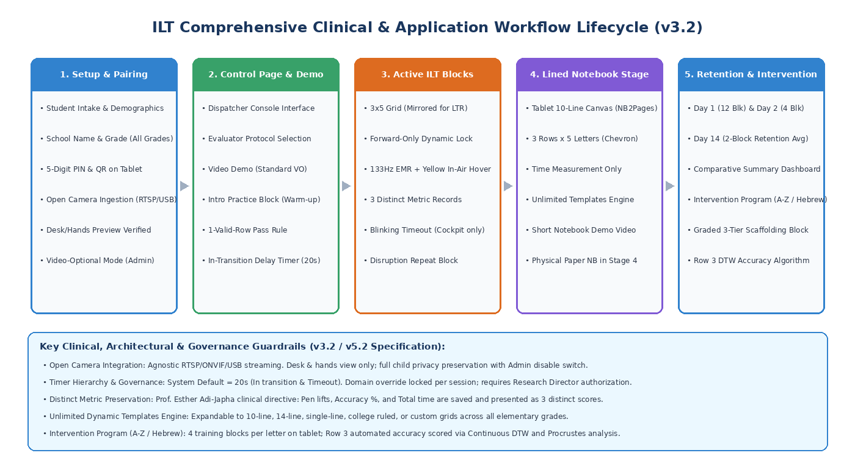
Figure 1: Comprehensive Clinical and System Lifecycle Workflow (Release 3.2)
5.1 Student Intake, Multi-Grade Demographics, and Device Pairing
• Header Bar Status: Permanently displays Proctor Name, Assessment Date, and Active Domain.
• Multi-Grade Intake: Captures Participant ID, Initials (2 letters), School Name, Grade Level (Kindergarten through Upper Elementary), Date of Birth, Dominant Hand, Stylus Model, and Test Language.
5.2 Day 1 Acquisition Protocol & Warm-up Pass Criterion
• Instructional Video: Triggered via [Show Intro Video] featuring female standard voiceover explaining the 3 target dots, 5 houses per street, 3 streets per block, and continuous stroke movement ('What comes out, I am satisfied').
• Warm-up Pass Criterion (1 Valid Row Rule): The examinee must complete exactly one valid row (5 houses executed with single continuous strokes and 0 internal pen lifts). Speed and width are not evaluated during warm-up. Success on Row 1 permits immediate transition to Block 1. If broken strokes occur, instructions are repeated and a new warm-up block is presented until 1 valid row is achieved.
• Day 1 Trial Sequence: [ILT 4 Blocks] (Blocks 1-4) -> [NB 2 Pages] (10-Line Notebook on Tablet, Time Only) -> [Show NB Video] -> [NB 2 Pages] (Pages 3-4) -> [ILT 4 Blocks] (Blocks 5-8 / 12 Blocks Total).
5.3 Day 2 Retention Protocol (24-Hour Consolidation)
• Trial Sequence: Administered exactly 24 hours later: [ILT 4 Blocks] (Blocks 1-4) + [NB 2 Pages] (2 Notebook Pages on Tablet, Time Only).
5.4 Session 3 (Day 14 Automaticity) & 3-Metric Comparative Summary Dashboard
• Retention Trial: Administered two weeks later: [ILT 2 Blocks] repeated. The system computes and displays the 2-block average.
• Preservation of 3 Distinct Metric Tracks (Prof. Esther Adi-Japha): The system preserves and displays three separate first-class metrics: (1) Pen Lifts Count, (2) Geometric Accuracy %, and (3) Total Block Execution Time. These metrics are not artificially merged into a single Z-score.
• Longitudinal Comparative Summary Dashboard: Compares the Day 14 2-block average across all 3 metrics side-by-side against: (1) Day 1 Opening Pair (Blocks 1-2), (2) Day 1 Closing Pair (Blocks 7-8), (3) Day 2 Opening Pair (Blocks 1-2), and (4) Day 2 Closing Pair (Blocks 3-4). An optional composite score is calculated based on administrator-calibrated weights strictly verifying Sum(Weights) == 100%.
5.5 Active Block Mechanics, In-Transition Delay, and Timing
• Cumulative Time Accounting: Skipping a house flags an error and locks the house. However, total block execution time accounts for cumulative trial duration, including any time spent correcting strokes.
• In-Transition Delay Timer (20 Seconds): Between blocks, the student places the stylus on the table beside the tablet for procedural consolidation rest. At the conclusion of 20 seconds, the student presses the large centered green [NEXT BLOCK >>] button.
• Timeout Warning: At 20 seconds of inactivity (or 30s post-15th letter), the [MANUAL FINISH BLOCK] button blinks in the Proctor Cockpit only, alerting the evaluator without distracting the child.
5.6 Intervention Program (A-Z / Hebrew Letters) & Tablet vs. Paper Protocol
The Intervention Program commences in Session 3 and spans ongoing longitudinal instructional sessions teaching the full alphabet (Hebrew Alef-Bet or Latin A-Z) ordered by stroke complexity and letter form. Stages 1 and 3 are executed entirely on the digital tablet; Stage 4 transitions to physical paper notebooks and wipe-clean boards.
• Stage 1 (Two-Week Retention Check on Previous Letter): Executed on tablet: 2 blocks of unguided blank houses (Measurements 5 & 6). The system logs execution time and calculates the 2-block average.
• Stage 2 (Animated Letter Demonstration Video): Plays an instructional animation of the new letter with two selectable audio modes: Level 1 (Background Music Only) and Level 2 (Spoken Verbal Guidance).
• Stage 3 (4 Training Blocks of New Letter on Tablet): Executed on tablet while background music plays: 4 blocks featuring 3-tier scaffolding (Row 1: Model + Target Dots; Row 2: Starting Dot Only; Row 3: Blank Freehand Writing). The system automatically records execution times across all 4 blocks, highlighting Block 2 separately as well as the 4-block mean.
• Stage 4 (Physical Paper Notebook and Wipe-Clean Board Practice): Examinees exit the tablet: 2 blocks in physical paper notebook -> video re-watch -> 2 blocks in notebook -> video re-watch -> 4 blocks on personal ruled wipe-clean board. Classroom follow-up continues on subsequent days.
5.7 Automated Accuracy Scoring Algorithm for Row 3 Freehand Writing
To provide objective, automated accuracy evaluation for freehand letter writing in Row 3 (where no guide dots exist), the system implements a multi-tier kinematic recognition pipeline:
• 1. Shape Fidelity (Continuous DTW & Procrustes Distance): Each alphabet letter possesses a canonical coordinate trajectory C(s) in the database. The child's stroke S(t) is normalized in scale/position and resampled to N=100 equidistant coordinates. The algorithm computes Procrustes distance and continuous Dynamic Time Warping (cDTW), yielding an objective Shape Fidelity score (0–100%).
• 2. Stroke Topology & Pen Lift Integrity: Verifies stroke count compliance (single continuous line for single-stroke letters like Tet or invented letter; flags internal pen lifts as topological fragmentation errors) and validates directional orientation.
• 3. Spatial Proportions & Baseline Adherence: Evaluates aspect ratio (W/H) within a +/-15% tolerance of the canonical letter model and enforces baseline adherence (baseline drift < 2mm).
• 4. Diagnostic Tagging: System outputs a composite accuracy score (0-100%) and automatic diagnostic flags: 'Accurate', 'Proportion Deviation', 'Fragmented Stroke', or 'Directional Deformation'. Raw stroke coordinates are archived for deep learning computer vision analysis.
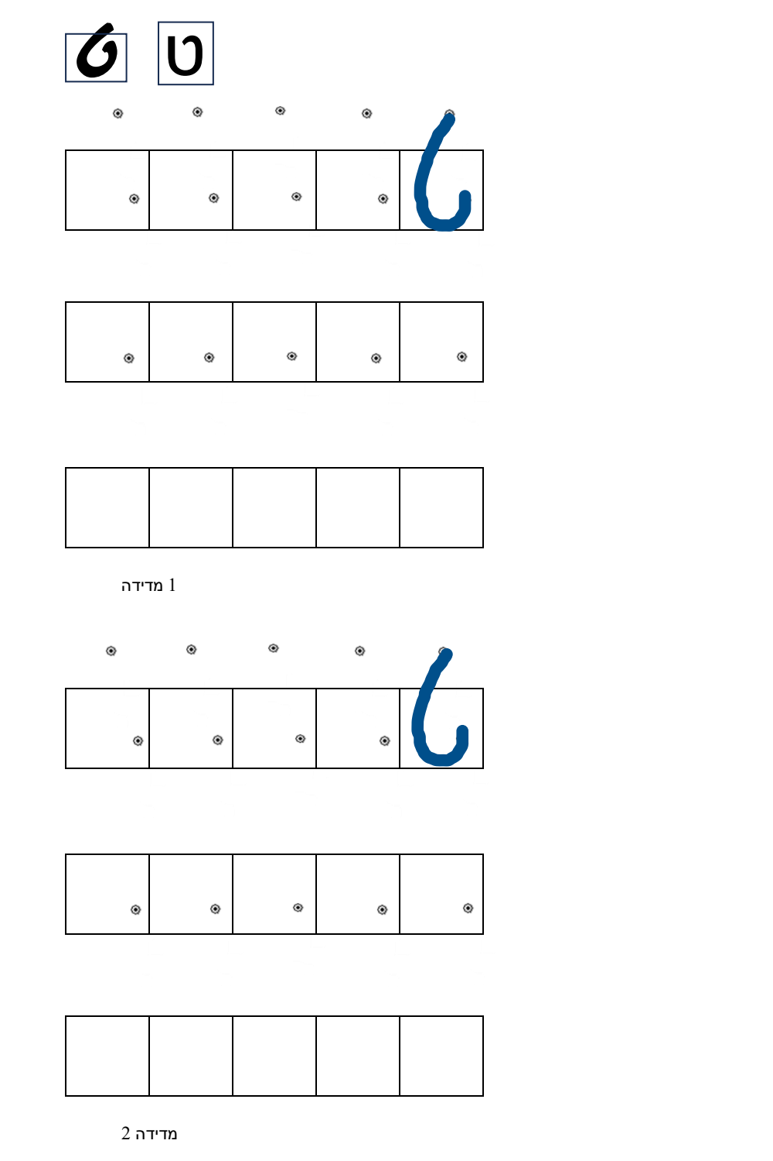
Figure 2: Sample Graded Intervention Training Sheet (Hebrew Letter Tet: Row 1 Model + Dots, Row 2 Reference Dot, Row 3 Blank)
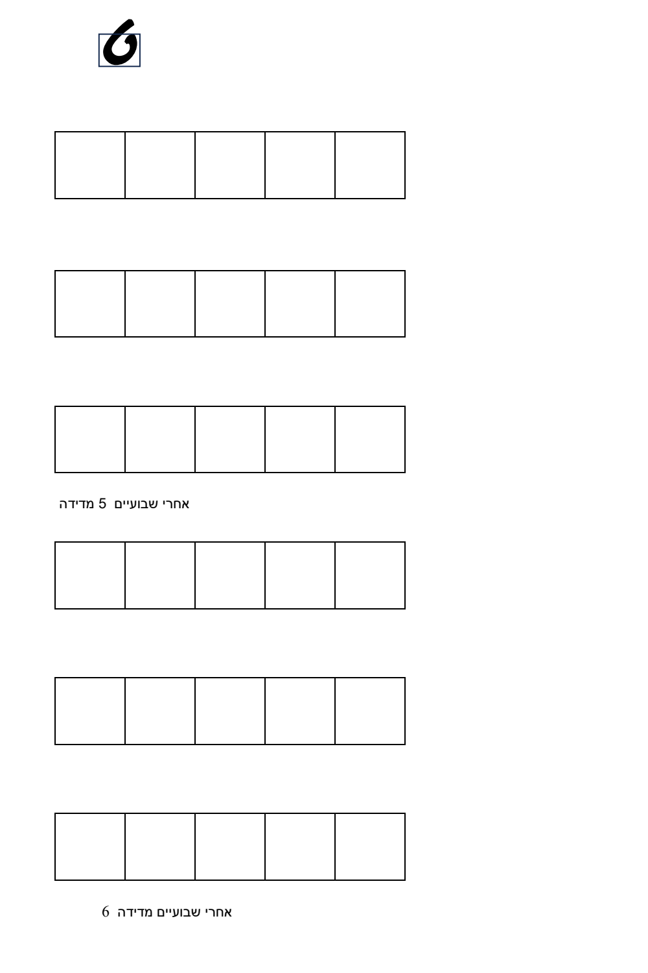
Figure 3: Sample 2-Week Retention Sheet for Intervention Letter (Measurements 5 & 6: Blank Boxes)
6. User Interface Specifications and English Wireframes (v3.2)
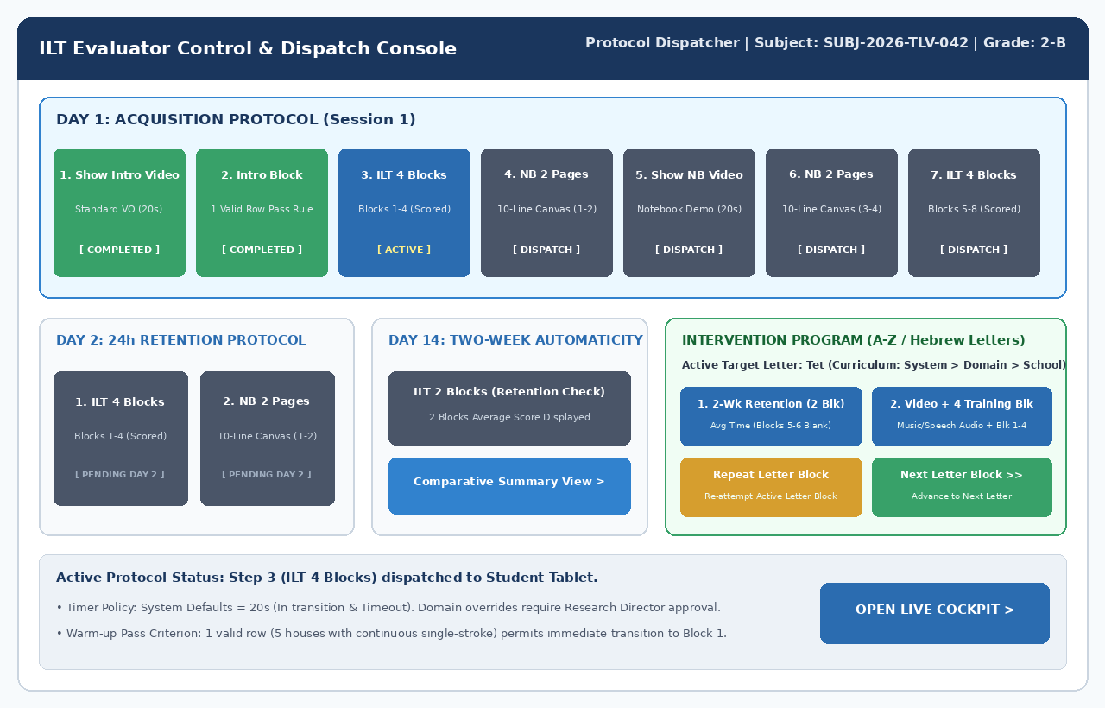
Figure 4: Evaluator Control & Dispatch Console with Intervention Program Rubric (Repeat / Next Letter Block)
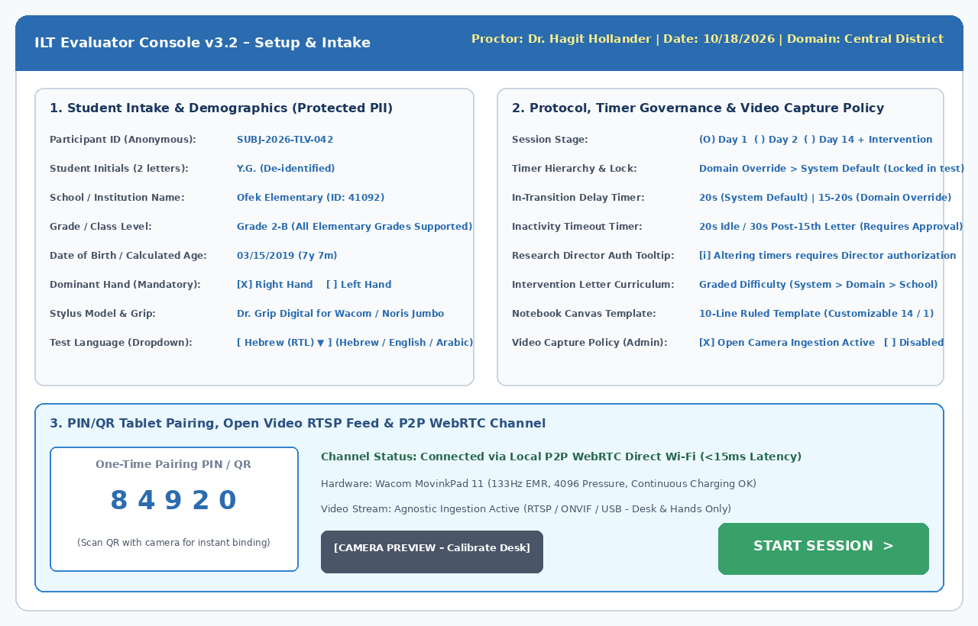
Figure 5: Evaluator Setup & Intake Console with Proctor Name, Date, School, Grade, and 20s In-Transition Timer
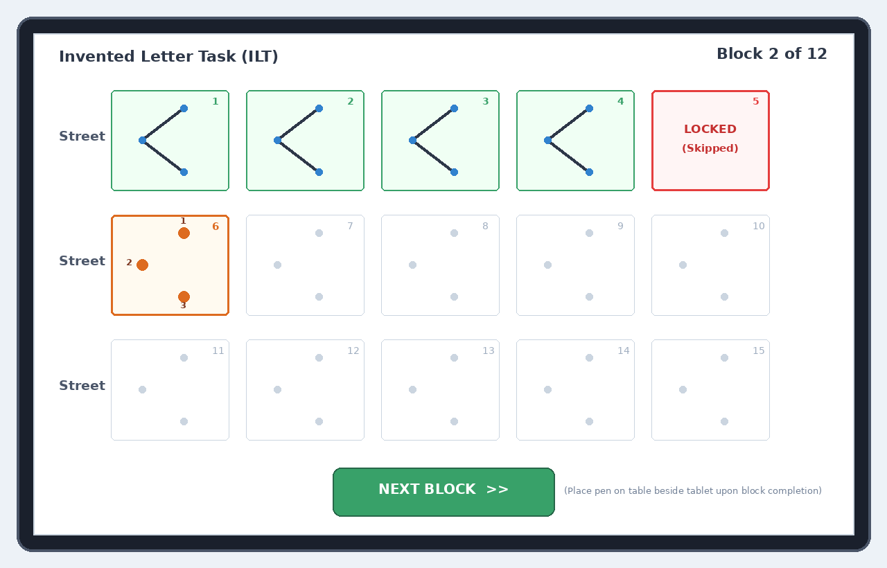
Figure 6: Student Tablet Canvas in LTR Mode (Left-to-Right Flow with Horizontally Mirrored Chevrons)
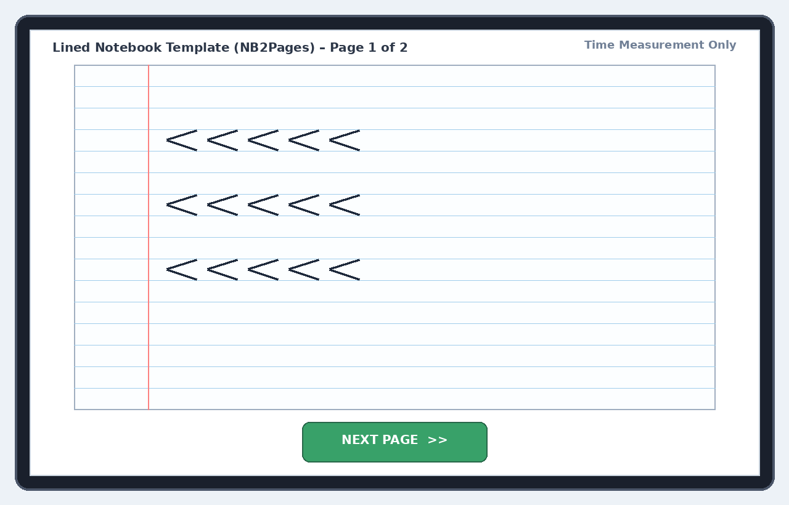
Figure 7: Lined Notebook Canvas (NB2Pages) Aligned to Original Figure 13 Ruling (3 Rows of 5 Chevrons)
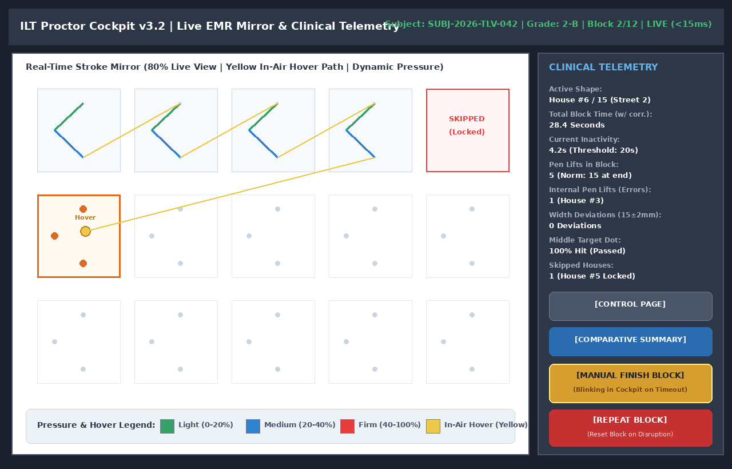
Figure 8: Proctor Cockpit (80% Live Mirror / 20% Telemetry) with Access to Comparative Summary
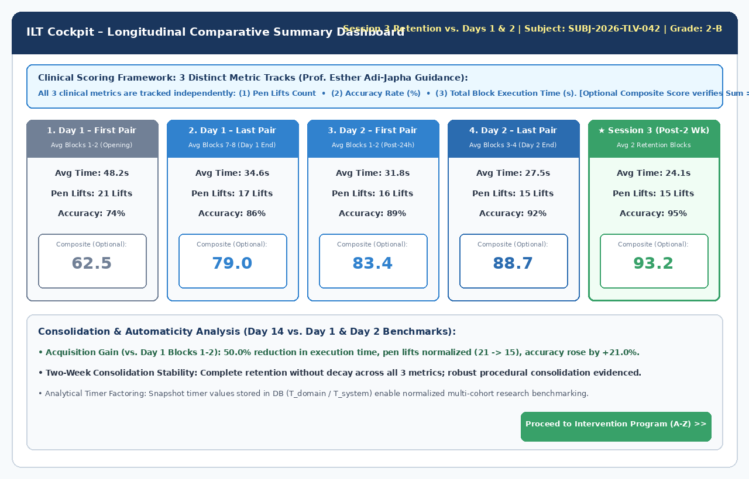
Figure 9: Longitudinal Comparative Summary Dashboard Displaying 3 Distinct Clinical Metrics (Prof. Adi-Japha)
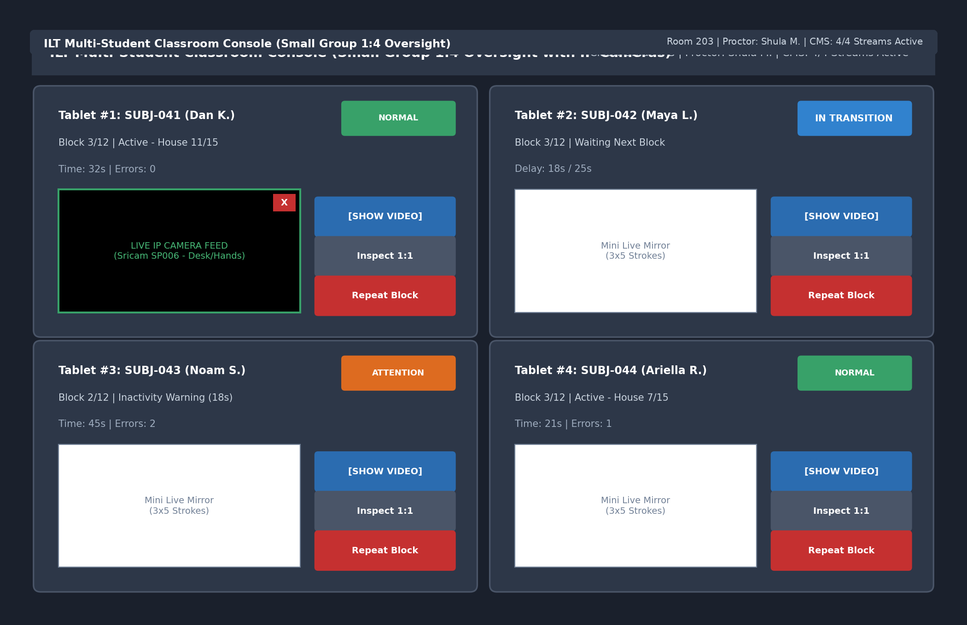
Figure 10: Multi-Student Classroom Console (1:4 Group Oversight) with IN TRANSITION Status Badge
7. Field Hardware, Ergonomic Styli, Notebook Samples, and Camera Configurations
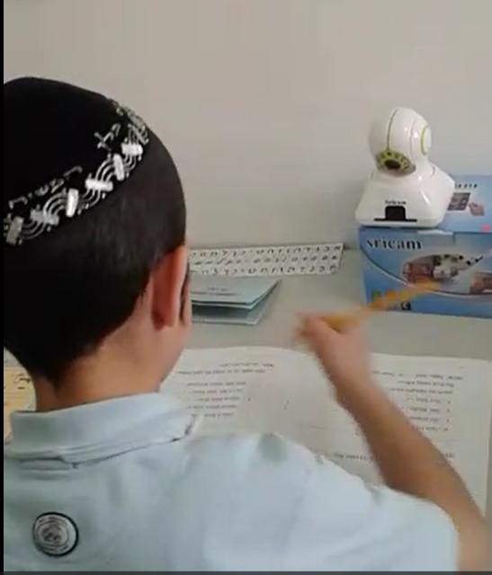
Figure 11: Wireless IP Camera Desk Setup (Calibrated for Desk and Hands Only)
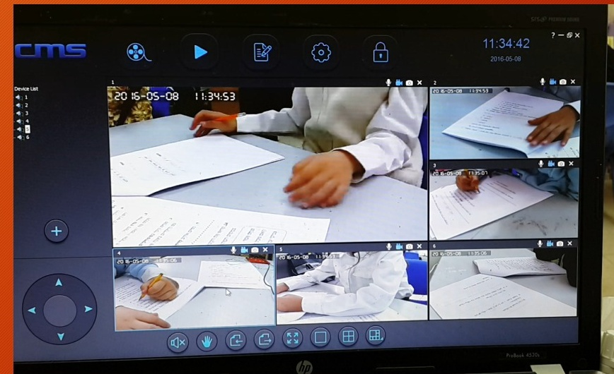
Figure 12: Camera Management System (CMS) Monitoring 6 Parallel Classroom Stations
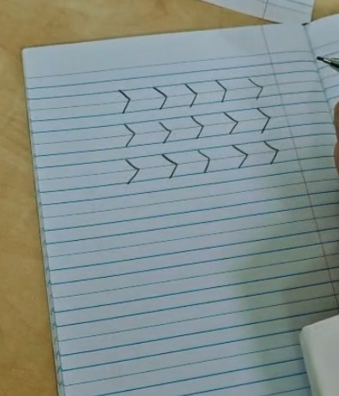
Figure 13: Authentic Lined Notebook Handwriting Sample from Original Study (3 Rows x 5 Chevrons)
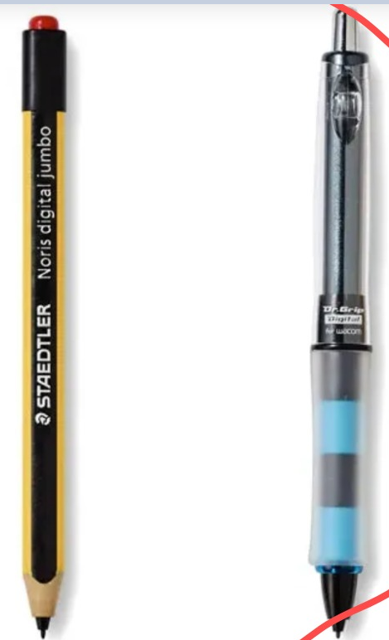
Figure 14: Preferred Ergonomic EMR Styli: Dr. Grip Digital for Wacom & STAEDTLER Noris Digital Jumbo
8. Error Calculation Engine, Kinematic Telemetry, and Scoring Formulation
• Distinct Metric Reporting Floor: Reporting must present Pen Lifts Count, Geometric Accuracy Rate (%), and Total Execution Time (s) as independent empirical dimensions.
• Strict Weight Validation Constraint: Whenever composite scores are evaluated, the administrator interface enforces: Sum(Weights) == 100%.

