ILT System - Architecture Design & Technical Specifications
Comprehensive Engineering Specification: Binary Wire Protocol, DDL, Local P2P Fallback, Kiosk Lockdown, Template Tooling & Privacy Controls
Document ID: ILT-ARCH-SPEC-V3.0-EN | Date: October 2026 | Scope: Educational Research (Open Source) | Input Hardware: Wacom DTHA116 (EMR)
Status: Approved for Implementation | Field Network: Local P2P + Async Cloud Sync | Video Privacy: Evaluator-Only Access + SSE-S3 | Stylus Protocol: Binary ArrayBuffer (20ms Batch)
1. Introduction, Vision & Core Architectural Principles
The ILT (Identification of Learning Disabilities System) platform is an open-source, distributed Web architecture designed for educational research and clinical screening of children with learning disabilities and literacy deficits. The system captures and analyzes fine-motor kinematics during handwriting and drawing tasks on a high-precision electromagnetic resonance (EMR) digitizer (Wacom DTHA116 with native 1140x2200 resolution). Telemetry streams include spatial coordinates (X, Y, Z hover/contact), 4,096 discrete pressure levels, flight-time vs. surface-time latencies, pen tremor, and real-time path deviation.
• Open-Source Educational Research Platform: Engineered strictly as a non-commercial, open-source educational research tool using proven open-source components, enabling flexible deployment across academic institutions, municipal clinics, and school districts.
• Zero WAN Dependency (Local P2P First with Async Sync): Diagnostic sessions operate over a direct peer-to-peer (P2P) local Wi-Fi channel. Network drops or internet unavailability do not disrupt ongoing evaluations; session telemetry and video are buffered locally and synchronized asynchronously once connectivity is restored.
• Zero-GC Binary Telemetry Protocol: Stylus kinematics sampled at 133Hz–200Hz are packed into fixed-size ArrayBuffer packets (3–5 samples batched), preventing garbage collection pauses and eliminating JSON overhead.
• Strict Privacy by Design & Data Segregation: Session video recordings are strictly confidential and accessible exclusively by the diagnosing evaluator. Personal identification is decoupled from biometric kinematic logs, and all persistent data is stored encrypted.
2. User Roles, RBAC & Privacy Access Controls
Role | Identity & Auth | Operating Interface | Key Responsibilities & Permissions
System Administrator | Email + Standard Password + Recovery Email | Administrative Web Portal | User management (Evaluators, Analysts), account activation/deactivation, password resets, Domain management (regions, schools, clinics).
Diagnostician (Evaluator) | Email + Password (Selects Domain at Login) | Cockpit Web Workstation (PC/Laptop) | Student alias intake, 5-digit PIN tablet pairing, task orchestration (Start/Pause/Stop/Clear), 80% live canvas mirror with real-time error HUD, exclusive access to observational session video.
Examinee (Student) | Not a registered user (Session ID only) | Tablet App (Wacom DTHA116) | Performs drawing/handwriting tasks on a fullscreen canvas (1140x2200) with zero UI distractions, no system bars, and no visible error indications.
Diagnostic Analyst | Email + Standard Password | Analytics & BI Dashboard | Access to centralized session databases, deterministic graphic replay, multi-variable cohort filtering across Domains, statistical modeling (no video access).
3. High-Performance Binary Wire Protocol & OpCodes Dictionary
3.1 Binary Packet Layout & Batching Performance Analysis
At sampling rates of 133Hz–200Hz, standard JSON encoding incurs an overhead of ~150 bytes per sample, creating severe CPU parsing strain and repetitive Garbage Collection (GC) pauses in browser runtimes. The system utilizes a direct, fixed-size binary struct (ArrayBuffer / DataView) batched in 3–5 sample windows (15–25ms, default 4 samples):
• Packet Header (8 Bytes): OpCode (1B, 0x01) | Batch Count N (1B, range 1-8) | Sequence Number (2B, uint16) | Base Timestamp (4B, uint32, ms epoch offset).
• Individual Sample Struct (11 Bytes): Delta_T (2B, uint16, ms offset) | X (2B, uint16, 0-1140) | Y (2B, uint16, 0-2200) | Pressure (2B, uint16, 0-4096) | TiltX (1B, int8, -90 to +90) | TiltY (1B, int8, -90 to +90) | Flags (1B: bit 0: InContact, bit 1: InBounds, bit 2: ButtonDown).
• Throughput Benchmark: A 4-sample batched packet requires exactly 52 bytes. Sustained 200Hz transmission consumes only ~2.6 KB/s, delivering sub-20ms latency and 60 FPS mirror rendering with negligible thread utilization.
3.2 WebSocket & WebRTC Protocol OpCodes Dictionary
The protocol dictionary is mapped to the relational database table protocol_opcodes, facilitating dynamic extensions for future feature sets:
OpCode | Message Identifier | Direction | Functional Description & Payload
0x01 | PEN_TELEMETRY_BATCH | Tablet -> Evaluator / Server | Batched binary ArrayBuffer payload containing 3-5 EMR point samples for live mirroring and storage.
0x02 | VALIDATION_ERROR | Tablet -> Evaluator | Real-time kinematic error notification: missed target waypoint, segment boundary breach, or premature pen lift.
0x03 | SESSION_START | Evaluator -> Tablet / Server | Initiates evaluation: locks canvas, starts master session timer, and triggers local USB video capture.
0x04 | SESSION_PAUSE | Evaluator -> Tablet | Temporarily pauses task: suspends pen input capture and pauses the master timer.
0x05 | SESSION_STOP | Evaluator -> Tablet / Server | Concludes task: closes pen channel, finalizes local video recording, and enqueues video for background upload.
0x06 | CANVAS_CLEAR | Evaluator -> Tablet | Clears the active canvas surface on the tablet upon evaluator command.
0x07 | PIN_PAIRING_REQ | Tablet -> Server / Evaluator | Broadcasts tablet 5-digit PIN for workstation pairing and handshake verification.
0x08 | PIN_PAIRING_ACK | Evaluator -> Tablet | Pairing acknowledgement: unlocks the tablet from the PIN screen to the task canvas.
0x09 | TEMPLATE_LOAD | Evaluator -> Tablet | Dispatches chosen task template definition (JSON) to initialize tablet boundaries and waypoints.
0x0A | SANITY_CHECK_TAP | Tablet -> Evaluator | Reports 3-second calibration tap delta to verify zero viewport offset and absence of magnetic interference.
4. Relational Database Schema & TimescaleDB Hypertables
4.1 PostgreSQL Core Relational Schema (DDL)
The database architecture is centered on the Session entity, linking administrative domains, RBAC users, paired tablets, and encrypted video URIs:
-- 1. Administrative Domains (Regions, Municipalities, Schools)
CREATE TABLE domains (
domain_id SERIAL PRIMARY KEY,
domain_name VARCHAR(100) NOT NULL UNIQUE,
domain_description TEXT,
created_at TIMESTAMP WITH TIME ZONE DEFAULT CURRENT_TIMESTAMP
);
-- 2. System Users (Admin, Evaluator, Analyst)
CREATE TABLE users (
user_id UUID PRIMARY KEY DEFAULT gen_random_uuid(),
email VARCHAR(255) NOT NULL UNIQUE,
password_hash VARCHAR(255) NOT NULL,
secondary_email VARCHAR(255),
role VARCHAR(20) NOT NULL CHECK (role IN ('ADMIN', 'DIAGNOSTICIAN', 'ANALYST')),
domain_id INT REFERENCES domains(domain_id) ON DELETE SET NULL,
is_active BOOLEAN DEFAULT TRUE,
created_at TIMESTAMP WITH TIME ZONE DEFAULT CURRENT_TIMESTAMP
);
-- 3. Registered Tablets (5-Digit PIN Identification)
CREATE TABLE tablets (
tablet_id SERIAL PRIMARY KEY,
pairing_pin VARCHAR(5) NOT NULL UNIQUE,
device_name VARCHAR(100) DEFAULT 'Wacom DTHA116',
local_ip VARCHAR(45),
last_seen_at TIMESTAMP WITH TIME ZONE DEFAULT CURRENT_TIMESTAMP
);
-- 4. Block Page Task Templates (Declarative Schema)
CREATE TABLE block_templates (
template_id VARCHAR(50) PRIMARY KEY,
template_name VARCHAR(100) NOT NULL,
canvas_width INT DEFAULT 1140,
canvas_height INT DEFAULT 2200,
template_schema JSONB NOT NULL,
created_at TIMESTAMP WITH TIME ZONE DEFAULT CURRENT_TIMESTAMP
);
-- 5. Diagnostic Sessions Master Entity
CREATE TABLE sessions (
session_id UUID PRIMARY KEY DEFAULT gen_random_uuid(),
session_number BIGSERIAL UNIQUE,
domain_id INT NOT NULL REFERENCES domains(domain_id),
evaluator_id UUID NOT NULL REFERENCES users(user_id),
tablet_id INT REFERENCES tablets(tablet_id),
examinee_alias VARCHAR(50) NOT NULL,
template_id VARCHAR(50) REFERENCES block_templates(template_id),
status VARCHAR(20) DEFAULT 'INITIALIZED' CHECK (status IN ('INITIALIZED', 'ACTIVE', 'PAUSED', 'COMPLETED', 'ABORTED')),
sync_status VARCHAR(20) DEFAULT 'LOCAL_ONLY' CHECK (sync_status IN ('LOCAL_ONLY', 'SYNCING', 'SYNCED_TO_CLOUD')),
start_time TIMESTAMP WITH TIME ZONE,
end_time TIMESTAMP WITH TIME ZONE,
duration_ms INT DEFAULT 0,
video_file_url TEXT NULL,
video_upload_status VARCHAR(20) DEFAULT 'NONE',
created_at TIMESTAMP WITH TIME ZONE DEFAULT CURRENT_TIMESTAMP
);
-- 6. Time-Stamped Diagnostic Errors Log
CREATE TABLE session_errors (
error_id BIGSERIAL PRIMARY KEY,
session_id UUID NOT NULL REFERENCES sessions(session_id) ON DELETE CASCADE,
segment_id INT NOT NULL,
error_type VARCHAR(30) NOT NULL,
error_details JSONB,
timestamp_ms INT NOT NULL
);
-- 7. Protocol OpCodes Dictionary Table
CREATE TABLE protocol_opcodes (
opcode_hex VARCHAR(4) PRIMARY KEY,
code_name VARCHAR(50) NOT NULL UNIQUE,
direction VARCHAR(50) NOT NULL,
category VARCHAR(30) NOT NULL,
description TEXT,
is_active BOOLEAN DEFAULT TRUE
);
4.2 TimescaleDB Hypertables & Compression Policies
High-density stylus point streams are persisted in a specialized time-series table transformed into a TimescaleDB Hypertable:
-- Biometric Stylus Telemetry Table
CREATE TABLE pen_telemetry (
session_id UUID NOT NULL,
sample_time TIMESTAMP WITH TIME ZONE NOT NULL,
delta_ms INT NOT NULL,
x NUMERIC(7,2) NOT NULL,
y NUMERIC(7,2) NOT NULL,
z_hover BOOLEAN DEFAULT FALSE,
pressure INT NOT NULL CHECK (pressure BETWEEN 0 AND 4096),
tilt_x SMALLINT DEFAULT 0,
tilt_y SMALLINT DEFAULT 0,
flags SMALLINT DEFAULT 0
);
-- Convert to TimescaleDB Hypertable
SELECT create_hypertable('pen_telemetry', 'sample_time',
chunk_time_interval => INTERVAL '1 day',
if_not_exists => TRUE
);
-- Compound Index for Sub-Millisecond Replay Queries
CREATE INDEX idx_pen_telemetry_session_time ON pen_telemetry (session_id, delta_ms ASC);
-- Enable Native Columnar Compression Grouped by Session
ALTER TABLE pen_telemetry SET (
timescaledb.compress,
timescaledb.compress_segmentby = 'session_id',
timescaledb.compress_orderby = 'delta_ms ASC'
);
• Configurable Chunk Partitioning: Chunk interval is managed externally via environment configuration (ENV: TIMESCALE_CHUNK_INTERVAL, default 1 day). This ensures operational adaptability across deployment scales.
• Transparent Columnar Compression: Upon session completion (status = 'COMPLETED'), an automated background compression job compresses the chunk. This achieves 85-90% disk space reduction while preserving full SQL queryability for analyst pipelines without decompression overhead.
5. Network Topology, Cloud Infrastructure & Local P2P Fallback
5.1 Educational Research Cloud Hosting Alternatives
Because ILT is designed as an open-source educational research platform, cloud hosting infrastructure focuses on cost predictability and open-source compatibility:
• Global Cloud Providers (AWS / Google Cloud / Azure Research): Major cloud vendors offer dedicated academic grant programs (e.g., AWS Cloud for Research Grants, Google Cloud Research Credits) that subsidize compute and storage. They offer premier container orchestration (EKS/GKE), automated multi-zone failover, and compliance certifications.
• Open-Source Friendly Infrastructure (Hetzner / OVHcloud): Leading European bare-metal and VPS providers deliver fixed, highly predictable monthly costs with unmetered bandwidth (no egress fees), making them optimal for academic research labs operating under fixed university budgets.
5.2 Local P2P Wi-Fi Direct Channel (Zero WAN Dependency)
In school and clinic environments, the student tablet and evaluator PC typically share a local Wi-Fi router. The network architecture leverages this topology:
• Direct Local P2P Channel (WebRTC DataChannel / Local WSS): Stylus data streams directly across the local LAN subnet. Telemetry latency drops below 15ms, and the evaluation remains fully functional even during total external WAN outages.
• Asynchronous Session Cloud Sync: Telemetry points and error events are buffered in local browser storage (IndexedDB on evaluator PC / tablet). When internet connectivity becomes available and the workstation is idle, a background sync agent performs a bulk ingestion into PostgreSQL/TimescaleDB and streams the local video file to MinIO.
6. Tablet Kiosk Configuration & Device Management
To prevent accidental app switching, gesture interruptions, or sleep modes during evaluations:
• Dedicated Kiosk Shell: Fully Kiosk Browser: Selected as the turnkey runtime for Android on the Wacom DTHA116. It enforces Lock Task Mode, completely blocks Android navigation and status bars, enables auto-launch on device boot, and ensures native hardware-accelerated WebGL/Canvas rendering.
• Open-Source Android Wrapper (Custom TWA): Alternative custom APK based on Trusted Web Activities (TWA) registered as Device Owner, utilizing Android's native `startLockTask()` API.
• Screen WakeLock API: The client application invokes `navigator.wakeLock.request('screen')` on task initiation, ensuring the digitizer display remains fully awake while the child plans strokes between segments.
7. Two-Phase Block Canvas Template Authoring Tooling
Block pages contain segmented grids and target waypoints requiring continuous strokes. Template generation follows a structured two-phase roadmap:
• Phase 1: In-Situ Pen Calibration Mode on Tablet: 1. Upload task graphic (PNG/SVG, 1140x2200). 2. Layer 1 (Grid Structure): Touching grid corners with the EMR stylus auto-generates bounding boxes. 3. Layer 2 (Movement Waypoints): Touching target points sequentially (P1 -> P2 -> P3) records sub-pixel coordinates. The system automatically compiles the declarative JSON schema into the database.
• Phase 2: AI & Computer Vision Template Generator: Future extension utilizing contour detection and OCR algorithms to process scanned test sheets, automatically suggesting grid segments and target coordinates for administrative verification.
8. Observational Video Subsystem & Real-Time Kinematic Validation FSM
• Local Recording via OPFS: A standard USB HD camera connects directly to the Evaluator PC. Upon [Start Task], the browser records local WebM/H.264 streams directly into the Origin Private File System (OPFS), imposing zero network strain during active tests.
• Exclusive Evaluator Access (Strict Privacy): Video recordings are exclusively viewable by the diagnosing evaluator (`evaluator_id = current_user.id`). Analysts receive access only to de-identified telemetry graphs and kinematic statistics.
• Cascading Deletion: Telemetry and video are retained until explicitly deleted. Deleting a Session triggers cascading deletion across PostgreSQL, TimescaleDB, and MinIO storage.
• Real-Time Validation FSM: Edge validation on the tablet continuously evaluates: (1) `POINTS_MISSED` (stroke vector failing to intersect waypoint tolerance $R=18 ext{px}$), (2) `OUT_OF_BOUNDS` (pen pressure $>0$ outside box), and (3) `PREMATURE_PEN_LIFT` (pressure dropping to 0 prior to completing all targets in a segment). Errors are instantly mirrored as red bounding boxes on the evaluator's 80% screen.
9. System Architecture & Process Diagrams
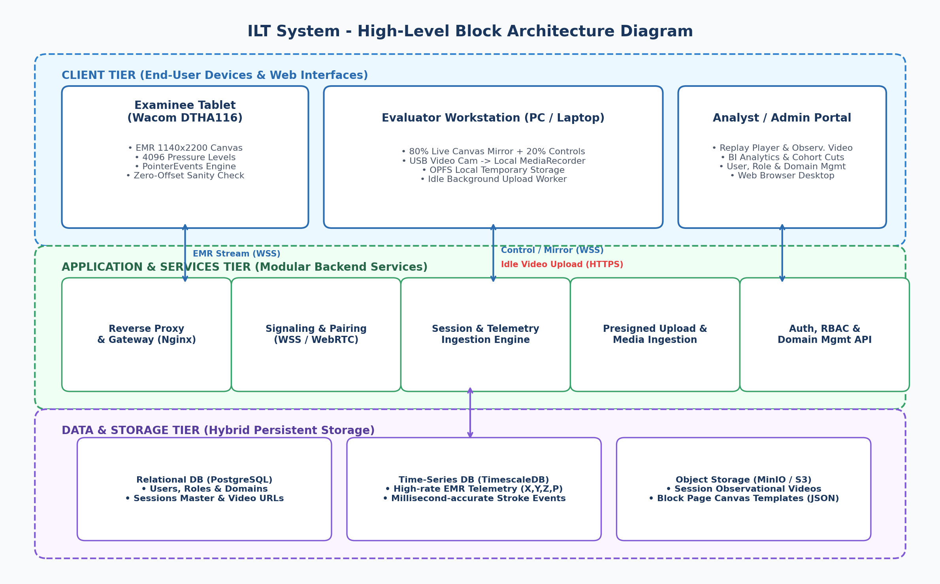
Figure 1: High-Level System Block Architecture Diagram
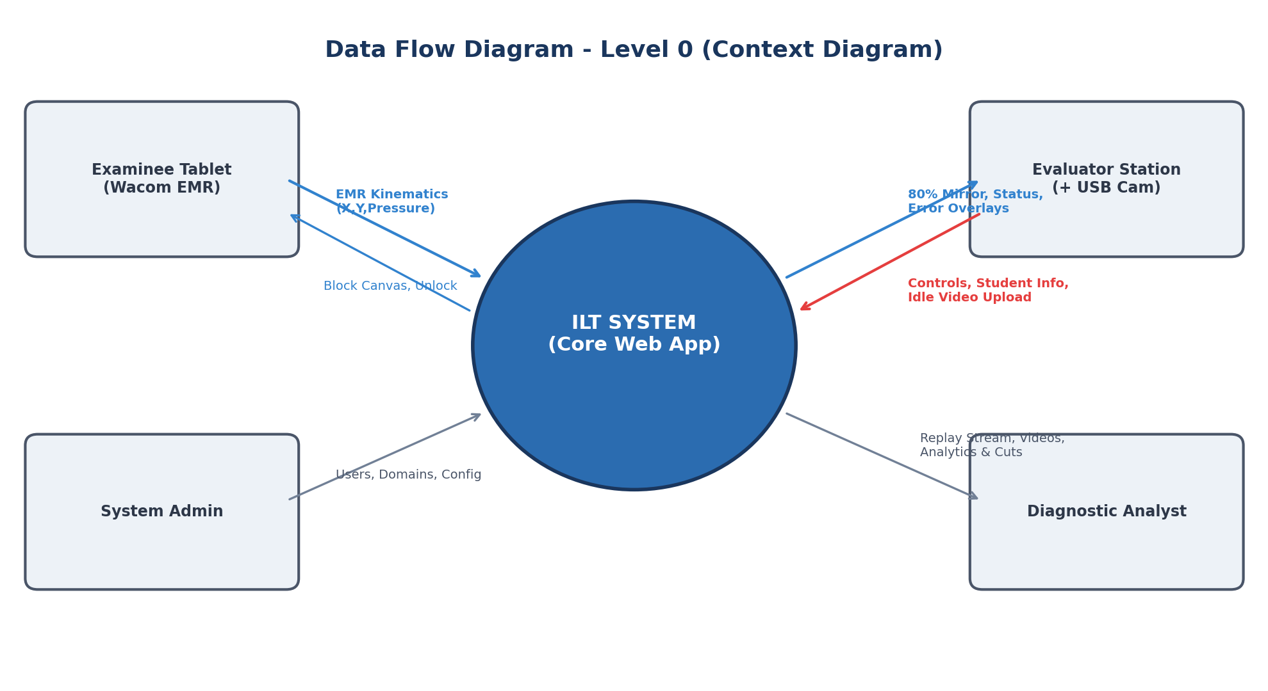
Figure 2: Data Flow Diagram - Level 0 (Context Diagram)
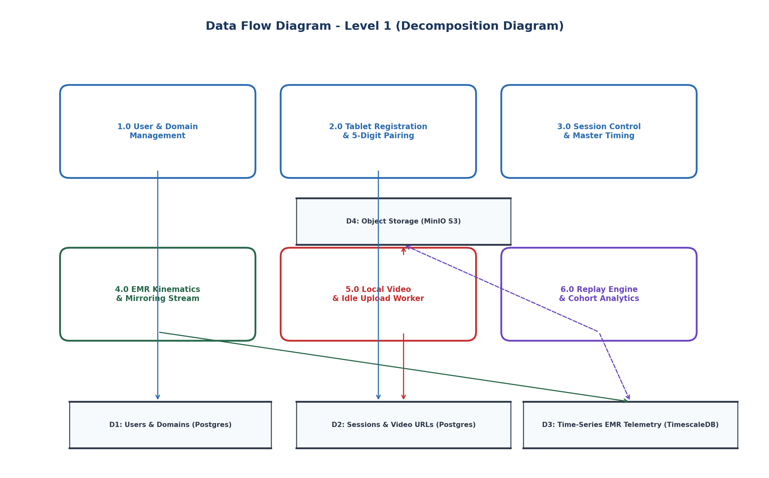
Figure 3: Data Flow Diagram - Level 1 (Decomposition Diagram)
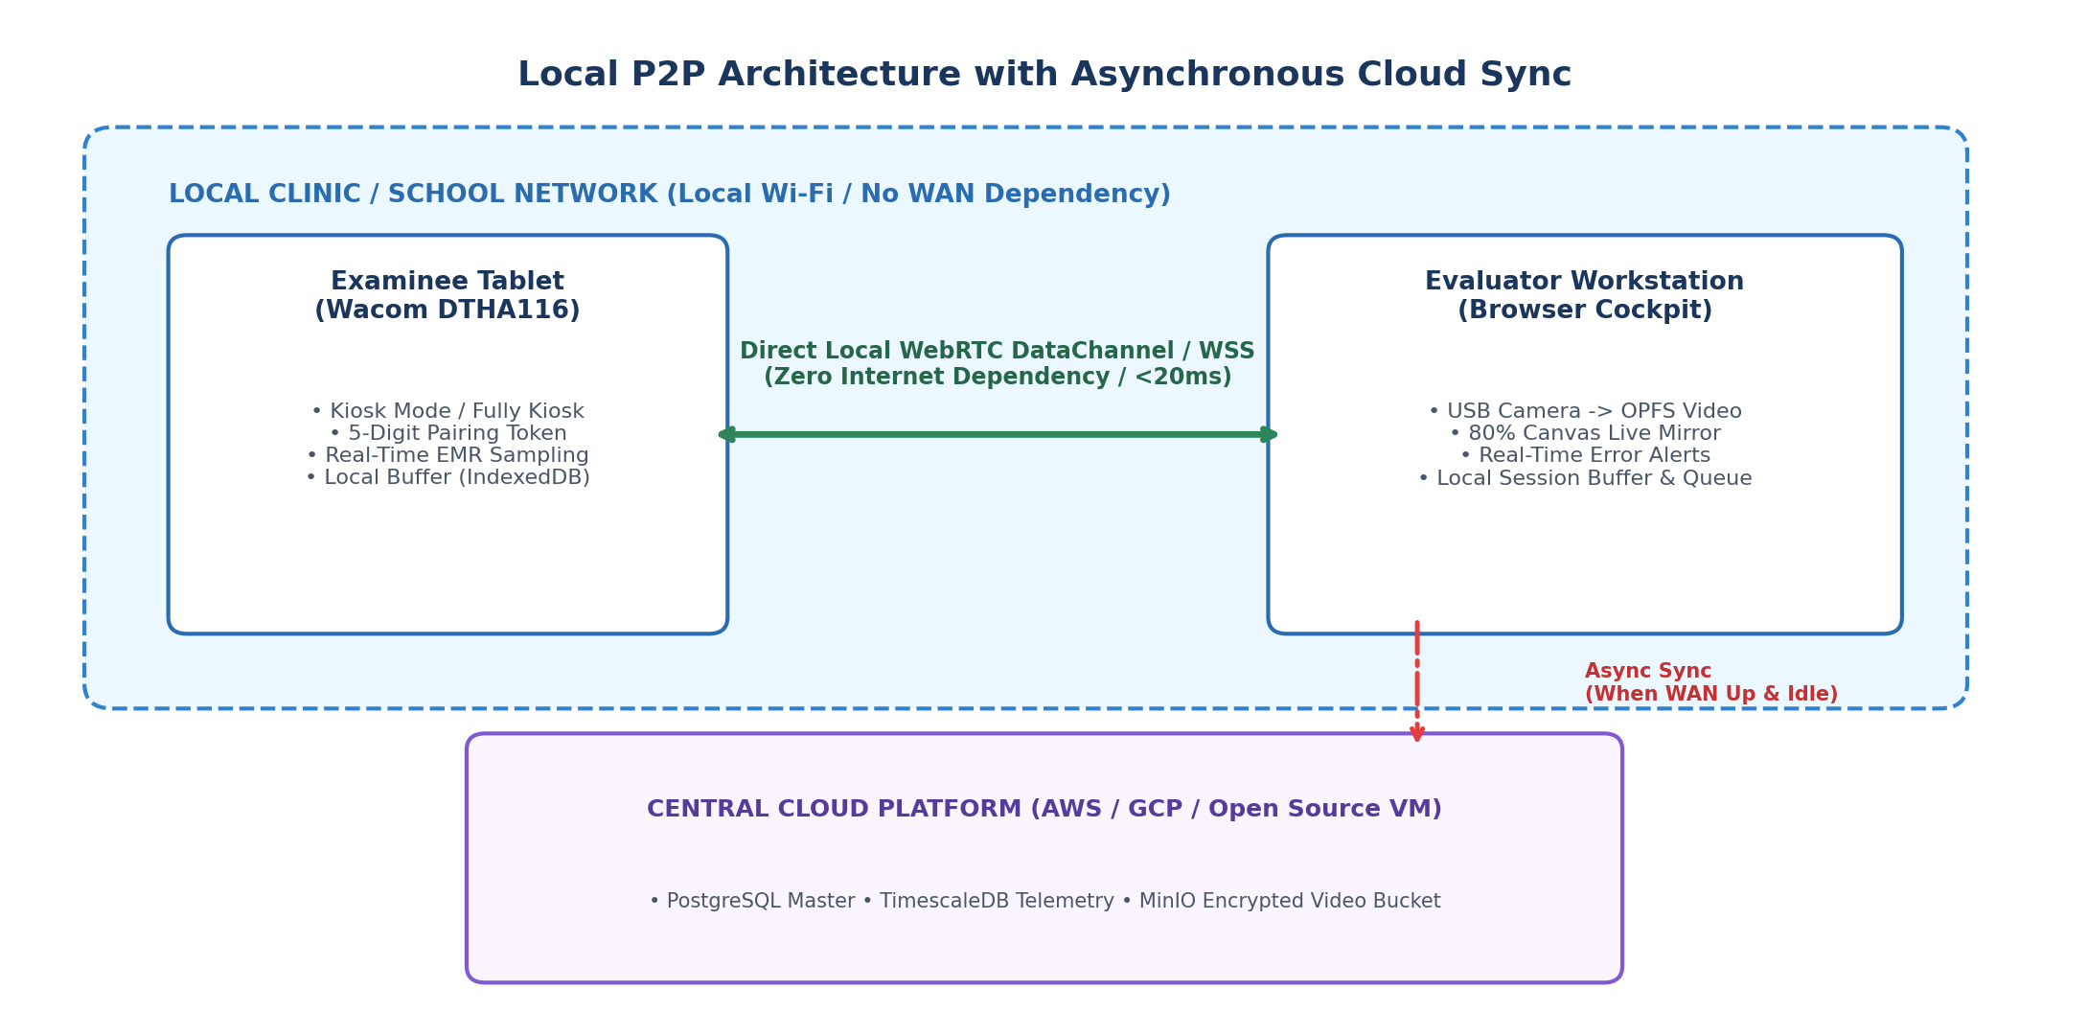
Figure 4: Local P2P Wi-Fi Architecture with Asynchronous Cloud Sync
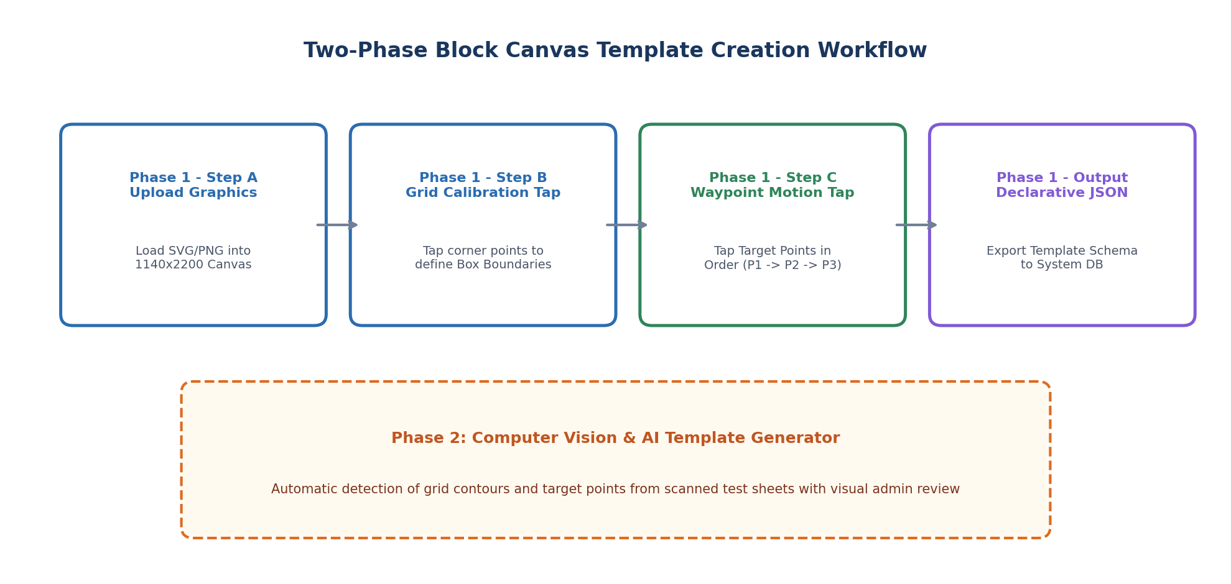
Figure 5: Two-Phase Block Canvas Template Creation Workflow
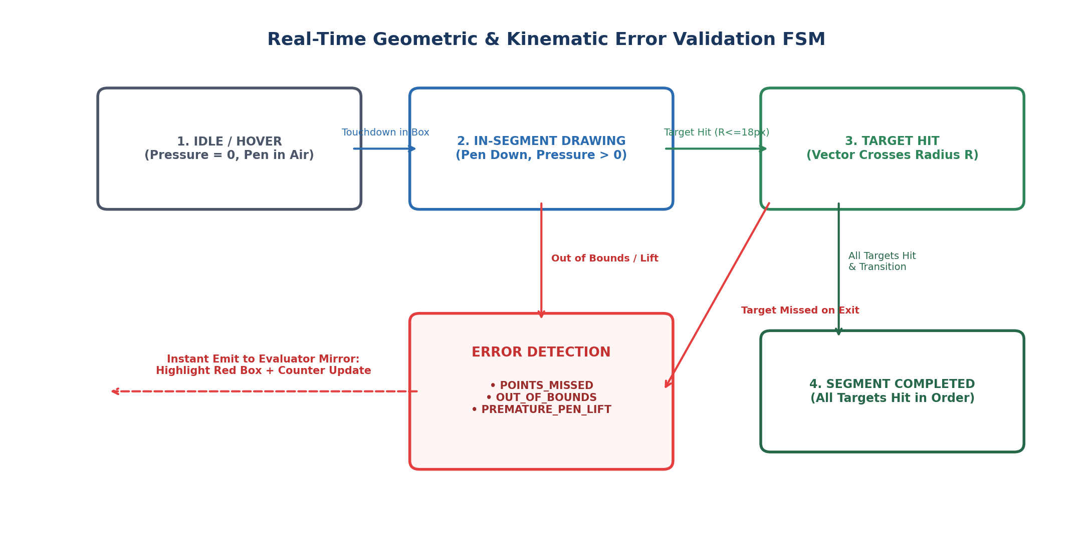
Figure 6: Real-Time Geometric & Kinematic Error Validation FSM
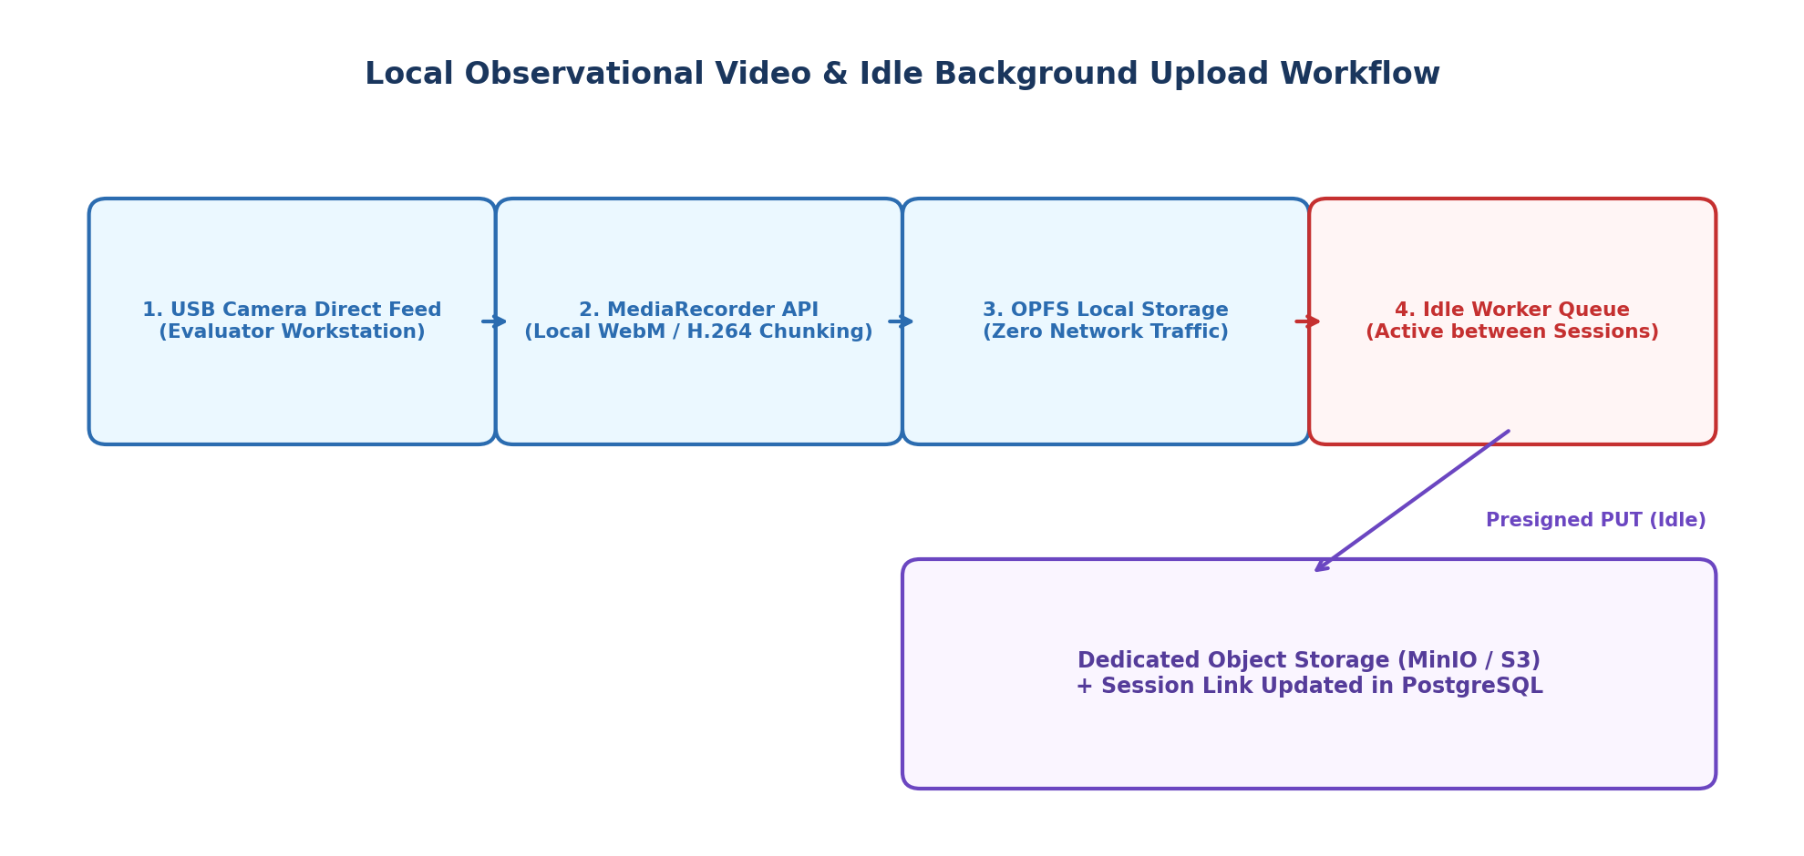
Figure 7: Local Observational Video Capture & Idle Background Upload Workflow
10. Open-Source Technology Stack & Infrastructure Bootstrap Roadmap
Layer / Subsystem | Primary Open-Source Tech | Viable Alternative | Architectural Role & Value
Tablet Client Runtime | HTML5 Canvas + Vanilla JS | Preact | Zero runtime overhead, 60+ FPS stylus rendering on Android WebView.
Evaluator Cockpit UI | React / Next.js or Vue 3 | Svelte | Modular reactive state management for 80% mirror and control telemetry.
Local Video Capture | MediaRecorder API + OPFS | IndexedDB Blob Stream | Direct-to-disk recording on evaluator PC without network saturation.
Backend API & Signaling | Node.js (Fastify / ws) or Go | Python FastAPI | Handles hundreds of concurrent WebSockets with low memory footprint.
Primary Relational DB | PostgreSQL 16 | MariaDB | Enterprise ACID compliance, robust JSONB support, and RBAC governance.
Time-Series Kinematics Store | TimescaleDB (Postgres Ext) | ClickHouse | Sub-millisecond partitioning and native columnar compression of point streams.
Dedicated Object Storage | MinIO (S3-Compatible) | Ceph | Secure on-premises / cloud storage for session videos with SSE-S3 encryption.
10.1 Immediate Infrastructure Deployment Steps
• Step 1: Containerized Foundation (Docker Compose): Deploy base containers for PostgreSQL 16 (with TimescaleDB extension), MinIO Object Storage, Redis, Nginx Reverse Proxy, and WebSocket signaling stub.
• Step 2: DDL Schema Deployment: Execute the SQL initialization script (Section 4) creating relational tables, the telemetry hypertable, indices, and the protocol opcodes dictionary.
• Step 3: Binary Protocol Implementation: Implement TypeScript/JavaScript serialization modules for the 52-byte ArrayBuffer struct and 20ms batch window.
• Step 4: End-to-End P2P Validation: Verify direct local Wi-Fi telemetry mirroring between a physical Wacom DTHA116 tablet and an evaluator PC.

