ILT System - Architecture & Technical Specifications (v4.0)
Infrastructure Architecture, Local P2P Network, Sricam IP Camera CMS Integration, DDL Schema, Binary Protocol & Multilingual Engine
Document Parameter | Value & Specification | Document Parameter | Value & Specification
Document ID: | ILT-ARCH-SPEC-V4.0-EN | Release Date: | October 2026
Clinical Basis: | Dr. Hollander, Prof. Adi-Japha, Dr. Dorfberger | Target Hardware: | Wacom MovinkPad 11 / DTHA116
Video System: | Sricam SP006 Wireless IP Cameras + CMS | Primary Data Link: | Local WebRTC DataChannel / P2P Wi-Fi
Database Schema: | PostgreSQL 16 + TimescaleDB + MinIO | Ergonomic Styluses: | Dr. Grip Digital for Wacom / Noris Jumbo

1. Introduction, Vision & Core Architectural Tenets
The ILT (Identification of Learning Disabilities) System delivers an open-source educational research platform for early objective screening of graphomotor deficits, dysgraphia, and literacy impairments in elementary school students. Based on seminal research by Dr. Hagit Hollander, Prof. Esther Adi-Japha (Bar-Ilan University), and Dr. Shoshi Dorfberger (Gordon College), the system captures fine motor handwriting kinematics over professional EMR digitizer screens (Wacom DTHA116, 2200x1440 resolution, 3:2 ratio), acquiring spatial coordinates (X, Y, Z hover/contact), 4,096 pressure levels, in-air latency, and tremor patterns.
• Local P2P First with Asynchronous Cloud Sync: Evaluation operates directly over local Wi-Fi via P2P WebRTC DataChannel. Wide-area internet drops do not interrupt testing; data is buffered locally and uploaded asynchronously in idle state.
• Wireless IP Camera Subsystem & CMS (Desk & Hands Only): Video surveillance utilizes Sricam SP006 720p Wireless IP cameras connected to local Wi-Fi and managed via an integrated CMS. Cameras are calibrated strictly to desk/hands, excluding children's faces for privacy protection.
• Multilingual Architecture & LTR Mirroring: Native support for RTL (Hebrew, Arabic) and LTR (English) scripts. LTR blocks are exact mirror images, with left-to-right street flow and horizontally mirrored letter glyphs.
• Centralized Control Page Dispatcher: Proctors manage testing stages (Intro Video, Intro Block, ILT 4 Blocks, Lined Notebook) via an interactive dispatch console with real-time stage status indicators.
2. Wireless IP Camera Subsystem & CMS Architecture
Version 4.0 integrates wireless IP surveillance managed via a local Camera Management System (CMS):
• Field Hardware: Sricam SP006 720p: Indoor Wi-Fi IP camera with Pan/Tilt, H.264 compression, streaming RTSP/ONVIF over local Wi-Fi.
• QR Code Pairing Protocol: Upon session initiation, the tablet displays a QR code containing the session token. Presenting the tablet before the Sricam camera lens binds the RTSP stream 1:1 to the active session in CMS.
• Desk View Calibration & Preview Button: The evaluator console provides a [CAMERA PREVIEW] button displaying live video to verify the camera frames the desk and hands only, strictly avoiding child faces.
• Classroom CMS Gateway: A local CMS service on the proctor workstation aggregates up to 6 concurrent RTSP streams, transcoding them to WebRTC/MSE for browser display and local disk recording.
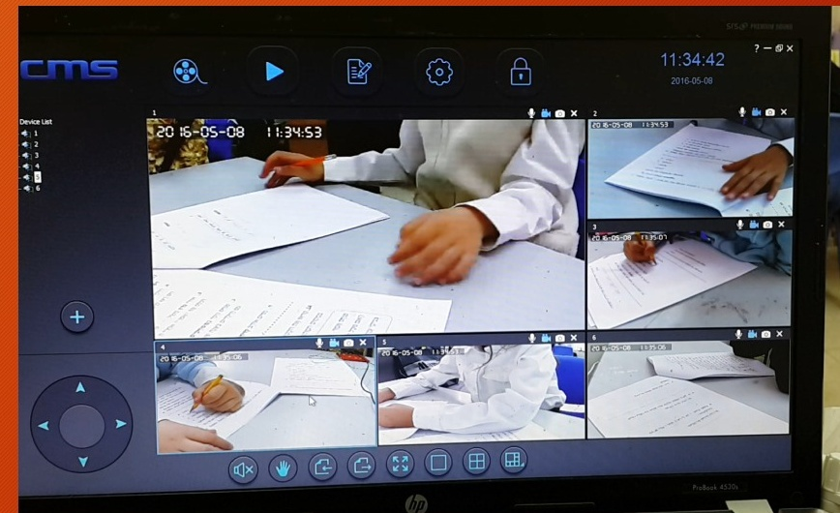
Figure 1: CMS (Camera Management System) Multi-Camera View Monitoring 6 Clinical Stations
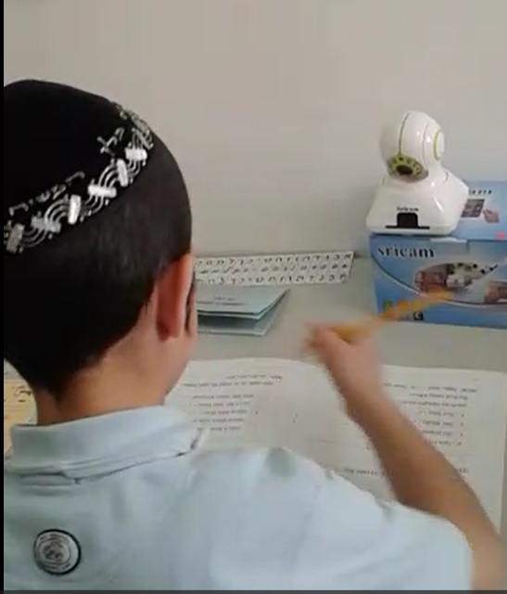
Figure 2: Desktop Placement of Sricam SP006 IP Camera (Framing Hands and Desk Surface Only)
3. Binary Protocol Specification & Expanded OpCode Dictionary
EMR pen events are batched into 4-sample binary frames (every 20ms, 52 bytes/frame, ~2.6 KB/s). The protocol dictionary spans 26 standardized OpCodes:
OpCode | Command / Event Name | Direction | Functional Purpose & Payload
0x01 | PEN_TELEMETRY_BATCH | Tablet -> Cockpit | Batched binary packet of 3-5 EMR pen samples for live mirroring and storage.
0x02 | VALIDATION_ERROR | Tablet -> Cockpit | Instant validation alert: missed target dot, out-of-bounds, or internal lift.
0x03 | SESSION_START | Cockpit -> Tablet | Session launch: locks canvas, starts timers, triggers IP camera recording.
0x04 | SESSION_PAUSE | Cockpit -> Tablet | Temporary pause: freezes canvas intake and pauses timers.
0x05 | SESSION_STOP | Bidirectional | Session termination: closes streams and queues files for cloud upload.
0x06 | BLOCK_START | Cockpit -> Tablet | Initializes next block canvas for drawing.
0x07 | PIN_PAIRING_REQ | Tablet -> Cockpit | Tablet broadcasts 5-digit PIN token for P2P pairing.
0x08 | PIN_PAIRING_ACK | Cockpit -> Tablet | Confirms pairing and displays QR code for camera binding.
0x09 | TEMPLATE_LOAD | Cockpit -> Tablet | Loads selected JSON template schema to tablet canvas.
0x0A | SANITY_CHECK_TAP | Tablet -> Cockpit | Transmits 3-second synchronization tap verification.
0x0B | BLOCK_COMPLETED | Bidirectional | Normal completion of 15 shapes, initiating consolidation rest timer.
0x0C | BLOCK_REPEAT_TRIGGERED | Cockpit -> Tablet | Proctor reset invalidating interrupted block and restarting fresh.
0x0D | DELAY_TIMER_TICK | Tablet -> Cockpit | Broadcasts synchronized countdown second during delay (20–30s).
0x0E | CONTROL_PAGE_NAVIGATE | Bidirectional | Transitions between Control Page dispatcher and Live Cockpit.
0x0F | SHOW_INTRO_VIDEO | Cockpit -> Tablet | Dispatches 20s intro video demonstrating invented letter drawing.
0x10 | SHOW_NB_VIDEO | Cockpit -> Tablet | Dispatches demo video showing lined notebook execution.
0x11 | NB_PAGE_START | Cockpit -> Tablet | Loads lined notebook template (NB2Pages) for time-only scoring.
0x12 | NB_PAGE_COMPLETE | Tablet -> Cockpit | Notebook page completed via [Next Page >>] button or timeout.
0x13 | CAMERA_QR_GENERATED | Tablet -> CMS | Generates QR code on tablet screen for Sricam camera binding.
0x14 | CAMERA_PREVIEW_TOGGLE | Cockpit -> CMS | Toggles live desk camera preview for angle calibration.
0x15 | HOVER_PATH_STREAM | Tablet -> Cockpit | Streams in-air hover coordinates for rendering yellow trajectory line.
0x16 | AVATAR_AUDIO_SYNC | Cockpit -> Tablet | Synchronizes Avatar teacher speech and animated graphics.
0x17 | MULTI_VIDEO_TOGGLE | Cockpit -> Tablet | Toggles [SHOW VIDEO] stream overlay in classroom multi-student view.
0x18 | BLOCK_TIMEOUT_WARNING | Tablet -> Cockpit | Inactivity timeout trigger activating dynamic blinking finish button.
0x19 | SEGMENT_SKIPPED_LOCKED | Tablet -> Cockpit | Forward-only lock event: locks skipped house and logs error.
0x1A | CLINICAL_NOTE_ADDED | Cockpit -> DB | Timestamped clinical observation recorded by evaluator.

4. Updated Database Schema (PostgreSQL Core DDL v4.0)
The schema introduces dedicated tables for wireless IP cameras, lined notebook trials, multilingual tags, and expanded session states:
-- 1. Domains
CREATE TABLE domains (
domain_id SERIAL PRIMARY KEY,
domain_name VARCHAR(100) NOT NULL UNIQUE,
domain_description TEXT,
created_at TIMESTAMP WITH TIME ZONE DEFAULT CURRENT_TIMESTAMP
);
-- 2. System Users
CREATE TABLE users (
user_id UUID PRIMARY KEY DEFAULT gen_random_uuid(),
email VARCHAR(255) NOT NULL UNIQUE,
password_hash VARCHAR(255) NOT NULL,
role VARCHAR(20) NOT NULL CHECK (role IN ('ADMIN', 'DIAGNOSTICIAN', 'ANALYST')),
preferred_ui_lang VARCHAR(5) DEFAULT 'en' CHECK (preferred_ui_lang IN ('he', 'en', 'ar')),
domain_id INT REFERENCES domains(domain_id) ON DELETE SET NULL,
is_active BOOLEAN DEFAULT TRUE,
created_at TIMESTAMP WITH TIME ZONE DEFAULT CURRENT_TIMESTAMP
);
-- 3. Wireless Sricam IP Cameras & CMS
CREATE TABLE ip_cameras (
camera_id SERIAL PRIMARY KEY,
camera_model VARCHAR(50) DEFAULT 'Sricam SP006 720p',
mac_address VARCHAR(17) NOT NULL UNIQUE,
local_ip VARCHAR(45) NOT NULL,
rtsp_stream_url TEXT NOT NULL,
cms_channel_id INT,
desk_preview_verified BOOLEAN DEFAULT FALSE,
last_ping_at TIMESTAMP WITH TIME ZONE DEFAULT CURRENT_TIMESTAMP
);
-- 4. Paired Tablets
CREATE TABLE tablets (
tablet_id SERIAL PRIMARY KEY,
pairing_pin VARCHAR(5) NOT NULL UNIQUE,
device_name VARCHAR(100) DEFAULT 'Wacom MovinkPad 11 (DTHA116)',
local_ip VARCHAR(45),
last_seen_at TIMESTAMP WITH TIME ZONE DEFAULT CURRENT_TIMESTAMP
);
-- 5. Block Templates (with LTR Mirroring and Notebook Paper)
CREATE TABLE block_templates (
template_id VARCHAR(50) PRIMARY KEY,
template_name VARCHAR(100) NOT NULL,
template_type VARCHAR(30) NOT NULL CHECK (template_type IN ('ILT_DOTS_3X5', 'ILT_DCD_SCAFFOLD', 'NB_LINED_PAPER')),
is_mirrored_ltr BOOLEAN DEFAULT FALSE,
canvas_width INT DEFAULT 2200,
canvas_height INT DEFAULT 1440,
template_schema JSONB NOT NULL,
created_at TIMESTAMP WITH TIME ZONE DEFAULT CURRENT_TIMESTAMP
);
-- 6. Core Sessions Table
CREATE TABLE sessions (
session_id UUID PRIMARY KEY DEFAULT gen_random_uuid(),
session_number BIGSERIAL UNIQUE,
domain_id INT NOT NULL REFERENCES domains(domain_id),
evaluator_id UUID NOT NULL REFERENCES users(user_id),
tablet_id INT REFERENCES tablets(tablet_id),
camera_id INT REFERENCES ip_cameras(camera_id),
examinee_alias VARCHAR(50) NOT NULL,
student_language VARCHAR(5) DEFAULT 'en' CHECK (student_language IN ('he', 'en', 'ar')),
pen_model VARCHAR(50) DEFAULT 'Dr. Grip Digital for Wacom',
dominant_hand VARCHAR(10) NOT NULL CHECK (dominant_hand IN ('RIGHT', 'LEFT')),
session_stage VARCHAR(30) NOT NULL CHECK (session_stage IN ('DAY_1_ACQUISITION', 'DAY_2_RETENTION', 'DAY_14_AUTOMATICITY')),
current_control_step VARCHAR(50) DEFAULT 'INIT',
status VARCHAR(20) DEFAULT 'INITIALIZED' CHECK (status IN ('INITIALIZED', 'ACTIVE', 'PAUSED', 'COMPLETED', 'ABORTED')),
sync_status VARCHAR(20) DEFAULT 'LOCAL_ONLY' CHECK (sync_status IN ('LOCAL_ONLY', 'SYNCING', 'SYNCED_TO_CLOUD')),
start_time TIMESTAMP WITH TIME ZONE,
end_time TIMESTAMP WITH TIME ZONE,
duration_ms INT DEFAULT 0,
video_recording_url TEXT NULL,
video_upload_status VARCHAR(20) DEFAULT 'NONE',
created_at TIMESTAMP WITH TIME ZONE DEFAULT CURRENT_TIMESTAMP
);
-- 7. Lined Notebook Pages Table (Time Only)
CREATE TABLE notebook_pages (
page_id BIGSERIAL PRIMARY KEY,
session_id UUID NOT NULL REFERENCES sessions(session_id) ON DELETE CASCADE,
page_number INT NOT NULL,
start_time TIMESTAMP WITH TIME ZONE NOT NULL,
end_time TIMESTAMP WITH TIME ZONE NOT NULL,
duration_ms INT NOT NULL,
total_letters_drawn INT DEFAULT 15,
created_at TIMESTAMP WITH TIME ZONE DEFAULT CURRENT_TIMESTAMP
);
-- 8. Error Events Table
CREATE TABLE session_errors (
error_id BIGSERIAL PRIMARY KEY,
session_id UUID NOT NULL REFERENCES sessions(session_id) ON DELETE CASCADE,
segment_id INT NOT NULL,
error_type VARCHAR(30) NOT NULL CHECK (error_type IN ('INTERNAL_PEN_LIFT', 'MISSED_MIDDLE_DOT', 'WIDTH_VIOLATION', 'SKIPPED_HOUSE')),
error_details JSONB,
timestamp_ms INT NOT NULL
);
4.2 TimescaleDB Kinematic Telemetry (Hypertable with In-Air Hover)
High-density pen samples including in-air hover coordinates are stored in TimescaleDB:
-- Kinematic Telemetry Table
CREATE TABLE pen_telemetry (
session_id UUID NOT NULL,
sample_time TIMESTAMP WITH TIME ZONE NOT NULL,
delta_ms INT NOT NULL,
x NUMERIC(7,2) NOT NULL,
y NUMERIC(7,2) NOT NULL,
z_hover BOOLEAN DEFAULT FALSE,
pressure INT NOT NULL CHECK (pressure BETWEEN 0 AND 4096),
tilt_x SMALLINT DEFAULT 0,
tilt_y SMALLINT DEFAULT 0,
flags SMALLINT DEFAULT 0
);
SELECT create_hypertable('pen_telemetry', 'sample_time',
chunk_time_interval => INTERVAL '1 day',
if_not_exists => TRUE
);
CREATE INDEX idx_pen_telemetry_session_time ON pen_telemetry (session_id, delta_ms ASC);
ALTER TABLE pen_telemetry SET (
timescaledb.compress,
timescaledb.compress_segmentby = 'session_id',
timescaledb.compress_orderby = 'delta_ms ASC'
);
5. Architecture & Workflow Diagrams (v4.0)
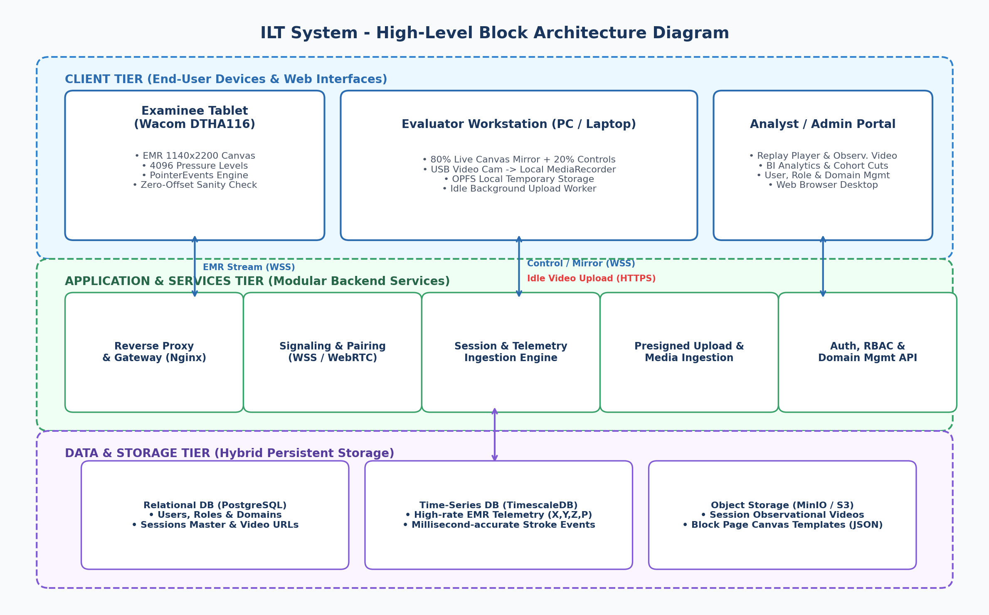
Figure 3: System Block Architecture Diagram
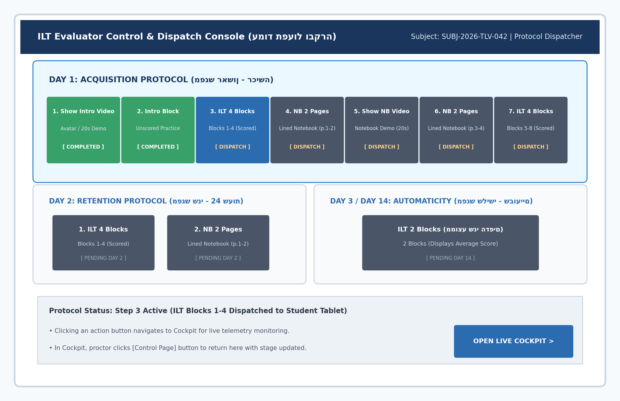
Figure 4: Evaluator Control Page Architecture (Protocol Dispatcher)
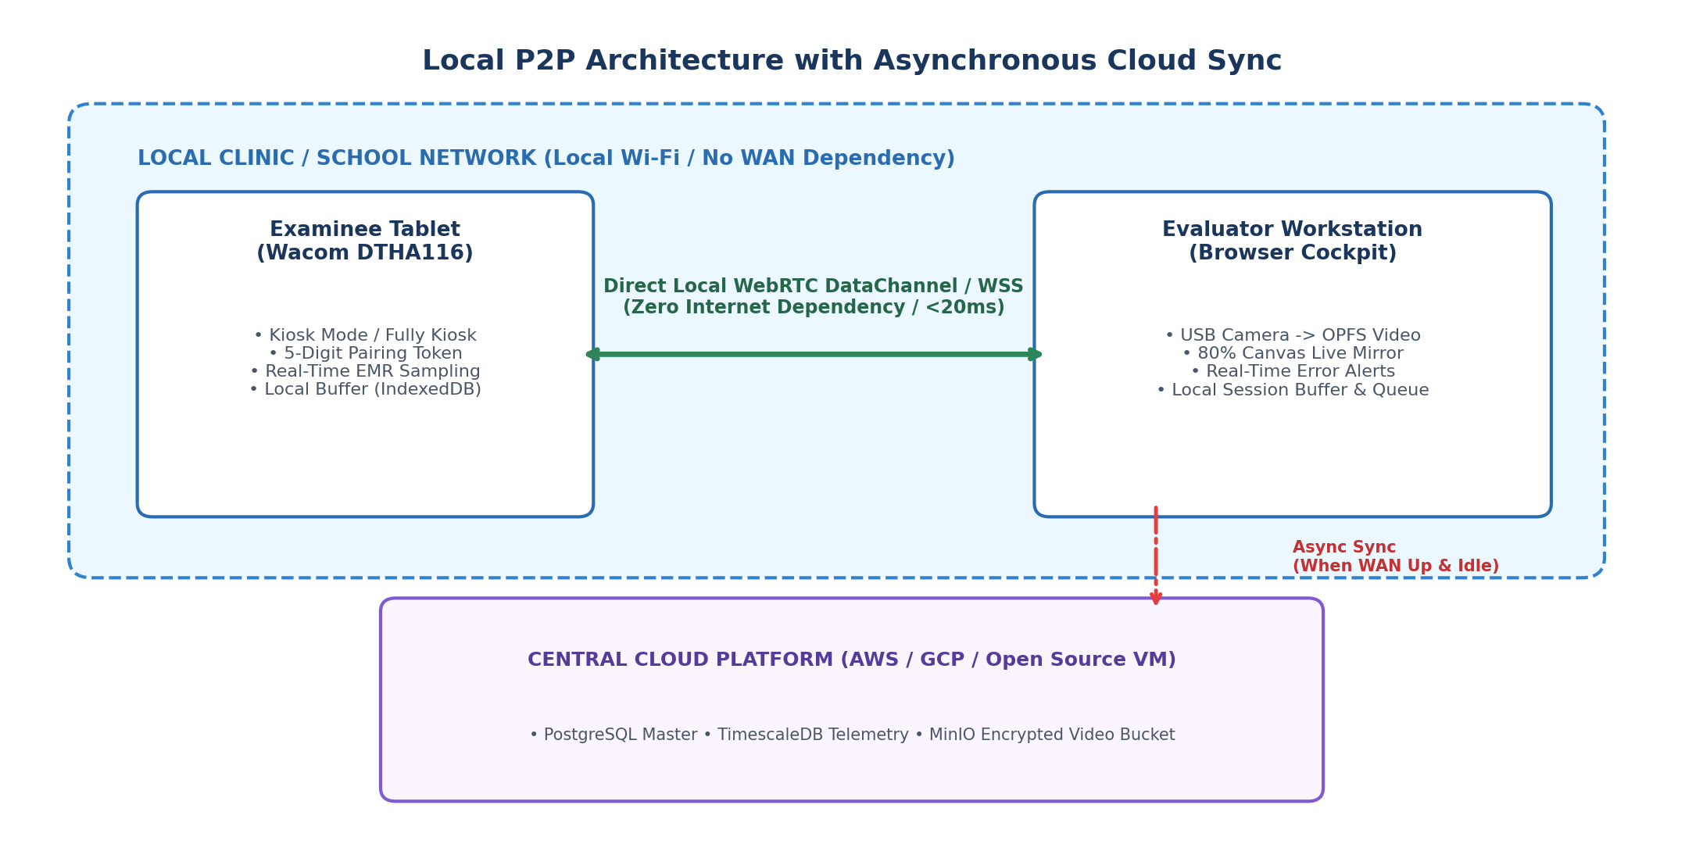
Figure 5: Local P2P Wi-Fi Architecture, IP Cameras & Asynchronous Cloud Sync
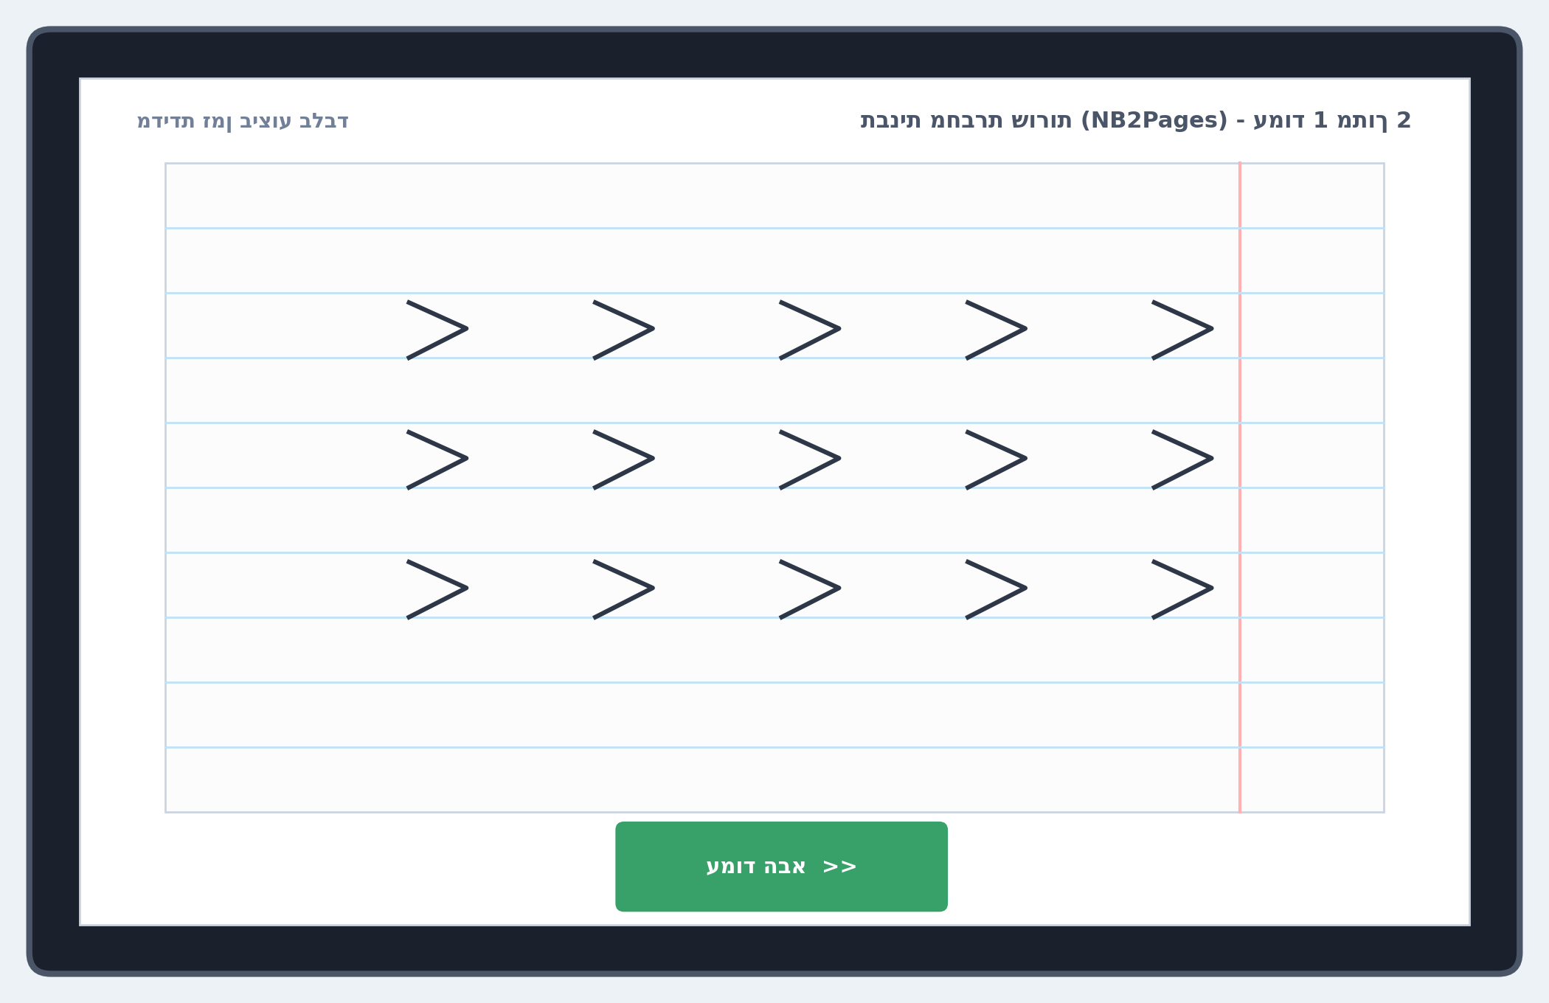
Figure 6: Lined Notebook Rendering Engine (NB2Pages)
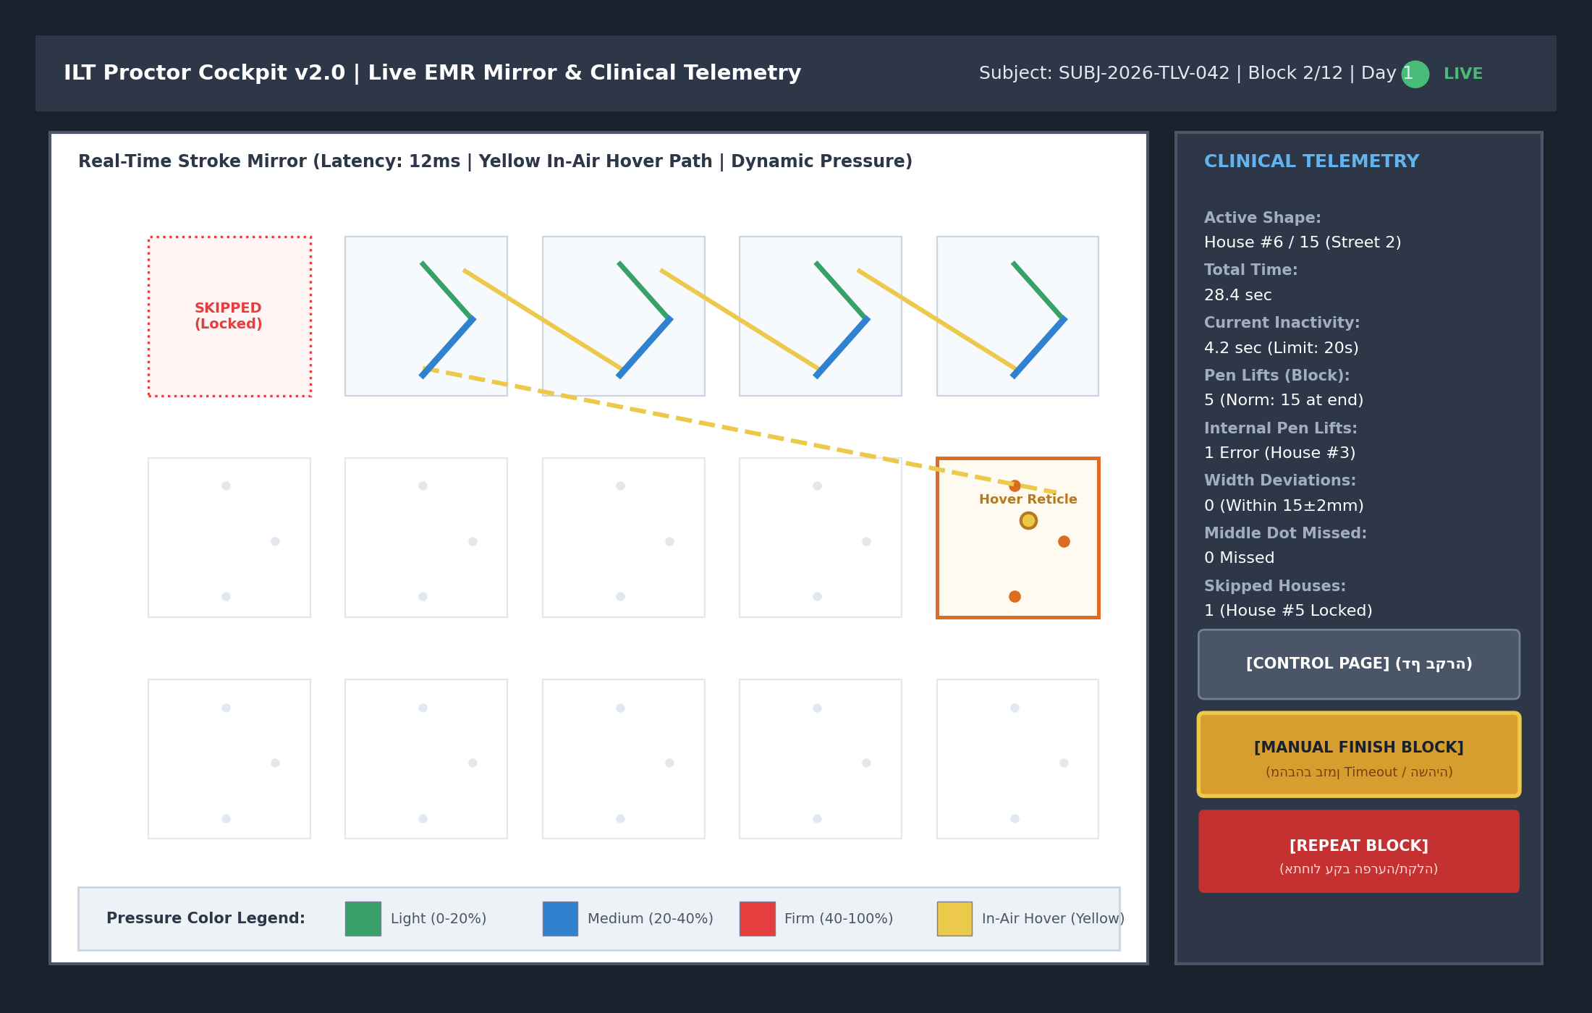
Figure 7: Proctor Cockpit - Yellow In-Air Hover Trajectory & Pressure Map
6. Ergonomic Styluses & Deployment Roadmap
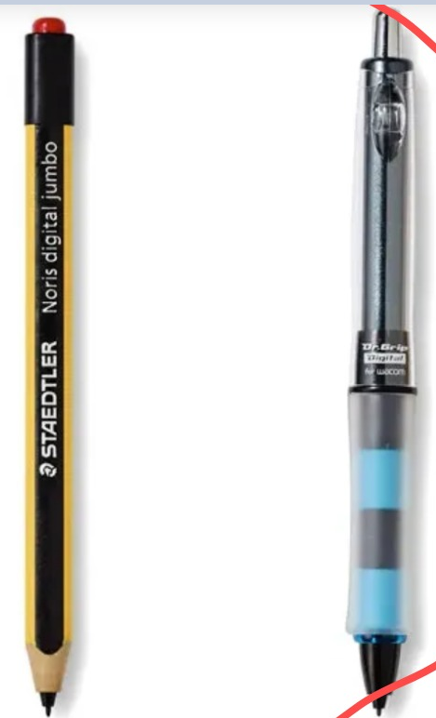
Figure 8: Approved Field EMR Styluses: Dr. Grip Digital for Wacom & STAEDTLER Noris digital jumbo
• Immediate Deployment Steps: 1. Deploy Docker Compose containers (PostgreSQL 16, TimescaleDB, MinIO, Nginx). 2. Configure local CMS gateway service for Sricam RTSP feeds. 3. Execute DDL v4.0 migration script.

