ILT Research System - System Architecture & Technical Specifications (v5.2)
Infrastructure Architecture, Agnostic Video Streaming, Unlimited Dynamic Templates Engine, Multi-Tier DTW Algorithm, and Relational/Time-Series Schema
Specification Parameter | Design Specification | Specification Parameter | Design Specification
Document Identifier: | ILT-ARCH-SPEC-V5.2-EN | Release Date: | October 2026 (Release 5.2 Full Edition)
Clinical Research Basis: | Prof. E. Adi-Japha, Dr. H. Hollander, Dr. S. Dorfberger | Hardware & Power: | Wacom MovinkPad 11 / DTHA116 (Certified Continuous USB-C PD Charging)
Timer Governance: | System Default = 20s; Domain Override requires Director Auth | Video Subsystem: | Camera-Agnostic Ingestion (RTSP/ONVIF/USB; Admin Disable Switch)
Database Architecture: | PostgreSQL 16 + TimescaleDB + MinIO Object Store | Scoring & Templates: | 3 Distinct Metrics + Unlimited Dynamic Templates + DTW Engine

1. Executive Architectural Summary (Release 5.2)
• Camera-Agnostic Video Ingestion Architecture: Eliminates vendor lock-in by providing an open RTSP/ONVIF/USB streaming ingestion pipeline. Handles varied resolutions (720p/1080p), framerates (25/30fps), and codecs (H.264/H.265) from Sricam, Hikvision, Dahua, Reolink, and USB webcams.
• Unlimited Dynamic Templates Engine: Implements table dynamic_templates with flexible JSONB schemas for ruling geometry and kinetic movement rules, enabling seamless administration of 10-line, 14-line, single-line notebooks, custom grids, or blank canvases across all elementary grade levels.
• 3 Independent Clinical Metric Architecture: Persists Pen Lifts Count, Accuracy Rate %, and Total Execution Time as first-class, independent database fields. Prevents premature aggregation into monolithic Z-scores while supporting optional composite scoring with strict Sum(Weights)==100% database check constraints.
• Automated Freehand Accuracy Engine (cDTW & Procrustes): Server-side and edge analytics module evaluating Row 3 freehand writing against canonical alphabet models, calculating spatial deformation, topological integrity, and baseline adherence.
• Continuous Charging Certification: Formally documents certified power architecture enabling uninterrupted administration while tablets are plugged into USB-C PD power sources.
2. Relational Database Schema (PostgreSQL 16 & TimescaleDB Core DDL v5.2)
The comprehensive database definition implements multi-tier timer governance, dynamic templates, independent metric tracking, and Row 3 DTW evaluations:
-- =============================================================================
-- ILT RESEARCH PLATFORM - RELATIONAL DATABASE SCHEMA (v5.2)
-- PostgreSQL 16 + TimescaleDB
-- =============================================================================
-- 1. System Configuration & Global Timer Defaults
CREATE TABLE system_config (
config_id INT PRIMARY KEY DEFAULT 1,
in_transition_delay_sec INT NOT NULL DEFAULT 20, -- Default In-Transition delay: 20s
inactivity_timeout_sec INT NOT NULL DEFAULT 20, -- Default Inactivity timeout: 20s
post_block_timeout_sec INT NOT NULL DEFAULT 30, -- Timeout post-15th letter: 30s
notebook_page_timeout_sec INT NOT NULL DEFAULT 60,
video_recording_enabled BOOLEAN NOT NULL DEFAULT TRUE,
require_research_director_approval BOOLEAN NOT NULL DEFAULT TRUE, -- Governance lock
-- Optional Composite Score Weights (Enforces Sum == 100%)
score_weight_pen_lifts_pct NUMERIC(5,2) NOT NULL DEFAULT 35.00,
score_weight_accuracy_pct NUMERIC(5,2) NOT NULL DEFAULT 40.00,
score_weight_time_pct NUMERIC(5,2) NOT NULL DEFAULT 25.00,
CONSTRAINT chk_weights_sum_100 CHECK (
(score_weight_pen_lifts_pct + score_weight_accuracy_pct + score_weight_time_pct) = 100.00
),
updated_at TIMESTAMP WITH TIME ZONE DEFAULT CURRENT_TIMESTAMP
);
-- 2. Domains Table (with Research Director Authorization for Timer Overrides)
CREATE TABLE domains (
domain_id SERIAL PRIMARY KEY,
domain_name VARCHAR(100) NOT NULL UNIQUE,
override_in_transition_sec INT NULL,
override_inactivity_timeout_sec INT NULL,
override_video_enabled BOOLEAN NULL,
timer_approved_by_research_director VARCHAR(100) NULL,
timer_approval_timestamp TIMESTAMP WITH TIME ZONE NULL,
created_at TIMESTAMP WITH TIME ZONE DEFAULT CURRENT_TIMESTAMP
);
-- 3. Educational Institutions (Kindergartens & Elementary Schools)
CREATE TABLE schools (
school_id SERIAL PRIMARY KEY,
domain_id INT NOT NULL REFERENCES domains(domain_id) ON DELETE CASCADE,
school_name VARCHAR(150) NOT NULL,
institution_type VARCHAR(30) DEFAULT 'ELEMENTARY' CHECK (institution_type IN ('KINDERGARTEN', 'ELEMENTARY', 'SPECIAL_ED')),
created_at TIMESTAMP WITH TIME ZONE DEFAULT CURRENT_TIMESTAMP
);
-- 4. Unlimited Dynamic Templates Engine
CREATE TABLE dynamic_templates (
template_id VARCHAR(50) PRIMARY KEY,
template_name VARCHAR(100) NOT NULL,
template_category VARCHAR(30) NOT NULL CHECK (template_category IN ('GRID_ILT', 'NOTEBOOK_LINED', 'INTERVENTION_LETTER', 'BLANK_CANVAS')),
ruling_type VARCHAR(30) NOT NULL CHECK (ruling_type IN ('NOTEBOOK_10_ROWS', 'NOTEBOOK_14_ROWS', 'NOTEBOOK_1_ROW', 'GRID_3X5', 'FREE_CANVAS')),
target_grade_level VARCHAR(30) DEFAULT 'ALL_GRADES',
canvas_schema JSONB NOT NULL, -- Geometry: line spacing, margins, coordinate anchors
rules_schema JSONB NOT NULL, -- Movement constraints, width tolerance, error states
is_active BOOLEAN DEFAULT TRUE,
created_at TIMESTAMP WITH TIME ZONE DEFAULT CURRENT_TIMESTAMP
);
-- 5. Canonical Alphabet Letter Models (for Automated Row 3 DTW Evaluation)
CREATE TABLE letter_canonical_models (
letter_id VARCHAR(10) PRIMARY KEY, -- e.g. 'HEB_TET', 'LAT_A'
language_code VARCHAR(5) NOT NULL,
letter_char VARCHAR(5) NOT NULL,
expected_strokes_count INT NOT NULL DEFAULT 1,
canonical_aspect_ratio NUMERIC(5,3) NOT NULL,
canonical_points JSONB NOT NULL, -- Resampled 100 normalized equidistant points (x, y)
created_at TIMESTAMP WITH TIME ZONE DEFAULT CURRENT_TIMESTAMP
);
-- 6. Core Assessment Sessions Table
CREATE TABLE sessions (
session_id UUID PRIMARY KEY DEFAULT gen_random_uuid(),
session_number BIGSERIAL UNIQUE,
domain_id INT NOT NULL REFERENCES domains(domain_id),
school_id INT REFERENCES schools(school_id),
school_name VARCHAR(150) NOT NULL,
grade_class VARCHAR(50) NOT NULL, -- All elementary grades supported
evaluator_name VARCHAR(120) NOT NULL,
assessment_date DATE NOT NULL DEFAULT CURRENT_DATE,
examinee_alias VARCHAR(50) NOT NULL,
examinee_initials VARCHAR(5) NOT NULL,
student_language VARCHAR(5) DEFAULT 'en',
dominant_hand VARCHAR(10) NOT NULL CHECK (dominant_hand IN ('RIGHT', 'LEFT')),
session_stage VARCHAR(30) NOT NULL,
is_charging_during_test BOOLEAN DEFAULT FALSE,
-- Immutable Timer Snapshots for Analytical Factoring
sys_in_transition_sec INT NOT NULL DEFAULT 20,
dom_in_transition_sec INT NOT NULL DEFAULT 20,
sys_inactivity_sec INT NOT NULL DEFAULT 20,
dom_inactivity_sec INT NOT NULL DEFAULT 20,
video_recording_enabled BOOLEAN NOT NULL DEFAULT TRUE,
warmup_row_passed BOOLEAN DEFAULT FALSE,
created_at TIMESTAMP WITH TIME ZONE DEFAULT CURRENT_TIMESTAMP
);
-- 7. Assessment Blocks Table (Preserving 3 Distinct Metrics Independently)
CREATE TABLE session_blocks (
block_id BIGSERIAL PRIMARY KEY,
session_id UUID NOT NULL REFERENCES sessions(session_id) ON DELETE CASCADE,
block_type VARCHAR(30) NOT NULL,
block_index INT NOT NULL,
target_letter VARCHAR(5) NULL,
-- 3 Distinct Clinical Metrics (Prof. Esther Adi-Japha Directive)
pen_lifts_count INT NOT NULL, -- Metric 1: Pen Lifts Count
accuracy_pct NUMERIC(5,2) NOT NULL, -- Metric 2: Geometric Accuracy Rate (%)
total_duration_ms INT NOT NULL, -- Metric 3: Total Block Duration (w/ correction)
composite_score NUMERIC(6,2) NULL, -- Optional Secondary Indicator
is_repeated_disrupted BOOLEAN DEFAULT FALSE,
created_at TIMESTAMP WITH TIME ZONE DEFAULT CURRENT_TIMESTAMP
);
-- 8. Row 3 Freehand Accuracy Evaluation Table
CREATE TABLE intervention_row3_evaluations (
eval_id BIGSERIAL PRIMARY KEY,
session_id UUID NOT NULL REFERENCES sessions(session_id) ON DELETE CASCADE,
block_index INT NOT NULL,
letter_id VARCHAR(10) REFERENCES letter_canonical_models(letter_id),
house_index INT NOT NULL CHECK (house_index BETWEEN 11 AND 15),
dtw_shape_distance NUMERIC(6,3) NOT NULL,
procrustes_shape_score NUMERIC(5,2) NOT NULL, -- 0-100%
actual_strokes_count INT NOT NULL,
topology_valid BOOLEAN NOT NULL,
aspect_ratio_deviation_pct NUMERIC(5,2) NOT NULL,
baseline_drift_mm NUMERIC(4,2) NOT NULL,
composite_accuracy_pct NUMERIC(5,2) NOT NULL,
diagnostic_tag VARCHAR(50) NOT NULL -- 'ACCURATE', 'PROPORTION_DISTORTION', 'BROKEN_STROKE'
);
3. System Component Architecture & Subsystems
• Agnostic Video Ingestion Architecture: CMS Gateway handles RTSP, ONVIF, and USB camera streams. Local storage in OPFS/MP4 with background MinIO chunked upload during idle periods.
• Continuous Charging Power Design: Hardware certification allows 100% uninterrupted EMR stylus sampling while tablet is connected to USB-C PD power.
• Automated Freehand Accuracy Engine: Resamples Raw 133Hz EMR data to 100 equidistant points; applies Continuous DTW and Procrustes analysis against canonical database models.
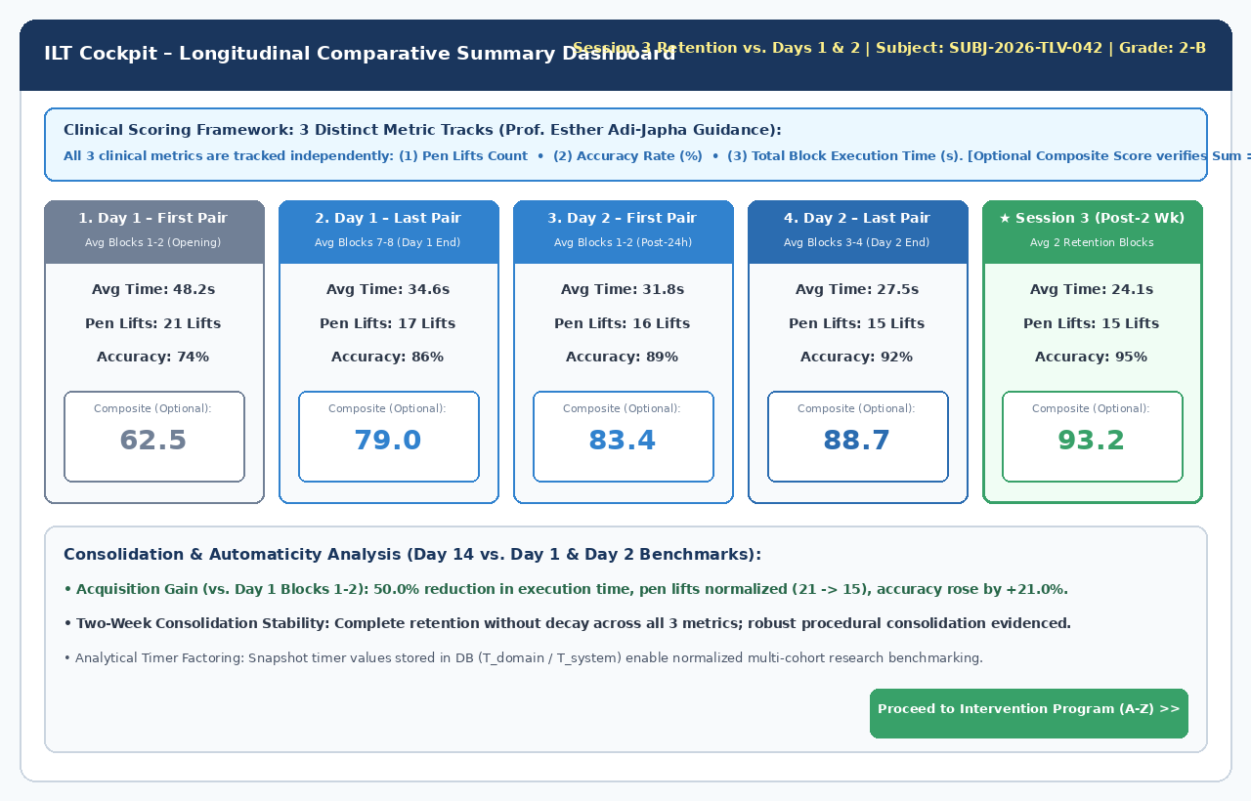
Figure 1: Proctor Cockpit Longitudinal Comparative Summary Dashboard (3 Distinct Clinical Metrics)
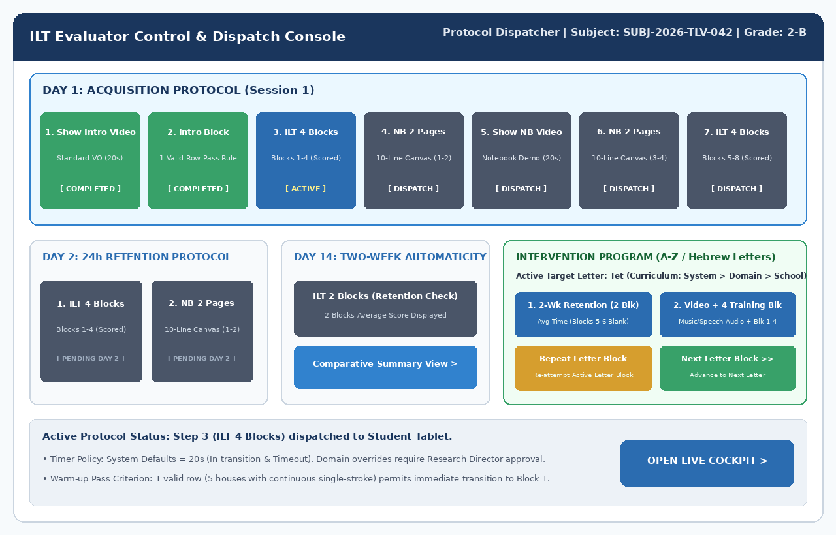
Figure 2: Evaluator Control & Protocol Dispatcher Console

