ILT Research System - Detailed Design Specification & Developer Guide (DDD v1.1 FINAL)
Comprehensive Engineering Specification for Coding Implementation: Component Architecture, 24-Byte Wire Protocol, Unlimited Dynamic Templates, cDTW Algorithms, FSMs, DDL Schema, and Developer Guide
Document Parameter | Specification Value | Document Parameter | Specification Value
Document Identifier: | ILT-DDD-V1.1-FINAL-EN | Publication Date: | October 2026 (Final Implementation Edition)
Functional Baseline: | FRS v3.2 & Architecture Spec v5.2 | Target Audience: | Software Engineers, Lead Architects, Full-Stack Developers
Scientific Direction: | Prof. Esther Adi-Japha & Dr. Hagit Hollander (Bar-Ilan Univ.) | Target Hardware: | Wacom MovinkPad 11 (EMR 133Hz, Certified Continuous Charging)
Readiness Status: | Coding-Ready (Includes Docker Compose & Mock Stylus Simulator) | Timer Governance: | 20s System Default; Domain Overrides require Director Auth

1. Document Purpose, System Overview & Technology Stack Matrix
This Detailed Design Document (DDD v1.1) is directly derived from the approved Functional Requirements Specification (FRS v3.2) and Architecture Specification (v5.2). Its objective is to serve as the definitive, unambiguous engineering blueprint for developers, enabling immediate code implementation with zero functional gaps while guaranteeing adherence to clinical research protocols.
System Layer | Technology & Core Libraries | Version | Engineering Rationale & Responsibilities
Student Tablet (Kiosk App) | React, TypeScript, Native Canvas 2D API, Wacom PointerEvents, Dexie.js | React 18+, TS 5+ | Ultra-low overhead 60 FPS rendering, 133Hz EMR capture without dropped frames, IndexedDB offline resilience, continuous charging support.
Proctor Cockpit Console | React, TypeScript, Canvas 80% Live Mirror, TailwindCSS, WebRTC DataChannel (Host) | React 18+, TS 5+ | Real-time stroke mirroring, clinical telemetry (20%), 3 distinct independent metrics summary, multi-student classroom console (1:4/1:6).
Local Edge Gateway | Node.js / Fastify / TypeScript, WebSocket Signaling, SQLite Cache | Node 20 LTS | Manages local Wi-Fi P2P direct channels, WebRTC signaling, asynchronous background cloud sync, and camera proxying.
CMS Camera Gateway | go2rtc / MediaMTX (RTSP to WebRTC/HLS Ingestion) | Latest Stable | Vendor-agnostic camera ingestion (RTSP/ONVIF/USB) converting video feeds to low-latency WebRTC streams (<100ms).
Kinematic Analytics & DTW | Python, FastAPI, SciPy, FastDTW, NumPy, scikit-learn | Python 3.11+ | Kinematic signal processing, Continuous DTW and Procrustes distance algorithms for Row 3 freehand evaluation, timer factoring.
Core Database Engine | PostgreSQL 16 + TimescaleDB Extension | Postgres 16 | Relational operational data (users, sessions, templates) and TimescaleDB Hypertables for high-frequency EMR pen telemetry.
Object Storage Subsystem | MinIO (AWS S3 Compatible) | Latest | Local and cloud object storage for session RTSP video files (MP4), raw coordinate dumps, and instructional letter animations.

2. Component Architecture, Data Flow, and Local P2P Network Topology
• Dual WebRTC DataChannels Architecture: Local communication between tablet and cockpit uses two separate DataChannels: (1) emr-stream in unordered/unreliable mode (ordered: false, maxRetransmits: 0) for 133Hz EMR coordinates (<15ms latency); and (2) control-events in ordered mode (ordered: true) for lifecycle events, timers, and alerts.
• Camera-Agnostic Video Ingestion: CMS Gateway handles any RTSP/ONVIF network camera (Sricam, Hikvision, Dahua, Reolink, Tapo) or USB webcam. Video is restricted to desk and hands only; an Admin disable switch allows video-optional operation.
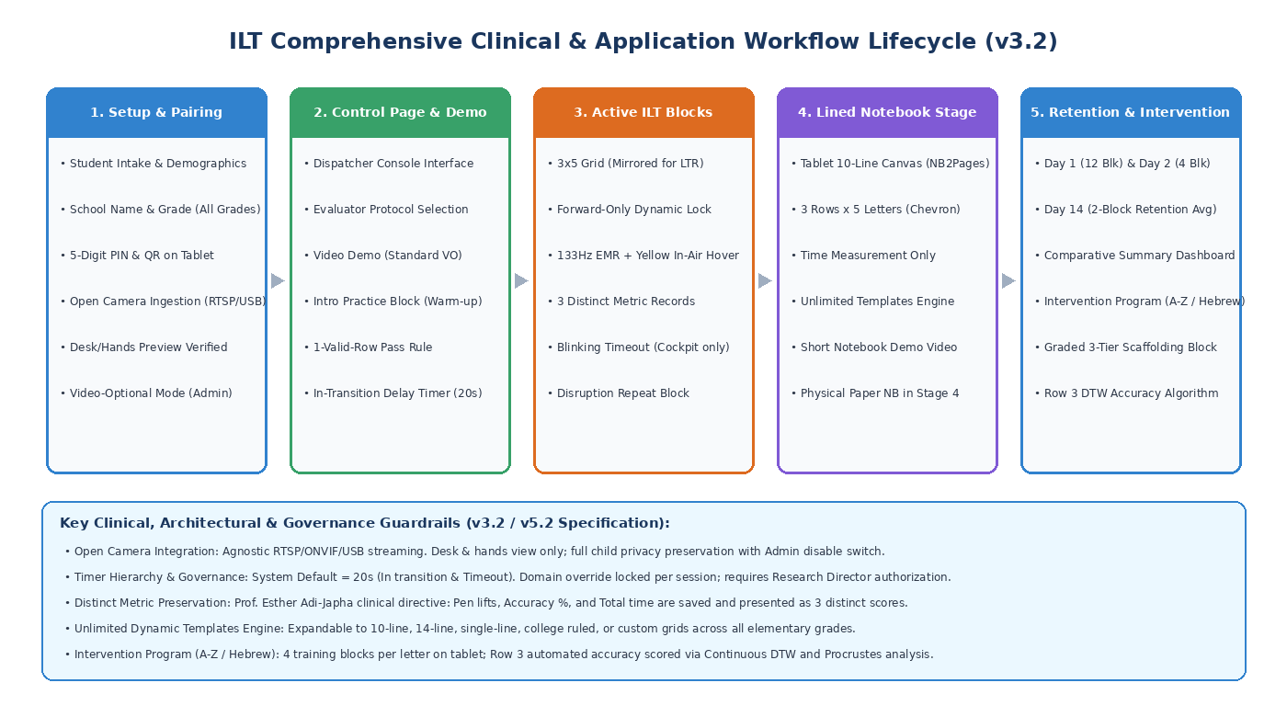
Figure 1: Comprehensive Clinical and System Lifecycle Workflow (Release 3.2)
3. Monorepo Project Structure & Module Organization
The repository is structured as a modular Monorepo (Turborepo / pnpm):
ilt-research-platform/
├── apps/
│ ├── student-tablet/ # Tablet Kiosk App (React + Canvas 2D + EMR Driver)
│ └── proctor-cockpit/ # Evaluator Console (Control Dispatcher, Live Cockpit, Comparative Dashboard)
├── services/
│ ├── gateway/ # Local Gateway (Signaling, DB Cache, Camera Proxy)
│ └── analytics/ # Kinematic Analytics & DTW Scoring Service (Python FastAPI)
├── packages/
│ ├── shared-types/ # Shared TypeScript interfaces, data models, and enums
│ ├── emr-protocol/ # 24-byte binary serialization and OpCodes parser
│ └── template-schemas/ # JSON Schemas for dynamic rulings (10-line, 14-line, 1-line, grids)
└── docker/ # Development and deployment containers (TimescaleDB, MinIO, go2rtc)
4. Binary Wire Protocol & Serialization Specification
• 24-Byte Binary Sample Record Structure: Every EMR sample is packed into a rigid 24-byte record (Little-Endian IEEE 754):
// C / C++ & TypedArray 24-Byte Binary EMR Sample Struct (Little-Endian IEEE 754)
#pragma pack(push, 1)
struct EMRSampleRecord {
uint32_t timestamp_offset_ms; // 4 Bytes: Milliseconds elapsed since block launch
float x_coord; // 4 Bytes: Normalized X sub-pixel coordinate (0.0000 - 1.0000)
float y_coord; // 4 Bytes: Normalized Y sub-pixel coordinate (0.0000 - 1.0000)
float pressure; // 4 Bytes: Normalized pen tip pressure (0.0000 - 1.0000)
int16_t tilt_altitude; // 2 Bytes: Pen vertical angle relative to tablet plane (0 - 90 deg)
int16_t tilt_azimuth; // 2 Bytes: Pen rotational angle around surface normal (0 - 360 deg)
uint8_t stroke_flags; // 1 Byte: Bit 0: PenDown, Bit 1: InAirHover, Bit 2: Eraser, Bit 3: TargetHit
uint8_t active_house_id; // 1 Byte: Identifier of active house/cell (1 to 15)
uint16_t reserved_padding; // 2 Bytes: Alignment padding (0x0000)
};
#pragma pack(pop)
// Total Record Size: Exactly 24 Bytes
• Batching Window (3–5 Samples): Tablet aggregates 3 to 5 samples (72–120 bytes) transmitted every 15–25ms, reducing TCP/WebRTC headers by over 75% while maintaining smooth 60 FPS live mirroring.
5. Dynamic Canvas Engine, Template Geometry, and Forward-Only Lock
• ILT 3x5 Standard Grid: 15 houses (170x145 logical px), 3 target dots with 7mm hit detection radius, and in-air hover trajectory tracking.
• Lined Notebook Template (Aligned to Figure 13): Authentic blue ruling lines, vertical margin line (left for LTR, right for RTL), and 3 active writing rows of 5 chevrons '<' in LTR mode.
• Unlimited Dynamic Templates Engine (JSON Schema): Table dynamic_templates enables arbitrary layouts (10-line, 14-line, 1-line, blank canvas) with configurable rules:
{
"$schema": "http://json-schema.org/draft-07/schema#",
"title": "ILTDynamicTemplateDefinition",
"type": "object",
"properties": {
"template_id": { "type": "string" },
"template_name": { "type": "string" },
"ruling_type": { "type": "string", "enum": ["NOTEBOOK_10_ROWS", "NOTEBOOK_14_ROWS", "NOTEBOOK_1_ROW", "GRID_3X5", "FREE_CANVAS"] },
"target_grade_level": { "type": "string", "default": "ALL_GRADES" },
"canvas_schema": {
"type": "object",
"properties": {
"num_lines": { "type": "integer" },
"line_spacing_px": { "type": "number" },
"margin_side": { "type": "string", "enum": ["RIGHT", "LEFT", "NONE"] },
"margin_offset_px": { "type": "number" },
"active_row_indices": { "type": "array", "items": { "type": "integer" } }
},
"required": ["num_lines", "line_spacing_px", "margin_side", "active_row_indices"]
},
"rules_schema": {
"type": "object",
"properties": {
"max_internal_pen_lifts": { "type": "integer", "default": 0 },
"width_nominal_mm": { "type": "number", "default": 15.0 },
"width_tolerance_mm": { "type": "number", "default": 2.0 },
"forward_only_locking": { "type": "boolean", "default": true }
}
}
},
"required": ["template_id", "template_name", "ruling_type", "canvas_schema", "rules_schema"]
}
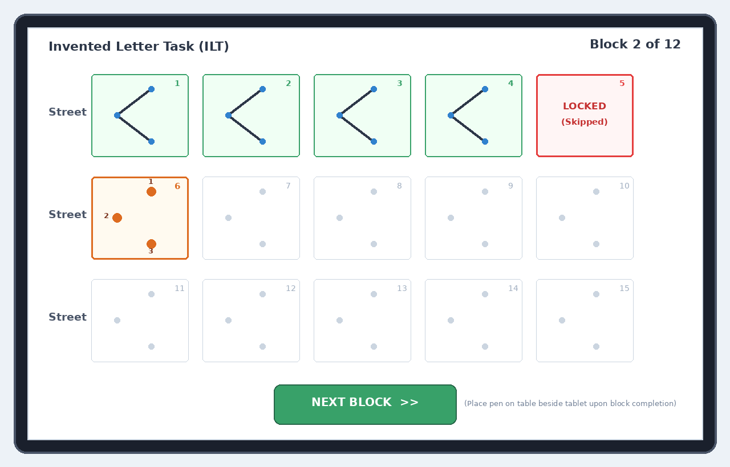
Figure 2: Student Tablet Canvas in LTR Mode – House 5 Locked (Skipped), House 6 Active
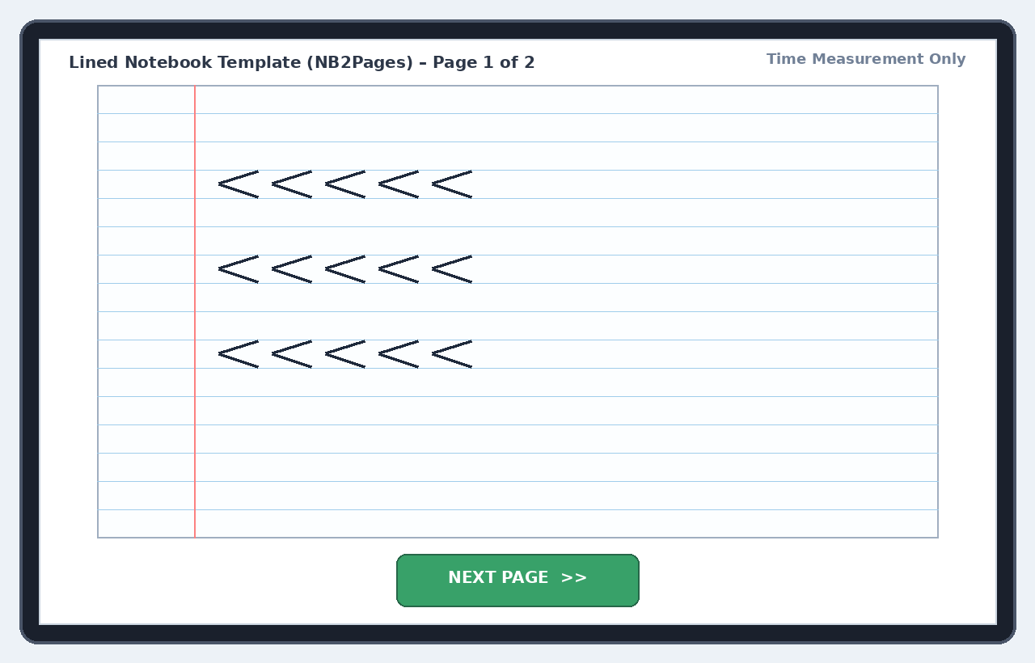
Figure 3: Lined Notebook Canvas (NB2Pages) Aligned to Original Figure 13 Handwriting Ruling
6. Finite State Machines & Protocol Workflow Execution (FSM)
• Warm-up Block Pass Rule (1 Valid Row Rule): Requires completing 1 valid row (5 houses with continuous single-stroke, 0 internal pen lifts). Speed and width are unscored. Success permits immediate transition to Block 1; failure triggers repeating instructions and a new warm-up block.
• In-Transition Delay Timer (20s Default): Stylus is placed on desk beside tablet for 20 seconds of consolidation rest, unlocking the green [NEXT BLOCK >>] button upon timer expiry.
• Cockpit-Only Timeout Alert: Inactivity timeout (20s) blinks the [MANUAL FINISH BLOCK] button in the Proctor Cockpit only, preventing child distraction.
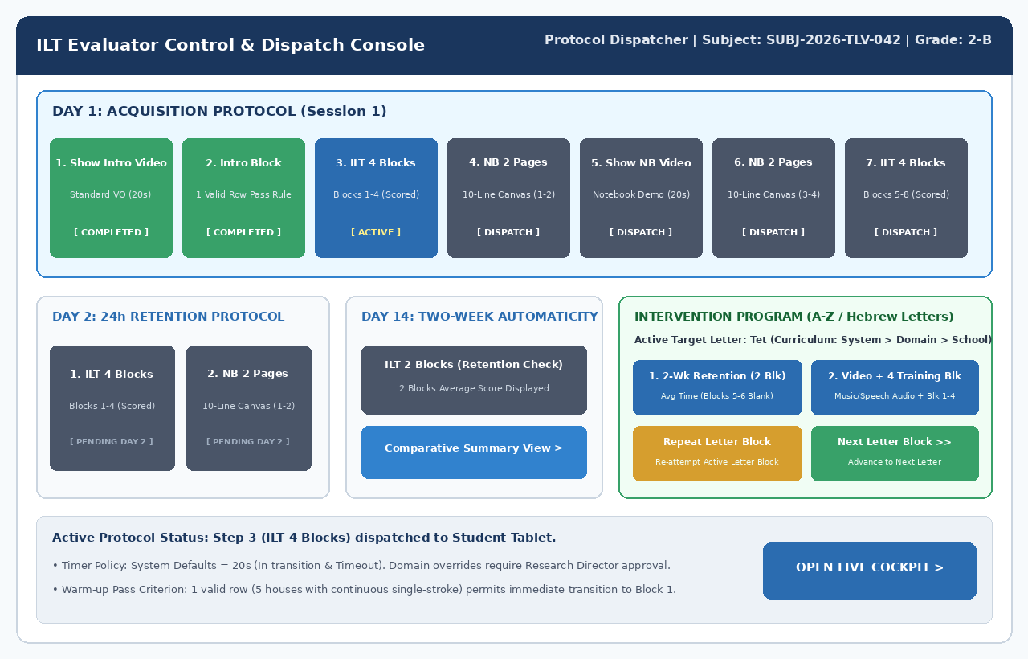
Figure 4: Evaluator Control & Protocol Dispatcher Console with Intervention Program Rubric
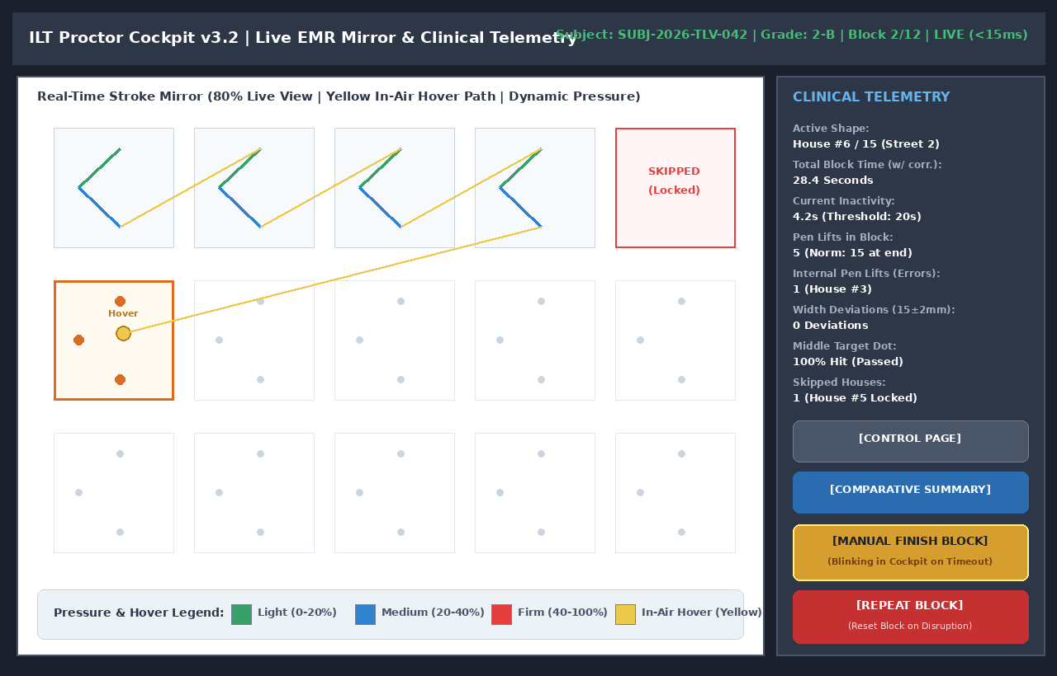
Figure 5: Proctor Cockpit (80% Live Mirror / 20% Clinical Telemetry) with Access to Comparative Summary
7. Physical Database Schema & Data Access Layer (PostgreSQL 16 + TimescaleDB)
Production DDL defining all relational entities, check constraints, and time-series hypertables with compression policies:
-- =============================================================================
-- ILT PRODUCTION DDL (PostgreSQL 16 + TimescaleDB) - Release 5.2 / DDD v1.1
-- =============================================================================
CREATE EXTENSION IF NOT EXISTS "uuid-ossp";
CREATE EXTENSION IF NOT EXISTS "timescaledb";
-- 1. System Configuration & Global Defaults
CREATE TABLE system_config (
config_id INT PRIMARY KEY DEFAULT 1,
in_transition_delay_sec INT NOT NULL DEFAULT 20, -- Default In-Transition: 20s
inactivity_timeout_sec INT NOT NULL DEFAULT 20, -- Default Inactivity Timeout: 20s
post_block_timeout_sec INT NOT NULL DEFAULT 30, -- Timeout post-15th letter: 30s
notebook_page_timeout_sec INT NOT NULL DEFAULT 60,
video_recording_enabled BOOLEAN NOT NULL DEFAULT TRUE,
require_research_director_approval BOOLEAN NOT NULL DEFAULT TRUE,
score_weight_pen_lifts_pct NUMERIC(5,2) NOT NULL DEFAULT 35.00,
score_weight_accuracy_pct NUMERIC(5,2) NOT NULL DEFAULT 40.00,
score_weight_time_pct NUMERIC(5,2) NOT NULL DEFAULT 25.00,
CONSTRAINT chk_weights_sum_100 CHECK (
(score_weight_pen_lifts_pct + score_weight_accuracy_pct + score_weight_time_pct) = 100.00
),
updated_at TIMESTAMP WITH TIME ZONE DEFAULT CURRENT_TIMESTAMP
);
-- 2. Domains Table (with Research Director Authorization for Overrides)
CREATE TABLE domains (
domain_id SERIAL PRIMARY KEY,
domain_name VARCHAR(100) NOT NULL UNIQUE,
override_in_transition_sec INT NULL,
override_inactivity_timeout_sec INT NULL,
override_video_enabled BOOLEAN NULL,
timer_approved_by_research_director VARCHAR(100) NULL,
timer_approval_timestamp TIMESTAMP WITH TIME ZONE NULL,
created_at TIMESTAMP WITH TIME ZONE DEFAULT CURRENT_TIMESTAMP
);
-- 3. Dynamic Templates Engine
CREATE TABLE dynamic_templates (
template_id VARCHAR(50) PRIMARY KEY,
template_name VARCHAR(100) NOT NULL,
template_category VARCHAR(30) NOT NULL,
ruling_type VARCHAR(30) NOT NULL,
target_grade_level VARCHAR(30) DEFAULT 'ALL_GRADES',
canvas_schema JSONB NOT NULL,
rules_schema JSONB NOT NULL,
is_active BOOLEAN DEFAULT TRUE,
created_at TIMESTAMP WITH TIME ZONE DEFAULT CURRENT_TIMESTAMP
);
-- 4. Canonical Models for Freehand Row 3 Evaluation
CREATE TABLE letter_canonical_models (
letter_id VARCHAR(10) PRIMARY KEY,
language_code VARCHAR(5) NOT NULL,
letter_char VARCHAR(5) NOT NULL,
expected_strokes_count INT NOT NULL DEFAULT 1,
canonical_aspect_ratio NUMERIC(5,3) NOT NULL,
canonical_points JSONB NOT NULL, -- 100 resampled normalized points
created_at TIMESTAMP WITH TIME ZONE DEFAULT CURRENT_TIMESTAMP
);
-- 5. Sessions Table (3 Metrics Preserved Independently + Timer Snapshots)
CREATE TABLE sessions (
session_id UUID PRIMARY KEY DEFAULT gen_random_uuid(),
session_number BIGSERIAL UNIQUE,
domain_id INT NOT NULL REFERENCES domains(domain_id),
school_name VARCHAR(150) NOT NULL,
grade_class VARCHAR(50) NOT NULL,
evaluator_name VARCHAR(120) NOT NULL,
assessment_date DATE NOT NULL DEFAULT CURRENT_DATE,
examinee_alias VARCHAR(50) NOT NULL,
examinee_initials VARCHAR(5) NOT NULL,
student_language VARCHAR(5) DEFAULT 'he',
session_stage VARCHAR(30) NOT NULL,
is_charging_during_test BOOLEAN DEFAULT FALSE,
sys_in_transition_sec INT NOT NULL DEFAULT 20,
dom_in_transition_sec INT NOT NULL DEFAULT 20,
sys_inactivity_sec INT NOT NULL DEFAULT 20,
dom_inactivity_sec INT NOT NULL DEFAULT 20,
video_recording_enabled BOOLEAN NOT NULL DEFAULT TRUE,
warmup_row_passed BOOLEAN DEFAULT FALSE,
created_at TIMESTAMP WITH TIME ZONE DEFAULT CURRENT_TIMESTAMP
);
-- 6. Session Blocks (Independent Metrics per Prof. Esther Adi-Japha)
CREATE TABLE session_blocks (
block_id BIGSERIAL PRIMARY KEY,
session_id UUID NOT NULL REFERENCES sessions(session_id) ON DELETE CASCADE,
block_type VARCHAR(30) NOT NULL,
block_index INT NOT NULL,
target_letter VARCHAR(5) NULL,
pen_lifts_count INT NOT NULL,
accuracy_pct NUMERIC(5,2) NOT NULL,
total_duration_ms INT NOT NULL,
composite_score NUMERIC(6,2) NULL,
is_repeated_disrupted BOOLEAN DEFAULT FALSE,
created_at TIMESTAMP WITH TIME ZONE DEFAULT CURRENT_TIMESTAMP
);
-- 7. Automated Row 3 Accuracy Evaluations (cDTW & Procrustes)
CREATE TABLE intervention_row3_evaluations (
eval_id BIGSERIAL PRIMARY KEY,
session_id UUID NOT NULL REFERENCES sessions(session_id) ON DELETE CASCADE,
block_index INT NOT NULL,
letter_id VARCHAR(10) REFERENCES letter_canonical_models(letter_id),
house_index INT NOT NULL CHECK (house_index BETWEEN 11 AND 15),
dtw_shape_distance NUMERIC(6,3) NOT NULL,
procrustes_shape_score NUMERIC(5,2) NOT NULL,
actual_strokes_count INT NOT NULL,
topology_valid BOOLEAN NOT NULL,
aspect_ratio_deviation_pct NUMERIC(5,2) NOT NULL,
baseline_drift_mm NUMERIC(4,2) NOT NULL,
composite_accuracy_pct NUMERIC(5,2) NOT NULL,
diagnostic_tag VARCHAR(50) NOT NULL
);
-- 8. High-Frequency EMR Telemetry (TimescaleDB Hypertable with 1-Day Chunks)
CREATE TABLE pen_telemetry_chunks (
recorded_at TIMESTAMP WITH TIME ZONE NOT NULL,
session_id UUID NOT NULL,
block_index INT NOT NULL,
house_id INT NOT NULL,
time_offset_ms INT NOT NULL,
x NUMERIC(8,4) NOT NULL,
y NUMERIC(8,4) NOT NULL,
pressure NUMERIC(6,5) NOT NULL,
tilt_altitude SMALLINT NOT NULL,
tilt_azimuth SMALLINT NOT NULL,
is_hover BOOLEAN NOT NULL,
is_pen_down BOOLEAN NOT NULL
);
SELECT create_hypertable('pen_telemetry_chunks', 'recorded_at', chunk_time_interval => INTERVAL '1 day');
ALTER TABLE pen_telemetry_chunks SET (timescaledb.compress, timescaledb.compress_segmentby = 'session_id, block_index');
SELECT add_compression_policy('pen_telemetry_chunks', INTERVAL '7 days');
8. Kinematic Algorithms, Scoring Formulations & Freehand Evaluation
• Internal Pen Lift Detection: Identifies pen-up events occurring prior to reaching the lower target dot P3.
• Target Dot Hit & 15±2mm Width Tolerance: Validates middle dot intersection and checks width bounds within 13.0–17.0 mm.
• Continuous DTW & Procrustes Freehand Accuracy for Row 3: Resamples strokes to 100 points, computes shape similarity, topology integrity, and baseline drift:
import numpy as np
from scipy.spatial import procrustes
from fastdtw import fastdtw
def evaluate_freehand_row3(stroke_points: np.ndarray, canonical_points: np.ndarray, canonical_aspect_ratio: float) -> dict:
# 1. Guardrail: Accidental dot or noise (< 10 points)
if len(stroke_points) < 10:
return {"composite_accuracy": 0.0, "diagnostic_tag": "EMPTY_OR_NOISE", "valid": False}
# 2. Resampling stroke trajectory to 100 equidistant points
diffs = np.diff(stroke_points, axis=0)
dists = np.hypot(diffs[:, 0], diffs[:, 1])
cum_dist = np.insert(np.cumsum(dists), 0, 0)
total_len = cum_dist[-1]
even_spaces = np.linspace(0, total_len, 100)
resampled_stroke = np.column_stack((
np.interp(even_spaces, cum_dist, stroke_points[:, 0]),
np.interp(even_spaces, cum_dist, stroke_points[:, 1])
))
# 3. Spatial Centering and Scale Normalization
norm_stroke = (resampled_stroke - np.mean(resampled_stroke, axis=0)) / (np.std(resampled_stroke) + 1e-6)
norm_canonical = (canonical_points - np.mean(canonical_points, axis=0)) / (np.std(canonical_points) + 1e-6)
# 4. Procrustes Disparity Analysis
_, _, disparity = procrustes(norm_canonical, norm_stroke)
procrustes_score = max(0.0, min(100.0, 100.0 * (1.0 - disparity * 2.2)))
# 5. Continuous Dynamic Time Warping (cDTW) Distance
dtw_dist, _ = fastdtw(norm_stroke, norm_canonical, dist=2)
dtw_score = max(0.0, min(100.0, 100.0 * (1.0 - (dtw_dist / 100.0))))
# 6. Aspect Ratio and Spatial Proportions
w, h = np.ptp(stroke_points[:, 0]), np.ptp(stroke_points[:, 1])
actual_ratio = w / (h + 1e-6)
ratio_dev_pct = abs(actual_ratio - canonical_aspect_ratio) / canonical_aspect_ratio * 100.0
# 7. Composite Accuracy Score & Diagnostic Classification
composite_acc = 0.55 * procrustes_score + 0.30 * dtw_score + 0.15 * max(0.0, 100.0 - ratio_dev_pct)
tag = "ACCURATE" if composite_acc >= 80.0 else ("PROPORTION_DISTORTION" if ratio_dev_pct > 25.0 else "SHAPE_DEFORMATION")
return {
"composite_accuracy": round(composite_acc, 2),
"procrustes_score": round(procrustes_score, 2),
"dtw_distance": round(dtw_dist, 2),
"aspect_ratio_deviation_pct": round(ratio_dev_pct, 2),
"diagnostic_tag": tag,
"valid": True
}
• Preservation of 3 Distinct Metric Tracks (Prof. Esther Adi-Japha): Comparative summary tracks Pen Lifts, Accuracy %, and Total Duration independently against 4 historical anchor pairs.
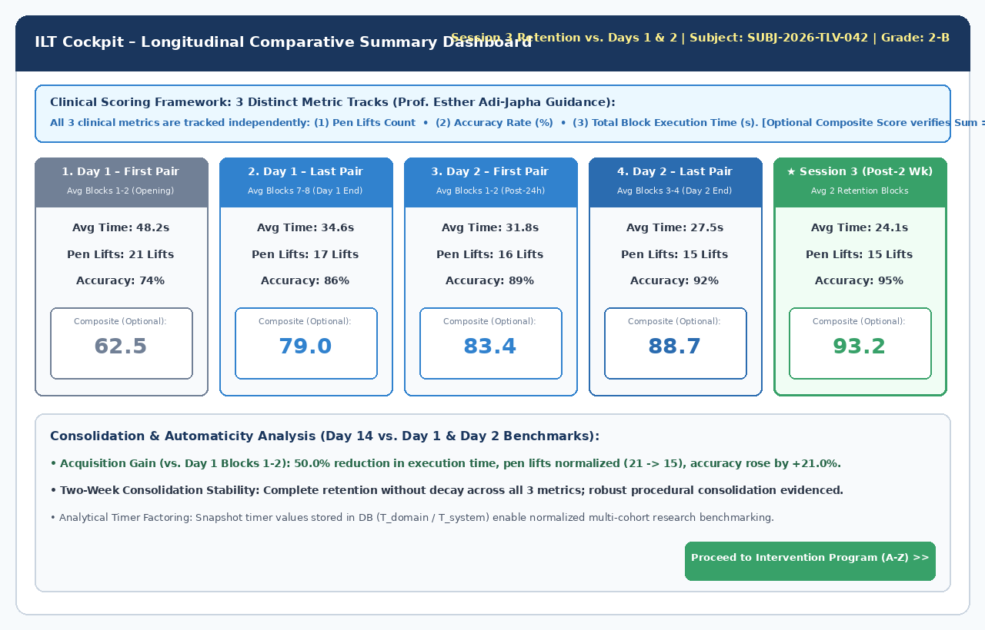
Figure 6: Longitudinal Comparative Summary Dashboard Displaying 3 Distinct Clinical Metrics
9. Intervention Program Implementation & Multi-Stage Execution
• Tablet vs. Physical Paper Division: Stages 1 and 3 are executed entirely on tablet (recording execution time across all 4 blocks and highlighting Block 2 separately). Stage 4 transitions to physical paper notebooks and wipe-clean boards.
• Evaluator Decision Commands: Progression across letters is controlled via [Repeat Letter Block] and [Next Letter Block >>] buttons.
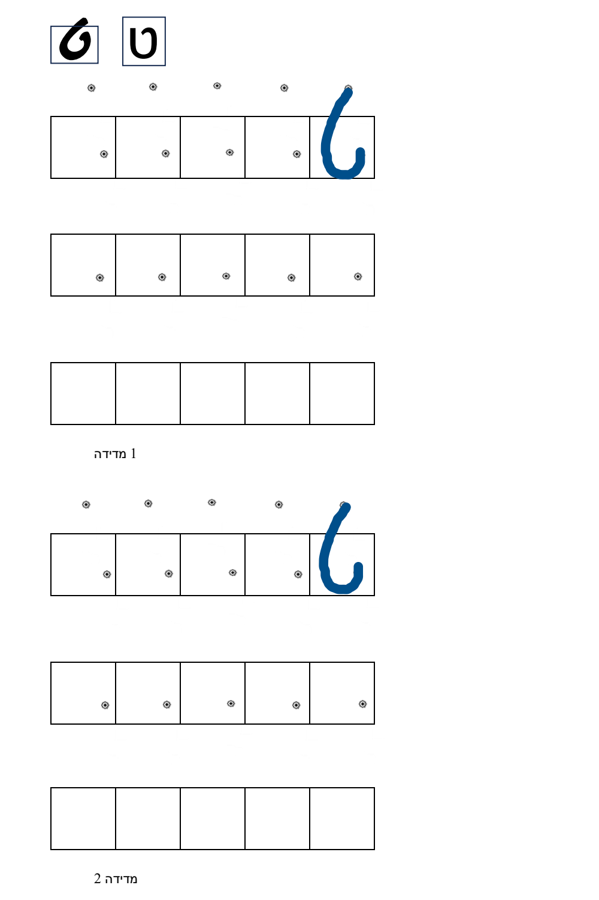
Figure 7: Sample Graded Intervention Training Sheet (Hebrew Letter Tet: Row 1 Model + Dots, Row 2 Dot, Row 3 Blank)
10. Appendix: Developer Implementation & Onboarding Guide
• Docker Compose Development Stack: Launch TimescaleDB, MinIO, and go2rtc locally with a single command (docker-compose up -d):
version: '3.8'
services:
db:
image: timescale/timescaledb:latest-pg16
container_name: ilt_db
environment:
POSTGRES_DB: ilt_research
POSTGRES_USER: ilt_admin
POSTGRES_PASSWORD: ilt_secret_password
ports:
- "5432:5432"
volumes:
- pgdata:/var/lib/postgresql/data
restart: always
minio:
image: minio/minio:latest
container_name: ilt_minio
command: server /data --console-address ":9001"
environment:
MINIO_ROOT_USER: minio_admin
MINIO_ROOT_PASSWORD: minio_secret_password
ports:
- "9000:9000"
- "9001:9001"
volumes:
- miniodata:/data
restart: always
go2rtc:
image: alexxit/go2rtc:latest
container_name: ilt_cms_gateway
ports:
- "1984:1984" # Management & WebRTC API
- "8554:8554" # RTSP Relay Port
- "8555:8555" # WebRTC Live Port
volumes:
- ./go2rtc.yaml:/config/go2rtc.yaml
restart: always
volumes:
pgdata:
miniodata:
• Mock Stylus Simulator for Desktop Browser Development: Emulates Wacom EMR pointer events (pressure, tilt altitude/azimuth, hover) using mouse inputs:
// Mock Wacom EMR Stylus Simulator for Desktop Browser Development
export class MockEMRStylusSimulator {
private isMouseDown = false;
private startTime = 0;
constructor(private canvas: HTMLCanvasElement, private onSample: (s: any) => void) {
this.canvas.addEventListener('mousedown', (e) => {
this.isMouseDown = true;
this.startTime = performance.now();
this.emit(e, 0.45, true, false);
});
window.addEventListener('mouseup', (e) => {
if (this.isMouseDown) {
this.isMouseDown = false;
this.emit(e, 0.0, false, false);
}
});
this.canvas.addEventListener('mousemove', (e) => {
const pressure = this.isMouseDown ? 0.55 + 0.15 * Math.sin(performance.now() / 80) : 0.0;
const isHover = !this.isMouseDown;
this.emit(e, pressure, this.isMouseDown, isHover);
});
}
private emit(e: MouseEvent, pressure: number, isPenDown: boolean, isHover: boolean) {
const rect = this.canvas.getBoundingClientRect();
const x = (e.clientX - rect.left) / rect.width;
const y = (e.clientY - rect.top) / rect.height;
this.onSample({
time_offset_ms: Math.round(performance.now() - this.startTime),
x: Number(x.toFixed(5)),
y: Number(y.toFixed(5)),
pressure: Number(pressure.toFixed(4)),
tilt_altitude: 60,
tilt_azimuth: 180,
is_pen_down: isPenDown,
is_hover: isHover
});
}
}
• Mandatory Developer Guardrails: (1) No JSON for live EMR telemetry – strictly 24-byte binary wire protocol; (2) Enforce Sum(Weights) == 100% in UI and API; (3) Research Director authorization code required for timer overrides; (4) Preserve 3 distinct metric columns across all APIs and exports.

