ILT Research System - Detailed Design Specification & Developer Guide (DDD v1.2 FINAL)
Engineering Blueprint for Coding: Analyst Replay, Dynamic Templates, Wire Protocol, DDL Schema & Developer Guide
Document Parameter | Specification Value | Document Parameter | Specification Value
Document ID: | ILT-DDD-V1.2-FINAL-EN | Publication Date: | October 2026 (Release 1.2 Final Edition)
Functional Baseline: | FRS v3.3 & Architecture Spec v5.3 | Target Audience: | Software Engineers, Lead Architects, Full-Stack Developers
Analyst Capabilities: | Video-Synced Replay + Open-Source BI | Target Hardware: | Wacom MovinkPad 11 (Certified Continuous Charging)
Readiness Status: | Coding-Ready (Includes Docker Compose & Mock Stylus) | Timer Governance: | 20s System Default (Director Auth Required)

1. Document Purpose, System Overview & Technology Stack
Complete engineering specification for coding implementation including the Research Analyst Portal and Kinematic Replay Engine.
System Layer | Technology | Version | Engineering Rationale
Analyst Portal (Replay & BI) | React, Canvas 2D Replayer, Apache Superset, DuckDB-Wasm | React 18+, DuckDB 1.0 | 133Hz stroke replay, video sync from MinIO, multi-dimensional cohort slicing, Parquet/Jupyter export.
Student Tablet (Kiosk App) | React, TypeScript, Native Canvas 2D, Wacom Web SDK, Dexie.js | React 18+, TS 5+ | 60 FPS rendering, 133Hz EMR sampling, IndexedDB resilience, continuous charging.
Proctor Cockpit Console | React, Canvas 80% Mirror, WebRTC DataChannel (Host), TailwindCSS | React 18+, TS 5+ | Live stroke mirror (80%), telemetry (20%), 3 distinct metrics dashboard, classroom oversight.
Local Edge Gateway | Node.js / Fastify, WebSocket Signaling, go2rtc Proxy | Node 20 LTS | P2P direct channels, WebRTC signaling, agnostic video proxy (RTSP/ONVIF/USB).
Analytics & DTW Engine | Python, FastAPI, SciPy, FastDTW, NumPy, DuckDB | Python 3.11+ | Kinematic signal processing, cDTW for Row 3, timer factoring queries.
Core Database & Storage | PostgreSQL 16 + TimescaleDB + MinIO S3 | Postgres 16 | Relational data, compressed TimescaleDB Hypertables, and MinIO S3 video storage.

2. Monorepo Project Structure & Module Organization
ilt-research-platform/
├── apps/
│ ├── student-tablet/ # אפליקציית הטאבלט לתלמיד (React + Canvas 2D + EMR Driver)
│ ├── proctor-cockpit/ # עמדת המאבחן (Control Page, Live Cockpit, Comparative Dashboard)
│ └── analyst-portal/ # פורטל אנליסט (Kinematic Replayer, Desk Video Sync, Superset Dashboards)
├── services/
│ ├── gateway/ # שרת שער מקומי (Signaling, DB Cache, go2rtc Camera Proxy)
│ └── analytics/ # שירות ניתוח קינמטי, cDTW לשורה 3, וייצוא DuckDB/Parquet (FastAPI)
├── packages/
│ ├── shared-types/ # מודלי נתונים, ממשקים ו-Enums משותפים (TypeScript)
│ ├── emr-protocol/ # מודול סריאליזציה בינארית (24-Byte Struct) ומילון OpCodes
│ └── template-schemas/ # סכמות JSON של תבניות כתיבה (גריד 3x5, מחברת 10 שורות, אותיות ט')
└── docker/ # תצורות Docker לפיתוח מקומי (Postgres+Timescale, MinIO, go2rtc)
3. Binary Wire Protocol & Serialization Specification
// C / C++ & TypedArray 24-Byte Binary EMR Sample Struct (Little-Endian IEEE 754)
#pragma pack(push, 1)
struct EMRSampleRecord {
uint32_t timestamp_offset_ms; // 4 Bytes: Milliseconds elapsed since block launch
float x_coord; // 4 Bytes: Normalized X sub-pixel coordinate (0.0000 - 1.0000)
float y_coord; // 4 Bytes: Normalized Y sub-pixel coordinate (0.0000 - 1.0000)
float pressure; // 4 Bytes: Normalized pen tip pressure (0.0000 - 1.0000)
int16_t tilt_altitude; // 2 Bytes: Pen vertical angle relative to tablet plane (0 - 90 deg)
int16_t tilt_azimuth; // 2 Bytes: Pen rotational angle around surface normal (0 - 360 deg)
uint8_t stroke_flags; // 1 Byte: Bit 0: PenDown, Bit 1: InAirHover, Bit 2: Eraser, Bit 3: TargetHit
uint8_t active_house_id; // 1 Byte: Identifier of active house/cell (1 to 15)
uint16_t reserved_padding; // 2 Bytes: Alignment padding (0x0000)
};
#pragma pack(pop)
4. Dynamic Canvas Engine & Templates Specification
{
"$schema": "http://json-schema.org/draft-07/schema#",
"title": "ILTDynamicTemplateDefinition",
"type": "object",
"properties": {
"template_id": { "type": "string" },
"template_name": { "type": "string" },
"ruling_type": { "type": "string", "enum": ["NOTEBOOK_10_ROWS", "NOTEBOOK_14_ROWS", "NOTEBOOK_1_ROW", "GRID_3X5", "FREE_CANVAS"] },
"target_grade_level": { "type": "string", "default": "ALL_GRADES" },
"canvas_schema": {
"type": "object",
"properties": {
"num_lines": { "type": "integer" },
"line_spacing_px": { "type": "number" },
"margin_side": { "type": "string", "enum": ["RIGHT", "LEFT", "NONE"] },
"margin_offset_px": { "type": "number" },
"active_row_indices": { "type": "array", "items": { "type": "integer" } }
},
"required": ["num_lines", "line_spacing_px", "margin_side", "active_row_indices"]
},
"rules_schema": {
"type": "object",
"properties": {
"max_internal_pen_lifts": { "type": "integer", "default": 0 },
"width_nominal_mm": { "type": "number", "default": 15.0 },
"width_tolerance_mm": { "type": "number", "default": 2.0 },
"forward_only_locking": { "type": "boolean", "default": true }
}
}
},
"required": ["template_id", "template_name", "ruling_type", "canvas_schema", "rules_schema"]
}
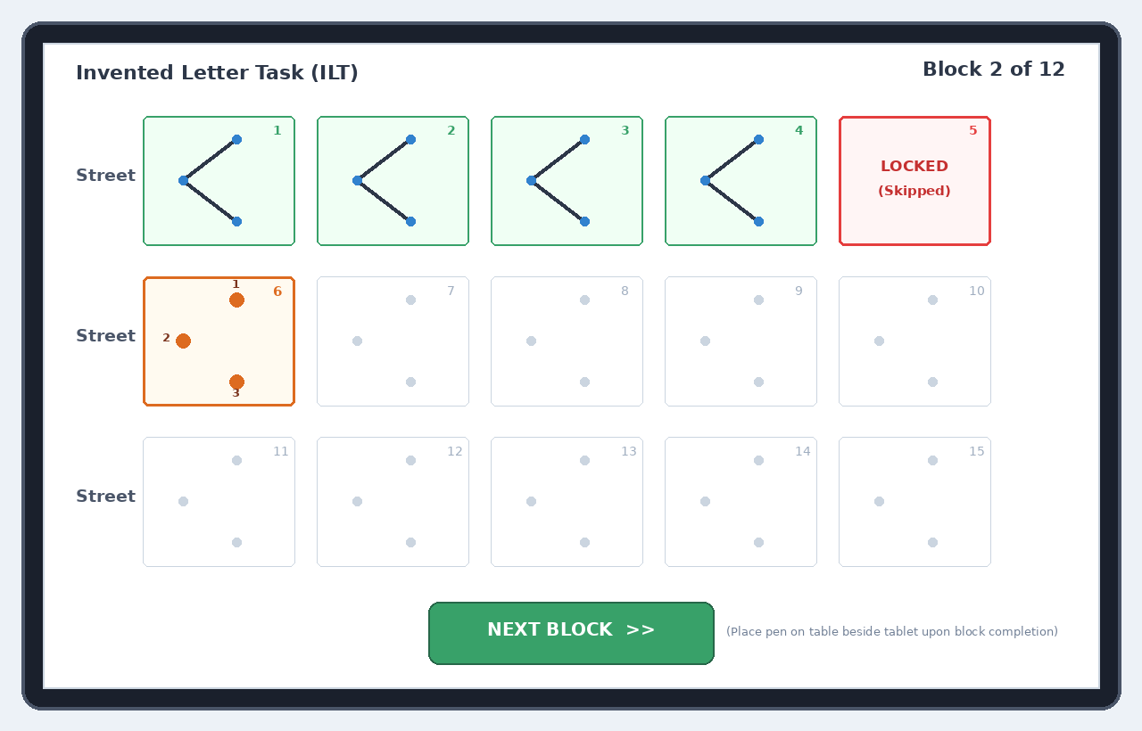
Figure 1: Student Tablet Canvas with Forward-Only Dynamic Lock
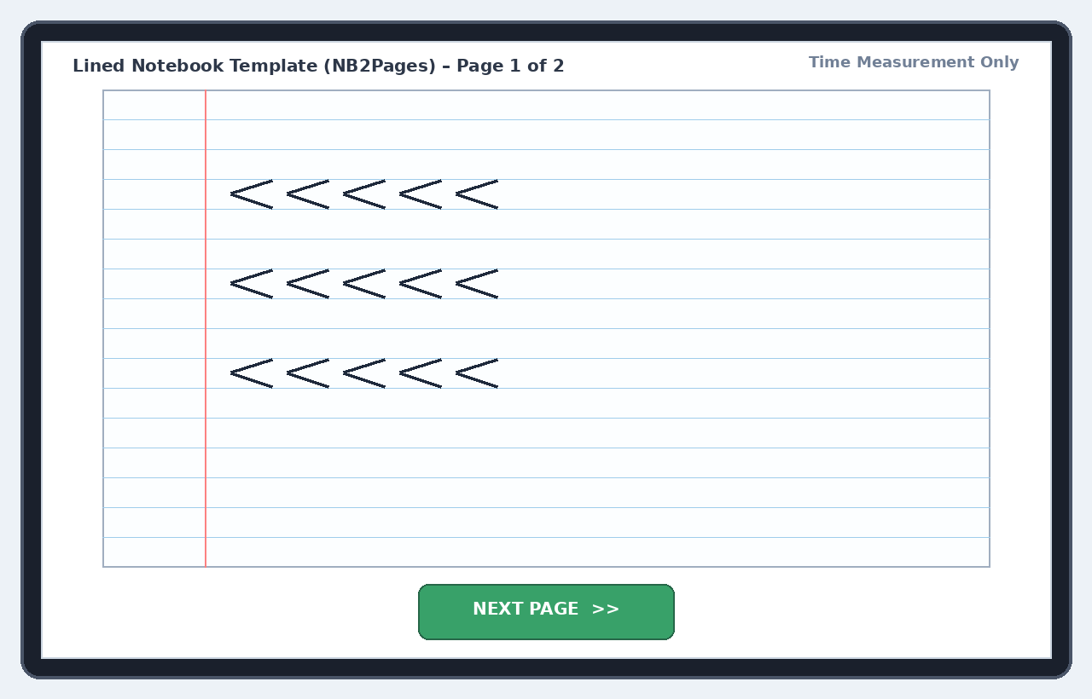
Figure 2: Lined Notebook Canvas Aligned to Original Study Ruling
5. State Machines, Proctor Cockpit & Comparative Dashboard
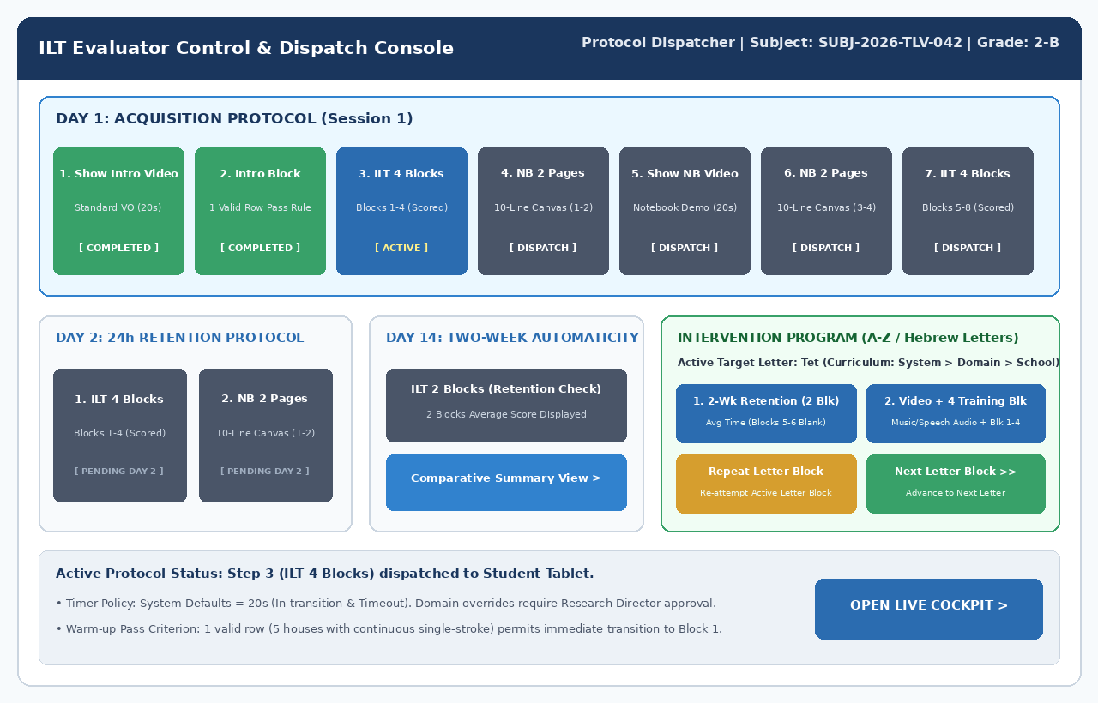
Figure 3: Evaluator Control & Protocol Dispatcher Console
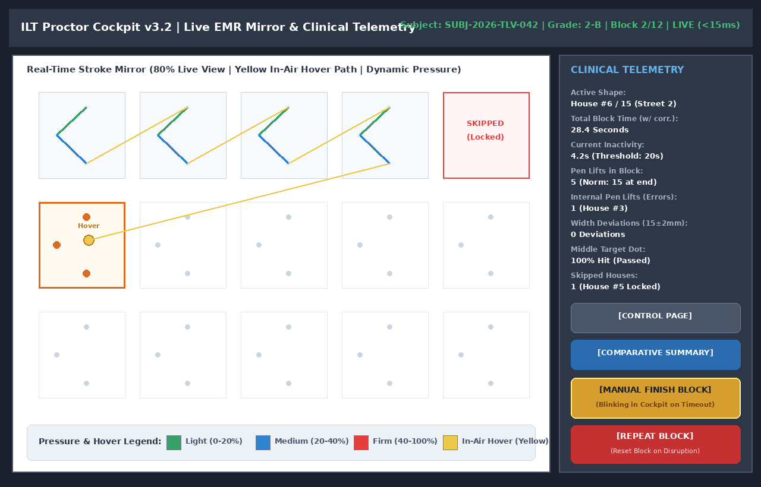
Figure 4: Proctor Cockpit (80% Live Mirror / 20% Telemetry)
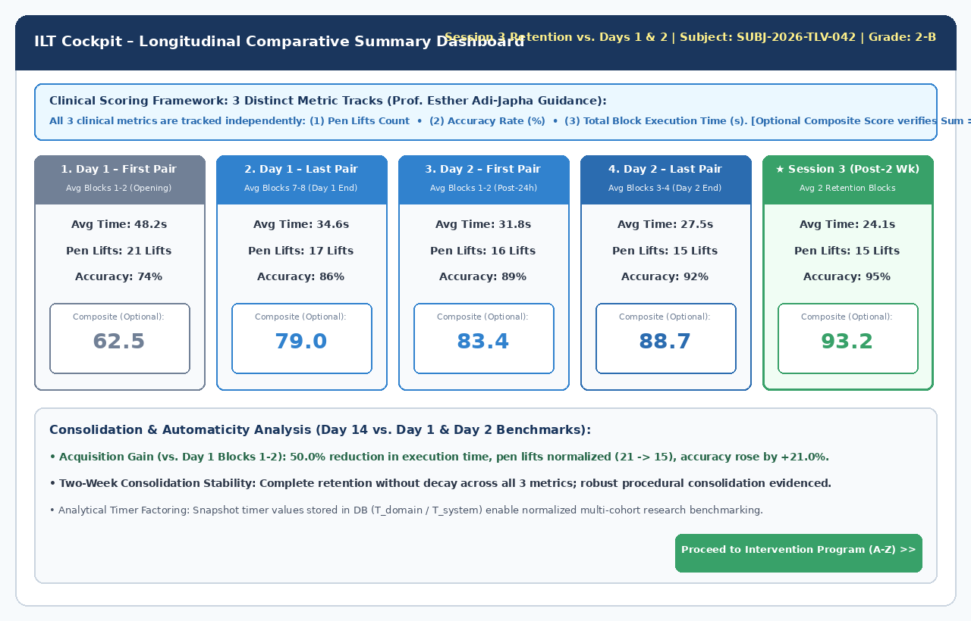
Figure 5: Longitudinal Comparative Summary Dashboard (3 Distinct Metrics)
6. Relational Database Schema & Analytical Views (DDL v5.3)
-- =============================================================================
-- ILT PRODUCTION DDL (PostgreSQL 16 + TimescaleDB) - Release 5.3 / DDD v1.2
-- =============================================================================
CREATE EXTENSION IF NOT EXISTS "uuid-ossp";
CREATE EXTENSION IF NOT EXISTS "timescaledb";
-- 1. System Configuration & Global Defaults
CREATE TABLE system_config (
config_id INT PRIMARY KEY DEFAULT 1,
in_transition_delay_sec INT NOT NULL DEFAULT 20, -- Default In-Transition: 20s
inactivity_timeout_sec INT NOT NULL DEFAULT 20, -- Default Inactivity Timeout: 20s
post_block_timeout_sec INT NOT NULL DEFAULT 30, -- Timeout post-15th letter: 30s
notebook_page_timeout_sec INT NOT NULL DEFAULT 60,
video_recording_enabled BOOLEAN NOT NULL DEFAULT TRUE,
require_research_director_approval BOOLEAN NOT NULL DEFAULT TRUE,
score_weight_pen_lifts_pct NUMERIC(5,2) NOT NULL DEFAULT 35.00,
score_weight_accuracy_pct NUMERIC(5,2) NOT NULL DEFAULT 40.00,
score_weight_time_pct NUMERIC(5,2) NOT NULL DEFAULT 25.00,
CONSTRAINT chk_weights_sum_100 CHECK (
(score_weight_pen_lifts_pct + score_weight_accuracy_pct + score_weight_time_pct) = 100.00
),
updated_at TIMESTAMP WITH TIME ZONE DEFAULT CURRENT_TIMESTAMP
);
-- 2. Domains Table (with Research Director Authorization for Overrides)
CREATE TABLE domains (
domain_id SERIAL PRIMARY KEY,
domain_name VARCHAR(100) NOT NULL UNIQUE,
override_in_transition_sec INT NULL,
override_inactivity_timeout_sec INT NULL,
override_video_enabled BOOLEAN NULL,
timer_approved_by_research_director VARCHAR(100) NULL,
timer_approval_timestamp TIMESTAMP WITH TIME ZONE NULL,
created_at TIMESTAMP WITH TIME ZONE DEFAULT CURRENT_TIMESTAMP
);
-- 3. Dynamic Templates Engine
CREATE TABLE dynamic_templates (
template_id VARCHAR(50) PRIMARY KEY,
template_name VARCHAR(100) NOT NULL,
template_category VARCHAR(30) NOT NULL,
ruling_type VARCHAR(30) NOT NULL,
target_grade_level VARCHAR(30) DEFAULT 'ALL_GRADES',
canvas_schema JSONB NOT NULL,
rules_schema JSONB NOT NULL,
is_active BOOLEAN DEFAULT TRUE,
created_at TIMESTAMP WITH TIME ZONE DEFAULT CURRENT_TIMESTAMP
);
-- 4. Canonical Models for Freehand Row 3 Evaluation
CREATE TABLE letter_canonical_models (
letter_id VARCHAR(10) PRIMARY KEY,
language_code VARCHAR(5) NOT NULL,
letter_char VARCHAR(5) NOT NULL,
expected_strokes_count INT NOT NULL DEFAULT 1,
canonical_aspect_ratio NUMERIC(5,3) NOT NULL,
canonical_points JSONB NOT NULL,
created_at TIMESTAMP WITH TIME ZONE DEFAULT CURRENT_TIMESTAMP
);
-- 5. Sessions Table (3 Metrics Preserved Independently + Timer Snapshots)
CREATE TABLE sessions (
session_id UUID PRIMARY KEY DEFAULT gen_random_uuid(),
session_number BIGSERIAL UNIQUE,
domain_id INT NOT NULL REFERENCES domains(domain_id),
school_name VARCHAR(150) NOT NULL,
grade_class VARCHAR(50) NOT NULL,
evaluator_name VARCHAR(120) NOT NULL,
assessment_date DATE NOT NULL DEFAULT CURRENT_DATE,
examinee_alias VARCHAR(50) NOT NULL,
examinee_initials VARCHAR(5) NOT NULL,
student_language VARCHAR(5) DEFAULT 'he',
session_stage VARCHAR(30) NOT NULL,
is_charging_during_test BOOLEAN DEFAULT FALSE,
sys_in_transition_sec INT NOT NULL DEFAULT 20,
dom_in_transition_sec INT NOT NULL DEFAULT 20,
sys_inactivity_sec INT NOT NULL DEFAULT 20,
dom_inactivity_sec INT NOT NULL DEFAULT 20,
video_recording_enabled BOOLEAN NOT NULL DEFAULT TRUE,
warmup_row_passed BOOLEAN DEFAULT FALSE,
created_at TIMESTAMP WITH TIME ZONE DEFAULT CURRENT_TIMESTAMP
);
-- 6. Assessment Blocks Table (Preserving 3 Distinct Metrics Independently)
CREATE TABLE session_blocks (
block_id BIGSERIAL PRIMARY KEY,
session_id UUID NOT NULL REFERENCES sessions(session_id) ON DELETE CASCADE,
block_type VARCHAR(30) NOT NULL,
block_index INT NOT NULL,
target_letter VARCHAR(5) NULL,
pen_lifts_count INT NOT NULL,
accuracy_pct NUMERIC(5,2) NOT NULL,
total_duration_ms INT NOT NULL,
composite_score NUMERIC(6,2) NULL,
is_repeated_disrupted BOOLEAN DEFAULT FALSE,
created_at TIMESTAMP WITH TIME ZONE DEFAULT CURRENT_TIMESTAMP
);
-- 7. High-Frequency EMR Telemetry (TimescaleDB Hypertable with 1-Day Chunks)
CREATE TABLE pen_telemetry_chunks (
recorded_at TIMESTAMP WITH TIME ZONE NOT NULL,
session_id UUID NOT NULL,
block_index INT NOT NULL,
house_id INT NOT NULL,
time_offset_ms INT NOT NULL,
x NUMERIC(8,4) NOT NULL,
y NUMERIC(8,4) NOT NULL,
pressure NUMERIC(6,5) NOT NULL,
tilt_altitude SMALLINT NOT NULL,
tilt_azimuth SMALLINT NOT NULL,
is_hover BOOLEAN NOT NULL,
is_pen_down BOOLEAN NOT NULL
);
SELECT create_hypertable('pen_telemetry_chunks', 'recorded_at', chunk_time_interval => INTERVAL '1 day');
ALTER TABLE pen_telemetry_chunks SET (timescaledb.compress, timescaledb.compress_segmentby = 'session_id, block_index');
SELECT add_compression_policy('pen_telemetry_chunks', INTERVAL '7 days');
-- 8. Video Replay Records (Desk & Hands RTSP / MP4 Ingestion)
CREATE TABLE session_video_records (
video_id BIGSERIAL PRIMARY KEY,
session_id UUID NOT NULL REFERENCES sessions(session_id) ON DELETE CASCADE,
camera_model VARCHAR(100) DEFAULT 'Wireless IP Camera (RTSP)',
storage_bucket VARCHAR(50) DEFAULT 'ilt-session-videos',
video_object_key TEXT NOT NULL,
duration_sec NUMERIC(8,2) NOT NULL,
start_time_utc TIMESTAMP WITH TIME ZONE NOT NULL,
fps NUMERIC(4,2) DEFAULT 25.00,
resolution VARCHAR(20) DEFAULT '1280x720',
created_at TIMESTAMP WITH TIME ZONE DEFAULT CURRENT_TIMESTAMP
);
-- 9. Analytical Cohort Slices View (for Apache Superset, Metabase, DuckDB, Jupyter)
CREATE OR REPLACE VIEW v_analyst_cohort_slices AS
SELECT
s.session_id,
s.session_number,
s.examinee_alias,
s.examinee_initials,
d.domain_name,
s.school_name,
s.grade_class,
s.dominant_hand,
s.student_language,
s.session_stage,
s.assessment_date,
s.sys_in_transition_sec,
s.dom_in_transition_sec,
(s.dom_in_transition_sec::numeric / s.sys_in_transition_sec::numeric) AS timer_factoring_ratio,
sb.block_id,
sb.block_type,
sb.block_index,
sb.target_letter,
sb.pen_lifts_count,
sb.accuracy_pct,
sb.total_duration_ms,
(sb.total_duration_ms::numeric / 1000.0) AS total_duration_sec,
((sb.total_duration_ms::numeric / 1000.0) * (s.sys_in_transition_sec::numeric / s.dom_in_transition_sec::numeric)) AS factored_duration_sec,
sb.composite_score,
sb.is_repeated_disrupted
FROM sessions s
JOIN domains d ON s.domain_id = d.domain_id
JOIN session_blocks sb ON s.session_id = sb.session_id;
7. Kinematic Session Replay Engine & Cohort Analytics Implementation
• TypeScript Kinematic Replay Engine Implementation: Canvas 2D stroke replayer, variable speed controls (0.25x-4x), and synchronized desk video:
// Kinematic Session Replay Engine (TypeScript / React Canvas 2D)
export class KinematicSessionReplayer {
private currentFrameIndex = 0;
private playbackSpeed = 1.0;
private isPlaying = false;
private animFrameId: number | null = null;
constructor(
private canvas: HTMLCanvasElement,
private samples: any[],
private videoElement?: HTMLVideoElement,
private onProgress?: (timeMs: number, sample: any) => void
) {}
public play(): void {
this.isPlaying = true;
if (this.videoElement) this.videoElement.play();
this.renderLoop();
}
public pause(): void {
this.isPlaying = false;
if (this.animFrameId) cancelAnimationFrame(this.animFrameId);
if (this.videoElement) this.videoElement.pause();
}
public setSpeed(speed: number): void {
this.playbackSpeed = speed;
if (this.videoElement) this.videoElement.playbackRate = speed;
}
public seek(targetTimeMs: number): void {
this.currentFrameIndex = this.samples.findIndex(s => s.timestamp_offset_ms >= targetTimeMs);
if (this.currentFrameIndex === -1) this.currentFrameIndex = this.samples.length - 1;
if (this.videoElement) this.videoElement.currentTime = targetTimeMs / 1000.0;
this.renderUpToCurrentFrame();
}
private renderLoop = (): void => {
if (!this.isPlaying) return;
const currentSample = this.samples[this.currentFrameIndex];
this.drawStrokeSegment(currentSample);
if (this.onProgress) this.onProgress(currentSample.timestamp_offset_ms, currentSample);
this.currentFrameIndex += Math.max(1, Math.round(this.playbackSpeed));
if (this.currentFrameIndex < this.samples.length) {
this.animFrameId = requestAnimationFrame(this.renderLoop);
} else {
this.pause();
}
};
private drawStrokeSegment(s: any): void {
const ctx = this.canvas.getContext('2d')!;
const x = s.x_coord * this.canvas.width;
const y = s.y_coord * this.canvas.height;
if (s.stroke_flags & 0x01) { // Pen Down
ctx.fillStyle = this.getPressureColor(s.pressure);
ctx.beginPath();
ctx.arc(x, y, 2 + s.pressure * 4, 0, Math.PI * 2);
ctx.fill();
} else if (s.stroke_flags & 0x02) { // In-Air Hover
ctx.fillStyle = '#ECC94B'; // Yellow hover line
ctx.fillRect(x - 1, y - 1, 2, 2);
}
}
private getPressureColor(p: number): string {
if (p < 0.20) return '#38A169'; // Light Green
if (p < 0.40) return '#3182CE'; // Medium Blue
return '#E53E3E'; // Firm Red
}
}
• Python DuckDB / Parquet Cohort Export Endpoint: High-speed cohort slicing and direct Parquet export for researchers:
# Python Cohort Analytics & Parquet / DuckDB Export Engine (FastAPI)
import duckdb
import pandas as pd
from fastapi import APIRouter, Response
router = APIRouter(prefix="/api/v1/analyst")
@router.get("/export/parquet")
def export_cohort_parquet(domain: str = None, grade: str = None, ses_low: bool = None):
con = duckdb.connect()
con.execute("INSTALL postgres; LOAD postgres;")
con.execute("ATTACH 'dbname=ilt_research user=ilt_admin host=db' AS pg (TYPE POSTGRES);")
query = "SELECT * FROM pg.v_analyst_cohort_slices WHERE 1=1"
if domain: query += f" AND domain_name = '{domain}'"
if grade: query += f" AND grade_class LIKE '%{grade}%'"
df = con.execute(query).df()
parquet_bytes = df.to_parquet(index=False)
return Response(
content=parquet_bytes,
media_type="application/octet-stream",
headers={"Content-Disposition": "attachment; filename=ilt_cohort_data.parquet"}
)
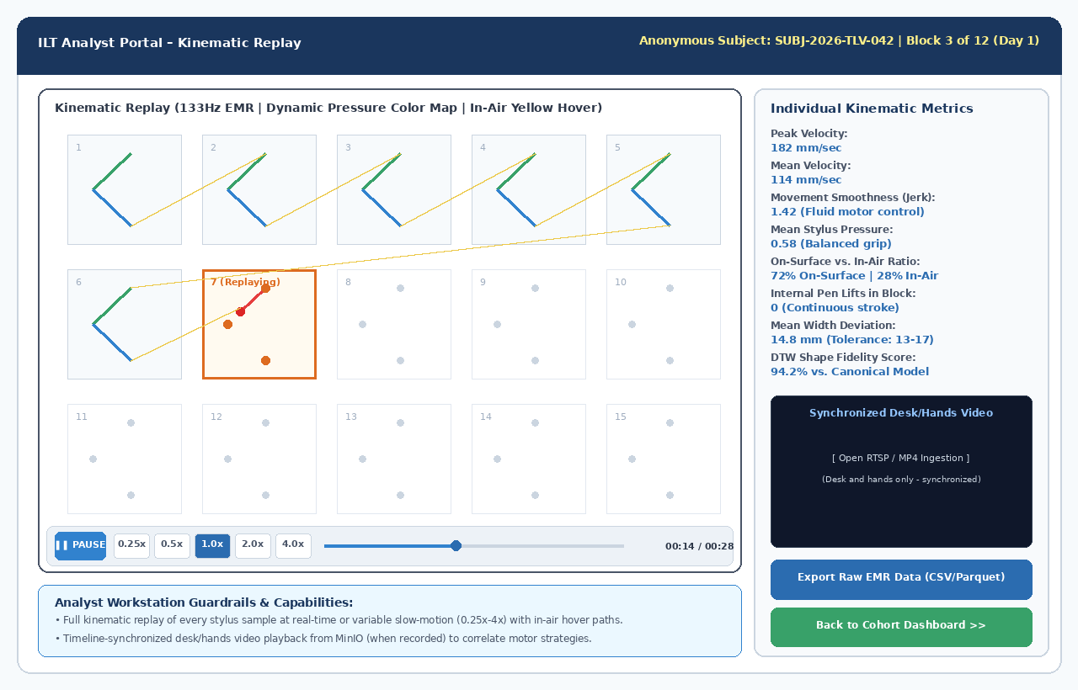
Figure 6: Analyst Portal – Kinematic Session Replay Engine Synced with Desk Video
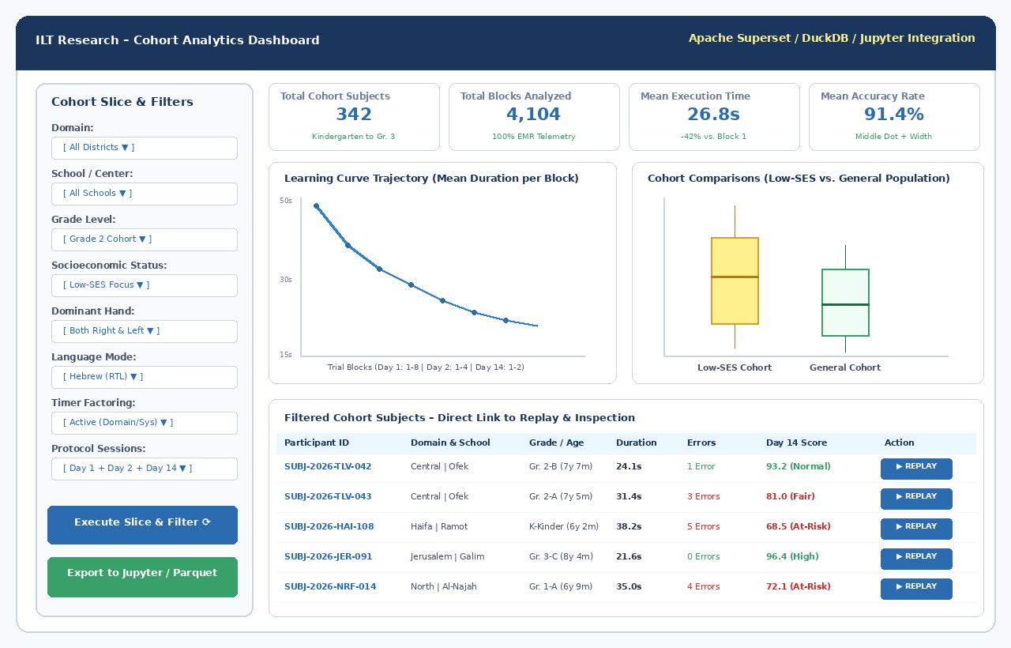
Figure 7: Open-Source Cohort Slice-and-Dice Analytics Dashboard
8. Kinematic Algorithms & Intervention Program
import numpy as np
from scipy.spatial import procrustes
from fastdtw import fastdtw
def evaluate_freehand_row3(stroke_points: np.ndarray, canonical_points: np.ndarray, canonical_aspect_ratio: float) -> dict:
if len(stroke_points) < 10:
return {"composite_accuracy": 0.0, "diagnostic_tag": "EMPTY_OR_NOISE", "valid": False}
diffs = np.diff(stroke_points, axis=0)
dists = np.hypot(diffs[:, 0], diffs[:, 1])
cum_dist = np.insert(np.cumsum(dists), 0, 0)
total_len = cum_dist[-1]
even_spaces = np.linspace(0, total_len, 100)
resampled_stroke = np.column_stack((
np.interp(even_spaces, cum_dist, stroke_points[:, 0]),
np.interp(even_spaces, cum_dist, stroke_points[:, 1])
))
norm_stroke = (resampled_stroke - np.mean(resampled_stroke, axis=0)) / (np.std(resampled_stroke) + 1e-6)
norm_canonical = (canonical_points - np.mean(canonical_points, axis=0)) / (np.std(canonical_points) + 1e-6)
_, _, disparity = procrustes(norm_canonical, norm_stroke)
procrustes_score = max(0.0, min(100.0, 100.0 * (1.0 - disparity * 2.2)))
dtw_dist, _ = fastdtw(norm_stroke, norm_canonical, dist=2)
dtw_score = max(0.0, min(100.0, 100.0 * (1.0 - (dtw_dist / 100.0))))
w, h = np.ptp(stroke_points[:, 0]), np.ptp(stroke_points[:, 1])
actual_ratio = w / (h + 1e-6)
ratio_dev_pct = abs(actual_ratio - canonical_aspect_ratio) / canonical_aspect_ratio * 100.0
composite_acc = 0.55 * procrustes_score + 0.30 * dtw_score + 0.15 * max(0.0, 100.0 - ratio_dev_pct)
tag = "ACCURATE" if composite_acc >= 80.0 else ("PROPORTION_DISTORTION" if ratio_dev_pct > 25.0 else "SHAPE_DEFORMATION")
return {
"composite_accuracy": round(composite_acc, 2),
"procrustes_score": round(procrustes_score, 2),
"dtw_distance": round(dtw_dist, 2),
"aspect_ratio_deviation_pct": round(ratio_dev_pct, 2),
"diagnostic_tag": tag,
"valid": True
}
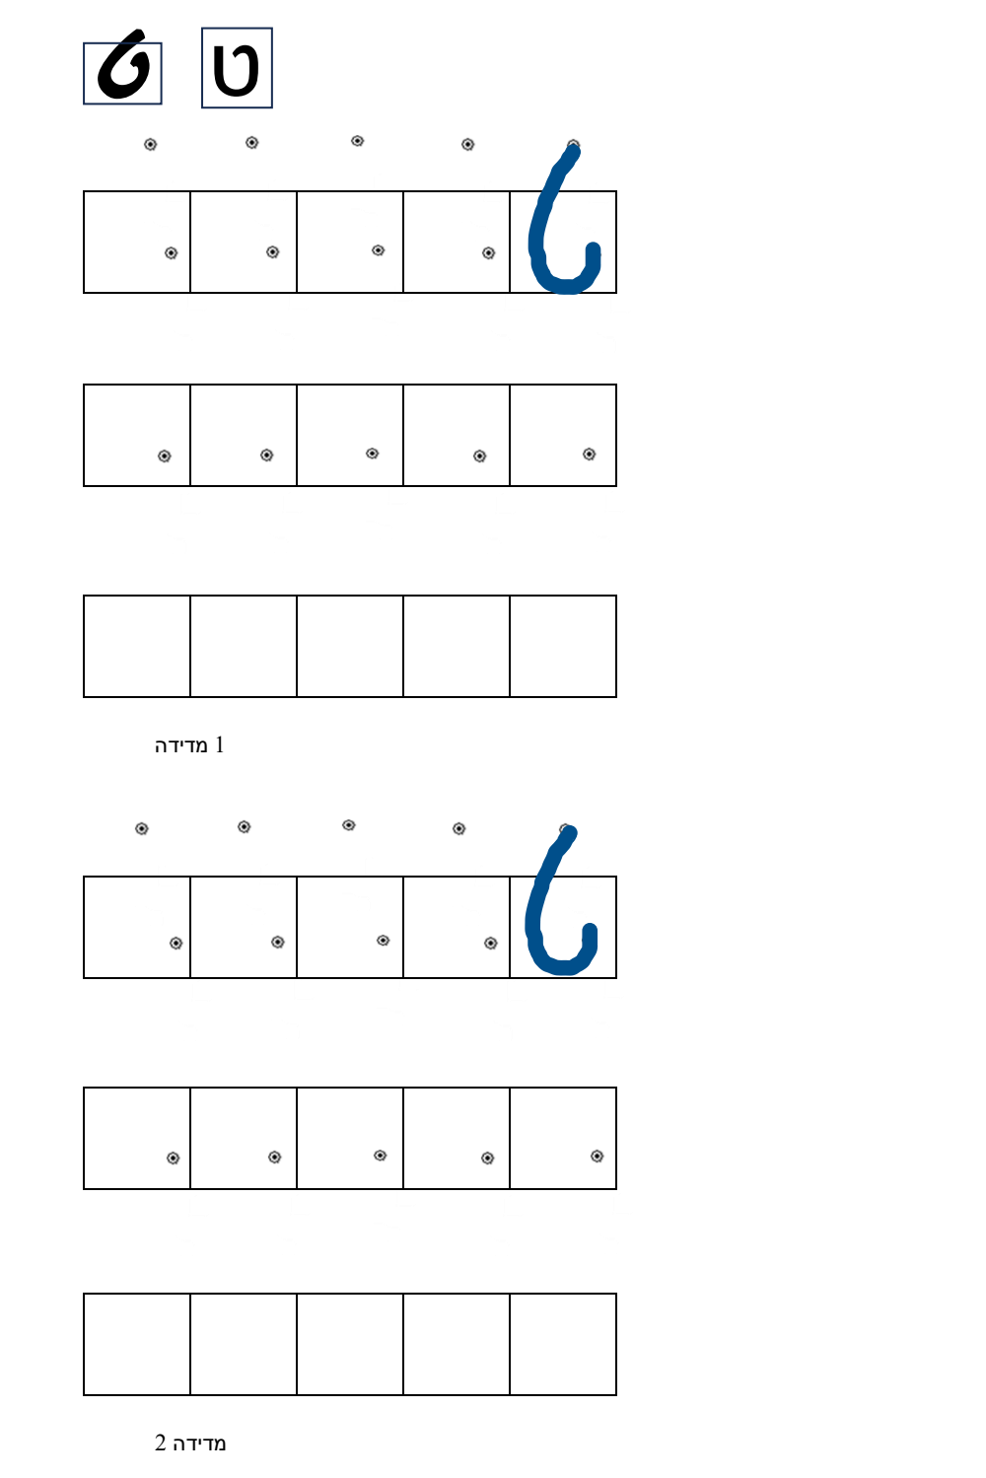
Figure 8: Sample Graded Intervention Training Sheet (Hebrew Letter Tet)
9. Appendix: Developer Implementation & Onboarding Guide
• Docker Compose Local Stack: Launch TimescaleDB, MinIO, and go2rtc locally with one command:
version: '3.8'
services:
db:
image: timescale/timescaledb:latest-pg16
container_name: ilt_db
environment:
POSTGRES_DB: ilt_research
POSTGRES_USER: ilt_admin
POSTGRES_PASSWORD: ilt_secret_password
ports:
- "5432:5432"
volumes:
- pgdata:/var/lib/postgresql/data
restart: always
minio:
image: minio/minio:latest
container_name: ilt_minio
command: server /data --console-address ":9001"
environment:
MINIO_ROOT_USER: minio_admin
MINIO_ROOT_PASSWORD: minio_secret_password
ports:
- "9000:9000"
- "9001:9001"
volumes:
- miniodata:/data
restart: always
go2rtc:
image: alexxit/go2rtc:latest
container_name: ilt_cms_gateway
ports:
- "1984:1984" # Management & WebRTC API
- "8554:8554" # RTSP Relay Port
- "8555:8555" # WebRTC Live Port
volumes:
- ./go2rtc.yaml:/config/go2rtc.yaml
restart: always
volumes:
pgdata:
miniodata:
• Mock Stylus Simulator for Desktop Development: Maps mouse events to simulated EMR samples with pressure and hover:
// Mock Wacom EMR Stylus Simulator for Desktop Browser Development
export class MockEMRStylusSimulator {
private isMouseDown = false;
private startTime = 0;
constructor(private canvas: HTMLCanvasElement, private onSample: (s: any) => void) {
this.canvas.addEventListener('mousedown', (e) => {
this.isMouseDown = true;
this.startTime = performance.now();
this.emit(e, 0.45, true, false);
});
window.addEventListener('mouseup', (e) => {
if (this.isMouseDown) {
this.isMouseDown = false;
this.emit(e, 0.0, false, false);
}
});
this.canvas.addEventListener('mousemove', (e) => {
const pressure = this.isMouseDown ? 0.55 + 0.15 * Math.sin(performance.now() / 80) : 0.0;
const isHover = !this.isMouseDown;
this.emit(e, pressure, this.isMouseDown, isHover);
});
}
private emit(e: MouseEvent, pressure: number, isPenDown: boolean, isHover: boolean) {
const rect = this.canvas.getBoundingClientRect();
const x = (e.clientX - rect.left) / rect.width;
const y = (e.clientY - rect.top) / rect.height;
this.onSample({
time_offset_ms: Math.round(performance.now() - this.startTime),
x: Number(x.toFixed(5)),
y: Number(y.toFixed(5)),
pressure: Number(pressure.toFixed(4)),
tilt_altitude: 60,
tilt_azimuth: 180,
is_pen_down: isPenDown,
is_hover: isHover
});
}
}
• Mandatory Developer Guardrails: (1) Strictly 24-byte binary protocol for live EMR telemetry; (2) Enforce Sum(Weights) == 100% in UI and API; (3) Research Director authorization code required for timer overrides; (4) Preserve 3 distinct metric columns across all APIs and exports.

