ILT Research System - Software Requirements Specification & Functional Design (SRS / FRS v3.3)
Functional Requirements, UI Wireframes, Workflows, Analyst Portal & Replay Engine, Open-Source Cohort Analytics, and Clinical Graphomotor Models
Document Parameter | Specification Value | Document Parameter | Specification Value
Document ID: | ILT-FRS-V3.3-EN | Publication Date: | October 2026 (Release 3.3 Full Edition)
Clinical Basis: | Prof. Adi-Japha, Dr. Hollander, Dr. Dorfberger | Hardware: | Wacom MovinkPad 11 (Continuous Charging OK)
Analyst Capabilities: | Individual Session Replay + Open-Source Cohort Slices | Target Cohort: | Kindergarten to All Elementary Grades
Video Integration: | Agnostic RTSP/ONVIF/USB (Admin Disable Switch) | Timer Governance: | 20s System Default (Director Auth Required)

1. Introduction, Objectives, and Clinical Research Foundation
An open-source non-commercial educational research platform for early screening and remediation of learning disabilities across kindergarten and all elementary school grades, with Low-SES focus.
• Clinical Validation Pilot Cohort: 50 children on digital tablet, 50 on standard paper, and 50 legacy historical datasets.
• Continuous Charging Support: Wacom MovinkPad 11 certified for continuous operation while plugged into USB-C PD power.
2. Summary of Clinical & Operational Decisions (Release 3.3)
# | Domain | Approved Policy | Technical Impact
1 | Analyst Portal, Kinematic Replay & Cohort Analytics | Analyst possesses independent database access (de-identified, not present during test). Ability to replay full stroke-by-stroke kinematics at 0.25x-4x speeds synced with desk video, and perform multi-dimensional cohort slice-and-dice using open-source tools (Apache Superset, DuckDB, Jupyter). | Dedicated Analyst Portal web app, Canvas kinematic replayer, analytical database views, and Parquet/DuckDB export pipeline.
2 | 3 Distinct Clinical Metrics (Prof. Esther Adi-Japha) | System preserves and reports 3 independent metrics: (1) Pen Lifts, (2) Accuracy %, (3) Total Time (w/ corrections), without collapsing into a single Z-score. | Distinct database columns; Comparative Summary Dashboard tracking 3 metrics independently against 4 anchor pairs.
3 | Timer Governance & Director Authorization | In-Transition = 20s, Inactivity Timeout = 20s. Domain overrides require Research Director authorization code and Admin tooltip. | Session snapshots; Director authorization lock; analytical timer factoring enabled in BI queries.
4 | Camera-Agnostic Ingestion & Video-Optional | Agnostic RTSP/ONVIF/USB ingestion (desk/hands only). System Admin toggle for video-optional administration. | go2rtc ingestion proxy; video_recording_enabled boolean flag in schema.
5 | Unlimited Dynamic Templates Engine | Unlimited custom templates (10-line, 14-line, 1-line, custom grids, blank) across all elementary grades. | Table dynamic_templates with JSON ruling geometry and kinetic movement rules.

3. Clinical Workflows & Research Analyst Subsystem
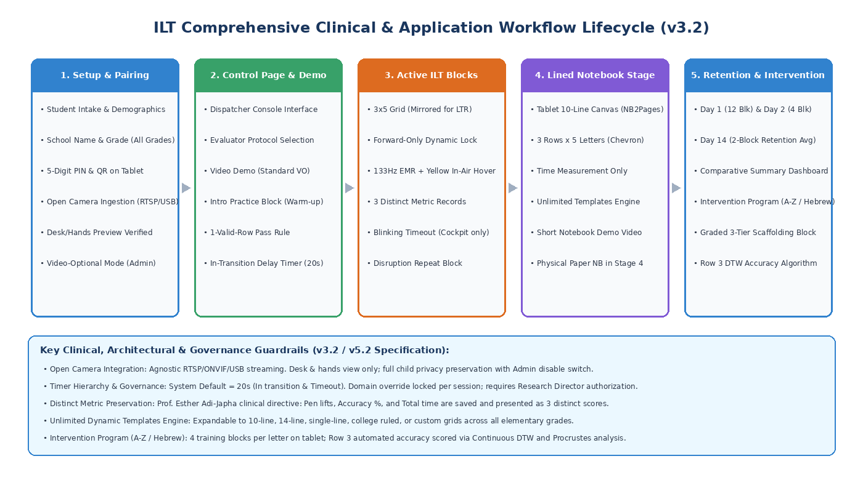
Figure 1: Comprehensive Clinical and System Lifecycle Workflow
3.1 Research Analyst Portal: Kinematic Session Replay & Cohort Analytics
• Analyst Role & Data Access Protocol: The diagnostic analyst is not present during testing sessions, but possesses role-based access to the centralized research database. All data is de-identified (protected Participant ID without PII).
• Individual Kinematic Stroke-by-Stroke Session Replay: Full kinematic playback: timeline scrubber, speed controls (0.25x, 0.5x, 1x, 2x, 4x, frame step), 133Hz canvas stroke replayer with dynamic pressure heatmaps, yellow in-air hover paths, velocity/jerk profiles, and synchronized desk video playback from MinIO (when recorded).
• Multi-Dimensional Cohort Slicing & Analytics Dashboard: Native integration with open-source analytics platforms (Apache Superset, Metabase, DuckDB, Jupyter): multi-dimensional cross-filtering by Domain, School, Grade, Low-SES status, Dominant hand, Language, Session stage, and Timer factoring ratio. Learning curve trajectories, box plots, and one-click Parquet/CSV export.
4. User Interface Specifications & Analyst Wireframes
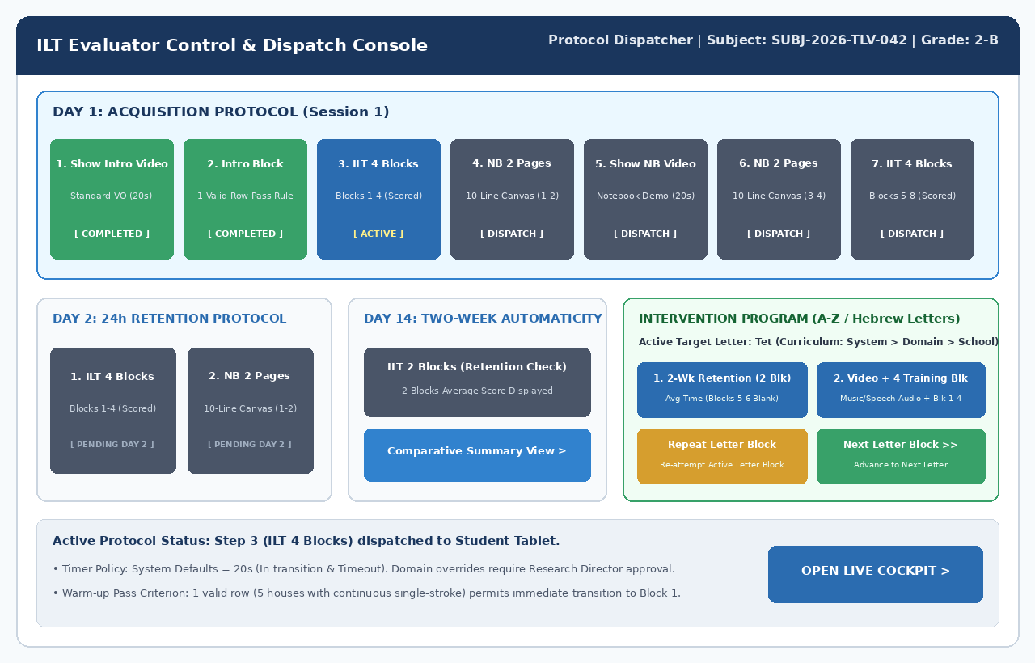
Figure 2: Evaluator Control & Protocol Dispatcher Console
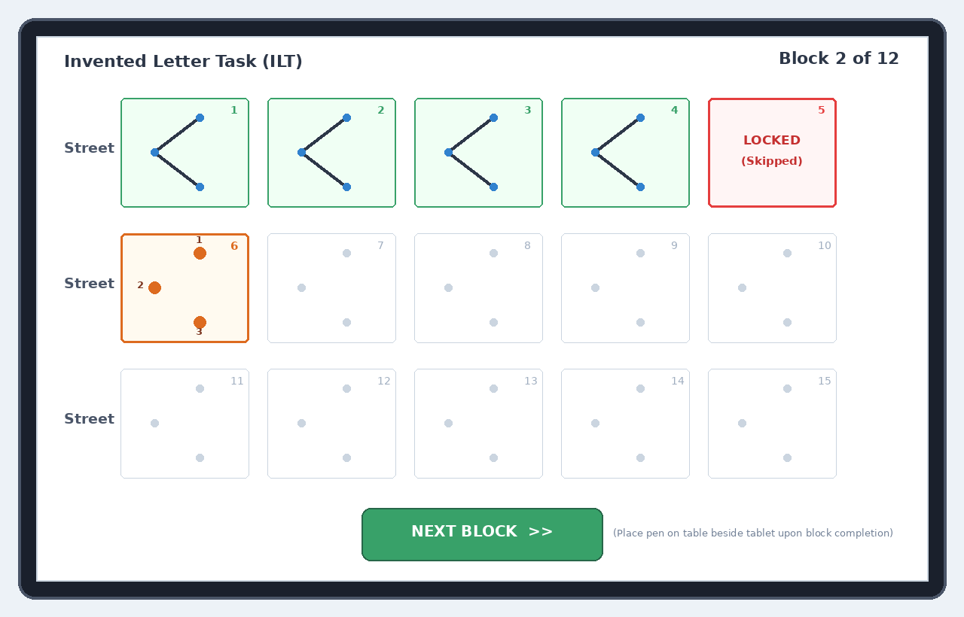
Figure 3: Student Tablet Canvas with Forward-Only Dynamic Lock
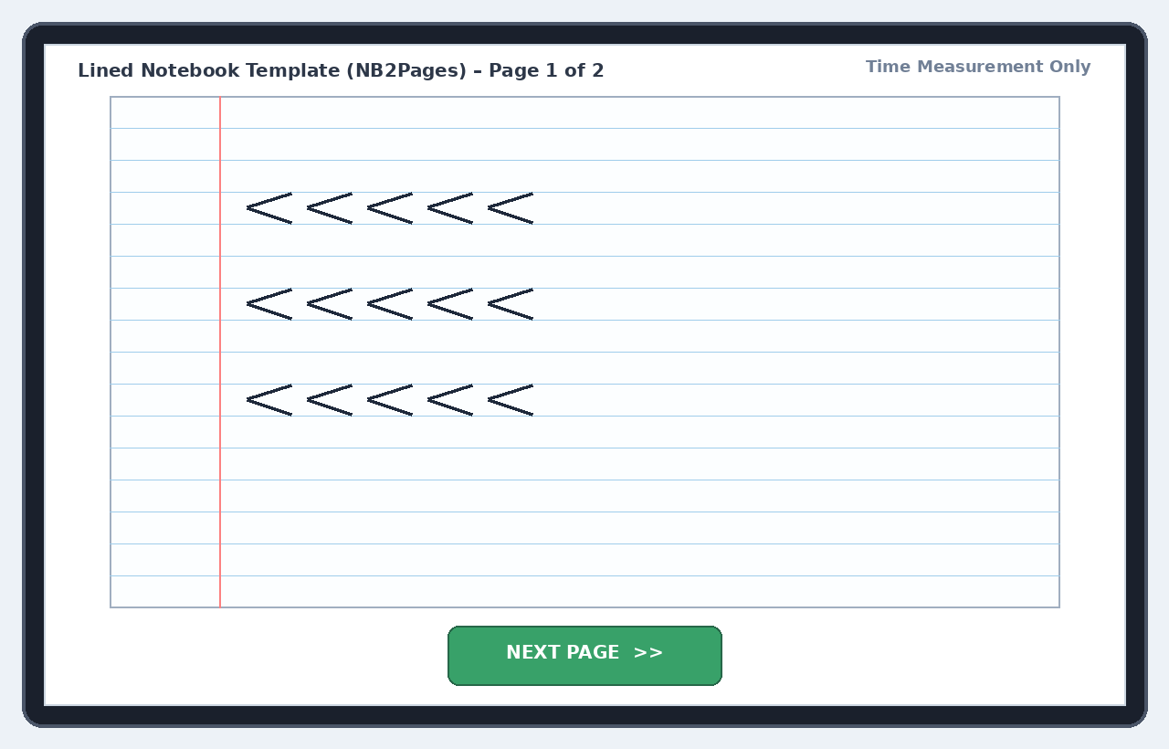
Figure 4: Lined Notebook Canvas Aligned to Original Study Ruling
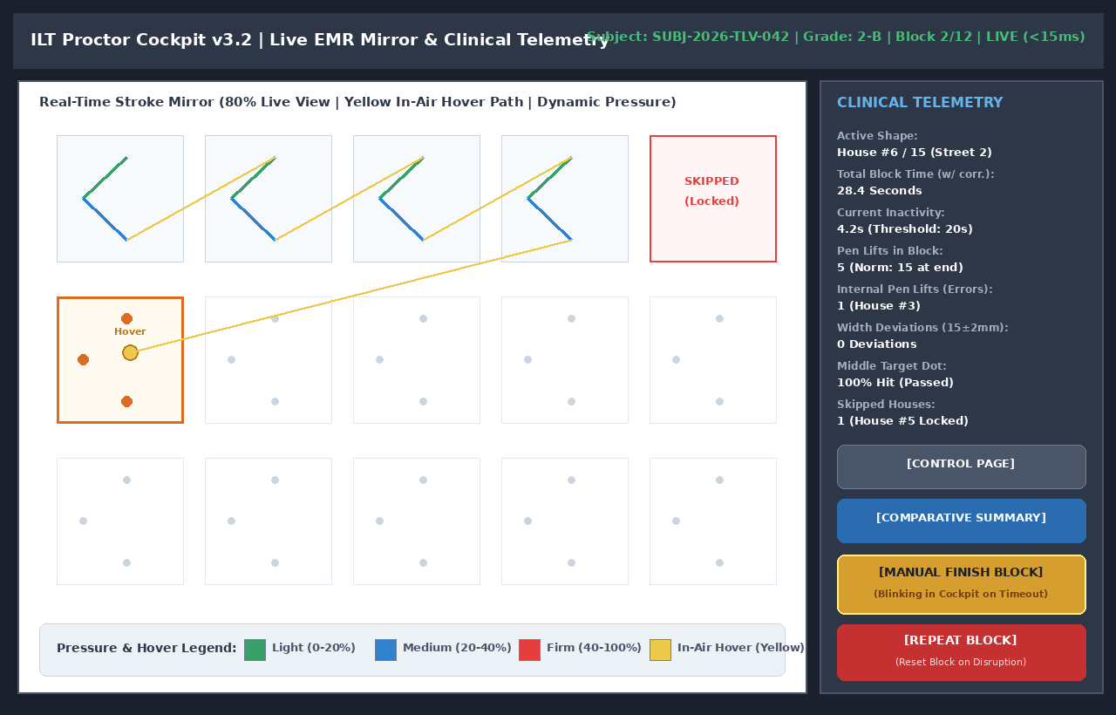
Figure 5: Proctor Cockpit (80% Live Mirror / 20% Telemetry)
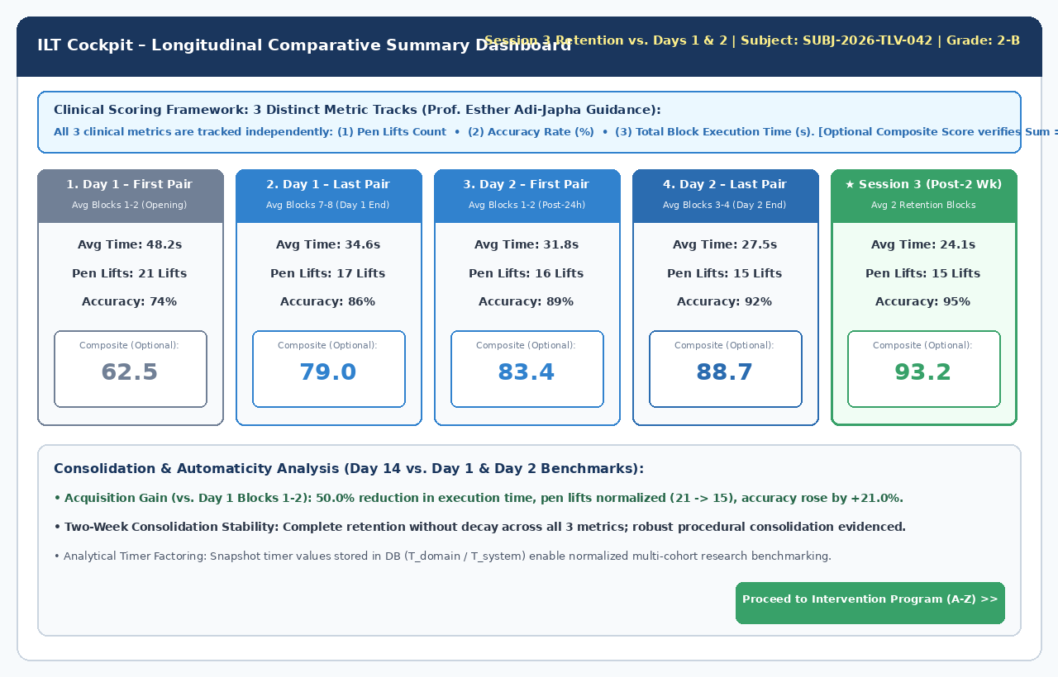
Figure 6: Longitudinal Comparative Summary Dashboard (3 Distinct Metrics)
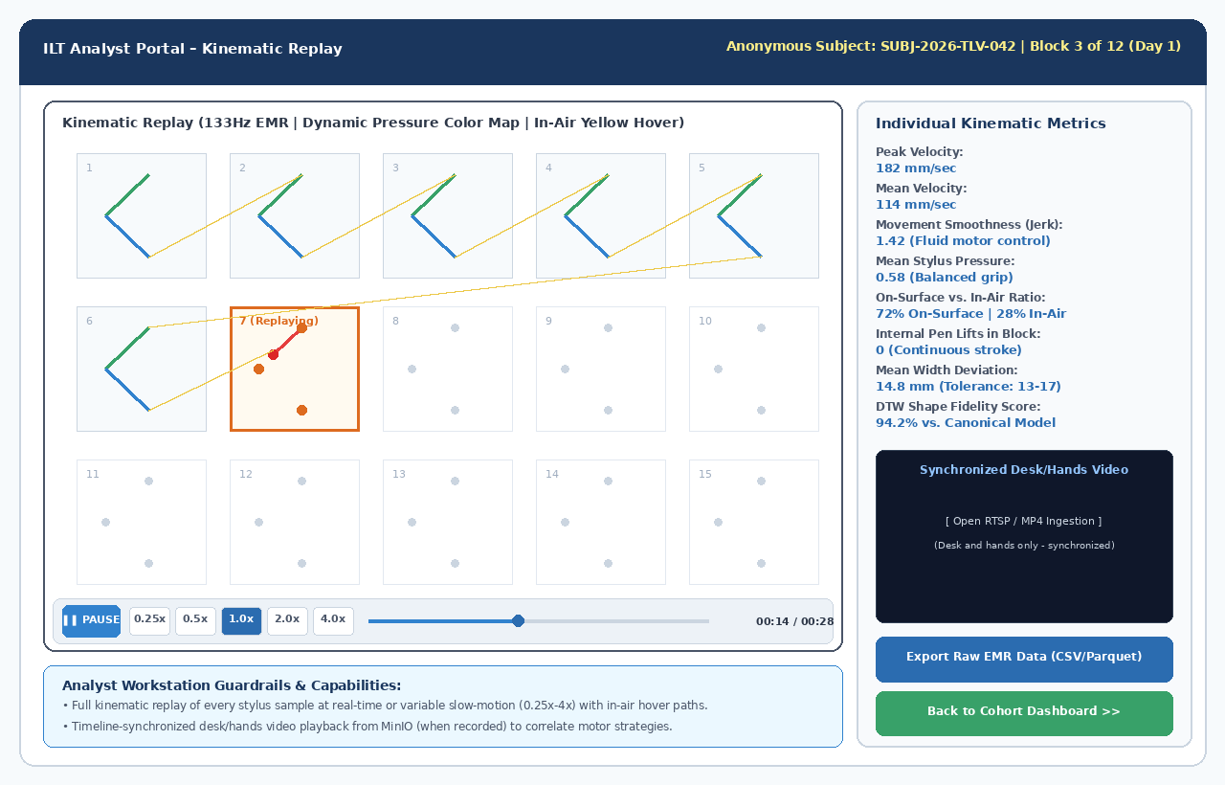
Figure 7: Analyst Portal – Kinematic Session Replay Engine Synced with Desk Video
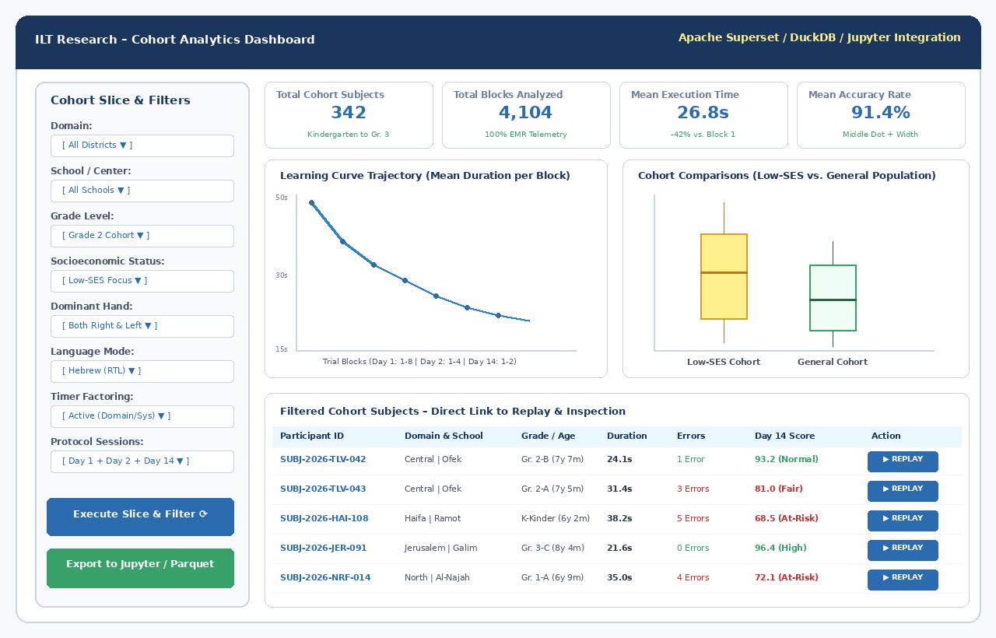
Figure 8: Open-Source Cohort Slice-and-Dice Analytics Dashboard
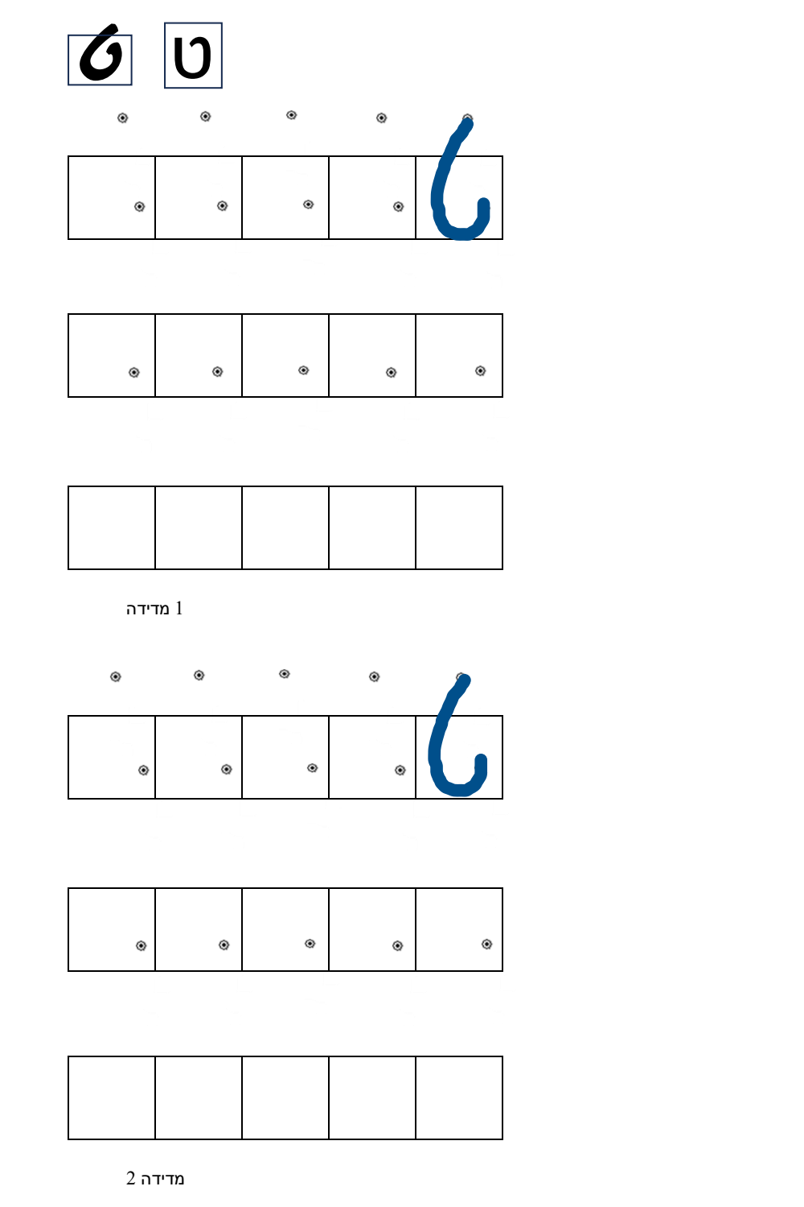
Figure 9: Sample Graded Intervention Training Sheet (Hebrew Letter Tet)
5. Kinematic Error Models & Freehand Row 3 Accuracy
• cDTW & Procrustes Algorithm for Freehand Row 3: Resamples stroke to 100 points, computes shape similarity vs. canonical model, validates topology and baseline drift:
import numpy as np
from scipy.spatial import procrustes
from fastdtw import fastdtw
def evaluate_freehand_row3(stroke_points: np.ndarray, canonical_points: np.ndarray, canonical_aspect_ratio: float) -> dict:
if len(stroke_points) < 10:
return {"composite_accuracy": 0.0, "diagnostic_tag": "EMPTY_OR_NOISE", "valid": False}
diffs = np.diff(stroke_points, axis=0)
dists = np.hypot(diffs[:, 0], diffs[:, 1])
cum_dist = np.insert(np.cumsum(dists), 0, 0)
total_len = cum_dist[-1]
even_spaces = np.linspace(0, total_len, 100)
resampled_stroke = np.column_stack((
np.interp(even_spaces, cum_dist, stroke_points[:, 0]),
np.interp(even_spaces, cum_dist, stroke_points[:, 1])
))
norm_stroke = (resampled_stroke - np.mean(resampled_stroke, axis=0)) / (np.std(resampled_stroke) + 1e-6)
norm_canonical = (canonical_points - np.mean(canonical_points, axis=0)) / (np.std(canonical_points) + 1e-6)
_, _, disparity = procrustes(norm_canonical, norm_stroke)
procrustes_score = max(0.0, min(100.0, 100.0 * (1.0 - disparity * 2.2)))
dtw_dist, _ = fastdtw(norm_stroke, norm_canonical, dist=2)
dtw_score = max(0.0, min(100.0, 100.0 * (1.0 - (dtw_dist / 100.0))))
w, h = np.ptp(stroke_points[:, 0]), np.ptp(stroke_points[:, 1])
actual_ratio = w / (h + 1e-6)
ratio_dev_pct = abs(actual_ratio - canonical_aspect_ratio) / canonical_aspect_ratio * 100.0
composite_acc = 0.55 * procrustes_score + 0.30 * dtw_score + 0.15 * max(0.0, 100.0 - ratio_dev_pct)
tag = "ACCURATE" if composite_acc >= 80.0 else ("PROPORTION_DISTORTION" if ratio_dev_pct > 25.0 else "SHAPE_DEFORMATION")
return {
"composite_accuracy": round(composite_acc, 2),
"procrustes_score": round(procrustes_score, 2),
"dtw_distance": round(dtw_dist, 2),
"aspect_ratio_deviation_pct": round(ratio_dev_pct, 2),
"diagnostic_tag": tag,
"valid": True
}

