ILT Research System - Functional Requirements Specification (FRS v3.4 - English)
Functional Requirements Specification Updated Edition: Wacom DTH-A116 240Hz Hardware Alignment, 6-Digit PIN Standardization, Privacy by Default, and Warm-Up Advancement Rules (Consolidated Edition)
Document Parameter | Specification Value | Document Parameter | Specification Value
Document Identifier: | ILT-FRS-V3.4-EN | Publication Date: | October 22, 2026
Previous Baseline: | FRS v3.3 | Target Digitizer: | Wacom MovinkPad 11 (DTH-A116)
Pairing PIN Length: | 6 Digits (Aligned with Architecture & DDD) | Video Default Policy: | Disabled (DEFAULT FALSE, Consent Required)
Warm-Up Protocol: | 3 Practice Items + 1 Valid Row of 5 Houses | Timer Governance: | 20s Defaults (Director Authorization Only)

1. Core Functional Updates in FRS v3.4 (Consolidated Gap Resolution)
• Pairing PIN Length Standardization (O4, O6): Standardized pairing code length to 6 digits across all documents.
• Child Privacy & Video Recording Default (P1, O6): Video recording is disabled by default (DEFAULT FALSE) requiring explicit parental consent.
• Warm-Up Advancement Rule (C6, O6): Harmonized warm-up rule: 3 practice items for sensory familiarization + 1 valid row of 5 houses completed without timeout.
• Hardware Calibration & Digitizer Rate (D1, D3): Aligned with DTH-A116 240Hz sampling rate and 5.195 px/mm geometric calibration.
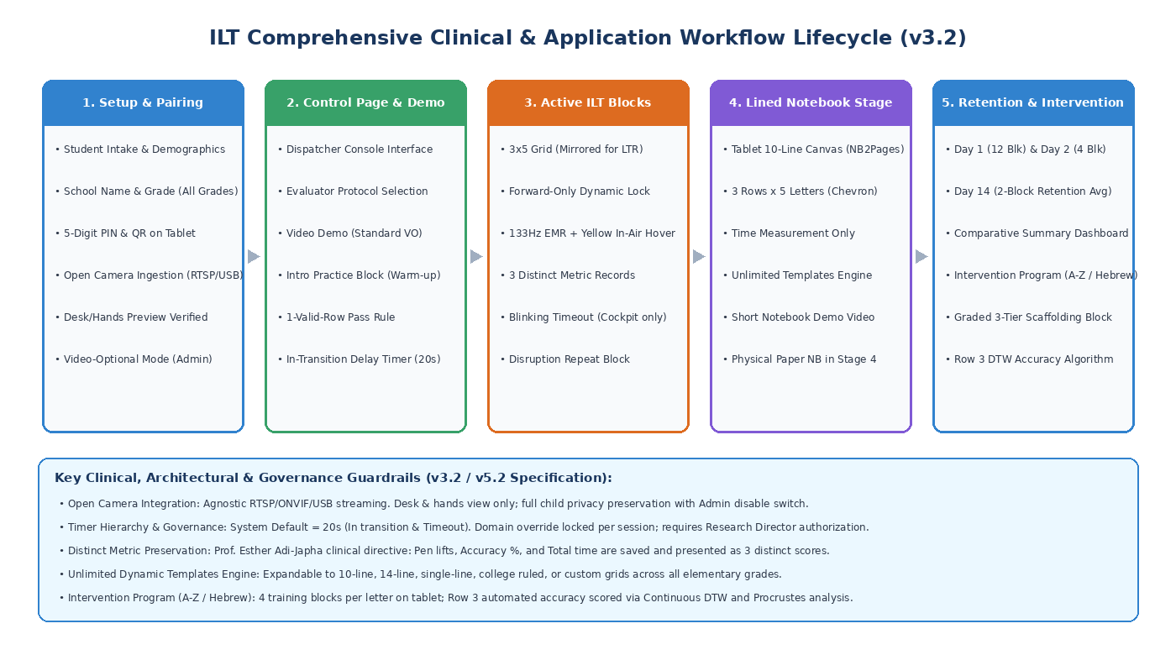
Figure 1: Comprehensive System Lifecycle & Clinical Workflow

