ILT Research System - Detailed Design Specification (DDD v1.5 CODING-READY)
Consolidated Pre-Coding Readiness Blueprint (Gemini & Claude Implementation Edition): Wacom DTH-A116 240Hz Hardware Calibration, Regressions R1-R9 Resolved, Closed Mathematical Metrics Engine, Complete FSM Specifications, and Production DDL
Document Parameter | Specification Value | Document Parameter | Specification Value
Document Identifier: | ILT-DDD-V1.5-CODING-READY-EN | Publication Date: | October 22, 2026 (Consolidated Status)
Functional Baseline: | FRS v3.4 & Architecture Spec v5.5 | Coding Agents: | Gemini & Claude (Parallel Autonomous Implementation)
Target Hardware: | Wacom MovinkPad 11 (DTH-A116, Android 14) | Digitizer Sampling: | 240Hz Design Rate (270Hz Peak, 0.1ms us timing)
Display Calibration: | 5.195 CSS px/mm (230.9 PPI), Millimeters | Readiness Verdict: | 100% Ready for Phase 0 & Phase 1

1. Document Purpose, System Overview & Consolidated Review Gap Closure
This Detailed Design Specification (DDD v1.5) serves as the definitive, contract-first engineering blueprint for the ILT Research Application System. It consolidates all findings from the October 22, 2026 Gap Report, incorporating real hardware measurements from the Wacom DTH-A116, resolving regressions R1–R9, defining mathematical formulations for the 3 clinical metrics (B1), completing the Evaluator Cockpit FSM (B2), standardizing control contracts (B3), restoring per-block results (R1) and desk video records (R2), and enforcing strict child privacy safeguards (P1–P4).
2. DTH-A116 Hardware Calibration, WebRTC Channels & Telemetry Data Flow (D1–D10)
• 240Hz Sampling Rate (D1): Real-device benchmarking verified a 240Hz sampling rate (270Hz peak) on the Wacom MovinkPad 11. Chunks of 50 samples represent ~208ms of continuous handwriting telemetry.
• Microsecond Time Offsets (D2): Timestamps are encoded in integer microseconds (time_offset_us) relative to block onset, matching the 0.1ms hardware digitizer resolution.
• Physical Millimeter Coordinates (D3, R4): All coordinates are stored in physical millimeters (float32) relative to the canvas origin. Display calibration factor for the DTH-A116 is 5.195 CSS px/mm (230.9 PPI).
• Sub-15ms Mirroring via pointerrawupdate (D4, D5): To eliminate the 16.7ms frame buffering delay at 60Hz display refresh, live WebRTC streaming (emr-stream) to the cockpit hooks directly into pointerrawupdate events.
• Complete Palm Rejection (D9): All touch events (pointerType === 'touch') are strictly rejected and discarded while an assessment block is active.
• Pen Lift Event Definition (D6): A pen lift is defined as the time gap between a pointerup event and the subsequent pointerdown event where the duration exceeds the 50ms threshold.
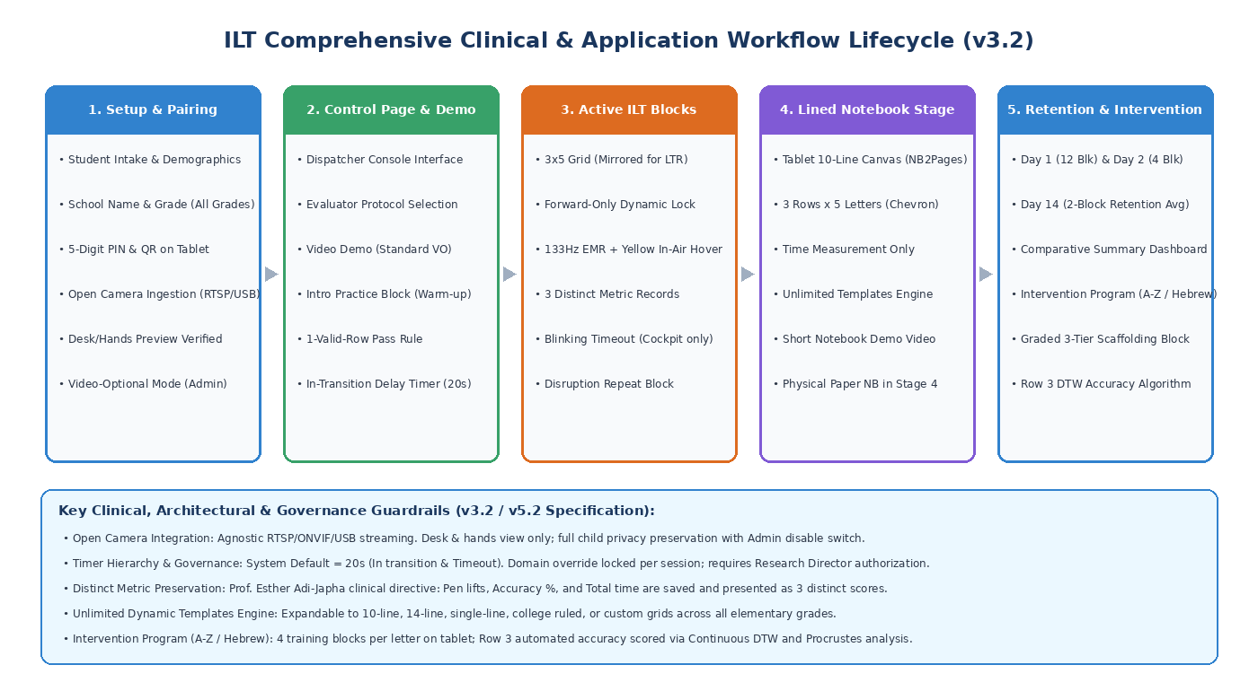
Figure 1: Comprehensive System Architecture, Network Topology & Data Pipeline
3. Monorepo Project Structure & Canonical PenSample Interface
Canonical PenSample Interface (packages/shared-types):
// packages/shared-types/src/telemetry.ts
// Single canonical interface across wire, database, simulator, and replayer (v1.5)
export interface PenSample {
time_offset_us: number; // Microseconds elapsed since block start (int32, D2)
x_mm: number; // Physical X position in millimeters from canvas origin (float32, D3, R4)
y_mm: number; // Physical Y position in millimeters from canvas origin (float32, D3, R4)
pressure: number; // Normalized stylus pressure: 0.000 to 1.000 (observed max calibrated, D8)
tilt_x: number; // Stylus tilt X angle: -90 to +90 degrees (int8)
tilt_y: number; // Stylus tilt Y angle: -90 to +90 degrees (int8)
active_box_id: number; // Active letter box ID: 0 to 14 (uint8, R5)
stroke_flags: number; // Bitmask: 0x01=Contact, 0x02=Hover, 0x04=Eraser, 0x08=TargetHit (uint8, R3)
}
export enum StrokeBitmask {
CONTACT = 0x01, // Tip touching digitizer surface (PenDown)
HOVER = 0x02, // Stylus in proximity (<10mm), tip off surface (Air)
ERASER_MODE = 0x04, // Stylus barrel button / eraser mode
TARGET_HIT = 0x08, // Trajectory intersects 3.5mm target dot radius
}
4. Binary Wire Protocol, Packet Framing & Control Contracts (B3, R3, R5, R7)
• 26-Byte Packet Framing Header (R7): Exact 26-byte header layout: Magic (2B), Type (1B), UUID (16B), Block (1B), Active Box ID (1B, R5), Monotonic Sequence Number (4B), and Sample Count (1B), followed by N 24-byte samples and CRC16 trailer (2B):
// packages/emr-protocol/src/packet.h & codec.ts
// Framed binary packet structure (240Hz design rate, 26-byte header, CRC16)
#pragma pack(push, 1)
// Packet Header (26 bytes exact layout, R7)
typedef struct {
uint16_t magic_header; // 0xAA55 (Framing synchronization)
uint8_t packet_type; // 0x01 = Live Stream, 0x02 = Batch Persistence, 0x03 = Control Event
uint8_t session_uuid[16]; // Session UUID (16 bytes binary)
uint8_t block_index; // Active block index (0 to 14)
uint8_t active_box_id; // Active letter box ID (0 to 14, R5)
uint32_t sequence_number; // Monotonically increasing sequence counter (packet loss detection)
uint8_t sample_count; // Number of samples in payload (e.g. 1 to 50 samples)
} EMRTelemetryPacketHeader; // sizeof == 26 bytes
// 24-Byte Canonical Pen Sample Wire Struct (Little-Endian IEEE 754)
typedef struct {
int32_t time_offset_us; // +0 (4B) Elapsed time in microseconds from block start (D2)
float x_mm; // +4 (4B) Physical X position in mm (IEEE 754 float32, D3, R4)
float y_mm; // +8 (4B) Physical Y position in mm (IEEE 754 float32, D3, R4)
float pressure; // +12 (4B) Normalized pressure [0.0 - 1.0] (D8)
int8_t tilt_x; // +16 (1B) Pitch/Tilt X (-90 to +90 deg)
int8_t tilt_y; // +17 (1B) Roll/Tilt Y (-90 to +90 deg)
uint8_t stroke_flags; // +18 (1B) Bitmask (0x01 Contact, 0x02 Hover, 0x04 Eraser, 0x08 Hit, R3)
uint8_t active_box_id; // +19 (1B) Active box ID (0 to 14, R5)
uint8_t reserved_pad[4]; // +20 (4B) Zero-padding to align to 24-byte boundary
} EMRSampleWire; // sizeof == 24 bytes
// Packet Trailer (2 bytes)
typedef struct {
uint16_t crc16_checksum; // CRC16-CCITT for payload integrity validation
} EMRTelemetryPacketTrailer;
#pragma pack(pop)
• Standardized Message Envelope & JSON Contracts (B3, O4): Standard envelope with message_id, timestamp_utc, and protocol_version:
// WebRTC Signaling & Control-Events Envelope & Contracts (JSON, B3)
// Standard Message Envelope:
{
"message_id": "9b1deb4d-3b7d-4bad-9bdd-2b0d7b3dcb6d",
"timestamp_utc": "2026-10-22T08:30:00.123Z",
"protocol_version": "1.4.1",
"event": "DISPATCH_BLOCK",
"payload": {
"session_id": "c7a8b3d4-1e2f-4a5b-9c8d-7e6f5a4b3c2d",
"block_index": 2,
"template_id": "TEMPLATE_ILT_GRID_3X5",
"transition_delay_sec": 20,
"inactivity_timeout_sec": 20,
"post_block_timeout_sec": 30
}
}
// 1. PIN / Pairing Handshake (6 digits standardized, O4)
{
"event": "PAIRING_REQUEST",
"payload": {
"pairing_pin": "849201",
"tablet_device": "Wacom MovinkPad 11 (DTH-A116)",
"sampling_rate_hz": 240,
"calibration_px_per_mm": 5.195,
"display_ppi": 230.9
}
}
{
"event": "PAIRING_RESPONSE",
"payload": {
"status": "ACCEPTED",
"session_id": "c7a8b3d4-1e2f-4a5b-9c8d-7e6f5a4b3c2d",
"participant_study_id": "STUDY-2026-TLV-042",
"assigned_district_id": 2
}
}
// 2. Pause / Resume / Abort Protocol (B2, B3)
{
"event": "PAUSE_SESSION",
"payload": {
"reason": "STUDENT_FATIGUE", // 'STUDENT_FATIGUE' | 'HARDWARE_CALIBRATION' | 'PROCTOR_INTERVENTION'
"paused_at_offset_us": 14250000
}
}
{
"event": "ABORT_SESSION",
"payload": {
"reason": "STUDENT_REFUSAL",
"save_partial_blocks": true
}
}
// 3. Block & Session Completion (B3)
{
"event": "BLOCK_COMPLETE",
"payload": {
"block_index": 2,
"box15_completed": true,
"total_samples": 4820,
"raw_duration_ms": 20150,
"sha256_batch_hash": "a591a6d40bf420404a011733cfb7b190d62c65bf0bcda32b57b277d9ad9f146e"
}
}
{
"event": "SESSION_COMPLETE",
"payload": {
"session_id": "c7a8b3d4-1e2f-4a5b-9c8d-7e6f5a4b3c2d",
"total_blocks_completed": 3,
"status": "COMPLETED"
}
}
// 4. Research Director Timer Override (O5)
{
"event": "OVERRIDE_TIMER",
"payload": {
"domain_id": 2, // Integer domain ID (O5)
"new_in_transition_sec": 15,
"new_inactivity_sec": 25,
"director_auth_pin_bcrypt": "$2b$12$DIRECTOR_HASH_VERIFIED"
}
}
5. Canvas Engine, Template Geometry & Ruling Specifications
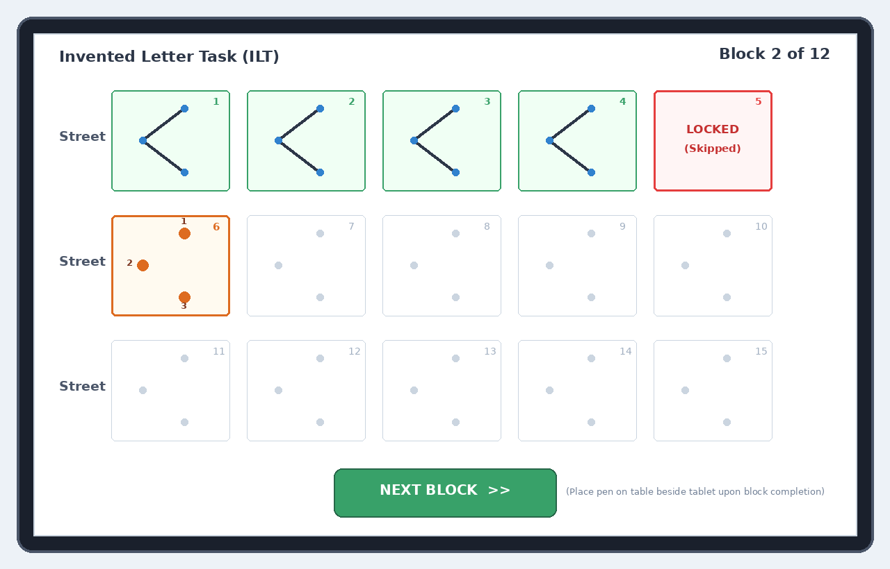
Figure 2: Student Kiosk Canvas with Forward-Only Locking & Continuous Charging
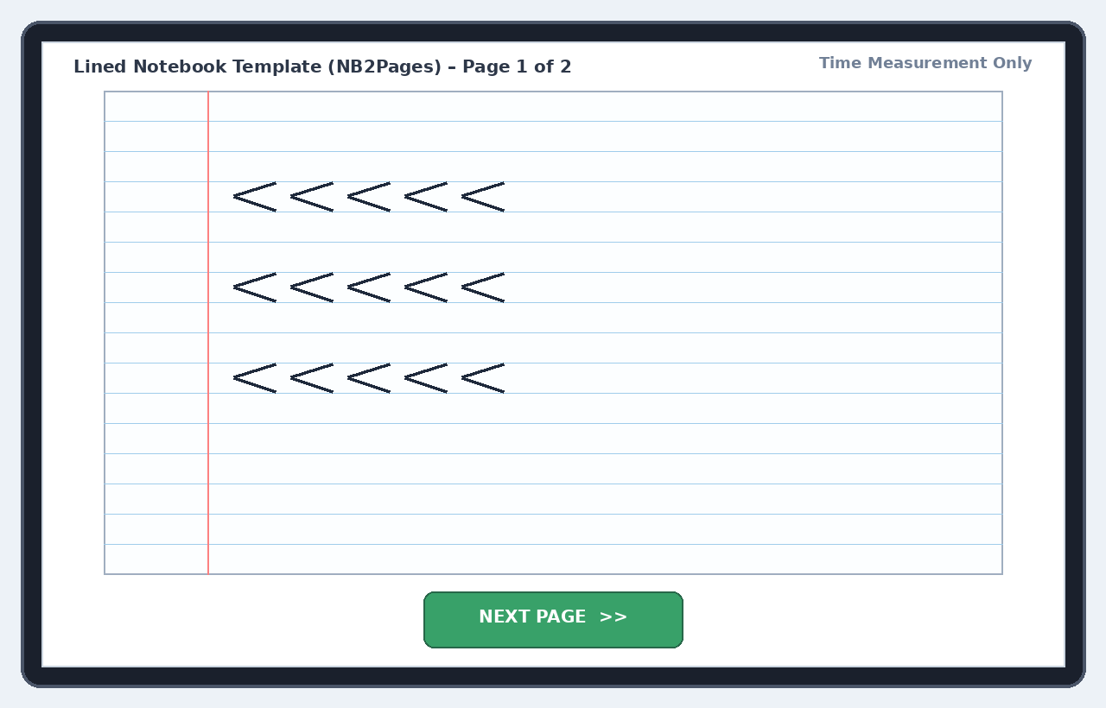
Figure 3: Authentic Elementary 10-Row Lined Notebook Canvas with 60s Page Timer
6. Mathematical Clinical Metrics Engine & Finite State Machines (FSM)
A. Closed Mathematical Formulations for the 3 Clinical Metrics (Prof. Esther Adi-Japha):
• Metric 1: Accuracy % Normalization Formulas: Score_Dots = (dots_hit / 3) * 100. Score_Width = 100 * max(0, 1 - |W - 15.0| / 5.0) where [13.0, 17.0] mm gives 100%. Score_cDTW = 100 * max(0, 1 - D_cDTW / Threshold). Accuracy% = 0.40 * Score_Dots + 0.30 * Score_Width + 0.30 * Score_cDTW.
• Metric 2: Pen Lifts: Separated into Internal Pen Lifts within letters (norm = 0) and Total Block Pen Lifts across 15 boxes (norm = 15). Threshold: pointerup to pointerdown gap >= 50ms.
• Metric 3: Total Execution Time with Skipped Box 15 (C4): Starts at first pointerdown in Box 1 and terminates on final pointerup in Box 15. If skipped, terminates at last contact with box15_completed=false and records skipped_boxes_count.
• Corrections Definition: Motor re-tracing of existing strokes within the same box or corrective internal liftoffs.
B. Evaluator Cockpit Finite State Machine Specification (B2):
Current State | Event / Trigger | Target State | System Action & Behavior
DISCONNECTED | Proctor login & join room | ROOM_JOINED | Generate 6-digit PIN, listen for tablet pairing.
ROOM_JOINED | Tablet paired successfully | TABLET_PAIRED | Display de-identified student details, enter practice mode.
TABLET_PAIRED | Warm-up finished / bypassed | BLOCK_PREVIEW | Preview block, select template, verify readiness.
BLOCK_PREVIEW | Dispatch block command | ACTIVE_MONITORING | Start 20s transition countdown, live mirror (<15ms via rawupdate).
ACTIVE_MONITORING | Proctor clicks Pause | PAUSED | Freeze tablet timer, display rest overlay, log pause reason.
PAUSED | Proctor clicks Resume | ACTIVE_MONITORING | Unfreeze timer, restore active writing canvas.
ACTIVE_MONITORING | Session aborted | ABORTED | Terminate session, save partial data, log abort reason.
ACTIVE_MONITORING | 20s Inactivity (+10s grace) | INACTIVITY_ALERT | Yellow chime on tablet, amber alert on cockpit.
ACTIVE_MONITORING | Block 15 completed / timeout | CRITERIA_SCORING | Lock canvas, compute SHA-256 hash, display criteria form.
CRITERIA_SCORING | Repeat block approved | REPEAT_BLOCK | Create attempt_number=2, preserve attempt 1 for audit.
CRITERIA_SCORING | Final block finished | SESSION_COMPLETE | Compute comparative summary, export data, close session.

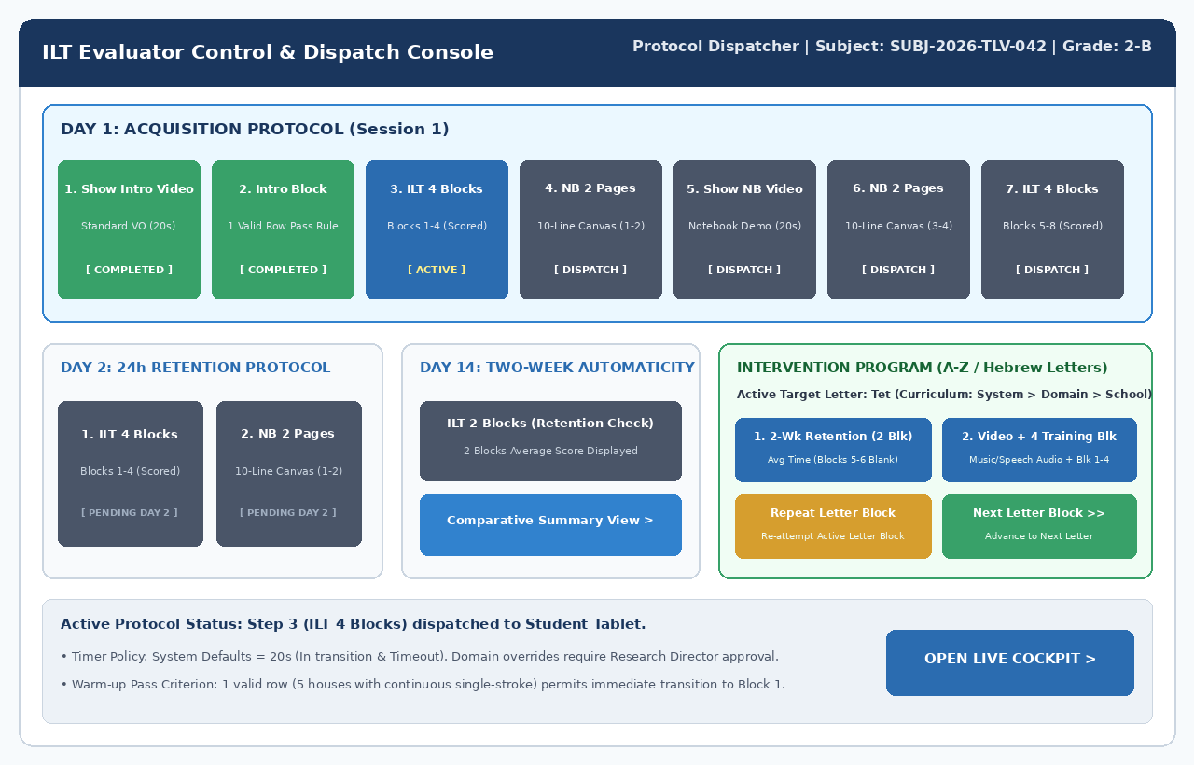
Figure 4: Evaluator Control & Dispatch Page
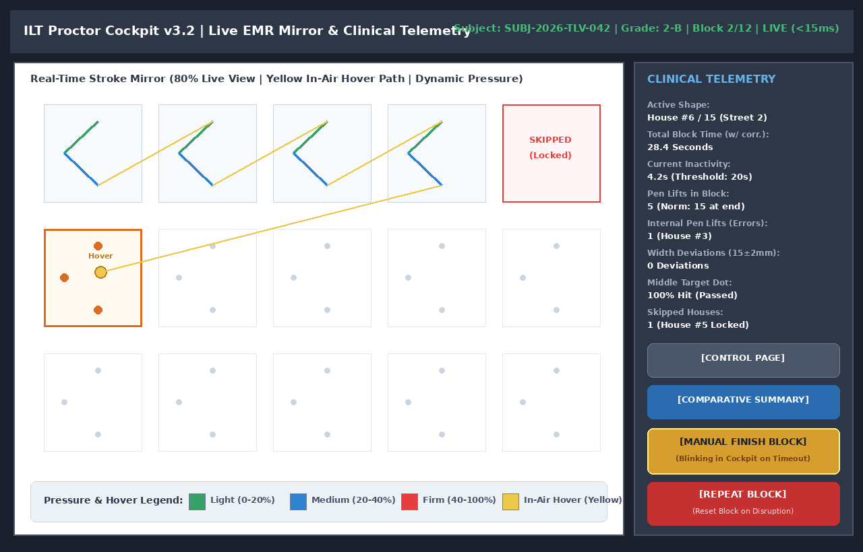
Figure 5: Evaluator Live Cockpit with Independent Metric Breakdown
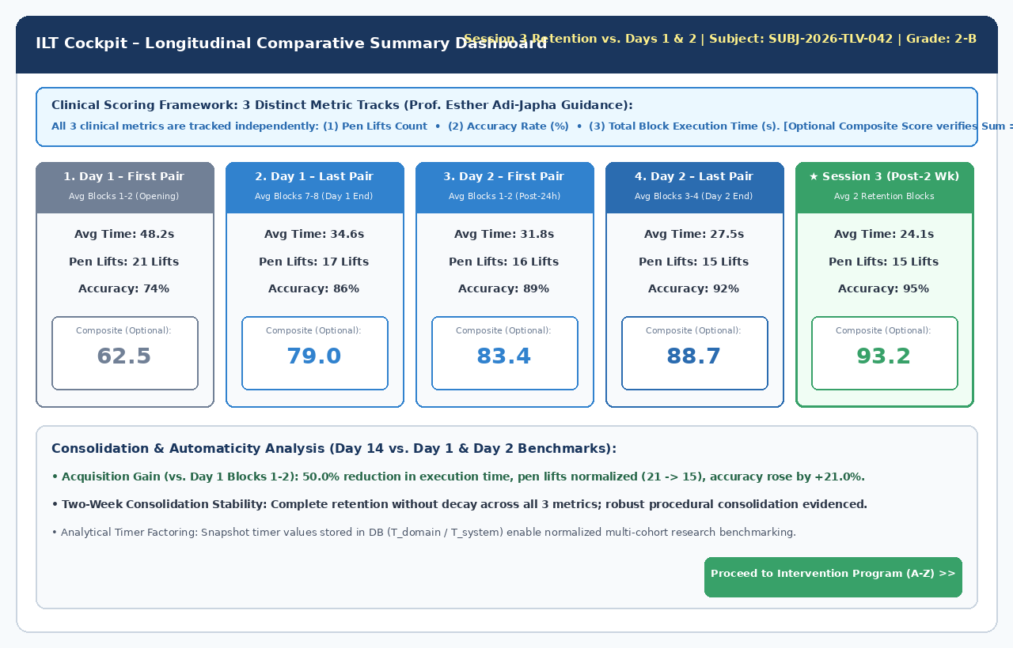
Figure 6: Comparative Summary Dashboard Displaying 3 Independent Metrics
7. Production Database DDL, Seed Scripts & Expanded REST API Contracts (v1.5)
PostgreSQL 16 + TimescaleDB Production DDL:
-- =============================================================================
-- ILT RESEARCH APPLICATION PLATFORM - PRODUCTION DATABASE DDL (v1.5)
-- Engine: PostgreSQL 16 + TimescaleDB Extension (DTH-A116 240Hz Calibrated)
-- =============================================================================
CREATE EXTENSION IF NOT EXISTS "uuid-ossp";
CREATE EXTENSION IF NOT EXISTS timescaledb CASCADE;
-- 1. System Users & RBAC Roles (Dev Accounts Standardized, O1)
CREATE TABLE IF NOT EXISTS users (
id UUID PRIMARY KEY DEFAULT gen_random_uuid(),
email VARCHAR(255) UNIQUE NOT NULL,
password_hash VARCHAR(255) NOT NULL,
full_name VARCHAR(100) NOT NULL,
role VARCHAR(50) NOT NULL CHECK (role IN ('RESEARCHER', 'EVALUATOR', 'ANALYST', 'ADMIN')),
director_auth_pin_hash VARCHAR(255),
is_active BOOLEAN DEFAULT TRUE,
created_at TIMESTAMPTZ DEFAULT NOW(),
updated_at TIMESTAMPTZ DEFAULT NOW()
);
-- 2. Sensitive Participant Identities (Strict Restricted Access, P2)
CREATE TABLE IF NOT EXISTS participant_identities (
id UUID PRIMARY KEY DEFAULT gen_random_uuid(),
national_id_hash VARCHAR(64) UNIQUE NOT NULL,
full_legal_name VARCHAR(100) NOT NULL,
birth_date DATE NOT NULL,
school_name VARCHAR(150) NOT NULL,
created_at TIMESTAMPTZ DEFAULT NOW()
);
-- 3. De-Identified Research Participants Entity (P2, P3, P4)
CREATE TABLE IF NOT EXISTS participants (
id UUID PRIMARY KEY DEFAULT gen_random_uuid(),
identity_ref_id UUID NULL REFERENCES participant_identities(id) ON DELETE SET NULL,
study_id VARCHAR(50) UNIQUE NOT NULL, -- Anonymous study code (e.g. STUDY-2026-TLV-042)
school_id_hash VARCHAR(64) NOT NULL, -- Keyed HMAC-SHA256 (P3)
age_months INT NOT NULL, -- Age recorded at registration (P2)
gender VARCHAR(20) NOT NULL CHECK (gender IN ('MALE', 'FEMALE', 'OTHER')),
grade_level VARCHAR(20) NOT NULL CHECK (grade_level IN ('KINDERGARTEN', 'GRADE_1', 'GRADE_2', 'GRADE_3', 'GRADE_4', 'GRADE_5', 'GRADE_6')),
socioeconomic_status VARCHAR(20) NOT NULL CHECK (socioeconomic_status IN ('LOW_SES', 'MID_SES', 'HIGH_SES')),
dominant_hand VARCHAR(20) NOT NULL CHECK (dominant_hand IN ('RIGHT', 'LEFT', 'AMBIDEXTROUS')),
consent_signed_date DATE NOT NULL,
ethics_approval_ref VARCHAR(100) NOT NULL, -- Helsinki / Ministry of Education approval (P4)
is_active BOOLEAN DEFAULT TRUE,
created_at TIMESTAMPTZ DEFAULT NOW()
);
-- 4. Parental Consent Records (Privacy by Default, P1)
CREATE TABLE IF NOT EXISTS consent_records (
consent_id UUID PRIMARY KEY DEFAULT gen_random_uuid(),
participant_id UUID NOT NULL REFERENCES participants(id) ON DELETE CASCADE,
consent_version VARCHAR(20) NOT NULL,
allows_hand_video_recording BOOLEAN NOT NULL DEFAULT FALSE, -- Privacy by default! (P1)
allows_anonymized_open_science BOOLEAN NOT NULL DEFAULT FALSE, -- Privacy by default! (P1)
signed_at TIMESTAMPTZ DEFAULT NOW()
);
-- 5. Global System Configuration (20s Defaults, 240Hz, Calibration)
CREATE TABLE IF NOT EXISTS system_config (
config_id INT PRIMARY KEY DEFAULT 1,
in_transition_delay_sec INT NOT NULL DEFAULT 20,
inactivity_timeout_sec INT NOT NULL DEFAULT 20,
post_block_timeout_sec INT NOT NULL DEFAULT 30,
notebook_page_timeout_sec INT NOT NULL DEFAULT 60,
digitizer_sampling_rate_hz INT NOT NULL DEFAULT 240, -- D1: 240Hz design rate
display_calibration_px_per_mm DECIMAL(6,3) NOT NULL DEFAULT 5.195, -- D3: 5.195 px/mm
display_ppi DECIMAL(5,1) NOT NULL DEFAULT 230.9,
video_recording_enabled BOOLEAN NOT NULL DEFAULT FALSE,
require_research_director_approval BOOLEAN NOT NULL DEFAULT TRUE,
score_weight_pen_lifts_pct DECIMAL(5,2) NOT NULL DEFAULT 35.00,
score_weight_accuracy_pct DECIMAL(5,2) NOT NULL DEFAULT 40.00,
score_weight_time_pct DECIMAL(5,2) NOT NULL DEFAULT 25.00,
updated_at TIMESTAMPTZ DEFAULT NOW(),
CONSTRAINT chk_score_weights_sum CHECK (
score_weight_pen_lifts_pct + score_weight_accuracy_pct + score_weight_time_pct = 100.00
)
);
-- 6. Domains (Districts)
CREATE TABLE IF NOT EXISTS domains (
domain_id SERIAL PRIMARY KEY,
domain_name VARCHAR(100) UNIQUE NOT NULL,
override_in_transition_sec INT NULL,
override_inactivity_timeout_sec INT NULL,
created_at TIMESTAMPTZ DEFAULT NOW()
);
-- 7. Canonical Letter Models (Real ILT Chevron Shape, B7)
CREATE TABLE IF NOT EXISTS letter_canonical_models (
model_id VARCHAR(50) PRIMARY KEY,
letter_symbol VARCHAR(20) NOT NULL,
script_type VARCHAR(30) NOT NULL CHECK (script_type IN ('ILT_INVENTED', 'HEBREW_STANDARD', 'ARABIC_STANDARD', 'ENGLISH_STANDARD')),
target_dots_json JSONB NOT NULL, -- 3 target dots (entry, apex, terminus)
nominal_width_mm DECIMAL(4,1) NOT NULL DEFAULT 15.0,
width_tolerance_mm DECIMAL(4,1) NOT NULL DEFAULT 2.0,
canonical_polyline JSONB NOT NULL, -- Array of [x_mm, y_mm] coordinates
created_at TIMESTAMPTZ DEFAULT NOW()
);
-- 8. Assessment Templates
CREATE TABLE IF NOT EXISTS dynamic_templates (
template_id VARCHAR(50) PRIMARY KEY,
template_name VARCHAR(150) NOT NULL,
template_category VARCHAR(50) NOT NULL,
ruling_type VARCHAR(50) NOT NULL,
canvas_schema JSONB NOT NULL,
rules_schema JSONB NOT NULL,
created_at TIMESTAMPTZ DEFAULT NOW()
);
-- 9. Diagnostic Sessions (Supporting Day 1/2/14 and Intervention Stages 1-4, R6)
CREATE TABLE IF NOT EXISTS diagnostic_sessions (
id UUID PRIMARY KEY DEFAULT gen_random_uuid(),
session_code VARCHAR(20) UNIQUE NOT NULL,
participant_id UUID NOT NULL REFERENCES participants(id) ON DELETE RESTRICT,
evaluator_id UUID NOT NULL REFERENCES users(id) ON DELETE RESTRICT,
domain_id INT NOT NULL REFERENCES domains(domain_id),
session_type VARCHAR(30) NOT NULL CHECK (session_type IN (
'DAY_1_BASELINE', 'DAY_2_RETENTION', 'DAY_14_TRANSFER',
'INTERVENTION_STAGE_1', 'INTERVENTION_STAGE_2', 'INTERVENTION_STAGE_3', 'INTERVENTION_STAGE_4'
)),
status VARCHAR(50) NOT NULL DEFAULT 'INITIALIZED' CHECK (status IN ('INITIALIZED', 'PAIRED', 'IN_PROGRESS', 'PAUSED', 'COMPLETED', 'ABORTED')),
active_in_transition_sec INT NOT NULL DEFAULT 20,
active_inactivity_sec INT NOT NULL DEFAULT 20,
is_timer_overridden BOOLEAN NOT NULL DEFAULT FALSE,
sync_status VARCHAR(50) NOT NULL DEFAULT 'LOCAL_BUFFER',
started_at TIMESTAMPTZ DEFAULT NOW(),
completed_at TIMESTAMPTZ NULL
);
-- 10. Per-Block Results Table (Restored, R1)
CREATE TABLE IF NOT EXISTS session_blocks (
id UUID PRIMARY KEY DEFAULT gen_random_uuid(),
session_id UUID NOT NULL REFERENCES diagnostic_sessions(id) ON DELETE CASCADE,
block_index SMALLINT NOT NULL,
attempt_number SMALLINT NOT NULL DEFAULT 1,
template_id VARCHAR(50) NOT NULL REFERENCES dynamic_templates(template_id),
box15_completed BOOLEAN NOT NULL DEFAULT TRUE,
skipped_boxes_count SMALLINT NOT NULL DEFAULT 0,
raw_duration_ms INT NOT NULL DEFAULT 0,
active_writing_time_ms INT NOT NULL DEFAULT 0,
air_time_ms INT NOT NULL DEFAULT 0,
total_pen_lifts_in_block INT NOT NULL DEFAULT 0,
internal_pen_lifts_count INT NOT NULL DEFAULT 0,
accuracy_percentage DECIMAL(5,2) NOT NULL DEFAULT 0.00,
dots_hit_percentage DECIMAL(5,2) NOT NULL DEFAULT 0.00,
width_compliance_percentage DECIMAL(5,2) NOT NULL DEFAULT 0.00,
dtw_trajectory_score DECIMAL(5,2) NOT NULL DEFAULT 0.00,
is_valid BOOLEAN NOT NULL DEFAULT TRUE,
is_repeated BOOLEAN NOT NULL DEFAULT FALSE,
sha256_batch_hash VARCHAR(64) NULL,
created_at TIMESTAMPTZ DEFAULT NOW(),
CONSTRAINT unq_session_block_attempt UNIQUE (session_id, block_index, attempt_number)
);
-- 11. Desk Video Records Table (Restored, R2)
CREATE TABLE IF NOT EXISTS session_video_records (
id UUID PRIMARY KEY DEFAULT gen_random_uuid(),
session_id UUID NOT NULL REFERENCES diagnostic_sessions(id) ON DELETE CASCADE,
video_uri VARCHAR(512) NOT NULL,
camera_angle VARCHAR(50) NOT NULL DEFAULT 'OVERHEAD_HANDS',
sync_offset_ms INT NOT NULL DEFAULT 0,
sha256_hash VARCHAR(64) NOT NULL,
created_at TIMESTAMPTZ DEFAULT NOW()
);
-- 12. Pen Telemetry Hypertable (REAL/float4, Microseconds, Active Box, R4, R5, D2)
CREATE TABLE IF NOT EXISTS pen_telemetry_chunks (
session_id UUID NOT NULL REFERENCES diagnostic_sessions(id) ON DELETE CASCADE,
block_index SMALLINT NOT NULL,
active_box_id SMALLINT NOT NULL DEFAULT 0, -- R5: active box id
time_offset_us BIGINT NOT NULL, -- D2: microseconds
x_mm REAL NOT NULL, -- D3, R4: millimeters (float4)
y_mm REAL NOT NULL, -- D3, R4: millimeters (float4)
pressure REAL NOT NULL, -- D8: normalized pressure [0.0 - 1.0]
tilt_x SMALLINT NOT NULL DEFAULT 0,
tilt_y SMALLINT NOT NULL DEFAULT 0,
stroke_flags SMALLINT NOT NULL DEFAULT 0, -- R3: bitmask
recorded_at TIMESTAMPTZ NOT NULL DEFAULT NOW()
);
SELECT create_hypertable('pen_telemetry_chunks', 'recorded_at', if_not_exists => TRUE, migrate_data => TRUE);
CREATE INDEX IF NOT EXISTS idx_telemetry_session_block_time
ON pen_telemetry_chunks (session_id, block_index, time_offset_us);
-- 13. De-Identified Analyst Research View (Zero PII, Full Kinematics & Demographics)
CREATE OR REPLACE VIEW v_analyst_cohort_slices AS
SELECT
s.id AS session_id,
p.study_id AS deidentified_study_code,
p.school_id_hash,
p.grade_level,
p.socioeconomic_status,
p.dominant_hand,
p.age_months,
p.gender,
s.session_type,
b.block_index,
b.attempt_number,
b.raw_duration_ms,
b.active_writing_time_ms,
b.air_time_ms,
b.total_pen_lifts_in_block,
b.internal_pen_lifts_count,
b.accuracy_percentage,
b.dots_hit_percentage,
b.width_compliance_percentage,
b.dtw_trajectory_score,
b.is_valid,
s.started_at,
s.completed_at
FROM diagnostic_sessions s
JOIN participants p ON s.participant_id = p.id
JOIN session_blocks b ON b.session_id = s.id
WHERE s.status = 'COMPLETED';
Initial Seed Data Script:
-- =============================================================================
-- SEED DATA & INITIAL CONFIGURATION (PostgreSQL 16) - v1.5 CONSOLIDATED
-- =============================================================================
-- 1. Standard Dev Users (Dev Accounts Only, O1)
INSERT INTO users (id, email, password_hash, full_name, role, director_auth_pin_hash)
VALUES
('11111111-1111-1111-1111-111111111111', 'dev-admin@ilt.local', '$2b$12$e8YyVvG1j0Y0K1Y2Y3Y4YeJ5K6L7M8N9O0P1Q2R3S4T5U6V7W8X9Y', 'Dev Admin', 'ADMIN', NULL),
('22222222-2222-2222-2222-222222222222', 'dev-researcher@ilt.local', '$2b$12$e8YyVvG1j0Y0K1Y2Y3Y4YeJ5K6L7M8N9O0P1Q2R3S4T5U6V7W8X9Y', 'Dev Lead Researcher', 'RESEARCHER', '$2b$12$DIRECTOR_PIN_HASH_9942'),
('33333333-3333-3333-3333-333333333333', 'dev-evaluator@ilt.local', '$2b$12$e8YyVvG1j0Y0K1Y2Y3Y4YeJ5K6L7M8N9O0P1Q2R3S4T5U6V7W8X9Y', 'Dev Proctor', 'EVALUATOR', NULL)
ON CONFLICT (email) DO NOTHING;
-- 2. System Default Configuration (240Hz, 5.195 px/mm calibration, Privacy Video = FALSE)
INSERT INTO system_config (
config_id, in_transition_delay_sec, inactivity_timeout_sec, post_block_timeout_sec,
notebook_page_timeout_sec, digitizer_sampling_rate_hz, display_calibration_px_per_mm, display_ppi,
video_recording_enabled, require_research_director_approval,
score_weight_pen_lifts_pct, score_weight_accuracy_pct, score_weight_time_pct
) VALUES (
1, 20, 20, 30, 60, 240, 5.195, 230.9, FALSE, TRUE, 35.00, 40.00, 25.00
) ON CONFLICT (config_id) DO NOTHING;
-- 3. Districts (Domains)
INSERT INTO domains (domain_name, override_in_transition_sec, override_inactivity_timeout_sec)
VALUES
('Central District (מחוז מרכז)', NULL, NULL),
('Tel Aviv District (מחוז תל אביב)', NULL, NULL),
('Haifa District (מחוז חיפה)', NULL, NULL),
('Jerusalem District (מחוז ירושלים)', NULL, NULL),
('Northern District (מחוז צפון)', NULL, NULL),
('Southern District (מחוז דרום)', NULL, NULL)
ON CONFLICT (domain_name) DO NOTHING;
-- 4. Canonical Letter Models (Real ILT Chevron Shape "<" with Upper Loop, B7)
INSERT INTO letter_canonical_models (
model_id, letter_symbol, script_type, target_dots_json, nominal_width_mm, width_tolerance_mm, canonical_polyline
) VALUES
(
'MODEL_ILT_CHEVRON_LOOP',
'ILT-1',
'ILT_INVENTED',
'[{"dot_id": 1, "name": "Entry", "x_mm": 12.0, "y_mm": 18.0, "radius_mm": 3.5}, {"dot_id": 2, "name": "Apex", "x_mm": 48.0, "y_mm": 68.0, "radius_mm": 3.5}, {"dot_id": 3, "name": "Terminus", "x_mm": 88.0, "y_mm": 82.0, "radius_mm": 3.5}]',
15.0,
2.0,
'[[12.0, 18.0], [22.0, 32.0], [35.0, 52.0], [48.0, 68.0], [62.0, 75.0], [75.0, 80.0], [88.0, 82.0]]'
),
(
'MODEL_HEBREW_TET',
'ט',
'HEBREW_STANDARD',
'[{"dot_id": 1, "name": "Start", "x_mm": 15.0, "y_mm": 15.0, "radius_mm": 3.5}, {"dot_id": 2, "name": "Base", "x_mm": 15.0, "y_mm": 85.0, "radius_mm": 3.5}, {"dot_id": 3, "name": "Inward", "x_mm": 60.0, "y_mm": 40.0, "radius_mm": 3.5}]',
16.0,
2.5,
'[[15.0, 15.0], [15.0, 50.0], [15.0, 85.0], [50.0, 85.0], [85.0, 85.0], [85.0, 40.0], [60.0, 40.0]]'
)
ON CONFLICT (model_id) DO NOTHING;
-- 5. Standard Assessment Templates (Fully Aligned Schemas)
INSERT INTO dynamic_templates (
template_id, template_name, template_category, ruling_type, canvas_schema, rules_schema
) VALUES
(
'TEMPLATE_ILT_GRID_3X5',
'Standard ILT 3x5 Grid (רשת 15 בתים לאות מומצאת)',
'GRID_ILT',
'GRID_3X5',
'{"rows": 3, "cols": 5, "box_w_mm": 32.7, "box_h_mm": 27.9, "dot_hit_radius_mm": 3.5, "num_lines": 3, "line_spacing_mm": 11.5, "margin_side": "RIGHT", "active_row_indices": [0, 1, 2]}',
'{"max_internal_pen_lifts": 0, "width_nominal_mm": 15.0, "width_tolerance_mm": 2.0, "forward_only_locking": true, "letters_per_row": 5}'
),
(
'TEMPLATE_NOTEBOOK_10_ROWS',
'Authentic 10-Row Elementary Notebook (מחברת 10 שורות לכיתות יסודי)',
'NOTEBOOK_LINED',
'NOTEBOOK_10_ROWS',
'{"num_lines": 10, "line_spacing_mm": 6.7, "margin_side": "RIGHT", "active_row_indices": [3, 5, 7]}',
'{"max_internal_pen_lifts": 0, "time_measurement_only": true, "page_timeout_sec": 60}'
),
(
'TEMPLATE_INTERVENTION_LETTER_TET',
'Intervention Scaffolding Template (האות העברית ט'')',
'INTERVENTION_LETTER',
'GRID_3X5',
'{"num_lines": 3, "line_spacing_mm": 11.5, "margin_side": "RIGHT", "row1": "MODEL_PLUS_TARGET_DOTS", "row2": "START_DOT_ONLY", "row3": "BLANK_FREEHAND"}',
'{"max_internal_pen_lifts": 0, "dtw_accuracy_evaluation_row3": true, "nominal_aspect_ratio": 0.85}'
)
ON CONFLICT (template_id) DO NOTHING;
Complete REST API Endpoints & RBAC Authorization Matrix (12 Endpoints, B6):
Method | Endpoint Path | Authorized Role | Description & Contracts
POST | /api/v1/auth/login | Public | User authentication returning JWT and refresh tokens.
GET/POST | /api/v1/participants | Evaluator / Researcher | Register and list de-identified participants.
GET/POST | /api/v1/sessions | Evaluator / Researcher | Create diagnostic sessions and list active rooms.
POST | /api/v1/sessions/pair | Evaluator / Tablet | Pair tablet kiosk to evaluator cockpit via 6-digit PIN.
POST | /api/v1/sessions/:id/override-timer | Researcher Only | Timer override requiring bcrypt PIN validation.
POST | /api/v1/sessions/:id/blocks/:idx/telemetry | Tablet | Batch telemetry upload with SHA-256 integrity verification.
GET | /api/v1/sessions/:id/results | Evaluator / Analyst | Fetch block results, attempt records, and 3 clinical metrics.
GET | /api/v1/telemetry/replay/:sessionId | Analyst / Researcher | Stream raw kinematic telemetry chunks for replay engine.
POST | /api/v1/consent | Evaluator / Admin | Log parental consent and ethics approval records.
GET | /api/v1/templates | Evaluator / Researcher | Fetch assessment templates and dynamic canvas schemas.
GET | /api/v1/domains | All Authenticated | List districts and active timer override policies.
POST | /api/v1/paper-cohort/scores | Evaluator | Manual score entry interface for physical paper cohort.

8. Kinematic Session Replayer & DuckDB Cohort Export (Analyst Subsystem)
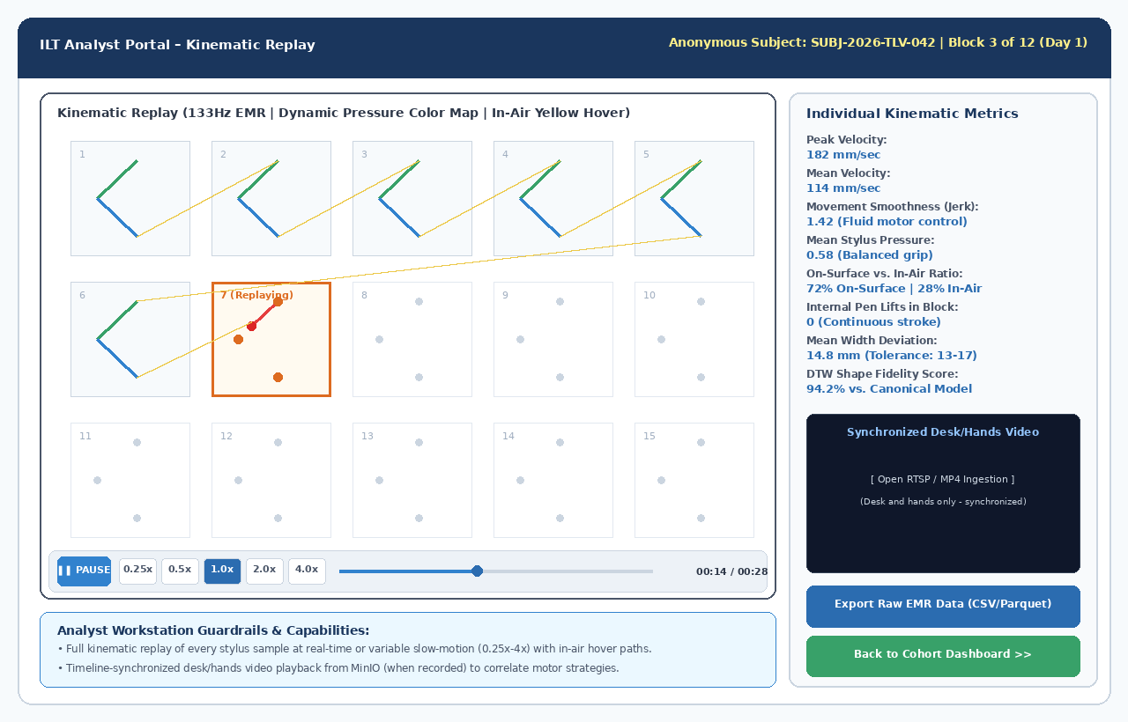
Figure 7: Analyst Portal - Kinematic Replay Engine Synchronized with Desk Video
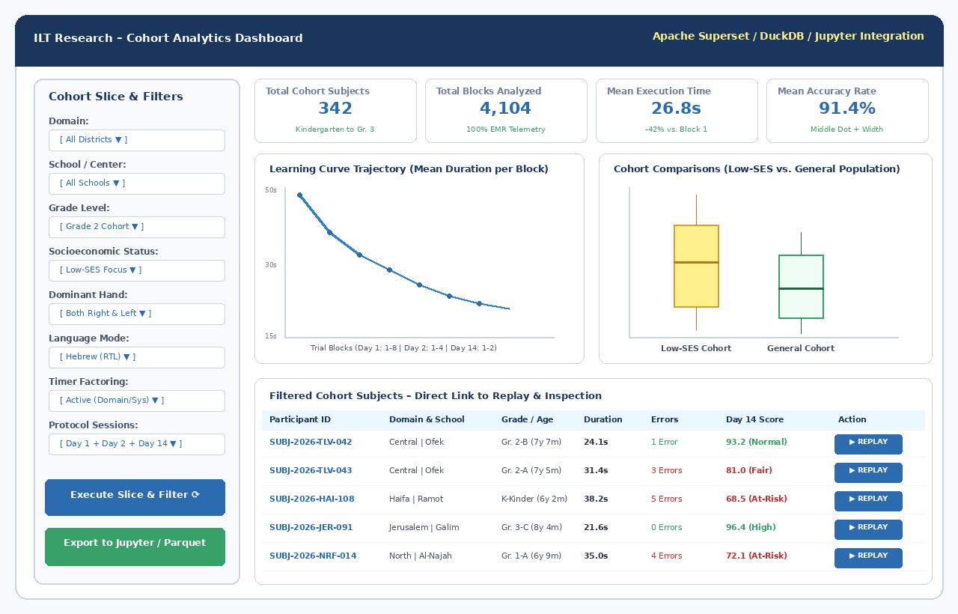
Figure 8: Cohort Analytics Dashboard with Multi-Variable Slicing
9. Intervention Scaffolding & Automated DTW Scoring
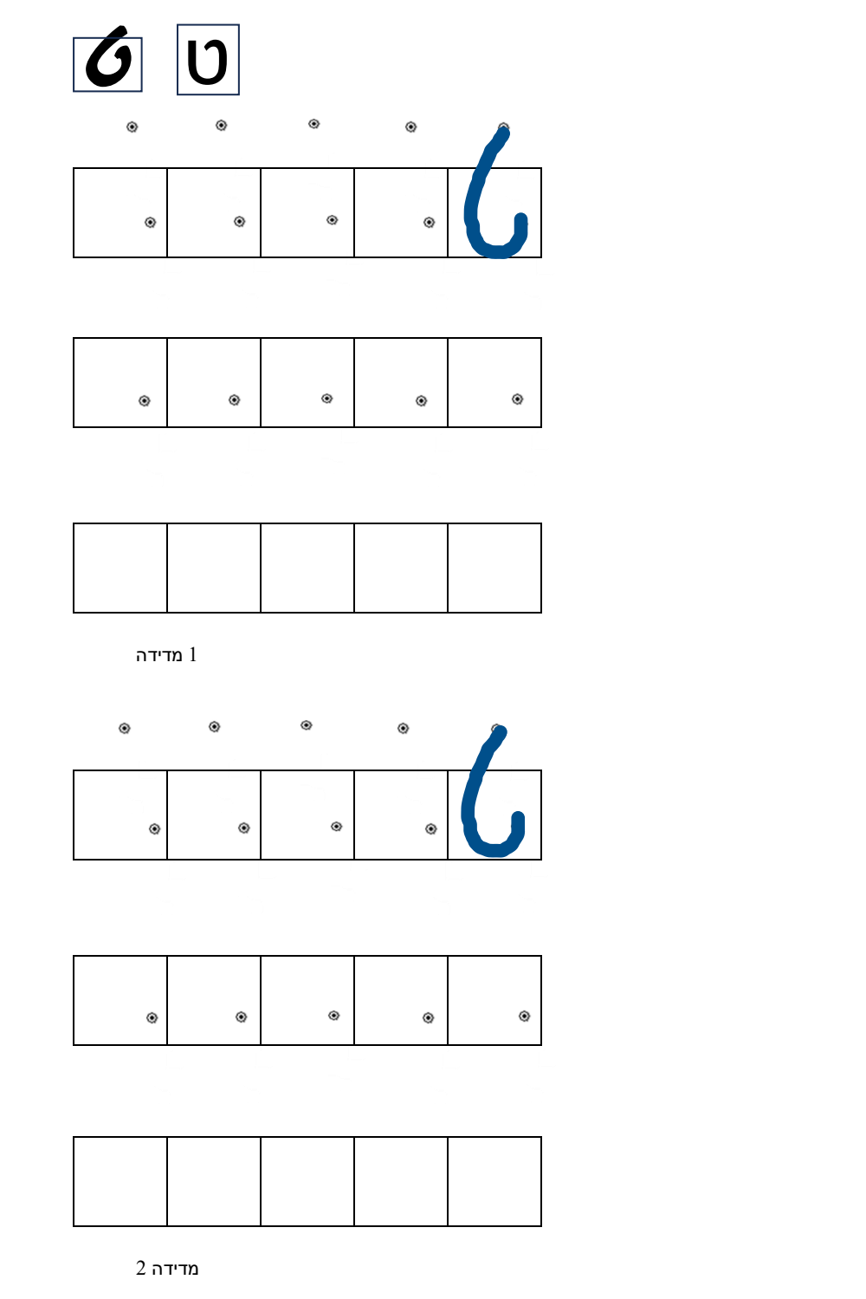
Figure 9: Intervention Training Worksheet Sample (Hebrew Letter Tet)
10. Developer Implementation Appendix, Docker Compose & Mock Stylus (D4, O3)
• PointerEvents-Based Mock EMR Stylus Simulator (D4, O3): Native browser pointerrawupdate and pointermove dispatcher with hover and calibrated pressure:
// apps/tablet-kiosk/src/drivers/MockEMRStylusSimulator.ts
// Native PointerEvent Generator with pointerrawupdate, hover, tilt & coalesced events (D4, D5, D10, O3)
export class MockEMRStylusSimulator {
private targetElement: HTMLElement;
private sessionStartTimeUs: number = 0;
private isHovering: boolean = false;
constructor(targetElement: HTMLElement) {
this.targetElement = targetElement;
}
public startSession() {
this.sessionStartTimeUs = Math.round(performance.now() * 1000);
}
public dispatchSyntheticHover(x_mm: number, y_mm: number) {
this.isHovering = true;
const timeOffsetUs = Math.round(performance.now() * 1000 - this.sessionStartTimeUs);
// Convert mm to CSS px using 5.195 px/mm (D3)
const clientX = x_mm * 5.195;
const clientY = y_mm * 5.195;
const event = new PointerEvent('pointerrawupdate', {
clientX,
clientY,
pressure: 0.0,
pointerType: 'pen',
pointerId: 1,
bubbles: true,
cancelable: true,
buttons: 0
});
Object.defineProperty(event, 'hardwareTimeOffsetUs', { value: timeOffsetUs });
Object.defineProperty(event, 'tiltX', { value: 0 });
Object.defineProperty(event, 'tiltY', { value: 0 });
this.targetElement.dispatchEvent(event);
}
public dispatchSyntheticContact(x_mm: number, y_mm: number, pressure: number, type: 'pointerdown' | 'pointermove' | 'pointerup') {
const timeOffsetUs = Math.round(performance.now() * 1000 - this.sessionStartTimeUs);
const clientX = x_mm * 5.195;
const clientY = y_mm * 5.195;
const event = new PointerEvent(type, {
clientX,
clientY,
pressure: Math.min(pressure, 0.86) / 0.86, // Calibrated normalisation (D8)
pointerType: 'pen',
pointerId: 1,
isPrimary: true,
bubbles: true,
cancelable: true,
buttons: type === 'pointerup' ? 0 : 1
});
Object.defineProperty(event, 'hardwareTimeOffsetUs', { value: timeOffsetUs });
this.targetElement.dispatchEvent(event);
}
}

