Here are some general instructions for the development phase:
- The application must be developed to support multi-lingual use.
- In the first stage (POC) only Hebrew and English languages need to be supported.
- Make sure that Hebrew language is fully supported which means all written labels and buttons must be with the correct Right to Left (RTL) writing.
- Raw data, such as pen-lifts, LTR writing speed, LTR accuracy etc., must be stored in the database and not only the computed results. This will allow the Analysts to slice and dice and run statistical analysis on the raw data.
- All computing formulas factors and weights (such as score computing) should be available for system setup by the System Administrator with default values. These variables can be modified in the Domain level only by the System Administrator.
- A detailed application log file must be written describing every action performed in the system. The application log structure should be easy to search for specific events.
- The system will enable the System Administrator to load new canvases for different LTR or real letters (intervention phase) for different languages as may be defined by researchers. The canvases will be grouped by Language and set(s) under language so that the selected language will determine which set of canvases will become available for planning the sessions.
- The basic graphics of a canvas layout must be kept - Blocks, Dots (structuring the ILT or Letters in the intervention phase), Notebook lines (in different styles).
- For each new canvas the system will enable to define related formula(s) for instance: in a 4 dots ILT the accuracy can be defined as: line direction = A->C->B->D with different accuracy radius (hit) for each dot.
The ILT draw line speed default benchmark value will be set.
The number of pen lifts per block and the block filling order will be defined by drawing “a sample block filling” on the new canvas displayed on the tablet by the System Administrator.
- System configuration settings which relate to the ILT process, can be modified by the System Administrator on the Region level so that different regions may have different settings.

Remarks and answers from the researches + my notes
Confirmed the dot-touch radius is 3.5 mm per DDD v1.4/v1.5 (FRS leaves it unspecified), and found 16 Hebrew letter sheets plus the Tet intervention sheet in the repo. Now updating the decisions register with these answers and a proposed solution for each open point.
The researchers' replies close almost everything. I updated the decisions register with a concrete solution for each point. Anything the researchers haven't fixed becomes a setting in the ILT setup screen with a sensible default,
so the system can be used now and tuned once real data exists.
My proposed solutions:
- Dot radius: the DDD sets 3.5 mm; the FRS doesn't specify it. It becomes a setup-screen setting, default 3.5 mm. The allowed range is capped at 5 mm so neighbouring dots (11.4 mm apart) can't overlap.
Note! To measure ILT line accuracy it is mandatory to set the Dot radius per dot. Explanations: according to the researcher accuracy is measured specifically for dot B. The line must closely hit dot B. Less important for accuracy is if the line starts exactly on for A or finishes exactly on dot C (see remark about ILT accuracy below). For example, the setting will be set as follows (this is an example of how the accuracy score computing setting is entered in the setup:
Dot | Radius mm  (default) | Accuracy score weight  Default values
A | 3.5 | 5%
B | 0.5 | 90%
C | 3.5 | 5%
 | Total > | 100%

- English mirroring: a per-language setting for fill direction and mirroring.
Note! Make it configurable when selecting the Language in the system level or domain level setup. For example: Selected language: English
Select LTR block canvas: (from a drop-down list of available canvases)
Select Notebook canvas: (from a drop-down list of available canvases)
Select Real Letter canvas: (from a drop-down list of available canvas sets)
Fill direction: Left to Right (drop-down list of optional directions)
Mirrored block: Yes/No

- ESTI SUGGESTS TO KEEP AN OPTION FOR MIRRORING IN ENGLISH. SINCE NO RESEARCH HAS BEEN DONE FOR WRITTEN LANGUAGE ACQUISITION IN LEFT TO RIGHT LANGUAGES WITH THE ILT(TO CHECK WHAT DIRECTION OF SEGMENT IS EASIER FOR AN ENGLISH WRITER); AND SINCE THERE ARE SOME LETTERS THAT ARE FORMATTED IN ENGLISH AS THE ILT IS NOW (E.G B P); AND THERE IS A GOOD OPTION TO COMPARE FROM PREVIOUS DATA. THEREFORE IT IS WISE TO KEEP BOTH OPTIONS AS AN OPEN CHOICE.

- ILT accuracy: a letter counts as correct when the dots are touched in order A→B→C, its width is 9–13 mm, and it's written without lifting the pen. Block accuracy is correct letters out of 15. Each condition can be switched on or off, so the team can test which definition best matches the paper ILT results.
the dots are touched in order A→B→C - ONLY DOT B MUST BE TOUCHED TO BE CONSIDERED 0=CORRECT. THE DIRECTION OF THE WRITING SHOULD BE FROM TOP DOWN. SO THE ORDER SHOULD BE AS IT IS WRITTEN A→B→C BUT IT IS CONSIDERED ACCURATE IF IT TOUCHES DOT B.
ACCURACY FOR THE PURPOSE OF MEASURING MEMORY CONSOLIDATION AND LEARNING IS MEASURED BY THE 2 FACTORS ;PEN LIFTS AND TOUCHING THE B DOT
accuracy for future building standardised results should include the segment size, direction, as mentioned above and pen lifts.
Note! I think radius 0 from dot B is not realistic so in the example above the setting for the B radius is to 0.5mm with a weight of 90%. In case the researchers insist on absolute accuracy they can ask the admin to set it up to 0.0mm and 100% weight.
- its width is 9–13 mm, ESTI MARKED AN IMPORTANT FACTOR: SPEED IS CALCULATED AS SEGMENT SIZE \ TIME . SOME RESEARCH MEASURED SPEED AND IT WAS AN IMPORTANT FACTOR. BUT MEASURING THE SIZE OF THE SEGMENT IS NOT FOR ACCURACY. SO THE MEASURES OF THE SIGMENT SIZE IS FOR SPEED CALCULATION.
Note! Size = ILT line length from the touching point of A radius going through B radius and finishing in C radius. Each ILT line speed should be calculated and recorded. However the Average ILT speed should be calculated in Block level as follows:
Average ILT Speed = sum (ILT line length) / sum (time of ILT line draw)
In the setting page there must be a value for a benchmark ILT speed, named as Normal ILT Speed (mm/sec), so that the Average ILT speed can be scored in relation to the benchmark as a reference.
The Normal ILT Speed will be computed by collecting a sample of one raw of ILT block drawn on a connected tablet by a person skilled in writing, with [Accept] (or [Clear]) buttons of the sampling results. Additional setting variable for the speed is - Flexibility range for deviation (in +/- %). For example: the computed Normal ILT Speed = 19.45mm/sec and the Flexibility range for deviation is 10% then the reference Normal ILT speed is in the range of 17.50 to 21.40.
Average ILT speed (X) less than 17.50mm/sec will score according to the following formula: 100 / (17.50 / X) where 100 is the best score. For example:
Average ILT speed = 15.00mm/sec
ILT Speed Score = 100 / (17.50 / 15.00) = 85.71

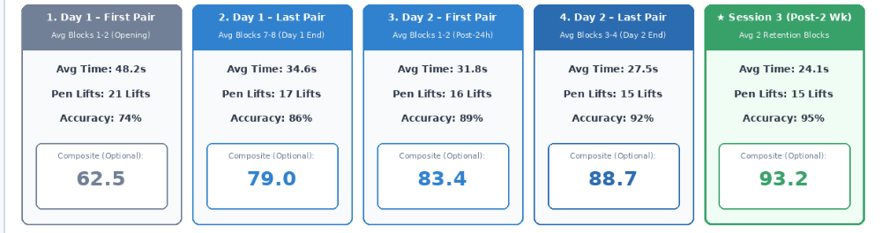
Add a [Replay] button in each of the session summary boxes. Clicking [Replay] will play the Mirrored Cockpit (like in Video mode with video controls bar). In Replay, present the computed ILT speed (value) under each house in the cockpit. Also display the pen movement data which was recorded during the session.

Add a line to the Clinical Telemetry – Average LTR Spped
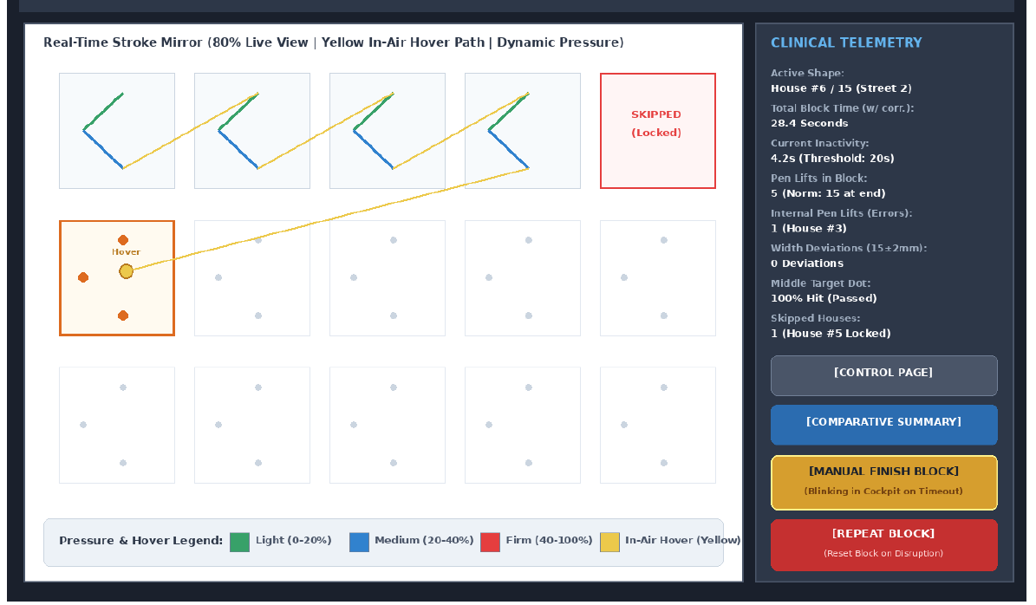
Note! How to compute block Pen-lift scoring: in the current ILT block the normal number of pen lifts is 15 – moving from one letter to another. So, 15 pen lifts = 100. If the actual number of pen lifts is X than the score is calculated as: Score = 100 / (X / 15). For example: number of pen lifts = 17, the score = 100 / (17 / 15) = 88.23
- Composite and Pass/Fail: Is this part of the intervention program? or the ILT? weights of 50% time, 25% accuracy and 25% pen lifts, for both it is CORRECT. BUT THERE MUST BE A SEPERATE SCORE FOR EACH COMPONANT on the ILT plus a Pass/Fail threshold in the Comparative Summary Dashboard, as you suggested for the intervention program. The 40/30/30 formula is droppe CORRECT .
- "0/1 per row" (you asked what it means): it summarises Dr. Hollander's own comment. Every intervention letter in each row is marked correct or error:
  - Row 1: the system checks it automatically (dots in order, no pen lift, except for ה ק ח ת א ).👍
  - Row 2: the system checks the starting point, and the evaluator confirms the letter's general form.👍
  - Row 3: the evaluator decides.👍
  - The cockpit shows the system's suggestions already filled in, so the evaluator only fixes what they disagree with.
- "Automatic trajectory scoring" (you weren't sure): earlier specs had the computer judge row 3 by comparing the child's pen path to a model letter. Under Dr. Hollander's criteria the evaluator decides row 3 instead. The computer's similarity hint never counts, but it's saved so the researchers can later check whether it agrees with evaluators.OK
- Intervention dot positions: I'll measure them from the 16 letter sheets in the repo and produce sheets like the corrected ILT one for the team to check. This needs Python, which gets installed in Phase 0.
- Day protocol: each day becomes an editable list of steps. Day 2's 👍 paper-notebook pages are timed by the evaluator in the cockpit.
- Ethics: each session is tagged as intervention use (the default) or research use. Research exports only include research-tagged sessions, so they stay empty until approval.
One suggestion for the team: ask the ethics committee to also approve research use of the data collected during the intervention period. Otherwise those months of data can never be analyzed.👍
5 small questions remain, each with a default so none blocks coding:
- Box width 34 or 35 mm? Your reply says 35 × 25, but the corrected sheet measures 34 mm (5 × 34 = 170 mm) and the same reply approved 34 × 25. The attachment you mentioned didn't come through. I'll use 34 mm unless you say otherwise. Corrected
- Turning time and pen lifts into scores for the composite. I propose a reference time per block and a penalty per pen lift, with both values chosen by the team after the first real blocks. NO Esti did not aapprove
- Is the warm-up block extra (13 blocks on Day 1), and do the two demo videos stay? YES
- Answerd English mirroring: see detailed reply above.
- Notebook pages on the tablet: same ">" letter, 3 rows × 5 letters, timed only? yes

