Advanced workshop in chemistry:

Linear molecules spectroscopy

Lea Bromberg, Yakir Levi Sagzan

Table of Contents

Spectrum of : 2

rotational constants: 3

harmonic and anharmonic correction vibration: 3

dissociation energy: 4

bond length: 4

spring constant: 4

the coefficient in Morse potential: 5

Temperature 5

Overtone transition of by using isotopic ratio: 8

Isotope abundance ratios: 8

Summary table: 9

Comparison to literature values: 9

9

10

12

13

To determine the rotational constant and its anharmonic correction, they were extracted directly from the fitting to equation.

We will show all the calculations for molecule, the same calculations were also performed on: , *,* .

# Spectrum of :

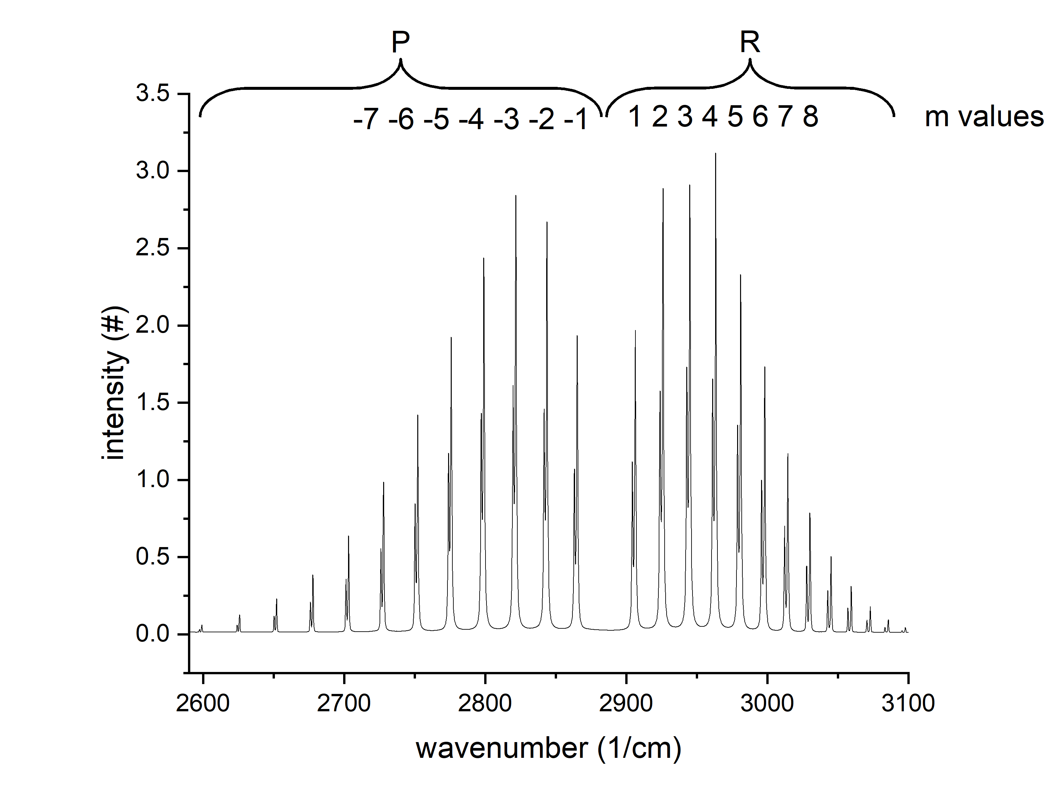

## rotational constants:

## harmonic and anharmonic correction vibration:

## dissociation energy:

## bond length:

the reduced mass of is:

## spring constant:

From the harmonic vibration we can extract the spring constant.

## the coefficient in Morse potential:

Temperature:  
To determine the temperature, we used the fundamental intensity proportions of the R and P branches for both and .   
for the R branch:  
for the P branch:  
it allows us to extrapolate the temperature via linear regression:

|  |  |  |  |  |
| --- | --- | --- | --- | --- |
|  |  |  |  |  |
|  |  |  |  |  |
|  |  |  |
|  |  |  |
|  |  |  |

# Overtone transition of by using isotopic ratio:

# Isotope abundance ratios:

To calculate the isotope abundance ratios, fundamental peak intensities were taken. The assumption is that for highly intense peaks, the background noise will have a minimal effect and we will manage to get more accurate ratios as a result.

|  |  |  |  |  |  |
| --- | --- | --- | --- | --- | --- |
|  |  |  |  |  |  |
|  |  |  |  |  |  |
|  |  |  |  |  |  |
|  |  |  |  |  |  |
|  |  |  |  |  |  |
|  |  |  |  |  |  |
|  |  |  |  |  |  |
|  |  |  |  |  |  |
|  |  |  |  |  |  |
|  |  |  |  |  |  |
|  |  |  |  |  |  |
|  |  |  |  |  |  |
|  |  |  |  |  |  |
|  |  |  |  |  |  |

# Summary table:

|  |  |  |  |  |
| --- | --- | --- | --- | --- |
|  |  |  |  |  |
|  |  |  |  |  |
|  |  |  |  |  |
|  |  |  |  |  |
|  |  |  |  |  |
|  |  |  |  |  |
|  |  |  |  |  |
|  |  |  |  |  |
|  |  |  |  |  |
|  |  |  |  |  |
|  |  |  |  |  |
|  |  |  |  |  |
|  |  |  |  |  |
|  |  |  |  |  |

# Comparison to literature values:

|  |  |  |  |
| --- | --- | --- | --- |
|  |  |  |  |
|  |  |  |  |
|  |  |  |  |
|  |  |  |  |
|  |  |  |  |
|  |  |  |  |
|  |  |  |  |
|  |  |  |  |
|  |  |  |  |
|  |  |  |  |
|  |  |  |  |
|  |  |  |  |
|  |  |  |  |
|  |  |  |  |

|  |  |  |  |
| --- | --- | --- | --- |
|  |  |  |  |
|  |  |  |  |
|  |  |  |  |
|  |  |  |  |
|  |  |  |  |
|  |  |  |  |
|  |  |  |  |
|  |  |  |  |
|  |  |  |  |
|  |  |  |  |
|  |  |  |  |
|  |  |  |  |
|  |  |  |  |
|  |  |  |  |

|  |  |  |  |
| --- | --- | --- | --- |
|  |  |  |  |
|  |  |  |  |
|  |  |  |  |
|  |  |  |  |
|  |  |  |  |
|  |  |  |  |
|  |  |  |  |
|  |  |  |  |
|  |  |  |  |
|  |  |  |  |
|  |  |  |  |
|  |  |  |  |
|  |  |  |  |
|  |  |  |  |

|  |  |  |  |
| --- | --- | --- | --- |
|  |  |  |  |
|  |  |  |  |
|  |  |  |  |
|  |  |  |  |
|  |  |  |  |
|  |  |  |  |
|  |  |  |  |
|  |  |  |  |
|  |  |  |  |
|  |  |  |  |
|  |  |  |  |
|  |  |  |  |
|  |  |  |  |
|  |  |  |  |