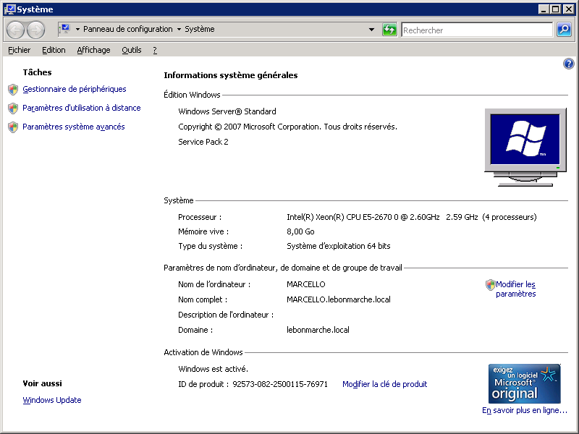

Requête remontée dans les traces avec un coût défavorable.

NB : Récurrence extrêmement forte :

NB : Je ne l’ai pas entièrement récupérée dans DBA_HIST_SQLTEXT. Par exemple select * from DBA_HIST_SQLTEXT where sql_id = 'ajjp35p484s14' ;

SELECT COUNT(*)

FROM lbm_vente_poste v

WHERE stecaisse IN (1, 2)

AND appl = 'SAP'

AND hca IS NULL

AND departement = '741'

AND (v.typegest != '5' AND v.typegest != '6')

AND topgu = 0

AND numcdeclt IS NULL

AND TRUNC (datehtrans) =

(SELECT TRUNC (datehtrans)

FROM (SELECT datehtrans

FROM lbm_vente_poste v2 LEFT JOIN lbm_cp_histo h

ON v2.cp = h.cp

WHERE stecaisse IN (1, 2)

AND v2.appl = 'SAP'

AND v2.hca IS NULL

AND departement = '741'

AND (v2.typegest != '5' AND v2.typegest != '6')

AND topgu = 0

AND ( (datehtrans < h.dateblocageinventaire)

OR (h.dateblocageinventaire IS NULL)

AND numcdeclt IS NULL

)

ORDER BY datehtrans)

WHERE ROWNUM <= 1)

AND ( (datehtrans < (SELECT dateblocageinventaire

FROM lbm_cp_histo h

WHERE h.cp = v.cp))

OR ((SELECT dateblocageinventaire

FROM lbm_cp_histo h

WHERE h.cp = v.cp) IS NULL)

;

* N’étant pas entière, je l’ai tracée en plans partiels :

SELECT datehtrans

FROM lbm_vente_poste v2 LEFT JOIN lbm_cp_histo h

ON v2.cp = h.cp

WHERE stecaisse IN (1, 2)

AND v2.appl = 'SAP'

AND v2.hca IS NULL

AND departement = '741'

AND (v2.typegest != '5' AND v2.typegest != '6')

AND topgu = 0

AND ( (datehtrans < h.dateblocageinventaire)

OR (h.dateblocageinventaire IS NULL)

AND numcdeclt IS NULL

)

ORDER BY datehtrans

;

* Avec mise en forme :

SELECT datehtrans

FROM lbm_vente_poste v2

LEFT JOIN lbm_cp_histo h ON v2.cp = h.cp

WHERE stecaisse IN (1, 2)

AND v2.appl = 'SAP'

AND v2.hca IS NULL

AND departement = '741'

AND (

v2.typegest != '5'

AND v2.typegest != '6'

)

AND topgu = 0

AND (

( datehtrans < h.dateblocageinventaire )

OR ( h.dateblocageinventaire IS NULL )

AND numcdeclt IS NULL

)

ORDER BY datehtrans

;

--