Oracle autotrace supports the following options:

Table 11-1 Autotrace Settings
Autotrace Setting | Result
SET AUTOTRACE OFF | No AUTOTRACE report is generated. This is the default.
SET AUTOTRACE ON EXPLAIN | The AUTOTRACE report shows only the optimizer execution path.
SET AUTOTRACE ON STATISTICS | The AUTOTRACE report shows only the SQL statement execution statistics.
SET AUTOTRACE ON | The AUTOTRACE report includes both the optimizer execution path and the SQL statement execution statistics.
SET AUTOTRACE TRACEONLY | Similar to SET AUTOTRACE ON, but suppresses the printing of the user's query output, if any. If STATISTICS is enabled, query data is still fetched, but not printed.

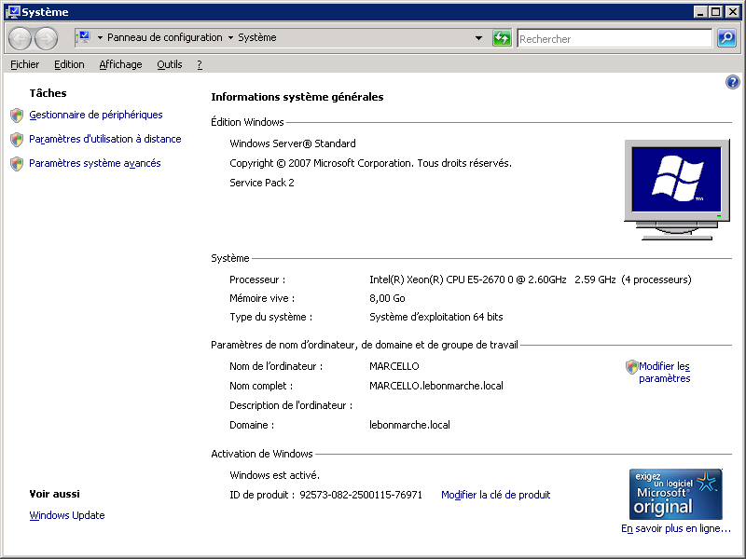

Requête remontée dans les traces avec un coût défavorable.
NB : Récurrence extrêmement forte :
NB : Je ne l’ai pas entièrement récupérée dans DBA_HIST_SQLTEXT. Par exemple select * from DBA_HIST_SQLTEXT where sql_id = 'ajjp35p484s14' ;
SELECT COUNT(*)
FROM lbm_vente_poste v
WHERE stecaisse IN (1, 2)
AND appl = 'SAP'
AND hca IS NULL
AND departement = '741'
AND (v.typegest != '5' AND v.typegest != '6')
AND topgu = 0
AND numcdeclt IS NULL
AND TRUNC (datehtrans) =
(SELECT TRUNC (datehtrans)
FROM (SELECT datehtrans
FROM lbm_vente_poste v2 LEFT JOIN lbm_cp_histo h
ON v2.cp = h.cp
WHERE stecaisse IN (1, 2)
AND v2.appl = 'SAP'
AND v2.hca IS NULL
AND departement = '741'
AND (v2.typegest != '5' AND v2.typegest != '6')
AND topgu = 0
AND ( (datehtrans < h.dateblocageinventaire)
OR (h.dateblocageinventaire IS NULL)
AND numcdeclt IS NULL
)
ORDER BY datehtrans)
WHERE ROWNUM <= 1)
AND ( (datehtrans < (SELECT dateblocageinventaire
FROM lbm_cp_histo h
WHERE h.cp = v.cp))
OR ((SELECT dateblocageinventaire
FROM lbm_cp_histo h
WHERE h.cp = v.cp) IS NULL)
;
- N’étant pas entière, je l’ai tracée en plans partiels :
SELECT datehtrans
FROM lbm_vente_poste v2 LEFT JOIN lbm_cp_histo h
ON v2.cp = h.cp
WHERE stecaisse IN (1, 2)
AND v2.appl = 'SAP'
AND v2.hca IS NULL
AND departement = '741'
AND (v2.typegest != '5' AND v2.typegest != '6')
AND topgu = 0
AND ( (datehtrans < h.dateblocageinventaire)
OR (h.dateblocageinventaire IS NULL)
AND numcdeclt IS NULL
)
ORDER BY datehtrans
;
- Avec mise en forme :
SELECT datehtrans
FROM lbm_vente_poste v2
LEFT JOIN lbm_cp_histo h ON v2.cp = h.cp
WHERE stecaisse IN (1, 2)
AND v2.appl = 'SAP'
AND v2.hca IS NULL
AND departement = '741'
AND (
v2.typegest != '5'
AND v2.typegest != '6'
)
AND topgu = 0
AND (
( datehtrans < h.dateblocageinventaire )
OR ( h.dateblocageinventaire IS NULL )
AND numcdeclt IS NULL
)
ORDER BY datehtrans
;
--
Plan :
set autotrace traceonly explain
Execution Plan
----------------------------------------------------------

---------------------------------------------------------------------------
| Id | Operation | Name | Rows | Bytes | Cost |
---------------------------------------------------------------------------
| 0 | SELECT STATEMENT | | 47553 | 2089K| 227K|
| 1 | SORT ORDER BY | | 47553 | 2089K| 227K|
| 2 | FILTER | | | | |
| 3 | HASH JOIN RIGHT OUTER| | 47553 | 2089K| 226K|
| 4 | TABLE ACCESS FULL | LBM_CP_HISTO | 9422 | 94220 | 21 |
| 5 | TABLE ACCESS FULL | LBM_VENTE_POSTE | 51031 | 1744K| 226K|
---------------------------------------------------------------------------

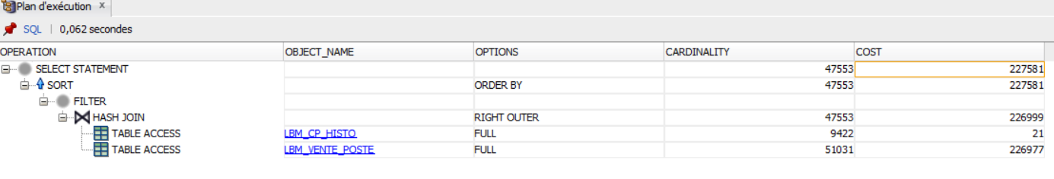

Niveau 2 de la requête (elle incorpore la précédente)
(SELECT TRUNC (datehtrans)
FROM (SELECT datehtrans
FROM lbm_vente_poste v2 LEFT JOIN lbm_cp_histo h
ON v2.cp = h.cp
WHERE stecaisse IN (1, 2)
AND v2.appl = 'SAP'
AND v2.hca IS NULL
AND departement = '741'
AND (v2.typegest != '5' AND v2.typegest != '6')
AND topgu = 0
AND ( (datehtrans < h.dateblocageinventaire)
OR (h.dateblocageinventaire IS NULL)
AND numcdeclt IS NULL
)
ORDER BY datehtrans)
WHERE ROWNUM <= 1)
select count (1) from lbm_vente_poste ; => 53295454 enregistrements
select count (1) from lbm_cp_histo ; => 9424

set lines 255
col column_name format A30
select at.table_name, at.status, at.num_rows, at.last_analyzed
, ai.index_name, ai.index_type, ai.uniqueness, ai.leaf_blocks, ai.distinct_keys, ai.status as i_status, ai.last_analyzed as i_last_analyzed, ai.global_stats
, aic.column_name, aic.column_position
from all_tables at
inner join all_indexes ai on ai.table_name = at.table_name
inner join all_ind_columns aic on aic.index_name = ai.index_name
where at.owner in ( 'STORELAND' )
and at.table_name in (upper ('lbm_vente_poste'), upper ('lbm_cp_histo'))
order by at.table_name, ai.index_name, aic.column_position
;

TABLE_NAME | NUM_ROWS | INDEX_NAME | UNIQUENES | DISTINCT_KEYS | COLUMN_NAME | COLUMN_POSITION
LBM_CP_HISTO | 9422 | LBM_CP_HISTO_PK | UNIQUE | 9422 | CP | 1
LBM_VENTE_POSTE | 52989172 | LBM_VENTE_POSTE_FK1 | NONUNIQUE | 3 | TOPGU | 1
LBM_VENTE_POSTE | 52989172 | LBM_VENTE_POSTE_PK | UNIQUE | 49990436 | STECAISSE | 1
LBM_VENTE_POSTE | 52989172 | LBM_VENTE_POSTE_PK | UNIQUE | 49990436 | DATEHTRANS | 2
LBM_VENTE_POSTE | 52989172 | LBM_VENTE_POSTE_PK | UNIQUE | 49990436 | NUMCAISSE | 3
LBM_VENTE_POSTE | 52989172 | LBM_VENTE_POSTE_PK | UNIQUE | 49990436 | NUMTICKET | 4
LBM_VENTE_POSTE | 52989172 | LBM_VENTE_POSTE_PK | UNIQUE | 49990436 | NUMLIGNE | 5
LBM_VENTE_POSTE | 52989172 | LBM_VENTE_POSTE_SK | NONUNIQUE | 233249 | DATHTOPGU | 1

Plan d’exécution :
set autotrace traceonly explain

SQL> SELECT datehtrans
2 FROM lbm_vente_poste v2
3 LEFT JOIN lbm_cp_histo h
4 ON v2.cp = h.cp
5 WHERE stecaisse IN (1, 2)
6 AND v2.appl = 'SAP'
7 AND v2.hca IS NULL
8 AND departement = '741'
9 AND (v2.typegest != '5' AND v2.typegest != '6')
10 AND topgu = 0
11 AND ( (datehtrans < h.dateblocageinventaire)
12 OR (h.dateblocageinventaire IS NULL)
13 AND numcdeclt IS NULL
14 )
15 ORDER BY datehtrans
16 ;

Execution Plan
----------------------------------------------------------

---------------------------------------------------------------------------
| Id | Operation | Name | Rows | Bytes | Cost |
---------------------------------------------------------------------------
| 0 | SELECT STATEMENT | | 47553 | 2089K| 227K|
| 1 | SORT ORDER BY | | 47553 | 2089K| 227K|
| 2 | FILTER | | | | |
| 3 | HASH JOIN RIGHT OUTER| | 47553 | 2089K| 226K|
| 4 | TABLE ACCESS FULL | LBM_CP_HISTO | 9422 | 94220 | 21 |
| 5 | TABLE ACCESS FULL | LBM_VENTE_POSTE | 51031 | 1744K| 226K|
---------------------------------------------------------------------------

Note
-----
- 'PLAN_TABLE' is old version

SQL> SELECT TRUNC (datehtrans)
2 FROM (SELECT datehtrans
3 FROM lbm_vente_poste v2 LEFT JOIN lbm_cp_histo h
4 ON v2.cp = h.cp
5 WHERE stecaisse IN (1, 2)
6 AND v2.appl = 'SAP'
7 AND v2.hca IS NULL
8 AND departement = '741'
9 AND (v2.typegest != '5' AND v2.typegest != '6')
10 AND topgu = 0
11 AND ( (datehtrans < h.dateblocageinventaire)
12 OR (h.dateblocageinventaire IS NULL)
13 AND numcdeclt IS NULL
14 )
15 ORDER BY datehtrans)
16 WHERE ROWNUM <= 1
17 ;

Execution Plan
----------------------------------------------------------

-----------------------------------------------------------------------------
| Id | Operation | Name | Rows | Bytes | Cost |
-----------------------------------------------------------------------------
| 0 | SELECT STATEMENT | | 1 | 9 | 227K|
| 1 | COUNT STOPKEY | | | | |
| 2 | VIEW | | 44312 | 389K| 227K|
| 3 | SORT ORDER BY STOPKEY | | 44312 | 1947K| 227K|
| 4 | FILTER | | | | |
| 5 | HASH JOIN RIGHT OUTER| | 44312 | 1947K| 226K|
| 6 | TABLE ACCESS FULL | LBM_CP_HISTO | 9422 | 94220 | 21 |
| 7 | TABLE ACCESS FULL | LBM_VENTE_POSTE | 51031 | 1744K| 226K|
-----------------------------------------------------------------------------

Note
-----
- 'PLAN_TABLE' is old version

SQL>

Améliorations :
- Le cache gagnerait avec des binds variables
- Résoudre les full SCAN sur les tables (surtout la + grosse)
- NB : la requête s’exécute en 100 secondes
SQL> SELECT COUNT(*)
2 FROM lbm_vente_poste v
3 WHERE stecaisse IN (1, 2)
4 AND appl = 'SAP'
5 AND hca IS NULL
6 AND departement = '741'
7 AND (v.typegest != '5' AND v.typegest != '6')
8 AND topgu = 0
9 AND numcdeclt IS NULL
10 AND TRUNC (datehtrans) =
11 (SELECT TRUNC (datehtrans)
12 FROM (SELECT datehtrans
13 FROM lbm_vente_poste v2 LEFT JOIN lbm_cp_histo h
14 ON v2.cp = h.cp
15 WHERE stecaisse IN (1, 2)
16 AND v2.appl = 'SAP'
17 AND v2.hca IS NULL
18 AND departement = '741'
19 AND (v2.typegest != '5' AND v2.typegest != '6')
20 AND topgu = 0
21 AND ( (datehtrans < h.dateblocageinventaire)
22 OR (h.dateblocageinventaire IS NULL)
23 AND numcdeclt IS NULL
24 )
25 ORDER BY datehtrans)
26 WHERE ROWNUM <= 1)
27 AND ( (datehtrans < (SELECT dateblocageinventaire
28 FROM lbm_cp_histo h
29 WHERE h.cp = v.cp))
30 OR ((SELECT dateblocageinventaire
31 FROM lbm_cp_histo h
32 WHERE h.cp = v.cp) IS NULL)
33 ) --- moi
34 ;

Execution Plan
----------------------------------------------------------

---------------------------------------------------------------------------------
| Id | Operation | Name | Rows | Bytes | Cost |
---------------------------------------------------------------------------------
| 0 | SELECT STATEMENT | | 1 | 35 | 454K|
| 1 | SORT AGGREGATE | | 1 | 35 | |
| 2 | FILTER | | | | |
| 3 | TABLE ACCESS FULL | LBM_VENTE_POSTE | 507 | 17745 | 226K|
| 4 | COUNT STOPKEY | | | | |
| 5 | VIEW | | 47553 | 417K| 227K|
| 6 | SORT ORDER BY STOPKEY | | 47553 | 2089K| 227K|
| 7 | FILTER | | | | |
| 8 | HASH JOIN RIGHT OUTER | | 47553 | 2089K| 226K|
| 9 | TABLE ACCESS FULL | LBM_CP_HISTO | 9422 | 94220 | 21 |
| 10 | TABLE ACCESS FULL | LBM_VENTE_POSTE | 51031 | 1744K| 226K|
| 11 | TABLE ACCESS BY INDEX ROWID| LBM_CP_HISTO | 1 | 10 | 2 |
| 12 | INDEX UNIQUE SCAN | LBM_CP_HISTO_PK | 1 | | 1 |
| 13 | TABLE ACCESS BY INDEX ROWID| LBM_CP_HISTO | 1 | 10 | 2 |
| 14 | INDEX UNIQUE SCAN | LBM_CP_HISTO_PK | 1 | | 1 |
---------------------------------------------------------------------------------

Note
-----
- 'PLAN_TABLE' is old version

SQL>

