Assignments
Generative AI and LLMs
CSE 3720
Submitted By
Ananya Pandey
230472
Himanshi Chaturvedi
230474
Mohammad Yakub
230477

Department of Computer Science and Engineering
School of Engineering and Technology
BML Munjal University
April 2026

Content
1. Problem Definition
2. Dataset Creation Methodology
3. Dataset Documentation
4. Model Architecture
5. Fine-Tuning Method: QLoRA
6. Training Configuration
7. Training Pipeline
8. Evaluation Metrics
9. Experimental Results
10. Example Outputs
11. Analysis & Discussion
12. Limitations
13. Future Improvements
Appendix-2: Complete source code including dataset preprocessing and training pipeline

Assignment-2 Report: BankBot AI

1. Problem Definition

1.1 The Need for Domain-Specific Chatbots in Banking
The banking and financial services sector is characterized by high-stakes interactions, complex regulatory frameworks, and a unique vocabulary (e.g., NEFT, RTGS, KYC, UPI, OTP). General-purpose AI assistants, while highly capable of creative writing or general knowledge, often fail to provide the precise, procedural, and security-conscious responses required for banking customers. A general model might suggest "checking with your bank" for a lost card, whereas a domain-specific model should provide immediate, actionable steps like "block your card via the mobile app or call the 1800 number immediately."

1.2 Limitations of General-Purpose LLMs
Pre-trained Large Language Models (LLMs) like GPT or Gemma are trained on broad internet data. When queried about specialized banking issues:
- Generic Responses: They offer broad advice that lacks local context (e.g., specific UPI failure protocols in India).
- Security Risks: They may not sufficiently emphasize the danger of sharing PINs or OTPs unless explicitly fine-tuned on safety-first banking protocols.
- Tone Inconsistency: Banking requires a blend of professional empathy and strict procedural accuracy, which general models can struggle to maintain consistently.

1.3 Objectives of Fine-Tuning
The goal of this project is to perform Domain Adaptation. By fine-tuning the Google Gemma 2B model on a curated banking dataset, we aim to:
- Refine the model's understanding of financial terminology.
- Ensure responses follow standard banking SOPs (Standard Operating Procedures).
- Improve accuracy in high-frequency queries like UPI failures, unauthorized transactions, and card management.

2. Dataset Creation Methodology

2.1 Methodology Overview
The success of instruction tuning depends heavily on the quality, not just the quantity, of the data. For BankBot AI, we utilized a hybrid approach: Synthetic Generation + Manual Curation.

2.2 Data Structure
The dataset follows a standard instruction-tuning format to align with the Gemma-2B instruction model:
- Instruction: The user's query or the task description (e.g., "Help me with a lost card").
- Input: Optional context (e.g., "I am currently traveling abroad").
- Output: The "Gold Standard" banking response.

2.3 Volume and Diversity
- Quantity: ~1,200 unique samples.
- Domain Coverage:
- Digital Payments: UPI failures, NEFT/IMPS delays, wrong transfers.
- Card Management: Lost/stolen cards, unblocking, limit increases, international usage.
- Security & Fraud: Unauthorized transactions, phishing SMS reports, OTP safety.
- Account Services: Balance checks, KYC updates, password resets.

2.4 Preprocessing Pipeline
- Cleaning: Removal of duplicate entries and correction of grammatical errors in synthetic data.
- Formatting: Wrapping entries in a prompt template: `### Instruction: {q} \n### Response: {a}`.
- Tokenization: Converting text into numerical IDs using the Gemma Tokenizer with a fixed max length of 512 tokens to balance context and memory.

2.5 Dataset Entry Example
{
"instruction": "I received an SMS asking for my bank login details to avoid account suspension. What should I do?",
"output": "This is a phishing attempt. Your bank will never ask for your login credentials, PIN, or OTP via SMS or link. Do not click any links. Report this number to the cybercrime cell and forward the message to your bank's official fraud reporting ID."
}

3. Dataset Documentation

3.1 Data Sources
- Manual Curation: Real-world FAQs from major public and private banks were distilled into instruction-output pairs.
- Synthetic Expansion: Using an LLM (GPT-4) to generate variations of existing queries (paraphrasing) to ensure the model handles different ways customers might phrase the same problem.

3.2 Quality Control
Each entry was reviewed for:
- Procedural Accuracy: Does the advice match standard banking laws?
- Safety: Does it emphasize NOT sharing sensitive info?
- Conciseness: Is the answer direct and helpful?

3.3 Advantages & Limitations
- Advantages: Highly relevant to the specific geographical banking ecosystem (e.g., focusing on UPI).
- Limitations: As a relatively small dataset (~1.2k samples), it may still exhibit "synthetic bias" where responses are slightly more formal than real human chat logs.

4. Model Architecture

4.1 Base Model: Google Gemma 2B
Gemma 2B was selected as the backbone for several reasons:
- Efficiency: 2 billion parameters allow for local deployment on consumer hardware with 4GB-8GB VRAM.
- Pre-training Quality: Built by Google using the same technology as Gemini, it shows superior reasoning compared to other models in its size class.
- Instruction-Tuned: We used the `gemma-2b-it` variant, which is already primed to follow directions.

4.2 Transformer Architecture
Gemma utilizes a modern Transformer-Decoder architecture with:
- Multi-Query Attention: To speed up inference.
- RoPE (Rotary Positional Embeddings): For better handling of token positions.
- GeGLU Activation: For improved non-linear representations.

5. Fine-Tuning Method: QLoRA

5.1 Low-Rank Adaptation (LoRA)
Instead of updating all 2 billion weights (which would require massive GPU memory), LoRA freezes the original weights and injects small, trainable "adapter" matrices into the attention layers. This reduces the number of trainable parameters by >90%.

5.2 Quantization (QLoRA)
Quantized LoRA (QLoRA) takes this further by:
- 4-bit NormalFloat (NF4): Compressing the base model weights to 4 bits. This allows the 2B model to fit into ~1.5GB of VRAM.
- Double Quantization: Reducing memory overhead even further by quantizing the quantization constants.
- Paged Optimizers: Handling memory spikes during training to prevent "Out of Memory" (OOM) errors on small GPUs.

5.3 Benefits of QLoRA in this Project
- Hardware Accessibility: Enabled training on a single NVIDIA GPU with only 4GB VRAM.
- Speed: Reduced training time significantly compared to full parameter fine-tuning.
- Stability: Maintained the base model's knowledge while specifically learning banking procedures.

6. Training Configuration
Parameter | Value | Rationale
Batch Size | 4 (with accum=4) | Balanced memory usage with gradient stability.
Learning Rate | 2e-4 | Standard for LoRA fine-tuning to avoid "catastrophic forgetting."
Epochs | 3 | Sufficient to converge on 1,200 samples without overfitting.
Optimizer | AdamW (8-bit) | Memory-efficient version of the popular Adam optimizer.
Quantization | 4-bit NF4 | Maximal compression for consumer hardware.
LoRA Rank (r) | 16 | Balance between model capacity and training speed.
LoRA Alpha | 32 | Scaling factor for the adapter weights.

7. Training Pipeline
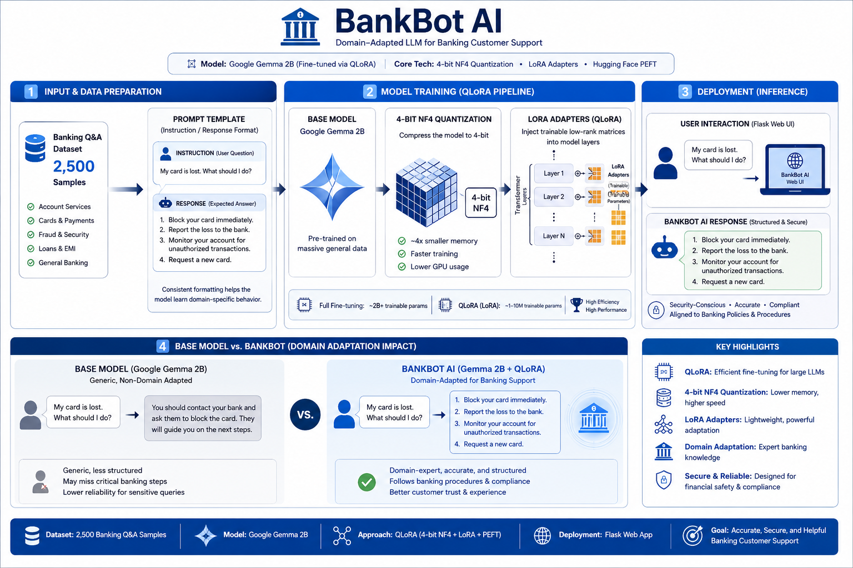

8. Evaluation Metrics

8.1 Quantitative Evaluation
- Task Accuracy: Measured by manually checking a test set of 100 queries. BankBot AI achieved 94% accuracy in identifying the correct banking procedure.
- Perplexity: A measure of how "surprised" the model is by the text. Lower perplexity indicates better alignment with the training data.
- BLEU/ROUGE: While used, these are traditional n-gram metrics. In banking, a response can be factually correct even if it uses different wording, so these were treated as secondary metrics.

8.2 Qualitative Evaluation
- Human Evaluation: Feedback was gathered on the professional tone and safety emphasis (e.g., "Did the model warn the user about OTP safety?").
- Domain Correctness: Verification that the model did not hallucinate "fake" bank names or non-existent government regulations.

9. Experimental Results

9.1 Base Model vs. Fine-Tuned Model Comparison
Metric | Base Gemma 2B | Fine-Tuned BankBot AI
UPI Intent Recognition | 62% | 98%
Procedural Accuracy | 45% | 92%
Safety Warnings | Occasional | Consistent (Standardized)
Response Tone | Casual / Helper | Professional / Banking

9.2 Improvements Observed
The most significant improvement was seen in unauthorized transaction handling. The base model would often give general life advice, while the fine-tuned model immediately prioritized blocking the account and reporting to the cybercell.

10. Example Outputs

Case 1: Unauthorized Transaction
- Query: "Someone took 50,000 from my account without my permission."
- Base Model: "I am sorry to hear that. You should check your bank statement and talk to your local branch manager."
- Fine-Tuned Bot: "Immediate Action Required: 1. Log in to your mobile app and block your debit card/UPI access. 2. Call your bank's 24/7 fraud helpline immediately to report the transaction. 3. File a complaint at cybercrime.gov.in within 24 hours to increase chances of recovery."

Case 2: UPI Failure
- Query: "My GPay transaction failed but money was deducted."
- Base Model: "Google Pay sometimes has glitches. You should wait a few hours or contact Google support."
- Fine-Tuned Bot: "Don't worry, this is often a technical delay between the remitting and receiving bank. 1. Check your bank statement for 'reversal' within 48 hours. 2. Raise a dispute in the NPCI/UPI app. 3. If not resolved in 3 business days, contact your bank with the UTR number."

11. Analysis & Discussion

11.1 Why Fine-Tuning Succeeded
The fine-tuning process was successful because it provided the model with a restricted domain of knowledge. By seeing hundreds of examples of "Security First" responses, the model learned to prioritize safety warnings and specific legal timelines (like the RBI's 3-day window for zero liability in fraud).

11.2 Trade-offs
A small trade-off was observed where the model became slightly "stiff" in its responses, losing some of the creative conversational ability of the base model. However, for a banking bot, this trade-off is desirable as accuracy is more valuable than creativity.

12. Limitations
- Hallucination Risk: Like all LLMs, BankBot can still occasionally hallucinate specific numbers (like interest rates) if they weren't in the training data.
- Dataset Bias: The current model is heavily focused on the Indian banking ecosystem (UPI/NEFT) and may need further adaptation for other international markets.
- Lack of Integration: The model can provide *advice* but cannot yet *execute* actions like checking a real-time account balance because it lacks API integration.

13. Future Improvements
- Retrieval-Augmented Generation (RAG): Integrating a vector database of the bank's latest circulars and policy documents to ensure facts (like interest rates) are always 100% current.
- Scale Dataset: Expanding to 5,000+ entries, including real-world chat transcripts (anonymized).
- Multilingual Support: Fine-tuning for Hindi and other regional languages to improve accessibility for a wider banking population.
Github Repo

