An enterprise has multiple applications that are being built independently, with different languages and platforms. The enterprise needs to share data and processes in a responsive way.

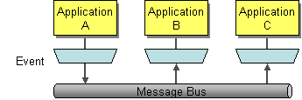

**How can I integrate multiple applications so that they work together and can exchange information?**

**Use *Messaging* to transfer packets of data frequently, immediately, reliably, and asynchronously, using customizable formats.**

Asynchronous messaging is fundamentally a pragmatic reaction to the problems of distributed systems. Sending a message does not require both systems to be up and ready at the same time. Furthermore, thinking about the communication in an asynchronous manner forces developers to recognize that working with a remote application is slower, which encourages design of components with high cohesion (lots of work locally) and low adhesion (selective work remotely).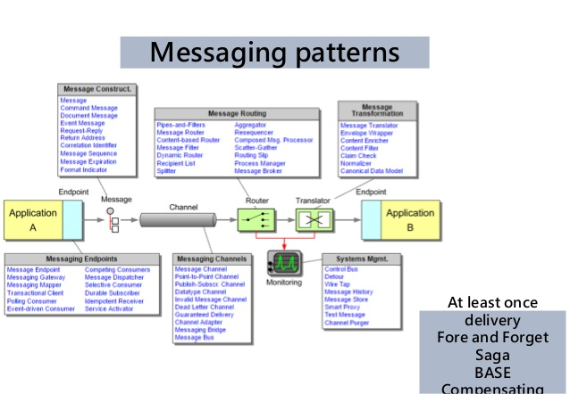

problem it can solve

It integrates disperse application to work together through it messaging style either asynchronous or synchronous

•      solution it provides

It decouples sender from receiver, it limits failure propagation and also the receiver can consume the message at its own pace.