**My Expense Manager**

By

Yaksh Bhatt

Submitted to

**The University of Roehampton**

In partial fulfilment of the requirements

for the degree of

**BACHELOR OF SCIENCE IN COMPUTER SCIENCE**

Abstract

This project aims to create a seamless expense and income tracking system that provides users with a simple and efficient way to manage their finances. Many people struggle with tracking their daily expenses and income, which can lead to financial difficulties. With this application, users can easily record their day-to-day costs and incomes in real time, helping them stay on top of their finances and reducing stress. Money is an essential part of life, and this application will allow users to manage it effectively, making their lives more comfortable and worry-free.

**My Expense Manager** is designed to help users take control of their finances and avoid unexpected expenses and financial difficulties. This innovative project will save time for users with busy lifestyles and guide them in making informed decisions about their spending habits. The application's user-friendly interface allows users to view their overall expenditure in a visually engaging bar graph format, categorized by spending categories. Additionally, the app provides a currency converter feature that will assist users in managing their finances across different currencies. With this comprehensive suite of features, My Expense Manager makes financial management easy and accessible for all users.

Declaration

I, Yaksh Bhatt, hereby declare that the following report on mobile application is my original work and that it has not been submitted to any other institution or for any other purpose.

All information and data used in this report are appropriately referenced and cited. Any ideas or words of others are properly acknowledged and cited in the reference list.

The report is based on extensive research and analysis, which I have conducted to the best of my knowledge and ability.

I take full responsibility for any errors or omissions that may be present in this report.

Signed: Yaksh Bhatt

Date: 12/05/23

Signed-: Yaksh Bhatt

Acknowledgements

I would like to extend my heartfelt gratitude to Alex Collins & Charles Clarke for their expert guidance and insightful feedback throughout the project. Their mentorship has been invaluable in shaping the content of this report.

I would also like to thank my peers and classmates for their support and cooperation during the research and data collection process. Their contributions have helped to enrich the content of this report.

I would like to acknowledge the contribution of the technical team and library staff for providing the necessary resources and support for the research process.

Finally, I would like to thank my family and friends for their unwavering support, encouragement, and motivation during the completion of this report.

Once again, thank you to everyone who has contributed to this report, directly or indirectly.

Table of Contents

**1.Introduction** 6

A problem that will be Addressed 6

Aims 6

Objectives 7

Legal, Social, Ethical and Professional Considerations 7

Background 8

Report overview 8

**2.Literature or Technology Review** 9

The Advantages of Dart - 11

Flutter - 12

Flutter Core Features 13

Advantages of Flutter 14

Java - 15

Object-oriented - 15

3.Design or Methodology 18

Spiral model 18

Comparison 20

Use case 22

**4.Results** 24

**5.Conclusion** 35

Reflection 35

Future Work 35

**1.** **References** 36

**2.** **Appendices** 37

# **1.Introduction**

**My Expense Manager** is an innovative application designed to simplify financial management for users. As a digital diary, users can effortlessly record their expenses and income with just a few clicks on their phones. This will enable users to monitor their daily, monthly, and yearly expenses and incomes with ease. The best part is that all data is saved in offline mode, eliminating the need for internet connectivity. Users can access their data anytime and anywhere by simply logging in to their accounts. The application's interface is straightforward and user-friendly, making it easy to record and view financial data. With this application, users can take control of their finances and make informed decisions about their spending habits. [1]

## 

## A problem that will be Addressed

Traditionally, keeping track of business and personal expenses was a time-consuming and challenging task. However, with the advancement of technology, mobile applications have made it possible to record daily and monthly expenses with ease. Unfortunately, some expense-tracking apps have specific phone memory and software version requirements, limiting their accessibility to many users. My expense manager also requires SDK version 21, minimum Android version 5 & application size 23.1mb so storage will not be an issue for any user straightforward interface and features make it user-friendly and accessible to everyone. Furthermore, the graphical representation of the data makes it easy to understand and analyse one's expenses. With my expense manager, managing finances has never been simpler or more efficient. [2]

## Aims

To analyse modern-day spending conduct and identify areas in which expenses may be decreased or removed, for you to enhance financial stability and decrease debt.

To evaluate the effectiveness of numerous price monitoring strategies and tools, and advise the exceptional options for people or agencies to use.

To study the impact of everyday prices on long-term financial desires, inclusive of retirement financial savings, funding portfolios, or paying off loans.

To evaluate and compare distinct budgeting strategies, inclusive of the envelope technique, 0-based budgeting, or percentage-based budgeting, and offer suggestions for which method to use.

To discuss the psychological and behavioural elements of everyday expense control, including impulse shopping, emotional spending, and the position of mindfulness in making economic selections.

To compare the impact of external elements, consisting of inflation, monetary downturns, or unexpected prices, on daily price control, and offer strategies for managing those demanding situations. [3]

## Objectives

To analyse the spending habits of people or families over a selected period, which includes per week, month, or yr.

To identify regions of useless or excessive spending and recommend ways to lessen charges in the one's areas.

To examine the real spending with a budget or a goal spending plan, and evaluate the effectiveness of the plan.

To propose strategies for saving cash and enhancing financial nicely-being, consisting of putting monetary desires, creating a budget, or usage of budgeting equipment.

To explore the effect of day-by-day prices on economic dreams, inclusive of saving for retirement, paying off debt, or reaching economic independence.

To determine the advantages and downsides of numerous price methods, including coins, credit score cards, or cell payment apps, and offer recommendations for the most effective charge method.

## Legal, Social, Ethical and Professional Considerations

This application encourages students to be financially honest by pushing them to be open and honest with their parents about their costs. Additionally, it teaches kids how valuable their parents' hard-earned money is and how to treat it carefully and wisely. Students can better understand their spending patterns and spot areas where they could be overspending by tracking and managing their expenses with this software. They may organise their resources more effectively and make informed judgements with the use of this information. Overall, this programme is a useful tool for teaching children the importance of being honest and financially responsible, empowering them to make better financial decisions and create more secure futures.

It may be challenging for the average person to locate a database because of the folder structure that the Android operating system maintains, but even if someone does, they will not be able to access our database's data because it is encrypted.

Because there is strong validation and sound judgement in place, no client will be able to view records of different users without identity and password, thus as long as a few consumers don't have the ID and password of different consumers they may not be able to acquire access to information of various.

## Background

This project was created utilising revolutionary software that provides an integrated currency converter and enables real-time tracking of financial data. The application was created using Flutter and Dart, two potent programming languages renowned for their durability and adaptability. Users may safely and quickly store and access their financial data thanks to the app's usage of SQLite for its local database. This application delivers a quick, dependable, and easy-to-use experience that improves the spending monitoring and management process by utilising the power of cutting-edge technology.

## Report overview

Overall, the introduction provided the basic idea of the project; now, the deep details of the project will be discussed. This information includes the technology used to create this application as well as the techniques and design principles used to make it very user-friendly and practical. After receiving good results, future progress and advancement will be described, followed by the results of the results and problems that were encountered while developing this application.

# **2.Literature or Technology Review**

There are many technological options available to create this application, In which we choose to build this project on In Dart with using of Flutter. Dart is an open platform with open source.

[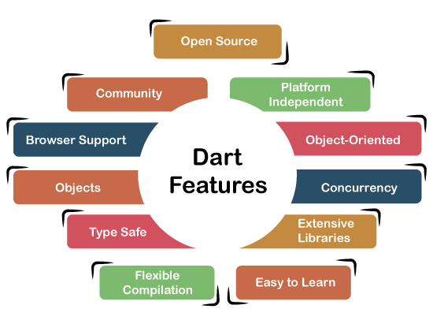](https://www.google.com/url?sa=i&url=https%3A%2F%2Fwww.tutorialandexample.com%2Fdart-tutorial&psig=AOvVaw2UB2VDz5-loVyXKIZqTS9N&ust=1683669471782000&source=images&cd=vfe&ved=0CBIQjhxqFwoTCLi11tjb5v4CFQAAAAAdAAAAABAJ)

Figure 1

**What is DART?**

Dart is an independent platform with an open-source and object-oriented programming language that provides a wide range of features and options to the Software developer.

Dart is a general-purpose, object-oriented programming language created by Google. It was initially released in 2011 and is mainly used for building web, mobile, and desktop applications.

Dart is an optionally typed language, which means that developers can choose to annotate their code with type information or let the Dart compiler infer the types. This flexibility allows developers to write code that is both concise and readable.

**The Core Features of Dart.**

One of the key features of Dart is its support for asynchronous programming. Dart provides built-in support for asynchronous operations, making it easy to write code that performs non-blocking I/O, such as network requests and files I/O. Concurrency,

1. Object-oriented programming: Dart is an object-oriented language that supports classes, inheritance, and interfaces.
2. Optional typing: Dart supports optional typing, which means that you can choose to specify variable types or let the Dart compiler infer them automatically.
3. Asynchronous programming: Dart provides built-in support for asynchronous programming, making it easy to write code that performs non-blocking I/O, such as network requests and files I/O.
4. Garbage collection: Dart uses garbage collection to automatically manage memory allocation and deallocation, which makes it easier to write memory-safe code.
5. Mixings: Dart supports mixing, which is a way of adding functionality to a class without having to create a new subclass.
6. Isolates: Isolates are lightweight and have their own memory space, which makes it easier to write concurrent programs.
7. Interoperability: Dart supports interoperability with other programming languages, which makes it easy to integrate with existing code bases.

1. Web development: Dart provides built-in support for web development, with a set of libraries that make it easy to create web applications.
2. Flutter: Dart is the primary language used for developing apps in Google's cross-platform development framework, Flutter, which provides a powerful set of tools for building high-performance, cross-platform mobile and web applications.

## The Advantages of Dart -

Productivity: Dart's optional typing, asynchronous programming support, and built-in libraries make it a highly productive language for developers. With features like hot reload in Flutter, developers can see the effects of changes to their code almost instantly, making it easier to iterate and improve their code.

Performance: Dart is a fast language, with a JIT (just-in-time) compiler that compiles code on the fly, and an AOT (ahead-of-time) compiler that generates highly optimized machine code for production deployment.

Cross-platform development: Dart is the primary language used in Google's cross-platform development framework, Flutter, which allows developers to build high-performance, native apps for iOS, Android, and the web with a single codebase.

Easy to learn: Dart is a relatively easy language to learn, with a clean syntax and a powerful set of libraries. Developers who are familiar with other languages such as Java or JavaScript should find Dart easy to pick up.

Strong type system: Dart's optional type system allows developers to write code that is both concise and readable, while still providing the benefits of static type checking.

Interoperability: Dart supports interoperability with other programming languages, which makes it easy to integrate with existing code bases and systems.

Large developer community: Dart has a growing community of developers who are actively contributing to the language and building new libraries and tools. This means that developers can find help and resources easily and benefit from the collective knowledge of the community.

## Flutter -

To build and use Dart I work with Flutter as a framework and for ide I choose android studio. Flutter is an object-oriented language that was released in 2017 by Google.

[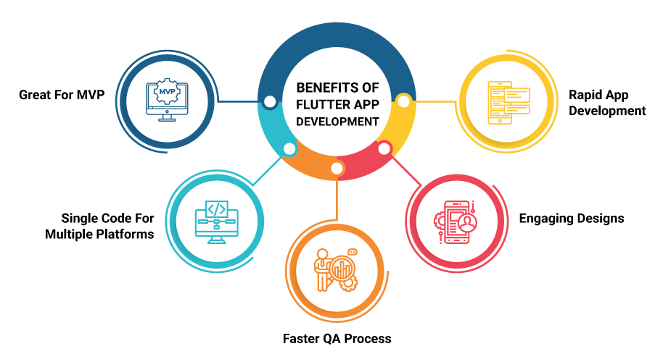](https://www.google.com/url?sa=i&url=https%3A%2F%2Fmedium.flutterdevs.com%2Fwhat-is-flutter-its-benefits-and-limitations-c795c94dfb16&psig=AOvVaw1eOI-bjVW0qTX7QJXNjRlI&ust=1683669673413000&source=images&cd=vfe&ved=0CBAQjRxqFwoTCPCEyLjc5v4CFQAAAAAdAAAAABAE)

Figure 2

What is Flutter?

Flutter was initially launched by Google in 2017 and has since gained popularity among developers due to its fast development cycle and ability to build high-performance, cross-platform mobile applications.

Flutter uses the Dart programming language as its primary language and provides a rich set of pre-built widgets and tools for building beautiful, responsive, and natively compiled applications for mobile, web, and desktop platforms.

One of the key features of Flutter is its ability to provide a highly customizable and performant user interface. Flutter uses a reactive programming model that allows developers to easily create complex UI elements and animations, all while maintaining smooth performance across a wide range of devices. [4]

Flutter also provides a "hot reload" feature that allows developers to see the effects of changes to their code almost instantly. This makes it easier for developers to iterate and improve their code, reducing the time required for testing and deployment.

Overall, Flutter's ability to quickly and efficiently build high-quality, cross-platform mobile applications has made it a popular choice among developers and businesses.

## Flutter Core Features

Some of the crucial features of the Flutter framework in app development include:

* Hot Reload: Flutter's hot reload feature allows developers to make changes to the code and see the results immediately in the app. This feature helps in making the development process faster and more efficient.
* Widgets: Flutter has a rich set of pre-built widgets that make it easier for developers to create beautiful and interactive user interfaces. Widgets can be customized to fit the specific design needs of the application.
* Dart Programming Language: Flutter uses Dart programming language which is easy to learn and offers features like just-in-time (JIT) compilation, garbage collection, and a rich set of libraries. It is also capable of running on different platforms like the web, server, and mobile.
* Cross-Platform Development: Flutter allows developers to build applications for multiple platforms like Android, iOS, and the web from a single codebase. This reduces the development time and effort significantly.
* Material Design and Cupertino Widgets: Flutter offers two sets of widgets that conform to the Material Design and iOS design guidelines, respectively. These widgets make it easier to create platform-specific user interfaces.
* Third-Party Libraries: Flutter has a large community of developers and offers a variety of third-party libraries that help in enhancing the functionality and user experience of the application.
* Performance: Flutter offers high-performance applications with fast rendering and smooth animations, even on low-end devices.
* Open-Source: Flutter is an open-source project and allows developers to contribute to the development of the platform. This also ensures that the platform is constantly updated with new features and improvements.

In summary, Flutter offers a rich set of features that make it an ideal platform for building cross-platform applications with beautiful user interfaces and high performance. [5]

## Advantages of Flutter

* Cross-platform development: With Flutter, developers can build applications for both Android and iOS platforms from a single codebase. This significantly reduces the development time and cost, making it easier to maintain and update the application.
* Fast development: Flutter provides a wide range of pre-built widgets that can be easily customized to create beautiful and responsive user interfaces. It also offers a rich set of libraries and tools that make it easier for developers to write clean, concise, and maintainable code.
* Great community support: Flutter has a large and active community of developers who constantly contribute to the development of the framework, providing help, support, and resources to other developers.
* Compatibility with other programming languages: Flutter is compatible with other programming languages such as Kotlin, Swift, and Java. This allows developers to integrate Flutter modules into existing applications and leverage its benefits without having to rewrite the entire application.
* Easy integration with backend technologies: Flutter provides built-in support for RESTful APIs and Graph, making it easier to integrate with backend technologies.
* In summary, Flutter provides several advantages to developers, including cross-platform development, Hot Reload, fast development, high performance, great community support, compatibility with other programming languages, and easy integration with backend technologies. These advantages make Flutter an excellent choice for building mobile applications. [6]

**Alternative:**

## Java -

Java is a popular and widely used general-purpose programming language that was first released in 1995 by Sun Microsystems (now owned by Oracle Corporation). Java is designed to be platform-independent, which means that programs written in Java can run on any platform that has a Java Virtual Machine (JVM) installed. Java is platform independent; it means that Java code can run on any platform. It doesn’t require the source code on that machine at which platform, where it will be executed. A class file (.class file) can be executed on any platform i.e. Windows, Linux, Mac, etc. It means your code is portable.

That’s why an application can run on several devices without changing any code. This feature allows the application can run on any smartphone whether it is Samsung, Nokia, Lenovo, etc. Android Studio (IDE) uses DVM (Dalvik Virtual Machine) instead of JVM (Java Virtual Machine). The file generated by DVM is in the. dex format.

## Object-oriented -

Java is an object-oriented language, which means that it is based on the concept of objects. This allows developers to create reusable code and promotes code modularity.

Platform independence: Java is designed to be platform-independent, which means that programs written in Java can run on any platform that has a JVM installed. This makes Java a highly portable language.

Robust: Java is a highly robust language that provides automatic memory management and strong type checking. This makes it less prone to errors and more reliable.

Secure: Java has a strong security model that protects malicious code. It also offers support for cryptography and digital signatures.

Multi-threaded: Java supports multi-threading, which allows multiple threads to execute simultaneously. This makes it easier to create responsive and interactive applications.

Rich API: Java has a rich set of APIs that provide support for various functionalities such as networking, I/O, and database access.

Large community: Java has a large community of developers who constantly contribute to the development of the language and provide support and resources to other developers.

In summary, Java is a versatile and widely used programming language that provides a range of features such as object-oriented programming, platform independence, robustness, security, multi-threading, and a rich API. These features make Java an excellent choice for developing a wide range of applications, including web applications, mobile applications, and desktop applications

**Why Dart over Java?**

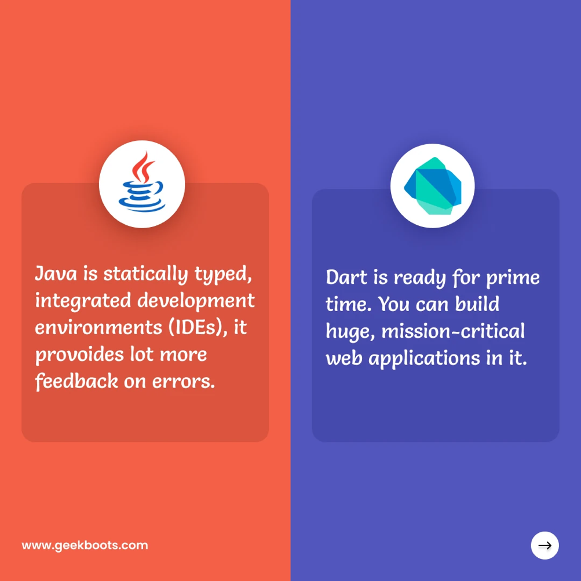

Figure 3

There are many alternative options available for this project, Java is one of them but there are some reasons why some options like Dart and Flutter are better than it.

* Simpler Syntax: Dart has a simpler and more concise syntax than Java, making it easier for beginners to learn and write code.

* Stronger Typing: Dart has a more robust type of system, which can help catch errors and improve code reliability.

* Better Performance: Dart's virtual machine and the just-in-time compiler can lead to faster performance than Java in certain situations.

* Designed for Web Development: Dart was designed with web development in mind, so it comes with features like asynchronous programming and a built-in package manager, which can make web development easier and more efficient.

* Flutter Framework: Dart is the primary language used for developing apps with the Flutter framework, which allows for the cross-platform development of mobile and web apps with a single codebase. [7]

# 3.Design or Methodology

A software development methodology typically includes a series of phases or stages that define the overall process, with specific activities, tasks, and deliverables for each step. The methodology also includes guidelines for project management and quality assurance.  
Various methodologies are available for software development, including Waterfall, Agile, DevOps, Rapid Application Development, and Lean. Each method has advantages and disadvantages, and choosing the right method depends on factors such as project scope, schedule, team size, and project complexity.

## Spiral model

The Spiral software methodology is an iterative model used in software development. It is a risk-driven process model that emphasizes risk analysis, evaluation, and management throughout the software development process.

The Spiral model consists of four key phases that are repeated in a continuous loop until the project is completed. These phases are:

1. Planning: In this phase, project objectives are defined, requirements are gathered, and a preliminary design is developed.
2. Risk Analysis: In this phase, risks are identified, analysed, and prioritized. Strategies are developed to manage and mitigate the risks, and the project is re-evaluated based on the results of the risk analysis.
3. Engineering: In this phase, the software is designed, developed, and tested in small increments. Results from each iteration are evaluated and incorporated into the next iteration.
4. Evaluation: In this phase, the software is evaluated to ensure that it meets the project requirements and objectives. Feedback is gathered, and the process starts again, moving on to the next iteration.

The Spiral model is particularly useful for large and complex projects where requirements are not clearly defined, or where risks are high. The model allows software developers to quickly identify and mitigate risks, and adjust their approach as necessary to ensure a successful outcome.

The Spiral model is also flexible and can be tailored to suit the needs of the specific project. The process is iterative and allows for continuous feedback and improvement, making it ideal for projects that require a high degree of collaboration between the development team and the client or customer.

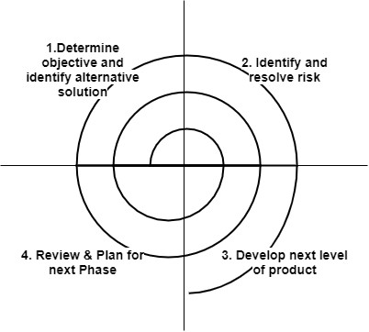

Figure 4

The Spiral software methodology is a risk-driven approach to software development that combines elements of both the Waterfall and Agile methodologies. Some of the advantages of using the Spiral methodology are:

1. Risk management: The Spiral model places a strong emphasis on risk management, with risk analysis and mitigation being a key aspect of each iteration. This helps to identify and address potential issues early in the development process, reducing the likelihood of major problems occurring later on.
2. Flexibility: The Spiral model is more flexible than the Waterfall model, allowing for changes to be made at any stage of the development process. This is particularly useful in projects where requirements are likely to change or evolve.
3. Incremental development: The Spiral model is an incremental development process, with each iteration building upon the previous one. This allows for feedback and adjustments to be made throughout the development process, resulting in a more refined final product.
4. Customer involvement: The Spiral model places a strong emphasis on customer involvement throughout the development process. This ensures that the final product meets the needs of the customer and is more likely to be accepted and adopted.

1. Efficient use of resources: The Spiral model allows for the efficient use of resources by focusing on high-risk areas early in the development process. This helps to avoid wasting time and resources on areas that are unlikely to cause problems.

## Comparison

The Spiral model and the Waterfall model are two common approaches to software development. While both models have their advantages and disadvantages, some key differences between them make them suitable for different types of projects. Here are some of the main differences between the Spiral model and the Waterfall model:

1. Approach: The Waterfall model is a linear, sequential approach to software development, where each phase of the development process is completed before moving on to the next phase. The Spiral model, on the other hand, is a risk-driven approach that emphasizes iterative development and risk analysis.
2. Flexibility: The Waterfall model is less flexible than the Spiral model, as it is difficult to make changes once a phase has been completed. The Spiral model allows for more flexibility, as changes can be made at any stage of the development process.
3. Risk management: The Waterfall model does not place a strong emphasis on risk management, while the Spiral model places risk analysis and mitigation at the centre of each iteration.
4. Time and cost: The Waterfall model is generally more predictable in terms of time and cost, as each phase has a clear set of objectives and deliverables. The Spiral model, however, can be more difficult to predict in terms of time and cost, as each iteration may uncover new risks and issues that need to be addressed.
5. Customer involvement: The Waterfall model typically involves less customer involvement than the Spiral model, as the customer is only involved in the requirements phase. The Spiral model, on the other hand, places a strong emphasis on customer involvement throughout the development process.

My Expense Manager follows the Spiral model methodology because it has many advantages that are best suited for my project requirements, such as the ability to add features at runtime. The Spiral model's focus on risk management and iterative development is particularly useful for projects that may have changing requirements over time. In addition, the model emphasizes customer involvement and feedback to ensure that the final product meets user needs and expectations.

By following the Spiral model, identify and address potential issues early in the development process, which reduces the likelihood of major problems arising later on. This helps to ensure a smoother development process while saving time and resources. Moreover, the model's incremental approach to development allows for frequent testing and validation of the product, leading to a more refined final product.

Overall, the Spiral model is a flexible and effective methodology that can help to deliver a high-quality Expense Manager that meets the evolving needs of the project definition.

Design

The application should have a simple user interface to navigate through and understand. Customers should have the choice to quickly and accurately enter their expenses and check their spending reports. The client should be able to track and plan their spending using the application. Customers should have the opportunity to add fees and sort them by kind. To ensure users' financial information security, the application should demand a reliable login. Customers should be given the choice between creating a unique login and a secret phrase. The application provides information perception highlights, such as outlines and charts, to help users better understand their money management strategies and identify areas where they may cut back.

Application Architecture

Model-View-Regulator (MVC) is an example of a programming configuration that is typically used to implement user interfaces (UIs), information, and controlling logic.

Data structure

In this project, we are using the Shiver SQLite package. SQLite uses a social information model, which means that data is stored in tables with lines and segments. Each table discusses a component, and each table's column discusses an occurrence of that component.

## Use case

A use case diagram is a type of behavioural diagram in the Unified Modelling Language (UML) that represents the interactions between actors (users, systems, or other entities) and the system under consideration to achieve a specific goal or function. It is used to depict the functionality of a system in a clear, concise, and graphical way and to help stakeholders understand how the system will be used in various scenarios. Use case diagrams typically consist of actors, use cases, and their relationships, which help to identify the requirements of the system and ensure that it meets the needs of its users. Below is a use case diagram of My Expense Manager.

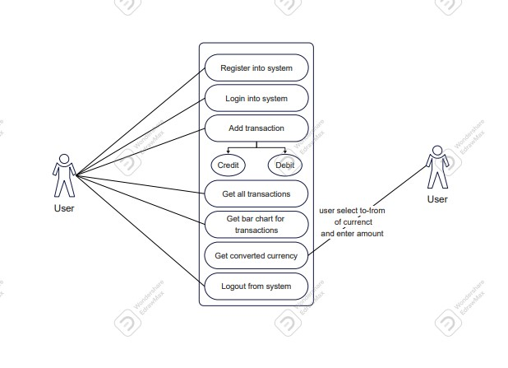

Figure 5

Wireframe

A wireframe for a mobile application is a visual representation of the layout and functionality of the app. It is a simple, low-fidelity blueprint that outlines the basic structure and navigation of the app, without getting into the details of the design or aesthetics.

The wireframe usually consists of a series of simple, monochromatic sketches or diagrams that depict the key elements of the app, such as buttons, menus, forms, and content areas. The wireframe may also include annotations or notes that describe the intended functionality of each element. [8]

Wireframes are an essential part of the mobile app development process, as they help to communicate the app's structure and functionality to stakeholders, developers, and designers. They allow for early feedback and iteration and can help to identify potential problems or usability issues before the app is built. Below is the wireframe of My Expense Manager.

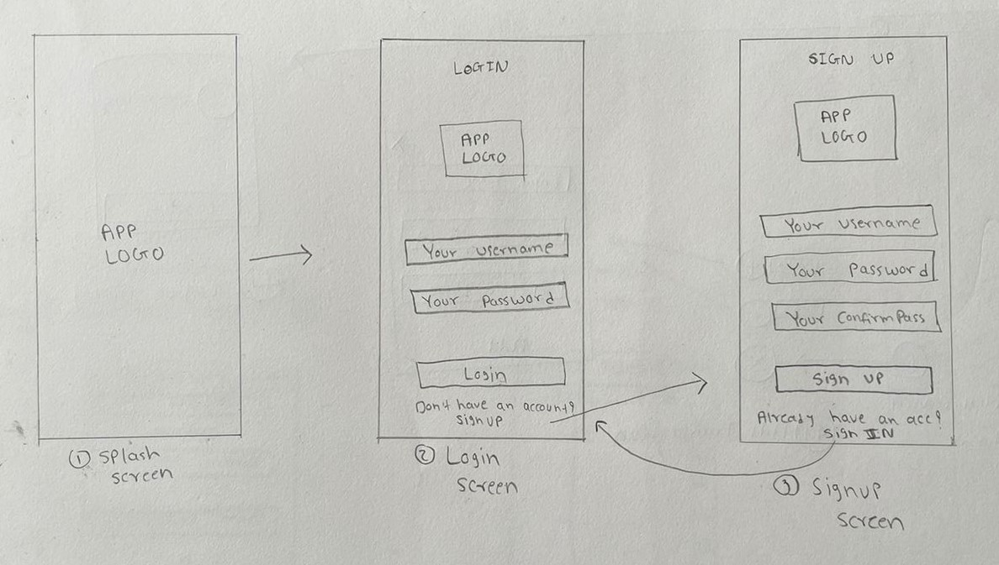

Figure 6

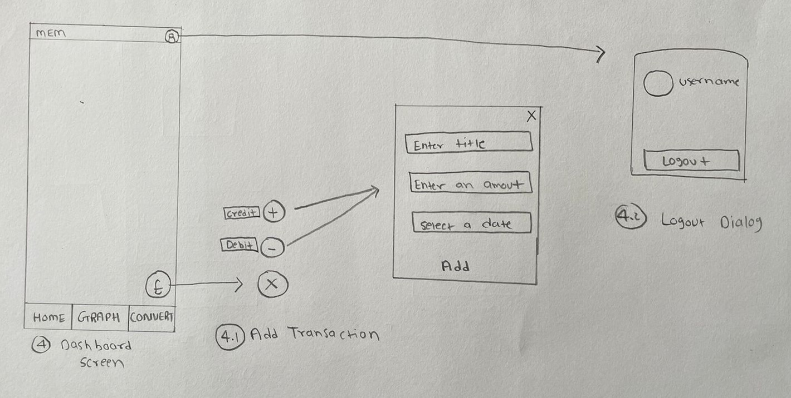

Figure 7

# **4.Results**

There are many applications available in the Appstore which work like MY EXPENSE MANAGER but in such applications, some errors and issues are happening which are faced by many users. For example, in Android, there is one application MYMONEY which we take as our reference for our project. We tested that application in a practical test after that we find out that there are some features which are not available in that application.

* In that application, action there is no multi-users feature available while in my expense manager, we provide the multi-user feature.
* The interface of that application is not that user-friendly. There are so many steps to enter data while, in my expense manager the interface is very simple and, in a few steps, users can enter their data in the record.
* The graphical representation in that application is not very understandable, while we kept that thing in our mind and my expense manager the graph of all incomes and expenses will come in a simple Bar chart which is very easy to understand.
* Many students are studying in foreign countries where they find difficulty calculating their earnings in their native currency. To solve this problem, my expense manager came up with a currency converter feature.

1. Login Screen

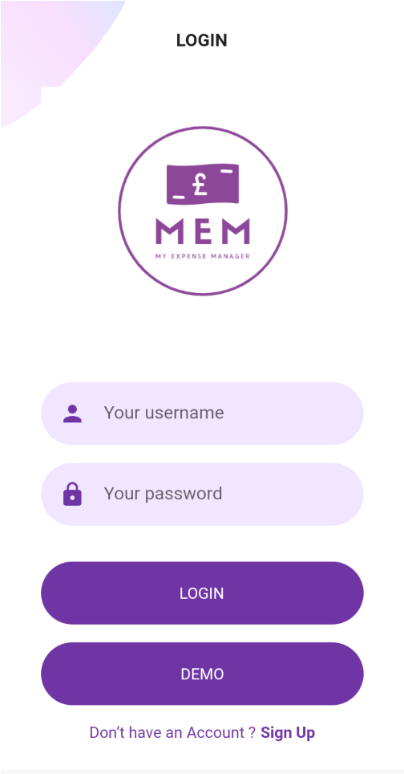

Figure 8

* This is the home view of the applications. It is the first interface which users will see. Here if a person has already an existing account in the application. If the user does not have an account in the application, then users can create their account by clicking on Sign Up where they redirect to another page.
* Clicking on the demo button will redirect you to a page where you can watch a demonstration video showing how everything works.

1. Signup Screen

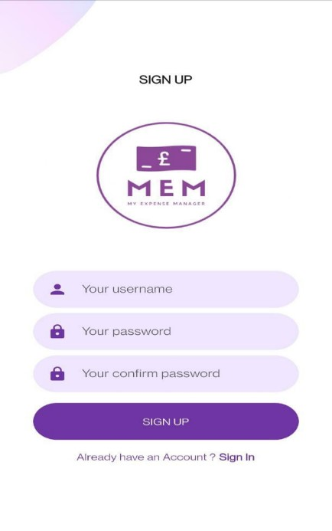

Figure 9

* + Here the user will be able to create a new account by entering details in the given fields. Then the user will be redirected to the first page where they must enter the login details which were given by them while creating a new account.

1. Dashboard

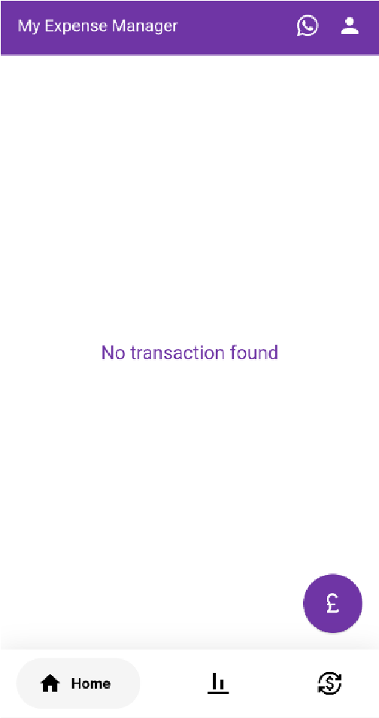

Figure 10

* + Once users enter their login details, they will come to this dashboard where they can see these transactions of all expenses and incomes. On Dashboard, they will also find 3 other options. By clicking on the purple button user will get two other options for entering their credit or debit.

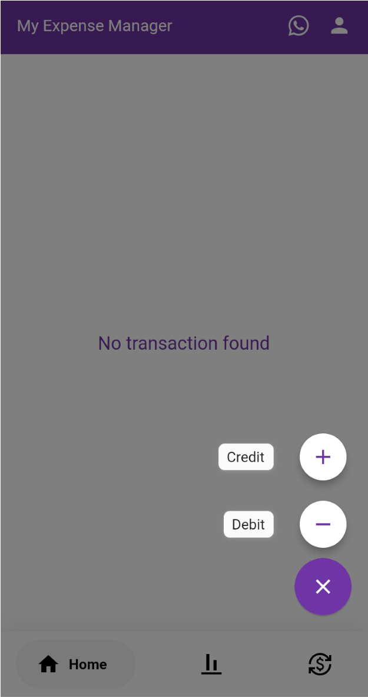

Figure 11

* + Now, this type of option will appear on the user’s screen where they can enter their expense and income by just clicking on the plus button for credit and the minus button for debit. After that users come see one option of entering the amount and date.
  + This is the interface which comes after clicking on the credit or debit button, here user will get three information options in which the first option is for the title of an expense then the user must enter the amount and in the last option date of that must be selected.
  + This is the dashboard view once the user enters the detail of transactions. Here the debit transactions will come minus sign, and the credit transaction will appear with a plus sign and at the bottom of that there is the date mentioned of that transaction. [9]

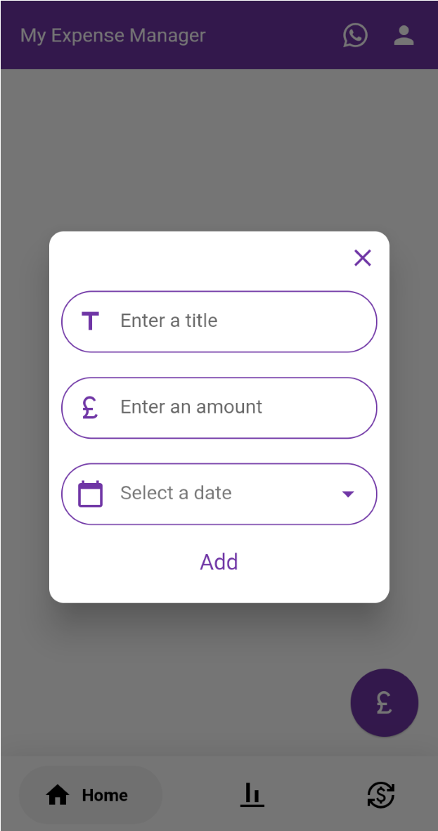 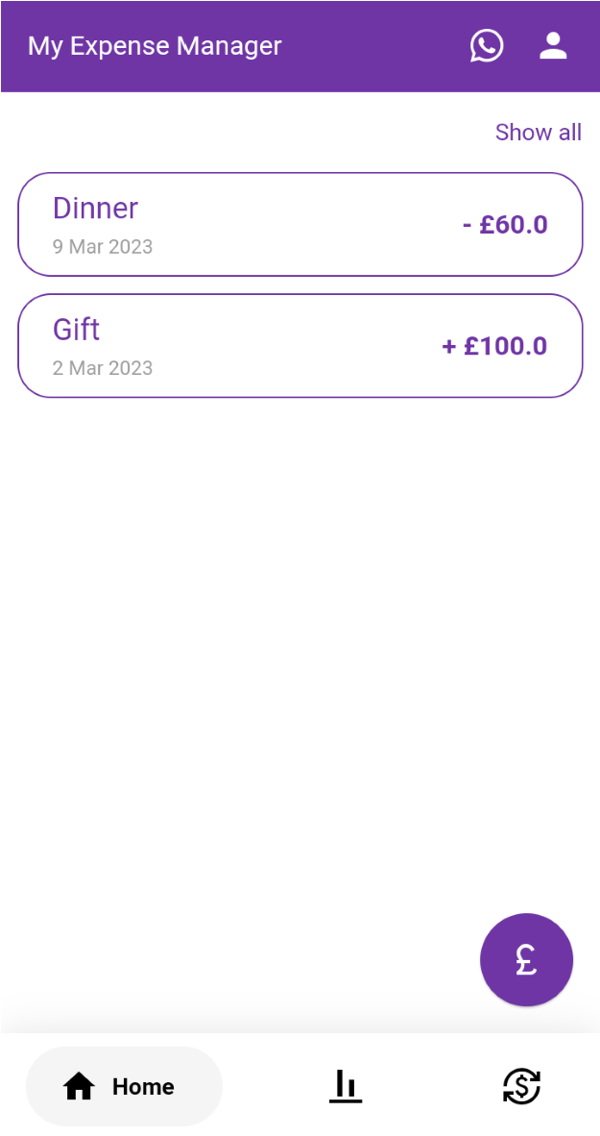

Figure 12

* + It appears that on the dashboard, there is a share button that allows users to share a list of transactions on other apps such as WhatsApp and email. When the user clicks on the share icon, the list of transactions is converted into a PDF format and can be shared directly from the dashboard. This feature makes it easier for users to share their transaction records with others, saving them time and effort in manually creating and sending the records.

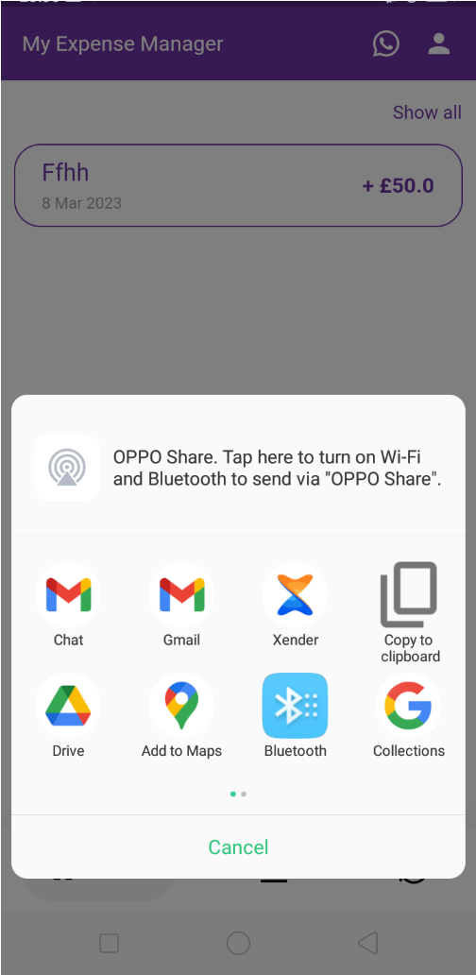

Figure 13

* + Here is the graphical representation of all expenses and income transactions which the user inputted in the dashboard. In the red bar, the expenses are given, while in the green bar, the incomes are shown with a respective date.

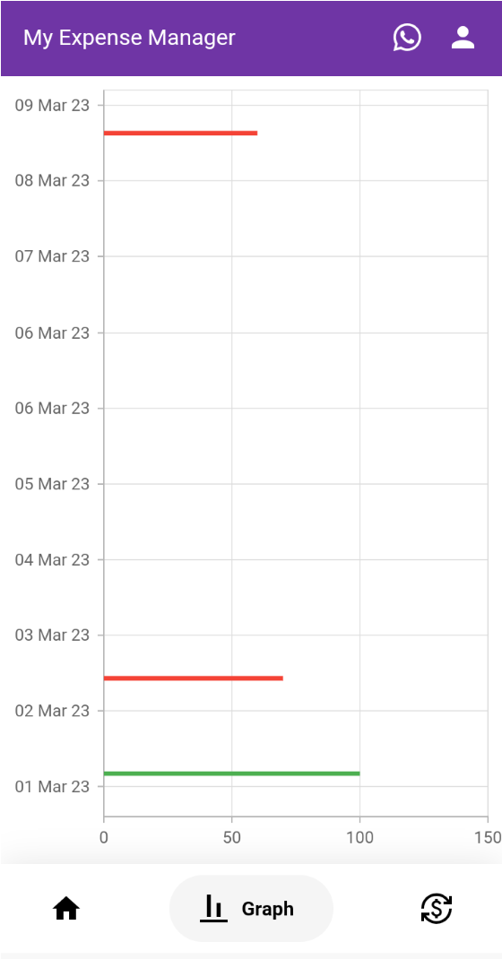

Figure 14

* + This option will come once the user clicks on the converter button which is given in the bottom right corner of the dashboard. This is a currency converter option in which the user can convert one country’s currency to another country, this type of option is not available in other applications.

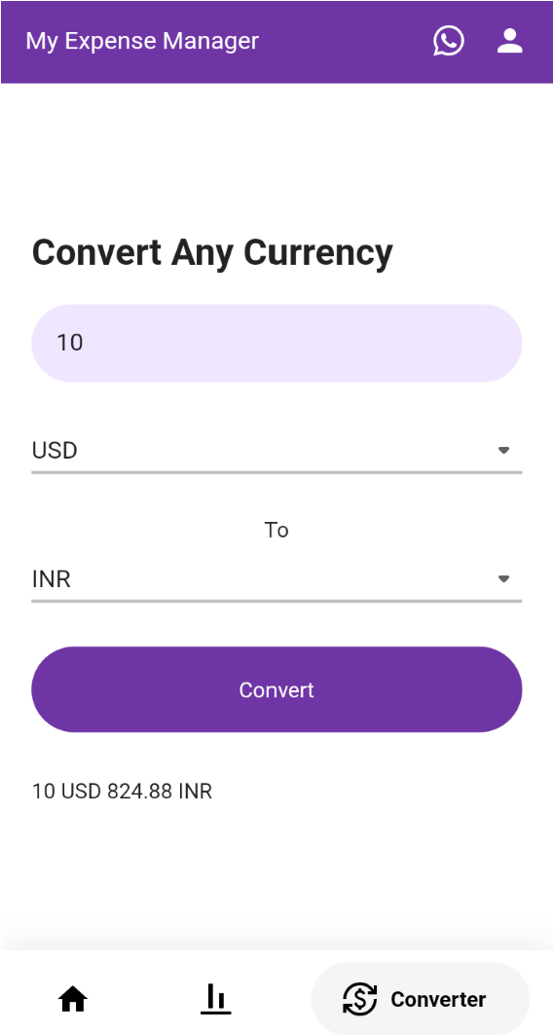

Figure 15

* + Users can log out of their account by clicking on the top right icon, then after an option will appear on the screen whereby clicking on the Logout button the account will be logged out. Users can also use this option to log in with different accounts.

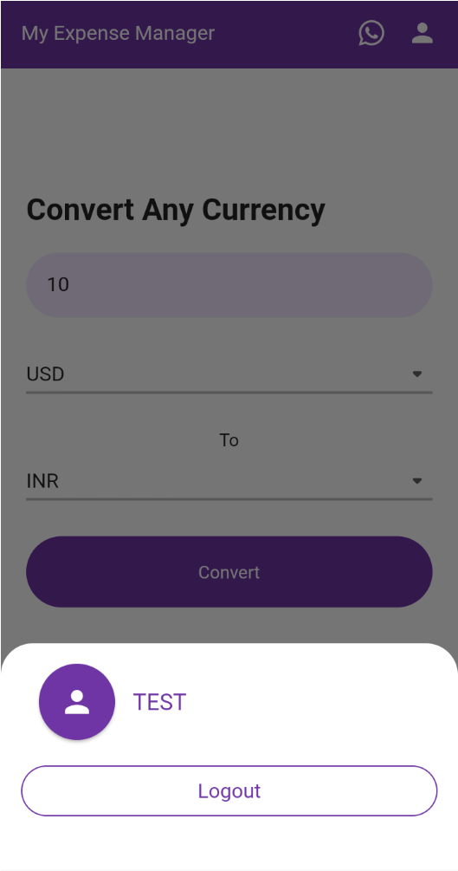

Figure 16

**Alternative approaches**

The fundamental add information in notes application on the phone and add information in Excel are the new and old methodologies, but they don't include other elements like offers, auto ascertainment, and other things. The Excel or note application is easy to use and quite basic. The two of them are also now available on our phones or PC. The two of them won't provide our application's features like diagramming, sharing, and currency conversion. Application configuration is made by me using web resources for this type of application, and it is extra simple and user-friendly. [10]

**Implementations**

By using APIs, for example, the money converter Programming interface, clients of the program can undoubtedly trade monetary standards across various nations, without the requirement for manual computations or getting to outside cash trade instruments.

Figure 17

The user's current costs and income are summarised in the home section, and their spending patterns over time are shown visually in the chart view. A currency converter is a useful tool for people who regularly travel or deal with foreign currencies since it allows users to convert between different currencies with ease and track their spending in the currency of their choice. Overall, this dashboard gives customers a thorough and individualised perspective of their money, assisting them in keeping tabs on their spending and making wise financial decisions. [11]

Figure 18

Figure 19

This strategy of designating unique folders for each library not only aids in improving the organisation of the job but also makes it simple for others to browse the various libraries and comprehend their purposes. Developers may quickly discover the precise library they require and examine its contents clearly and straightforwardly by putting each library into its folder. As a result, developers may more quickly locate the necessary code and begin to work without wasting time looking through crowded or disorganised files, which helps to minimise confusion and increase overall productivity.

**Evaluation**

I used a client-focused plan method, which involved gathering feedback from clients throughout the improvement cycle, to evaluate the practicality of expense management application. To understand the needs and preferences of clients, I led the client's Google survey analysis.

I made significant improvements here in response to criticism of the application's announcing and arranging features, including sharing reports to make it easier to share reports with loved ones.

In general, the feedback I received from clients helped me much as I worked to improve the functionality and usability of my daily cost application. I had the opportunity to create an application that solves the concerns and preferences of our objective clients, providing a useful tool for managing daily expenses. This was made possible by a client-focused plan approach and regular evaluation of our work.

Figure 20

**Related work**

When developing an Expense management application, it's important to look at comparable work in the industry to better understand current arrangements, spot any gaps that need to be filled, and get inspiration for new ideas and functionality. In my research, I looked at a few current expense management programmes, such as Mint, Expensify, and Pocket Guard, to learn more about the crucial features and design elements that make these programmes effective.

One key feature of many of these programmes is the ability to follow and order costs in a timely manner, saving users time and effort when managing their money. Numerous programmes also provide clients with natural views and reports that enable them to successfully monitor their money management practises and identify growth areas.

CC

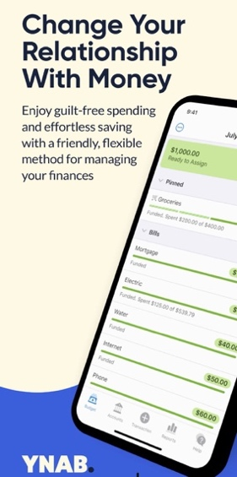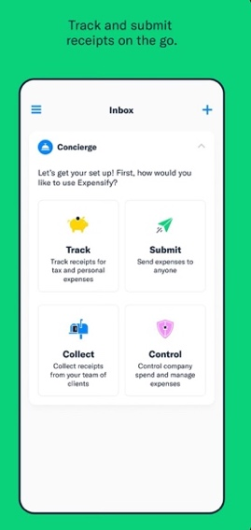

Figures 21 & 22

# **5.Conclusion**

All my efforts in this project have been directed towards making this programme beneficial for users, and I can tell you that my expense manager will assist users in controlling the expense of their regular outlays.

Users may use this software to become more mindful of their everyday costs. Many young people become irritated by their inability to manage their costs. To assist them resolve this problem, my expense manager keeps track of all their daily outlays and can help them alter their habitual spending patterns. Users can effortlessly manage their hard-earned money in beneficial goods after using this programme for a few weeks. In addition to this, they can also plan their saved amount of money for any future investment, or they can also use this money for any start-up.

## Reflection

Many obstacles are undoubtedly encountered while working on this project, but some lessons are primarily learned along the way, such as the value of saving money and planning for a financially secure future in case of emergencies like pandemics, or so they originally believed. Other than teaching me how to accomplish this assignment, which is undoubtedly rather vital, this project also taught me about respect for time and discipline, which generally play a crucial role in life.

Technical Side

* How android studio work with Dart and Flutter.
* Flutter UIUX using widgets.
* Local Database of Flutter (SQLite).
* Flutter Plugins.

## Future Work

Currently, the programme only keeps data locally, which means that if a user uninstalls the application, all of their data would be lost. In the future, I aim to build an online real-time database using Google services. This means that any user may log in from any device and see the most recent data. In addition, I'll develop a web service for commercial use.

# **References**

These are the references that are used to create this application, which is mentioned below.

|  |  |
| --- | --- |
| [1] | “Usage of Android Studio for this project.,” [Online]. Available: https://developer.android.com/studio/install . |
| [2] | “How does Flutter work in this project?,” [Online]. Available: https://support.macincloud.com/support/solutions/articles/8000095836-use-flutter-withandroid-studio-on-macincloud-hello-world- #:~:text=Install%20the%20Android%20SDK%20tools,the%20bottom%20of%20the%20w window . |
| [3] | “How GitHub can use in this application?,” [Online]. Available: https://support.macincloud.com/support/solutions/articles/8000095836-use-flutter-withandroid-studio-on-macincloud-hello-world- #:~:text=Install%20the%20Android%20SDK%20tools,the%20bottom%20of%20the%20w window . |
| [4] | “Flutter practices best for Designs,” [Online]. Available: https://support.macincloud.com/support/solutions/articles/8000095836-use-flutter-withandroid-studio-on-macincloud-hello-world- #:~:text=Install%20the%20Android%20SDK%20tools,the%20bottom%20of%20the%20w window . |
| [5] | “Flutter pub spec.,” [Online]. Available: https://docs.flutter.dev/development/tools/pubspec . |
| [6] | “How Flutter plugins work.,” [Online]. Available: https://medium.flutterdevs.com/plugins-in-flutter-plugins-created-by-flutterdevsd45b8ac29cb9#:~:text=Plugins%20are%20the%20wrapper%20of,other%20developers %20to%20its%20ecosystem . |
| [7] | “Flutter works with local database SQLite.,” [Online]. Available: https://pub.dev/packages/sqflite . |
| [8] | “Logo creation for application,” [Online]. Available: https://www.wix.com/createlogo6/logo- maker?utm_source=google&utm_medium=cpc&utm_campaign=19604758279^1470862 51642&experiment_id=create%20a%20logo%20app^e^645859685928^&gclid=Cj0KCQi Az9ieBhCIARIsACB0oGKCj_4pB- jraw2j3. |
| [9] | “Open exchange API for currency.,” [Online]. Available: https://openexchangerates.org/ . |
| [10] | “Reference from Times of India’s article on money management for youngsters.,” [Online]. Available: https://timesofindia.indiatimes.com/education/online-schooling/why-is-financialmanagement-essential-for-senior-school-children/articleshow/94101487.cms . |
| [11] | “The application took as a reference for this project.,” [Online]. Available: https://play.google.com/store/apps/details?id=com.raha.app.mymoney.free. |
| [12] | Developers, “Install Android Studio,” Developers. |
| [13] | MainCloud, “Use Flutter with Android Studio on MacinCloud: Hello World!,” *Application and Software,* 2022. |

# **Appendices**

MS2 submission-: Milestone 02 project approval.pdf

MS3 feedback-: Milestone 03 Mid Project Review_v03_Yaksh.pdf

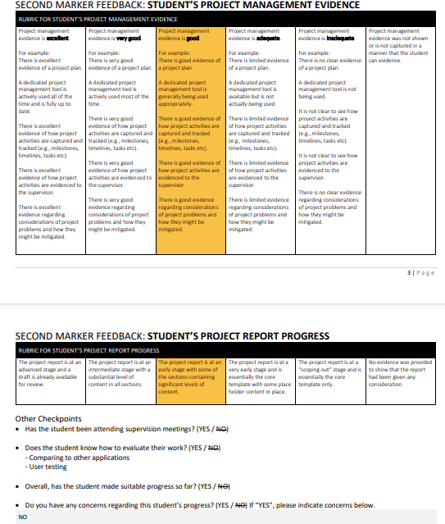

Project management tool-: https://yakshbhat.atlassian.net/jira/software/projects/MEM/boards/1

GitHub repo URL-: https://github.com/yaksh09/my_expense_manager.git

Project meeting evidence with supervisor-: “OUTLOOK & TEAMS”

