**Different Azure practicals during training**

**-Making of Load Balancer**

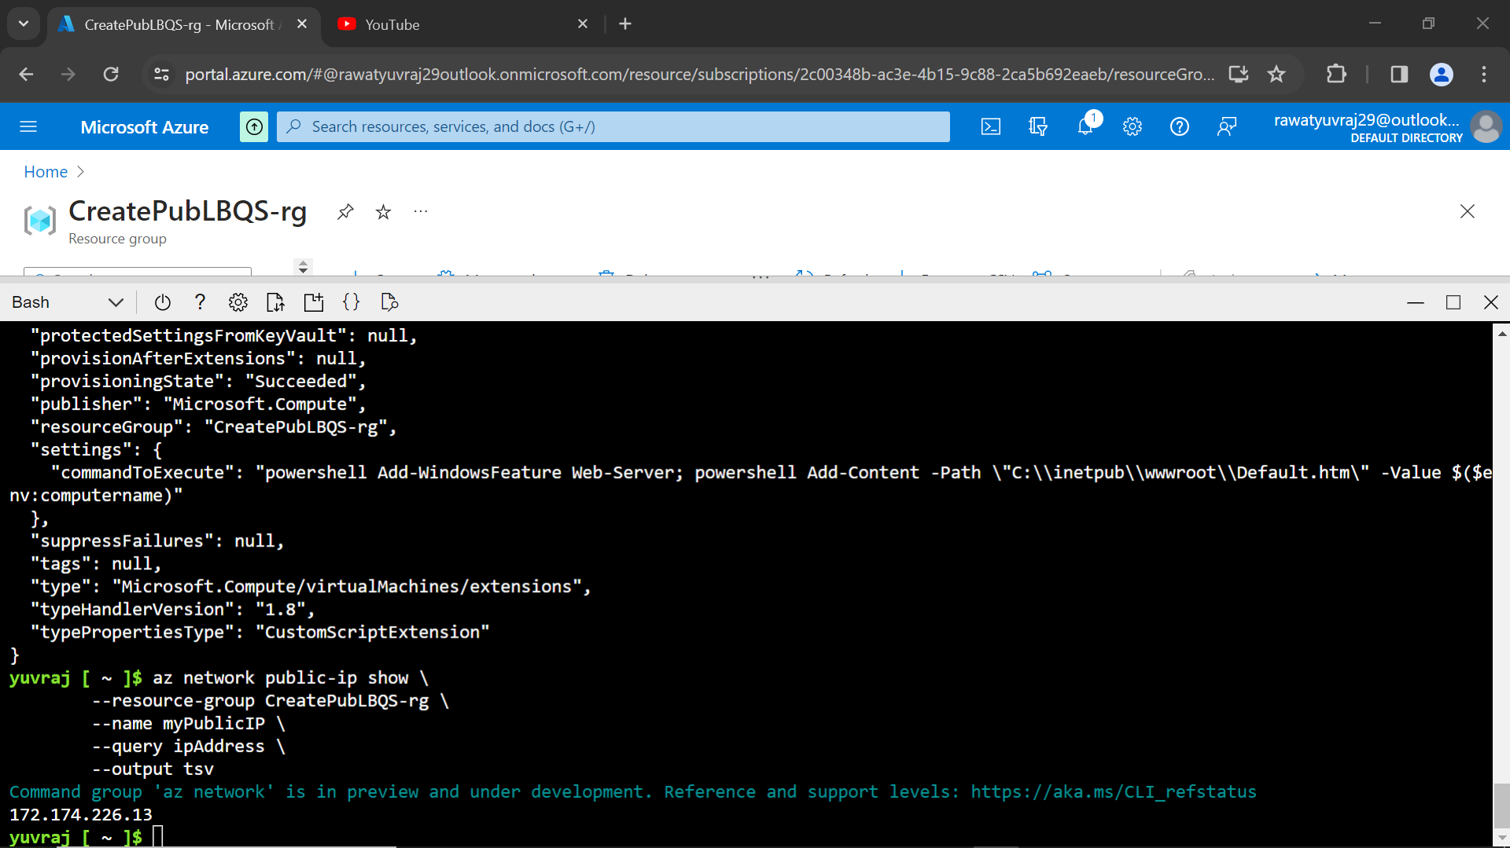

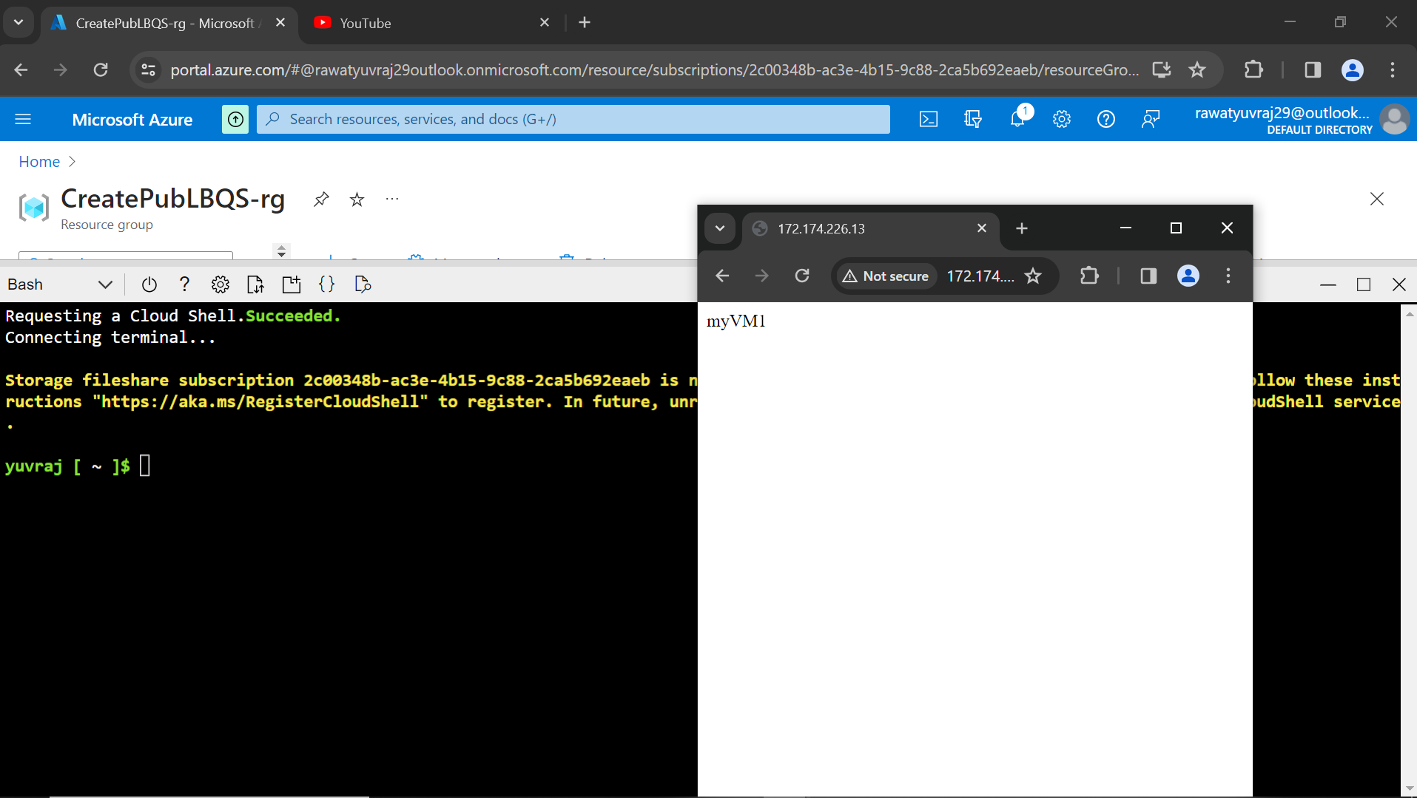

VNET PEERING

* **Connecting to the vm using ssh**

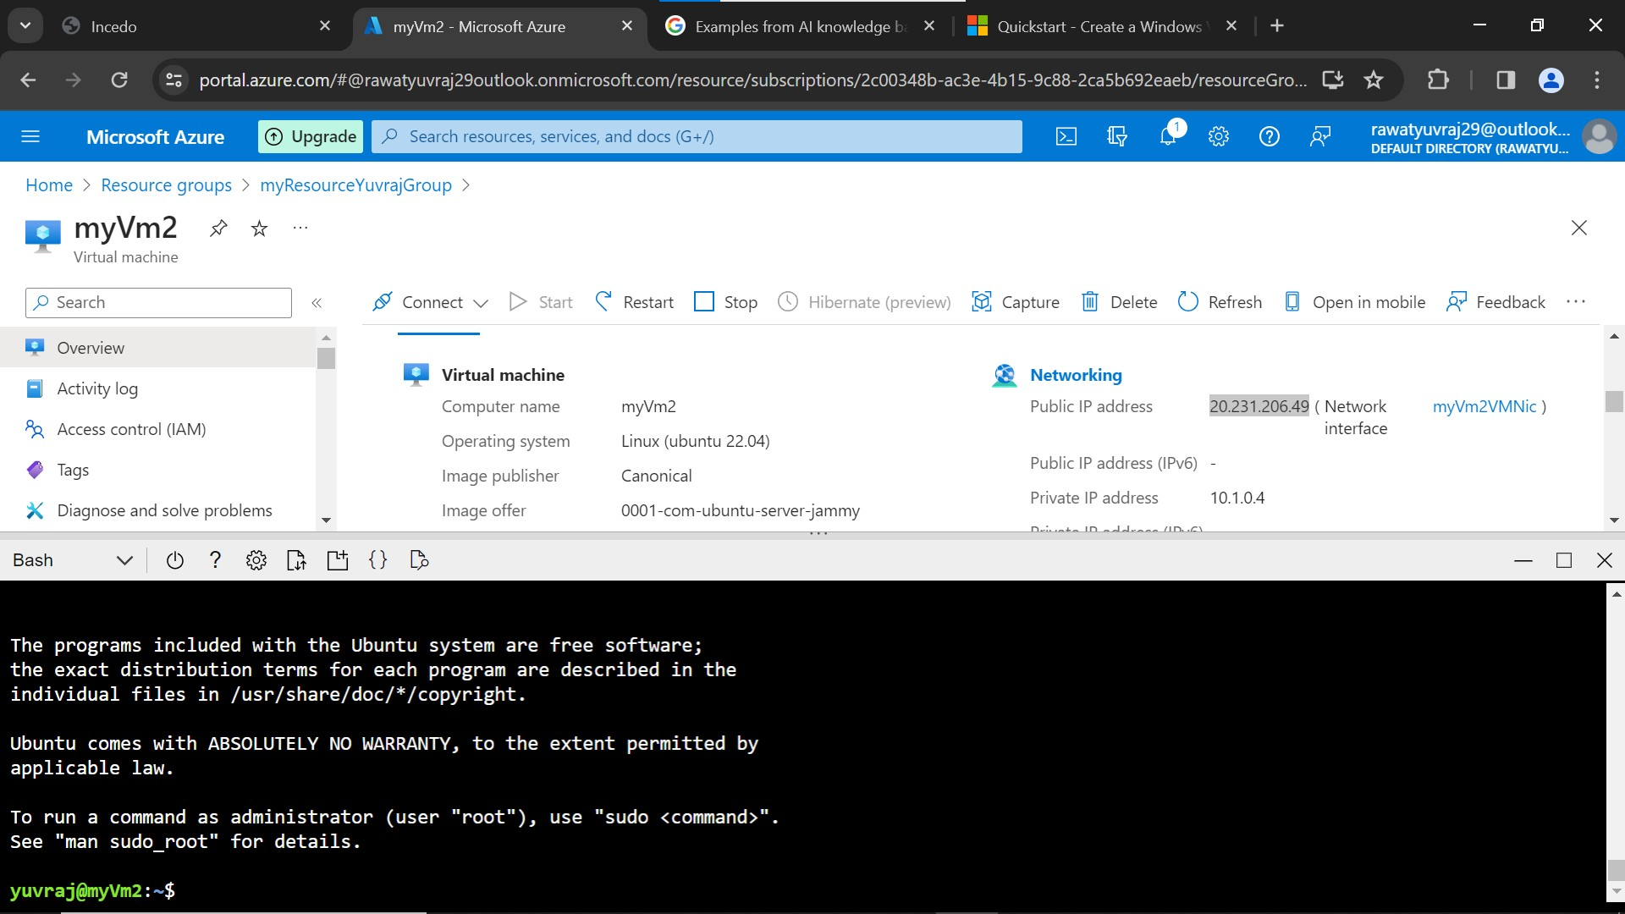

* **VNet1 is connected to Vnet2**

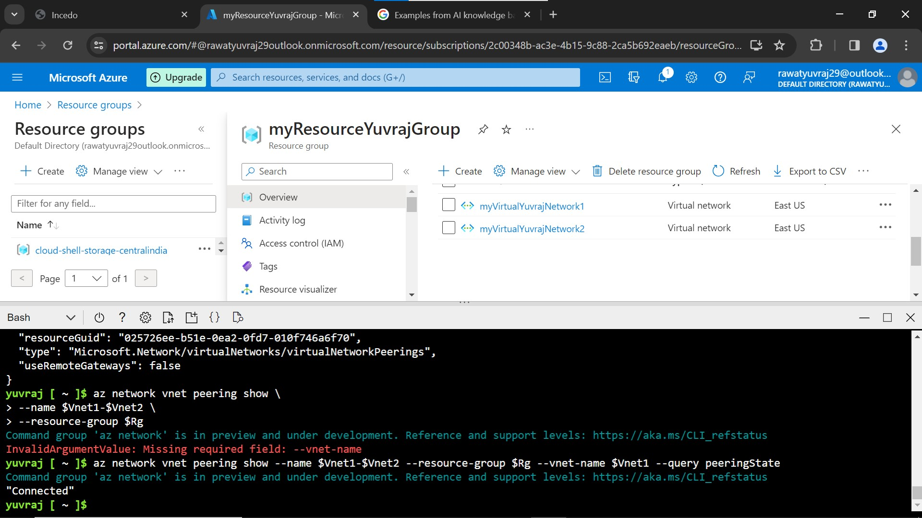

**– Pinging from one virtual machine in Vnet2 to virtual machine in Vnet1**

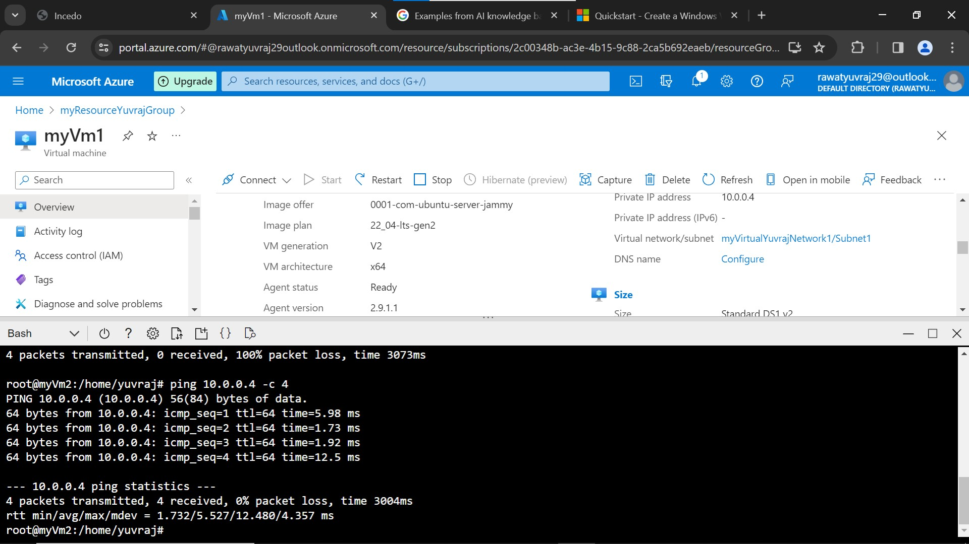

Docker

**– Pinging from one container to another container**

**Both the containers are in the same bridge network we made**

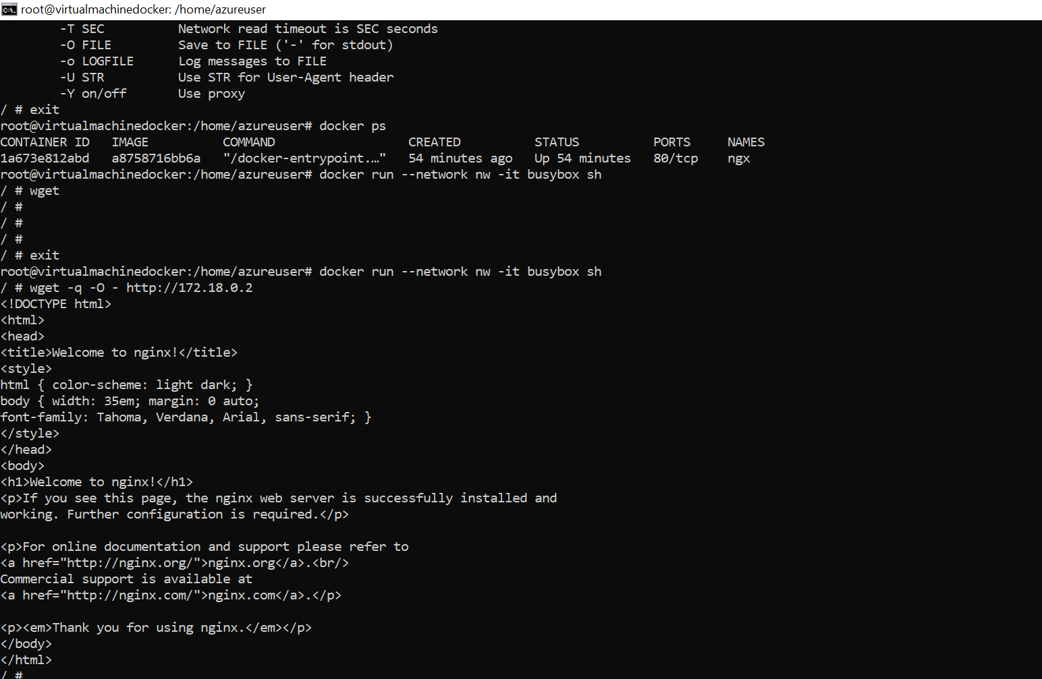

Data factory

**EXCEL TO EXCEL**

**–Making dataset 1 for source and connecting it to the link 1 and sink to link the dataset or location at 2 and making the pipeline**

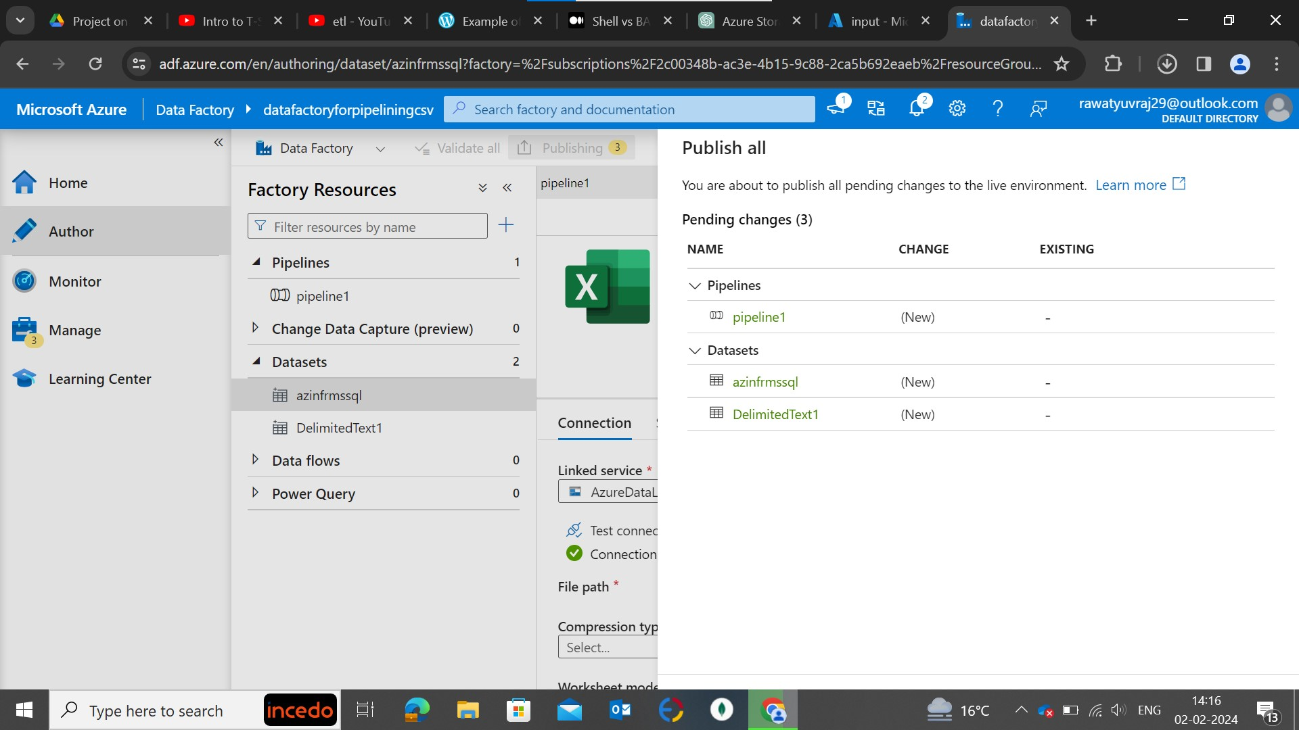

**–Executing the pipeline after publishing it**

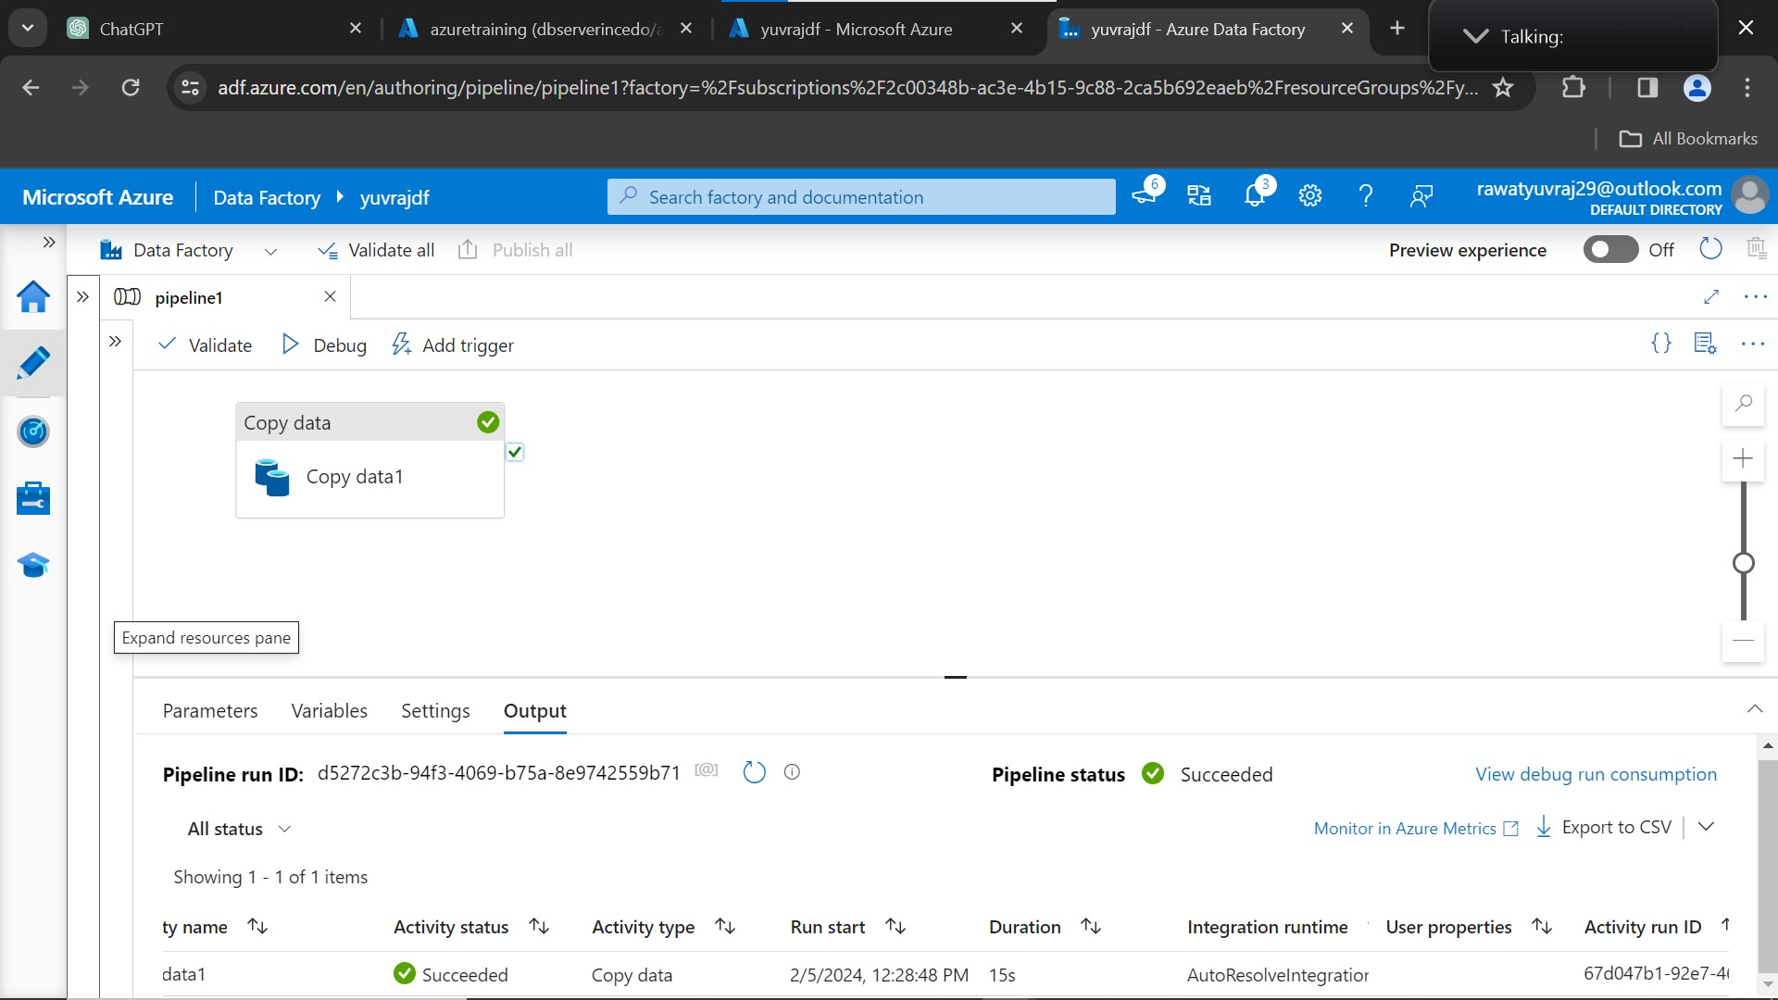

**– output container after the execution of the pipeline**

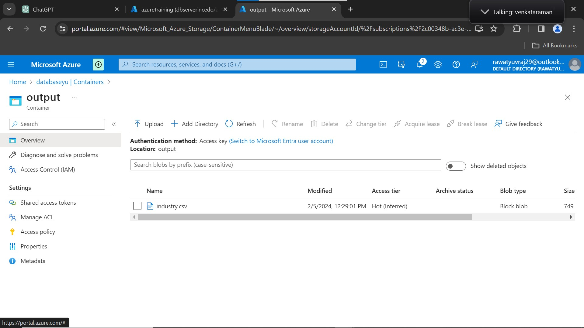

* **BLOB TO SQL**

**Made the text file and saved that file in container 1 and made a table in sql**

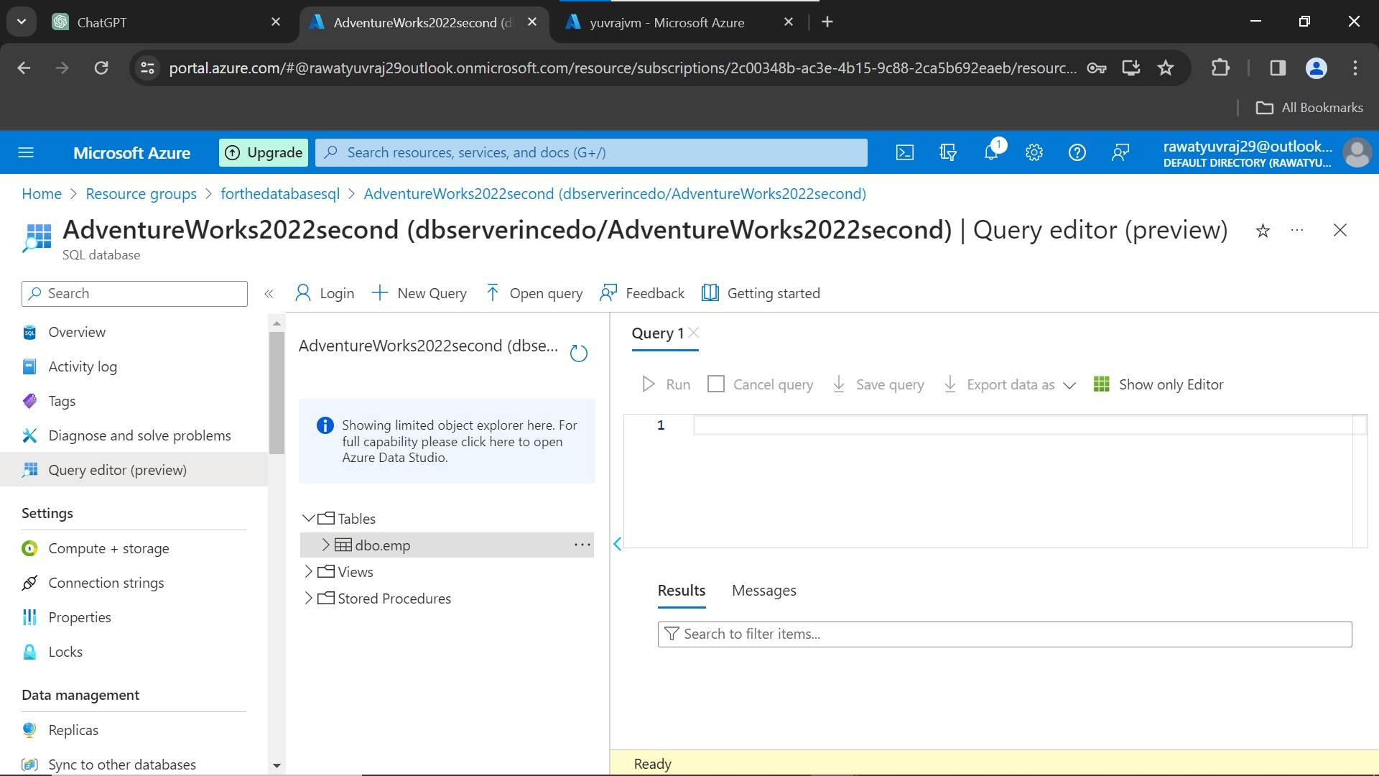

**–Made the pipeline connect the source(with the input container) and sink (with the sql database server)**

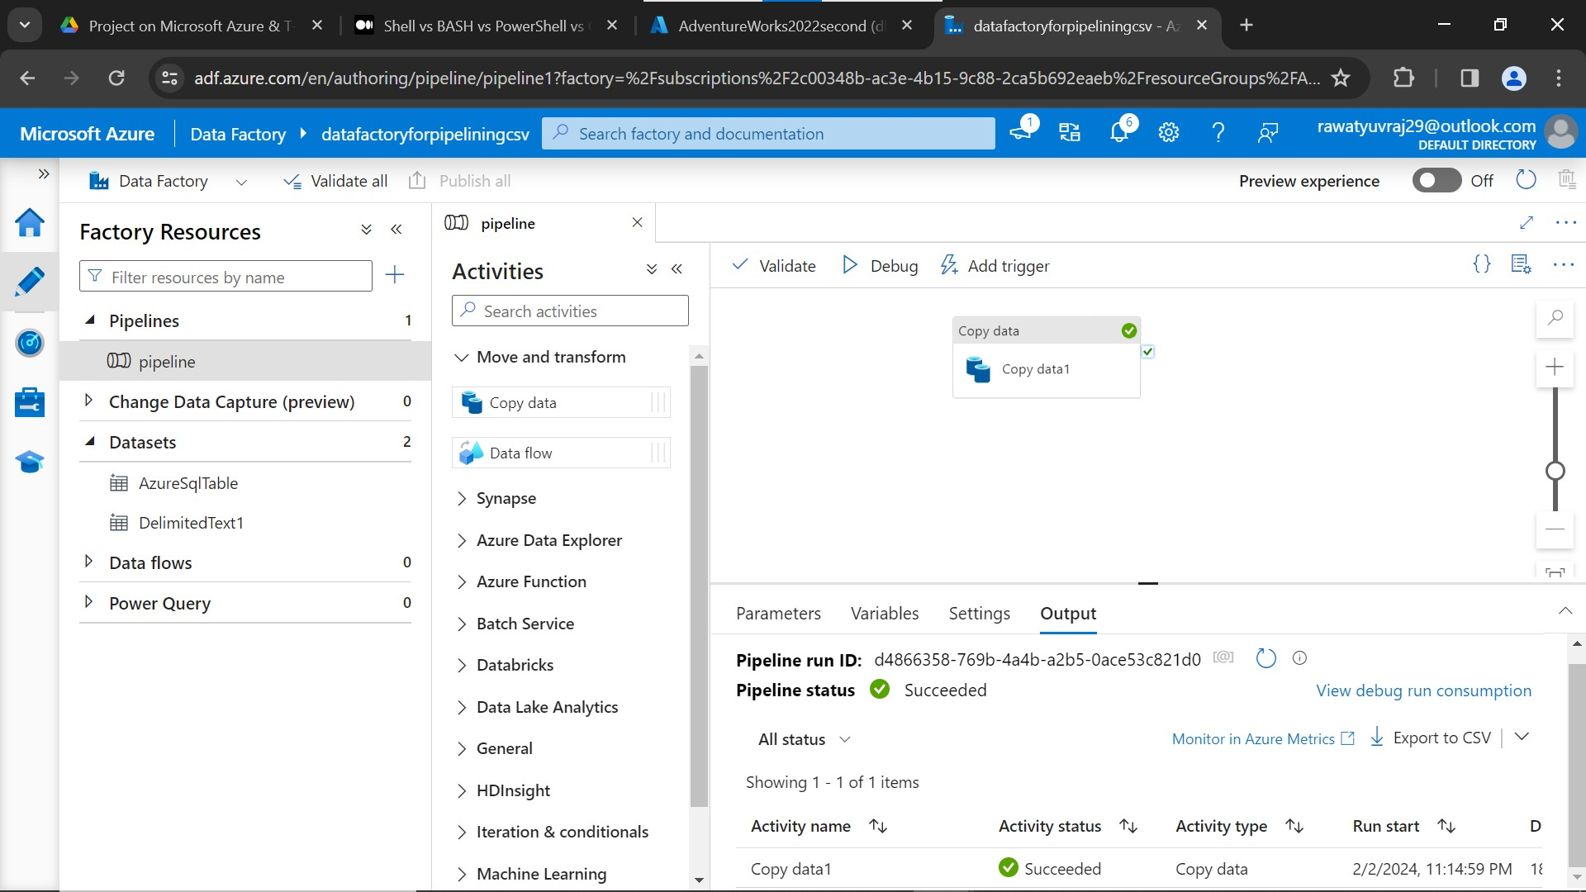

**– execute the pipeline after publishing it**

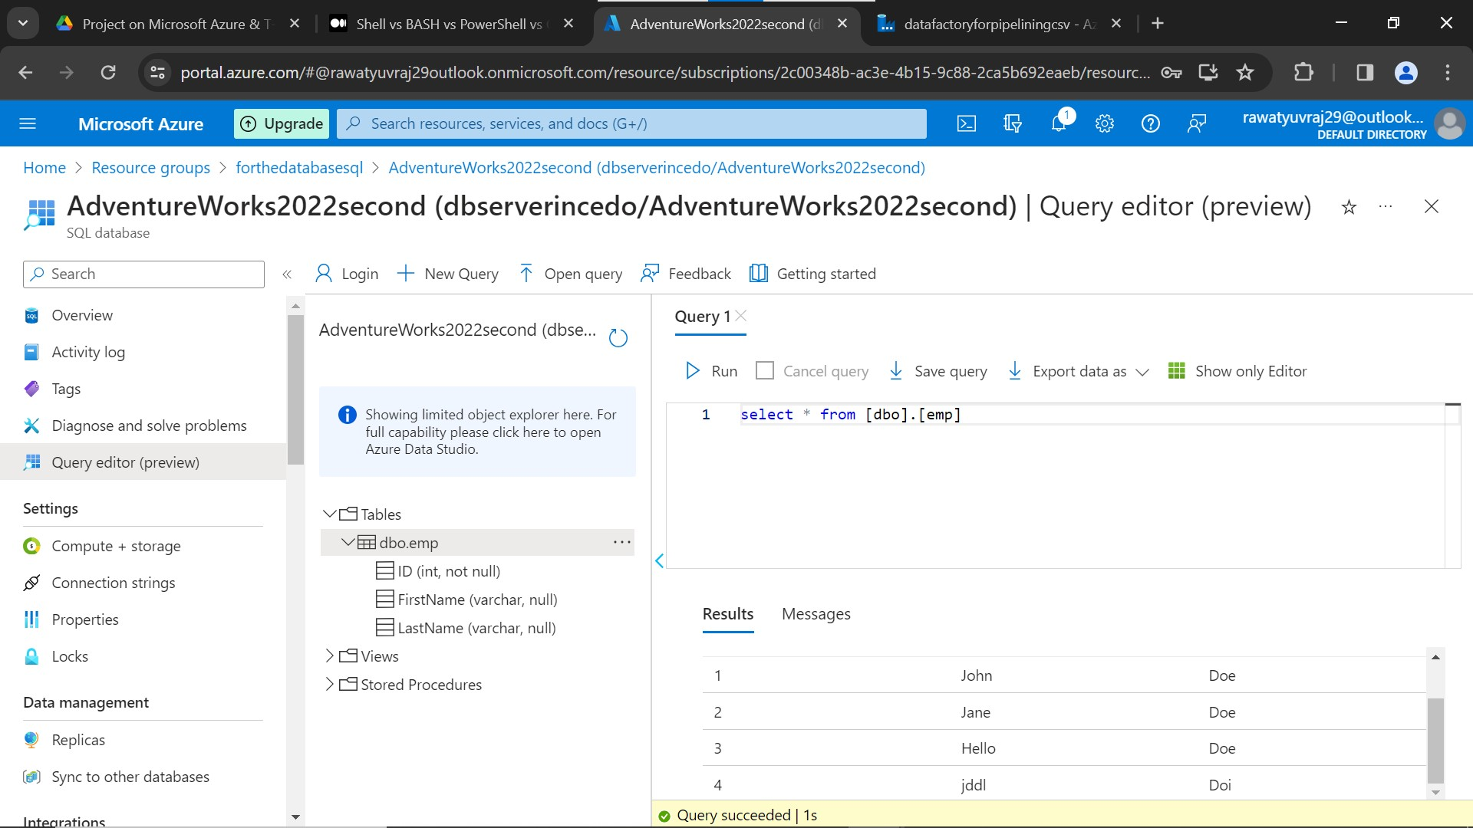

**–made a trigger to execute the pipeline on time or even recurring**

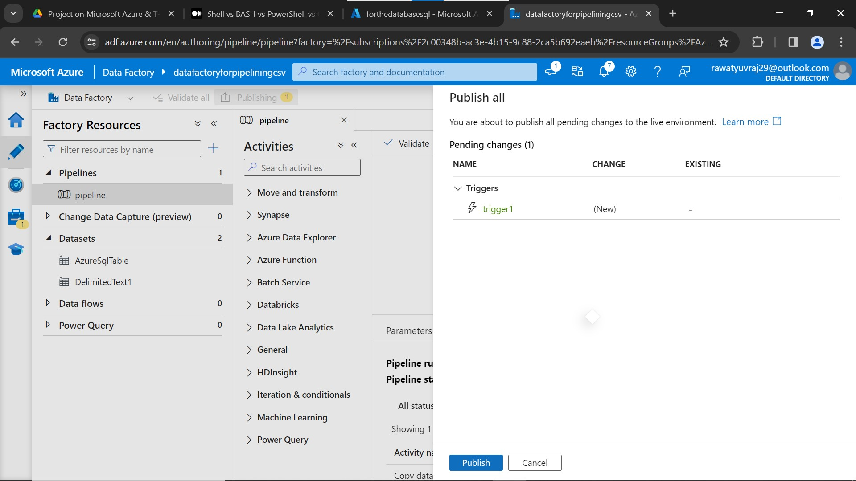

**Connecting to the dbserver using sql query editor and using DBeaver**

**–dbeaver**

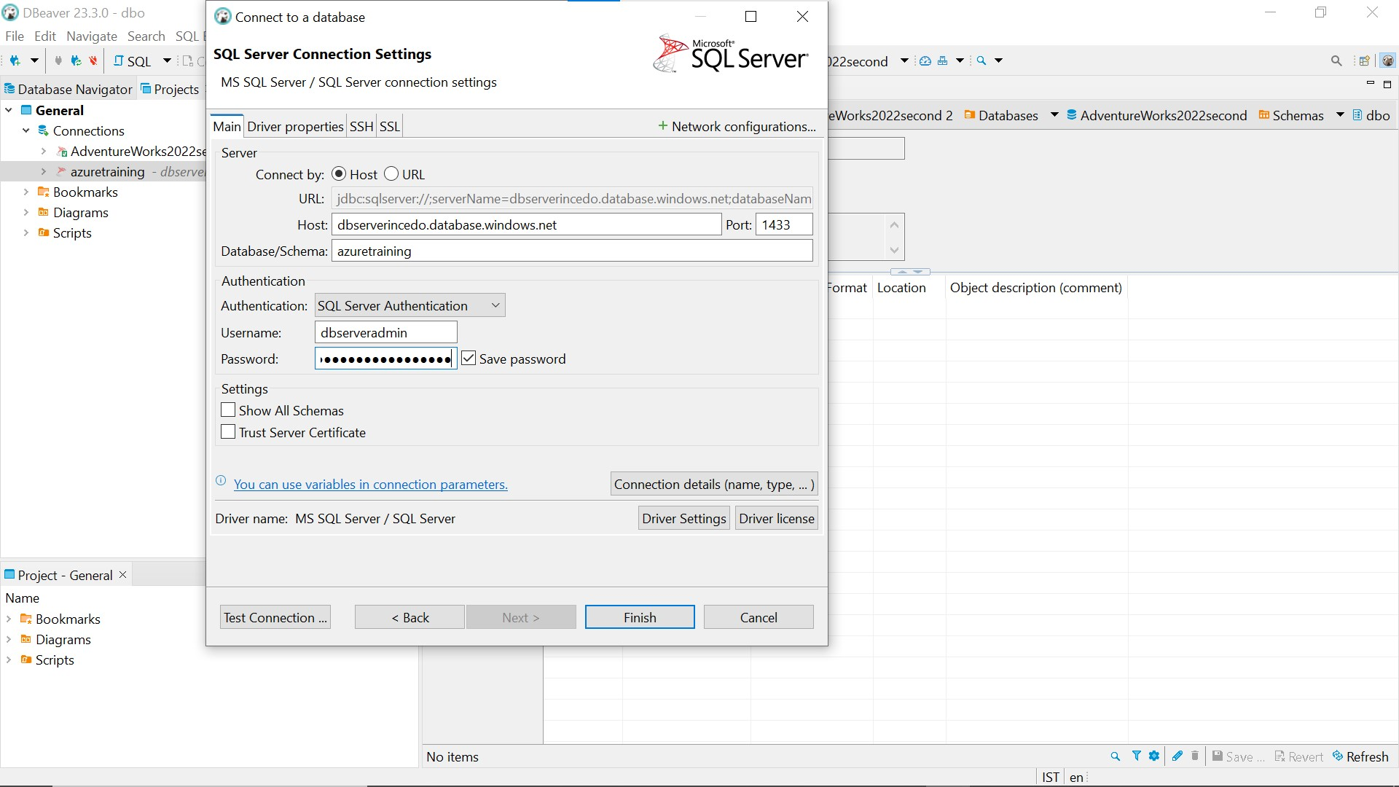

**–query editor**

