**About:**

[Code Editor: Sublime Text]

We have implemented concepts from digital Electronics that we studied this semester through c++ programming.

This is a very simple logical project design that performs circuit operations through CLI or command line interface programming.

Operations Included:

1. Base Convertor
2. Base Calculator
3. Complement Calculator

**OUTPUT SCREEN**

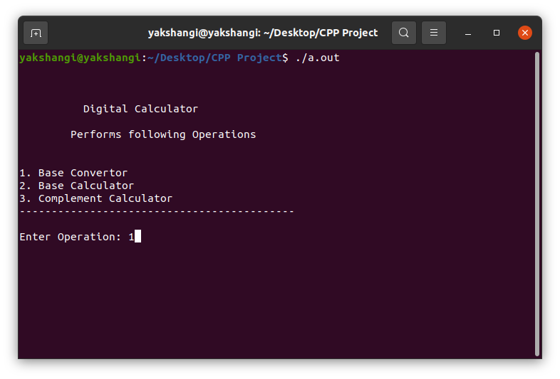

1. **Base Converter**

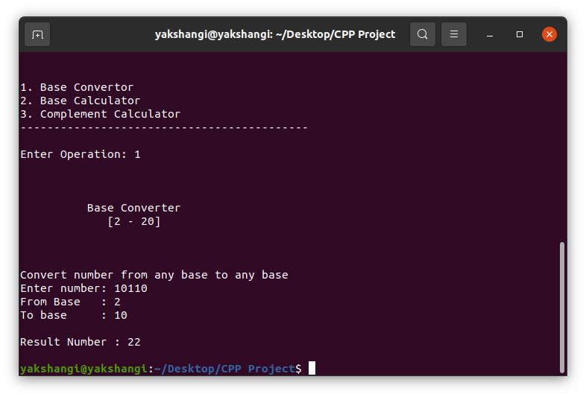

1. **Base Calculator**

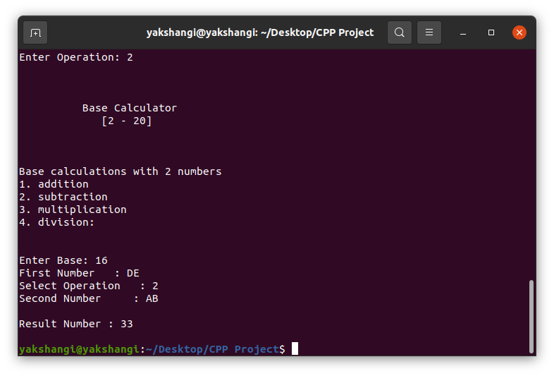

1. **Complement Calculator**

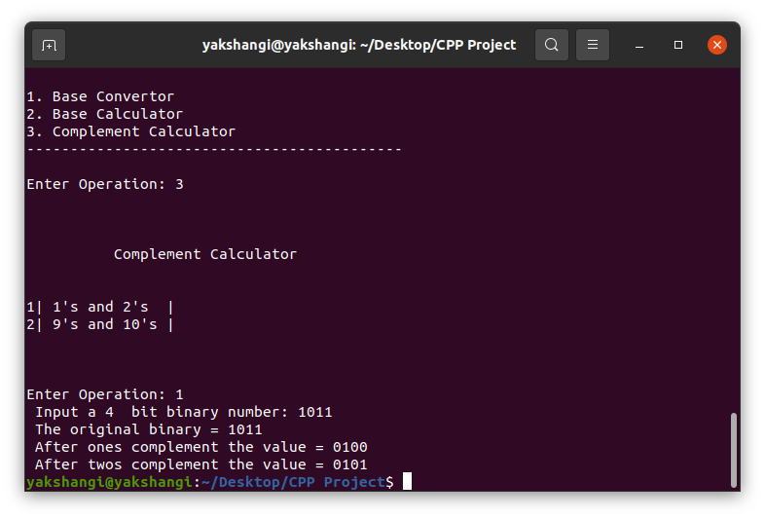

**Future Scope:**

* Further Implementation:

1. (R-1) ‘s and R ‘s complement
2. Weighted binary codes
3. Non - Weighted binary codes
4. History

**Testing Values:**

[ASCII Values](https://www.techonthenet.com/ascii/chart.php)

[Base Converter](https://www.rapidtables.com/convert/number/base-converter.html)

[Base Calculator](https://www.rapidtables.com/calc/math/base-calculator.html)

[COMPLEMENT CALCULATOR](https://madformath.com/calculators/digital-systems/complement-calculators/1-s-complement-calculator/1-s-complement-calculator)