# Introduction

“Yakshanota” is a platform for one of art form called “Yakshagana”, there are two types of user for this platform

1. Who perform this art-Artist
2. Who watch this art-User

We are introducing platform to collaborate both these people in one place to share their experience and introduce this art form to next generation

This platform will work similar to Facebook and linked-in kind of social platform

# Solution

To tryout the platform I have purchased ready-to-use application and customized to my needs

This platform has 2 variants

1. Web application
2. Mobile application

**Web application**: web application is developed using PHP and MySQL as database

**Mobile application**: Mobile application developed using android and iOS (not in scope)

# Challenges

The source code which I have purchased is generic social application which has many features and developed in mind set of educated users

But “Yakshanota” is a platform which is used by both educated and uneducated users

Due to this, application should be customize to my needs to fulfil user needs

# Features of Yakshanota

There are many features in this application, few of them needs to be remove/hide, and 3 feature needs to be added

**User Module**

* 1. Registration [Update]: API is available
  2. Login [Update] API is available
  3. Forgot Password [Update] API is available
  4. Settings
     + General
     + Push Notification
     + Privacy
     + Change Password
     + Change Mobile number [New feature V1]
     + Deactivate account
     + View blocked list
     + About
     + Others

Home Page Update

* 1. Banner [New feature V1]
  2. Stream (Landing Page)[Update]
  3. Users List [Update]
  4. Artist List [New feature V1] : API is available
  5. Video List [New feature V1] backend is in progress
  6. Guest
  7. Communities [Update]
  8. Friends
  9. Popular

# Features for Removal

* 1. Facebook login
  2. Gallery
  3. News (current landing page )
  4. Market
  5. People Nearby
  6. Favorites
  7. Upgrade
  8. Settings
     + Referrals
     + Balance
     + Balance
     + Service

# User Module Requirement [Phase 1]

## Registration [Update]

Original Registration Page

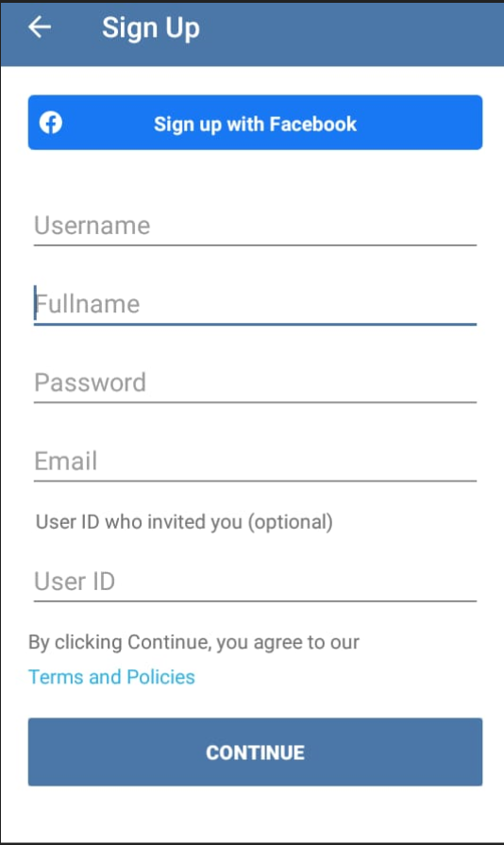

Sachin Update

Hidden Facebook login option

Hidden email, user ID invited

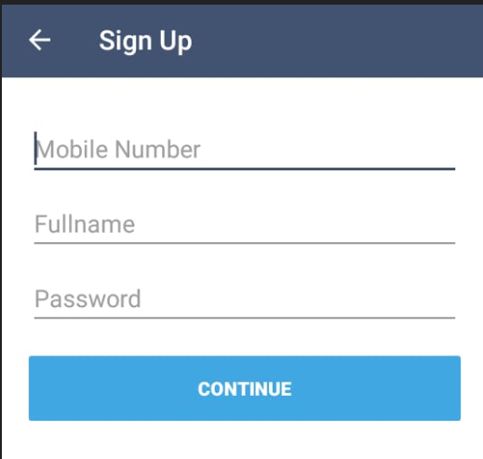

Bindhu Update

First Signup Page: Validate all 3 attribute before redirect next page: Mobile number validation needs to be added and color and style needs to be update with latest trends



Second Signup Page:User Role selection

Currently second page is photo selection, move photo selection to next page bring Gender and age selection to 2nd page

**Update required in gender selection page:**

1. Change color and remove top description and image
2. Change Gender Selection to Artist with Value Yes or No

If Artist **Yes** then populate list of groups, for value **Yes** group selection is must

If Artist **No** the redirect to next page

Next Page is **photo selection**

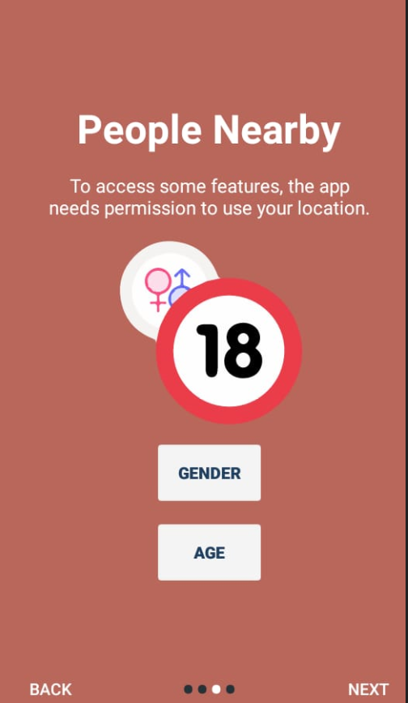

Third Sign-up page: **Phot selection**

**Update:** Photo selection is optional**,** Remove next **People nearby (GRATN ACCESS) page**

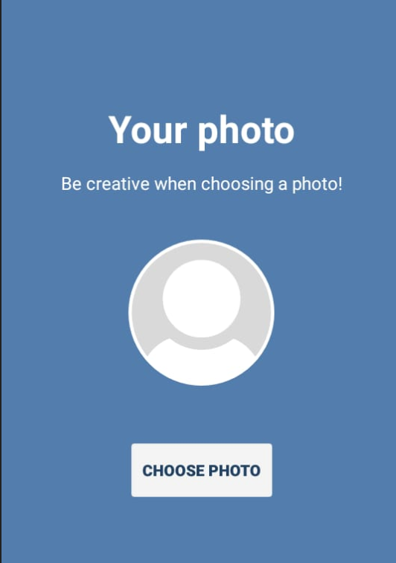

**After Signup Landing Page: After photo selection landing page should be “Stream” Stream page modification will be in another requirement point**

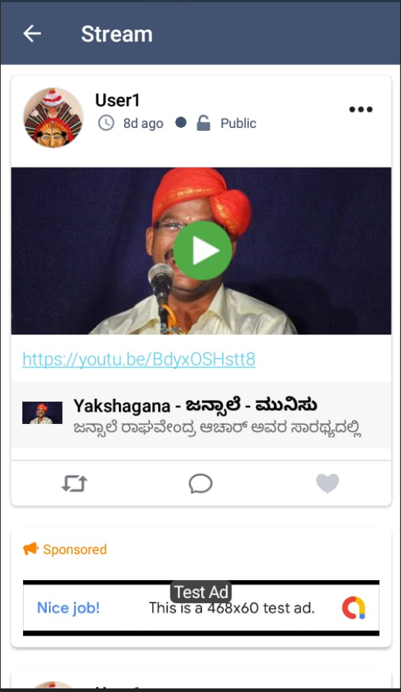

## Login Page Update

Sachin is already updated login page with mobile number and password, Binduh has to validate this changes if any modification required needs to be added, color and style needs to be change

Original login page Sachin Update

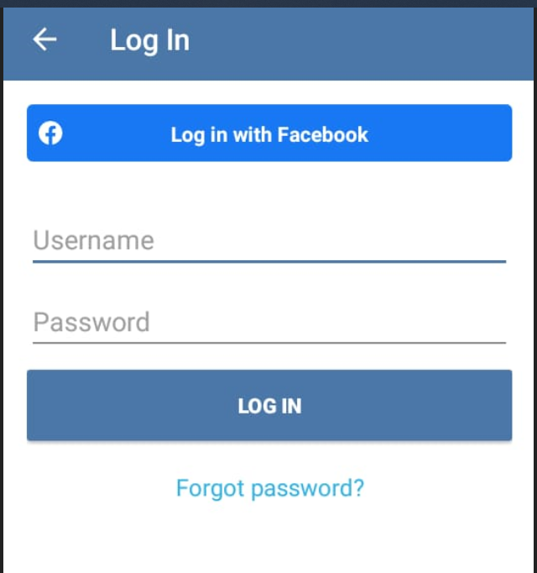 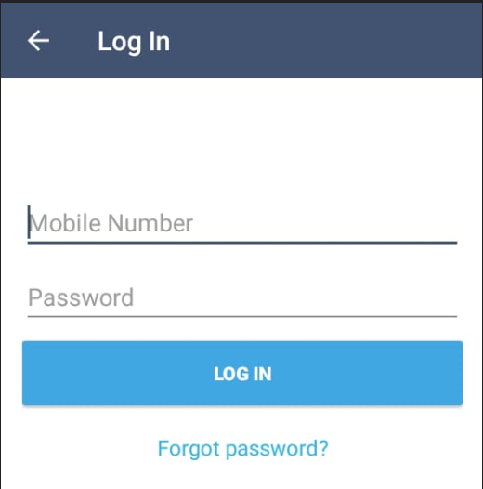

## Forgot Password

Email should change to Mobile number, mobile number validation should be added

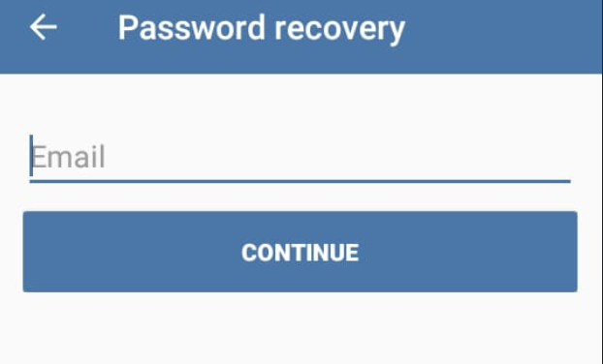

## Change Mobile number

New section needs to add under setting section (Similar to web application)

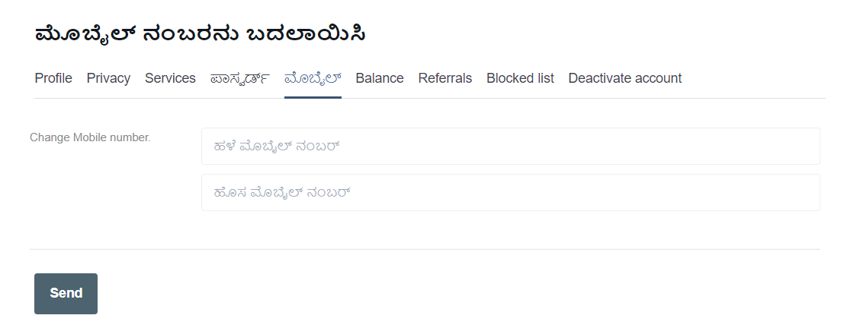

# Home Page Requirement [Phase 1]

## Stream page update

### Add Banner

## Menu Option Update

### Hide/Remove Few features

### Add Artist List Page

### Add User List Page

# Community Page Requirement [Phase 2]

# Mobile Application Update details (Android)

## Login Module Update:

Update login module same as web application, Hide/remove Facebook login feature from both login and registration page

|  |  |  |  |  |
| --- | --- | --- | --- | --- |
| # | Feature | Module | Attribute | New Changes |
| 1 | Registration | Login | Mobile Number  Full Name  Password  Artist (If Yes)  Select Mela from drop down (Populated from list of mela) | **Update**: in application developer used user id in different place changing userid to mobile number is not possible, change email to mobile number and hide userid, while registering generate userid using some character of name and some digit of mobile number. |
| 2 | Login | Login | Mobile Number  Password | **Update**: Map mobile number with respective user id while login |
| 3 | Password Reset | Login | Mobile Number | **Update**: Send Password reset link to Mobile |
| 4 | Change Mobile number | Login | Old Mobile Number  New Mobile Number | **Update**: Change mobile number using verify existing number, by sending SMS or OTP verification |