**ALGORITHMS AND DATA STRUCTURES**

Exercise 7 : Financial Forecasting

1. **Recursive Algorithms**  :

* Recursive is a programming technique where a function calls itself .
* It is used to solve problems by breaking them into smaller ,repetitive subproblems.
* It requires a

**Base case** : condition to stop the recursion.

**Recursive case** : function calling itself with modified input.

* It is useful in solving problems such as factorials, Fibonacci sequence , financial forecasting , etc.

1. **Implementation :**

**FinancialForecast.java**

public class FinancialForecast {  
 public static double forecast(double principal, double growth, int period)  
 {  
 if(period==0) return principal;  
 return *forecast*(principal*(1+growth),growth,period-1);  
 }  
 public static void main(String[] args)  
 {  
 int period=7;  
 int principal=1000;  
 double growth=0.05;  
 System.*out*.println("Future value of your investment : "+*forecast*(principal,growth,period));  
 }  
}

1. **Output :**

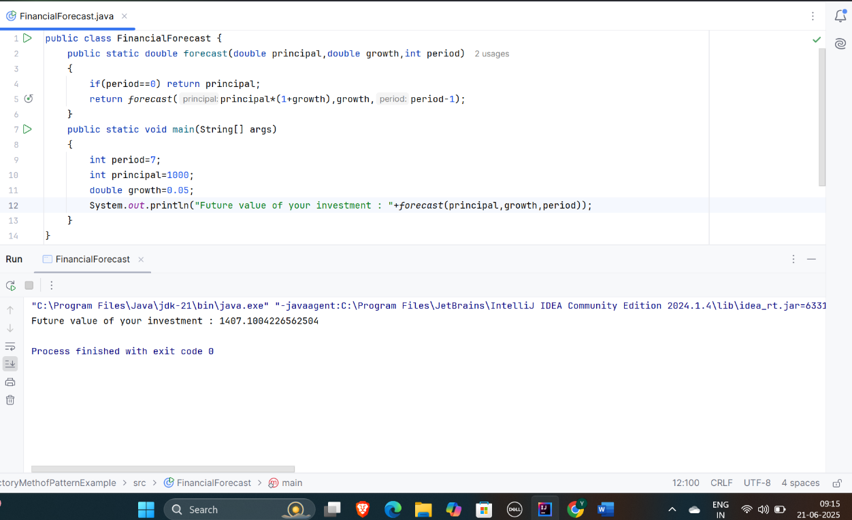

1. **Analysis:**

In this case, recursion method runs once per period . Since there is no repeated subproblem, no exponential growth.

**Optimizations:**

Use Iterative method for large values of n as recursion in such cases may cause stack overflow.

Otherwise , use the apply the forecast formula directly using Math.pow()

|  |  |
| --- | --- |
| **Method** | **Time Complexity** |
| Recursive | O(n) |
| Iterative | O(n) |
| Math.pow() | O(1) |