**JUnit Basic Testing Exercises**

**Exercise 1: Setting up JUnit**

1. Created a maven-based Java project named ‘Testing’ and added the Junit dependency into pom.xml file

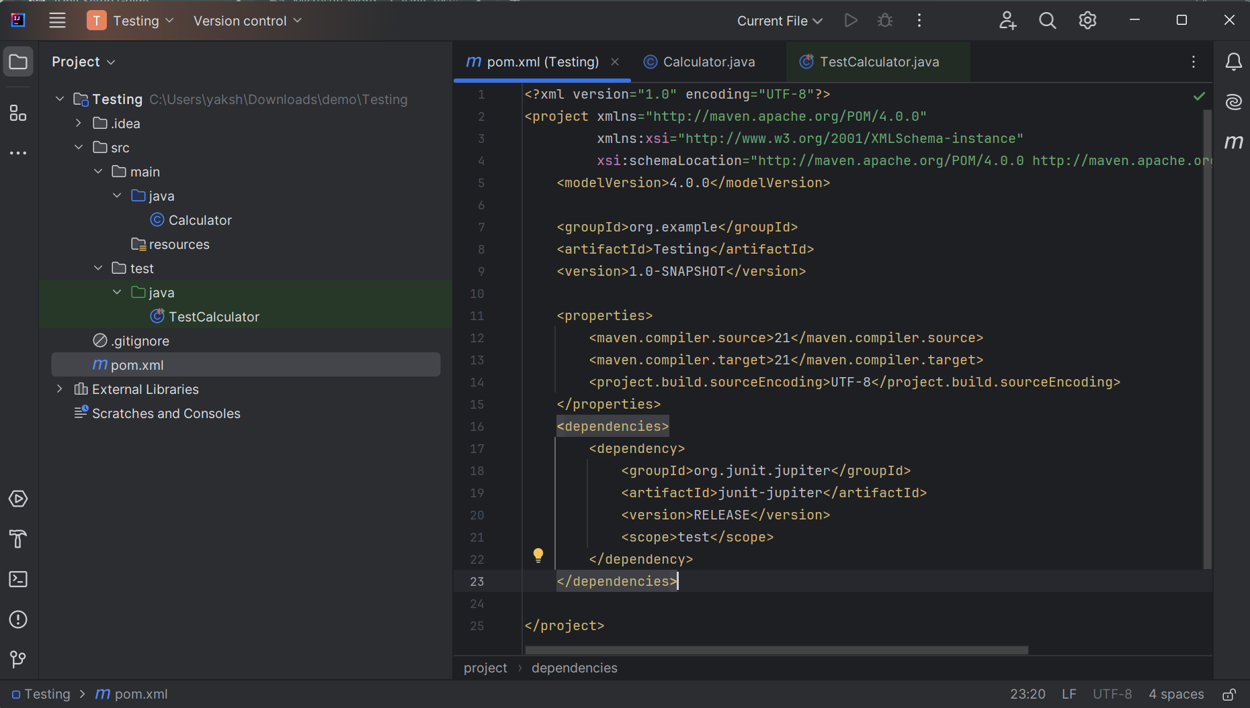

1. Created class file under src/main/java and added the following code for a simple Calculator operation.

public class Calculator {  
 public int add(int a,int b)  
 {  
 return a+b;  
 }  
}

1. Created a test class under src/test/java and added the following code :

import org.junit.jupiter.api.Test;  
import static org.junit.jupiter.api.Assertions.*assertEquals*;  
public class TestCalculator {  
 Calculator c=new Calculator();  
 @Test  
 public void testAdd()  
 {  
 *assertEquals*(10,c.add(4,6));  
 }  
}

1. Project build successful and test case executed without any errors.

