**JUnit Basic Testing Exercises**

**Exercise 4: Arrange-Act-Assert (AAA) Pattern, Test Fixtures, Setup and Teardown Methods in JUnit**

1. Creating a test class using the AAA pattern for the same calculator class created as in Exercise1 :

import org.junit.jupiter.api.*;

import static org.junit.jupiter.api.Assertions.assertEquals;

public class TestCalculator {

Calculator c;

@BeforeEach

public void setUp()

{

c=new Calculator(); **//ARRANGE**

}

@AfterEach

public void tearDown()

{

c=null;

}

@Test

public void add()

{

int result=c.add(14,17);  **//ACT**

assertEquals(31,result);  **//ASSERT**

}

}

1. **OUTPUT:**

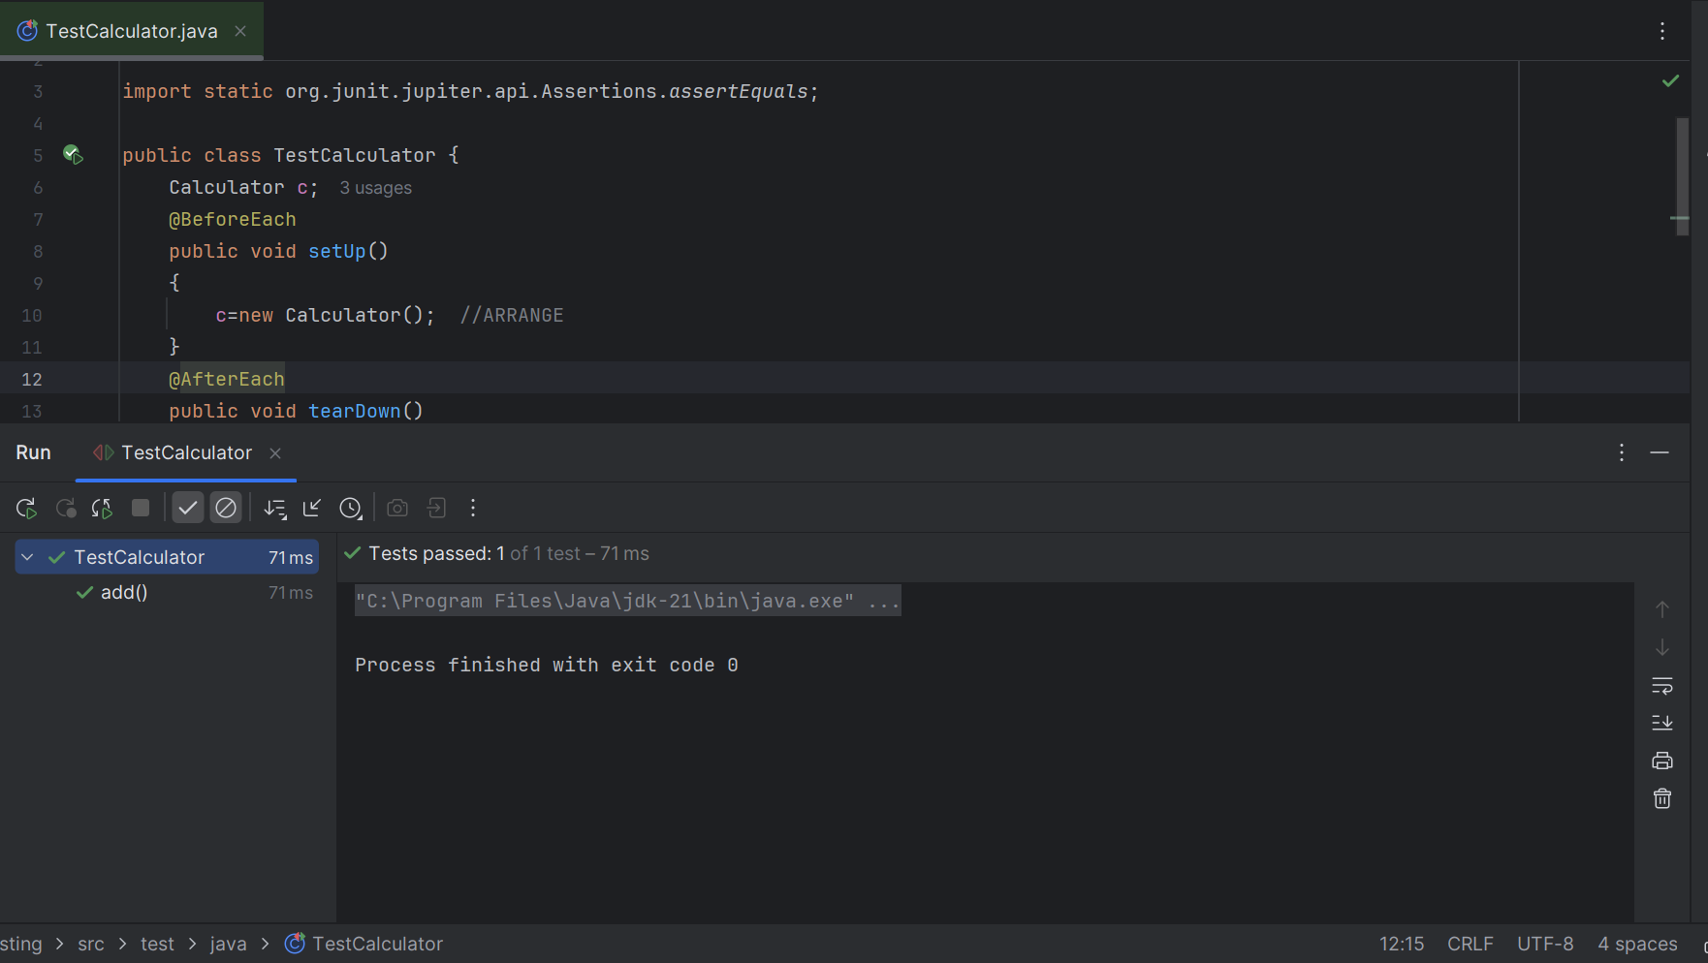

Project build successful and AAA pattern JUnit testing implemented successfully.