**Mockito Exercises**

**Exercise 1: Mocking and Stubbing**

1. Created an Externalapi interface and a service class that uses the api interface.

public interface Externalapi {  
 String fetchData();  
}

public class MyService {  
 private Externalapi api;  
  
 public MyService(Externalapi api) {  
 this.api = api;  
 }  
  
 public String getData() {  
 return api.fetchData();  
 }  
}

1. Created a test class using Mockito and performed :

* Mock object creation
* Method Stubbing
* Testing the mock object

import static org.junit.jupiter.api.Assertions.*;  
import static org.mockito.Mockito.*mock*;  
import static org.mockito.Mockito.*when*;  
  
import org.junit.jupiter.api.Test;  
  
  
public class MyServiceTest {  
  
 @Test  
 public void testGetData() {  
 Externalapi mockapi = *mock*(Externalapi.class);  
 *when*(mockapi.fetchData()).thenReturn("Mock World");  
 MyService service = new MyService(mockapi);  
 String result = service.getData();  
 *assertEquals*("Mock World", result);  
 }  
}

**OUTPUT:**

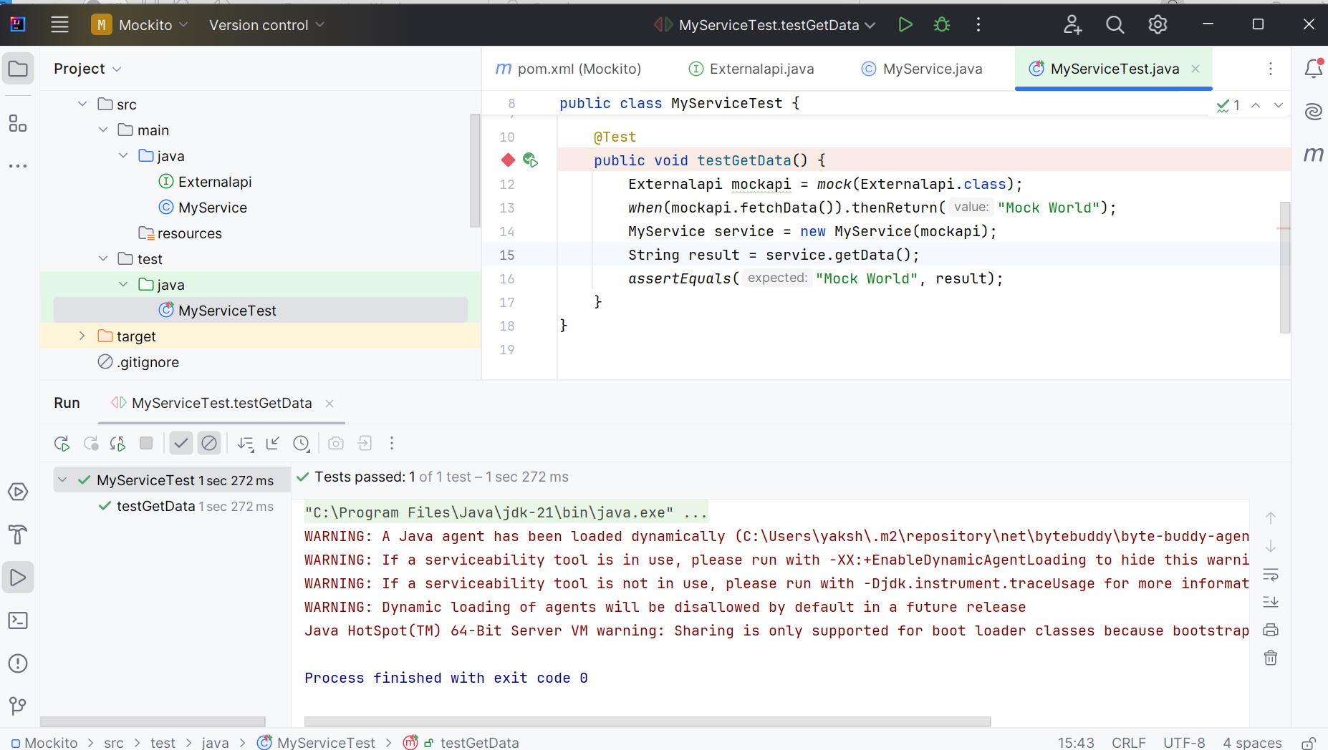

Testing using Mockito successfully done without any errors.