**Mockito Exercises**

**Exercise 2: Verifying Interactions**

**Solution :**

Created

* An ‘ExternalApi’ interface
* a service class that uses the api interface
* a test class using Mockito which also verifies interaction to check if the method of the mock object was actually called.

import static org.mockito.Mockito.*;

import static org.junit.jupiter.api.Assertions.*;

import org.junit.jupiter.api.Test;

interface ExternalApi {

String fetchData();

}

class MyService {

private ExternalApi api;

public MyService(ExternalApi api) {

this.api = api;

}

public String getData() {

return api.fetchData();

}

}

public class MyServiceTest {

@Test

public void testGetDataAndVerifyCall() {

ExternalApi mockApi = mock(ExternalApi.class);

when(mockApi.fetchData()).thenReturn("Hello World");

MyService service = new MyService(mockApi);

String result = service.getData();

assertEquals("Hello World", result);

verify(mockApi).fetchData(); // verifies interaction

}

}

**OUTPUT:**

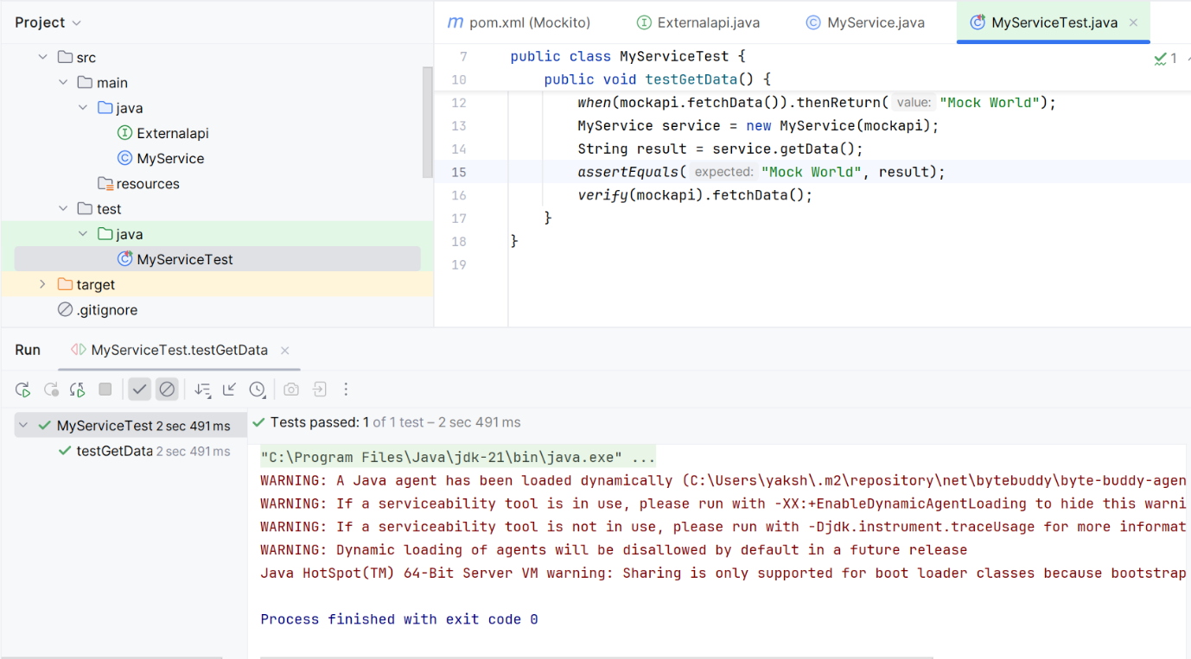

Verified interactions successfully without any errors.