**PL/SQL PROGRAMMING**

**Exercise 1: Control Structures**

**Code:**

**-- Scenario 1: Apply 1% Interest Discount for Customers > 60**

BEGIN

FOR c IN (SELECT CustomerID, DOB FROM Customers) LOOP

IF MONTHS_BETWEEN(SYSDATE, c.DOB) / 12 > 60 THEN

UPDATE Loans

SET InterestRate = InterestRate - 1

WHERE CustomerID = c.CustomerID;

END IF;

END LOOP;

COMMIT;

END;

/

**-- Scenario 2: Set IsVIP Flag for High Balance Customers**

ALTER TABLE Customers ADD IsVIP CHAR(1);

BEGIN

FOR c IN (SELECT CustomerID, Balance FROM Customers) LOOP

IF c.Balance > 10000 THEN

UPDATE Customers

SET IsVIP = 'Y'

WHERE CustomerID = c.CustomerID;

END IF;

END LOOP;

COMMIT;

END;

/

**--Scenario 3: Remind Customers with Loans Due in Next 30 Days**

BEGIN

FOR l IN (

SELECT

LoanID,

c.Name AS cust_name,

EndDate

FROM

Loans l

JOIN Customers c ON l.CustomerID = c.CustomerID

WHERE

EndDate <= SYSDATE + 30

) LOOP

DBMS_OUTPUT.PUT_LINE(

'Reminder: Loan ID ' || l.LoanID ||

' for customer ' || l.cust_name ||

' is due on ' || TO_CHAR(l.EndDate, 'YYYY-MM-DD')

);

END LOOP;

END;

/

**Output Screenshots :**

Loan table before scenario1:

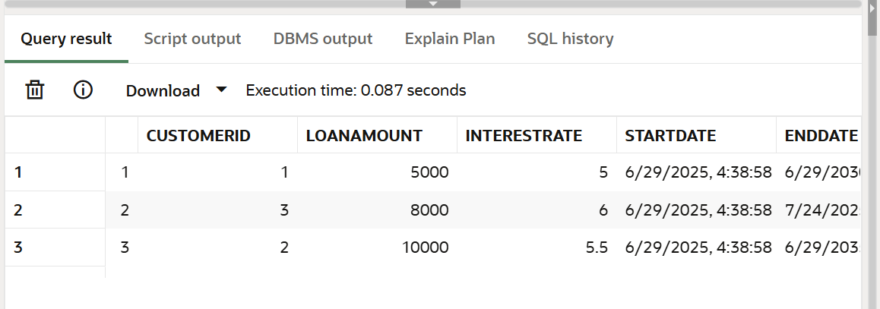

Loan table after scenario 1:

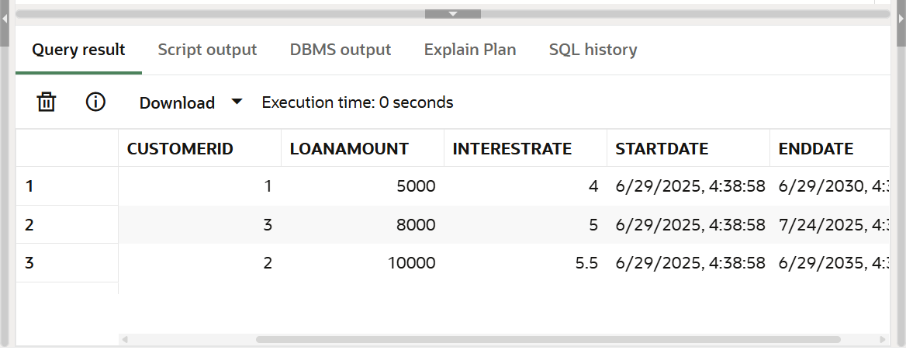

Customer table before scenario 2:

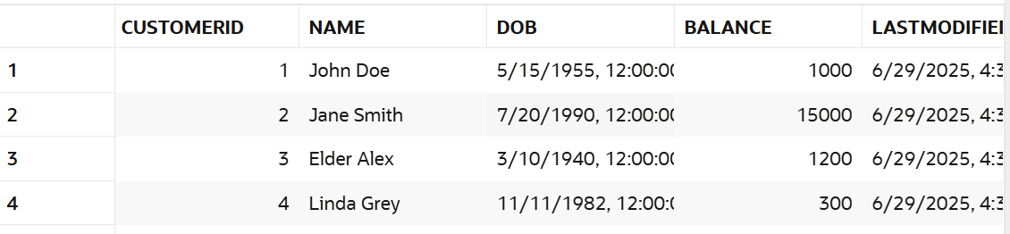

Customer table after scenario 2:

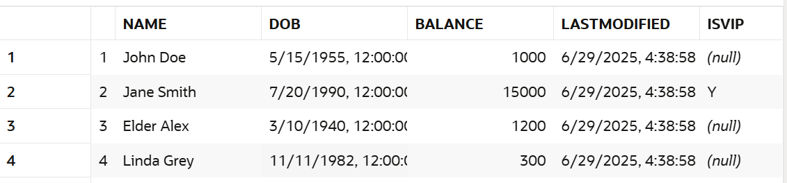

Scenario 3:

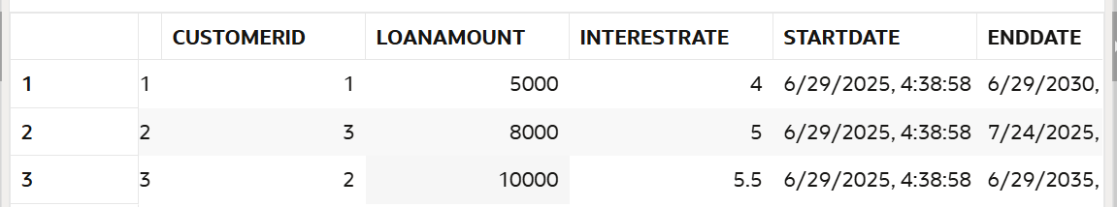

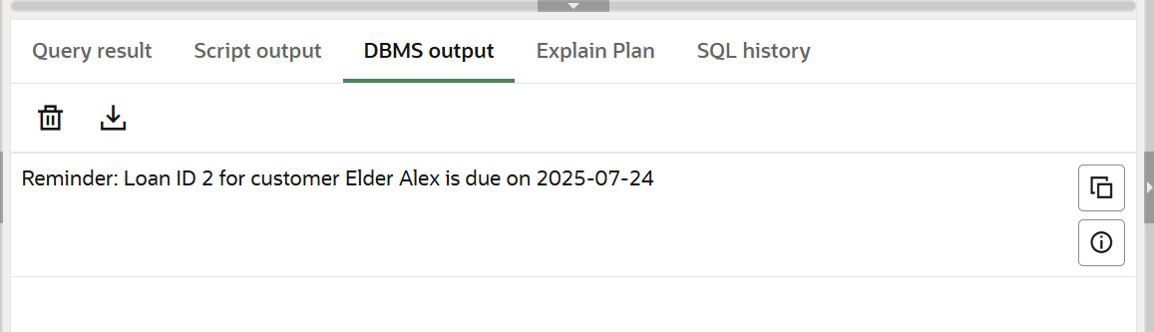

Thus, the table with given schema has been created with sample records and PL/SQL blocks have been executed successfully.