**PL/SQL PROGRAMMING**

**Exercise 3: Stored Procedures**

**Code:**

**-- Scenario 1: Process Monthly Interest for Savings Accounts**

CREATE OR REPLACE PROCEDURE ProcessMonthlyInterest IS

BEGIN

FOR acc IN (

SELECT AccountID, Balance

FROM Accounts

WHERE AccountType = 'Savings'

) LOOP

UPDATE Accounts

SET Balance = Balance + (Balance * 0.01),

LastModified = SYSDATE

WHERE AccountID = acc.AccountID;

END LOOP;

COMMIT;

END;

/

**-- Scenario 2: Add Bonus to Employees in a Department**

CREATE OR REPLACE PROCEDURE UpdateEmployeeBonus(

dept_name IN VARCHAR2,

bonus_percent IN NUMBER

) IS

BEGIN

UPDATE Employees

SET Salary = Salary + (Salary * (bonus_percent / 100))

WHERE Department = dept_name;

COMMIT;

END;

/

EXEC UpdateEmployeeBonus('IT', 10);

**--Scenario 3: Transfer Funds Between Accounts**

CREATE OR REPLACE PROCEDURE TransferFunds(

from_acc_id IN NUMBER,

to_acc_id IN NUMBER,

amount IN NUMBER

) IS

from_balance NUMBER;

BEGIN

SELECT Balance INTO from_balance FROM Accounts WHERE AccountID = from_acc_id;

IF from_balance < amount THEN

RAISE_APPLICATION_ERROR(-20001, 'Insufficient balance');

ELSE

UPDATE Accounts

SET Balance = Balance - amount,

LastModified = SYSDATE

WHERE AccountID = from_acc_id;

UPDATE Accounts

SET Balance = Balance + amount,

LastModified = SYSDATE

WHERE AccountID = to_acc_id;

COMMIT;

END IF;

END;

/

EXEC TransferFunds(1, 2, 200);

**Output Screenshots :**

Scenario1 (Account table)

Before:

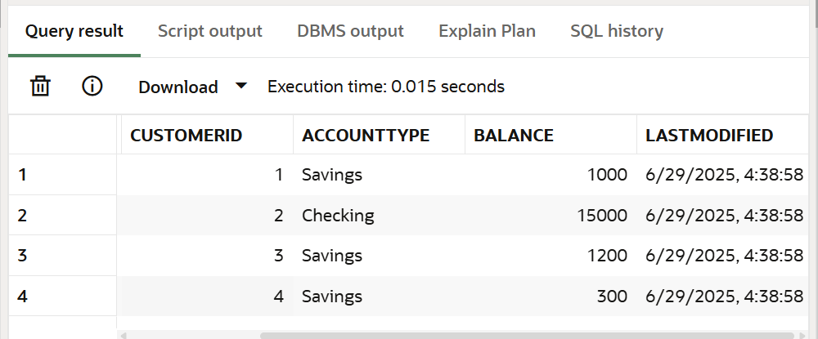

After:

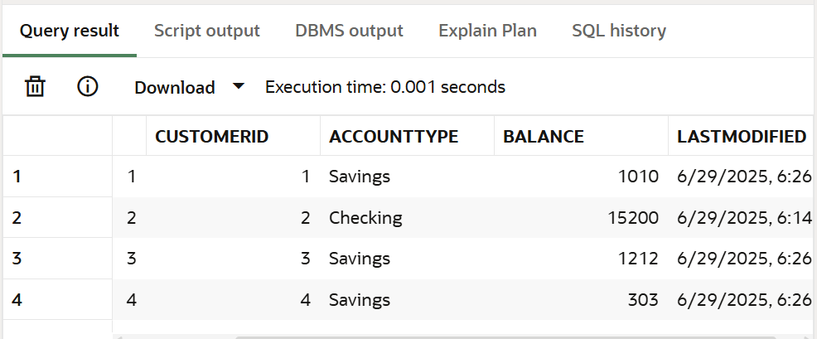

Scenario 2 (Employee table) Before/After :

Before:

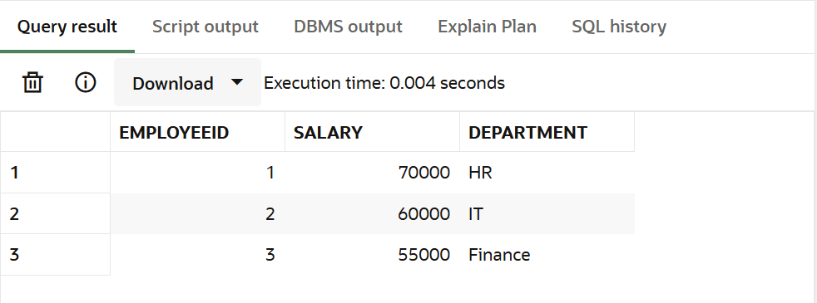

After:

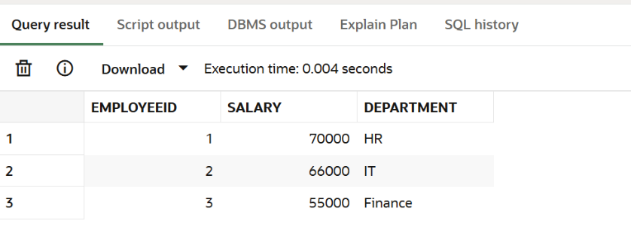

Scenario 3 (Accounts table) :

Before :

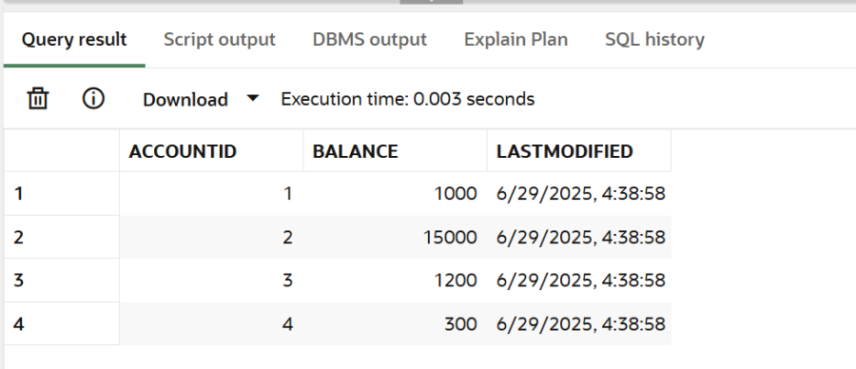

After:

