**SL4J Logging Exercises**

**Exercise 1: Logging Error Messages and Warning Levels**

**Solution :**

1. Add the following to pom.xml (Logger interface and implementation) :

<dependencies>

<dependency>

<groupId>org.slf4j</groupId>

<artifactId>slf4j-api</artifactId>

<version>2.0.9</version>

</dependency>

<dependency>

<groupId>org.slf4j</groupId>

<artifactId>slf4j-simple</artifactId>

<version>2.0.9</version>

</dependency>

</dependencies>

1. Create a java class file named ‘SampleLoggin’ and add the following code:

import org.slf4j.Logger;  
import org.slf4j.LoggerFactory;  
  
public class SampleLogging {  
 private static final Logger= LoggerFactory.*getLogger*(SampleLogging.class);  
  
 public static void main(String[] args) {  
 int[] numbers = {1, 2, 3};  
 try {  
 int result = numbers[5];  
 } catch (ArrayIndexOutOfBoundsException e) {  
 *logger*.error("You are trying to access an item that is out of bound!");  
 }  
 *logger*.warn("Memory not sufficient");  
 }  
}

**OUTPUT:**

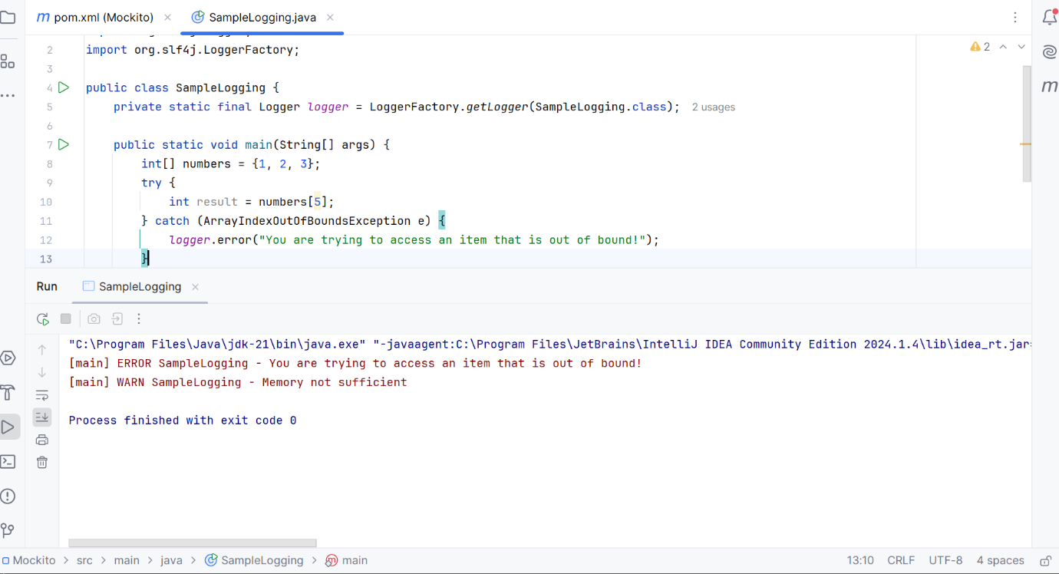

Logging error and warning messages demonstrated using SLF4J framework successfully.