**Spring Core Maven**

**Exercise 1 : Configuring a Basic Spring Application**

1. **Created Project Structure :**

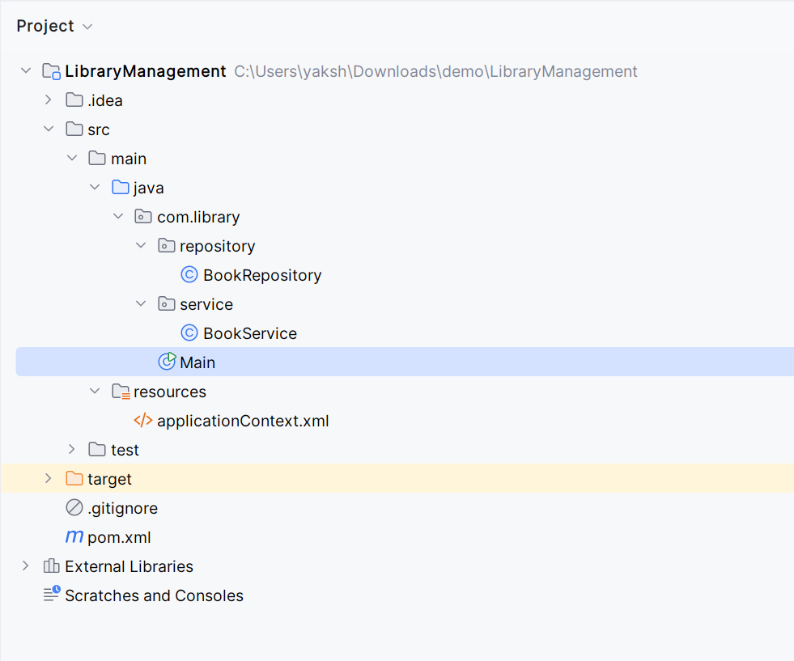

1. **Configuration files :**

pom.xml

<dependencies>  
 *<!-- https://mvnrepository.com/artifact/org.springframework/spring-context -->* <dependency>  
 <groupId>org.springframework</groupId>  
 <artifactId>spring-context</artifactId>  
 <version>7.0.0-M6</version>  
 </dependency>  
</dependencies>

src/main/resources/applicationContext.xml

*<?*xml version="1.0" encoding="UTF-8"*?>*<beans xmlns="http://www.springframework.org/schema/beans"  
 xmlns:xsi="http://www.w3.org/2001/XMLSchema-instance"  
 xsi:schemaLocation="http://www.springframework.org/schema/beans  
 http://www.springframework.org/schema/beans/spring-beans.xsd">  
<bean id="bookService" class="com.library.BookService"/>  
</beans>

1. **Service and Repository Classes:**

BookService.java

package com.library.service;

import com.library.repository.BookRepository;

public class BookService {

private BookRepository bookRepository;

public BookService() {

this.bookRepository = new BookRepository(); // direct instantiation

}

public void addBook(String title)

{

System.out.println("Adding Book "+title);

bookRepository.saveBook(title);

}

}

BookRepository.java

package com.library.repository;  
  
public class BookRepository {  
 public void saveBook(String title)  
 {  
 System.*out*.println("Book "+title+" has been saved successfully.");  
 }  
}

1. **Main class**

package com.library;  
  
import com.library.service.BookService;  
import org.springframework.context.ApplicationContext;  
import org.springframework.context.support.ClassPathXmlApplicationContext;  
  
public class Main {  
 public static void main(String[] args)  
 {  
 ApplicationContext c=new ClassPathXmlApplicationContext("applicationContext.xml");  
 BookService service=(BookService) c.getBean("bookService");  
 service.addBook("Lord of the Rings");  
 }  
}

**OUTPUT:**

