**Spring Core Maven**

**Exercise 2 : Implementing Dependency Injection**

1. **Project Structure (same as Ex 1):**

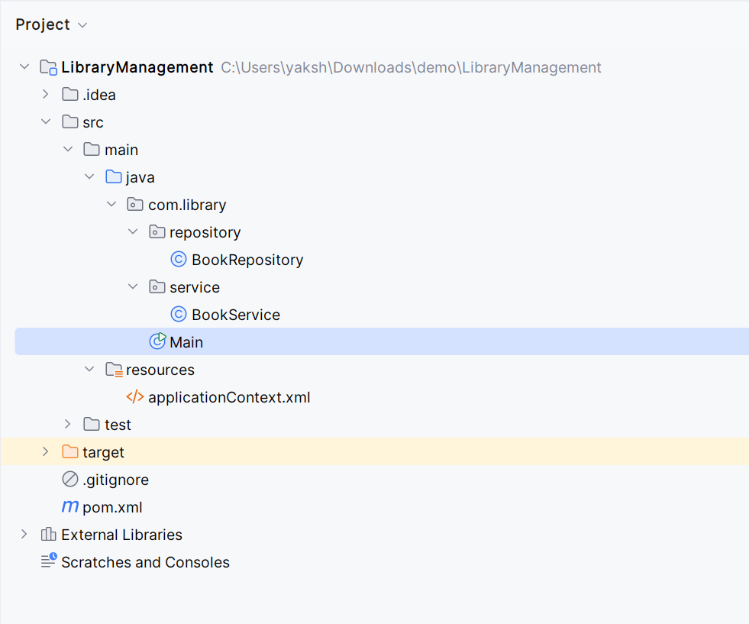

1. **Updated applicationContext.xml –** wired BookRepository into BookService

*<?*xml version="1.0" encoding="UTF-8"*?>*<beans xmlns="http://www.springframework.org/schema/beans"  
 xmlns:xsi="http://www.w3.org/2001/XMLSchema-instance"  
 xsi:schemaLocation="http://www.springframework.org/schema/beans  
 http://www.springframework.org/schema/beans/spring-beans.xsd">  
<bean id="bookRepository" class="com.library.repository.BookRepository"/>

<bean id="bookService" class="com.library.service.BookService">  
 <property name="bookRepository" ref="bookRepository"/>  
 </bean>  
  
</beans>

1. **Updated BookService class:**

package com.library.service;

import com.library.repository.BookRepository;

public class BookService {

private BookRepository bookRepository;

**public void setBookRepository(BookRepository bookRepository)**

**{**

**this.bookRepository=bookRepository; // setter for Spring DI**

**}**

public void addBook(String title)

{

System.out.println("Adding Book "+title);

bookRepository.saveBook(title);

}

}

**OUTPUT:**

