**Spring Core Maven**

**Exercise 4 : Creating and Configuring a Maven Project**

1. **Creating Maven Project with artifact and groupId**

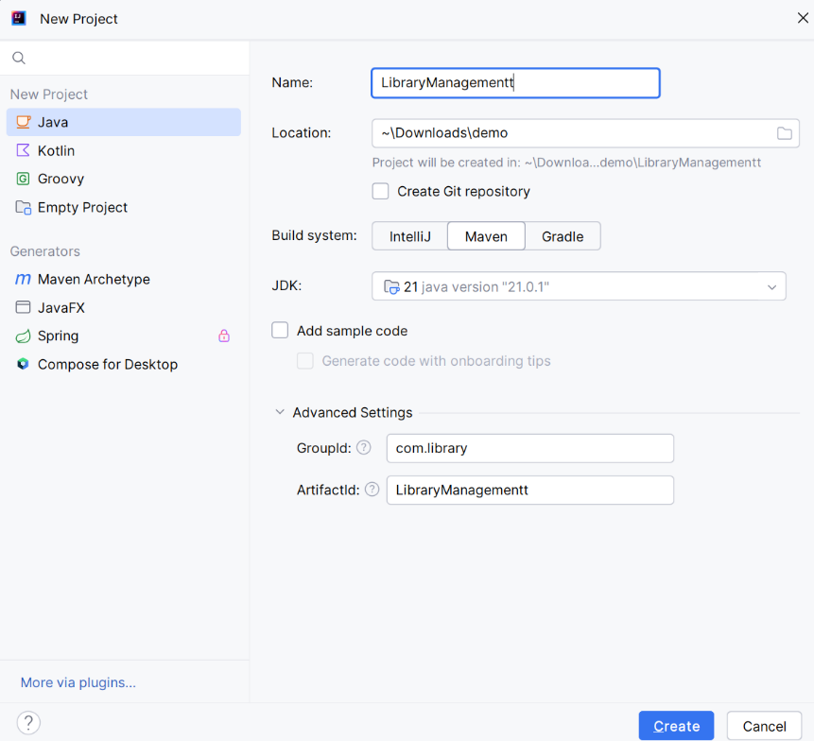

1. Adding Spring Dependencies to pom.xml:

<dependencies>  
 *<!-- https://mvnrepository.com/artifact/org.springframework/spring-context -->* <dependency>  
 <groupId>org.springframework</groupId>  
 <artifactId>spring-context</artifactId>  
 <version>7.0.0-M6</version>  
 </dependency>  
 *<!-- https://mvnrepository.com/artifact/org.springframework/spring-aop -->* <dependency>  
 <groupId>org.springframework</groupId>  
 <artifactId>spring-aop</artifactId>  
 <version>7.0.0-M6</version>  
 </dependency>  
 *<!-- https://mvnrepository.com/artifact/org.springframework/spring-webmvc -->* <dependency>  
 <groupId>org.springframework</groupId>  
 <artifactId>spring-webmvc</artifactId>  
 <version>7.0.0-M6</version>  
 </dependency>  
</dependencies>

1. Configuring Maven Plugin for Java 1.8 in pom.xml :

<build>  
 <plugins>  
 <plugin>  
 <groupId>org.apache.maven.plugins</groupId>  
 <artifactId>maven-compiler-plugin</artifactId>  
 <version>3.8.1</version>  
 <configuration>  
 <source>1.8</source>  
 <target>1.8</target>  
 </configuration>  
 </plugin>  
 </plugins>  
</build>